1.Develop a java application with Employee class with Emp_name, Emp_id,
Address, Mail_id, Mobile_no as members. Inherit the classes, Programmer,
Assistant Professor, Associate Professor and Professor from employee class.
Add Basic Pay (BP) as the member of all the inherited classes with 97% of BP as
DA, 10 % of BP as HRA, 12% of BP as PF, 0.1% of BP for staff club fund.
Generate pay slips for the employees with their gross and net salary
Program:
class Employee{
String Emp_name, Emp_id,Address, Mail_id;
long Mob_no;
Employee(String name,String id,String addr,String mail,long phn){
Emp_name=name;
Emp_id=id;
Address=addr;
Mail_id=mail;
Mob_no=phn;
}

}
class Assistant_professor extends Employee{
int bp;
Assistant_professor(String name,String id,String addr,String mail,long phn,int pay){
super(name,id,addr,mail,phn);
bp = pay;
}
void payslip(){
float da = bp*(0.97f);
float hra = bp*(0.10f);
float pf = bp*(0.12f);
float sc = bp*(0.001f);
float net_salary = (da + hra)- (pf+sc);
float gross_salary = (da+hra);
System.out.println("the gross salary is"+ gross_salary);
System.out.println("the net salary is"+ net_salary);
}
}
class Associate_professor extends Employee{
int bp;
Associate_professor(String name,String id,String addr,String mail,long phn,int pay){
super(name,id,addr,mail,phn);
bp = pay;
}
void payslip(){
float da = bp*(0.97f);
float hra = bp*(0.10f);
float pf = bp*(0.12f);
float sc = bp*(0.001f);
float net_salary = (da + hra)- (pf+sc);
float gross_salary = (da+hra);
System.out.println("the gross salary is"+ gross_salary);
System.out.println("the net salary is"+ net_salary);
}
}
class Professor extends Employee{
int bp;
Professor(String name,String id,String addr,String mail,int phn,int pay){
super(name,id,addr,mail,phn);
bp = pay;
}
void payslip(){
float da = bp*(0.97f);
float hra = bp*(0.10f);
float pf = bp*(0.12f);
float sc = bp*(0.001f);
float net_salary = (da + hra)- (pf+sc);
float gross_salary = (da+hra);
System.out.println("the gross salary is"+ gross_salary);
System.out.println("the net salary is"+ net_salary);
}
}
public class Main
{
public static void main(String[] args) {

Assistant_professor ap = new Assistant_professor("gopikrishna","4081","piduguralla","gopikrishna@gmail.com",98677,22500);
Associate_professor ap1 = new Associate_professor("gautham","4189","rayachoti","gauthammrrv@gmail.com",890571,31230);
Professor p = new Professor("sai krishna","4655","piduguralla","salmanshaik960@gmail.com",788031,90000);
ap.payslip();
ap1.payslip();
p.payslip();
}
}
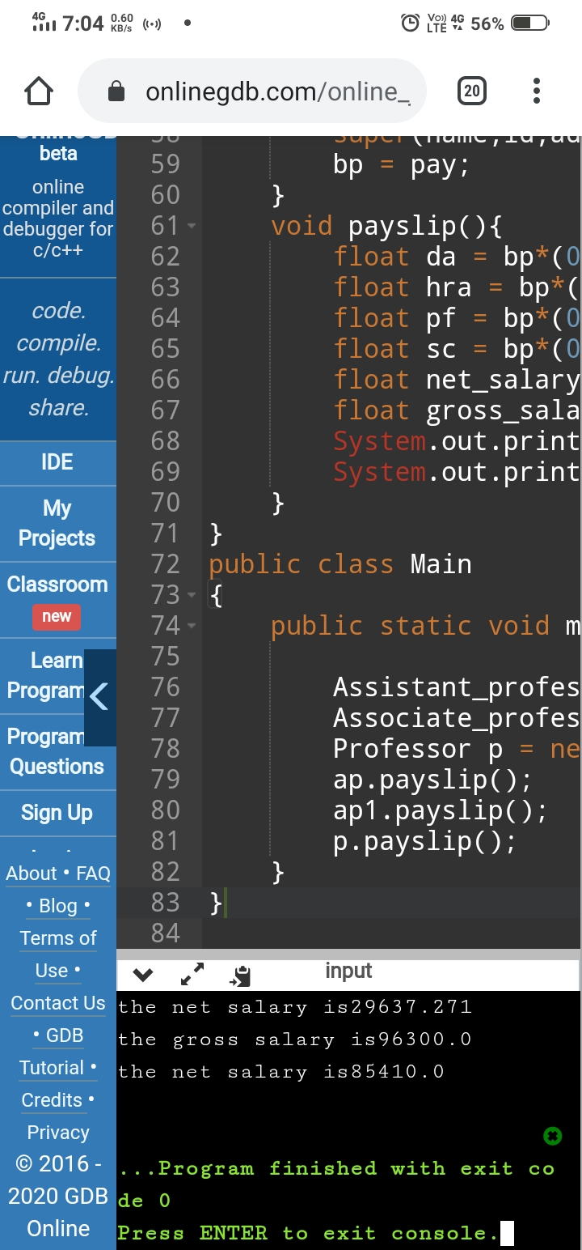

Program 2:
Create a Circle class with following members.

A data member that stores the radius of a circle
A constructor function with an argument that initializes the radius
A function that computes and returns are of a circle
Create two derived classes Sector and Segment that inherit the Circle class.
Both classes inherit radius and the function that returns the circle&#39;s area from
Circle. In addition to the members inherited from Circle, Sector and Segment
have some specific members as follows:
Sector
A data member that stores the control angle of a sector(in radians)
A constructor function with arguments that initialize radius and angle
A function that computes and returns the area of a sector
Segment
A data member that stores the angle of a segment in a circle
A constructor function with arguments that initialize radius and angle
A function that computes and returns the area of a segment
Create the main () function to instantiate an object of each class and then call
appropriate memb
Note :Area_of_circle =π r 2
Area_of_Sector=r 2 θ/2
Area_of_segment= ½ * r 2 ( θ – sin θ)
Program:-
import java.lang.Math;
class Circle{
float radius;
public Circle(float r){
radius = r;
}
float cirArea(){
return (3.14f*radius*radius);
}
}
class Sector extends Circle{
float angle;
public Sector(float r,float ang){
super(r);
angle = ang;
}
float secArea(){
return (0.5f*(radius*radius)*angle);
}
}
class Segment extends Circle{
float angle;
public Segment(float r,float ang){
super(r);
angle = ang;
}
float segArea(){
return ((float)(0.5f*(radius*radius)*(angle-Math.sin(angle))));
}
}

public class Main
{
public static void main(String[] args) {
Circle c = new Circle(6);
float cir = c.cirArea();
System.out.println("the circle area is "+ cir);
Sector s = new Sector(12,20);
float sec = s.secArea();
System.out.println("the sector area is "+ sec);
Segment sg = new Segment(23,32);
float seg = sg.segArea();
System.out.println("the segment area is "+ seg);

}
}
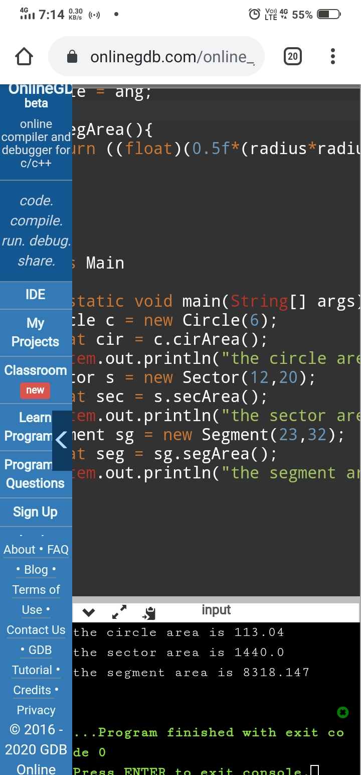
Program 3:
Create a base class Shape with relevant data members and member functions to get data and print the area. Create two more classes Rectangle and Triangle which inherit Shape class. Test the classes in main method.

Program:-
abstract class Figure{
double dim1,dim2;
Figure(double a,double b){
dim1 = a;
dim2 = b;
}
abstract double area();

}
class Rectangle extends Figure{
Rectangle(double a,double b){
super(a,b);
}
double area(){
return dim1*dim2;
}
}
class Triangle extends Figure{
Triangle(double a,double b){
super(a,b);
}
double area(){
return (0.5*dim1*dim2);
}
}
public class Main
{
public static void main(String[] args) {

Rectangle r = new Rectangle(6,7);
Triangle t= new Triangle(7,8);
Figure superref;
superref = r;
System.out.println("area is "+ superref.area());
superref = t;
System.out.println("area is "+ superref.area());

}
}


