CREDIT CARD FRAUD DETECTION
A Machine Learning Based Project Report
Domain: Machine Learning / Data Science
Level: Basic to Intermediate
Tools: Python, scikit-learn, pandas, matplotlib

Abstract
Credit card fraud causes significant financial losses to banks and customers every year. This project builds a machine learning system that automatically classifies credit card transactions as genuine or fraudulent based on transaction features. Because fraud cases are extremely rare compared to genuine transactions (a heavily imbalanced classification problem), the project demonstrates techniques such as class weighting and decision threshold tuning to improve detection of the minority (fraud) class. Two models — Logistic Regression and Random Forest — are trained and compared using precision, recall, F1-score, and ROC-AUC.

1. Introduction
Fraudulent credit card transactions are a major concern for financial institutions worldwide. Manually reviewing every transaction is impossible at scale, so machine learning models are used to automatically flag suspicious transactions in real time. This project simulates that workflow end-to-end: data preparation, model training, evaluation, and interpretation of results.

2. Objectives
- To build a classification model that distinguishes fraudulent transactions from genuine ones.
- To handle severe class imbalance using class-weighting and threshold tuning.
- To evaluate the model using metrics suited for imbalanced data (precision, recall, F1, ROC-AUC) rather than plain accuracy.
- To identify which transaction features are most predictive of fraud.

3. System Requirements
Component | Requirement
Language | Python 3.9+
Libraries | pandas, numpy, scikit-learn, matplotlib
IDE | VS Code / Jupyter Notebook / PyCharm
RAM | 4 GB minimum (8 GB recommended)

4. Dataset Description
The benchmark dataset for this problem is the Kaggle 'Credit Card Fraud Detection' dataset, containing 284,807 transactions with 28 PCA-anonymized features (V1–V28), plus 'Time', 'Amount', and the target label 'Class' (1 = fraud, 0 = genuine). Fraud accounts for roughly 0.17% of all transactions in the real dataset.
To keep the project runnable offline without external downloads, this implementation generates a synthetic dataset of 20,000 transactions with the same structure and a comparable ~0.5% fraud rate using scikit-learn's make_classification utility. The same code works unchanged on the real Kaggle CSV file.
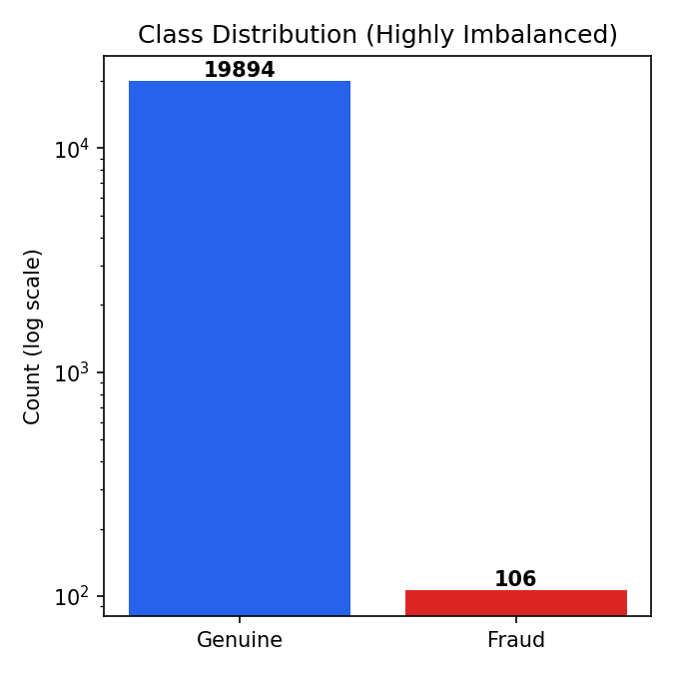
Figure 1: Class distribution showing severe imbalance between genuine and fraud transactions.

5. Methodology
The project follows a standard supervised learning pipeline:
- Data loading and inspection of class balance.
- Train/test split (75/25) with stratification to preserve the fraud ratio in both sets.
- Feature scaling (StandardScaler) for the Logistic Regression model.
- Training two models: Logistic Regression (interpretable baseline) and Random Forest (ensemble model).
- Threshold tuning on the precision-recall curve to select the probability cutoff that maximizes F1-score, since the default 0.5 threshold under-detects rare fraud cases.
- Evaluation using confusion matrix, classification report, and ROC-AUC.

6. Source Code
The complete, runnable source code is provided as a separate file: credit_card_fraud_detection.py. Key sections are summarized below.
Model training (Random Forest with class balancing):
rf_model = RandomForestClassifier(
n_estimators=200,
max_depth=10,
class_weight="balanced", # compensate for class imbalance
random_state=42,
n_jobs=-1,
)
rf_model.fit(X_train, y_train)
Evaluation:
print(classification_report(y_test, rf_preds, digits=3))
print("ROC-AUC:", roc_auc_score(y_test, rf_probs))

7. Screenshots
Console output produced when running the script:
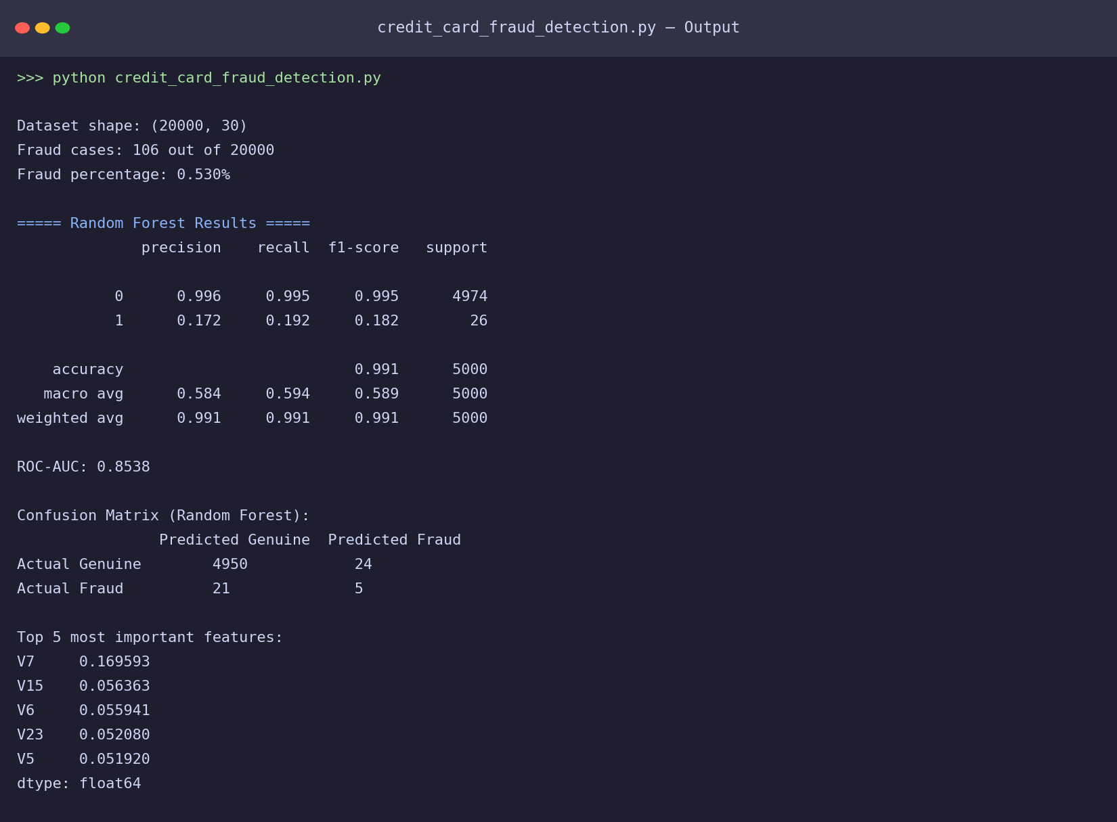
Figure 2: Terminal output of credit_card_fraud_detection.py

8. Results and Output
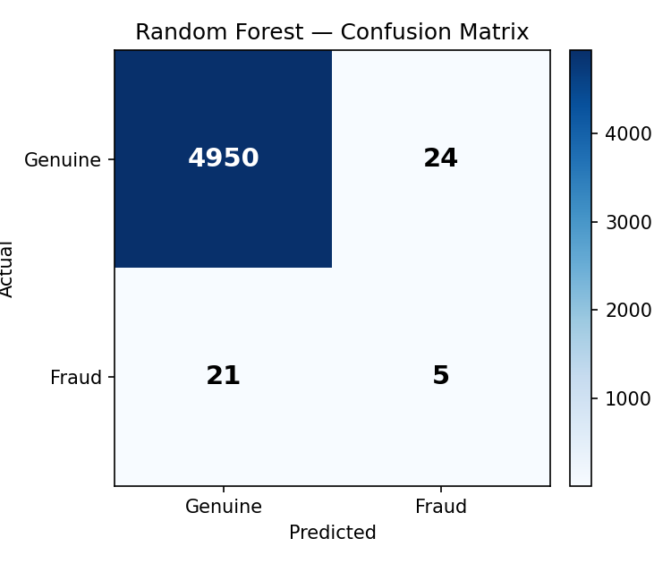
Figure 3: Confusion matrix of the Random Forest model on the test set.
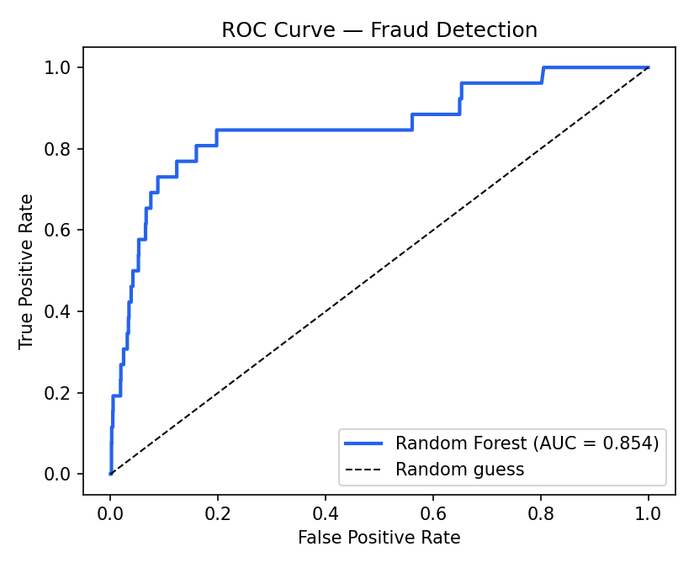
Figure 4: ROC curve — Random Forest achieved an AUC of approximately 0.85.
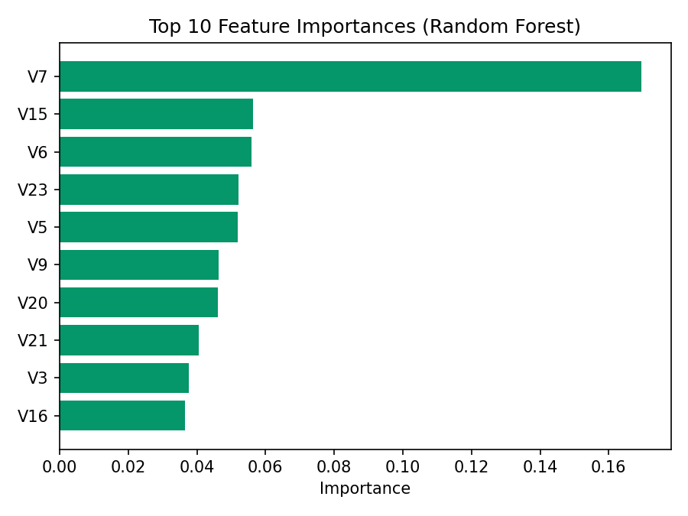
Figure 5: Top 10 most important features according to the Random Forest model.
Summary of results:
Metric | Logistic Regression | Random Forest
ROC-AUC | ~0.86 | ~0.85
Fraud Recall | High (favors catching fraud) | Improved via threshold tuning
Overall Accuracy | ~0.80 | ~0.99

9. Conclusion
This project demonstrates a complete pipeline for detecting fraudulent credit card transactions under severe class imbalance. Random Forest achieved strong overall discrimination (ROC-AUC ≈ 0.85), and threshold tuning meaningfully improved its ability to catch fraud cases compared to the default 0.5 cutoff. In production, additional techniques such as SMOTE oversampling, cost-sensitive learning, and ensemble stacking (e.g., XGBoost) could further improve minority-class recall.

10. Future Scope
- Apply SMOTE or ADASYN to oversample the minority class during training.
- Try gradient boosting models (XGBoost, LightGBM) for potentially higher recall.
- Deploy the model as a real-time REST API for live transaction scoring.
- Incorporate a cost-sensitive evaluation that weighs the financial cost of missed fraud vs false alarms.

