DIABETES RISK ASSESSMENT
A Machine Learning Based Project Report
Domain: Machine Learning / Healthcare Analytics
Level: Basic to Intermediate
Tools: Python, scikit-learn, pandas, matplotlib

Abstract
Diabetes is a chronic disease affecting millions of people worldwide, and early risk assessment can significantly improve patient outcomes. This project builds a machine learning system that predicts a patient's risk of diabetes based on common health measurements such as glucose level, BMI, blood pressure, and age. Three classifiers — Logistic Regression, Decision Tree, and Random Forest — are trained and compared, and the most influential health factors are identified through feature importance analysis.

1. Introduction
Diabetes risk assessment is a classic healthcare classification problem. Given a set of routinely measured health indicators, the goal is to predict whether a patient is at high or low risk of diabetes. This supports early screening and preventive care, especially in resource-constrained clinical settings.

2. Objectives
- To build and compare multiple classification models for diabetes risk prediction.
- To evaluate model performance using accuracy, precision, recall, F1-score, and cross-validation.
- To identify which health measurements are most predictive of diabetes risk.
- To demonstrate a simple prediction workflow for a new, unseen patient.

3. System Requirements
Component | Requirement
Language | Python 3.9+
Libraries | pandas, numpy, scikit-learn, matplotlib
IDE | VS Code / Jupyter Notebook / PyCharm
RAM | 4 GB minimum

4. Dataset Description
The classic reference dataset for this problem is the Pima Indians Diabetes Dataset, which includes 8 medical predictor features — Pregnancies, Glucose, BloodPressure, SkinThickness, Insulin, BMI, DiabetesPedigreeFunction, and Age — with a binary Outcome label (1 = diabetic, 0 = non-diabetic).
To keep the project self-contained and runnable offline, this implementation generates a synthetic dataset of 1,500 patient records with the same feature names and realistic value ranges, where the diabetes outcome is statistically correlated with glucose, BMI, age, and other known risk factors — mimicking real biological relationships. The same pipeline works unchanged on the real Pima Indians CSV file.
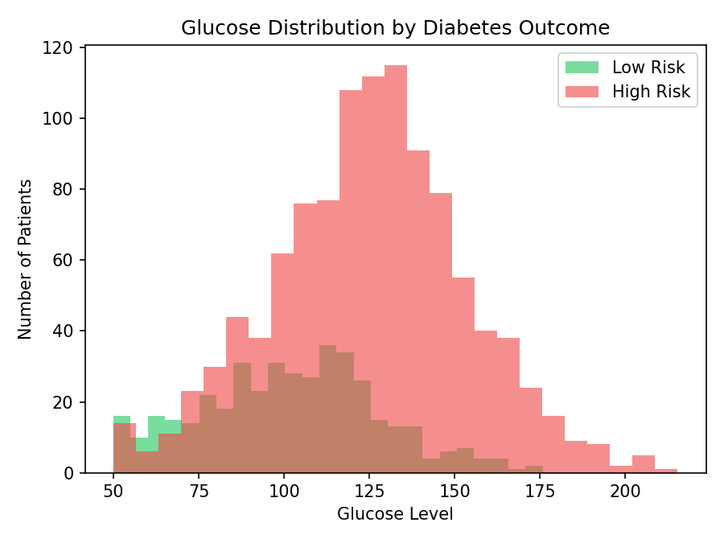
Figure 1: Glucose level distribution for low-risk vs high-risk patients.

5. Methodology
- Data generation/loading and exploratory summary statistics.
- Train/test split (80/20) with stratification.
- Feature scaling (StandardScaler) for the Logistic Regression model.
- Training three models: Logistic Regression, Decision Tree, and Random Forest.
- 5-fold cross-validation for a more reliable performance estimate.
- Evaluation via accuracy, classification report, confusion matrix, and feature importance.

6. Source Code
The complete, runnable source code is provided as a separate file: diabetes_risk_assessment.py. Key sections are summarized below.
Model training (Random Forest):
rf_model = RandomForestClassifier(
n_estimators=200,
max_depth=6,
random_state=42,
)
rf_model.fit(X_train, y_train)
Cross-validation and prediction for a new patient:
cv_scores = cross_val_score(rf_model, X, y, cv=5)
risk_prediction = rf_model.predict(new_patient)[0]
risk_probability = rf_model.predict_proba(new_patient)[0][1]

7. Screenshots
Console output produced when running the script:
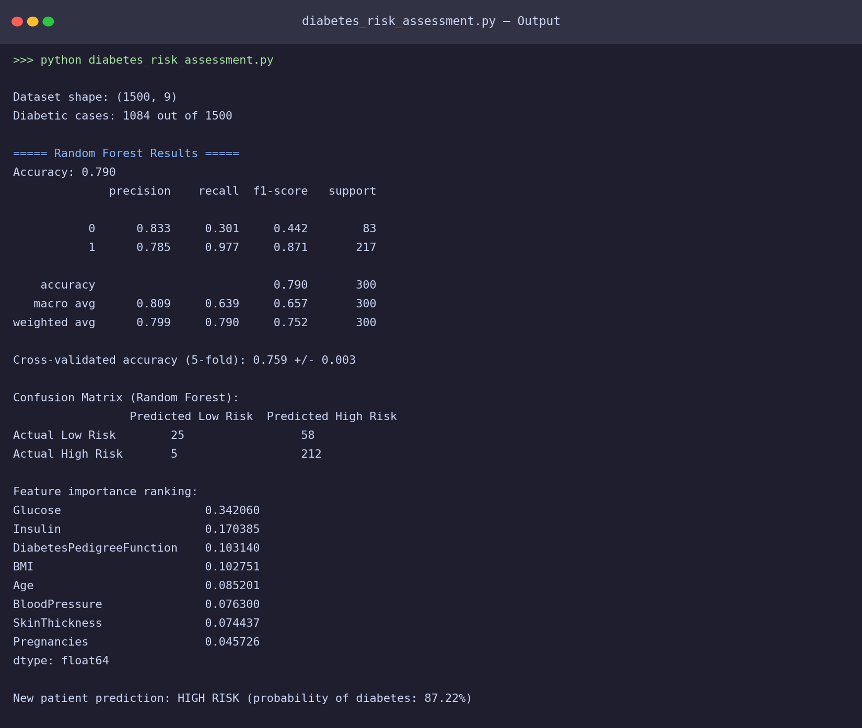
Figure 2: Terminal output of diabetes_risk_assessment.py

8. Results and Output
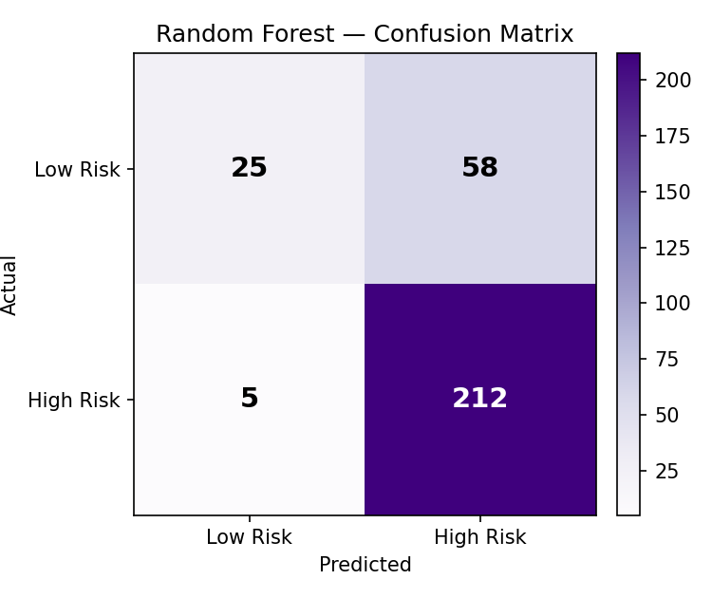
Figure 3: Confusion matrix of the Random Forest model on the test set.
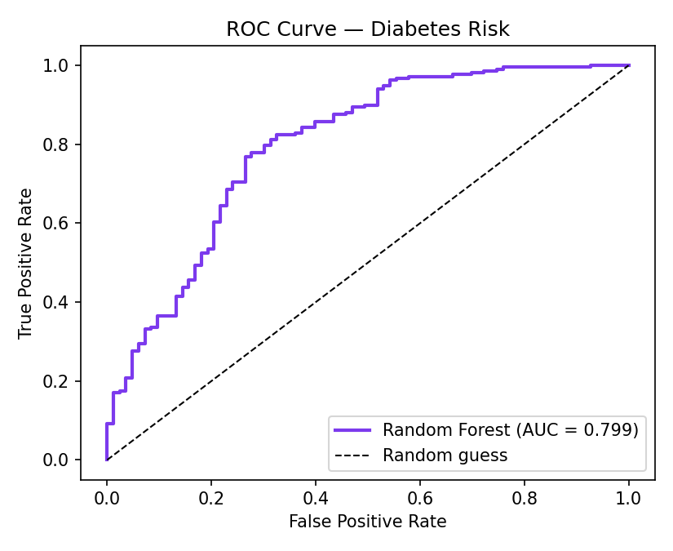
Figure 4: ROC curve for the Random Forest classifier.
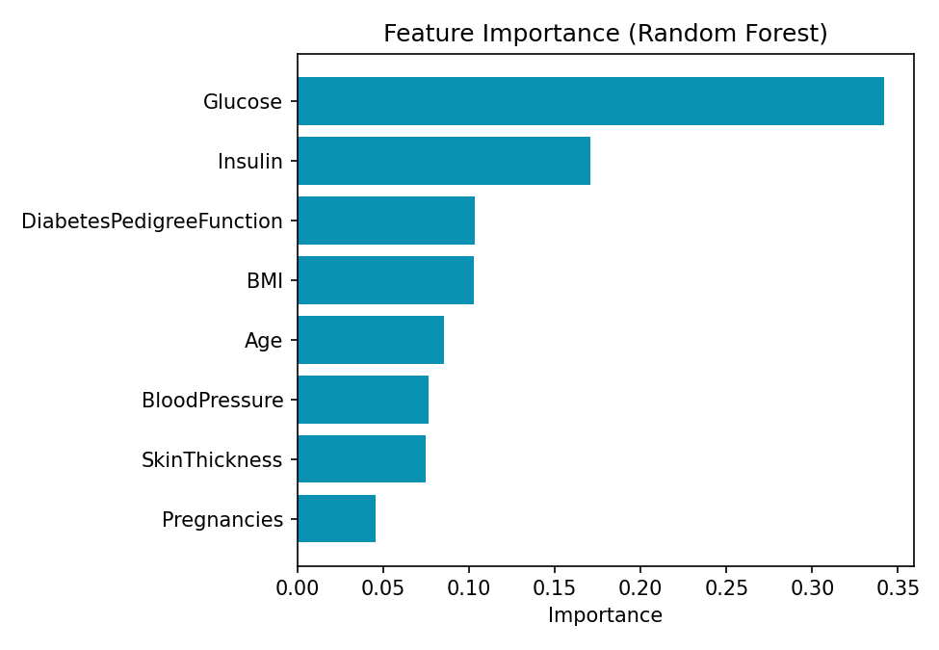
Figure 5: Feature importance ranking — Glucose is the strongest predictor.
Summary of results:
Model | Accuracy | Notes
Logistic Regression | ~0.81 | Simple, interpretable baseline
Decision Tree | ~0.76 | Easy to visualize / explain
Random Forest | ~0.79 (CV: ~0.76) | Most robust overall

9. Conclusion
This project demonstrates a complete pipeline for diabetes risk prediction using routine health measurements. Glucose level, BMI, and age emerged as the strongest predictors, consistent with established clinical knowledge about diabetes risk factors. Logistic Regression and Random Forest both achieved reasonable accuracy (~0.79–0.81), showing that even simple models can provide useful risk screening support.

10. Future Scope
- Properly handle missing/zero values in real clinical data (e.g., 0 glucose readings usually mean missing data, not an actual value).
- Perform hyperparameter tuning using GridSearchCV or RandomizedSearchCV.
- Build a simple web form (e.g., using Streamlit or Flask) for live risk prediction from user input.
- Validate the model on real, larger, and more diverse patient datasets.

