PAYMENT PROCESSING
PLATFORM
Design, Architecture and Operations

Spring Boot 4.1 (Java 21) · PostgreSQL 16 · React 19 + TypeScript
20 October 2026

Contents
1. What the system does
The money path, the lifecycle, and what is deliberately out of scope
2. Setup instructions
Prerequisites, database, backend, dashboard, test cards, configuration
3. API
Endpoints, request and response shapes, filters, the error model
4. Architectural overview
Components, data model, and why the boundaries fall where they do
5. Sequence diagrams
Nine flows: login, authorize, replay, capture, settle, retry, outage, refund, end to end
6. Resilience, fault tolerance and retries
The failure taxonomy, idempotency, the outbox, backoff, timeouts, locking
7. Observability and operations
Logs, metrics, tracing, health probes, operator endpoints, audit trail
8. Testing strategy
Where the tests concentrate and why
9. Assumptions
Decisions made where the brief was open to interpretation
10. Tradeoffs made
What was chosen, what it gained, and what it gave up
11. Production considerations
What would change before this carried real money
12. Areas for future improvement
What would come next with more time

1. What the system does
This is a card-acquiring API with a merchant-facing dashboard. A merchant authenticates, submits a payment against a tokenized card, and the platform drives that payment through its lifecycle, recording every transition as an immutable audit event. It is a small slice of a real payments system done properly: correctness (no double charges), a complete audit trail and operability were chosen over feature breadth.

The money path
Step | What happens
Authorize | POST /payments asks the processor to reserve funds on the card. Success becomes AUTHORIZED; a decline becomes FAILED with a reason. Synchronous, so the caller learns the outcome in the response.
Capture | POST /payments/{id}/capture tells the processor to take the reserved funds. AUTHORIZED → CAPTURED, and a settlement job is enqueued in the same database transaction.
Settle | A background worker picks up that job after a configurable delay, standing in for the processor’s batch cut-off, and moves CAPTURED → SETTLED. This is the asynchronous workflow.
Refund | POST /payments/{id}/refund returns money, in full or in part. A partial refund leaves the payment PARTIALLY_REFUNDED and still settleable for the net amount; refunding the remainder takes it to REFUNDED.

The lifecycle
PENDING ──► AUTHORIZED ──► CAPTURED ─────────────► SETTLED
│ │ │ │
│ │ └──► PARTIALLY_REFUNDED ◄┘ (repeatable; can still settle the net)
│ │ │
└──► FAILED ◄─┘ └──► REFUNDED ◄── CAPTURED / SETTLED
FAILED and REFUNDED are terminal. Every legal transition is declared in one place (PaymentStatus) and applied only through Payment.transitionTo(...), which returns the audit event persisted alongside the state change. Nothing anywhere mutates a status directly.
The dashboard signs in, creates test payments, searches and filters the ledger by status, date range, amount range, payment id or merchant-reference substring, sorts by created date, amount or status, pages through results, and opens a payment to see its full status history and capture or refund it.
What it deliberately is not. There is no sign-up flow, no multi-user merchant, no webhook delivery to merchants and no reconciliation against processor reports. The platform never sees a raw card number.

2. Setup instructions

Prerequisites
Tool | Version | Notes
Java | 21+ | Maven is not needed; the project ships the Maven Wrapper (mvnw)
Node.js | 20+ | For the dashboard
PostgreSQL | 16+ | Either a local install or Docker

Step 1 — Database
Local PostgreSQL, no Docker:
psql -U postgres -f scripts/create-local-db.sql
Or with Docker:
docker compose -f payments/compose.yaml up -d
Either way this creates the role payments and the database payments. Flyway creates every table, index and the demo merchants when the backend starts; no other SQL needs to be run.

Step 2 — Backend (port 8080)
cd payments
./mvnw spring-boot:run # Windows: .\mvnw.cmd spring-boot:run
Ready when http://localhost:8080/actuator/health reports "status":"UP".
The backend does not hot-reload. Any change under payments/src/ or db/migration/ requires a restart. The dashboard does hot-reload.

Step 3 — Dashboard (port 5173)
cd frontend
npm install
npm run dev
Open http://localhost:5173. Vite proxies /api to the backend, so no CORS configuration is needed locally.

Demo accounts
Merchant | Email | Password
Argyle Payments | argyle@example.com | demo-password
Globex Electronics | globex@example.com | demo-password

Two merchants exist so tenant isolation can be demonstrated: neither can see or act on the other’s payments.

Test cards and magic amounts
The processor is deterministic, in the style of Stripe’s test cards.
Input | Result
tok_visa / tok_success | Authorized, VISA •••• 4242
tok_mastercard | Authorized, MASTERCARD •••• 4444
tok_decline | FAILED, reason insufficient_funds
tok_processor_error | 503 PROCESSOR_UNAVAILABLE; nothing stored, safe to retry
tok_timeout | Processor hangs past the read timeout → 503, safe to retry
amount > 1,000,000.00 | FAILED, reason exceeds_limit
amount ending .13 | Settlement fails twice then succeeds — demonstrates retry with backoff
amount ending .99 | Settlement always fails — dead-lettered after 5 attempts
a raw card number as the token | 400 RAW_CARD_DATA_REJECTED (PCI guard)

The .13 and .99 rules apply in the default stub mode. In http mode the WireMock mappings in payments/stubs/ decide the outcome.

Choosing a processor mode
# default: in-process stub, no network
PROCESSOR_MODE=stub ./mvnw spring-boot:run
# over HTTP against the WireMock stub (real timeouts, 5xx and connection resets)
PROCESSOR_MODE=http ./mvnw spring-boot:run

Configuration
Everything has a local default; override with environment variables.
Variable | Default | Purpose
DB_URL / DB_USERNAME / DB_PASSWORD | local payments DB | Database connection
JWT_SECRET | dev-only value | HMAC signing key; must be set (32+ random bytes) outside local dev
JWT_TTL | 15m | Access token lifetime
OPS_USERNAME / OPS_PASSWORD | ops / empty | HTTP Basic for operator actuator endpoints; an empty password locks them for everyone
PROCESSOR_MODE | stub | stub or http
PROCESSOR_URL | http://localhost:8089 | Processor base URL in http mode
SETTLEMENT_DELAY | 10s | Delay after capture before settlement runs
OUTBOX_RETENTION | P7D | DONE jobs older than this are purged hourly; DEAD jobs are kept
CORS_ALLOWED_ORIGINS | http://localhost:* | Allowed browser origins
MANAGEMENT_PORT | same as PORT | Put actuator on a port that is not publicly exposed
SPRINGDOC_ENABLED | true | OpenAPI schema and Swagger UI
OTLP_METRICS_ENABLED | false | Push metrics to an OpenTelemetry Collector
PORT | 8080 | HTTP port

Running the tests
cd payments && ./mvnw test # 69 backend tests across 13 classes
cd frontend && npm test # frontend unit tests
cd frontend && npm run typecheck # TypeScript, no emit
Integration tests use Testcontainers when Docker is available. Without Docker they fall back to the local PostgreSQL in an isolated it_tests schema, so development data is never touched. If neither is available the integration tests are skipped and the unit tests still run.

3. API
Base path /api/v1. JSON throughout. Money is an integer in minor units (1050 = 10.50) with an ISO 4217 currency code, so no amount ever passes through a float.
Method | Path | Purpose | Success
POST | /auth/login | Email + password → access token | 200
GET | /auth/me | Current merchant | 200
POST | /payments | Create and authorize (Idempotency-Key required) | 201 + Location
GET | /payments/{id} | Payment plus its status history | 200
POST | /payments/{id}/capture | AUTHORIZED → CAPTURED, enqueues settlement (Idempotency-Key required) | 200
POST | /payments/{id}/refund | Full or partial refund (Idempotency-Key required) | 200
GET | /payments | List, search, filter, sort, paginate | 200

The OpenAPI schema is served at /v3/api-docs, with Swagger UI at /swagger-ui.html.

Creating a payment
POST /api/v1/payments
Authorization: Bearer <token>
Idempotency-Key: 7f2a9c1e-…
Content-Type: application/json
{ "amount": 2500, "currency": "USD", "merchantReference": "order-481207",
"paymentMethod": { "token": "tok_visa" } }

Refunding
POST /api/v1/payments/{id}/refund
Idempotency-Key: 9b3d…
{ "amount": 1000 } # partial; omit the body to refund everything still refundable
A refund larger than the remaining refundable amount is rejected with 422 REFUND_AMOUNT_INVALID before the processor is called, and the database enforces the same invariant with a check constraint, so it cannot be violated even by direct SQL.

Listing and searching
Parameter | Meaning
status | Repeatable; any of the seven lifecycle states
from / to | ISO-8601 instants; to is exclusive
q | Exact payment id, or a case-insensitive substring of the merchant reference
currency, minAmount, maxAmount | Structured filters
sort | createdAt, amount or status, each ,asc or ,desc (default createdAt,desc)
page, size | From 0; size 1–100, default 20

sort is validated against an allowlist and mapped to entity property names, so no user input ever reaches a query as an identifier. Every filter is bound as a JPA parameter.

Errors
Every error uses the same RFC 7807 problem shape, extended with a stable machine-readable code and the request’s correlationId.
{
"type": "https://payments.example.com/errors/invalid-state-transition",
"title": "Invalid state transition",
"status": 409,
"detail": "Payment 9f1c… cannot move from SETTLED to CAPTURED.",
"code": "INVALID_STATE_TRANSITION",
"correlationId": "my-capture-1"
}
Status | Codes
400 | VALIDATION_FAILED (with errors[] per field), IDEMPOTENCY_KEY_REQUIRED, INVALID_IDEMPOTENCY_KEY, RAW_CARD_DATA_REJECTED, INVALID_SORT_FIELD, INVALID_SORT_DIRECTION
401 | UNAUTHENTICATED, INVALID_TOKEN, INVALID_CREDENTIALS
404 | NOT_FOUND — also returned for another merchant’s payment, so its existence is not leaked
409 | INVALID_STATE_TRANSITION, CONCURRENT_MODIFICATION, IDEMPOTENCY_REQUEST_IN_PROGRESS
422 | IDEMPOTENCY_KEY_REUSED, REFUND_AMOUNT_INVALID, PROCESSOR_REJECTED
503 | PROCESSOR_UNAVAILABLE (with Retry-After) — retry with the same Idempotency-Key
500 | INTERNAL_ERROR — details only in logs, never in the response

Request values are never echoed back in error messages, so card data and secrets cannot leak through them.

4. Architectural overview
Every box below is implemented in this repository. Nothing is aspirational: there is no gateway, message broker, object store, reconciliation worker or webhook consumer, because none of those are built.
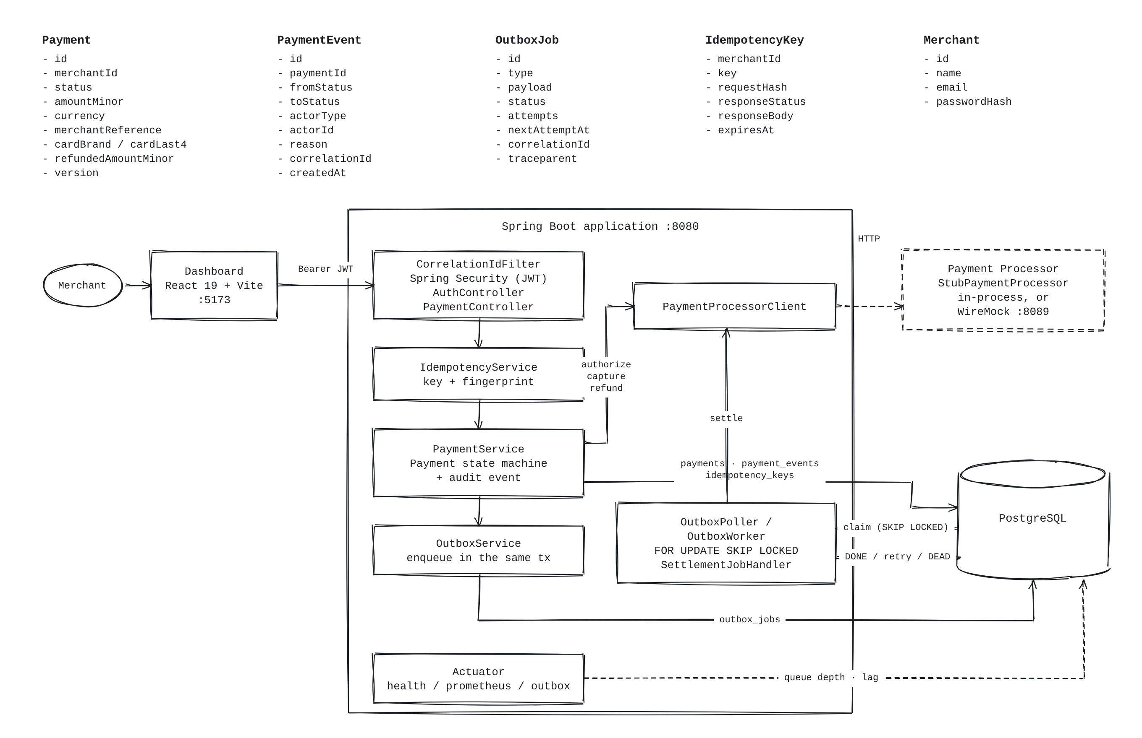
Figure 1 — Components, data model and the paths between them.

Components
Package | Responsibility
security | JWT issuing and validation, CORS, operator Basic auth, problem-detail 401/403, merchant id in the log context
auth | Login and me
payment | Domain model and state machine, use cases, search and sorting, business metrics, the processor boundary
payment.processor | PaymentProcessorClient with two implementations: in-process stub and HTTP client
idempotency | Safe retries for every money-moving endpoint
outbox | Generic transactional outbox: claiming, retries, backoff, dead-letter, retention, metrics, health, operator endpoint
settlement | The settlement job handler
common | Error format, correlation id filter and access log, trace propagation, clock

Data model
Table | Purpose
merchants | Tenant; bcrypt password hash
payments | Amount, currency, status, card brand and last4, merchant reference, refunded_amount_minor, @Version
payment_events | Append-only audit trail: one row per transition with actor, reason, correlation id
idempotency_keys | (merchant_id, idempotency_key) unique, plus the request fingerprint and the stored response
outbox_jobs | Job type, payload, status, attempts, next_attempt_at, correlation id, W3C traceparent

Every payment query leads with merchant_id, and so does every index, because tenancy is the first predicate on every read. Six Flyway migrations own the schema; Hibernate is set to validate and never alters it.
Three boundaries carry most of the design. The state machine is the single source of truth about what may happen to a payment. The processor sits behind one interface, so the stub and a real client are interchangeable and the failure modes a real network produces stay testable offline. The outbox is generic — settlement is one job type, and merchant webhooks would be a second handler reusing the claiming, backoff, dead-lettering, metrics and health that already exist.

5. Sequence diagrams
Nine diagrams covering every flow through the system: the happy paths, the duplicate-request path, the asynchronous workflow, and each way the system can fail.

5.1 Login
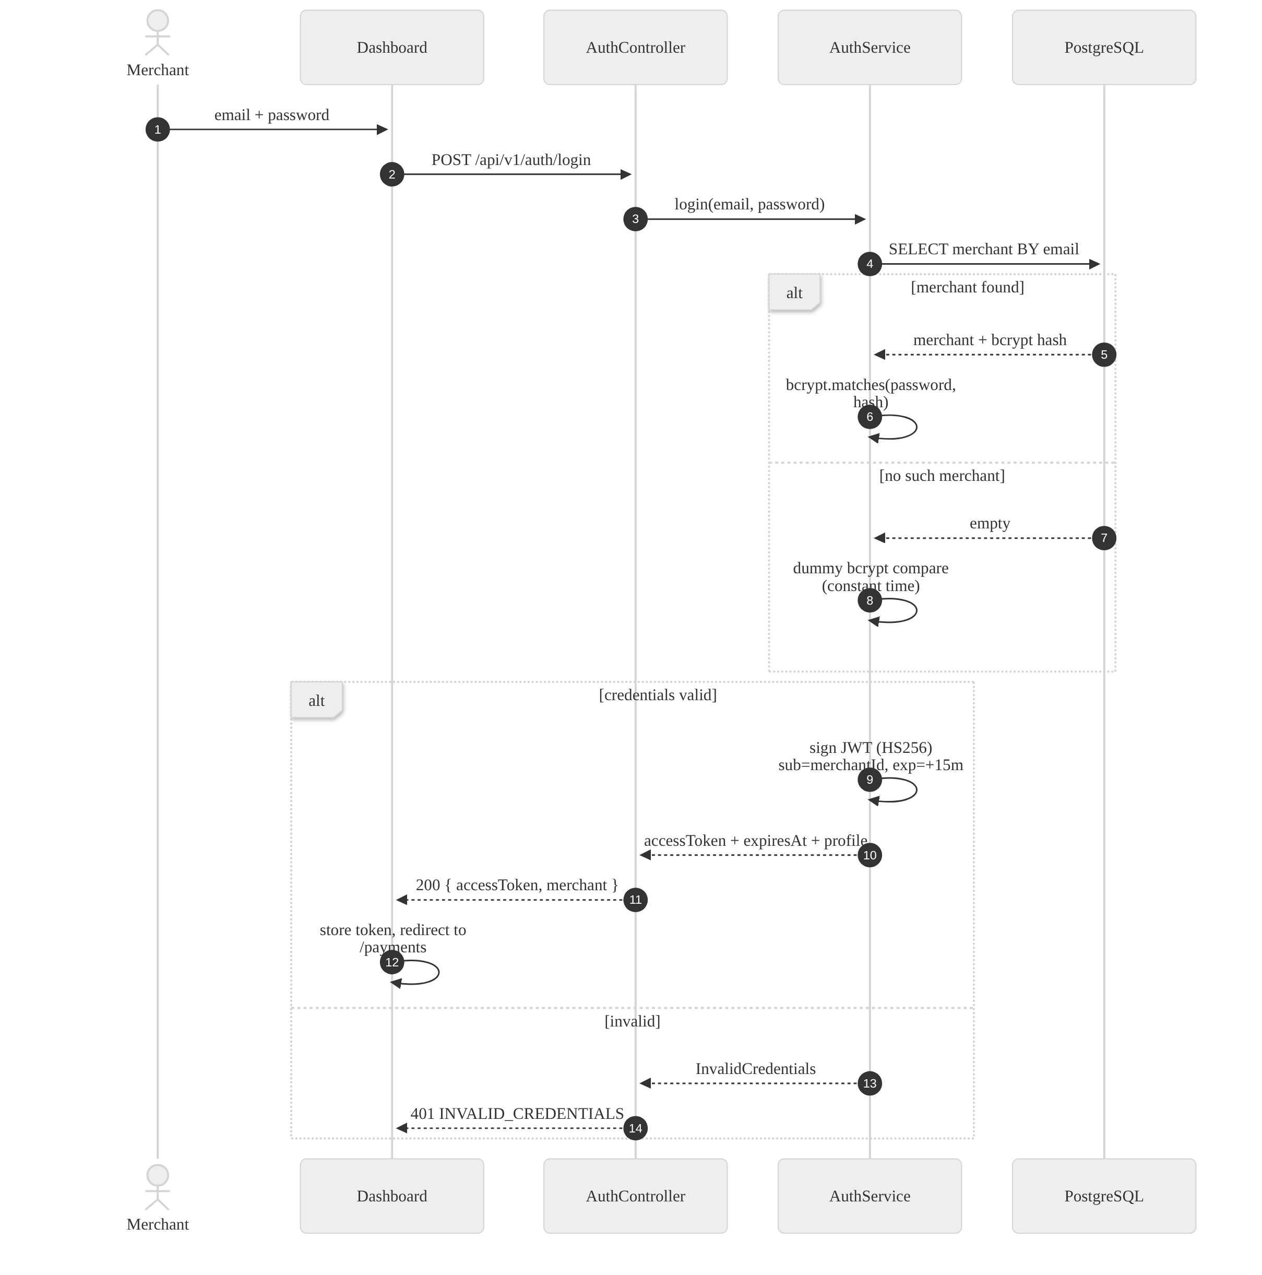
Figure 2 — Authentication and token issue.
The dummy bcrypt comparison on the "no such merchant" branch is deliberate: without it, response time would reveal which email addresses exist.

5.2 Create payment (authorization) — the happy path
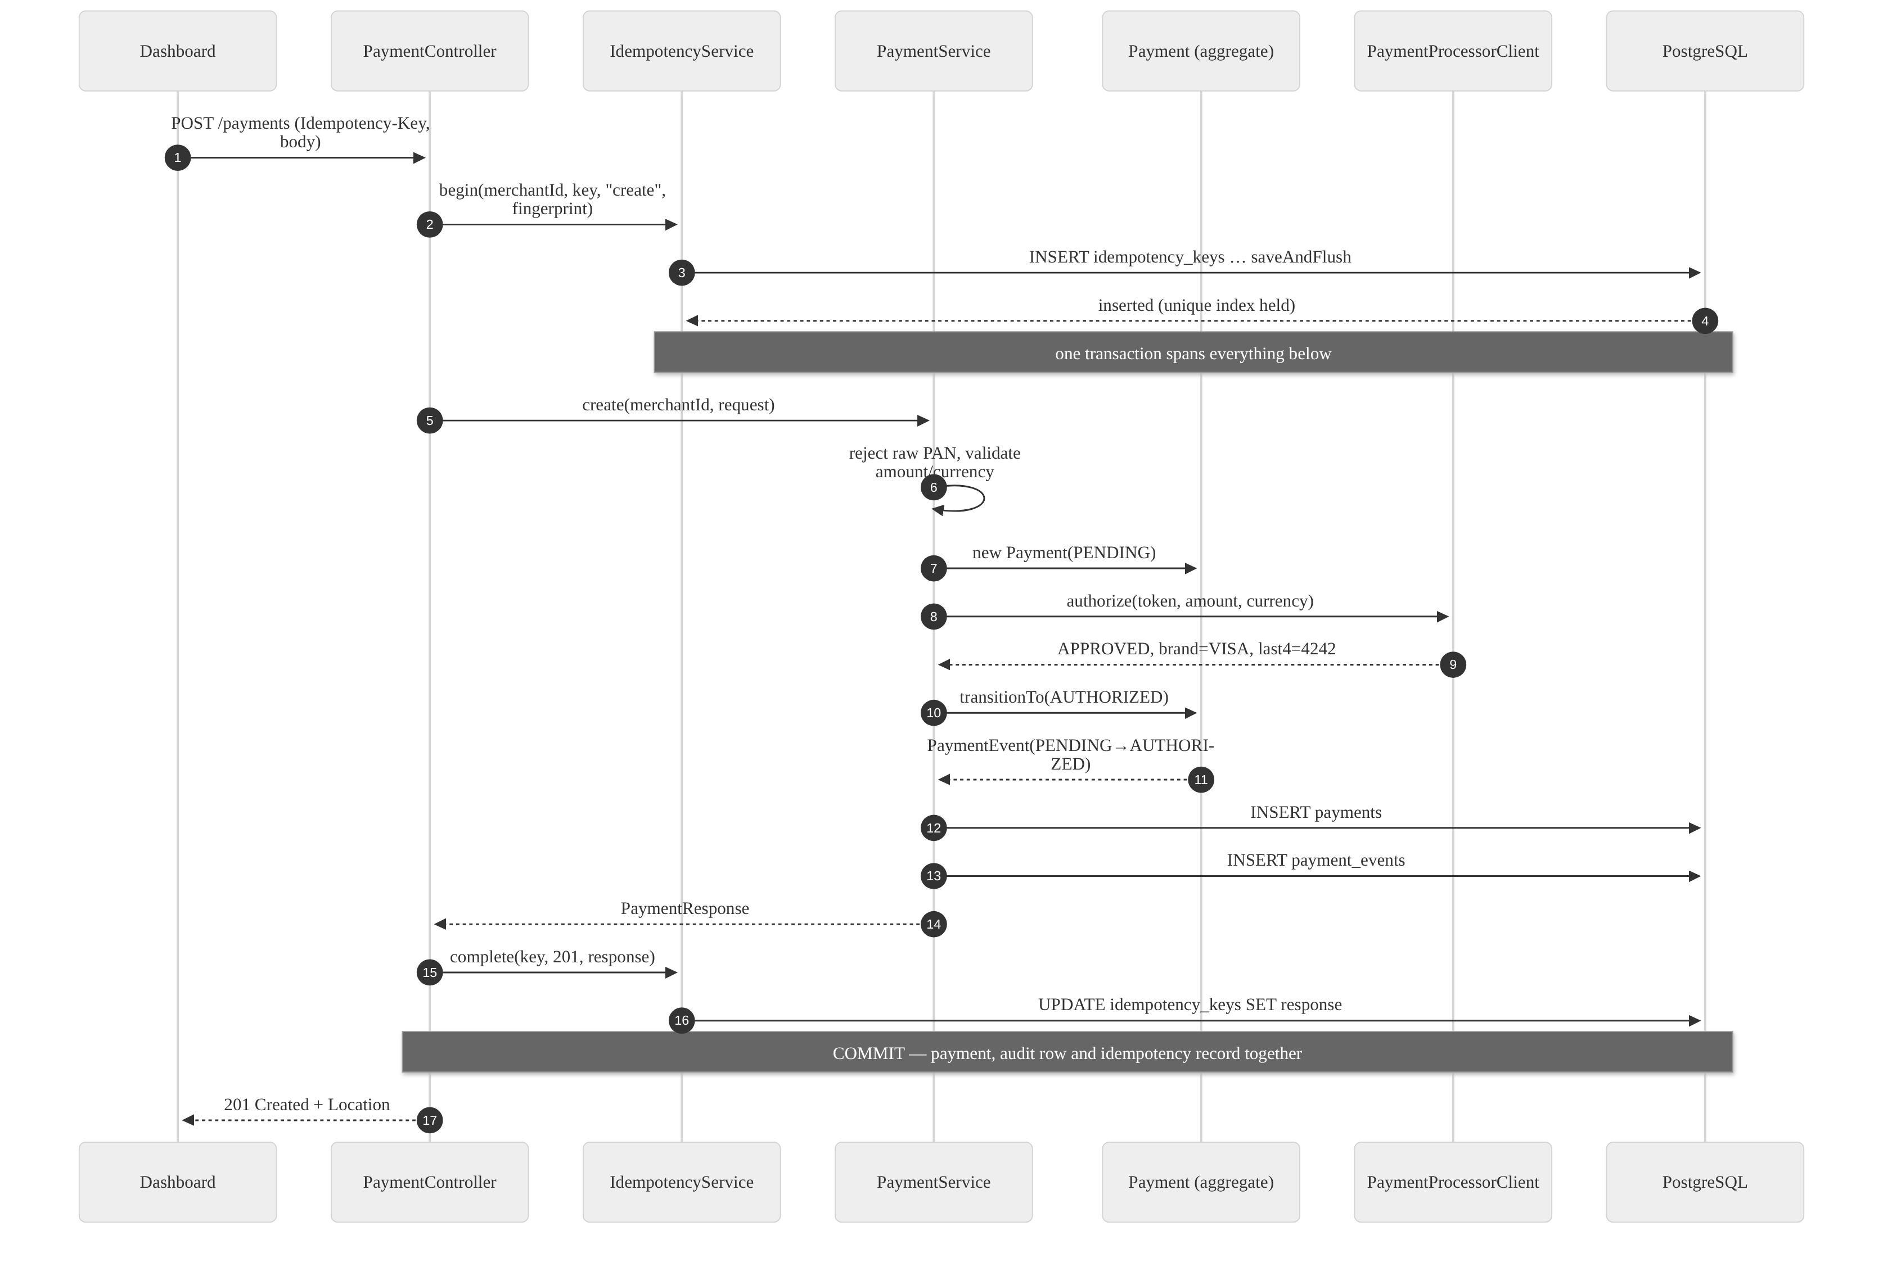
Figure 3 — Authorization, with the idempotency record inside the same transaction.
A decline differs only in the middle: the processor answers DECLINED, the payment transitions PENDING → FAILED with a failureReason, and the response is still 201 — a decline is a legitimate business outcome, not a transport error. A processor outage is different again (Figure 8).

5.3 Idempotent replay — the same request sent twice
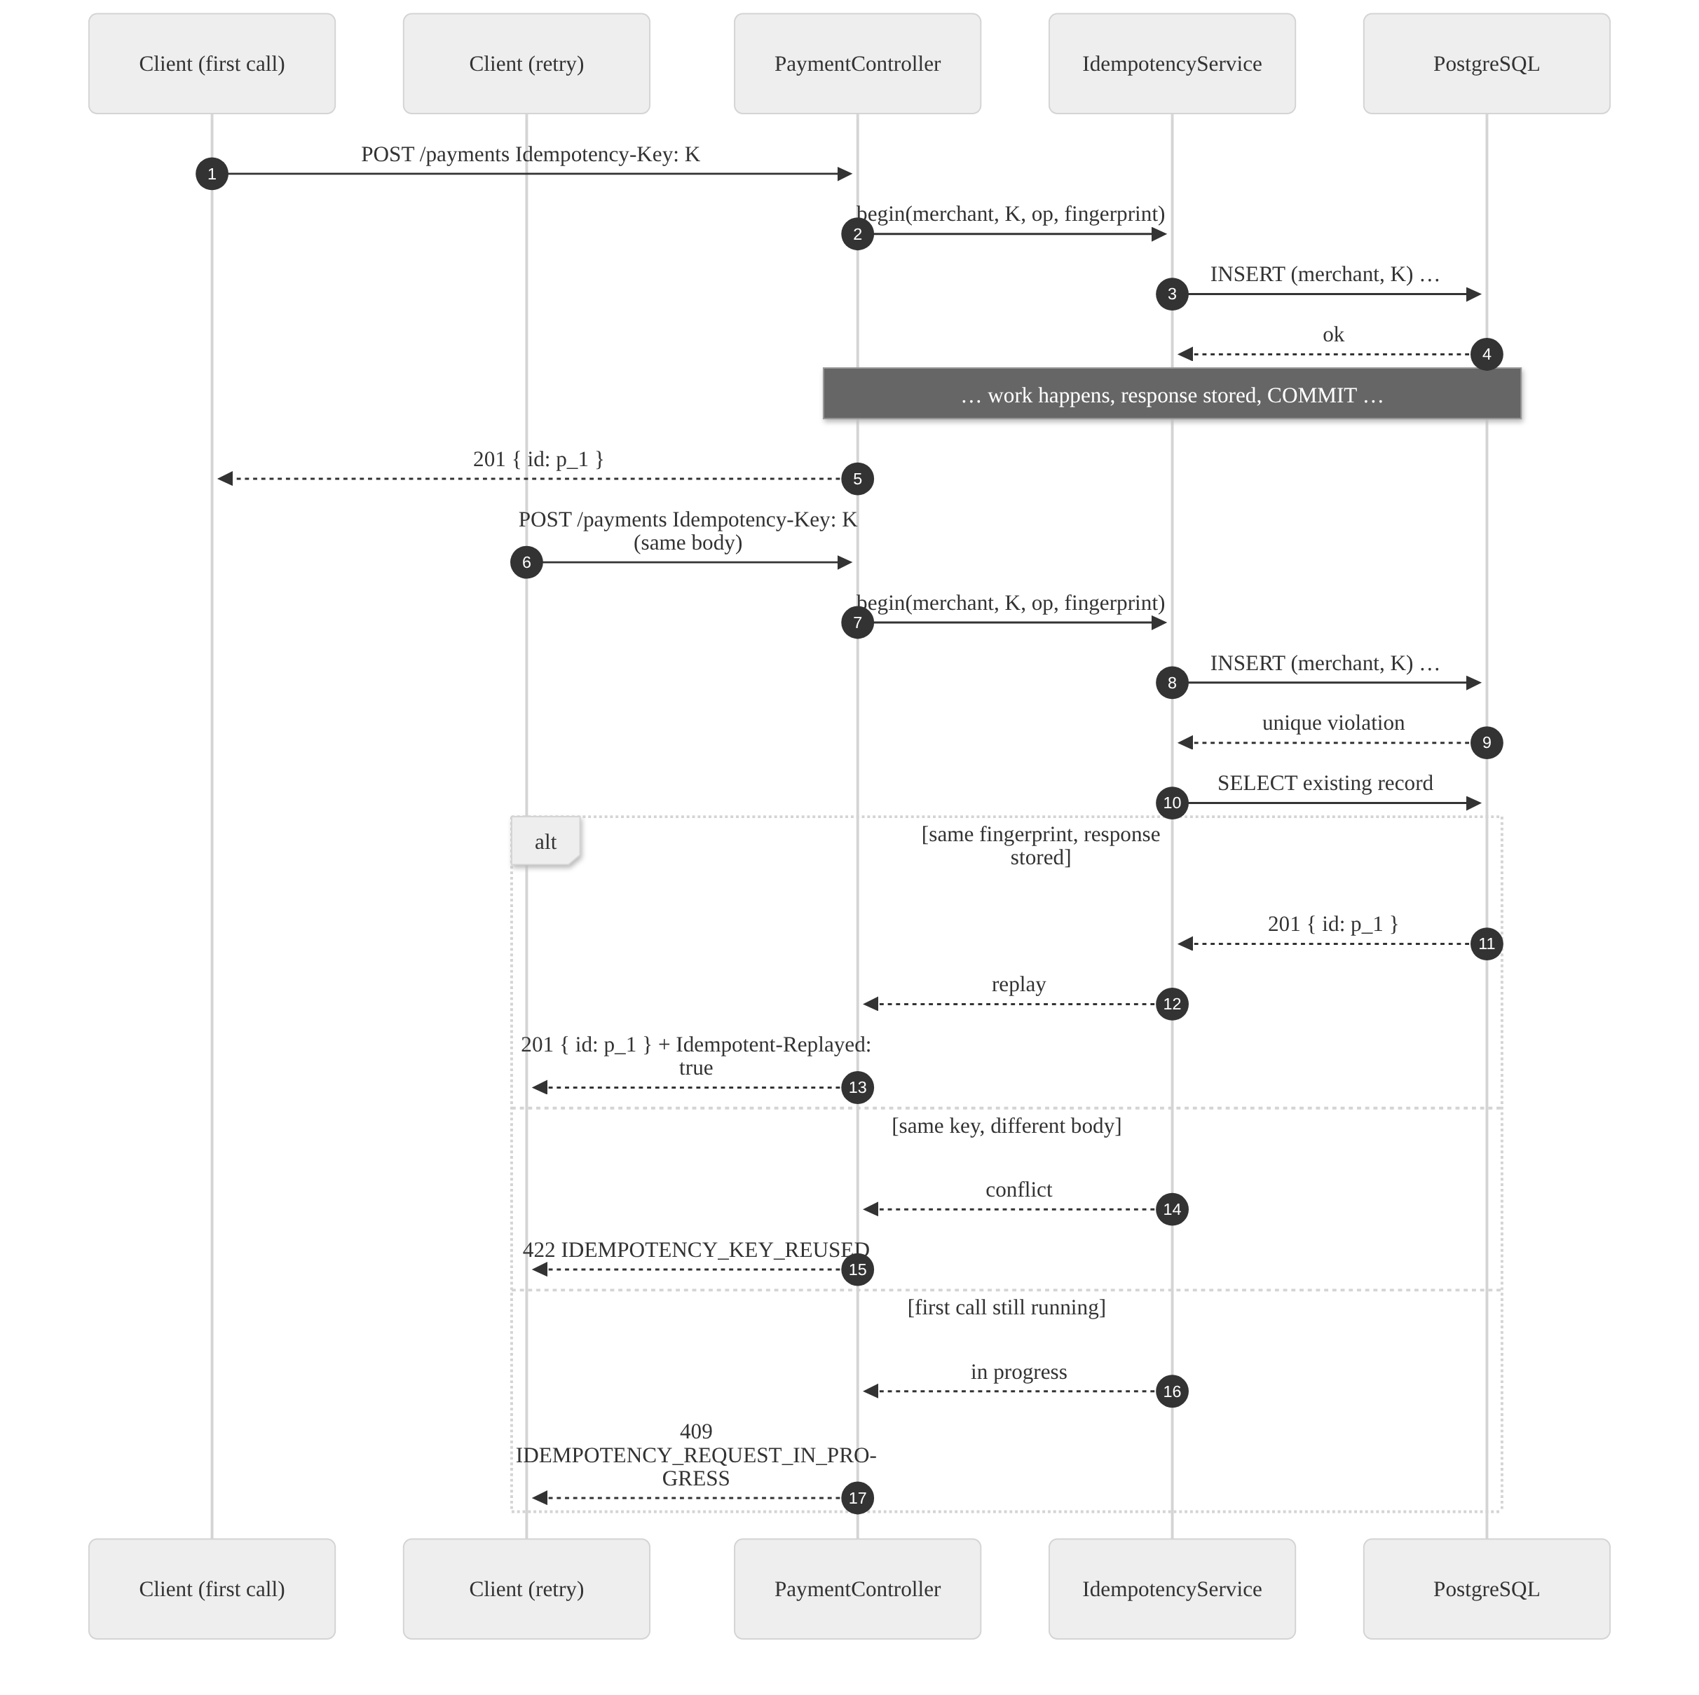
Figure 4 — Replay, key reuse and the concurrent-duplicate path.
The fingerprint is a SHA-256 of the operation plus the request body, so reusing a key for a different payment is caught rather than silently returning the wrong result. Because the insert is flushed immediately, two genuinely concurrent duplicates serialize on the unique index: one proceeds, the other waits and then replays. An integration test fires eight identical concurrent requests and asserts that exactly one payment exists.

5.4 Capture and enqueue settlement
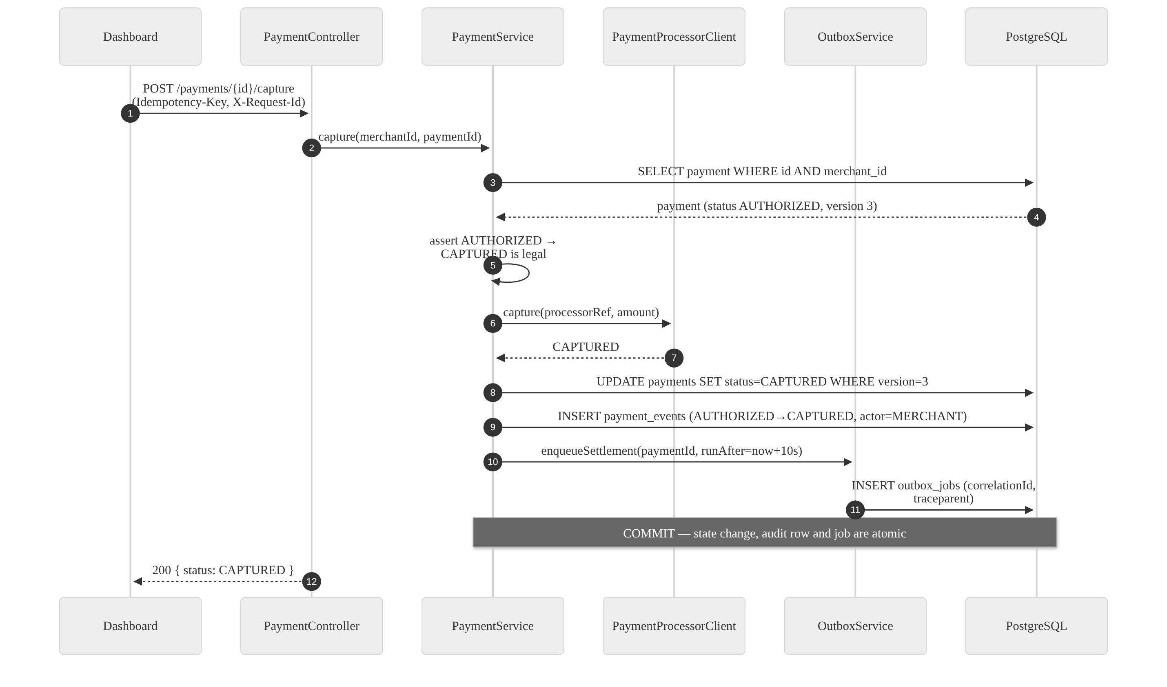
Figure 5 — Capture, with the outbox job written in the same commit.
enqueueSettlement is annotated Propagation.MANDATORY: it refuses to run outside a transaction. That turns "someone later enqueues a job outside the transaction" from a subtle production bug into a startup-time failure. The consequence is the invariant that matters: there can never be a captured payment without a settlement job, nor a job for a capture that rolled back.

5.5 Settlement — the asynchronous workflow
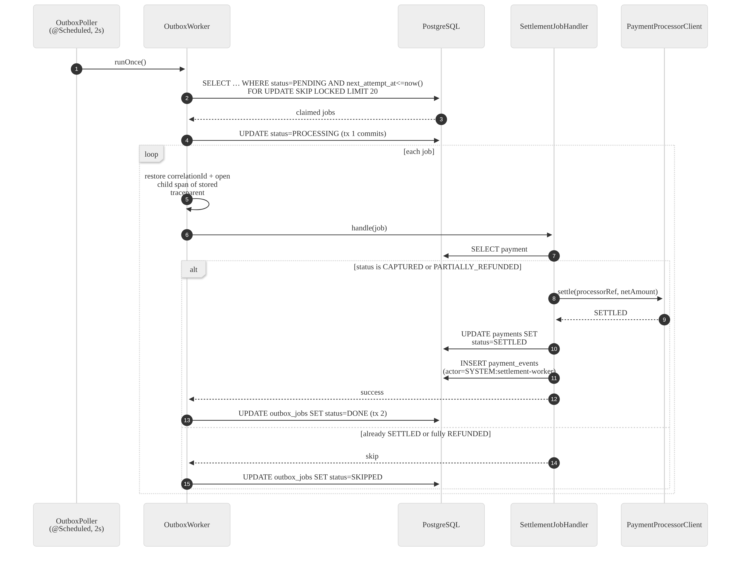
Figure 6 — The outbox worker claiming and running settlement jobs.
Three short transactions rather than one long one — claim, run, record the outcome — so a hung processor call never holds a claim open, and a crash between them leaves the job recoverable rather than lost.
The job carries the originating request’s correlationId and W3C traceparent. The worker restores both, so a log search for one correlation id returns the API request and the settlement that happened seconds later on a different thread, and the two appear as a single trace.

5.6 Settlement failure — retry, backoff, dead-letter
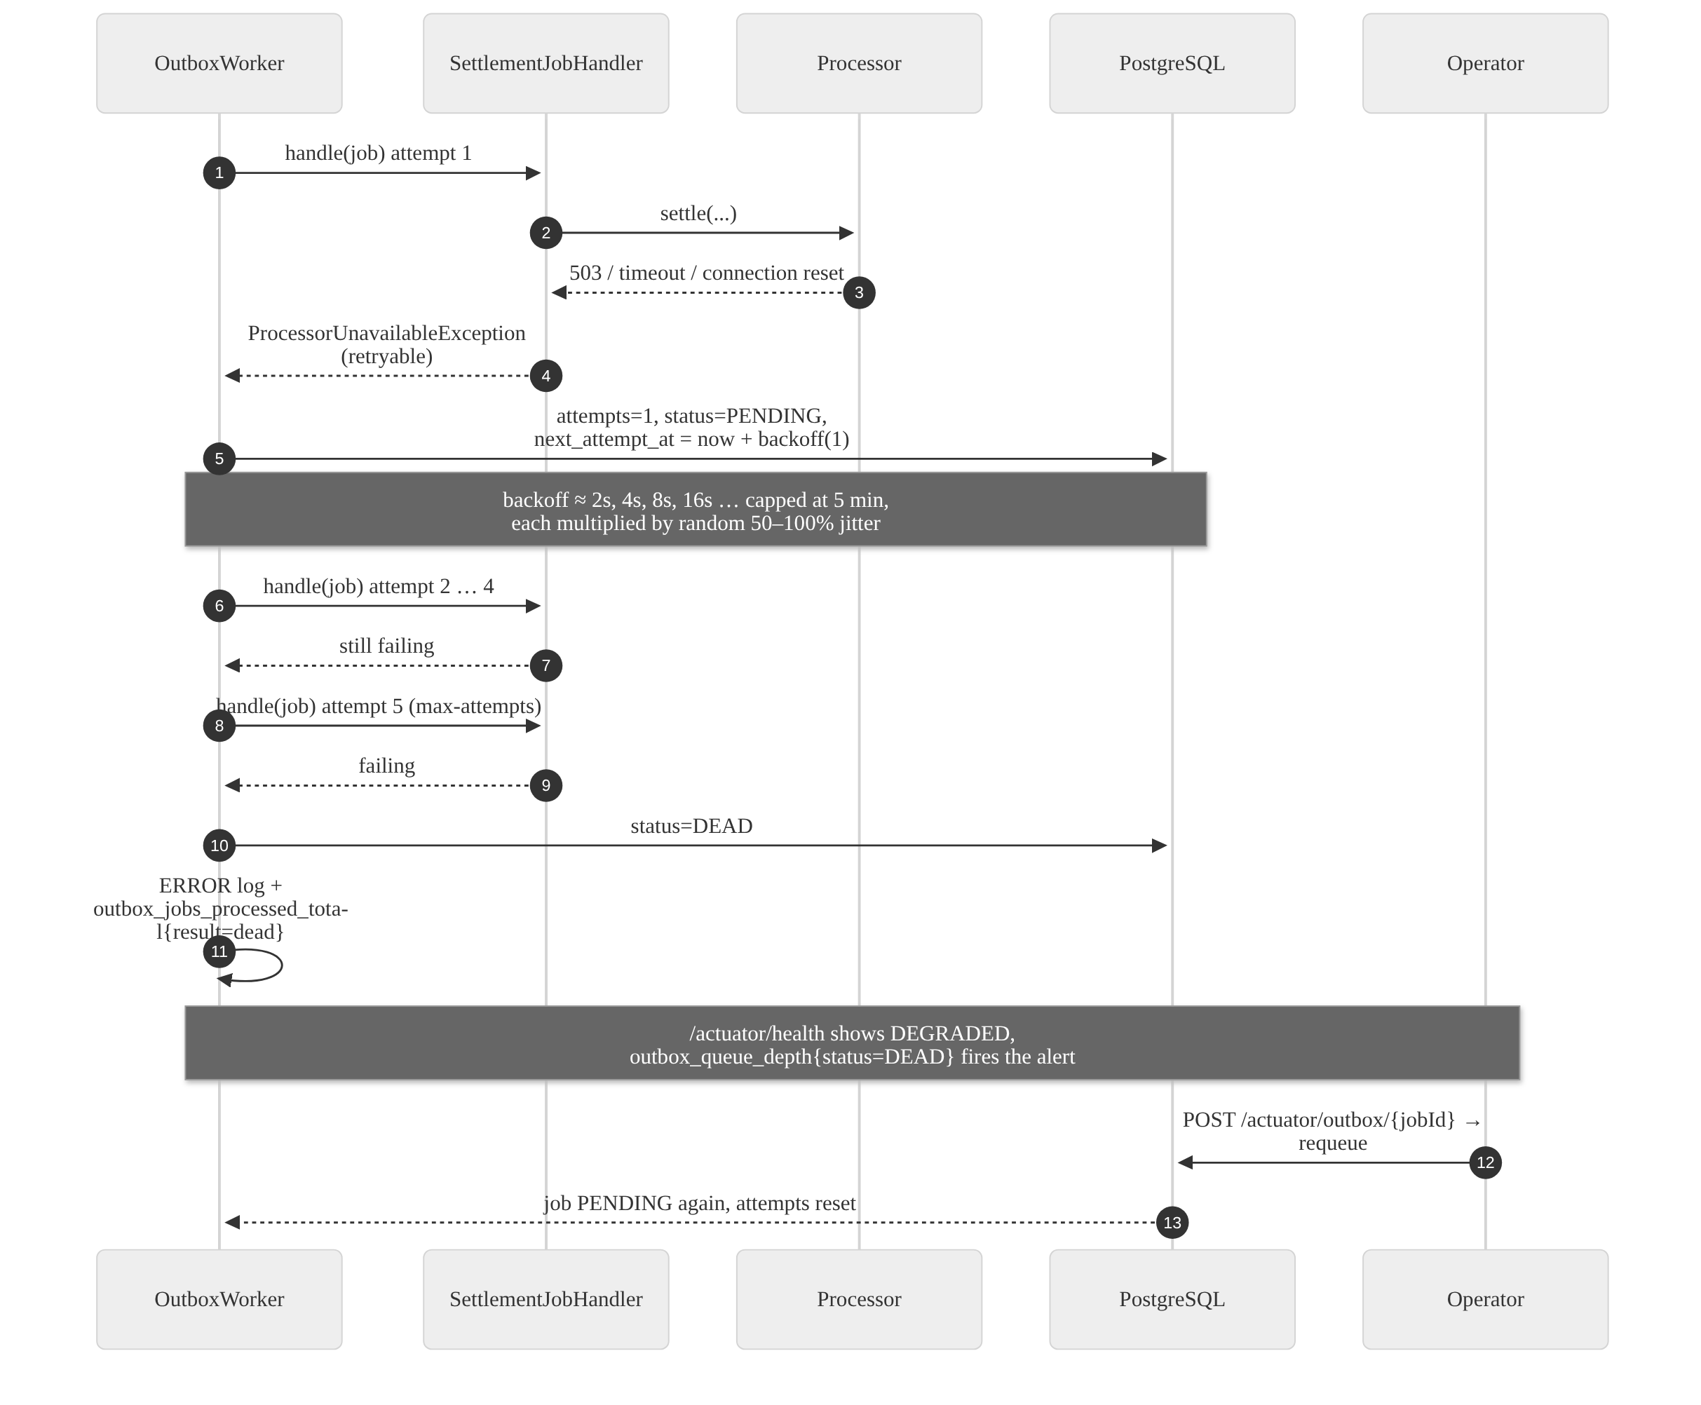
Figure 7 — Exponential backoff with jitter, dead-lettering and operator requeue.
A non-retryable failure short-circuits this: if the handler throws NonRetryableJobException — the payment no longer exists, or the processor rejected the request outright — the job goes straight to DEAD without burning five attempts on something that cannot succeed.

5.7 Processor unavailable during authorization
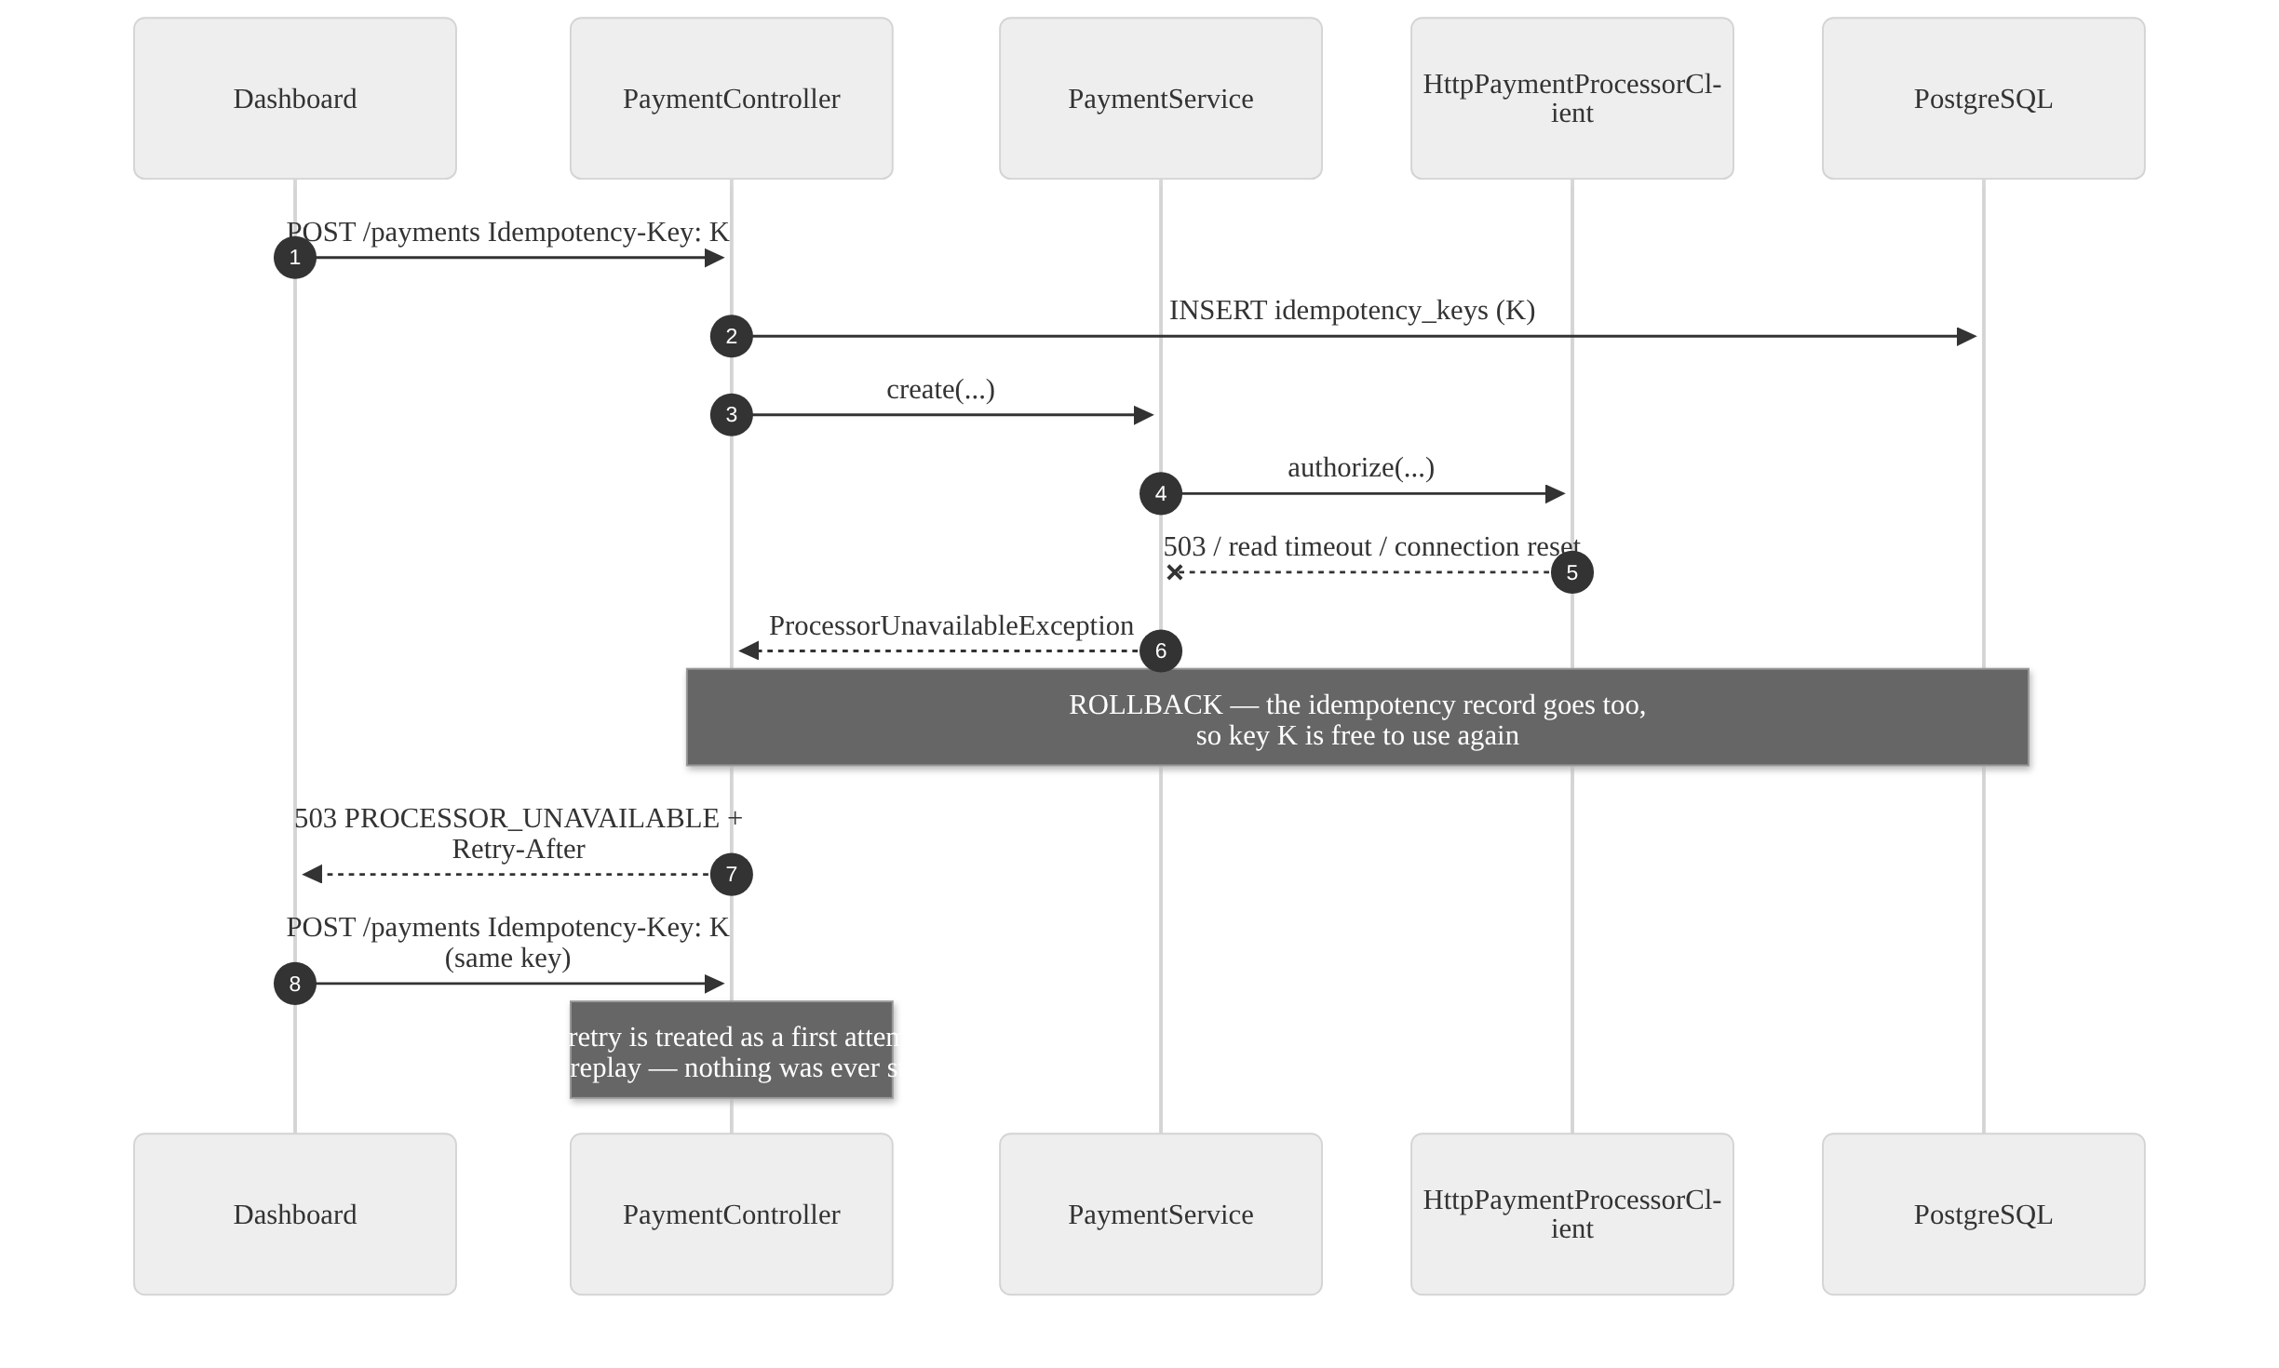
Figure 8 — An outage rolls back the idempotency record, freeing the key for a genuine retry.
This is the distinction the status codes encode. A decline is an answer, so it is stored and returned 201. An outage is the absence of an answer, so nothing is stored and the caller is told to retry — with the same key, which is the whole point of having one.

5.8 Partial refund
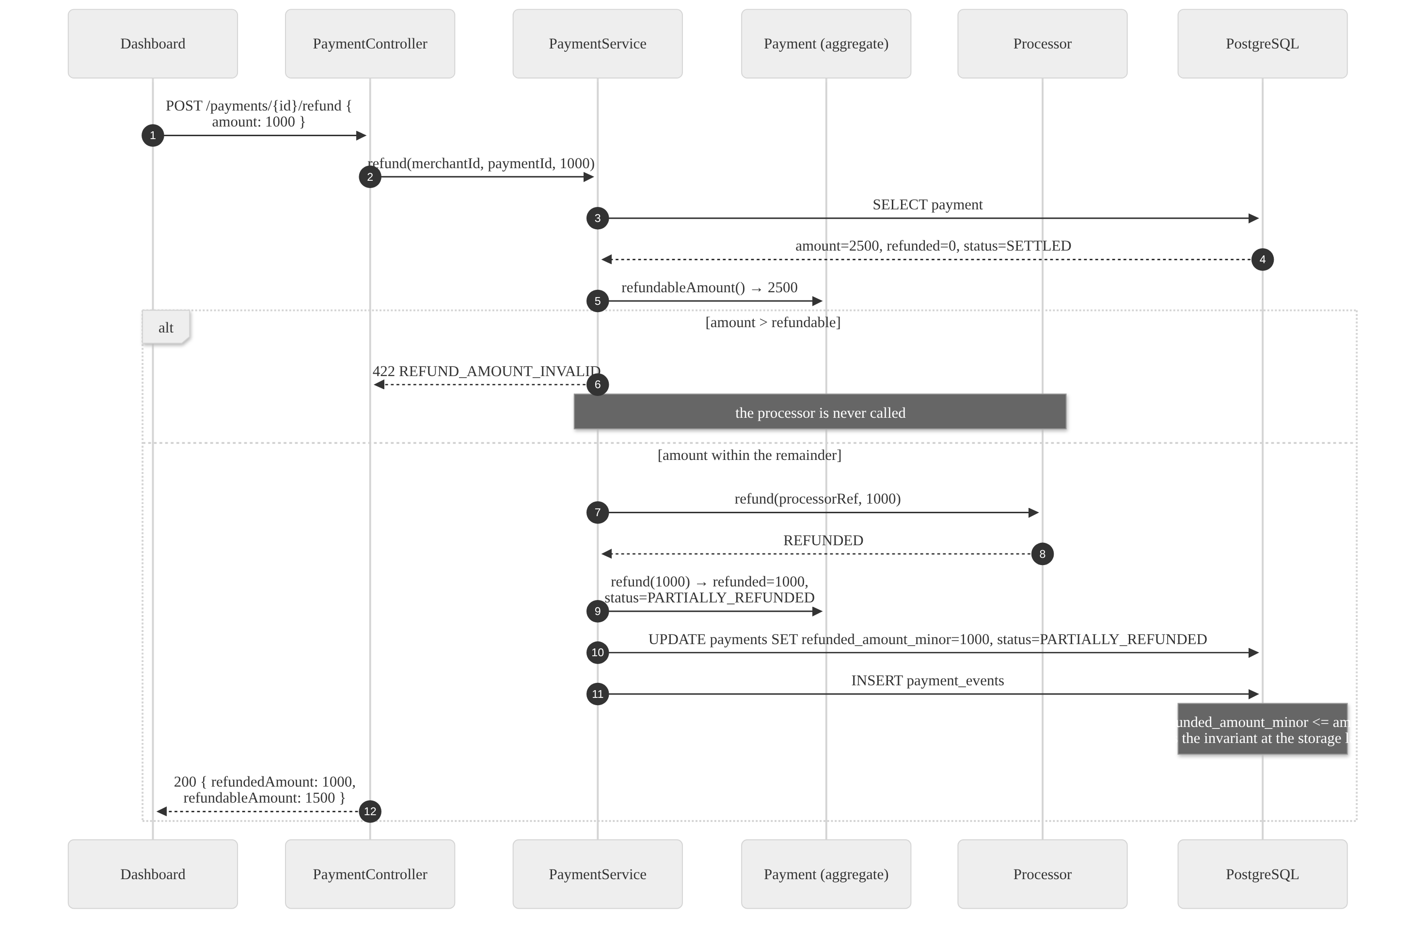
Figure 9 — Partial refund, validated before the processor is called and again at the storage layer.
Refunding the remaining amount takes the payment to REFUNDED. If a settlement job is still pending, it settles the net amount, which is why PARTIALLY_REFUNDED → SETTLED is a legal transition.

5.9 End to end — one payment’s whole life
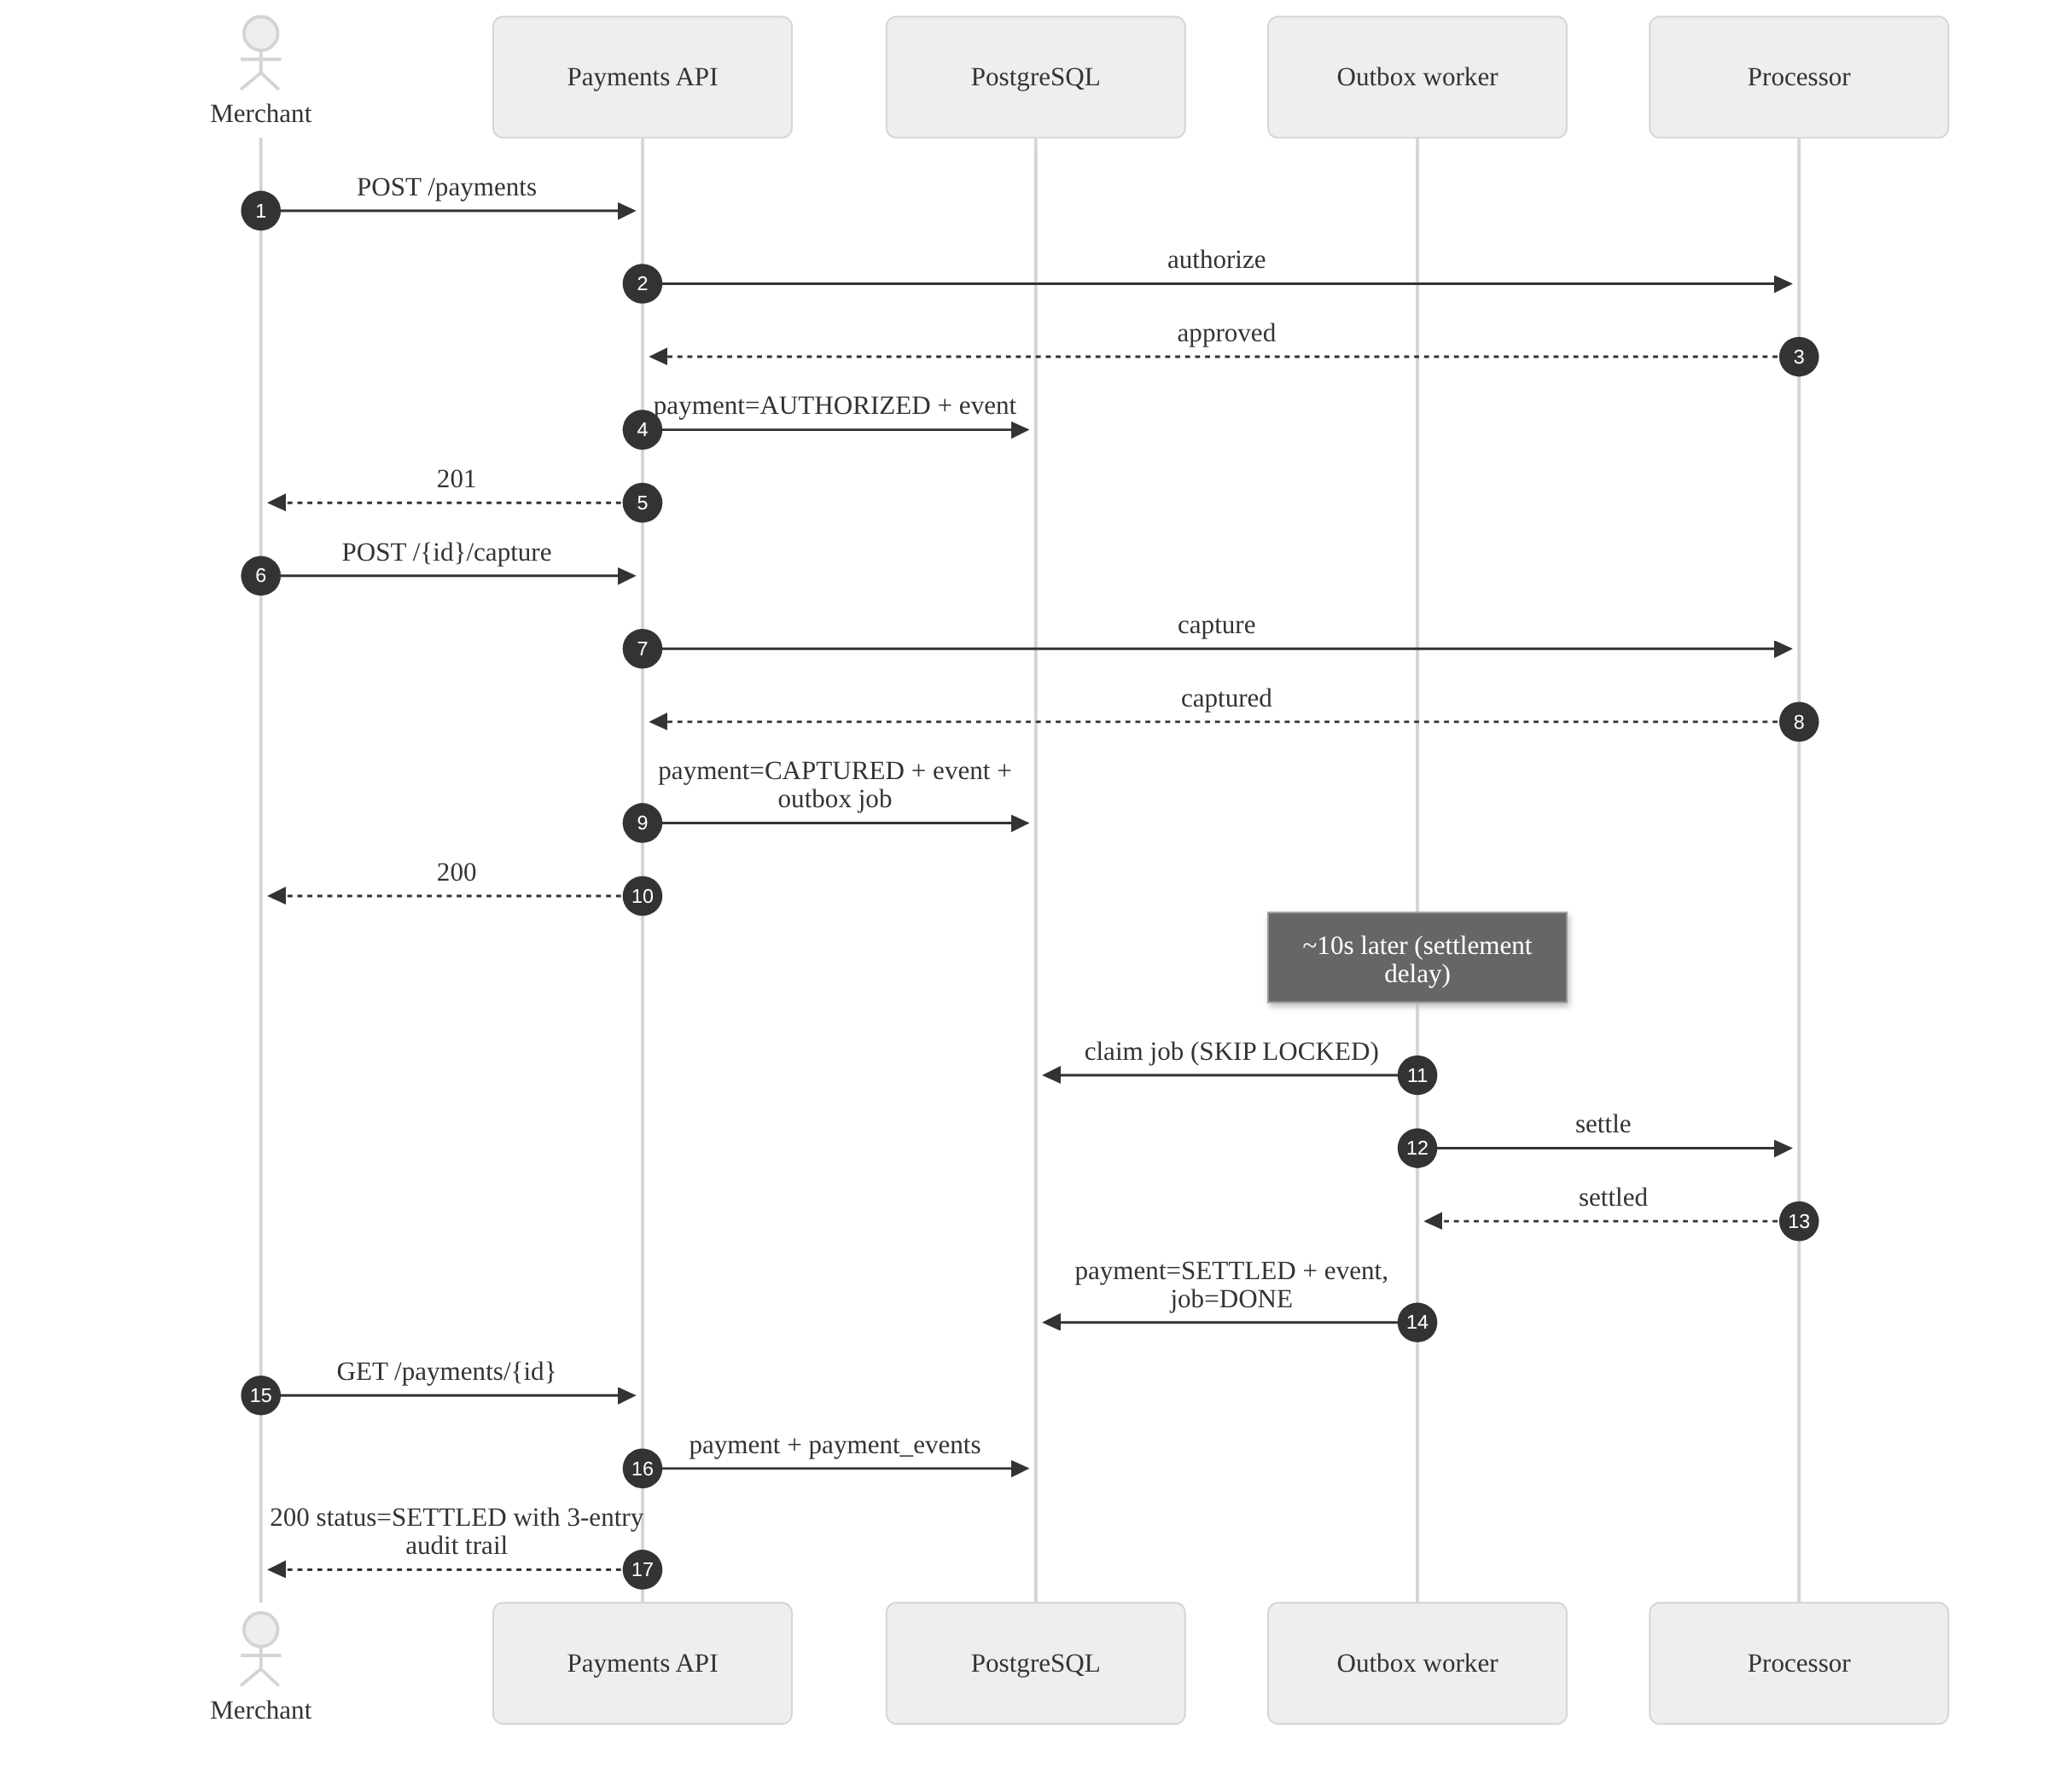
Figure 10 — Authorize, capture, settle and read back the audit trail.

6. Resilience, fault tolerance and retries
Payments fail in ways that cost money when handled badly: a retry that charges twice, a captured payment that never settles, a worker that dies mid-job. Each is addressed explicitly.

6.1 The failure taxonomy
The system classifies every failure into one of three kinds, because each demands a different response.
Kind | Example | Response
A definite answer | Card declined, limit exceeded | Store it (FAILED), return 201. Retrying will not change it.
No answer | Timeout, 503, connection reset | Store nothing, return 503 with Retry-After. The caller retries with the same key.
A wrong request | Over-refund, illegal transition, bad sort field | Reject before any side effect: 4xx, and the processor is never called.

Getting this wrong in either direction is expensive. Treating a decline as retryable produces a retry storm against a card that will never approve; treating a timeout as a decline tells a merchant the payment failed when the funds may in fact have been reserved.

6.2 Exactly-once effects: idempotency
Every money-moving endpoint requires an Idempotency-Key. The record is written in the same transaction as the operation, which means there is no window where a key exists but the work did not happen, and no stuck "in progress" rows after a crash — a rollback takes the key with it.
Scenario | Outcome
Same key, same body, after completion | Stored response replayed, with Idempotent-Replayed: true
Same key, different body | 422 IDEMPOTENCY_KEY_REUSED
Same key, concurrently | The second request blocks on the unique index, then replays
Same key, after a rolled-back attempt | Treated as a fresh attempt
Same key, different merchant | Independent — keys are scoped per merchant

Keys are retained for 24 hours.

6.3 Never losing work: the transactional outbox
The classic failure here is a dual write — update the payment, then publish a message — where a crash between the two leaves a captured payment that will never settle. The outbox removes the gap by making the job part of the same commit, and Propagation.MANDATORY means this cannot be bypassed by accident.

6.4 Retries and backoff
Concern | Approach
Who picks up a job | SELECT … FOR UPDATE SKIP LOCKED LIMIT 20 — any number of workers, no job processed twice concurrently, no lock contention between them
Retry schedule | Exponential: roughly 2s, 4s, 8s, 16s, 32s, capped at 5 minutes
Thundering herd | Each delay is multiplied by random 50–100% jitter, so a batch failed by one outage does not retry in lockstep
Give-up point | 5 attempts, then DEAD: ERROR log, result=dead metric, visible in /actuator/health
Fast failure | NonRetryableJobException dead-letters immediately rather than burning attempts
Recovery | An operator requeues with POST /actuator/outbox/{jobId} (Basic auth, operator credentials only)

6.5 Surviving a crashed worker
A worker that dies after claiming a job leaves it PROCESSING forever. Jobs stuck in PROCESSING for longer than five minutes are returned to PENDING and retried. If the worker in fact died after settling but before recording the job as done, the handler finds the payment already SETTLED and completes the job as SKIPPED — the handler is idempotent, so replay is always safe. There is an integration test for exactly this.

6.6 Containing a slow processor
Guard | Value | Why
Connect timeout | 1s | A processor that will not accept a connection should fail fast
Read timeout | 3s | The processor call happens inside a database transaction, so this is precisely how long one slow response can hold a connection from a pool of 10
Pool connection timeout | 5s | Requests fail fast instead of queueing when the pool is exhausted
HTTP/1.1 pinned | — | The JDK client defaults to HTTP/2 and attempts an h2c upgrade some servers refuse with RST_STREAM

These numbers are related, not arbitrary: pool size divided by read timeout bounds how badly a degraded processor can affect unrelated requests. A circuit breaker is the next step.

6.7 Concurrency on a single payment
payments carries a JPA @Version. Two simultaneous captures both read version 3; the first commits and bumps it, the second’s UPDATE … WHERE version = 3 matches no rows and becomes 409 CONCURRENT_MODIFICATION. The client re-reads and sees the payment is already captured. No lock is held in the common case. An integration test asserts that two concurrent captures produce exactly one 200 and one 409.

6.8 Graceful degradation and shutdown
- Shutdown is graceful on both sides: in-flight HTTP requests finish, and the scheduler waits up to 20 seconds for an in-flight outbox batch.
- Readiness includes the database, so an instance that cannot reach PostgreSQL is pulled from the load balancer rather than serving errors.
- Liveness checks nothing external, so a database blip restarts no processes.
- Outbox health is reported but deliberately excluded from readiness: a settlement backlog is an operational problem to alert on, not a reason to stop serving API traffic that is working perfectly well.
- `DONE` jobs are purged hourly after seven days; DEAD jobs are kept, because they are evidence.

7. Observability and operations

Logs
Structured JSON (Elastic Common Schema) on stdout. Every line carries correlationId (from X-Request-Id or generated, and echoed back in the response), traceId and spanId, and where known merchantId, paymentId and jobId.
Levels: INFO for state changes, logins and the access log; WARN for retries, failed logins and rejected optimistic locks; ERROR for dead-lettered jobs and unhandled exceptions; DEBUG for processor calls.
Sensitive data: raw card numbers are rejected at the API and never stored or logged — only brand and last4. Request bodies, passwords and Authorization headers are never logged; DTOs holding secrets override toString(). A failed login logs a reason, not the email address.

Metrics
Signal | Metric
Rate, errors, duration | http_server_requests_seconds{uri,method,status,outcome} with histograms for p95/p99
Business | payments_transitions_total{from,to}, payments_current{status}
Auth | auth_logins_total{result}
Queue depth | outbox_queue_depth{status=PENDING|PROCESSING|DEAD}
Processing lag | outbox_lag_seconds — age of the oldest due job not yet processed
Retries and failures | outbox_jobs_processed_total{type,result=success|skipped|retry|dead}
Async latency | outbox_job_duration_seconds, outbox_job_end_to_end_seconds

Gauges refresh on a schedule, so a Prometheus scrape never queries the database. Suggested alerts: outbox_queue_depth{status="DEAD"} > 0, outbox_lag_seconds > 120, 5xx ratio above 1%, p99 above 500 ms.

Tracing
Micrometer Tracing (Brave bridge, W3C propagation) creates a span per request. When a job is enqueued the current traceparent is stored on the outbox row; the worker opens a child span of that context, so an API request and the settlement that follows it seconds later form a single trace. Sampling is 100% locally and around 10% in production.

Health and operator endpoints
Endpoint | Use
/actuator/health/liveness | Restart the process if this fails
/actuator/health/readiness | Remove from the load balancer if this fails (includes the database)
/actuator/health | Full view including outbox (pending / processing / dead / lag)
/actuator/outbox | Operator only. Lists dead letters; POST /{jobId} requeues one
/actuator/prometheus, /actuator/metrics | Scrape and inspect

Operator endpoints sit behind HTTP Basic with credentials separate from merchant tokens; a merchant JWT is never accepted there. With no OPS_PASSWORD set they are locked for everyone.

Audit trail
payment_events is append-only: one row per transition with from_status, to_status, actor_type (MERCHANT or SYSTEM), actor_id, reason, correlation_id and timestamp, written in the same transaction as the change. It is returned by GET /payments/{id} and rendered as the dashboard’s status history.

8. Testing strategy
Tests concentrate where a bug costs money or trust.
Layer | What | Why
Unit | All status pairs of the state machine | The core invariant; any change must be deliberate
Unit | Payment transitions, partial-refund arithmetic, OutboxJob retry and dead-letter, BackoffPolicy, stub processor, JWT issue/expiry/forgery, short-secret rejection | Pure logic, fast
Integration | Login, 401s, expired and tampered tokens, actuator security, health probes | Security is configuration-heavy; only an end-to-end test proves it
Integration | Create, decline, processor outage, raw PAN, validation, capture, refund, invalid transitions, search, sorting, pagination | Real SQL, real constraints, real serialization
Integration | Tenant isolation — another merchant gets 404 and cannot capture | Data-leak prevention
Integration | Idempotency — replay, key reuse, per-merchant scope, 8 concurrent identical requests produce 1 payment, 2 concurrent captures produce one 200 and one 409 | Proves "no double charge" under races, not merely in sequence
Integration | Settlement — success with the correlation id carried across, retry until success, dead-letter, refund-before-settle skip, crashed-worker recovery | The async failure paths are the ones that break in production
Integration | Partial refunds — instalments cannot exceed the original, retrying an instalment replays rather than refunding twice | The invariant that protects the merchant’s money
Integration | SQL injection — 7 payloads across every filter; a payload stored as a reference comes back verbatim | Proves parameterization rather than asserting it
Frontend | Money parsing and formatting, amount validation across letters, symbols, separators and multiple decimal points | The UI logic that touches amounts

Tests drive the worker directly instead of waiting for the scheduler, so they are deterministic. Deliberately not covered: UI component tests and browser end-to-end tests.

9. Assumptions
Where the brief was open to interpretation, these are the calls that were made.
Area | Assumption
Money | Integers in minor units, one currency per payment, maximum 1,000,000.00 per payment. No currency conversion.
Card data | The client never sends a raw PAN. Tokenization happens at the processor (a hosted field or SDK), and the platform stores only a token reference, brand and last4. A request containing something that looks like a card number is rejected outright. This keeps PCI DSS scope minimal.
Authorization | Synchronous at creation, so PENDING is transient. A decline is a business outcome stored as FAILED with HTTP 201; an outage is a transport error with HTTP 503 and nothing stored.
Capture | Full capture only. Partial capture is not supported; partial refund is.
Settlement | Triggered per payment after a configurable delay, standing in for the processor’s batch cut-off. Chosen as the asynchronous workflow because it is the only path to SETTLED in the lifecycle and needs no fabricated external system — webhooks would need a fake receiver and reconciliation a fake bank report.
Refunds | Multiple partial refunds are allowed up to the original amount. A payment with outstanding refunds can still settle, for the net. Refunds are not themselves first-class entities with their own ids.
Merchants | Provisioned out of band (seeded); no sign-up flow, one user per merchant.
Idempotency | Keys are client-generated, scoped per merchant, and retained 24 hours.
Search | Payment id lookup or merchant-reference substring, plus structured filters. Not full-text search.
Merchant reference | Merchant-supplied and deliberately not unique: one order can legitimately have several payments (a retry after a decline, a deposit then the balance). Duplicate charges are prevented by the idempotency key, which is a different question.
Time | All timestamps are UTC instants; the dashboard renders in the viewer’s locale.

10. Tradeoffs made
Chose | Instead of | Gained | Gave up / when to revisit
PostgreSQL outbox table with a polling worker | Kafka or RabbitMQ | No extra infrastructure; the job and the state change commit atomically | Broker throughput and fan-out, plus up to ~2s polling latency. At volume, stream the outbox to Kafka via CDC
Stateless JWT (HS256), 15 minutes, no refresh token | Server sessions or refresh tokens | Horizontal scaling, trivial validation | Cannot revoke before expiry; re-login every 15 minutes. Add refresh tokens with a deny-list, or RS256 with key rotation
Idempotency record in the same transaction as the work | A separate "in progress" record committed first | Crash-safe with no stuck keys; concurrent duplicates serialize on the unique index | A long operation holds its transaction and that row lock open
Processor call inside the database transaction | Call outside, then persist | Simple, consistent rollback | A connection is held during an external call. Acceptable with a 3s read timeout; otherwise split into two steps and rely on processor idempotency
One deployable (API + worker) | Separate services | Easy to run and reason about | Cannot scale API and worker independently, though a flag already allows API-only instances
Settlement only | Settlement + webhooks + reconciliation | Depth: retries, dead-letter queue, metrics, tracing, tests | Breadth. Webhooks are the next handler on the same outbox
Offset pagination | Keyset / cursor | Page numbers in the UI, simple | Slower on deep pages, and rows can shift between pages. Switch to cursors at scale
Trigram GIN index for substring search | Prefix-only LIKE | Searching 913 finds order-913447, which is what users expect | A larger index and slower writes. Measured at 1.4ms against 42.5ms on 200k rows, so worth it
Token in sessionStorage | httpOnly cookie | No CSRF handling, simple | Readable by injected scripts (XSS). Mitigate with CSP, or move to an httpOnly cookie plus a CSRF token
Optimistic locking (@Version) | Pessimistic row locks | No lock held in the common case | Rare conflicts return 409 and the client must re-read
Deterministic stub processor, with an optional WireMock HTTP mode | A real sandbox such as Stripe test mode | Offline, repeatable, every failure path testable — including timeouts and connection resets | Real network behaviour at scale is not exercised; a real client goes behind the same interface
Flyway migrations with Hibernate set to validate | ddl-auto: update | The schema is reviewable, versioned and identical everywhere | Every change needs a migration file, including during development

11. Production considerations
What would change before this carried real money.
- Secrets. JWT_SECRET, database credentials and OPS_PASSWORD from a secret manager (Vault, AWS Secrets Manager), never from defaults. Prefer RS256 with a JWKS endpoint and key rotation over a shared HMAC secret.
- Seed data. Remove classpath:db/seed from spring.flyway.locations; provision merchants through an admin flow. Disable Swagger UI on public ports.
- Network. TLS everywhere. Actuator on a separate management port that is not internet-facing, with show-details: when-authorized.
- Abuse protection. Rate limiting and lockout on login, request size limits, a WAF.
- Real processor client. Timeouts (already in place) plus a circuit breaker (Resilience4j) so a sustained outage fails fast instead of consuming the connection pool, bulkheads per downstream, the processor’s own idempotency keys on every call, and webhooks from the processor for asynchronous outcomes.
- Observability stack. OTLP exporter into an OpenTelemetry Collector, then Tempo or Jaeger; Prometheus and Grafana with the alerts above; logs to Loki or ELK with retention policies. Operator tooling for bulk dead-letter replay.
- Database. Managed PostgreSQL with HA and point-in-time backups; pool sized against replica count; time-partitioning for payment_events and outbox_jobs; a read replica for search. Migrations applied expand/contract so deploys stay zero-downtime.
- Deployment. Container images, Kubernetes using the liveness and readiness probes above, the worker as a separate deployment so it scales independently, and a rollout strategy that tolerates two versions at once.
- Compliance. PCI DSS scope kept minimal by never touching a PAN; audit-trail retention; operator access logging; data retention and GDPR policy for merchant data.
- Frontend. Built as static assets behind a CDN with a strict Content Security Policy; the accent webfont self-hosted rather than fetched from a third party.

12. Areas for future improvement
- Refunds as first-class entities — a refunds table with its own ids, statuses and processor references, instead of a running total on the payment. Voids of authorizations, and authorization expiry.
- Merchant webhooks as a second outbox job type: signed payloads, retries on the existing machinery, and a delivery log the merchant can inspect.
- Reconciliation against processor settlement reports, with a report of unmatched payments.
- Auth — refresh tokens, multiple users per merchant with roles, and API keys for server-to-server use.
- Search and scale — cursor pagination, CSV export, saved filters, and a read replica once search traffic justifies one.
- Dashboard — component tests (React Testing Library) and browser end-to-end tests (Playwright); live updates over SSE instead of polling; bulk actions.
- Operations — a Grafana dashboard checked into the repository, a dead-letter replay UI, and load tests that establish what the outbox throughput actually is.
- Delivery — a full-stack docker compose up, and CI running the suite with Testcontainers on every push.

