Macros
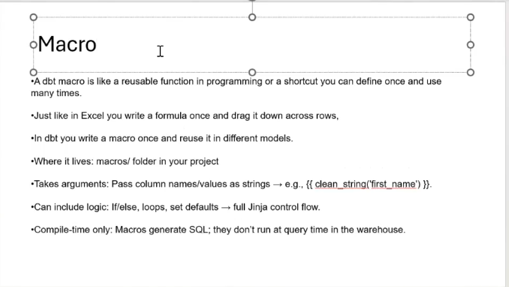
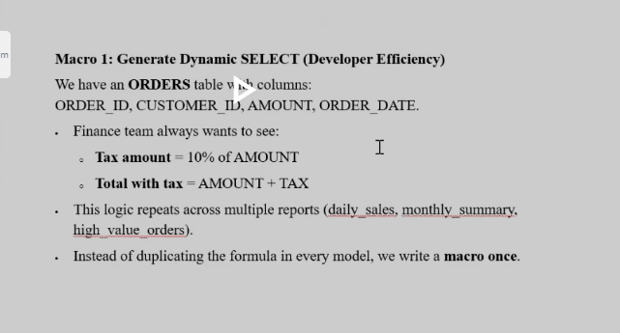
Macrs/calc_tax.sql
{% macro calc_tax(amount_column, tax_rate=0.1) %} --tax_rate 10 percent
({{ amount_column }} * {{ tax_rate }}) as TAX_AMOUNT,
({{ amount_column }} * (1 + {{ tax_rate }})) as TOTAL_AMOUNT
{% endmacro %}
Sample model call macro
with source as
(
select
order_id,
customer_id,
amount,
{{ calc_tax('amount', 0.1) }} --passing column name and tax rate 8 percent
from {{ source('rawsource', 'orders') }}
)

select *
from source

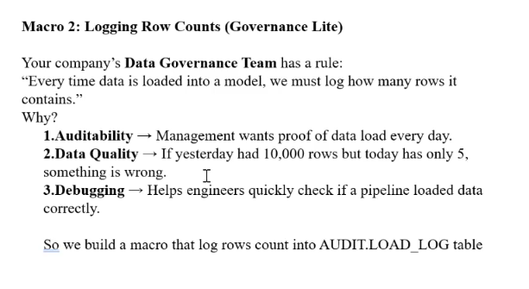
Macros/load_log.sql
{% macro log_load(table_name) %}
{% if execute %}
{% set sql %}

insert into DEMO_DB.AUDIT.LOAD_LOG(table_name, row_count, loaded_at)
select
'{{ table_name }}' as tbl_name,
count(*) as cnt,
current_timestamp
from {{ table_name }}

{% endset %}

{% do run_query(sql) %}
{% endif %}

{# intentionally return nothing #}
{% endmacro %}

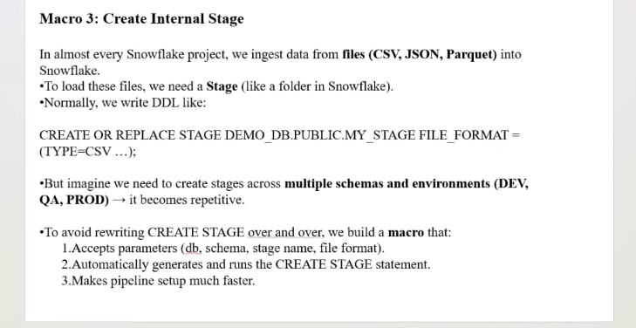
Automating Customer Data Load with DBT & Snowflake - Cloudyard

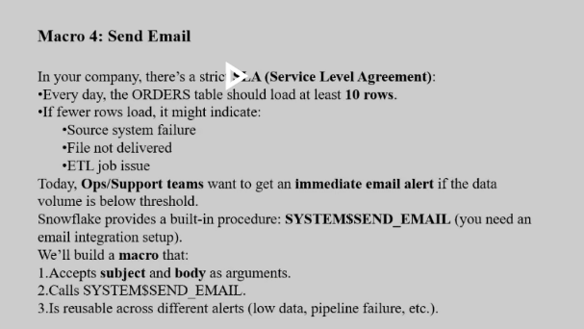
4. send_email_notification
Macro

{% macro send_email_notification(subject, body) %}

{% set sql %}
CALL SYSTEM$SEND_EMAIL(
'EMAIL_ALERT_INT', -- Email integration name
'mohan.krishna.k@gds.ey.com', -- Recipient email
'{{ subject | replace("\"", "\"\"") }}',
'{{ body | replace("\"", "\"\"") }}'
)
{% endset %}

{% do log("Sending Email -> " ~ subject, info=True) %} --display output on cli
{% do run_query(sql) %}
{% endmacro %}

Model code

--runtime logic
{{ config(materialized='ephemeral') }}
{% set count_query %}
SELECT COUNT(*) AS row_count FROM
DEMO_DB.PUBLIC.ORDERS
{% endset %}

{% set result = run_query(count_query) %} --run_query is dbt built in function to execute sql

/* result = {
columns
: [
{
name: 'ROW_COUNT',
values: 4
}
]
} */

{% if result %}
{% set row_count = result.columns[0].values()[0] %} --fetch values from python dictionary
{% do log("Orders count: " ~ row_count, info=True) %}

{% if row_count < 10 %}
{{ send_email_notification(
"ALERT: Low Orders Volume",
"Orders table has only " ~ row_count ~ " rows today. Please check the pipeline."
) }}
{% endif %}
{% endif %}

