Capstone Project Report

Project Title: Music Library

Name: | Kolasani Mohan Krishna
Batch: | Full Stack Programming
Institute: | Great Learning
Date: | 2025
GitHub: | github.com/MohanKrishnaKolasani/Music_Library

Table of Contents
Table of Contents 2
1. Problem Definition and Objectives 4
1.1. Problem Statement 4
1.2. Project Goals and Objectives 4
2. Frontend & Backend Architecture 6
2.1. Technology Stack 6
2.2. Frontend Architecture 6
2.3. Backend Architecture 7
2.4. System Design Diagram 7
3. Component Breakdown & API Design 9
3.1. Frontend Components 9
3.2. API Endpoints 9
Authentication 10
Songs 10
Playlists 10
Artists 10
Albums 10
Directors 11
Notifications 11
4. Database Design & Storage 12
4.1. Entity-Relationship Diagram (ERD) 12
4.2. Database Optimization Techniques 13
5. Testing 14
5.1. Frontend Unit & Component Tests (Jest + React Testing Library) 14
5.2. Backend Integration Tests (Mocha + Chai + Supertest) 14
5.3. End-to-End Tests (Cypress) 15
6. Project Demonstration 17
6.1. Login Page 17
6.2. Register Page 17
6.3. Songs Page (User) 17
6.4. Song Details Panel 18
6.5. Audio Player 18
6.6. Playlists Page 19
6.7. Playlist Details Page 19
6.8. Library Page 20
6.9. Profile Page 20
6.10. Admin Dashboard 21
6.11. Manage Songs (Admin) 21
6.12. Manage Artists (Admin) 22
6.13. Manage Albums (Admin) 22
6.14. Notification Bell 23
7. Sprint Plan 24
Sprint I — Foundation 24
Sprint II — Core Features 24
Sprint III — Polish & Integration 24
8. References 25

1. Problem Definition and Objectives

1.1. Problem Statement
Music is one of the most universal forms of entertainment, yet there was no centralised digital platform to manage and listen to a curated music library in a role-aware environment. The Music Library application was built to address this gap by providing a full-stack web platform where users can discover and enjoy music while administrators maintain the content.

The application supports two distinct roles. Regular users need the ability to browse an ever-growing catalogue, search songs by multiple attributes, build personalised playlists, and experience seamless audio playback. Administrators need a separate interface to manage all content — adding songs with audio files, managing artists, music directors, and albums, controlling song visibility, and notifying users when new songs are added.

Without such a platform, both content management and user discovery suffer from a lack of structure. This capstone project solves that by delivering a production-quality MERN stack application that satisfies all requirements set out in the Great Learning Full Stack Programming capstone brief.

1.2. Project Goals and Objectives
The following goals guided the entire development process:

- Role-Based Access Control: Implement two distinct user roles — Admin and User — with separate routes, dashboards, and capabilities protected by a JWT-based authentication system.
- User Authentication & Registration: Allow users to register with their name, email, phone number, and password, log in securely, and manage their profile including a profile picture upload.
- Song Discovery: Provide users with a browseable and searchable list of all visible songs, with the ability to filter by song name, artist, album, and music director.
- Song Details: Display complete song information including name, singer(s), music director, album, release date, and duration when a song is selected.
- Playlist Management: Allow users to create multiple playlists, rename them, delete them, and add or remove individual songs from each playlist. Full CRUD on both playlists and playlist songs.
- Playlist Playback Controls: Provide Play, Stop, Repeat, and Shuffle controls within the playlist view, along with previous and next track navigation.
- Audio Player: Embed a persistent bottom-of-screen audio player that plays songs with real-time progress tracking, volume control, and queue management.
- Admin Content Management: Give administrators full CRUD over songs (including file uploads), artists, music directors, albums, and user accounts.
- Song Visibility Control: Allow admins to toggle individual song visibility so that hidden songs do not appear to regular users.
- Notifications: Send notifications to all users whenever a new song is added to the library.
- Component & End-to-End Testing: Write Jest + React Testing Library unit tests for components, hooks, and services, and Cypress end-to-end tests for critical user flows.
- Responsive Design: Ensure the application is fully usable across desktop and mobile devices using Bootstrap 5.
- Single Page Application: Build the frontend as a SPA using React Router v7 so that navigation happens without full page reloads.

2. Frontend & Backend Architecture

2.1. Technology Stack

Layer | Technology | Purpose
Frontend | React 19 | Component-based SPA — hooks, context, custom hooks
Frontend | React Router v7 | Client-side routing with PrivateRoute guard
Frontend | Bootstrap 5 | Responsive grid, layout and UI utilities
Frontend | Axios | HTTP client with JWT interceptor for all API calls
Frontend | Context API | AuthContext + PlayerContext for global state
Backend | Node.js | JavaScript runtime — event-driven, non-blocking I/O
Backend | Express 5 | REST API framework — routing and middleware
Backend | MongoDB | NoSQL document database for flexible schema storage
Backend | Mongoose | ODM — schema definition, validation, and relationships
Auth | JWT (jsonwebtoken) | Stateless token-based authentication
Auth | bcryptjs | Password hashing — salted hash, never plain text
File Upload | Multer | Middleware for song (mp3) and image file uploads
Testing | Jest + RTL | Unit and component tests — 195 test cases
Testing | Cypress | End-to-end tests — login, register, songs, playlists
Backend Testing | Mocha + Chai + Supertest | Backend API integration tests
Version Control | Git + GitHub | Source control and project hosting

2.2. Frontend Architecture
The frontend is a Single Page Application built with React 19. It follows a clear separation of concerns through a layered architecture:

- Pages: Each major view of the application is a dedicated page component — Login, Register, SongsPage, PlaylistsPage, PlaylistDetails, ProfilePage, LibraryPage, AdminDashboard, ManageSongs, ManageArtists, ManageDirectors, ManageAlbums, and ManageUsers.
- Components: Reusable UI building blocks — SongCard (displays a single song with expand/collapse detail panel), SongList (renders a grid of SongCards), SongPlayer (persistent bottom audio player), Pagination (reusable page navigator), Sidebar (role-aware navigation), Navbar (responsive top navigation), NotificationBell (polls for unread notifications), and PlaylistSelector (dropdown to add songs to playlists).
- Custom Hooks: Business logic is encapsulated in 14 custom hooks — useSongs, usePlaylists, usePlaylistDetail, usePlaylistSelector, usePagination, useNotifications, useProfile, useAuth, useAdminSongs, useAdminArtists, useAdminDirectors, useAdminAlbums, useAdminUsers, and useAdminStats. Pages never import services directly — they use hooks only.
- Context Providers: AuthContext holds token, role, user state and login/logout actions. PlayerContext holds currentSong, queue, and playback controls. Both are provided at the root in index.js so the entire app can consume them.
- Services: Thin Axios wrapper functions organised by domain — authService, songService, playlistService, artistService, albumService, directorService, userService. All use a shared axiosConfig.js that auto-attaches the JWT Authorization header.
- Routing: React Router v7 handles all navigation. PrivateRoute redirects unauthenticated users to /login. Role-based redirects ensure admins cannot access user pages and users cannot access admin pages.

2.3. Backend Architecture
The backend is a RESTful API built with Node.js and Express 5, following a three-layer architecture:

- Routes Layer: Express route files (auth.js, songs.js, playlists.js, artists.js, directors.js, albums.js, notifications.js) define the API endpoints and map them to service functions. The JWT auth middleware is applied to all protected routes.
- Service Layer: Each domain has a dedicated service file (authService.js, songService.js, playlistService.js, etc.) that contains all business logic. Routes call services; services interact with models. This separation makes the backend fully testable.
- Model Layer: Mongoose schemas define the data structure for all eight MongoDB collections — User, Song, Playlist, Album, Artist, MusicDirector, Notification, and Role.
- Middleware: auth.js verifies the JWT token on every protected request. upload.js configures Multer for audio and image file uploads with type validation and destination routing.
- Upload Management: On server start, server.js automatically creates the required upload directories (uploads/songs, uploads/albums, uploads/artists, uploads/directors, uploads/profiles) so that a fresh clone works without manual setup.

2.4. System Design Diagram

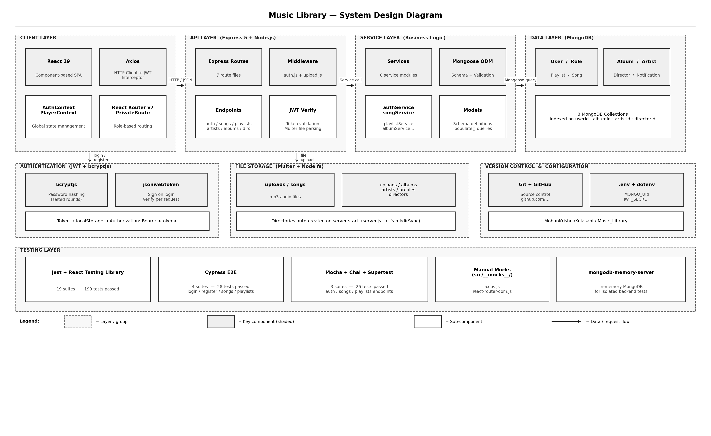
Fig. System Design Diagram — Client → API → Service → Data layers with Auth, File Storage, and Testing

3. Component Breakdown & API Design

3.1. Frontend Components
The following table summarises all major frontend components and their responsibilities:

Component | Responsibility
Login | Email + password form with inline validation, calls AuthContext.login(), redirects by role
Register | Registration form with name, email, phone, password validation, calls registerUser API
SongsPage | Song catalogue with search bar (name, artist, album, director), paginated SongCard grid
SongCard | Individual song card — collapsed meta view and expandable detail panel, Play and Add to Playlist buttons
SongPlayer | Fixed bottom audio player with prev, play/pause, next, progress scrubber, and volume control
PlaylistsPage | List all user playlists with create, rename (modal), and delete (confirm modal) actions
PlaylistDetails | Single playlist view with search bar, song list, Play/Stop/Repeat/Shuffle controls
LibraryPage | Tabbed browser for Albums, Artists, and Directors with song detail panel
ProfilePage | User profile display with profile picture upload functionality
AdminDashboard | Stats cards (total songs, artists, directors, albums, users) with quick action links
ManageSongs | Full CRUD table for songs — add with audio/image upload, edit, delete, visibility toggle
ManageArtists | CRUD for artists with photo upload
ManageDirectors | CRUD for music directors with photo upload
ManageAlbums | CRUD for albums with cover image upload
ManageUsers | Admin view of all registered users with edit and delete
Navbar | Responsive top nav — role-aware links, logout button, notification bell
Sidebar | Side navigation — shows user links for regular users, admin links for admins
NotificationBell | Polls for unread notifications every 30 seconds, displays count badge, mark as read
Pagination | Reusable pagination bar — page buttons with ellipsis, prev/next, item count display
PlaylistSelector | Dropdown to add the current song to any existing playlist

3.2. API Endpoints
All endpoints are prefixed with /api. Protected endpoints require a valid JWT Bearer token in the Authorization header.

Authentication
Method | Endpoint | Description
POST | /auth/register | Register a new user with name, email, phone, password
POST | /auth/login | Login and receive a JWT token
GET | /auth/profile | Get the logged-in user's profile (protected)
POST | /auth/profile-picture | Upload or update profile picture (protected)
GET | /auth/users | Get all users — admin only
PUT | /auth/users/:id | Update a user — admin only
DELETE | /auth/users/:id | Delete a user — admin only

Songs
Method | Endpoint | Description
GET | /songs | Get all visible songs (supports query params: search, artist, album, director)
GET | /songs/admin/all | Get all songs including hidden ones — admin only
GET | /songs/:id | Get a single song by ID
POST | /songs | Add a new song with audio file — admin only
PUT | /songs/:id | Update song details — admin only
DELETE | /songs/:id | Delete a song — admin only
PATCH | /songs/:id/visibility | Toggle song visibility — admin only

Playlists
Method | Endpoint | Description
GET | /playlists | Get all playlists for the logged-in user
GET | /playlists/:id | Get a single playlist with all songs populated
POST | /playlists | Create a new playlist
PUT | /playlists/:id | Rename a playlist
DELETE | /playlists/:id | Delete a playlist
POST | /playlists/:id/songs | Add a song to a playlist
DELETE | /playlists/:id/songs/:songId | Remove a song from a playlist

Artists
Method | Endpoint | Description
GET | /artists | Get all artists
POST | /artists | Add a new artist with optional photo
PUT | /artists/:id | Update artist details
PATCH | /artists/:id/photo | Update artist photo only
DELETE | /artists/:id | Delete an artist

Albums
Method | Endpoint | Description
GET | /albums | Get all albums
POST | /albums | Add a new album with optional cover image
PUT | /albums/:id | Update album details
DELETE | /albums/:id | Delete an album

Directors
Method | Endpoint | Description
GET | /directors | Get all music directors
POST | /directors | Add a new director with optional photo
PUT | /directors/:id | Update director details
PATCH | /directors/:id/photo | Update director photo only
DELETE | /directors/:id | Delete a director

Notifications
Method | Endpoint | Description
GET | /notifications | Get all unread notifications for the logged-in user
PATCH | /notifications/:id/read | Mark a single notification as read
POST | /notifications | Create a notification — called internally when a new song is added

4. Database Design & Storage

4.1. Entity-Relationship Diagram (ERD)
The application uses MongoDB with Mongoose for data storage. The database consists of eight collections with the following structure and relationships:

- User: Stores user information — name, email, phone, password (hashed), profilePicture path, roleId (reference to Role). Timestamps included.
- Role: Simple lookup collection — roleName field with enum values 'admin' or 'user'. Referenced by User.
- Song: Core entity — songName, albumId (ref Album), artistId[] (array of Artist refs), directorId (ref MusicDirector), duration, releaseDate, filePath (mp3 path), isVisible (boolean for admin visibility control). Text index on songName, compound indexes on artistId, albumId, directorId for fast search.
- Playlist: playlistName, userId (ref User — ownership), songs[] (array of Song refs). Users own their playlists and control their contents.
- Album: albumName, releaseDate, directorId (ref MusicDirector), coverImage path.
- Artist: artistName, artistPhoto path.
- MusicDirector: directorName, directorPhoto path.
- Notification: userId (ref User), type (enum: new_song / system), songId (ref Song), message, isRead (boolean).

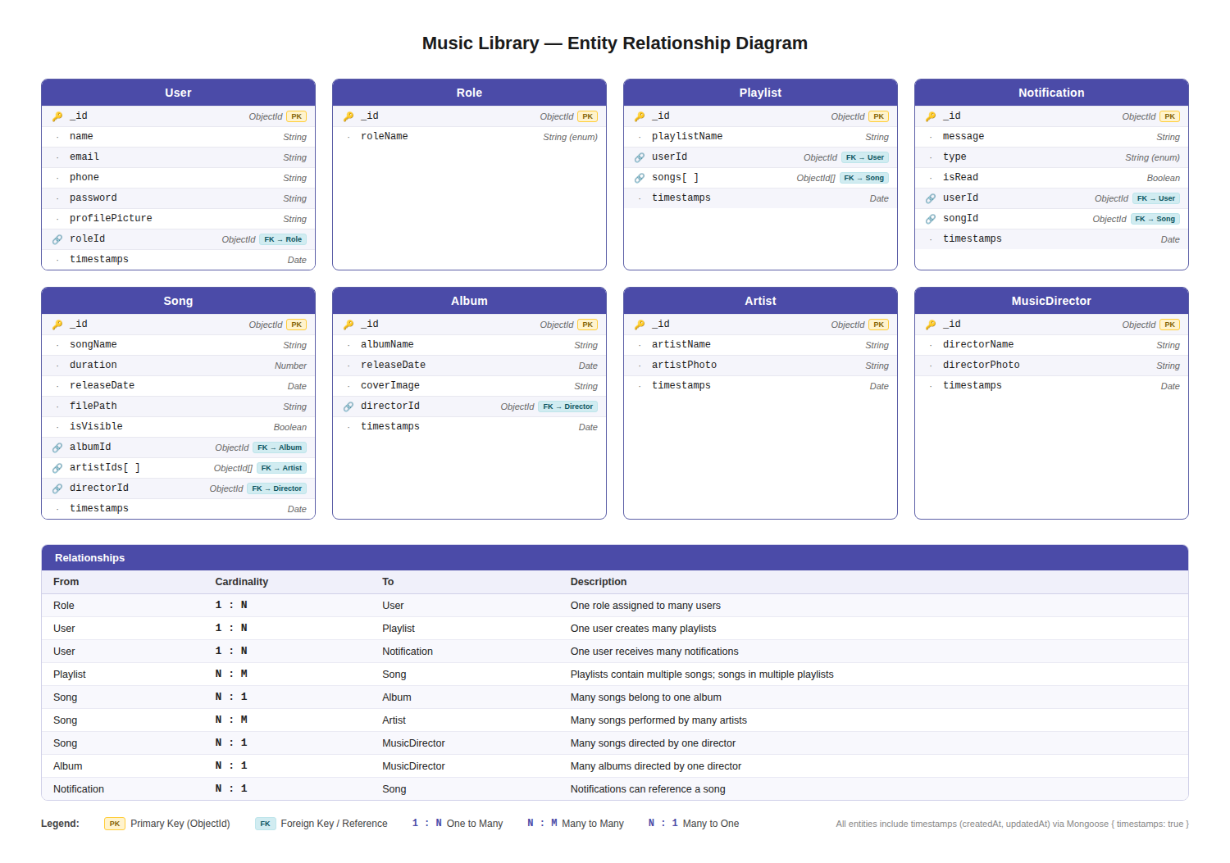
Fig. ER Diagram — All 8 MongoDB collections with fields, types and relationships

4.2. Database Optimization Techniques
- Text Indexing: A text index is created on Song.songName to support full-text search queries efficiently. This allows the search functionality to find songs by partial name matches without scanning the entire collection.
- Compound Indexing: Additional indexes are created on Song.artistId, Song.albumId, and Song.directorId. These fields are the most frequently queried filters in the song search feature, and indexes dramatically reduce query time for large catalogues.
- Reference-Based Relationships: Rather than embedding full documents, the schema uses Mongoose ObjectId references ($ref). When data is needed, Mongoose's .populate() method is used to join related documents. This keeps documents small and avoids duplication of artist or album data across hundreds of songs.
- Selective Population: The song search endpoint only populates the fields needed for display — artistName, albumName, directorName, coverImage — rather than full documents, reducing payload size and serialisation cost.
- Visibility Filtering: The isVisible field on Song allows the user-facing song API to apply a { isVisible: true } filter at the query level, meaning MongoDB never returns hidden songs to the user endpoint. The admin endpoint bypasses this filter.
- Auto-Created Upload Directories: Upload folders are created programmatically on server start using Node's fs.mkdirSync with { recursive: true }. This means the project works correctly after a fresh git clone without any manual setup.

5. Testing

5.1. Frontend Unit & Component Tests (Jest + React Testing Library)
The frontend test suite was written using Jest and React Testing Library, which comes pre-configured with Create React App. Tests are organised into four layers under src/__tests__/:

- Utility / Pure Function Tests: loginValidation.test.js (14 tests), registerValidation.test.js (19 tests), songCardUtils.test.js (11 tests), and usePagination.test.js (22 tests). These test the validation logic and pure helper functions extracted from components without any React rendering.
- Custom Hook Tests: usePlayerContext.test.js (13 tests), useSongs.test.js (7 tests), and usePlaylists.test.js (6 tests). These use renderHook from @testing-library/react to test hook behaviour in isolation, with the service layer fully mocked.
- Component Tests: Login.test.js (12 tests), Register.test.js (15 tests), SongCard.test.js (17 tests), Pagination.test.js (10 tests), PrivateRoute.test.js (4 tests), and Sidebar.test.js (15 tests). These render actual React components using RTL and simulate user interactions.
- Service Tests: authService.test.js (4 tests), songService.test.js (8 tests), playlistService.test.js (7 tests), artistService.test.js (5 tests), albumService.test.js (4 tests), and userService.test.js (3 tests). These verify that each service function calls the correct API endpoint with the correct method and parameters.

Total: 19 test suites, 195 individual test cases. All pass with 0 errors and 0 ESLint warnings.

Two manual mocks were created in src/__mocks__/ to handle ESM compatibility issues with react-scripts 5:
- axios.js — A CJS mock for axios v1.x which ships as ESM and cannot be parsed by Jest's CommonJS runtime.
- react-router-dom.js — A full functional mock providing MemoryRouter, Routes, Route, Navigate, Link, and useNavigate, working around jest-resolve v27's inability to resolve packages using the exports field.

5.2. Backend Integration Tests (Mocha + Chai + Supertest)
The backend uses Mocha as the test runner, Chai for assertions, Supertest for HTTP-level API testing, and mongodb-memory-server to spin up an in-memory MongoDB instance so tests run independently without a real database connection.

- auth.test.js: Tests user registration (successful, duplicate email), login (successful, wrong credentials), profile retrieval (authenticated, unauthenticated).
- songs.test.js: Tests song creation by admin, retrieval of visible songs by user, retrieval of all songs including hidden by admin, and visibility toggle.
- playlists.test.js: Tests playlist creation, retrieval, add song to playlist, remove song from playlist, and delete playlist.

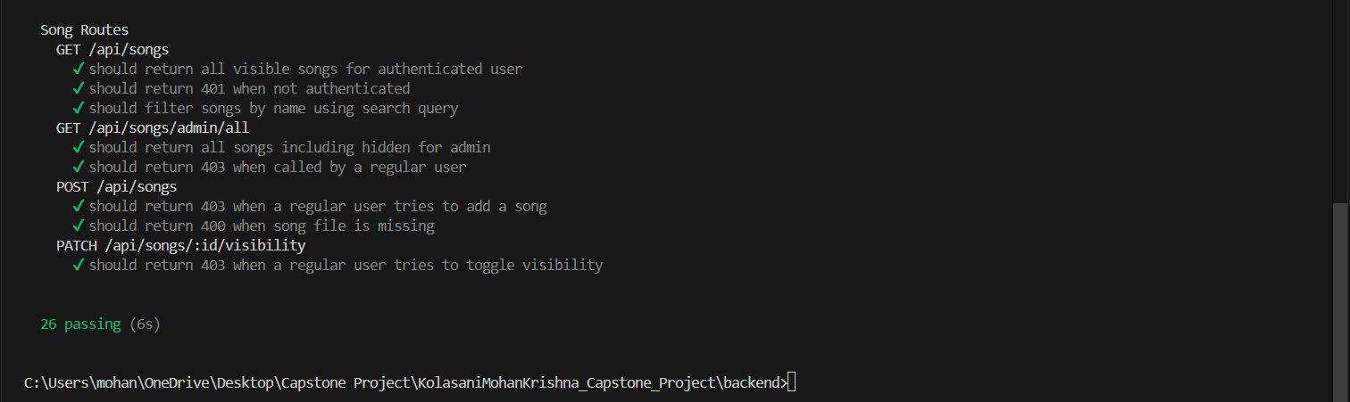
Fig. Mocha backend tests — 26 passing

5.3. End-to-End Tests (Cypress)
Cypress end-to-end tests are located in frontend/cypress/e2e/ and test the full application flow from the browser perspective. Tests require both the backend server (port 5000) and the frontend dev server (port 3000) to be running.

- login.cy.js: Displays login form, shows validation errors for empty/invalid inputs, shows error for wrong credentials, redirects to /songs after successful login, and navigates to register page.
- register.cy.js: Displays registration form, shows all four validation errors on empty submit, validates email format, phone format, password length, clears errors on correction, and links to login.
- songs.cy.js: Displays song cards after login, shows details panel on View Details click, hides details on Hide Details click, filters songs by name search, clears search results, and opens audio player on Play.
- playlists.cy.js: Creates a new playlist, prevents creation with empty name, navigates into a playlist, renames a playlist via the modal, and deletes a playlist with confirmation.

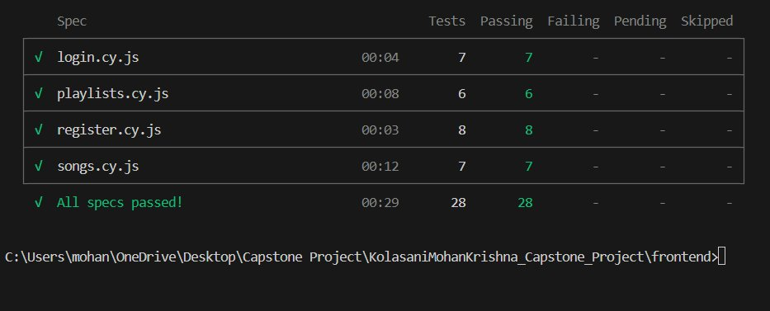
Fig. Cypress E2E tests — All 28 specs passed (login: 7, playlists: 6, register: 8, songs: 7)

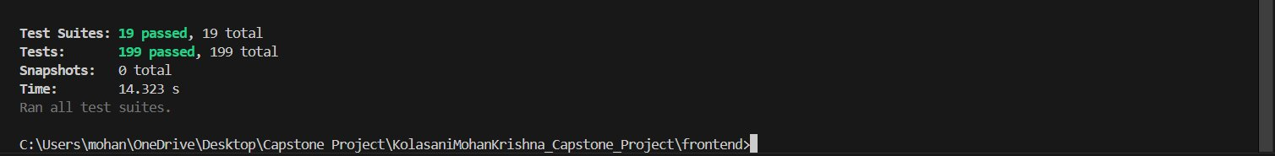
Fig. Jest unit tests — 19 suites, 199 tests passed

6. Project Demonstration

6.1. Login Page
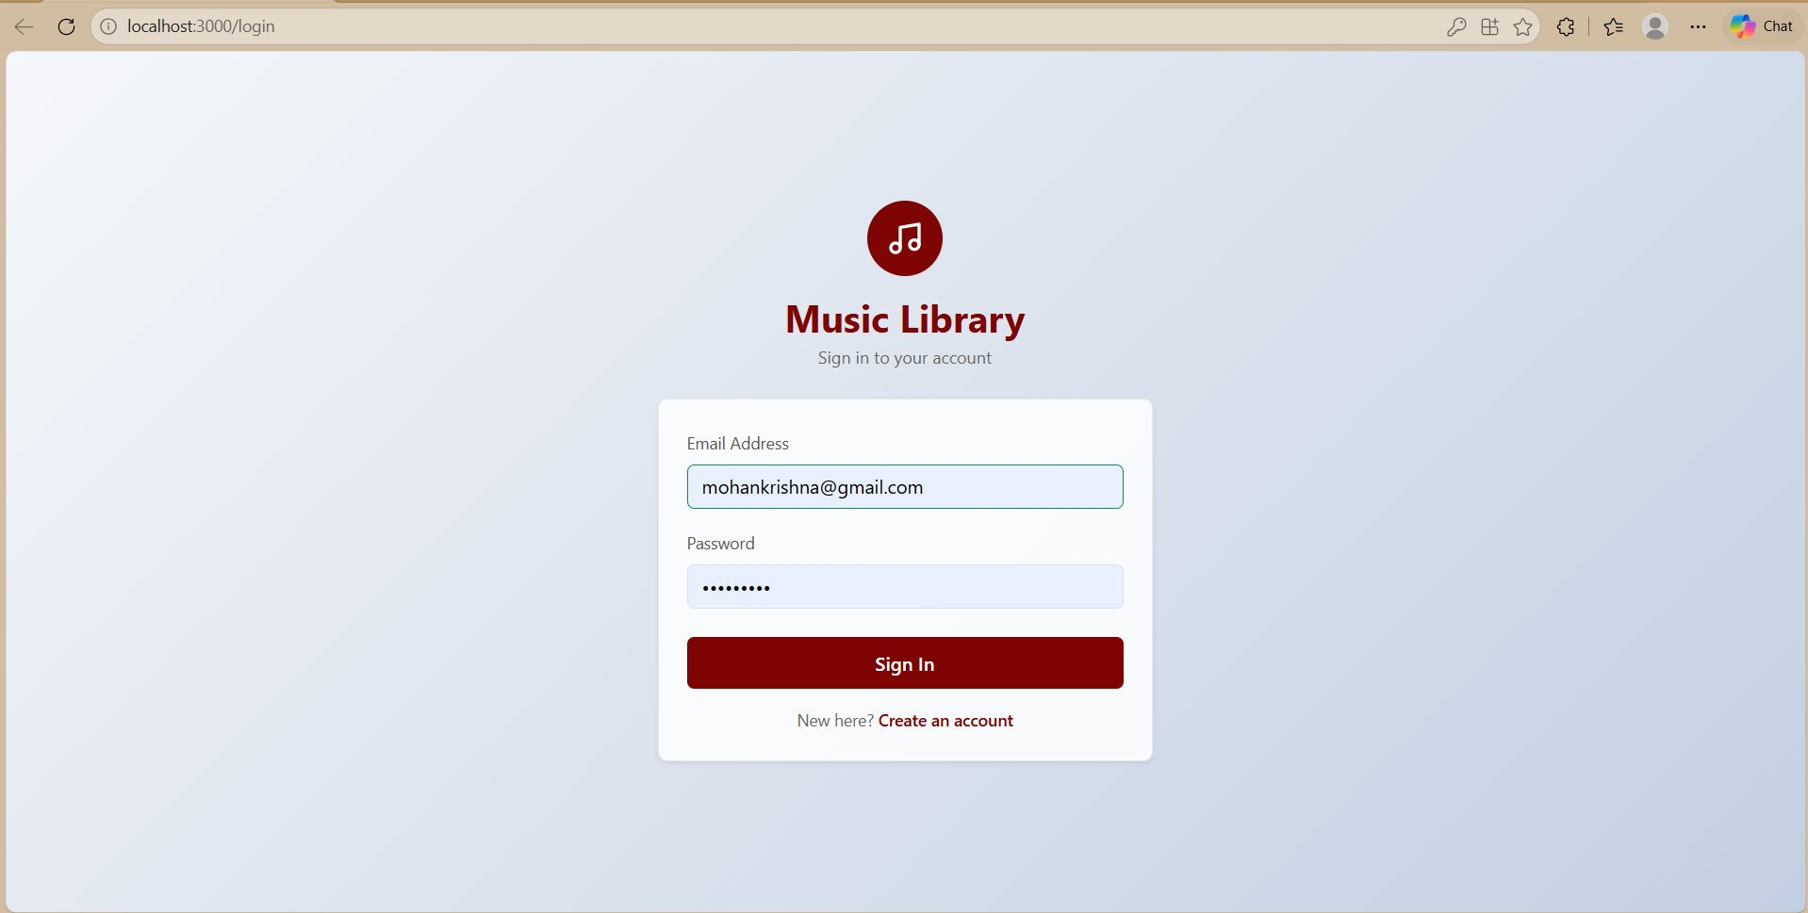
Fig. Login Page — email and password form with validation

6.2. Register Page
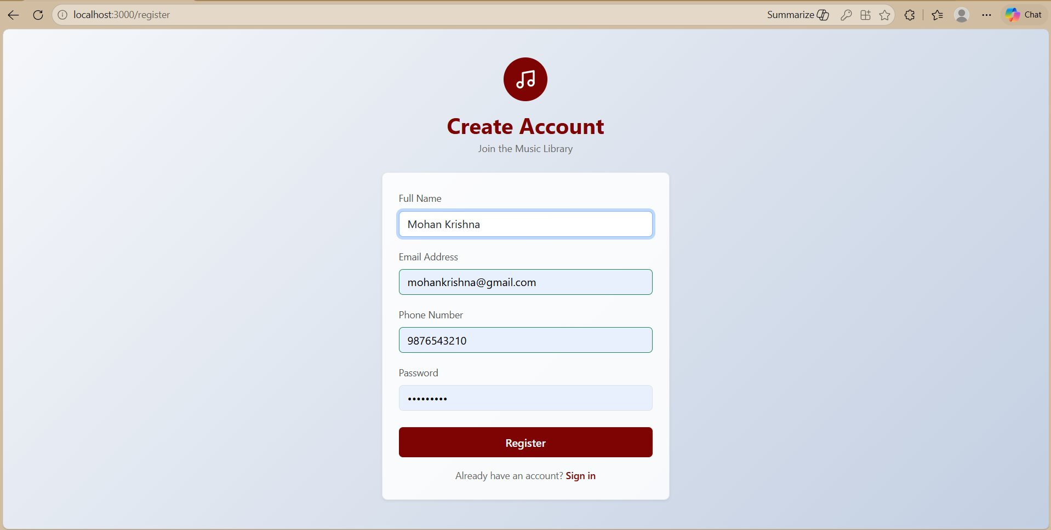
Fig. Register Page — name, email, phone, password fields with validation

6.3. Songs Page (User)
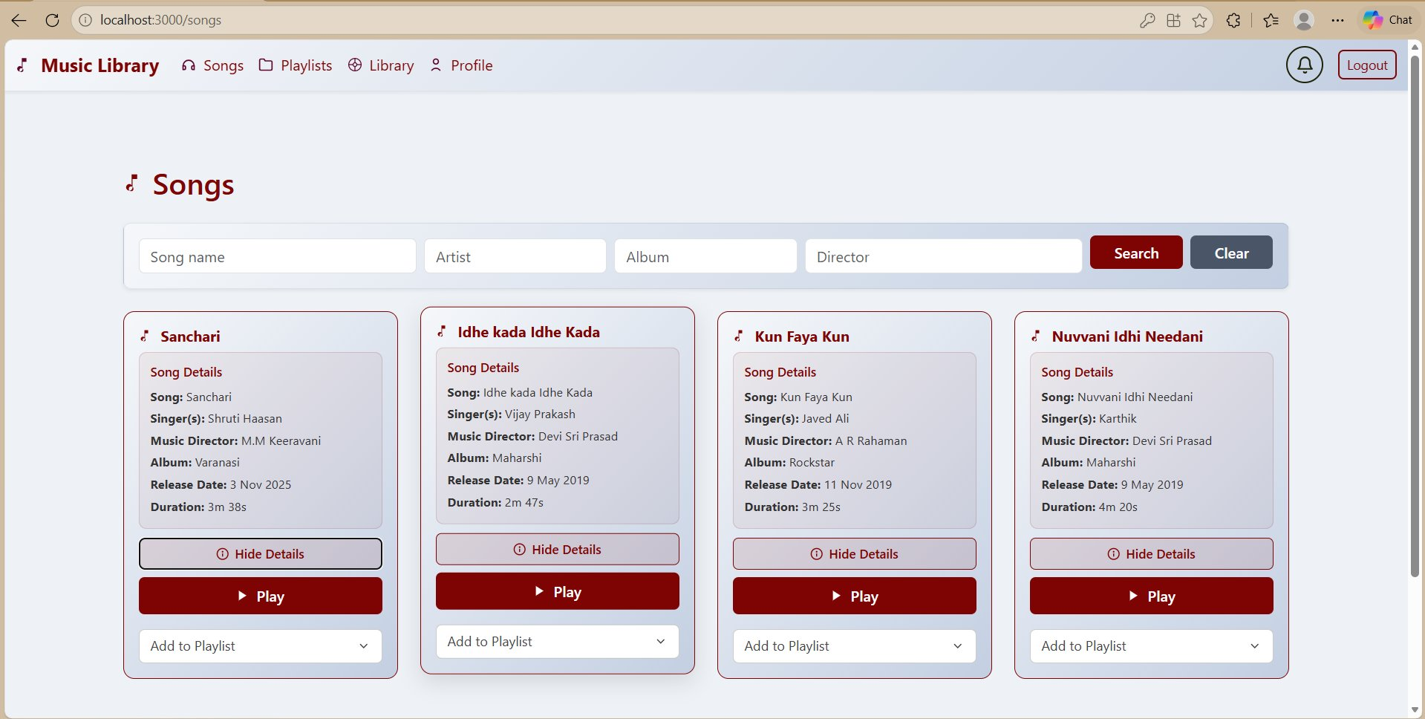
Fig. Songs Page — browseable song catalogue with search filters

6.4. Song Details Panel

Fig. Song Details — singer, music director, album, release date, duration

6.5. Audio Player
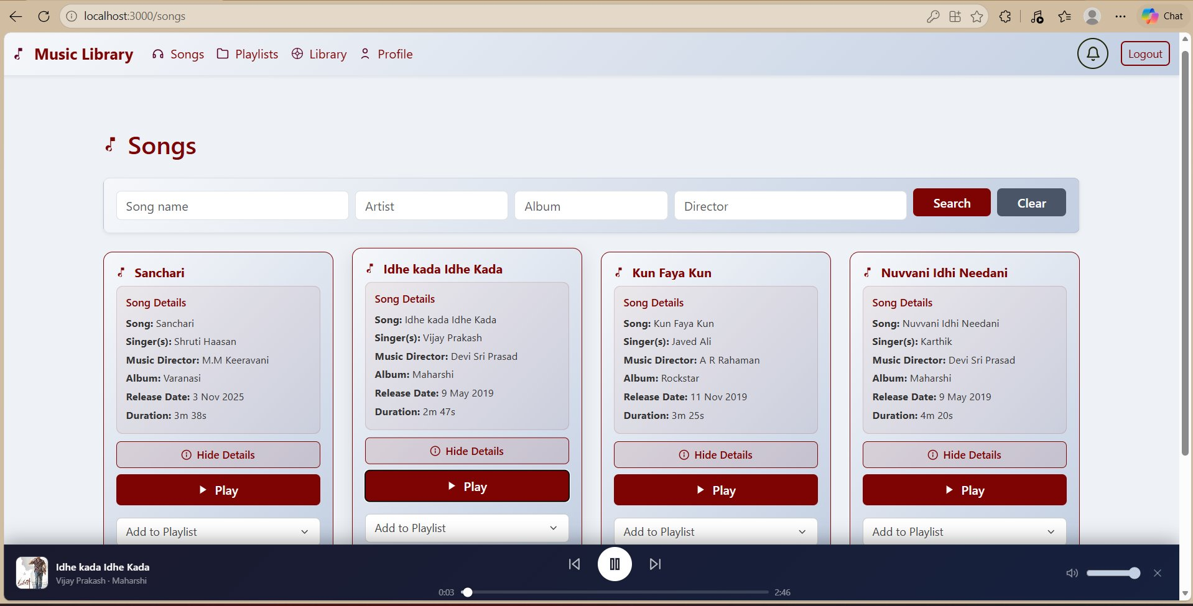
Fig. Audio Player — prev, play/pause, next, progress bar, volume control

6.6. Playlists Page
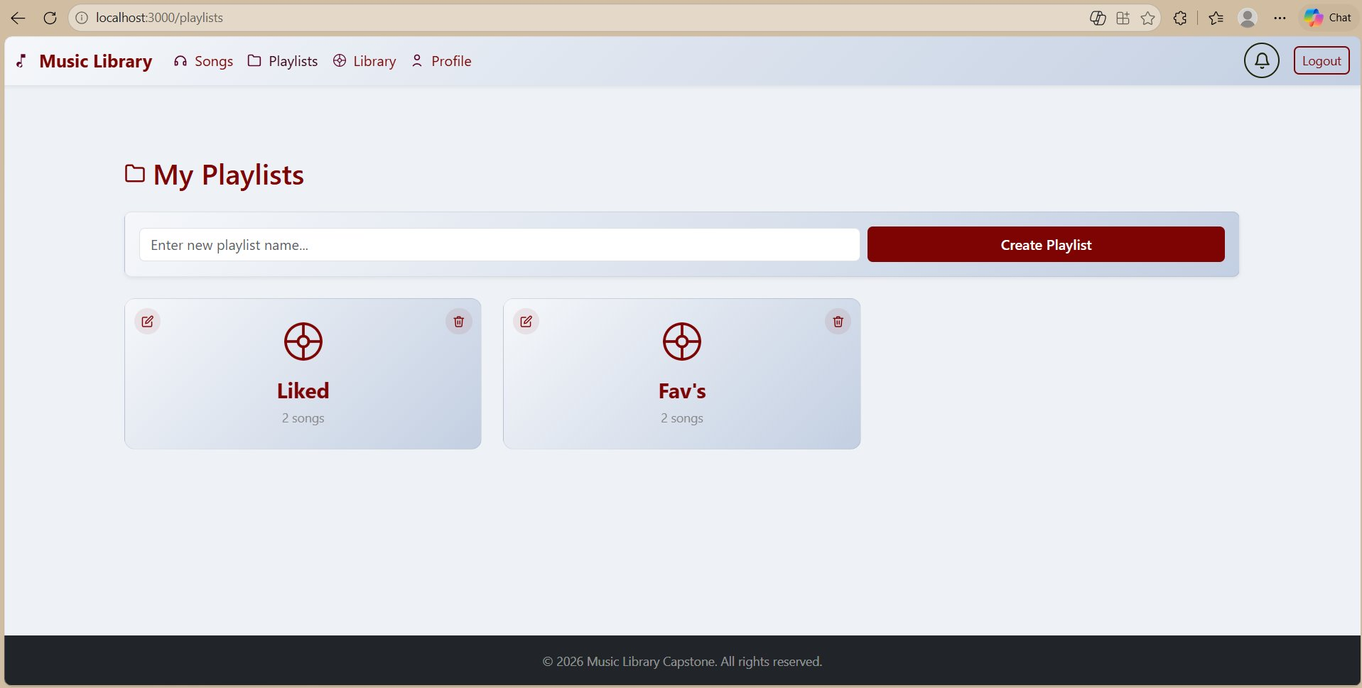
Fig. Playlists Page — create, rename, delete, navigate into playlists

6.7. Playlist Details Page
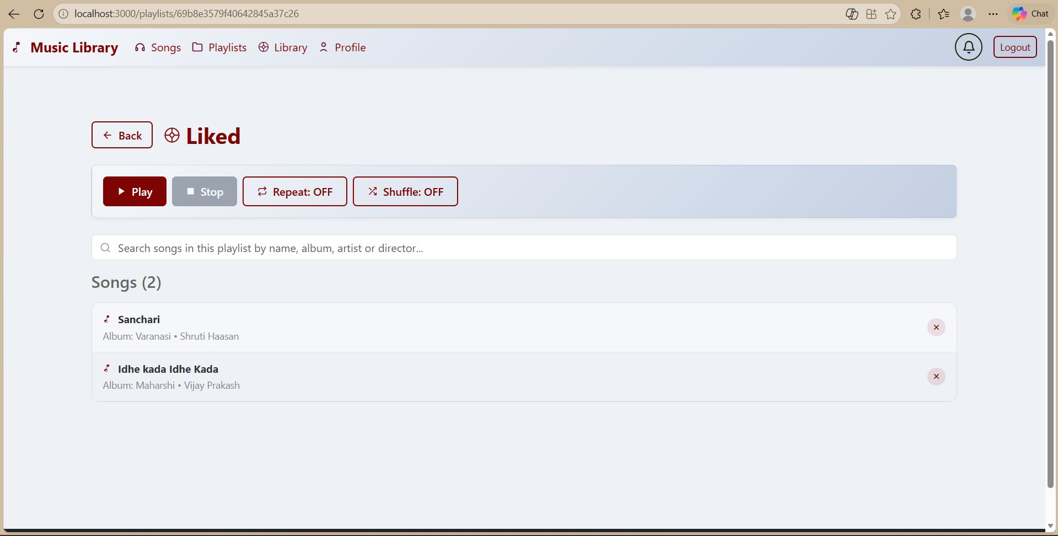
Fig. Playlist Details — Play, Stop, Repeat, Shuffle, song search, remove songs

6.8. Library Page
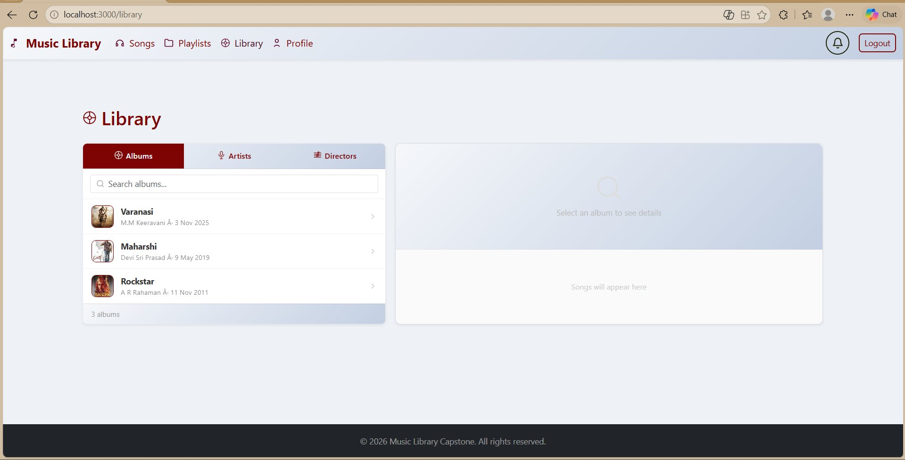
Fig. Library — browse by album, artist, or director with song detail panel

6.9. Profile Page
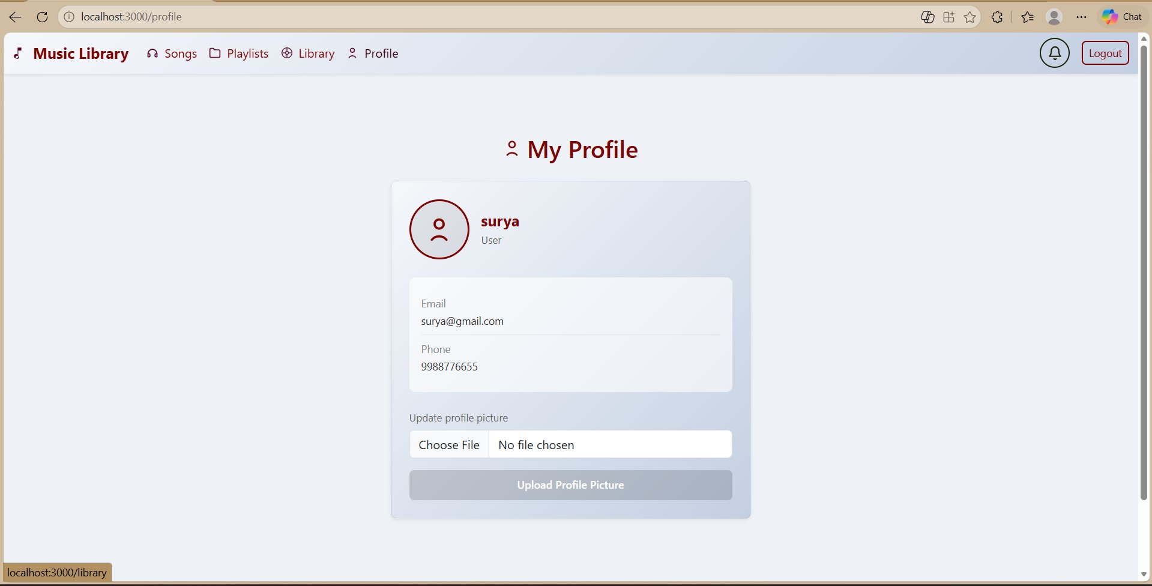
Fig. Profile Page — user info and profile picture upload

6.10. Admin Dashboard
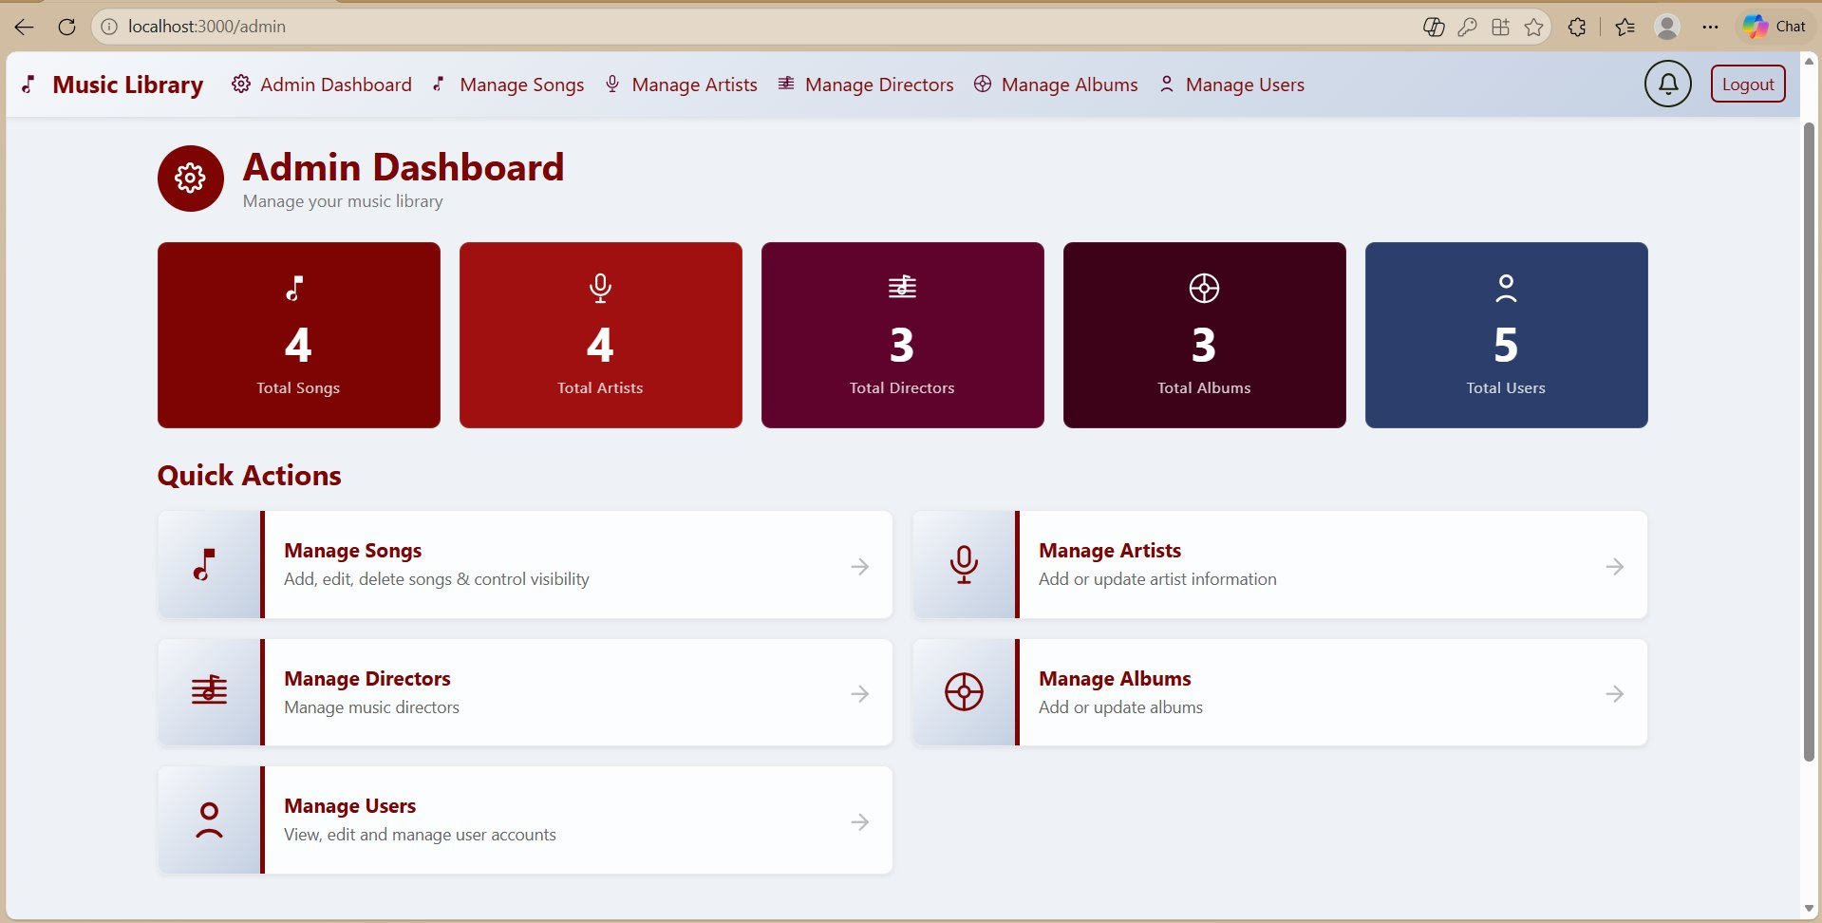
Fig. Admin Dashboard — total songs, artists, directors, albums, users

6.11. Manage Songs (Admin)
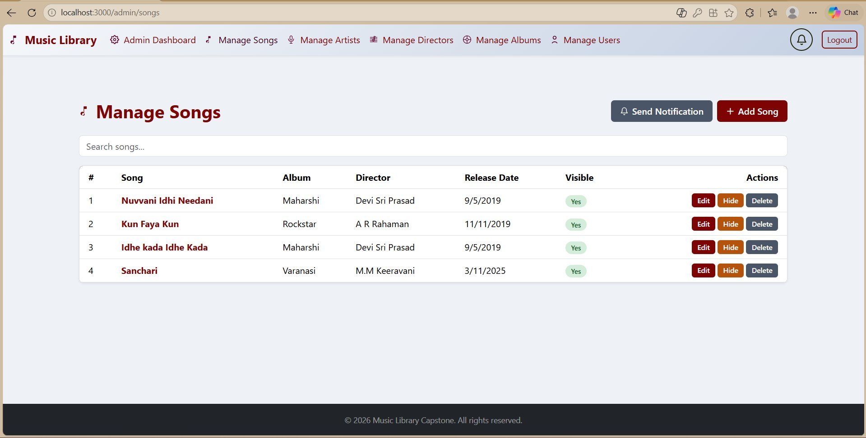
Fig. Manage Songs — add, edit, delete, and toggle song visibility

6.12. Manage Artists (Admin)
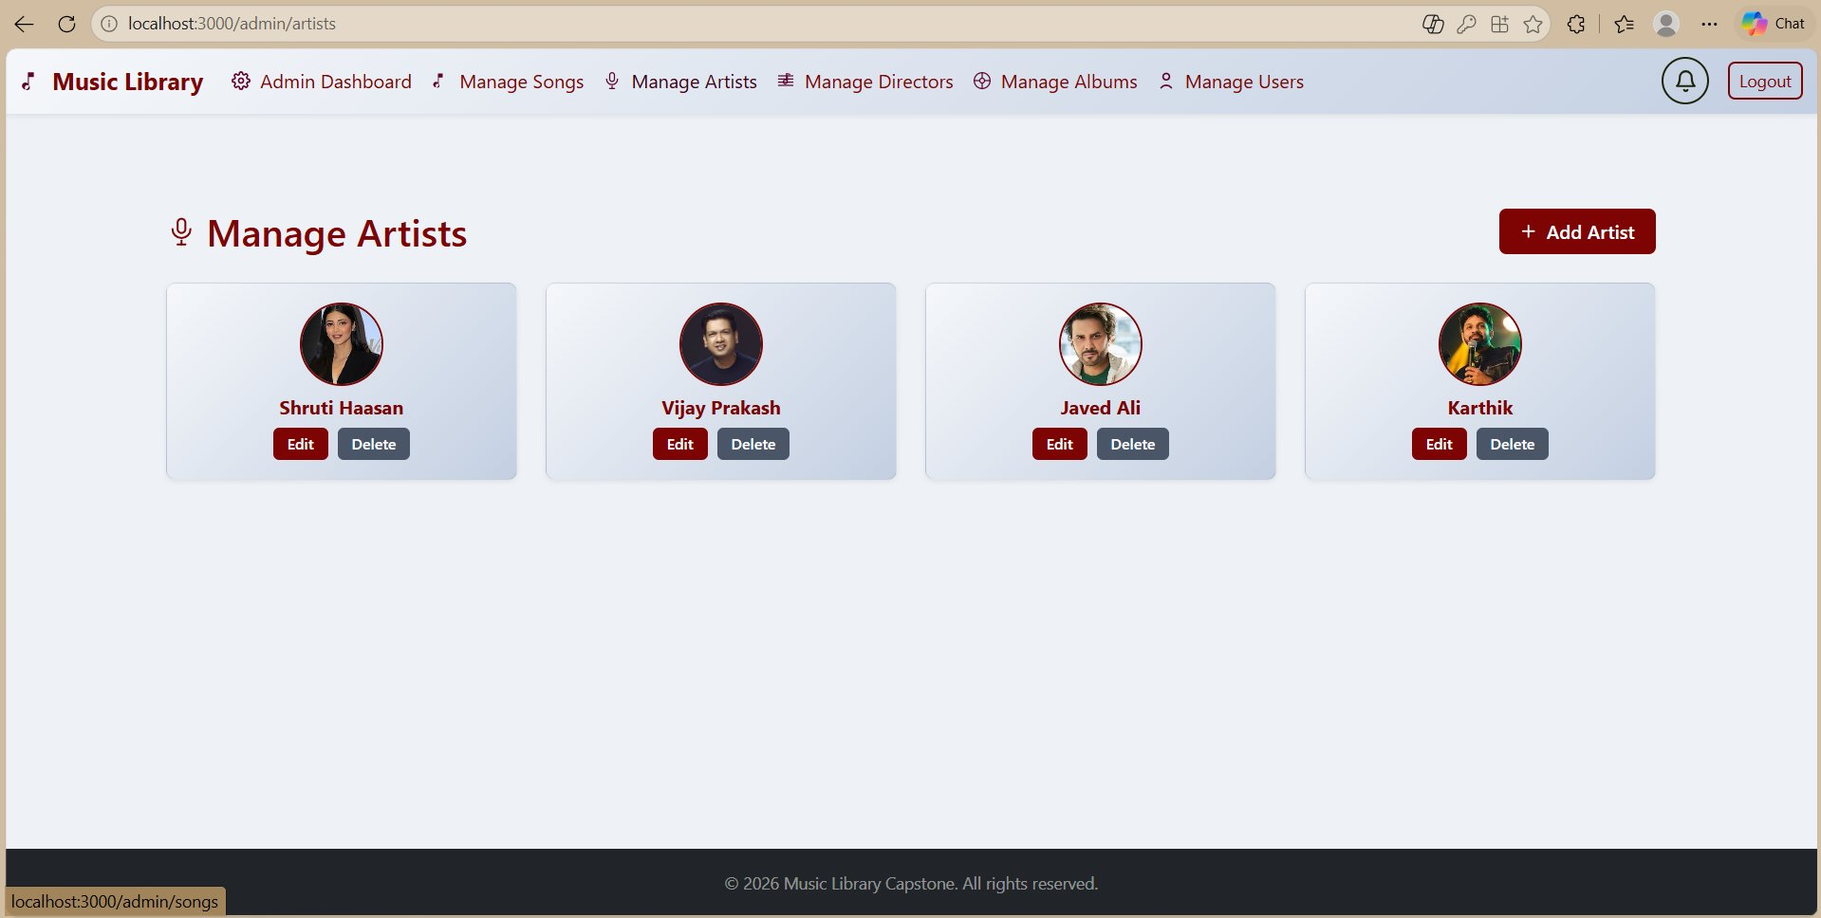
Fig. Manage Artists — CRUD with photo upload

6.13. Manage Albums (Admin)
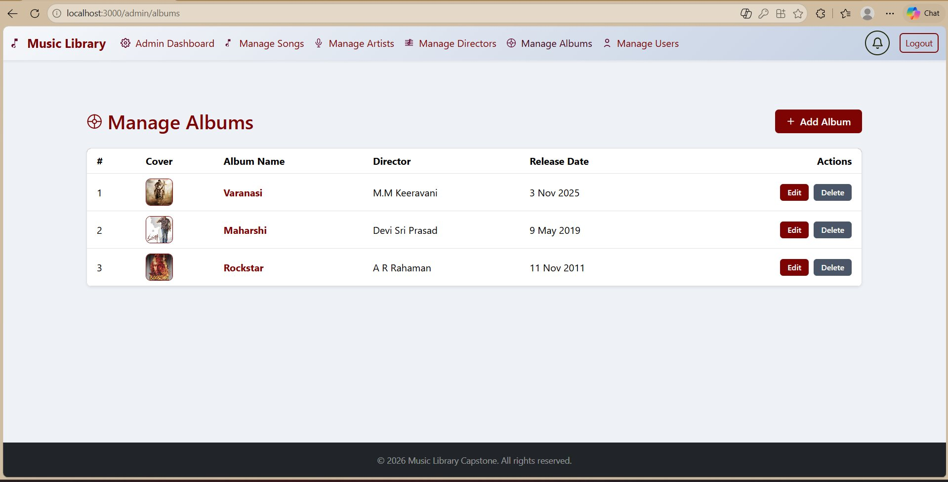
Fig. Manage Albums — CRUD with cover image upload

6.14. Notification Bell
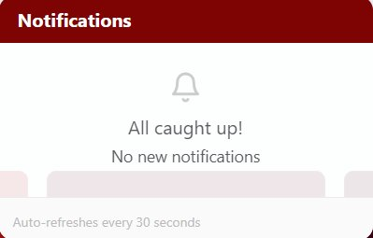
Fig. Notifications — new song notifications with mark as read

7. Sprint Plan

Sprint I — Foundation
- Designed MongoDB database schema for all 8 collections with relationships
- Implemented CRUD for User and Role using Node.js and Express
- Set up the React project with routing, Auth context, and Login/Register pages

Sprint II — Core Features
- Developed full-text and filtered song search (by name, artist, album, director)
- Implemented admin CRUD for songs with audio file upload via Multer
- Built song visibility restriction — isVisible toggle, filtered user endpoint
- Implemented full playlist CRUD for users — create, rename, delete
- Implemented song CRUD within playlists — add and remove songs
- Added JWT authentication middleware protecting all private routes
- Wrote component tests with Jest + RTL and E2E tests with Cypress

Sprint III — Polish & Integration
- Extracted business logic into a dedicated service layer for all 8 domains
- Implemented notification service — creates notifications when admin adds songs
- Integrated frontend and backend end-to-end with live data
- Added audio player, Library page, Profile page, and admin user management
- Fixed stale auth state bug — App.js and Navbar now consume AuthContext directly
- Fixed player persistence bug — PlayerContext clears on logout
- Made application fully responsive using Bootstrap 5 grid

8. References

- React Documentation — https://react.dev
- React Router v7 Documentation — https://reactrouter.com
- Express.js Documentation — https://expressjs.com
- Mongoose Documentation — https://mongoosejs.com
- JWT Documentation — https://jwt.io
- Bootstrap 5 Documentation — https://getbootstrap.com
- Jest Documentation — https://jestjs.io
- React Testing Library Documentation — https://testing-library.com
- Cypress Documentation — https://docs.cypress.io
- Multer Documentation — https://github.com/expressjs/multer
- bcryptjs Documentation — https://github.com/dcodeIO/bcrypt.js
- Great Learning Full Stack Programming Capstone — Problem Statement PDF

GitHub Repository: https://github.com/MohanKrishnaKolasani/Music_Library

