IBM AI:101 Measure Energy Consumption

Mohan Krishna.N ([mohankrish3027@gmail.com](mailto:mohankrish3027@gmail.com))

Prakash.A ([prakashmokesh2004@gmail.com](mailto:prakashmokesh2004@gmail.com))

Raguram.R ([raguramrramanan@gmail.com](mailto:raguramrramanan@gmail.com))

Reegan Anto.J ([reegananto21@gmail.com](mailto:reegananto21@gmail.com))

Phase 3: Development Part 1

Data Visualization:

Data visualization is an integral part of machine learning, and it is also necessary to guide us to come up with various interpretations of the obtained data.

The visualized data is split into 80% training data(blue) and 20% testing data(orange).

The charts given below describe my partitions.

(Note: The name of the city is represented in the legend of the charts)

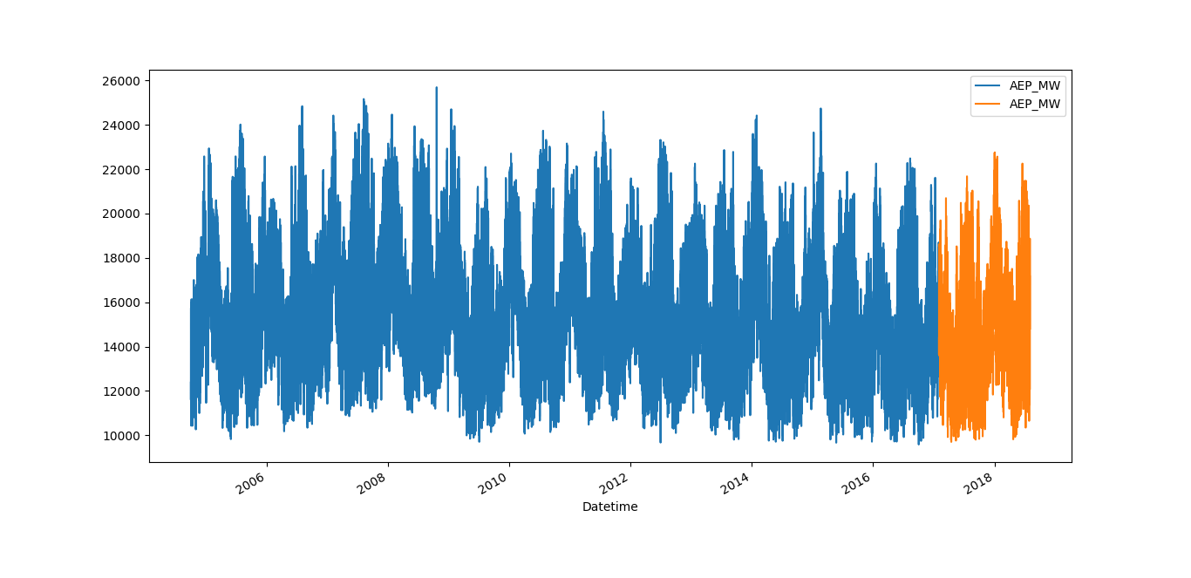

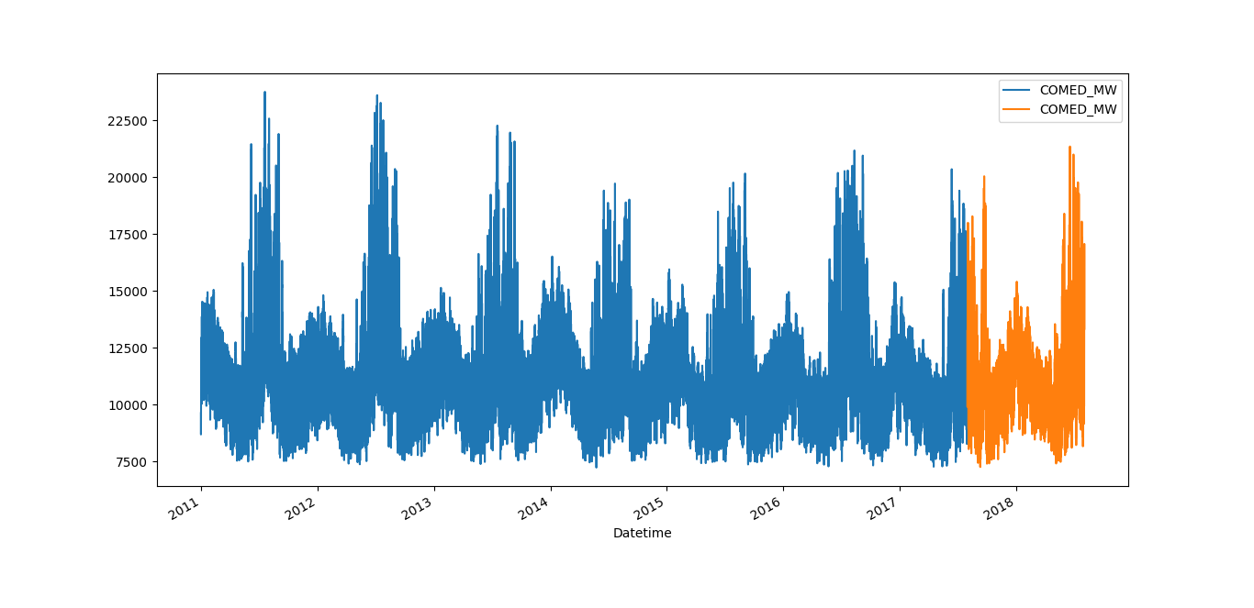

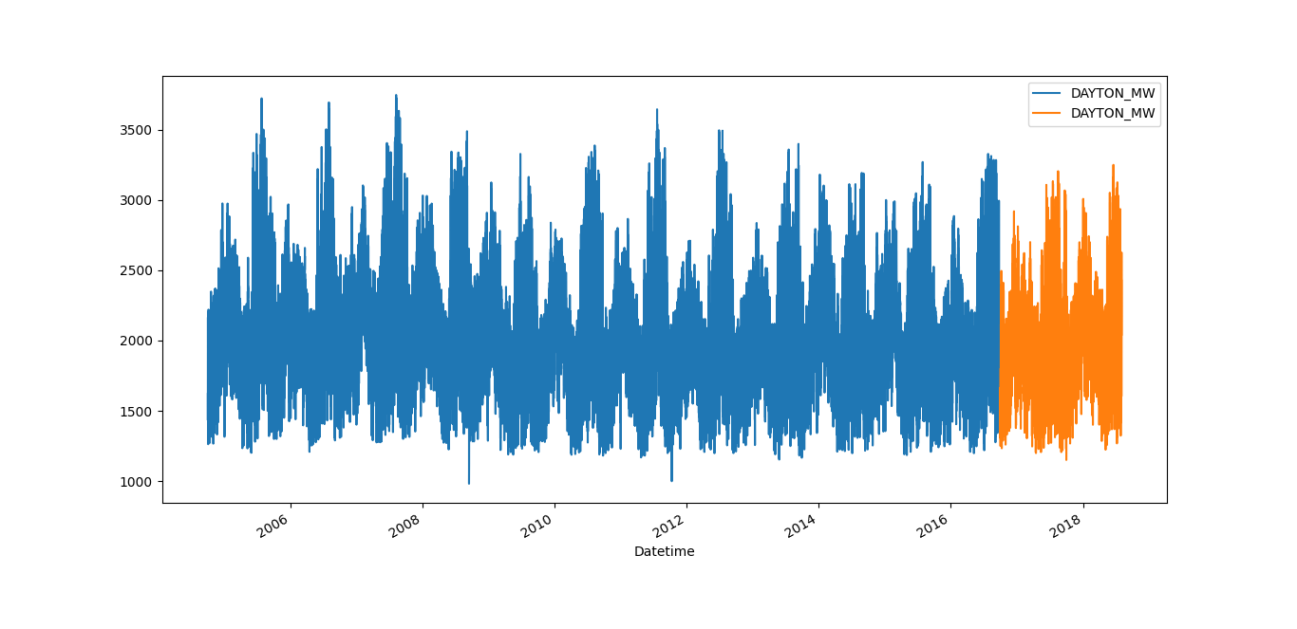

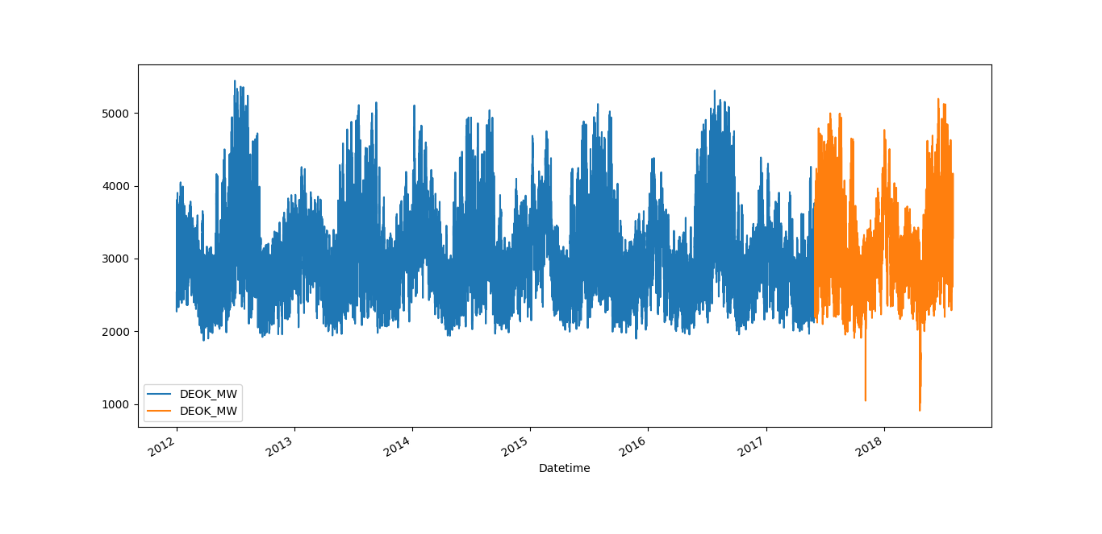

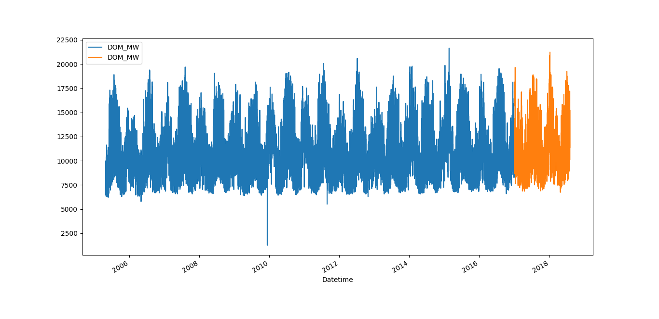

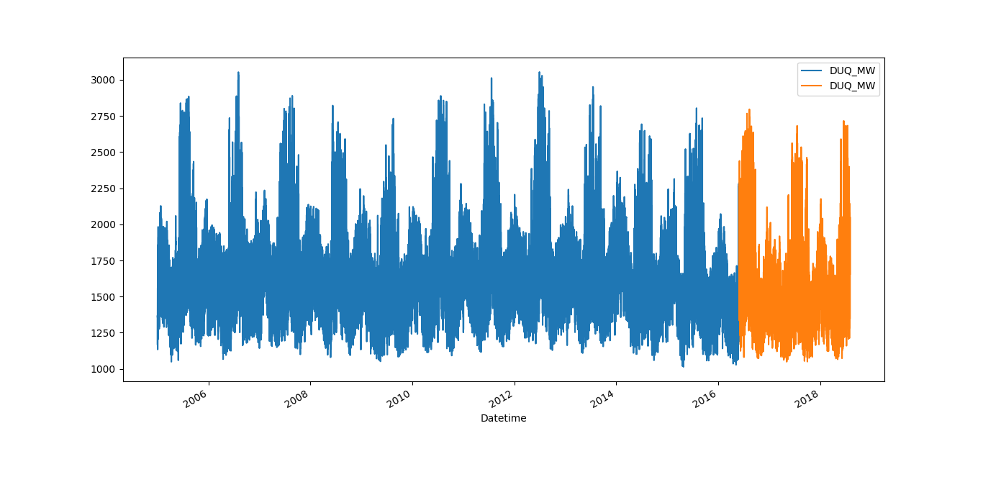

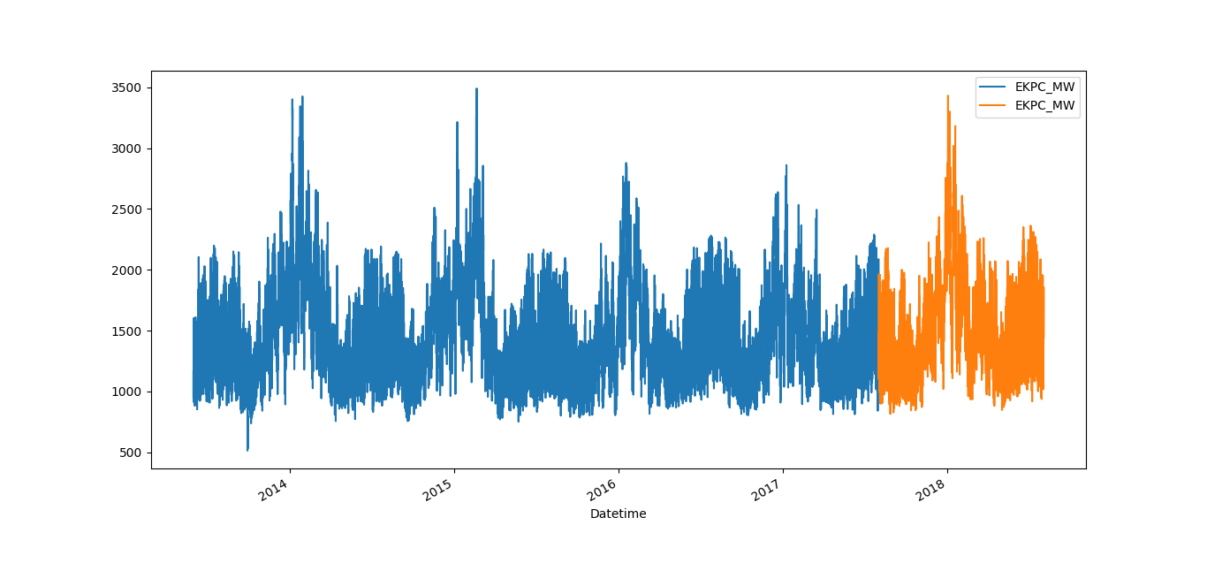

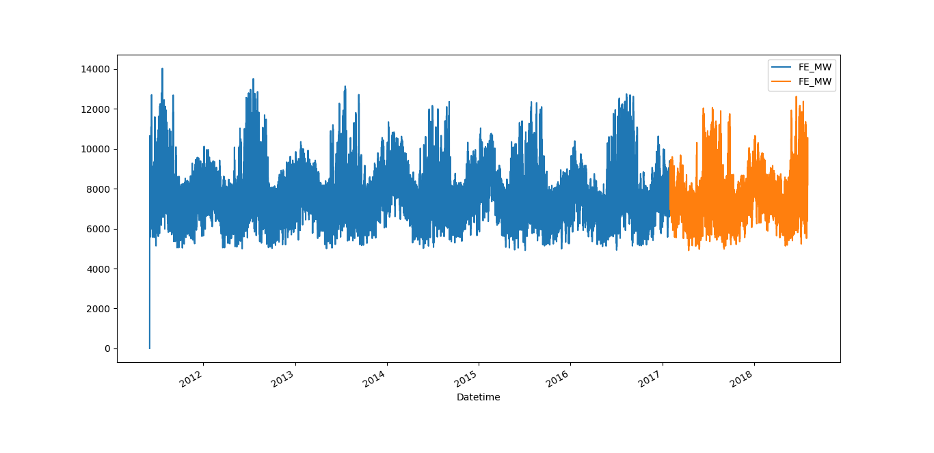

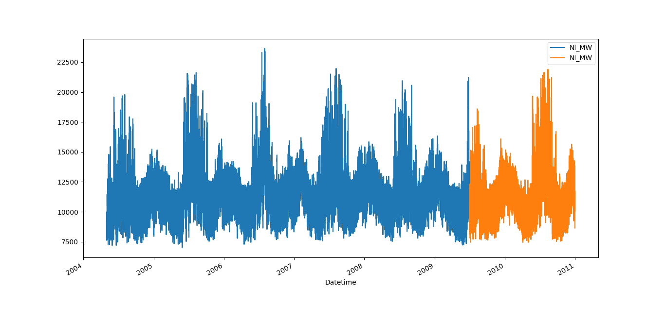

Insights Obtained from Data Visualization:

From our visualization process we noticed that the charts don’t seem to show any gradual increase even when the number of electrical appliances has increased per home.

After analyzing various generations of electrical appliances and their usage we noticed that as time passes even though the number of electrical appliances increases, and so does its efficiency and due to which the graph shows a steady pace instead of gradually rising.

But this is not enough to draw any solid conclusions, hence we must opt for different forms of analysis to obtain some valuable insights.

Feature Extraction:

The little information we gained from visualization is not sufficient to draw many conclusions, so we opt to seaborn library to clearly understand more trends beyond the seasonal ones, the results from feature extraction are shared below.

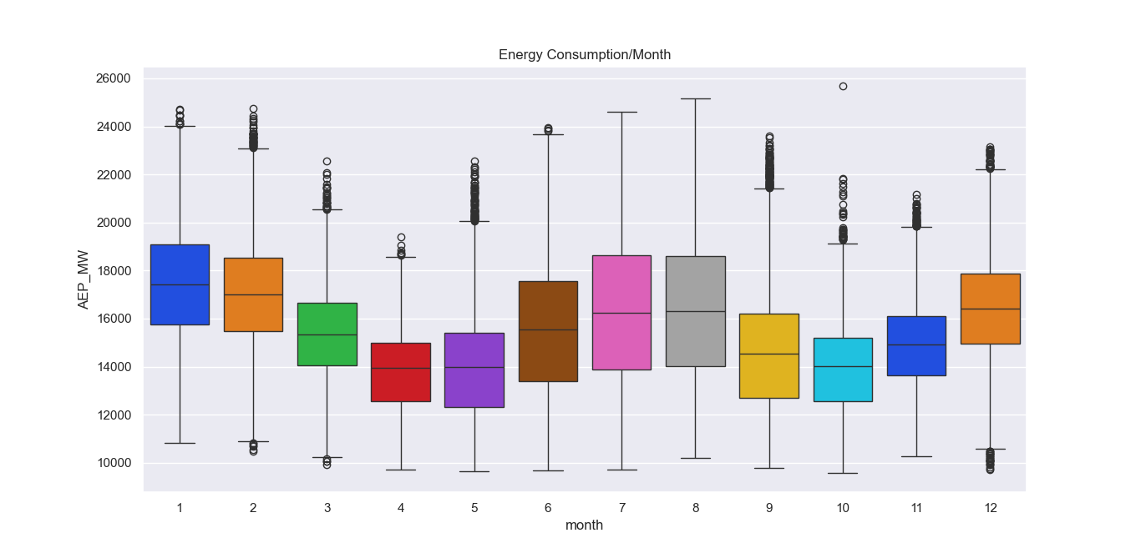

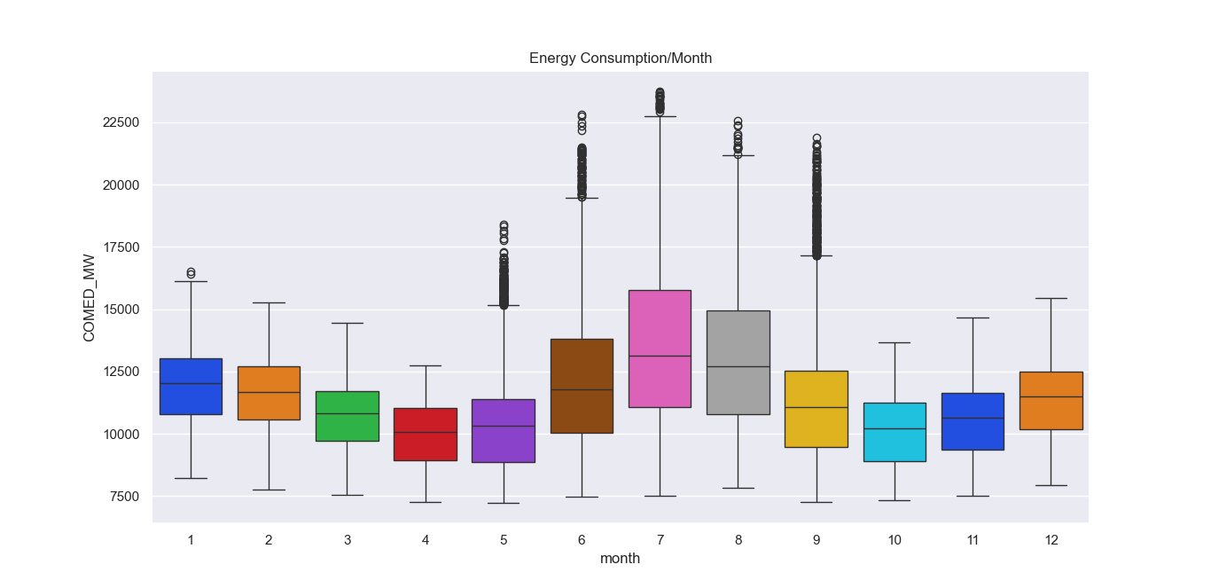

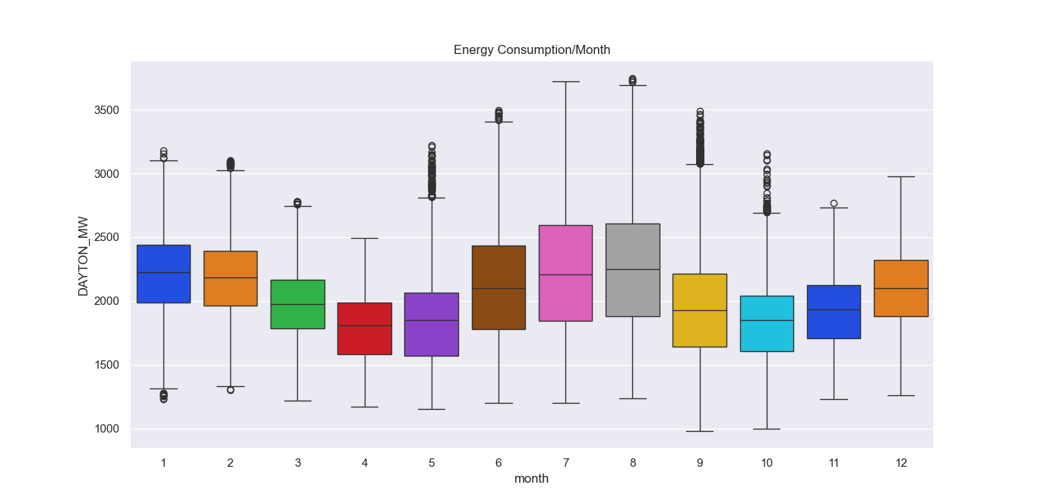

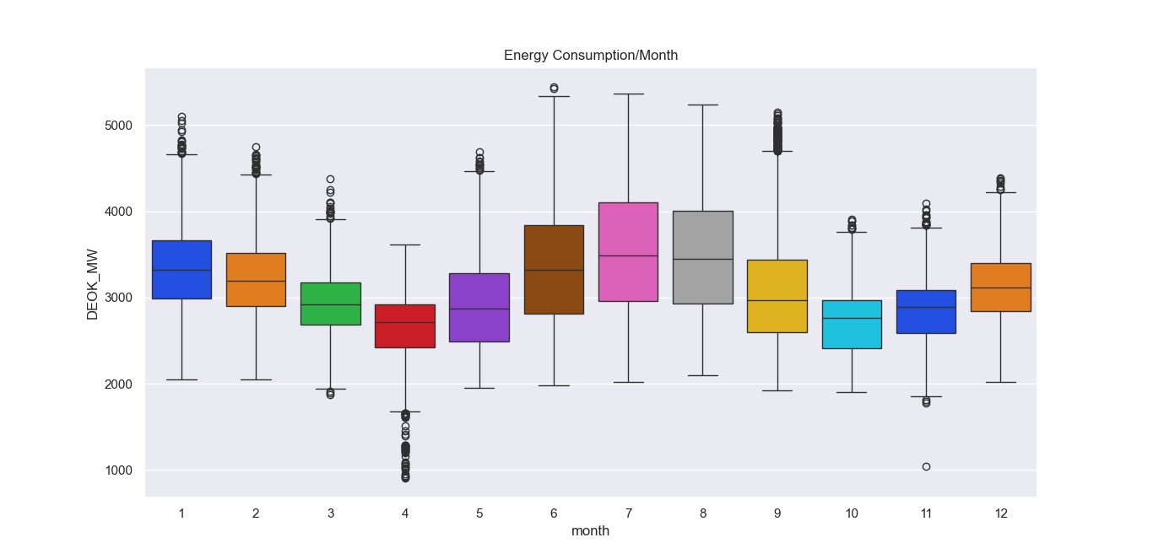

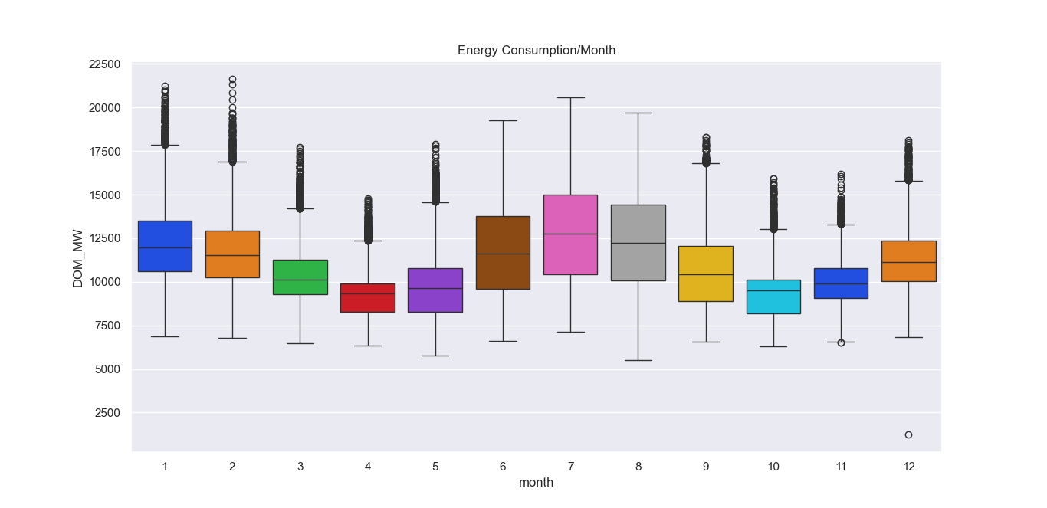

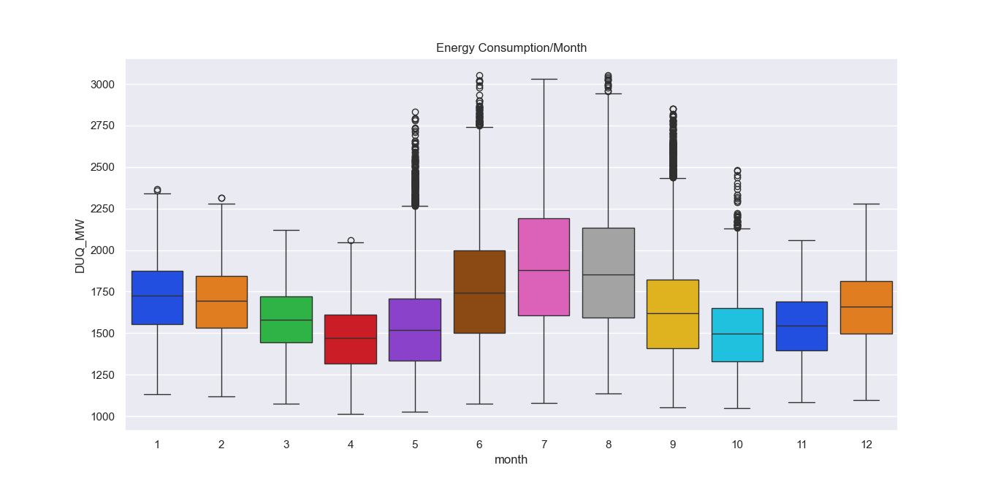

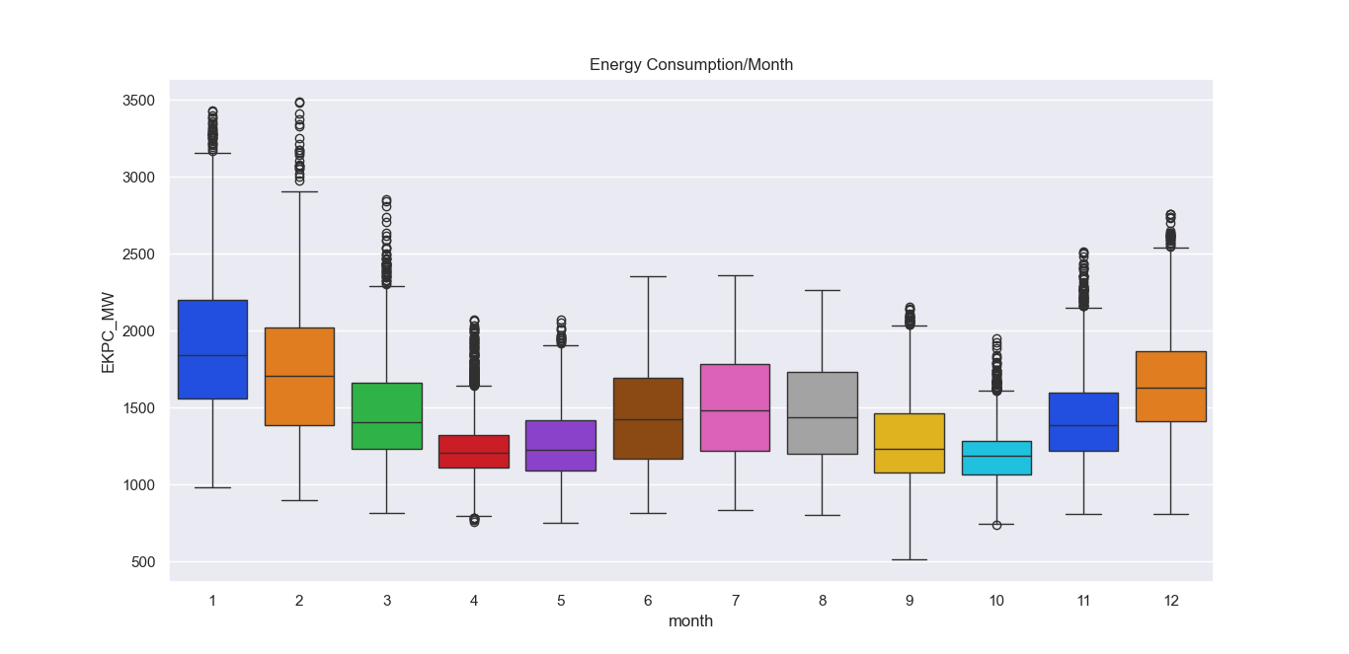

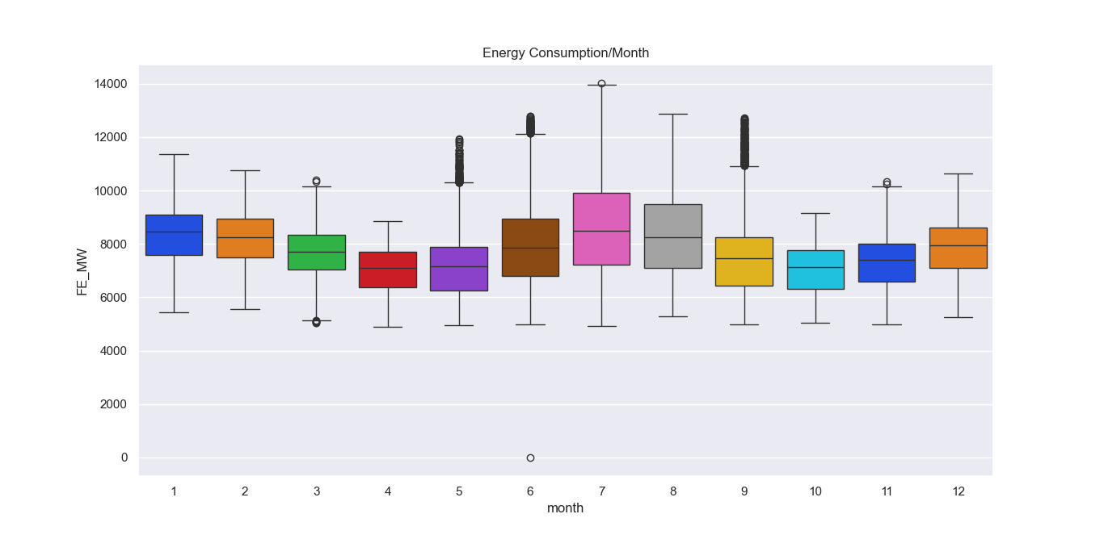

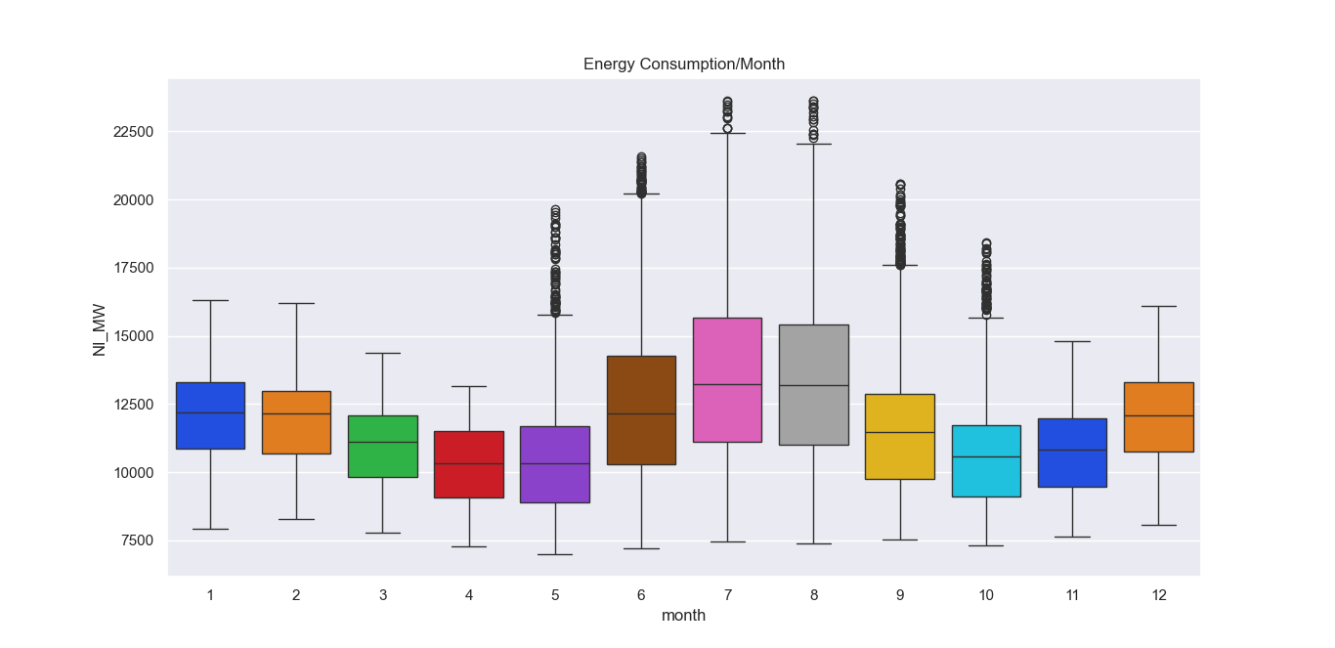

Insights Obtained from Feature Extraction:

From the feature extraction process of the given dataset, we have noticed that the amount of energy used by each city follows a seasonal pattern. The electricity usage is extremely high around the summer, which must be due to the extensive usage of air conditioners.

From that we can conclude that the data follows a seasonal pattern.

Conclusion:

From analyzing the dataset by visualization and feature extraction we can confidently conclude that the dataset follows a seasonal pattern due to the usage of air conditioner in summer season and the graph doesn’t gradually rise due to increase in efficiency of modern electrical appliances.

The python program used for visualization (Visualization.py) and the png files of the obtained charts can be found in my GitHub repository [ReeganAnto-J/4101-AI-Team6-MeasureEnergyConsumption: IBM: AI101 Measure Energy Consumption (github.com)](https://github.com/ReeganAnto-J/4101-AI-Team6-MeasureEnergyConsumption)