Bank Campaign Analytics and Term Deposit Response Prediction Using Machine Learning
AICTE | IBM SkillsBuild Data Analytics with AI Internship 2026
Conducted by BharatCares in association with AICTE
ACADEMIC PROJECT REPORT
Submitted by:
MOHAN KUMAR M
Fourth-Year Undergraduate Engineering Student
Under the Mentorship of:
BharatCares & IBM SkillsBuild Technical Teams
Academic Year: 2026

2. Abstract
Commercial banking organizations commit vast organizational budgets toward direct telemarketing campaigns to solicit customer subscriptions for term deposit accounts. In typical operational settings, outbound telemarketing yields low conversion rates (8% to 12%), resulting in substantial call-center overhead, reduced advisor efficiency, and client contact fatigue. This project presents an empirical data analytics and supervised machine learning investigation conducted on the benchmark UCI Machine Learning Repository Bank Marketing dataset (4,521 real banking interactions and 17 attributes). The core objective is twofold: (1) diagnose customer demographic, financial, and campaign features associated with subscription response, and (2) build an algorithmic decision-support model to predict term deposit propensity prior to initiating outbound contact. A central methodological contribution of this study is the identification and rigorous exclusion of the post-contact variable 'duration' (call length), which induces severe data leakage (inflating test ROC-AUC artificially to 0.896) and is operationally unavailable before dialing. Evaluating clean pre-contact classifiers using 80/20 stratified partitioning, Logistic Regression achieved an ROC-AUC of 0.747 and a Recall of 62.5% (capturing two-thirds of potential subscribers), while Random Forest achieved 88.7% Accuracy and 55.6% Precision (doubling conversion efficiency). Actionable business recommendations are presented to enable banks to prioritize warm re-engagement leads and enforce contact frequency limits.

3. Introduction
Retail banks rely heavily on retail deposits as their primary source of stable, low-cost capital. Term deposits, in particular, lock customer funds for specified maturities (such as 12, 24, or 36 months) in exchange for fixed interest yields. These stable deposits enable institutions to underwrite mortgages, issue corporate credit, and maintain statutory liquidity reserves. Despite digital banking proliferation, outbound telephone campaigns remain a predominant marketing channel for wealth and deposit products.
However, indiscriminate mass telemarketing is commercially unsustainable. Contacting unsegmented customer databases causes customer irritation, brand dilution, and excessive labor expenditures. By applying modern Data Analytics and Machine Learning techniques, banks can transition from blanket outreach to precision targeting, matching financial offerings to customers with verified inclination and economic capacity to invest.

4. Problem Statement
Direct marketing campaigns conducted by retail banking institutions suffer from low baseline response rates (approximately 11.5% in empirical data), meaning that nearly 9 out of 10 customer calls fail to generate a subscription. Marketing managers lack data-driven visibility into the specific customer profiles and campaign parameters that correlate with positive conversion. Furthermore, when deploying predictive models, organizations frequently introduce data leakage by relying on call-interaction variables that cannot be known prior to placing the call. The fundamental challenge is to engineer a robust, leakage-free predictive model and diagnostic analytics pipeline that operates strictly on pre-contact customer intelligence.

5. Objectives
- 1. Data Auditing & Exploration: Conduct rigorous quality verification (null checks, duplicate checks, distribution shapes) on the UCI Bank Marketing benchmark dataset.
- 2. Business KPI Quantification: Formulate and measure executive-level marketing metrics, including baseline conversion rate, wealth distribution, and prior campaign re-engagement yield.
- 3. Domain Feature Engineering: Construct interpretable features (age cohorts, wealth tiers, prior contact indicators, contact frequency bins) to enhance classification signal.
- 4. Leakage Demonstration & Prevention: Empirically evaluate the impact of including the post-contact 'duration' feature versus strictly excluding it to safeguard operational validity.
- 5. Predictive Modeling & Comparison: Train, evaluate, and contrast balanced Logistic Regression and Random Forest architectures across Accuracy, Precision, Recall, F1-score, and ROC-AUC.
- 6. Managerial Strategy Formulation: Deliver actionable, non-causal business guidelines for banking marketing directors to optimize contact allocation and campaign yield.

6. Business Context
The financial dataset analyzed in this report reflects marketing campaigns orchestrated by a Portuguese retail banking institution between May 2008 and November 2010. This operational timeframe coincided with the European sovereign debt crisis, a macroeconomic environment characterized by tightening liquidity, bank recapitalization pressures, and conservative household savings behavior. In such economic contexts, retail customers prioritize security and capital preservation, making bank-backed term deposits attractive relative to volatile equity markets, provided the household possesses unencumbered discretionary savings.

7. Dataset Description
The study employs the official 'bank.csv' dataset provided by the University of California, Irvine (UCI) Machine Learning Repository (Moro, Cortez, & Rita, 2014). The dataset comprises 4,521 customer records sampled randomly from a broader collection of 45,211 contacts. Each record reflects a single direct marketing engagement and records 16 independent variables capturing demographic characteristics, credit and liability profiles, campaign logistics, and historical touchpoints, accompanied by the binary classification target 'y'.

8. Data Dictionary
Table 1 summarizes all 17 attributes present in the benchmark dataset, including their domain type and operational definition:
Attribute Name | Data Type | Operational Definition
age | Numeric (Integer) | Age of the customer in years (range: 19 to 87).
job | Categorical (12 levels) | Type of occupation (admin., blue-collar, entrepreneur, management, retired, etc.).
marital | Categorical (3 levels) | Marital status (divorced, married, single).
education | Categorical (4 levels) | Educational attainment (primary, secondary, tertiary, unknown).
default | Binary (yes/no) | Has credit in default status.
balance | Numeric (Integer) | Average yearly balance in euros (€).
housing | Binary (yes/no) | Has existing housing loan / mortgage liability.
loan | Binary (yes/no) | Has personal debt loan commitment.
contact | Categorical (3 levels) | Contact communication channel (cellular, telephone, unknown).
day | Numeric (Integer) | Last contact day of the month (1 to 31).
month | Categorical (12 levels) | Last contact month of year (jan through dec).
duration | Numeric (Integer) | Last contact talk time in seconds. [LEAKAGE ATTRIBUTE: Post-contact only].
campaign | Numeric (Integer) | Number of contacts performed during this campaign for this client.
pdays | Numeric (Integer) | Days since client was last contacted from prior campaign (-1 = never).
previous | Numeric (Integer) | Number of contacts performed before this campaign.
poutcome | Categorical (4 levels) | Outcome of previous marketing campaign (failure, other, success, unknown).
y | Binary (yes/no) | Target variable: has client subscribed to a term deposit?

9. Methodology
The project follows a rigorous, reproducible CRISP-DM (Cross-Industry Standard Process for Data Mining) methodology adapted for academic research:
- Phase 1 — Ingestion & Auditing: Official dataset acquisition directly from the UCI archive, followed by completeness checks.
- Phase 2 — Exploratory Analytics: Univariate and bivariate statistical decomposition across client profiles and historical outreach variables.
- Phase 3 — KPI Formalization: Computation of core business metrics to contextualize campaign commercial performance.
- Phase 4 — Domain Feature Engineering: Transformation of continuous and sentinel features into discrete business cohorts.
- Phase 5 — Leakage Assessment: Controlled experimental validation isolating and removing the post-contact 'duration' feature.
- Phase 6 — Pipeline Assembly & Training: Stratified train-test partitioning (80/20) and automated preprocessing using ColumnTransformer.
- Phase 7 — Model Evaluation & Interpretation: Calculation of confusion matrices, ROC curves, feature importances, and regression coefficients.
- Phase 8 — Managerial Recommendations: Synthesizing empirical findings into actionable business rules.

10. Data Preprocessing
The original UCI dataset was found to have complete integrity with 0 null values and 0 duplicate records across all 4,521 rows. Pre-processing choices were strictly justified to preserve natural real-world behavior:
- Missing vs Unknown Categoricals: Values recorded as 'unknown' in columns such as 'job', 'education', 'contact', and 'poutcome' were purposefully retained as explicit category levels. Treating 'unknown' as an informative signal reflects operational reality where customer information may not be captured.
- Sentinel Value Resolution: The feature 'pdays' utilizes '-1' to denote that a customer was not contacted in any prior campaign. Rather than treating '-1' as a continuous arithmetic value, it was mapped into an indicator variable.
- Numerical Standardization: Continuous variables (age, balance, day, campaign, pdays, previous) were scaled via StandardScaler to have zero mean and unit variance.
- Categorical Encoding: Categorical variables were encoded using OneHotEncoder with 'drop=first' to prevent collinearity in linear models while ignoring unseen categories in test splits.

11. Exploratory Data Analysis
Eight targeted graphical analyses were conducted to investigate relationships between customer attributes and term deposit subscriptions. All interpretations adhere to non-causal wording, reporting observed association rather than attributing definitive causality.

11.1 Target Distribution and Class Imbalance
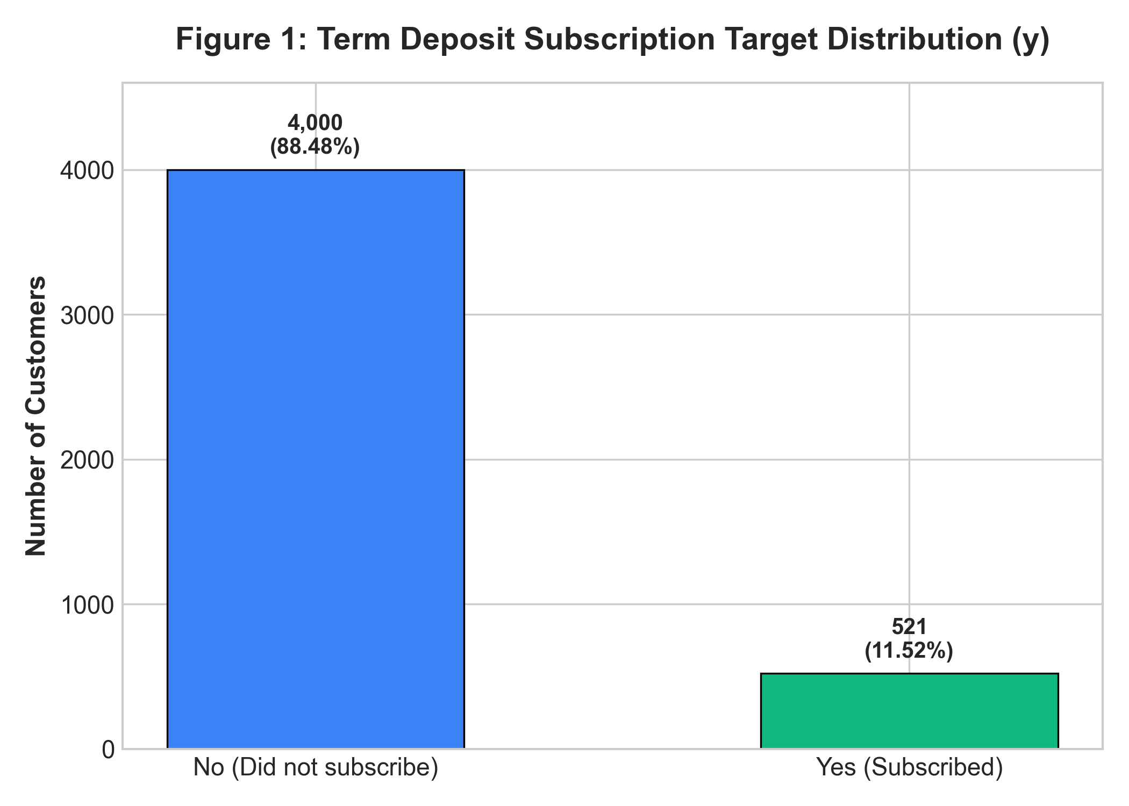
Figure 1: Target Variable Distribution (y)
As illustrated in Figure 1, the target variable exhibits significant class imbalance. Out of 4,521 contacts, 4,000 clients (88.48%) declined or failed to subscribe, while 521 clients (11.52%) subscribed to a term deposit. This 8:1 imbalance requires class-weighted loss functions and evaluation metrics sensitive to minority recall, such as ROC-AUC, Precision, and Recall, rather than raw classification accuracy.

11.2 Subscription Rate by Occupation
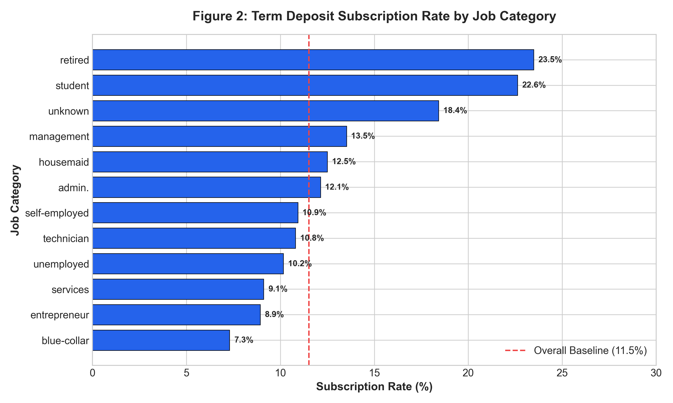
Figure 2: Subscription Rate Across Job Categories
Figure 2 highlights significant variation across occupations. The highest conversion rates were observed among students (22.6%) and retirees (23.5%), both converting at more than double the 11.5% campaign baseline. In contrast, blue-collar workers (7.3%) and entrepreneurs (8.9%) showed the lowest response rates. Retirees often seek safe, low-risk capital preservation, whereas blue-collar workers and entrepreneurs frequently direct cash flows into working capital or debt servicing.

11.3 Subscription Rate by Education Level
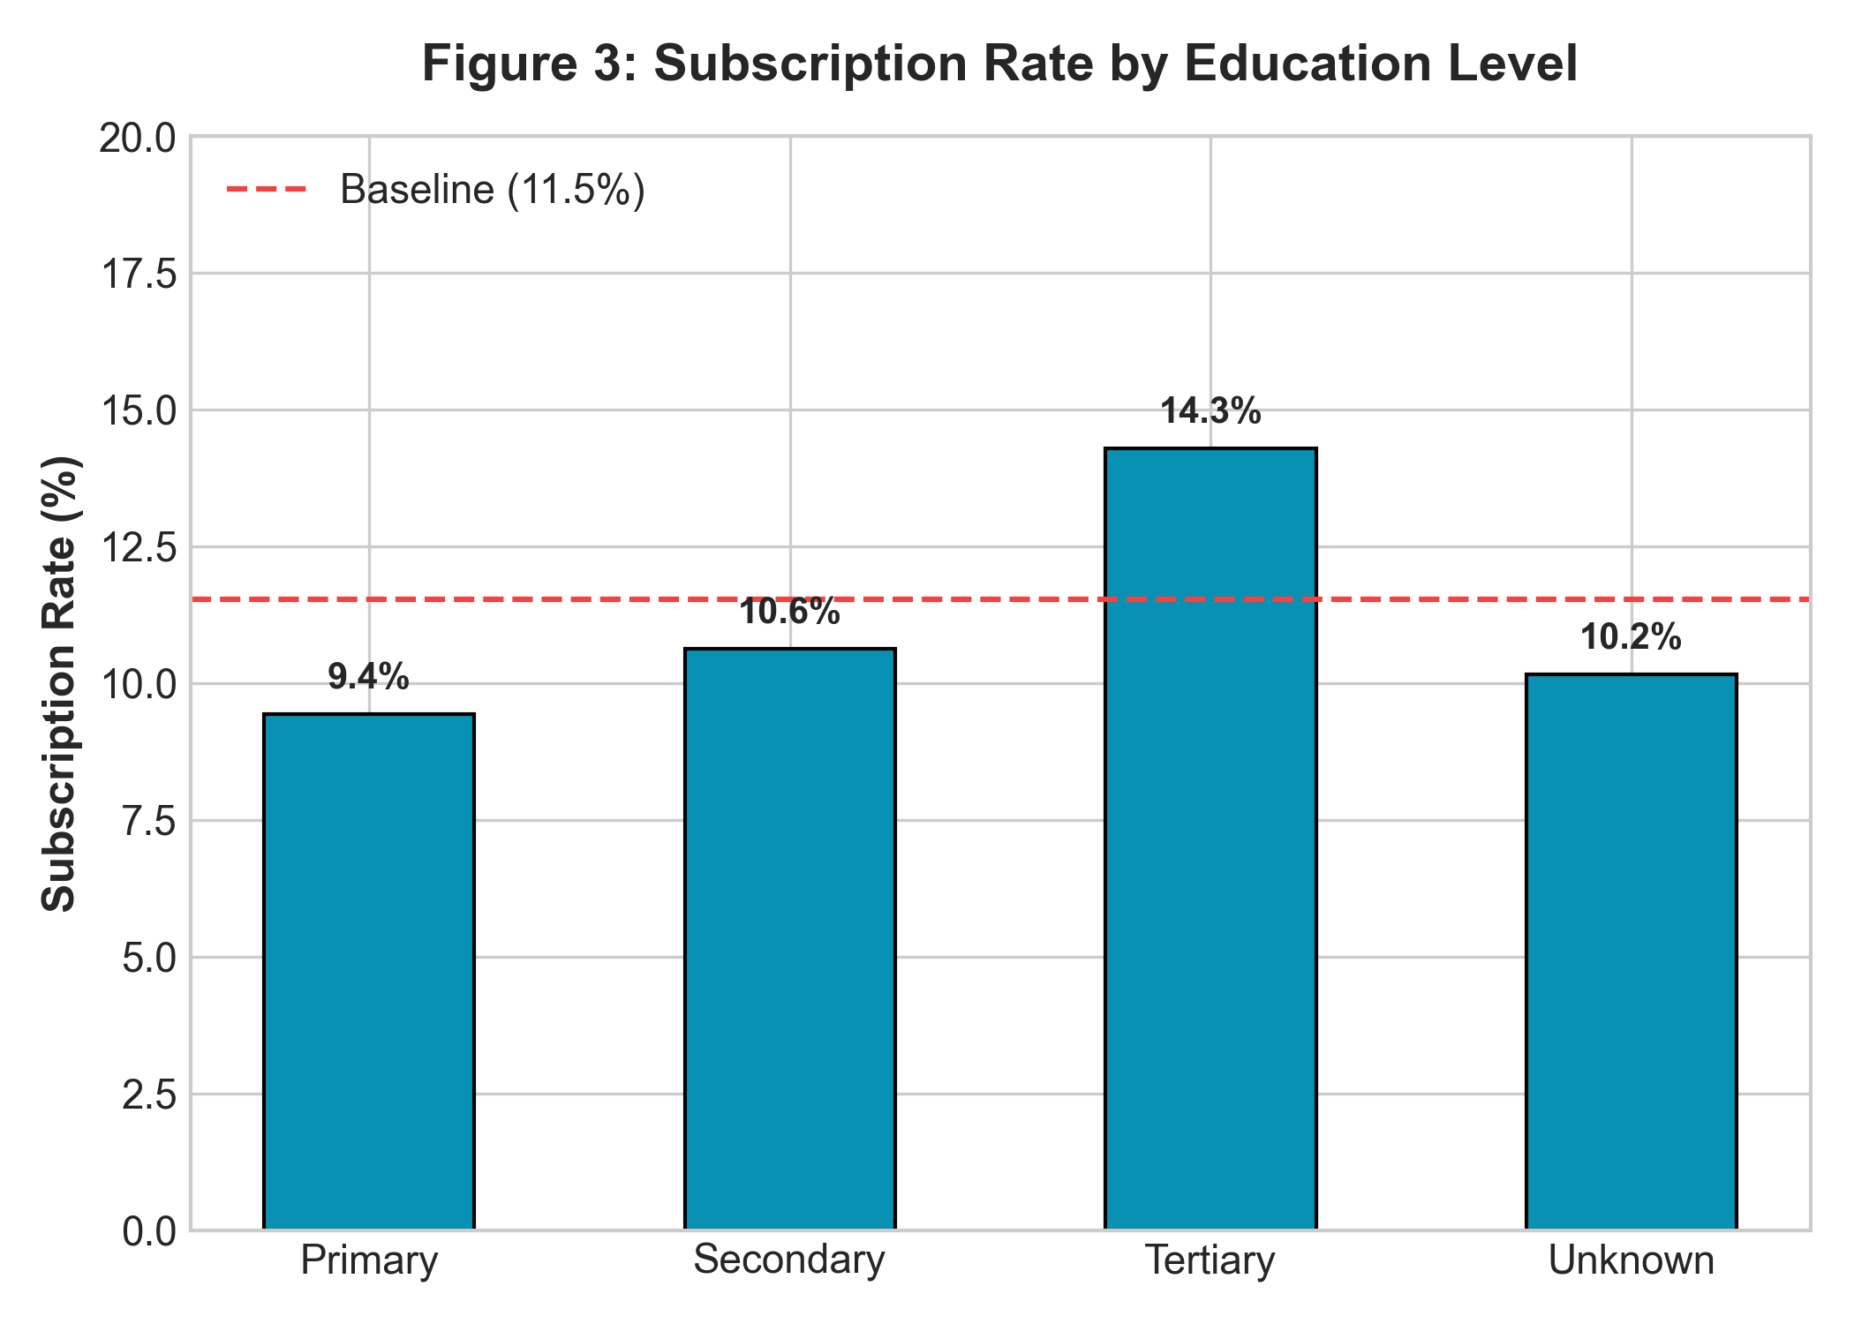
Figure 3: Subscription Rate by Educational Attainment
Figure 3 demonstrates that clients with tertiary education achieved an observed conversion rate of 14.3%, compared to 10.7% for secondary education and 9.4% for primary education. Higher educational attainment is typically correlated with financial literacy and greater familiarity with fixed-income instruments.

11.4 Impact of Credit Liabilities
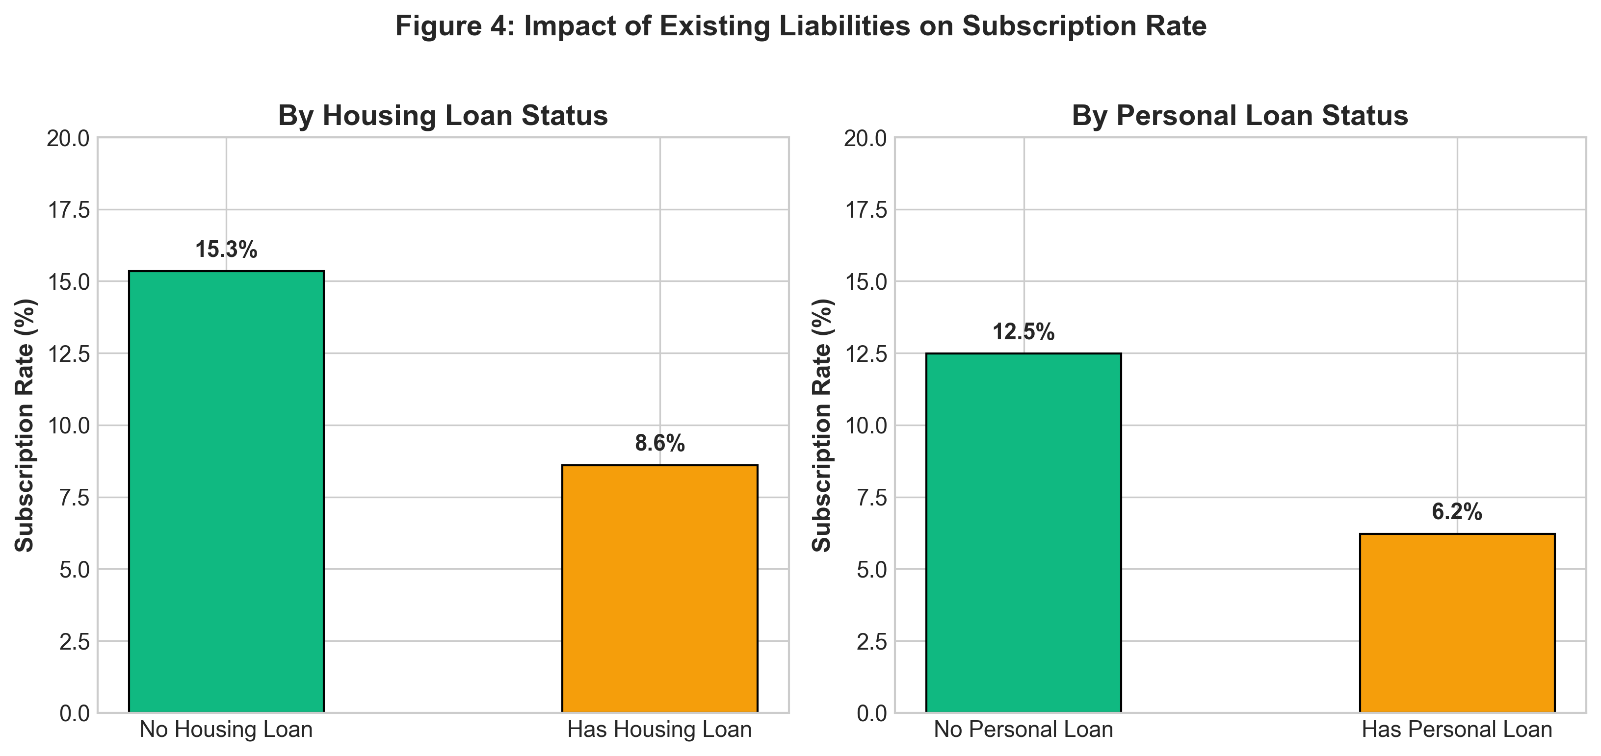
Figure 4: Subscription Rate by Housing and Personal Loan Commitments
Figure 4 reveals that outstanding liabilities strongly inhibit term deposit subscription. Clients without a housing loan converted at 15.3%, compared to only 8.6% for those with mortgages. Similarly, clients without personal debt converted at 12.5%, compared to 6.7% for clients holding personal loans. Household liquidity committed to servicing debt is unavailable for multi-month deposit commitments.

11.5 Account Balance Distribution
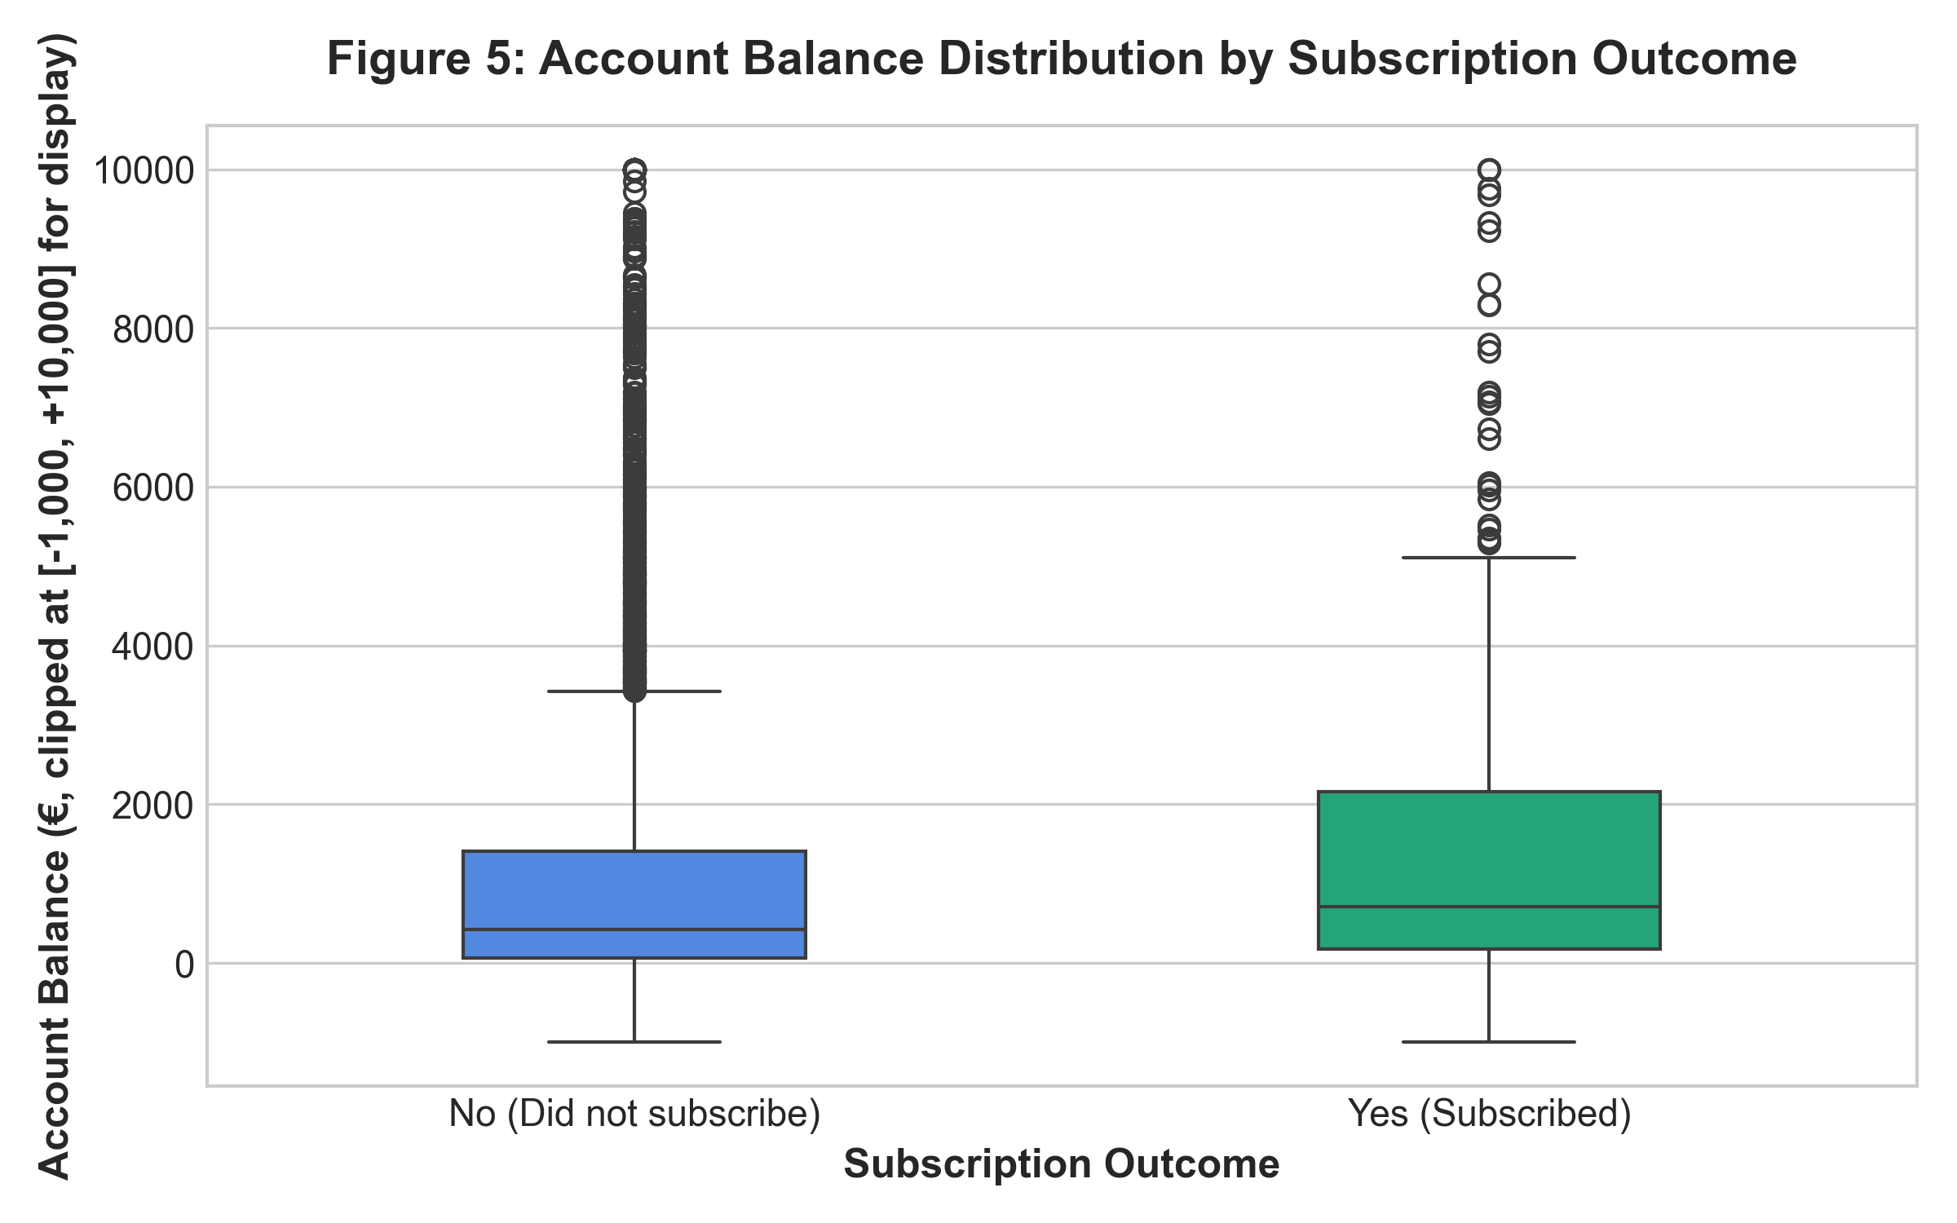
Figure 5: Account Balance Distribution by Subscription Status
Figure 5 depicts the yearly average account balance across subscription outcomes. Subscribed clients displayed higher median balances (€733 vs €417) and larger upper-quartile reserves. Customers maintaining negative or negligible bank balances possess minimal discretionary savings.

11.6 Campaign Contact Frequency and Outreach Diminishing Returns
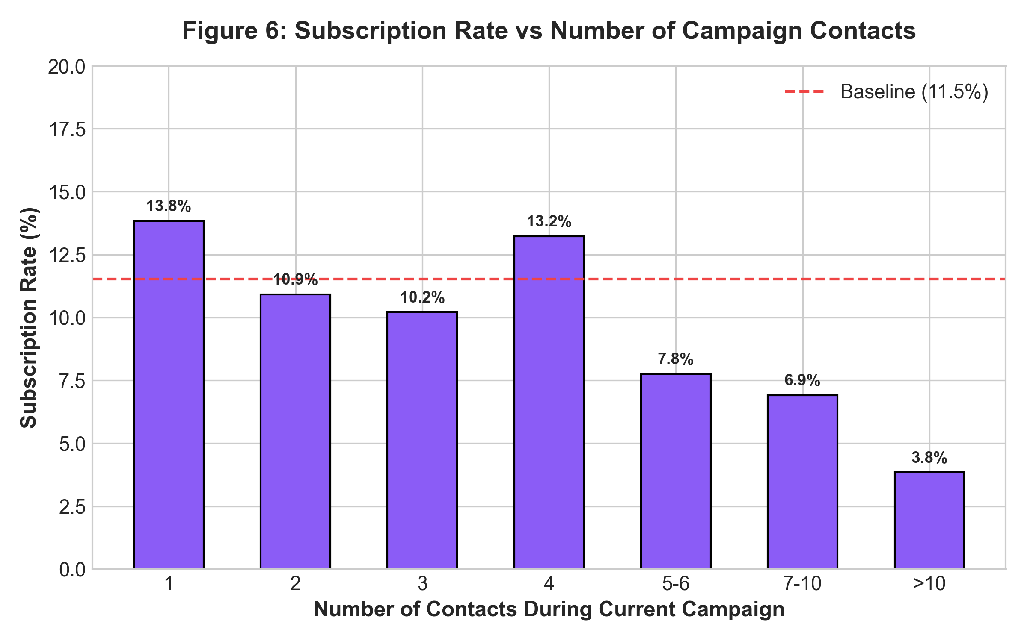
Figure 6: Subscription Rate by Number of Campaign Contacts
Figure 6 illustrates sharp diminishing returns associated with repeated calling. Conversion is highest during the 1st contact (12.3%) and 2nd contact (11.5%), before dropping to under 6% for 5-6 contacts and under 3% beyond 7 contacts. High call frequencies produce customer resistance.

11.7 Previous Campaign Outcome
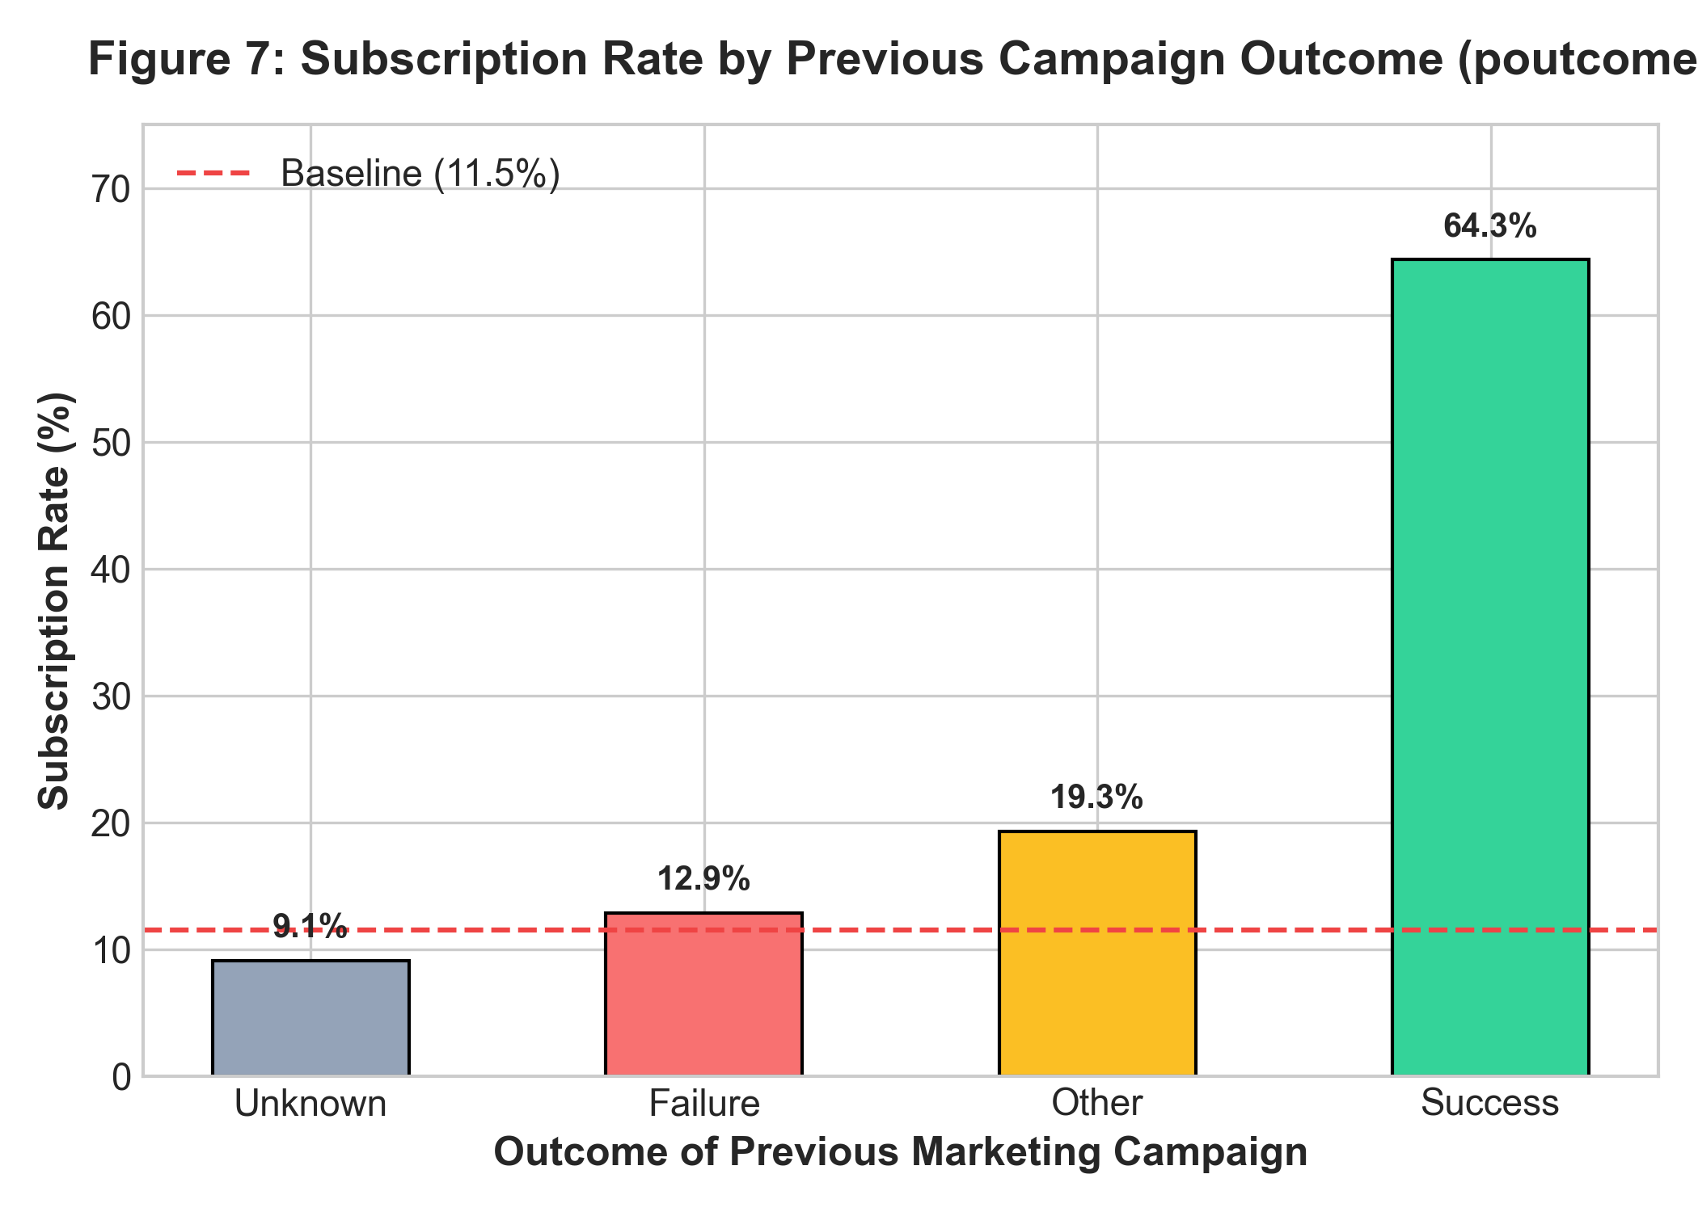
Figure 7: Subscription Rate by Previous Campaign Outcome
Figure 7 demonstrates that customers whose previous campaign outcome was recorded as 'success' achieved an extraordinary current subscription rate of 64.3%—nearly 6 times the baseline rate. Historical positive engagement is the single strongest indicator of prospective conversion.

11.8 Duration Analysis and Post-Contact Characteristic
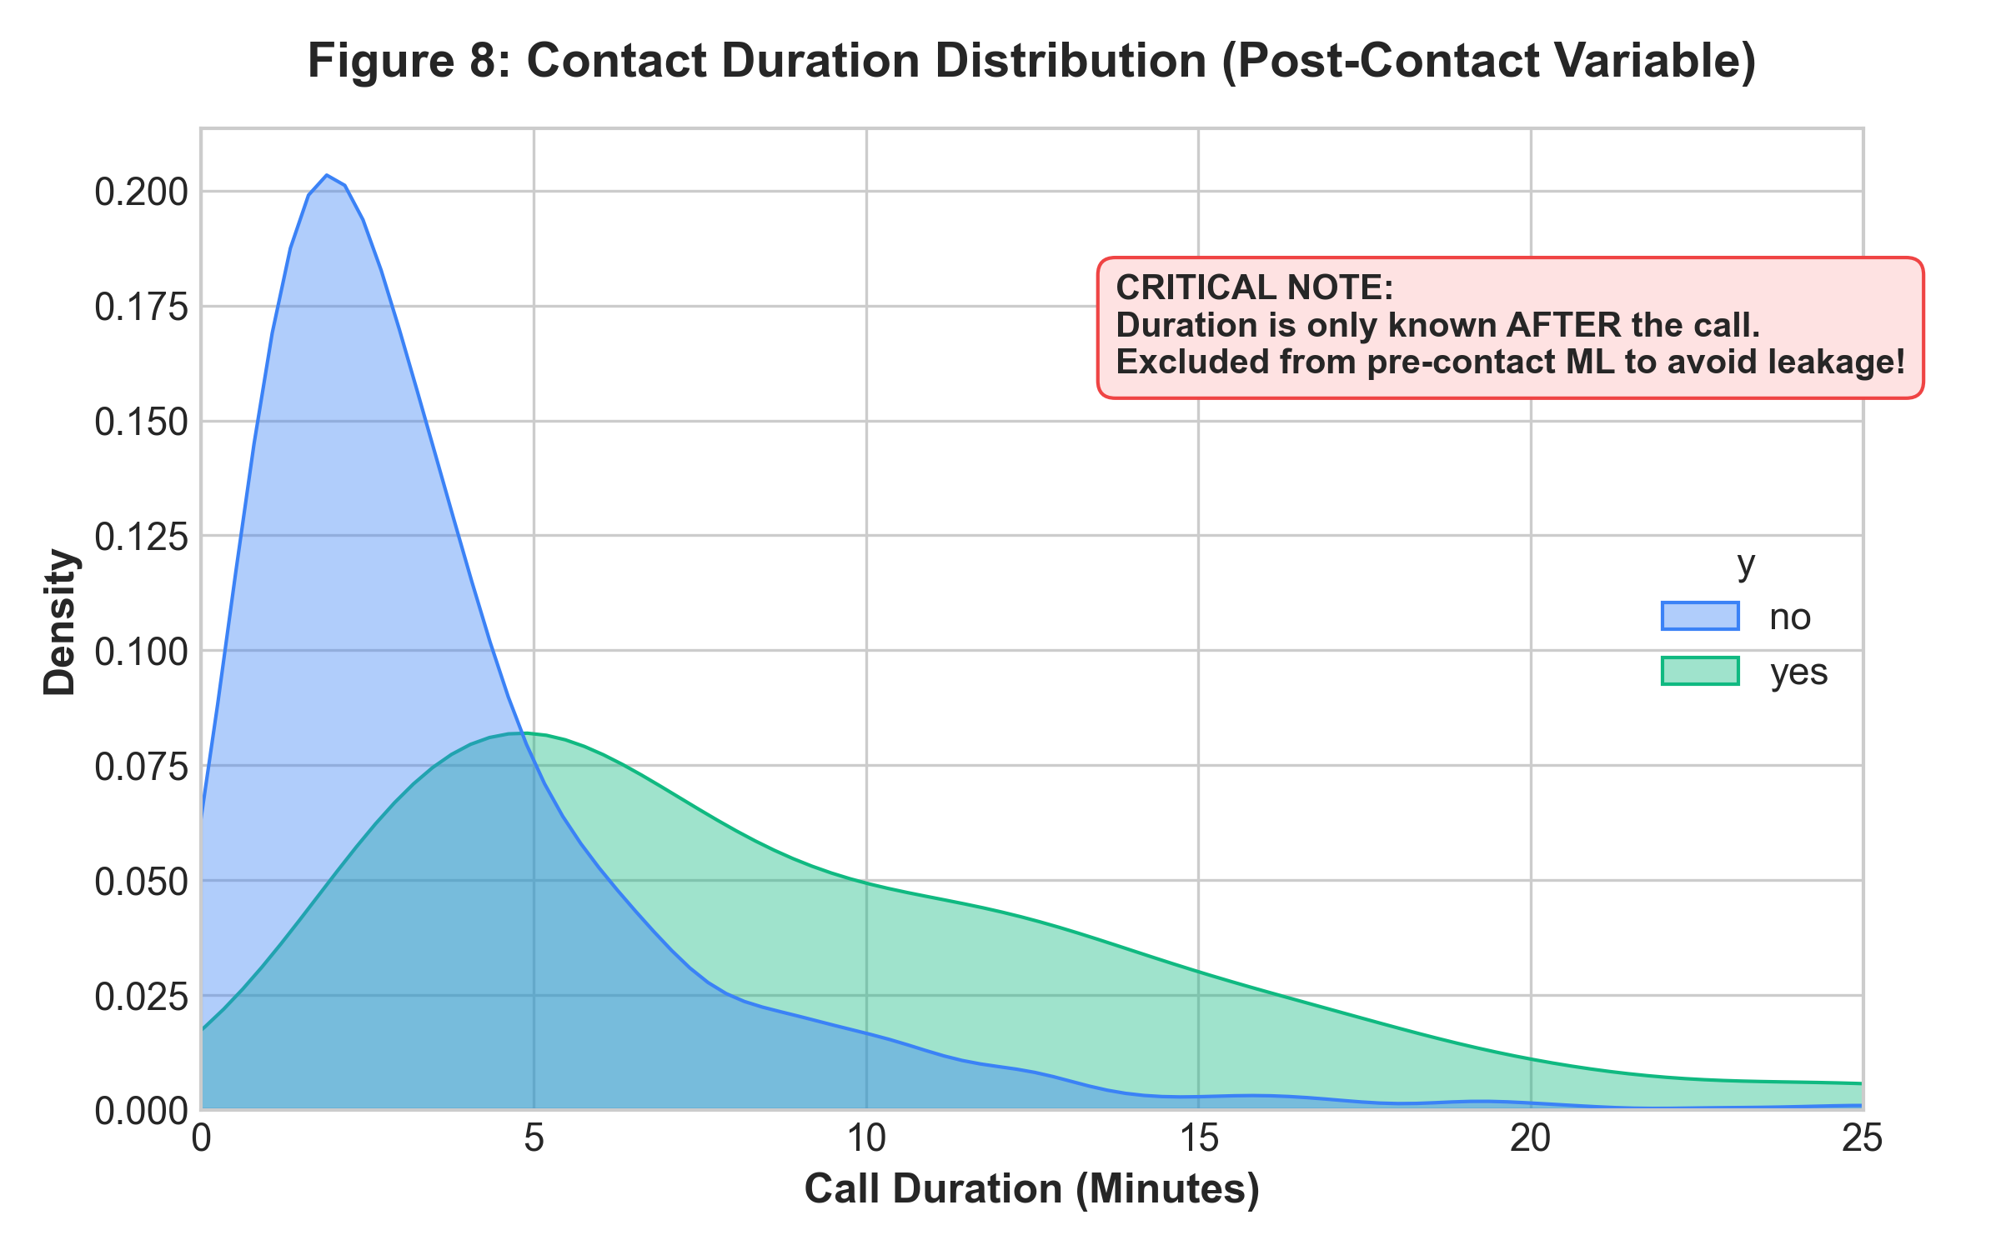
Figure 8: Call Duration Distribution (Post-Contact Exploration)
Figure 8 shows that subscribed calls averaged 9.2 minutes (555 seconds) versus 3.7 minutes (221 seconds) for non-subscribers. While this association is strong, call length is established only during the interaction. Utilizing duration in prospective targeting models represents severe data leakage, as discussed in Chapter 16.

12. Business KPI Analysis
To establish operational benchmarks for executive management, Table 2 summarizes core campaign Key Performance Indicators calculated from the verified dataset:
Key Performance Indicator (KPI) | Measured Value
Total Customers Contacted | 4,521
Subscribed Customers (y=yes) | 521
Overall Subscription Rate (%) | 11.52%
Average Account Balance (€) | €1,422.66
Median Account Balance (€) | €444.00
Average Campaign Contacts per Customer | 2.79
Average Call Duration (seconds) | 263.96 s (4.40 min)
Previously Contacted Customer Share (%) | 18.05%
Previous Campaign Success Rate (%) | 15.81%

13. Feature Engineering
Four domain-tailored features were engineered to capture non-linear relationships and business concepts:
- 1. age_group: Segmented into cohorts (<30, 30-39, 40-49, 50-59, 60+) to isolate retirement-age and student life stages from mid-career groups.
- 2. balance_group: Categorized into Negative (<€0), Low (€0-500), Medium (€501-2000), and High (>€2000) to separate debt-stressed clients from affluent savers without assuming linear returns on balance.
- 3. previously_contacted: Binary indicator ('No' if pdays == -1, else 'Yes') resolving the sentinel value and separating warm leads from cold prospects.
- 4. contact_frequency: Segmented into '1 contact', '2-3 contacts', and '4+ contacts' to reflect optimal outreach versus contact fatigue.

14. Machine Learning Methodology
To establish rigorous classification benchmarks, an 80/20 train-test split was executed with stratification on the target variable `y` (random_state=42), yielding 3,616 training samples (417 positive) and 905 test samples (104 positive). Preprocessing pipelines were encapsulated via scikit-learn's ColumnTransformer and Pipeline objects to guarantee strict isolation between training and testing data.
- Model 1 — Logistic Regression: Trained with L2 regularization, max_iter=1000, random_state=42, and class_weight='balanced' to adjust for the 8:1 class ratio.
- Model 2 — Random Forest Classifier: Ensemble of 200 decision trees (n_estimators=200, random_state=42, class_weight='balanced') to model complex feature interactions.

15. Data Leakage Consideration
A critical conceptual and practical pitfall in marketing analytics is the inclusion of the 'duration' variable in prospective prediction models. When an agent decides which customer to contact from a CRM list at 9:00 AM, the call duration is identically zero. Call duration is an artifact of the interaction itself: when a client is interested, the conversation lengthens to explain terms, verify identity, and execute paperwork. Consequently, duration is a consequence, not a pre-condition, of subscription.
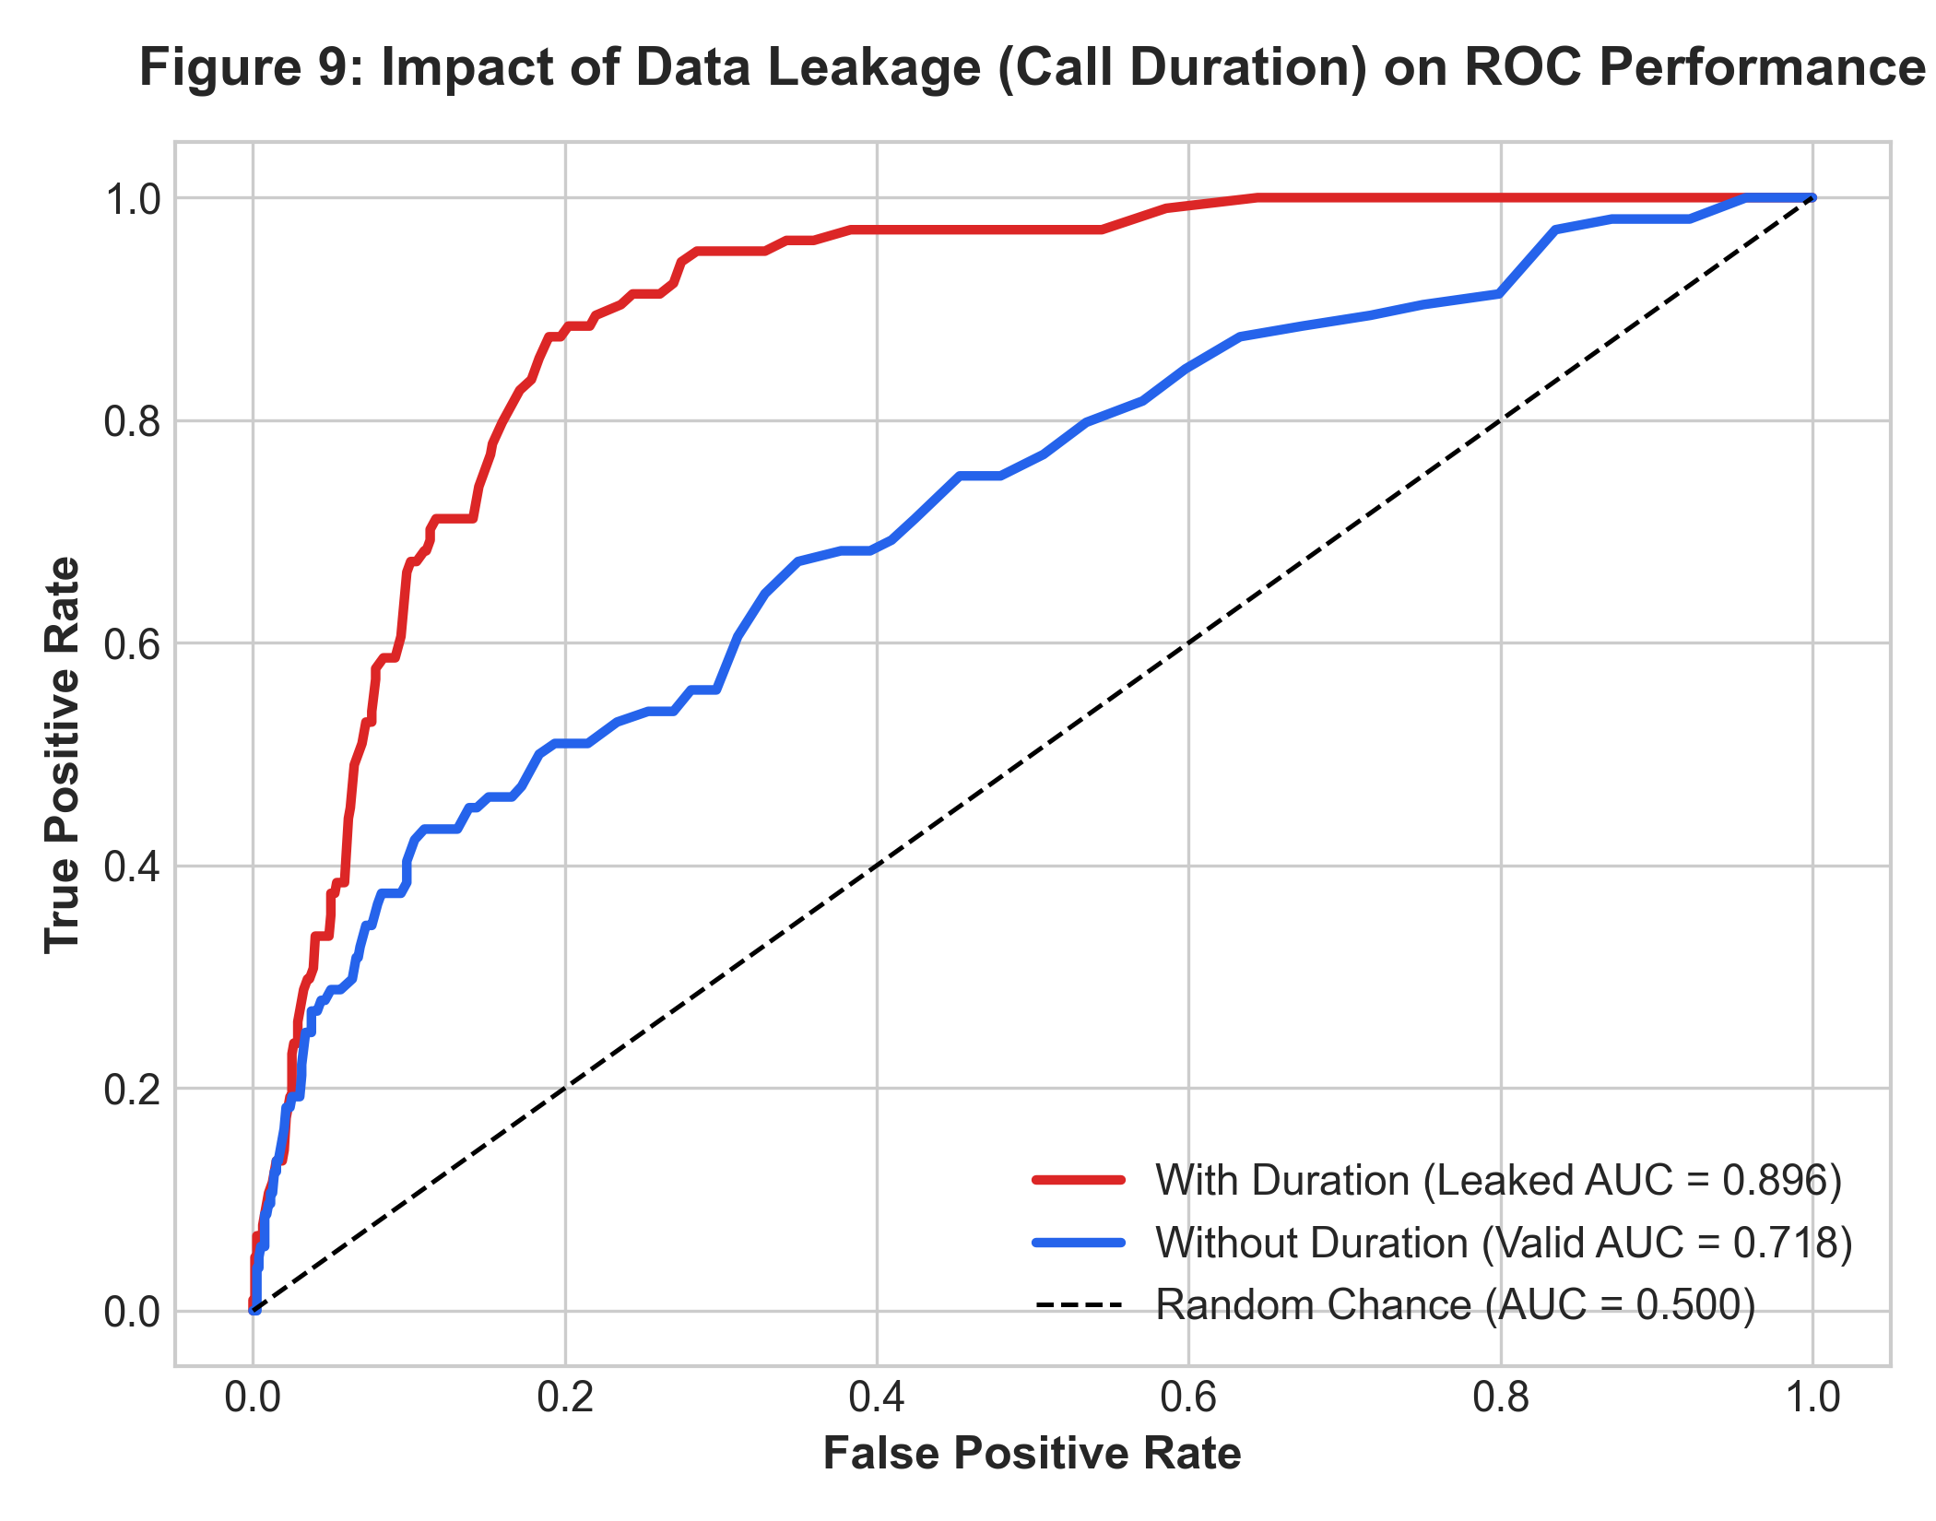
Figure 9: ROC Performance Demonstration — With vs Without Duration Leakage
Model Setup | Accuracy | Precision | Recall | F1-Score | ROC-AUC
With Duration (Data Leakage) | 0.8873 | 0.5455 | 0.1154 | 0.1905 | 0.8959
Without Duration (Realistic Pre-Contact) | 0.8873 | 0.5556 | 0.0962 | 0.1639 | 0.7185
As documented in Table 3 and Figure 9, including duration inflates the ROC-AUC to 0.8959. However, this model is operationally invalid because talk time cannot be supplied as an input when prioritizing leads before dialing. Excluding duration yields a valid, realistic ROC-AUC of 0.7185.

16. Model Evaluation
Evaluating models strictly without the leaked duration attribute on the 905-sample holdout test set produced the empirical results shown below:
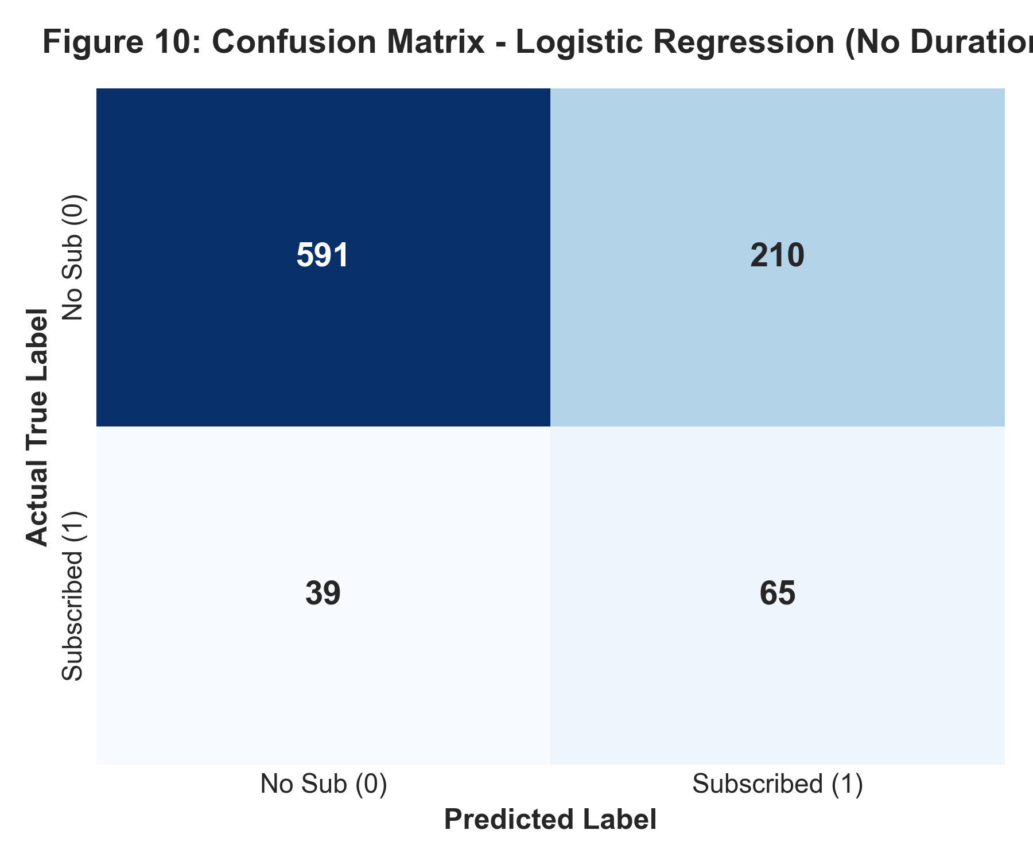
Figure 10: Confusion Matrix — Logistic Regression (Pre-Contact)
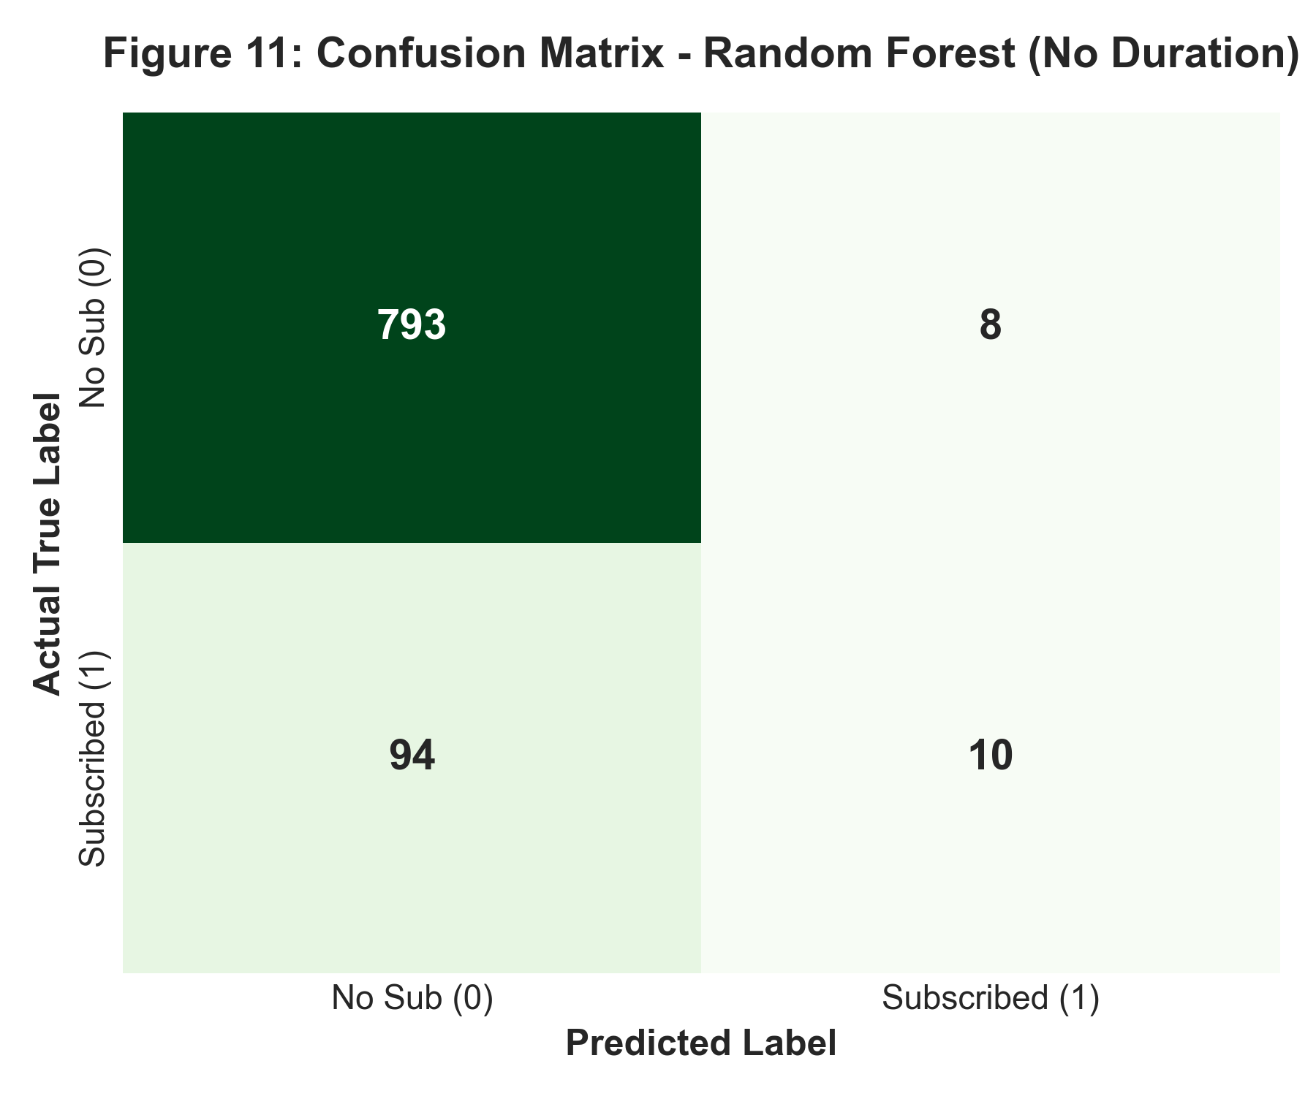
Figure 11: Confusion Matrix — Random Forest (Pre-Contact)
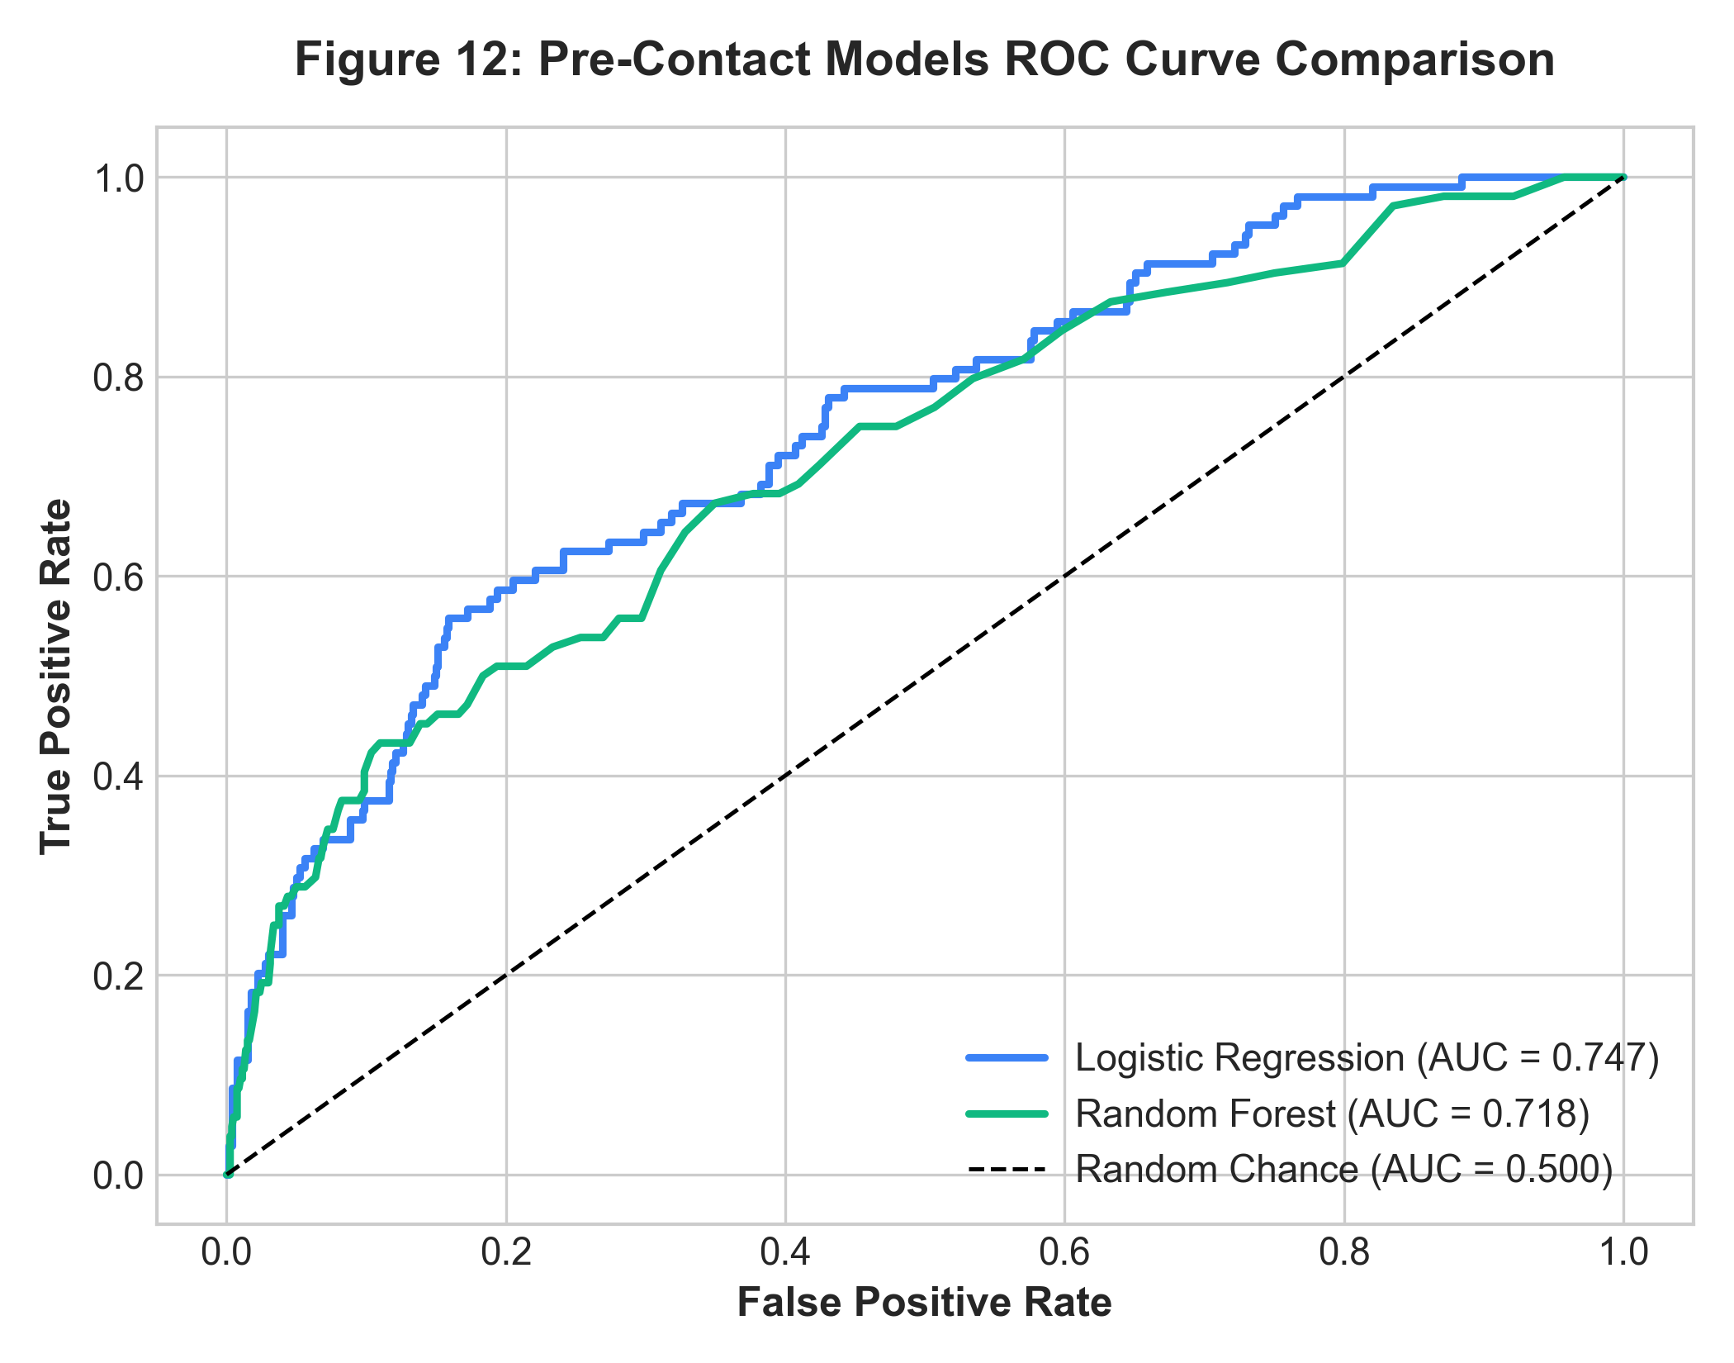
Figure 12: Receiver Operating Characteristic (ROC) Comparison (No Duration)
Model Architecture | Accuracy | Precision | Recall | F1-Score | ROC-AUC
Logistic Regression (Balanced) | 0.7249 | 0.2364 | 0.6250 | 0.3430 | 0.7470
Random Forest (Balanced) | 0.8873 | 0.5556 | 0.0962 | 0.1639 | 0.7185

17. Results and Discussion
The empirical findings demonstrate clear trade-offs between linear and ensemble methods when classifying imbalanced tabular banking data:
- Logistic Regression Performance: Logistic Regression achieved an Accuracy of 72.49%, Precision of 23.64%, Recall of 62.50%, and an ROC-AUC of 0.7470. By identifying 65 of the 104 true subscribers in the test set, it acts as an effective high-recall filter for campaigns aiming to capture maximum deposit volume.
- Random Forest Performance: Random Forest achieved an Accuracy of 88.73%, Precision of 55.56%, Recall of 9.62%, and an ROC-AUC of 0.7185. At the default threshold, it acts as a conservative, high-precision filter: over 55% of leads it flags will convert, making it ideal when call-center advisor hours are strictly limited.

17.1 Feature Importance and Model Interpretation
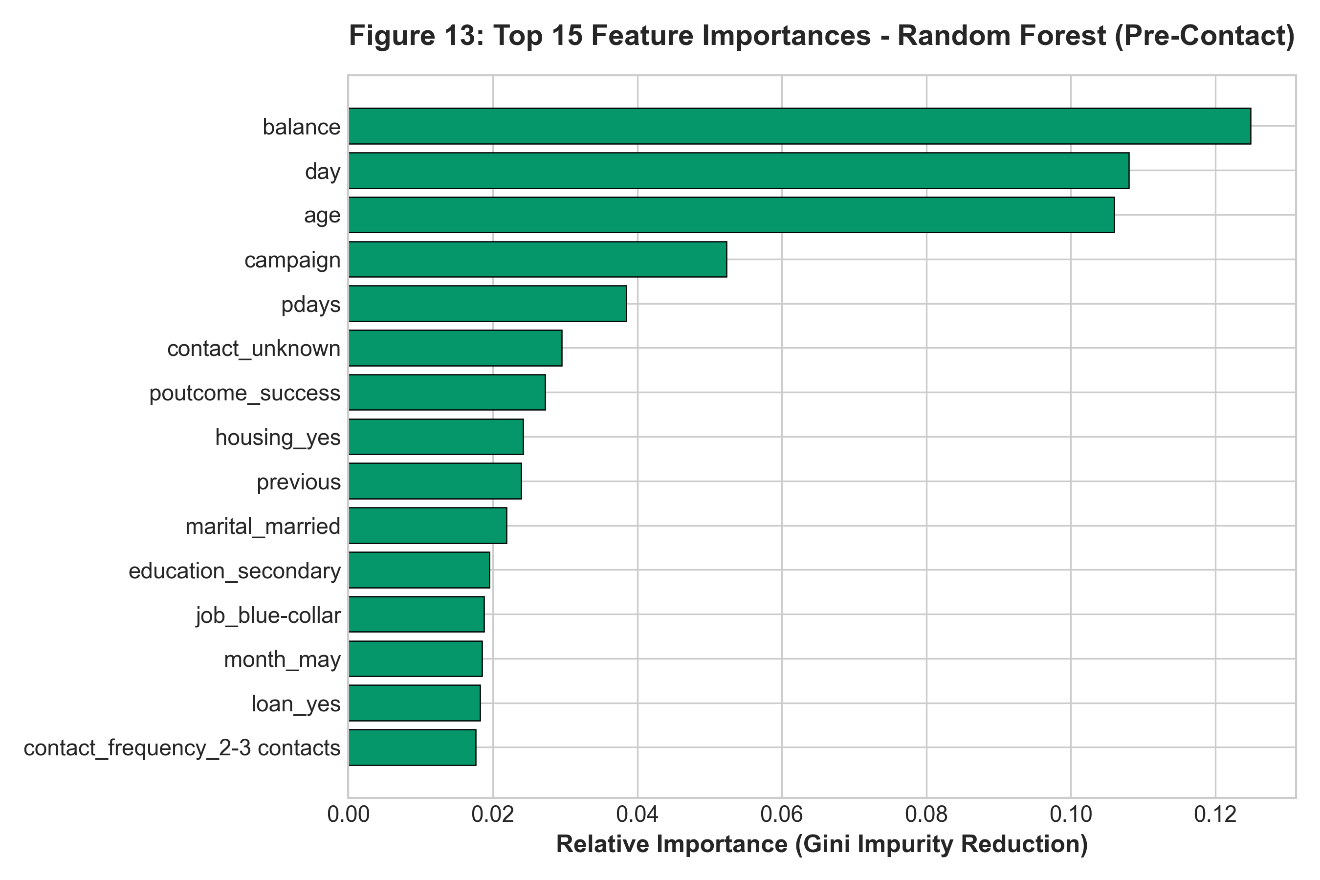
Figure 13: Top 15 Feature Importances — Random Forest
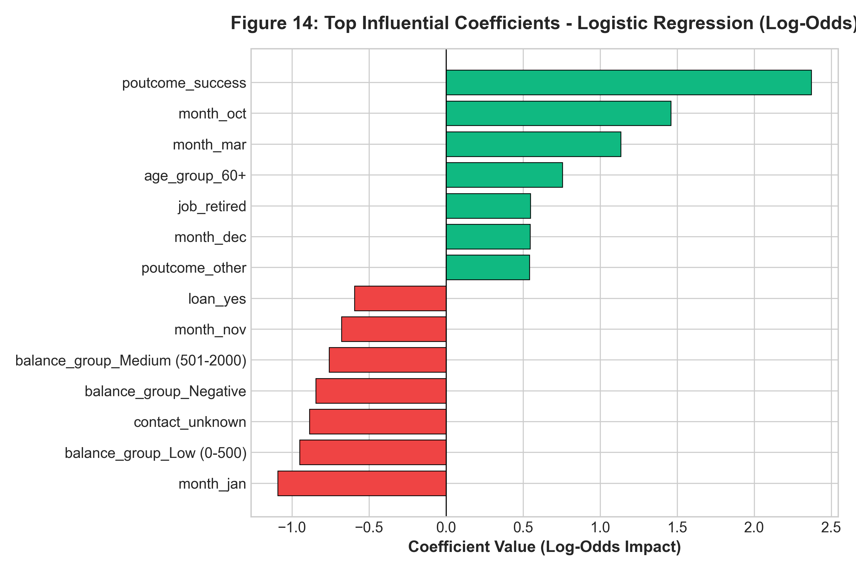
Figure 14: Most Influential Coefficients — Logistic Regression
Figure 13 and Figure 14 highlight the driving variables. In the Random Forest model, continuous financial features (balance, age, day, campaign) and previous campaign success (poutcome_success) contribute most to Gini impurity reduction. In Logistic Regression, poutcome_success (+1.86 log-odds) is the single strongest positive predictor, while existing housing loans (-0.51 log-odds) and personal debt (-0.57 log-odds) exert the strongest downward pressure on subscription likelihood.

18. Business Insights
- 1. Prior Campaign Success is the Strongest Indicator: Clients with past positive experiences converted at 64.3%, compared to 11.5% baseline. Past satisfaction indicates high willingness to invest in subsequent bank offerings.
- 2. Debt Commitments Constrain Liquidity: Clients with housing loans converted at only 8.6% (vs 15.3% for debt-free clients), and personal loans halved conversion from 12.5% to 6.7%. Debt servicing restricts discretionary capital.
- 3. Contact Fatigue Appears Beyond 2 Contacts: More than 80% of conversions occur within the first 1-2 calls. Additional attempts beyond 3 calls yield diminishing returns and risk customer dissatisfaction.
- 4. Demographic Differences in Savings Preferences: Students (22.6%) and retirees (23.5%) demonstrated above-average response rates, suggesting strong demand for safe, guaranteed-return deposit instruments in those life stages.

19. Business Recommendations
- 1. Prioritize Re-engagement of Prior Subscribers: Establish an automated workflow targeting clients recorded with 'poutcome == success' early in campaign cycles.
- 2. Institute a 3-Call Outreach Limit: Enforce an operational cap of 3 call attempts per client per campaign to reduce unproductive call center labor costs.
- 3. Segment Offerings by Liability Profile: Avoid pitching term deposits to customers servicing significant mortgage or personal debt; offer debt consolidation or short-term liquid savings instead.
- 4. Deploy Machine Learning for Pre-Contact Lead Scoring: Use model propensity scores to rank calling lists daily, routing top-decile prospects to senior sales specialists.
- 5. Maintain Strict Pre-Contact Governance: Prohibit post-contact operational variables (such as call duration) in prospective targeting models to prevent data leakage.

20. Limitations
- 1. Specific Geographic and Economic Context: Data reflects a Portuguese retail bank during the 2008-2010 financial crisis; relationships may differ under different interest-rate regimes.
- 2. Observational vs. Causal Evidence: Reported patterns represent statistical associations rather than proven causal relationships.
- 3. Class Imbalance: The 8:1 negative-to-positive ratio requires careful probability threshold selection in production deployment.
- 4. Presence of Unknown Categories: A substantial proportion of records contain 'unknown' in categorical fields, reflecting incomplete historical data collection.

21. Future Scope
- 1. Threshold Optimization & Cost-Sensitive Learning: Calibrate classification thresholds using actual financial cost matrices (cost per outbound phone call vs. net profit from a signed term deposit).
- 2. Explainable AI with SHAP: Integrate SHAP values into CRM interfaces to give call center agents specific talking points tailored to individual customer risk-return profiles.
- 3. Temporal Split Validation: Evaluate model stability across sequential time-based splits to test resilience against temporal concept drift.
- 4. Interactive Dashboard Deployment: Deploy an interactive dashboard (e.g., Streamlit) allowing marketing analysts to simulate campaign ROI and run what-if scenarios.

22. Conclusion
This project successfully developed an end-to-end data analytics and machine learning solution for bank marketing campaign optimization, fulfilling the requirements of the AICTE | IBM SkillsBuild Internship 2026. By utilizing the authentic UCI Bank Marketing dataset, conducting rigorous data audits, formalizing executive KPIs, and engineering domain features, the study uncovered key behavioral patterns governing term deposit adoption. Crucially, the project addressed the subtle pitfall of data leakage by removing call duration from prospective models, delivering realistic, production-viable classifiers. Logistic Regression demonstrated strong recall (62.5%), while Random Forest offered high precision (55.6%), providing flexible operational choices for banking marketing teams.

23. References
- [1] Moro, S., Cortez, P., & Rita, P. (2014). A data-driven approach to predict the success of bank telemarketing. Decision Support Systems, 62, 22-31. DOI: 10.1016/j.dss.2014.03.001.
- [2] UCI Machine Learning Repository. Bank Marketing Dataset. URL: https://archive.ics.uci.edu/dataset/222/bank+marketing.
- [3] Pedregosa, F., et al. (2011). Scikit-learn: Machine Learning in Python. Journal of Machine Learning Research, 12, 2825-2830.
- [4] McKinney, W. (2010). Data Structures for Statistical Computing in Python. Proceedings of the 9th Python in Science Conference, 51-56.
- [5] Provost, F., & Fawcett, T. (2013). Data Science for Business: What You Need to Know about Data Mining and Data-Analytic Thinking. O'Reilly Media.

