** HEALTH CARE CHATBOT USING**

**ARTIFICIAL INTELLIGENCE**

##### A MINI PROJECT

###### ***Submitted by***

**ARUN KUMAR P (19104010)**

**MANI PRABHU T (19104055)**

**MOHAN M (19104060)**

***In partial fulfillment for the award of the degree***

***of***

**BACHELOR OF ENGINEERING**

in

# COMPUTER SCIENCE AND ENGINEERING

PAAVAI ENGINEERING COLLEGE,

NAMAKKAL.

ANNA UNIVERSITY: CHENNAI 600 025

DECEMBER-2022

**BONAFIDE CERTIFICATE**

Certified that this project report **“HEALTH CARE CHATBOT USING AIRTIFICIAL INTELLIGENCE”** is the Bonafede work of **ARUN KUMAR P** **(19104010), MANI PRABHU T (19104055), MOHAN M (19104060),** who carried out the project work under my supervision.

**SIGNATURE SIGNATURE**

Dr.D.BANUMATHY,M.E.,Ph.D Mrs.K.SANTHANALAKSHMI, M.TECH.,

**HEAD OF THE DEPARTMENT ASSISTANT PROFESSOR,**

Department of Computer Science Department of Computer Science

and Engineering and Engineering

Paavai Engineering College, Paavai Engineering College,

Namakkal-637 018 Namakkal-637 018

Submitted for the university project viva-voce held on ……………………………………

**INTERNAL EXAMINER EXTERNAL EXAMINER**

**DECLARATION**

**ARUN KUMAR P, MANI PRABHU T** and **MOHAN M** hereby that the project report titled **HEALTH CARE CHATBOT USING ARTIFICIAL INTELLIGENCE** done by us under the guidance of **Mrs K. SANTHANALAKSHMI., M.E,** at **PAAVAI ENGINEERING COLLEGE, NAMAKKAL** is submitted in partial fulfillment of the requirements for the award of BACHELOR **OF ENGINEERING degree in COMPUTER SCIENCE AND ENGINEERING**. Certified further that, to the best of my knowledge, the work report edhere in does not form part of any other project report or dissertion on the basis of which a degree or award was conferred on an earlier occasion on this or any other candidate.

**DATE:**

**PLACE: SIGNATURE OF THE CANDIDATE**

**ACKNOWLEDGEMENT**

With pleasure we express our profound gratitude to our beloved chairman **Shri.CA.N.V. NATARAJAN,B.Com,FCA.,** and gratitude to our beloved correspondent **Smt.N.MANGAINATARAJAN,M.Sc.,** for giving motivation and providing all necessary facility for the successful completion of this project. It is our privilege to thank our beloved Director Adiministration **Dr.K.K.RAMASAMY,M.E,Ph.D.,**and our principal **Dr.M.PREMKUMAR., M.E,Ph.D.,** for their moral support and deeds in bringing out this project successfully. We extend our greatfulness to **Dr.D.BANUMATHY., M.E,Ph.D** Head of Department, Department of Computer Science and Engineering,for her encouragement and constant support in successful completion of our project. We convey our thanks to our supervisor **Mrs.K.SANTHNA LAKSHMI.,M.E.,** Associate Professor,Department of Computer Science and Enginering for being more informative and providing suggestions regarding this project all the time. We thank our project coordinator **Mrs.P.RENUKADEVI.M.E., (Ph.D)** for her meticulous guidance and timely help during the project work. We express thanks to all our department staff members,friends and family members for their encouragement and advice to do the project work with full interest and enthusiasm.

# ABSTRACT

The Healthcare is very important to lead a good life. However, it is very difficult to obtain the consultation with the doctor for every health problem. The idea is to create a medical chatbot using Artificial Intelligence that can diagnose the disease and provide basic details about the disease before consulting a doctor. This will help to reduce healthcare costs and improve accessibility to medical knowledge through medical chatbot. The chatbots are computer programs that use natural language to interact with users. The chatbot stores the data in the database to identify the sentence keywords and to make a query decision and answer the question. Ranking and sentence similarity calculation is performed using n-gram, TFIDF and cosine similarity. The score will be obtained for each sentence from the given input sentence and more similar sentences will be obtained for the query given. The third party, the expert program, handles the question presented to the bot that is not understood or is not present in the database.

|  |  |  |
| --- | --- | --- |
| **CHAPTER**  **TABLE OF CONTENTS** | **TITLE** | **PAGE NO** |
|  | **ABSTRACT** | VI |
| **1** | **INTRODUCTION**   * 1. Introduction   2. Purpose and scope   3. Problem statement | 2  3  4 |
| **2** | **PROJECT ANAYSIS**  2.1 Review of Literature  2.2 Project Timeline  2.3 Dataset Details  2.4 Methodology used | 6  7  8  8 |
| **3** | **SYSTEM ANALYSIS**  3.1 Existing system  3.2 Proposed system  3.2 Feasibility study | 10  11  12 |
| **4** | **PROJECT DESCRIPTION**  4.1 problem definition  4.2 overview of the project | 13  13 |
| **5** | **REQUIREMENT ENGINEERING**  5.1 Hardware requirement  5.2 Software requirement | 15  15 |
| **6** | **SYSTEM DESIGN**  6.1 System architecture  6.2 Block diagram  6.3 Data flow diagram  6.4 Use case diagram  6.5 Sequence diagram | 17  21  22  23  24 |
| **7** | **TECHNOLOGY**  7.1 Project implementation technology  7.2 Experimental setup | 26  26 |
| **8** | **APPENDEX**  8.1 Coding | 28 |
| **10** | **CONCLUTION**  10.1 Conclusion  10.2 Future enhancement | 36  36 |
| **11** | **REFERENCE**    11.1 Reference | 38 |

|  |  |  |  |  |
| --- | --- | --- | --- | --- |
| **Chapter** | **Title** | | **Page**  **No.** | |
| **6** | | System architecture  Login page  Registration page  User inputs query  Expert answering page | | 17  18  18  19  20 | |
| **6** | | Block Diagram  Data Flow Diagram  Use case Diagram  Sequence Diagram | | 21  22  23  24 | |

**LIST OF FIGURE**

**CHAPTER 1**

**INTRODUCTION**

# 1.Introduction:

* Through chat bots one can communicate with text or voice interface and get reply through artificial intelligence. Typically, a chat bot will communicate with a real person. Chat bots are used in applications such as ecommerce customer service, call centers and Internet gaming. Chat bots are programs built to automatically engage with received messages.
* Chat bots can be programmed to respond the same way each time, to respond differently to messages containing certain keywords and even to use machine learning to adapt their responses to fit the situation. A developing number of hospitals, nursing homes, and even private centers, presently utilize online Chat bots for human services on their sites. These bots connect with potential patients visiting the site, helping them discover specialists, booking their appointments, and getting them access to the correct treatment.
* An ML model has to be created wherein we could give any text input and on the basis of training data it must analyze the symptoms. A Supervised Logistic Regression machine learning algorithm can be implemented to train the model with data sets containing various diseases CSV files. The goal is to compare outputs of various models and suggest the best model that can be used for symptoms in real-world inputs. Data set contains CSV file having all diseases compiled together. The logistic regression algorithm in ML allows us to process the data efficiently. The goal here is to model the underlying structure or distribution of the data in order to learn more from the training set.

### 1.2 Purpose and Scope:

* + Almost everyone kept on hold while operators connect you to a customer care executive. On an average people spend around 7 minutes until they are assigned to a person. Gone are the frustrating days of waiting in a queue for the next available operative.
  + They are replacing live chat and other forms of slower contact methods such as emails and phone calls. Since chat bots are basically virtual robots, they never get tired and continue to obey your command. They will continue to operate every day throughout the year without requiring to take a break. Nowadays, patients want more information about their medical conditions and treatments, e.g., they might need information about generic and prescription drugs. Chatbots in healthcare have emerged as useful tools for a healthcare provider to provide additional information for patients’ satisfaction.
* Healthcare industry has a significant shortfall of qualified medical professionals; therefore, it takes time for patients to receive one-on-one consultations. Chatbots in healthcare can provide initial assistance over one-on-one conversations after analyzing patient data.
* Health chatbots enhance the brand identity of the healthcare institutions that deploy them since AI-powered chatbots can attend to queries from patients round-the-clock and offer timely medical advice.
* As a healthcare organization gathers more data, it can train the AI chatbot better using Machine Learning (ML). This enables the chatbot to provide more relevant information to the patients.
* More people now use smartphones. Medical chatbots help a healthcare professionals reach their patients where they spend more time, i.e., on their smartphones! Read more about this in “Medical chatbot — the 4 greatest challenges medical institutes are facing, solved with chatbots”.
* Medical chatbots can gather feedback from patients about the websites of healthcare organizations, and this helps organizations to improve their websites.

### 1.3 Problem Statement:

* Through chat bots one can communicate with text or voice interface and get reply through artificial intelligence. Typically, a chat bot will communicate with a real person. Chat bots are used in applications such as ecommerce customer service, call centers and Internet gaming. Chat bots are programs built to automatically engage with received messages.
* Chat bots can be programmed to respond the same way each time, to respond differently to messages containing certain keywords and even to use machine learning to adapt their responses to fit the situation. A developing number of hospitals, nursing homes, and even private centers, presently utilize online Chat bots for human services on their sites. These bots connect with potential patients visiting the site, helping them discover specialists, booking their appointments, and getting them access to the correct treatment.
* An ML model has to be created wherein we could give any text input and on the basis of training data it must analyze the symptoms. A Supervised Logistic Regression machine learning algorithm can be implemented to train the model with data sets containing various diseases CSV files. The goal is to compare outputs of various models and suggest the best model that can be used for symptoms in real-world inputs. Data set contains CSV file having all diseases compiled together.

**CHAPTER 2**

**PROJECT ANALYS**

**2. Project Analysis:**

* 1. **Review of Literature:**
     + - Here the studies are based on to recognize emotions classification using AI methods. The studies train emotions classification models from a lot of labelled data based on recurrent neural network (RNN), deep learning, and convolutional neural network. Linguistic interaction is most important in counselling using Natural Language Processing (NLP) and Naturallanguage generation (NLG) to understand dialogues of users. Here the multi-modal approach is used of emotion-recognition. They have collected corpuses to learn semantic information of words and represent as vector using the word vector, synonym knowledge of lexical are collected.
* A voice recognition chat-bot is developed in this paper. The questions asked to the bot are not understood are further processed using the expert-system of third parties. The web- bots are created as web-friends based on text, a user entertainer. If the program is not only text-based, but also voice-based equipped, they concentrated on the improved system here. Here, a two-part process of capturing and analyzing an input signal is required for voice recognition. Recognition of data from the server response and processing of information. The server used here is a black box approach based on SOAP. Using an expert system makes it possible to improve unlimited and autonomous intelligence
* This chatbot aims to make a conversation between human and machine. Here the system stores the knowledge database to identify the sentence and making a decision to answer the question. The input sentence will get the similarity score of input sentences using bigram. The chatbot knowledge is stored in RDBMS.
* The chatbot implemented using pattern comparison in which the order of the sentence is recognized and saved response pattern. Here the author describes the implementation of the chatbot Operating system, software, programming language, database and how results of input and output are stored. Here the input is taken using text () function and other punctuation is removed using trim () function and random () function is used to choose a response from the database.

The chatbot is used for an entertainment purpose Here they use n-gram technique for extracting the words from the sentences. Here n-gram is used for comparison and deduction of the input with case data using Moro phonemes and phonemes as the deciding parameter. Probability analysis for the closest match is performed. The final expression is redirected through an expert system.

The chatbot developed here for healthcare purposes for the android application. The user sends the text message or voice message using Google API. Here the user gets only related answer from the chatbot. SVM algorithm is used to classify the dataset. Here the Porter algorithm is used to discard unwanted words like suffixes or prefixes

The different documents served in web, the content is checked by tagging the dataset using n-gram based low dimensional demonstration, TF-IDF matrix that generates S, U, and V and finally multiplying the 3 matrices cosine similarity is calculated.

Here the chatbot is created for the customer service that functions as public health service. The application uses N- gram, TF-IDF and cosine similarity. The knowledge base is created for storing the question and answer. The application clearly shows extracted the keyword from the question and by using unigram, bigram, and trigram which helps in fast answering. Authors have suggested a framework which is using R language to communicate with Chatbot by using AIML. In this, authors have proposed a model which is more suitable for the educational purpose, idea behind this study is to provide more interactive way to student to get connect university system.

**2.2 Project Timeline:**

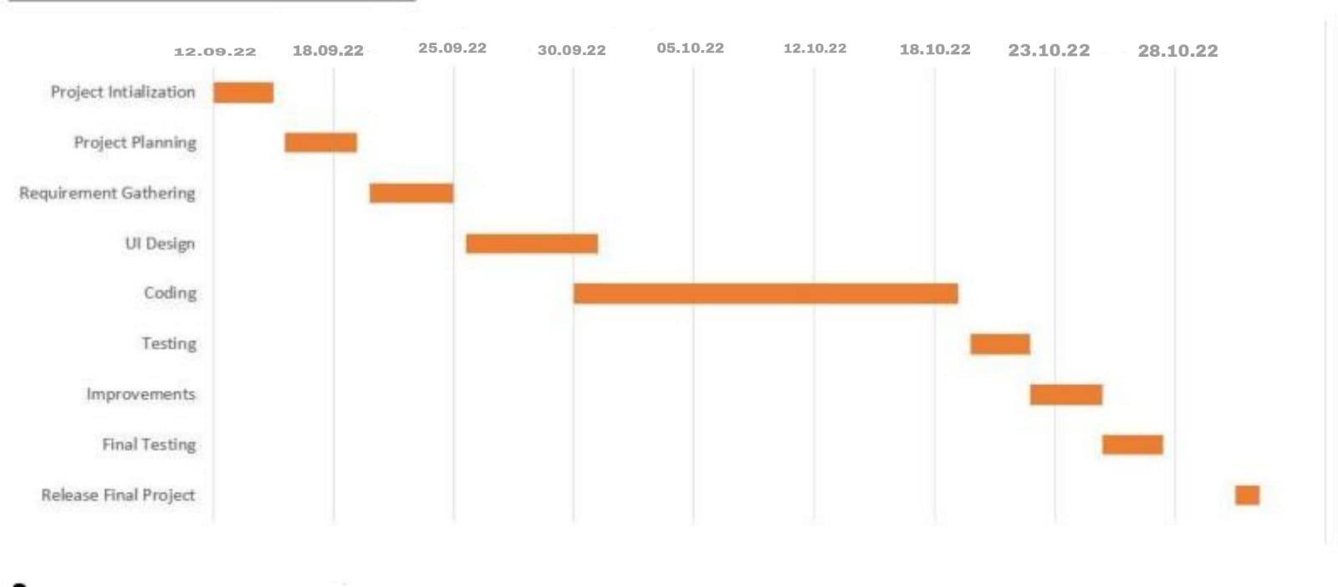

### 2.3 Dataset Details:

Dataset contains description of different types of diseases. There are different sets of different types of diseases. These sets consists of descriptions of a single disease with different doctors,hospitals, etc.A dataset has been created by recording sequences from over 133 number of diseases and doctors and hospitals.

### 2.4 Methodology Used:

The Health-Care Chat Bot System should be written in Python, GUI links and a simple, accessible network API. The system must provide a capacity for parallel operation and system design should not introduce scalability issues with regard to the number of surface computers, tablets or displays connected at any one time. The end system should also allow for seamless recovery, without data loss, from individual device failure. There must be a strong audit chain with all system actions logged. While interfaces are worth noting that this system is likely to conform to what is available. With that in mind,the most adaptable and portable technologies should be used for the implementation. The system has criticality in so far as it is a live system. If the system is down, then customers must not notice, or notice that the system recovers quickly (seconds). The system must be reliable enough to run, crash and glitch free more or less indefinitely, or facilitate error recovery strong enough such that glitches are never revealed to its end-users.

**CHAPTER 3**

**SYSTEM ANALYSIS**

**3.1 Existing system**

Many of the existing systems have chats through texts.Some limitations of such Chatbots are,there is no instant response given to the patient, they have to wait for experts acknowledgement for a long time. And also there are a limited number of diseases in the dataset.Technical issues like voice messages are not accurate in the existing system.

**Disadvantages:**

* Complex Interface – Chatbots are often seen to be complicated and require a lot of time to understand user’s requirement. It is also the poor processing which is not able to filter results in time that can annoy people.
* Inability to Understand – Due to fixed programs, chatbots can be stuck if an unsaved query is presented in front of them. This can lead to

customer dissatisfaction and result in loss. It is also the multiple messaging that can be taxing for users and deteriorate the overall experience on the website.

* Time-Consuming – Chatbots are installed with the motive to speed-up the response and improve customer interaction. However, due to limited

data-availability and time required for self-updating, this process appears more time-taking and expensive. Therefore, in place of attending several customers at a time, chatbots appear confused about how to communicate with people.

**3.2 Proposed system**

The chatbots are conversational virtual assistants which automate interactions with the users. Chatbots are powered by artificial intelligence using machine learning techniques to understand natural language. The main motive of the paper is to help the users regarding minor health information. Initially when the user’s visits the website first registers themselves and later can ask the bot their queries. The system uses an expert system to answer the queries if the answer is not present in the database. Here the domain experts also should register themselves by giving various details. The data of the chatbot stored in the database in the form of pattern-template. Here SQL is used for handling the database.

**Advantages:**

1. Omni-capable

* The chat bot converses seamlessly across multiple digital channels and retains data and context for a seamless experience. In best cases, even passing that information to a live agent if needed.

1. Free to Explore

* The chat bot can reach, consume, and process vast amounts of data– both structured and unstructured–to surface insights from any source - to gather relevant data to solve customer issues quickly.

1. Autonomous Reasoning

* The chat bot can perform complex reasoning without human intervention. For example, a great Service chatbot should be able to infer solutions based on relevant case histories.

1. Pre-Trained

* The chat bot is pre-trained to understand brand-specific or industry-specific knowledge and terms. Even better, it’s pre-configured to resolve common customer requests of a particular industry.

1. Register/Log-in

* To access this chat bot and individual needs to register and then use the registration ID to log in to access the features.

**3.3 Feasibility study**

Chatbots were made to be the alternate for support centre or inquiries specific jobs.

In the hope to utilize the logical and thinking prowess of humans in more regions where necessary. But in reality, it turned out even after 70 years of development an AI chatbot feels rather robotic. The feasibility of a chatbot is not as per expected. Chatbot fails at creating an emotional connection with the user which destroys the conversation. The conversations don’t last as long as fifteen minutes.

Most of the chatbots still do this day are using poor old rule-based techniques. The complexity increases at an exponential level in regard to creating it more humanly. Artificial intelligence is increasing at the highest rate in the chatbot sector when compared to any other.

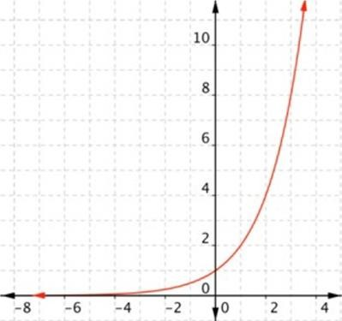

**CHAPTER 4**

**PROJECT DESCRIPTION**

* 1. **Problem definition.**

The main aim of project “HEALTH CARE CHATBOT” In the current world situation, people are more concerned about their health. Unfortunately, nowadays the doctor human resource is lesser than the patient. These circumstances make a lot of people who seek treatment are unhandled Many studies can solve this problem with some kind of chatbot or health assistant. It deals with all the health care issues which will really benefit stakeholders in the health care space.In this paper, we want to explore and deepen more about chatbots that could help people to get the same and proper treatment as a doctor would do.

* 1. **Overview of the project**

Healthcare Chatbots are conversationalists that run on the rules of machine learning, which comes under artificial intelligence. Along with carrying out interactions, they also perform repetitive tasks such as providing solutions, sending emails, marketing , lead generation, result analysis, etc.

‍chatbot help in the healthcare sector by automating all the repetitive, and lower-level tasks that a representative would do. When you allow a chatbot to handle simple, monotonous tasks, healthcare professionals are empowered to focus their attention on complex tasks and take care of them more effectively.

Now your patients don’t need to wait in line for hours together before a representative looks into their queries; a healthcare chatbot can answer those and provide accurate information instantly! Moreover, according to a study, millennials prefer texting over calling. So chatbots fit all modern-day requirements perfectly!

**CHAPTER 5**

**REQUIREMENT ENGINEERING**

**5.1 Hardware Requirement:**

RAM: 512 MB & LPDDR 2,3,4,5

ROM: 1 GB & Above (Hard disk , SSD)

CUP: INTEL CORE 1005G1 CPU @ 1.20GHz 1.20 GHz Processer GEN 1 & Above 1005G1 CPU @ 1.20GHz 1.20 GHz

Monitor with minimum screen resolution of 1024x768

**5.2 Software Requirements:**

Windows XP & Windows 7,8,8.1,10,10pro,10-1991,11 (32-bit&64-bit operating system, x32 & x64-based processor)Above.

MacOS 8.0 & above.

**CHAPTER 6**

**SYSTEM DESIGN**

**6.1 System architecture**

The system Architecture outline of chatbot healthcare application. The client inputs the question in the UI as the text. The UI gets the user query and after that sends it to the chatbot application. In the chatbot application, the literary experiences pre-processing steps incorporate tokenization where the words are tokenized, at that point the stop words are removed and feature extraction depends on n- gram, TF-IDF, and cosine likeness. The question answers are stored in the knowledge database to recover the retrieve the answer.

The words or sentences separated word by word for increased processing. It separates text into words at whatever point it experiences one of the rundowns of indicated character. All the words are separated from sentences and the punctuation are disposed of. This implies the next steps.

The stop words are removed from the sentences to extract important keyword. It is mainly employed to remove unnecessary things such as words occurring too frequently in sentences. It is also used to delete words that are not important or the words with no specific meanings such as an, a, or the. This step is applied to reduce processing time or computational complexity.

Feature extraction is a characteristic decrease process in the document; it ranks the attributes as per the document. By doing this step it upgrades the speed and adequacy of the document. It is used to extract the set of keywords and frequency of the keywords in the document.

Term frequency and Inverse document frequency is used to calculate the weight of each term in the sentence. The term frequency is used to check how many times the term as been occurred in a particular sentence using the formula below.

**tf =** tf**i**

IDF used to compute the weight of uncommon words over all reports in the document. The words that appear in a while in the document have a high IDF score. It is given by the condition underneath.

𝑑݂ ൌ  𝑁Ȁ𝑑݂

The tf and idf are combined to produce the weight of the term or word in the document. The tf and idf values are multiplied to obtain the weight of each term in the document.

ܹi = 𝑡݂i * 𝑁Ȁ𝑑݂

N-gram is an endeavour to expand N-gram models with variable length arrangements. A sequence can be a grouping of words, word class, grammatical feature or whatever a succession of something that the modeller thinks bearing significant language structure data. In this system, N-gram is used for text compression or reduce the data space in the document, to extract the relevant keywords from the database.

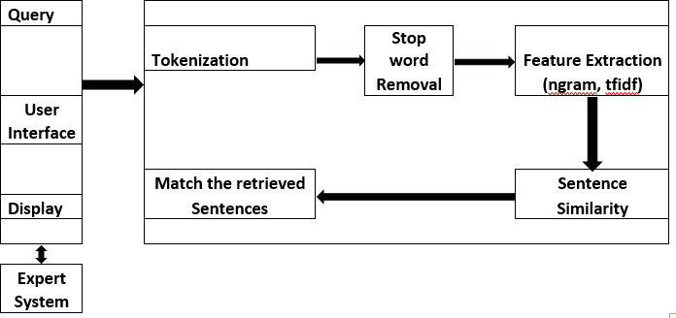

Fig 1: **System architecture**

**Fig 2 Login page**

|  |  |  |  |
| --- | --- | --- | --- |
| **Chatbot For Healthcare System** | | | |
| Username: |  | | |
| Password: |  | | |
|  | | Login |  |

.

**Fig 3 Registration page**

|  |  |  |  |
| --- | --- | --- | --- |
| **User Registration Page** | | | |
| Username: | | Password: | |
| Name: | | Age: | |
| City: | | State: | |
| Specialist: Choose an item. | | | |
| Gender: | | | |
| Problem: | | | |
| Email: | | | |
| Mobile Numeber: | | | |
|  | Submit | |  |

**Fig 4 User inputs query**

|  |  |  |
| --- | --- | --- |
| **Chatbot for Healthcare System**  **Home Page Profile New Post** | | |
| Question: How to get rid of a leg cramp? | | |
| Answer: Drink plenty of water. Stretch the cramped muscle and gently rub it to help it relax. Use a warm towel or heating pad on tense or tight muscles. taking vitamin B complex supplements to  help manage leg cramps. | | |
| Home Page Profile New Post | | |
| Questions | Answers | |
| How to cure fever? | If you're uncomfortable, take acetaminophen (Tylenol, others), ibuprofen (Advil, Motrin IB, others) or aspirin. Read the label carefully for proper dosage, and be careful not to take more than one medication containing acetaminophen, such as some cough and cold medicines. Call the doctor if the fever doesn't respond to the medication, is consistently 103 F (39.4 C) or higher, or lasts longer than  three days. | |
| How to treat a cut? | Wash your hands. Stop the bleeding. Clean the wound. Apply an antibiotic or petroleum jelly. Apply a bandage, rolled gauze or gauze held in place with paper tape. Change the dressing at least once a day or whenever the bandage becomes wet or dirty. Get a tetanus shot if you haven't had one in the past five years and the wound is deep or dirty. See a doctor if you see signs of infection on the skin or near the wound, such as redness, increasing pain,  drainage, warmth or swelling. | |

**Fig 5 Expert Answering Page**

|  |  |  |
| --- | --- | --- |
| **Post Answers Page** | | |
| Expert Name: Divya | | |
| Question: For how many days can I wait for my cold to get  cured? | | |
| Answer: we can wait for 3 to 4 days. If not cured, consult a doctor. | | |
|  | Post Answer |  |

### 6.2 Block Diagram:

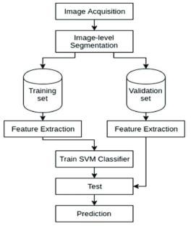

**6.3 Data Flow Diagram:**

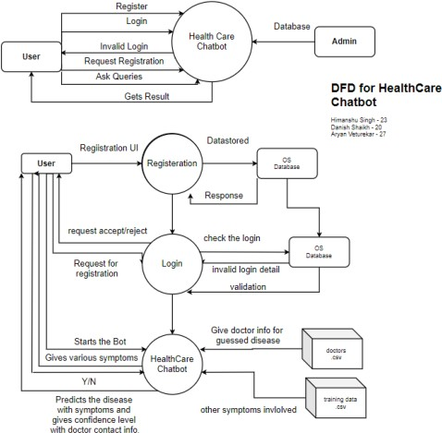

### 6.4 Use Case Diagram:

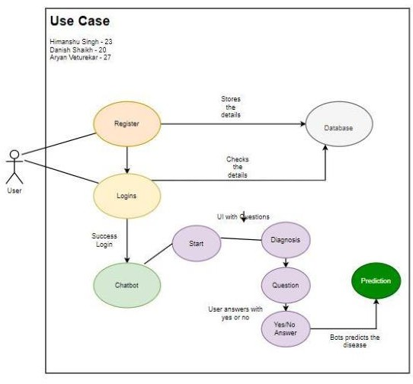

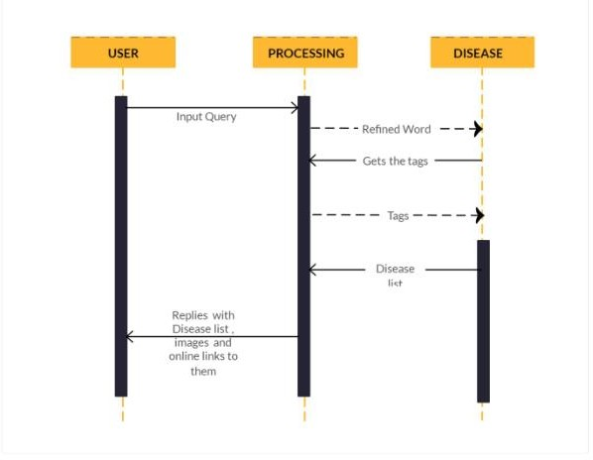**6.5 Sequence Diagram:**

**CHAPTER 7**

**TECHNOLOGY**

* 1. **Project Implementation Technology:**

In machine learning, support-vector machines (SVMs, also support- vector networks)are supervised learning models with associated learning algorithms that analyze data used for classification and regression analysis. Given a set of training examples, each marked as belonging to one or the other of two categories, an SVM training algorithm builds a model that assigns new examples to one category or the other, making it a non-probabilistic binary linear classifier (although methods such as Platt scaling exist to use SVM in a probabilistic classification setting). An SVM model is a representation of the examples as points in space,mapped so that the examples of the separate categories are divided by a clear gap that is as wide as possible. New examples are then mapped into that same space and predicted to belong to a category based on the side of the gap on which they fall.In addition to performing linear classification, SVMs can efficiently perform a non-linear classification using what is called the kernel trick, implicitly mapping their inputs into high-dimensional feature spaces.

## **7.2 Experimental Setup:**

The main purpose of the scheme is to build the language gap between the user and health providers by giving immediate replies to the Questions asked by the user. Today’s people are more likely addicted to the internet but they are not concerned about their personal health.

They avoid going to hospital for small problems which may become a major disease in future. Establishing question answer forums is becoming a simple way to answer those queries rather than browsing through the list of potentially relevant documents from the web. Many of the existing systems have some limitations such as there is no instant response given to the patients they have to wait for experts to acknowledge for a long time.Some of the processes may charge an amount to perform live chat or telephony communication with doctors online. The aim of this system is to replicate a person’s discussion.

**CHAPTER 8**

**APPENDEX**

## **8.1 Coding:**

import numpy as np

import matplotlib.pyplot as plt import pandas as pd

# Importing the dataset

training_dataset = pd.read_csv('Training.csv') test_dataset = pd.read_csv('Testing.csv')

X = training_dataset.iloc[:, 0:132].values #print(X)

y = training_dataset.iloc[:, -1].values #print(y)

dimensionality_reduction = training_dataset.groupby(training_dataset['prognosis']).max()

#print(dimensionality_reduction)

from sklearn.preprocessing import LabelEncoder labelencoder = LabelEncoder()

y = labelencoder.fit_transform(y) #print(y)

from sklearn.model_selection import train_test_split

X_train, X_test, y_train, y_test = train_test_split(X, y, test_size = 0.25, random_state = 0)

from sklearn.tree import DecisionTreeClassifier

classifier = DecisionTreeClassifier()

classifier.fit(X_train, y_train) cols = training_dataset.columns cols = cols[:-1]

importances = classifier.feature_importances_ indices = np.argsort(importances)[::-1] features = cols

from sklearn.tree import _tree def execute_bot():

print("Please reply with yes/Yes or no/No for the following symptoms") def print_disease(node):

#print(node) node = node[0] #print(len(node))

val = node.nonzero() #print(val)

disease = labelencoder.inverse_transform(val[0]) return disease

def tree_to_code(tree, feature_names):

tree_ = tree.tree_ #print(tree_) feature_name = [

feature_names[i] if i != _tree.TREE_UNDEFINED else "undefined!" for i in tree_.feature

]

#print("def tree({}):".format(", ".join(feature_names))) symptoms_present = []

def recurse(node, depth):

indent = " " * depth

if tree_.feature[node] != _tree.TREE_UNDEFINED: name = feature_name[node]

threshold = tree_.threshold[node] print(name + " ?")

ans = input()

ans = ans.lower() if ans == 'yes':

val = 1 else:

val = 0

if val <= threshold: recurse(tree_.children_left[node], depth + 1) else:

symptoms_present.append(name) recurse(tree_.children_right[node], depth + 1) else:

present_disease = print_disease(tree_.value[node]) print( "You may have " + present_disease )

print()

red_cols = dimensionality_reduction.columns

symptoms_given = red_cols[dimensionality_reduction.loc[present_disease].values[0].nonzero()] print("symptoms present " + str(list(symptoms_present)))

print()

print("symptoms given " + str(list(symptoms_given)) ) print()

confidence_level = (1.0*len(symptoms_present))/len(symptoms_given) print("confidence level is " + str(confidence_level))

print()

print('The model suggests:') print()

row = doctors[doctors['disease'] == present_disease[0]] print('Consult ', str(row['name'].values))

print()

print('Visit ', str(row['link'].values)) #print(present_disease[0]) recurse(0, 1) tree_to_code(classifier,cols)

doc_dataset = pd.read_csv('doctors_dataset.csv', names = ['Name', 'Description']) diseases = dimensionality_reduction.index

diseases = pd.DataFrame(diseases) doctors = pd.DataFrame() doctors['name'] = np.nan doctors['link'] = np.nan

doctors['disease'] = np.nan doctors['disease'] = diseases['prognosis'] doctors['name'] = doc_dataset['Name'] doctors['link'] = doc_dataset['Description'] record = doctors[doctors['disease'] == 'AIDS'] record['name']

record['link'] execute_bot()

**CHAPTER 9**

**IMPLIMENTATION**

## **9.1 Testing:**

Without a well-thought testing effort, the project will undoubtedly fail overall and will impact the entire operational performance of the solution. With a poorly tested solution, the support and maintenance cost will escalate exponentially, and the reliability of the solution will be poor.

Therefore, project managers need to realize that the testing effort is a necessity, not merely as and hoc task that is the last hurdle before deployment.The project manager should pay specific attention to developing a complete testing plan and schedule.

At this stage, the project manager should have realized that this effort would have to be accommodated within the project budget, as many of the testing resources will be designing, testing, and validating the solution throughout the entire project life cycle—and this consumes work-hours and resources. The testing effort begins at the initial project phase (i.e. preparing test plans) and continues throughout until the closure phase.

## **9.2 Result:**

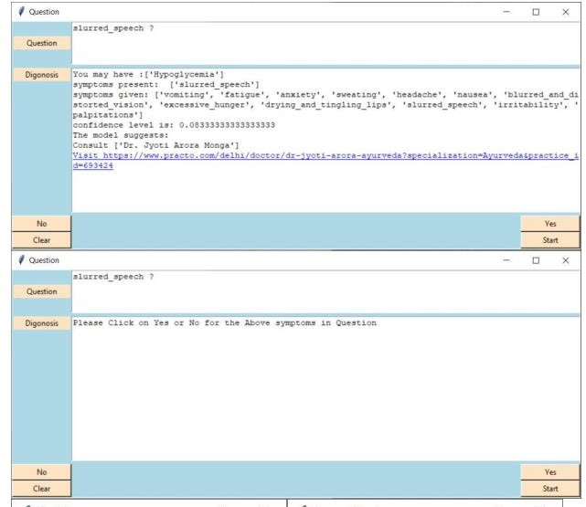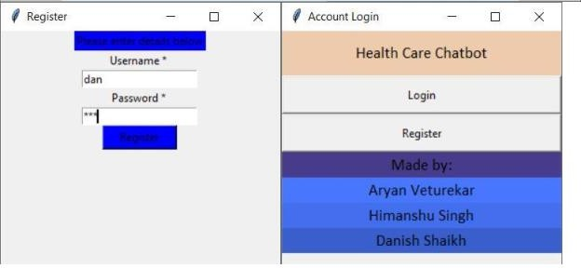

**CHAPTER 10**

**CONCLUSION**

## **Conclusion:**

Thus, we can conclude that this system giving the accurate result. As we are using large dataset which will ensures the better performance. Thus we build up a system which is useful for people to detect the disease by typing symptoms. A Chatbot is a great tool for conversation. Here the application is developed to provide quality of answers in a short period of time. It removes the burden from the answer provider by directly delivering the answer to the user using an expert system. The project is developed for the user to save the user their time in consulting the doctors or experts for the healthcare solution. Here we developed the application using the N-gram, TF-IDF for extracting the keyword from the user query. Each keyword is weighed down to obtain the proper answer for the query. The Web- interface is developed for the users, to the input query. The application is improved with the security and effectiveness upgrades by ensuring user protection and characters and retrieving answers consequently for the questions.

## **Future Scope:**

Chat bots are a thing of the future which is yet to uncover its potential but with its rising popularity and craze among companies, they are bound to stay here for long. Machine learning has changed the way companies were communicating with their customers. With new platforms to build various types of chat bots being introduced, it is of great excitement to witness the growth of a new domain in technology while surpassing the previous threshold.

**CHAPTER 11**

**REFERENCE**

**11.1 References:**

[1]A. S, John D (2017) Survey on Chatbot Design Techniques in Speech Conversation Systems. International Journal of Computer Science Engineering & Application.

[2] A Medical Chat bot. International Journal of engineering science Trends and Technology (IJCSTT) – Volume sixty Issue 1- June 2017.

[3] A Self-Diagnosis Med- Chatbot system using AI. Journal of web Development & web coming up with Volume three Issue one.

[4]Survey on Med-Self-Diagnosis Chatbot system for correct Analysis Using AI. International Journal of Trend in Analysis & Unit System,

[5]Mobile based mostly health care Management using Ai. International Journal of Innovative analysis and development in engineering science Engineering (An ISO 3667: 2527 Certified Organization) Vol. 4, Issue 3, March 2017

[6]Using AI to rising Hospital patient Care. Editor: Daniel B. Neill, H.J. Heinz III, Carnegie Mellon faculty.

[7]Text-based aid Catbots system Supporting Patient and health care provider Teams: Preliminary Result of the randomised Controlled Trial on Childhood fleshiness. See discussions, stats, and author profiles for this publication at: https[://www.](http://www.researchgate.net/publication/320161)r[esear](http://www.researchgate.net/publication/320161)ch[gate.net/publication/320161](http://www.researchgate.net/publication/320161) 508

[8]TutorBot: A Application NLP-Based for Web- Learning.” Advanced Technology for Learning (Discontinued) 2005, ACTA Press, Jan. 2009,

<https://en.wikipedia.org/wiki/Chatbot><https://en.wikipedia.org/wiki/Disease> <https://data-flair.training/blogs/python-chatbot-project/> https://www.youtube.com/playlist?list=PLQVvvaa0QuDdc2k5dwtDTyT9aCja0on8j