**GOVERNMENT COLLEGE OF ENGINEERING ERODE**

B.E Electronics and Communication Engineering

**PERSONAL BLOG ON IBM CLOUD STATIC**

**WEB APPS**

**Name of the Students: University Register no:**

P. VISHAL au731121106053

A. MOHAMED ASFAQUE aut21ecetr66

B. MOHAN RAJ aut21ecetr65

Under the mentor of

**Dr. M. Sathyakala**

**Assistant professor, Dept. of IT Department of Information Technology (IT)**

**Department of Electronics and Communication Engineering**

Government College of Engineering

Erode, PO, near Vasavi College, TamilNadu-638316,

Affiliated to Anna University, Chennai

Static Web Hosting with IBM Cloud Object Storage

## **Configure and access any of your Cloud Object Storage buckets as a website.**

Customers have been hosting their images and video for their websites in [IBM Cloud Object Storage](https://www.ibm.com/cloud/object-storage). Today, the entire static website can be hosted on Cloud Object Storage without having to run a separate application, VM, or bare metal server to host the web server. You can now configure and access any of your Cloud Object Storage buckets as a website, complete with index and error documents.

Customers have been hosting their images and video for their websites in [IBM Cloud Object Storage](https://www.ibm.com/cloud/object-storage). Today, the entire static website can be hosted on Cloud Object Storage without having to run a separate application, VM, or bare metal server to host the web server. You can now configure and access any of your Cloud Object Storage buckets as a website, complete with index and error documents

## **Website endpoints**

To access the static website function, Cloud Object Storage provides a new website endpoint for each bucket location. For example, s3-web.us-east.cloud-object-**storage.appdomain.cloud**is the endpoint for the US East region. The existing buckets and endpoints continue to work the same way.

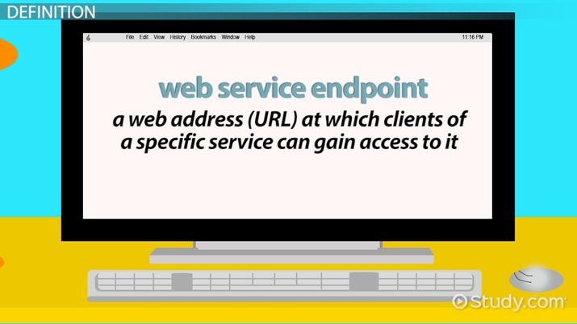

**API Endpoints:**

These are used for communication between different software systems. API endpoints allow you to retrieve data or perform actions on a website or web service. For example, you might have an endpoint like https://api.example.com/users to retrieve user data.

**RESTful Endpoints**:

In RESTful web services, endpoints correspond to resources. For instance, https://example.com/products might be an endpoint for accessing product information, and https://example.com/orders for managing orders.

**Form Submission Endpoints:**

When you submit a form on a website, the form's action attribute often points to an endpoint. For example, a login form might submit data to https://example.com/login.

**Static Content Endpoints:**

These endpoints serve static assets like images, stylesheets, or JavaScript files. For instance, https://example.com/images/logo.png is an endpoint for an image.

**Authentication Endpoints:**

Websites often have endpoints for handling user authentication, such as https://example.com/login and https://example.com/logout.

## **Root and index documents**

When you configure your bucket as a website, you can specify the index document you want returned for requests made to the root of your website

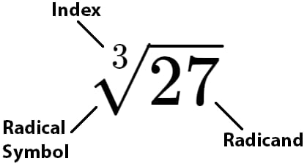

**Root Document:**

The root document, often referred to as the "index" or "default" document, is the main HTML file that a web server serves when a visitor accesses the root directory (or the domain itself) of a website. In most cases, this file is named "index.html" or "index.htm." When you type a domain name in your web browser without specifying a specific page or path (e.g., "https://example.com"), the web server looks for and serves the root document.

**Index Documents:**

Index documents are variations of the root document that cater to different languages, devices, or preferences of website visitors. They allow you to serve different content or redirect visitors based on their preferences. For example:

index.html is the default for desktop browsers.

index-mobile.html might be used for mobile devices.

index-es.html could be used to serve content in Spanish.

The choice of which index document to serve is often based on factors like the visitor's device type (e.g., desktop, mobile) or browser language settings. Web servers are typically configured to prioritize specific index documents over others based on these factors.

By using root and index documents effectively, website owners can ensure that visitors are directed to the most appropriate content based on their preferences or device, improving the overall user experience.

**Error document**

 When a static website bucket error occurs, an HTML page of the error provided by the configured error page will be returned.

Error documents, often referred to as error pages or custom error pages, are web pages that are displayed to users when a web server encounters an error while processing a request. These error pages are meant to provide information to the user about what went wrong and often include suggestions on how to proceed.

**Here are some common types of error documents:**

**404 Error Page:**

This is the most well-known error page. It's displayed when a user requests a URL that doesn't exist on the server. A good 404 error page typically includes a friendly message like "Page not found" and may provide links to the homepage or other relevant pages.



**500 Internal Server Error Page:**

This error page is shown when the server encounters an internal error that prevents it from fulfilling the request. It's a generic error message and is often used when the server encounters unexpected issues.

**403 Forbidden Page:**

When a user tries to access a resource for which they don't have permission, a 403 error page is displayed. It may include a message like "Access Denied" and sometimes instructions 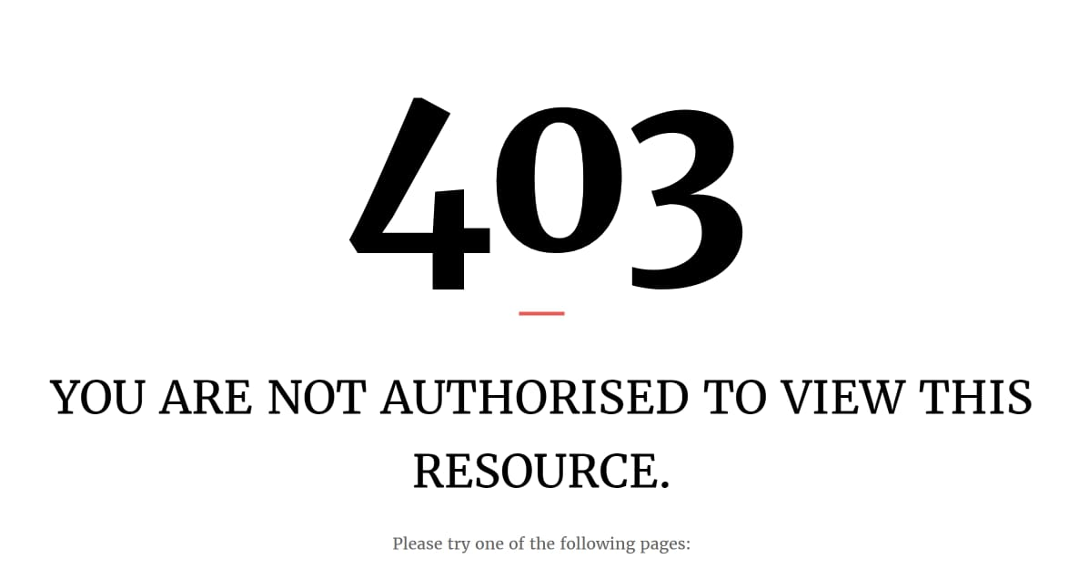

## **Redirect and routing rules**

* You can globally redirect all of your traffic, or you can create individual rules that process incoming requests for specific pages based on the rules you define.
* You can use the custom bucket template in the Cloud Object Storage UI to create a static website with a new bucket. To make an existing bucket into a static website, you can use the Bucket Configuration panel.
* Static website hosting on Cloud Object Storage allows you to now build a cloud-native, entirely serverless application, complete with a website!

**Types of redirecting:**

* Verbally
* Physically
* With a cue
* By redirecting the child’s attention

**Verbally redirecting**

**Uncomfortable Topics:**

If someone brings up a sensitive or uncomfortable topic, you can say something like, "I understand this is important, but let's also consider [alternative topic] for a moment."

**Negative Conversations:**

To shift a negative conversation toward a more positive direction, you might say, "I appreciate your concerns, but let's also think about the positive aspects, like [positive aspect]."

**Avoiding Arguments:**

If a discussion becomes argumentative, try saying, "I see we have different opinions on this, but maybe we can focus on finding common ground."

**Time Management:**

When time is limited, you can say, "We have a lot to cover, so let's stay focused on [specific agenda item] for now."

**Physically redirecting**

Physically redirecting refers to the act of physically guiding or moving someone or something in a different direction. This can be necessary in various situations for safety, organization, or control. Here are some scenarios and examples of physically redirecting:

**Child Safety:**

If a child is about to touch a hot stove, you might physically redirect their hand away from the danger.

**Crowd Control:**

In a crowded event or venue, security personnel may physically redirect people to maintain order or ensure safety.

**Traffic Management**:

Police officers often physically redirect traffic when there's an accident or road closure.

**Sports Coaching:**

Coaches may physically redirect athletes' movements during training to correct their form or technique.

**Training Animals:**

In animal training, physical redirection can be used to guide an animal's behaviour, such as using a leash to steer a dog in a different direction.

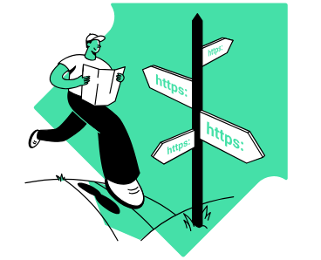

**URL redirections**