**Reg.No: BP230503**

**NAME: S.Mohan**

**MSc Computer Science**

**Pattern Printing**

**Program:**

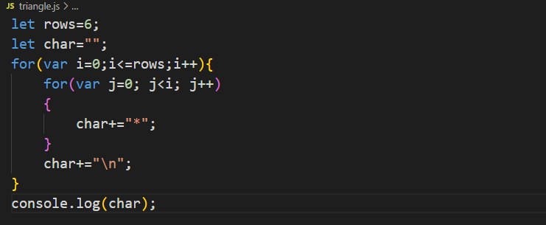

**Output:**

