**RegNo: BP230503**

**NAME: S.Mohan**

**MSC Computer science**

**Simple function using 5 packages**

**1 package**

**Program:**

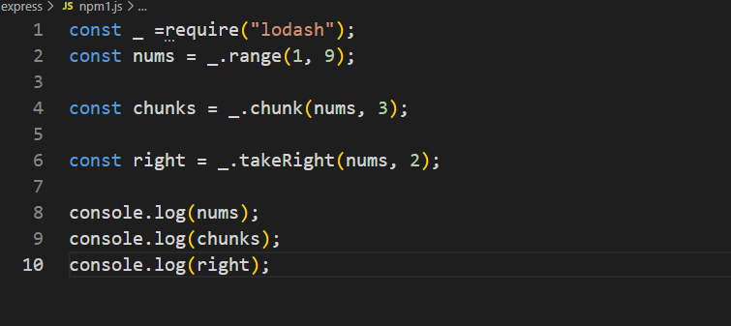

**Output:**

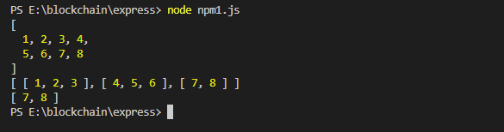

**2 package**

**Program:**

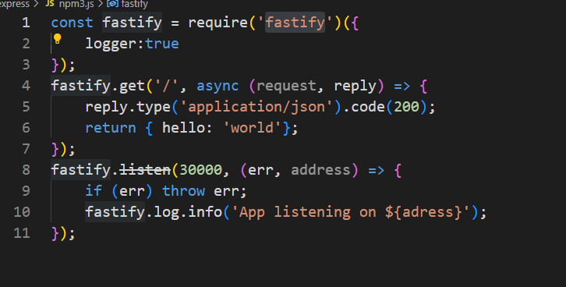

**Output:**

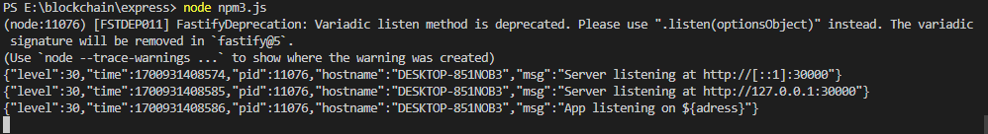

**3package:**

**Program:**

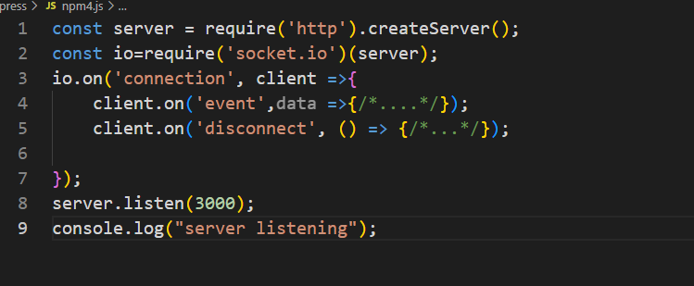

**Output:**



**4 package:**

**Program:**

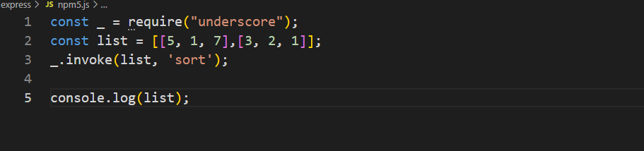

**Output:**

**222.PNG**