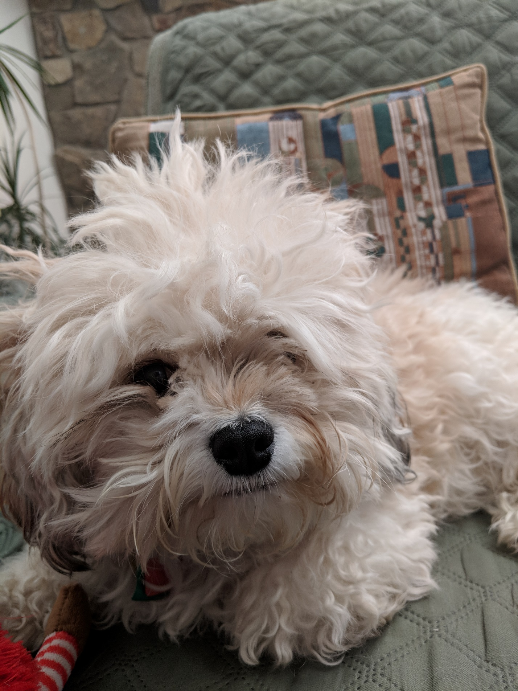

This document is WIP. For now, enjoy a photo of my dog, Ripley (after the character from the Alien franchise)