SOFTWARE REQUIREMENT SPECIFICATION FOR NEWS AND TRENDS WEBSITE

Introduction
The News and Trends is an interface between the Reader and the Author. Here, almost all work is computerized. Show the accuracy is maintained easily. The aim is to automate the existing system by the help of computerized systems and full-fledged computer software, fulfilling the requirements so that their valuable information and data can be stored for a longer period with easy access and manipulation of the same. It aims at improving the efficiency in the issue of News and Trends and reduces the complexities involved in it to the maximum possible extent.

Purpose
Physical newspapers are dying nowadays because people use their devices to be informed about everything that happens around. That would be useful for news company to have good equipment to make their web newspaper easier.
The main purpose of the Project on News and Trends Website is to manage the details of News, News Category, Trends etc. It manages all the information about the reader, author, comment etc.

Scope
The objective of the website is to provide an easy way for users to read news through online. Manage the details of News, Readers, Authors, Trends etc. Override the problems prevailing in the practicing manual system. The main goal of this website is the time efficiency. Provide a communication platform between the Readers and the Authors.

Definitions, Acronyms and Abbreviations
User : Any user (Reader, Author or Administrator)
RAM : Random access memory
Authentication : the process of identifying an individual, usually based on username and password.
HTTP : HyperText Transfer Protocol is the underlying protocol used by the world wide web. It defines how the messages are formatted and what actions should be taken in response to various commands.

References
- ‘A Practitioner’s Guide to Software Testing Design’ by Lee Copeland, Artech House, 2004
- ‘’Software Engineering’ by KK Aggarwal and Yogesh Singh, New Age Publishing House, 2nd Ed.
- IEEE Recommended practice for Software Requirements Specifications – IEEE Std 830-1998.
- IEEE Standard for Software Test Documentation – IEEE Std. 829-1998

Overview
The SRS contains an analysis of the requirements necessary to help early design of the system. The overall description provides interface requirements for the News website, product perspective, hardware interfaces, software interfaces, communication interface, memory constraint, product function, user characteristics, and other contraints. Succeeding pages illustrate characteristics of typical naïve users accessing the system along with legal and functional contraints enforced that affect the news and trends website in any fashion.

Overall Description
This Website acts as an interface between the 'Reader' and the 'Author'. This website tries to make the interface as simple as possible and at the same time not risking the security of data stored in. This website is developed to save energy and time of the users and is eco-friendly too as it does not uses paper as its medium to present news.
The following functionalities and interfaces will be added to the news and trends website portal:
• A news and trend website to be implemented which updates real time news data fetched using APIs.
• Auto completion of keywords to make searching articles easy for the user.
• System will have a wide variety of customization options available for the user - font size for readability, article length, search filters to allow users to search articles from their choice of publishers.
• Easy navigation system with the navbar and a side bar with the clutter free user interface having clear distinction between the Adverts and news content.

Product Perspective
The propose system shall be developed used in client/server architecture and be compatible with Microsoft windows operating system. The front and of the system will be developed using react and the back and will be mongo hosted on NETLIFY.

System Interfaces :
None

User Interfaces
The portal will have the following user friendly and menu driven interfaces:
• Provides the searching functionality based on various factors such as news, weather, sports, general news.
• Online news portal also manage the comment bookmark and sharing on social media functionalities.
• Manage the information of news category.
• Integration of all records of weather data.
• Searching of articles from trusted new sources to increase transparency and build credibility.

Hardware Interfaces
•Any general purpose CPU will work for this software but it must be after second generation to run a web server.
•A computer system with at least 1 GB of RAM will be required for the smooth function of this application.
•Graphics card to render high quality video content to stream for future enhancement in this system.
•Mobile or desktop for and users to take and enroll for this course

Software Interfaces
The portal is designed to be accessed through most of the versions windows operating systems Linux or Unix operating system such as
•Windows 2000
•Windows XP
•Windows Vista
•Windows 7
•Windows 8
•Windows 10
•Any Linux distribution
•Unix operating system

Communication Interfaces
None

Memory Constraints
At least 512 MB RAM NAD 500 MB space of hard disk will be required to run the software.

Operations
None

Site Adaptation Requirements
The terminal at the client site will have to support the hardware and software interfaces specified in the section 2.1.3 and 2.1.4 respectively.

Product Functions
- The Website secures the information about the users
- The Website provides the searching facilities based on various factors
- The Website has a good user interface which is made understandable to the user
- The Website shows the information and description of the News and Trends
- The Website also provide a choice of dark theme mode to the user

User Classes and Characteristics
- Reader - They are the person who login into the website and reads the news.
- Author – They are the person whose published news is been presented on the website
- Administrator - He has the certain privileges . He may contain a group of persons under him to verify the news and give suggestion whether or not to approve the news.

Constraints
• There will be only one administrator handling the system.
• The delete operation is available only to the administrator. To reduce the complexity of the system there is no check on the deletion operation hence the administrator should be very careful before deletion of any record and he/she will be responsible for data consistency.
• The users require a computer or a mobile to submit their information.
• Although the security is given high importance, there is always a chance of intrusion in the web world which requires constant monitoring.
• The user has to be careful while submitting the information.
• The information of all users must be stored in a database that is accessible by the administrators.

Assumption and Dependencies
• The User and Administrator must have basic knowledge of computers and English Language.
• The User and Administrator should have a internet connection to avoid disruption.

Apportioning of Requirements
Not Required.

External Interface Requirements

External Interface Requirements

User Interfaces

- The interface should be user friendly for the user.
- The user interface is easy to implement and should be made understandable for the user.

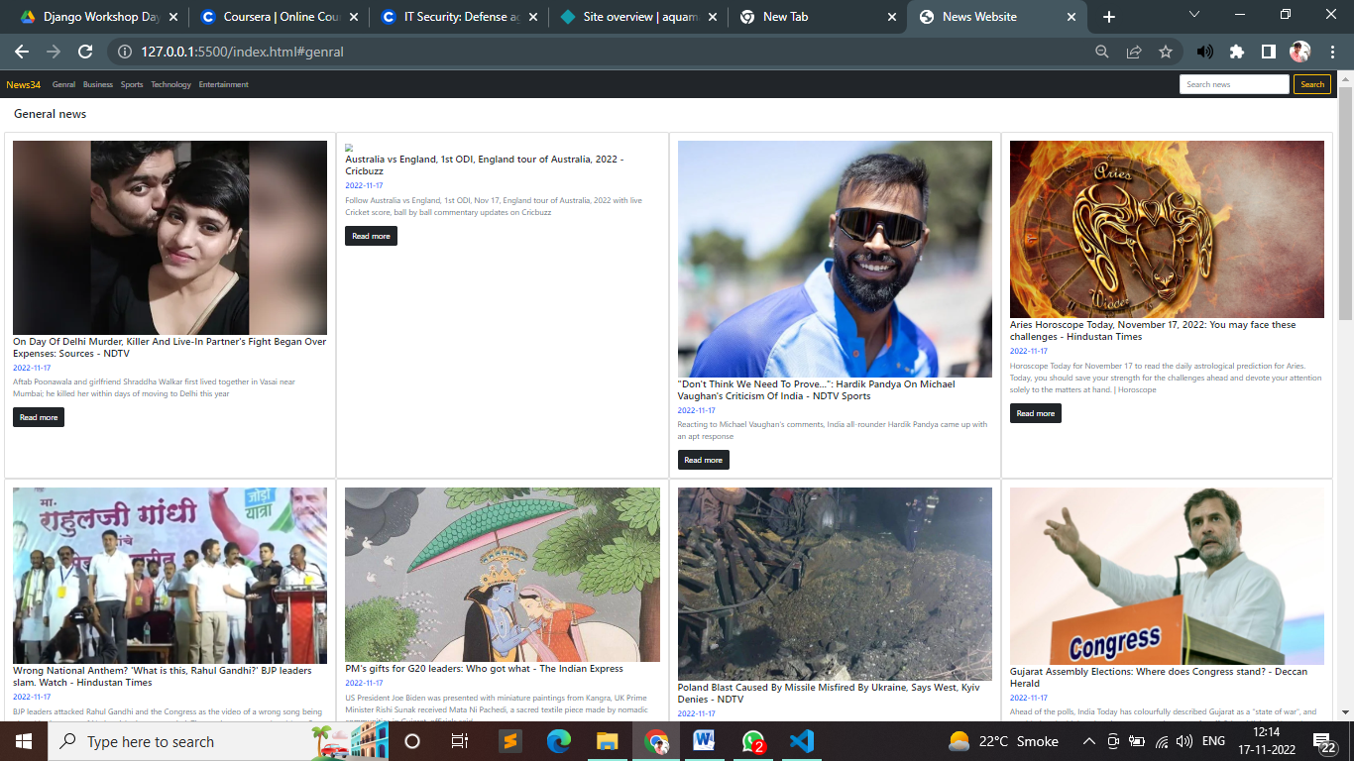

(ii) Login Form:
This is an authentication form that is required if the user wishes to access more functionalities.

Various fields available in the form will be-
- Login ID: alphanumeric of 11 characters in length and digits from 0 to 9 only are allowed alphabets special characters and blank space are not allowed.
- Password: alphanumeric in the range of 4 to 15 characters in length blank spaces are not allowed, however, special characters are allowed.

(iii) Sign Up:
This is a registration form that is required if the user wishes to access more functionalities.

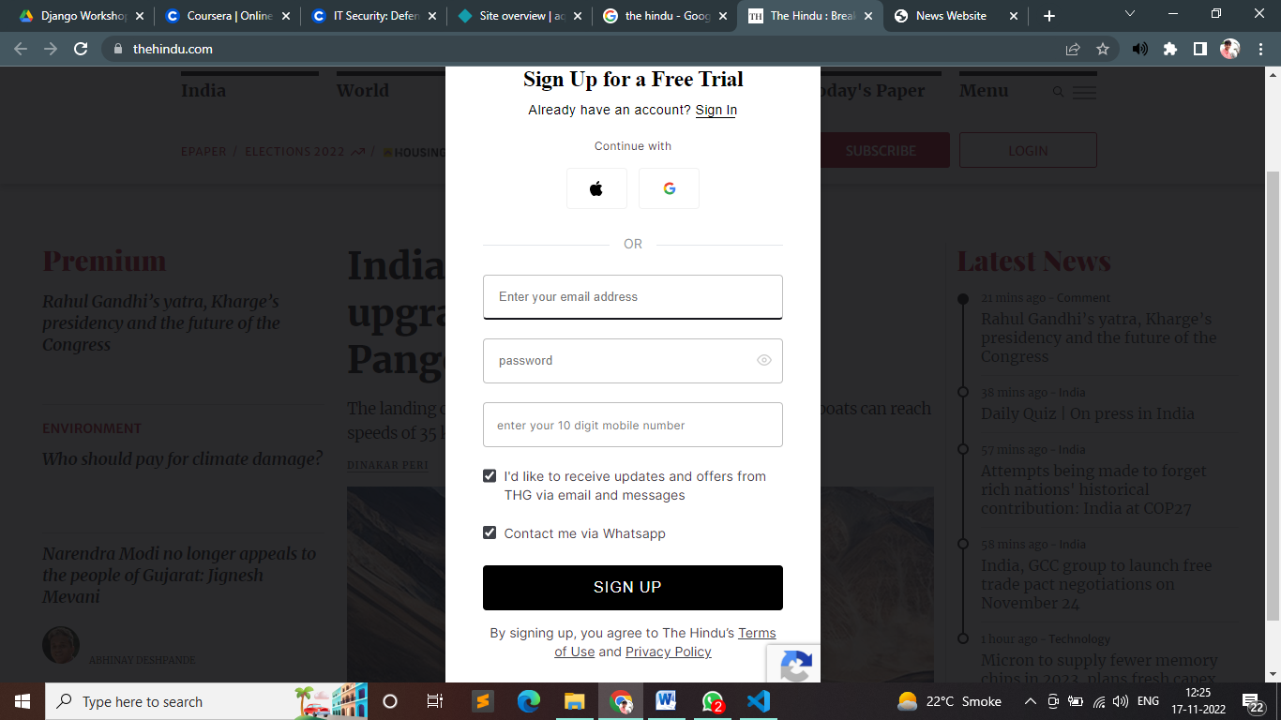
Various fields available in this form will be-
- Mobile Number : 10 digit long mobile number is accepted.
- Email: alphanumeric and can have length up to 50 characters. This email must have one '@' and '.' symbol.
- Password: alphanumeric in the range of 4 to 15 characters in length blank spaces are not allowed, however, special characters are allowed.

(iv) Search by Keyword:

Using search filter user can select the news he she wants to access associated with a given keyword. Effective search engine optimization helps improve our website rankings like using correct keywords and matter data which will learn credibility to the website
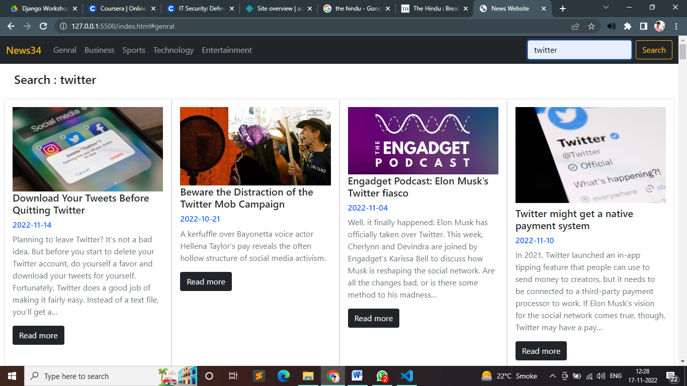

(v)News Articles:
Upon clicking any news article link from the homepage, it redirects the user to another website to the news article from a credible source of the news agency.

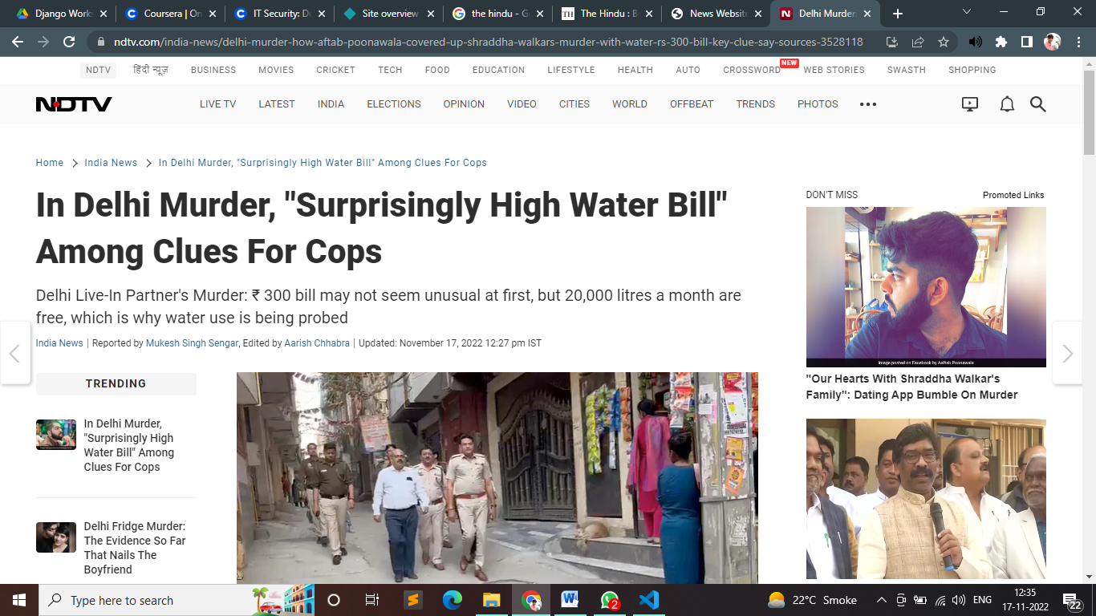

Hardware Interfaces
As stated in Section 2.1.3.

Software Interfaces
As stated in Section 2.1.4

Communication interfaces
None

Appendix

Use Case Diagram :
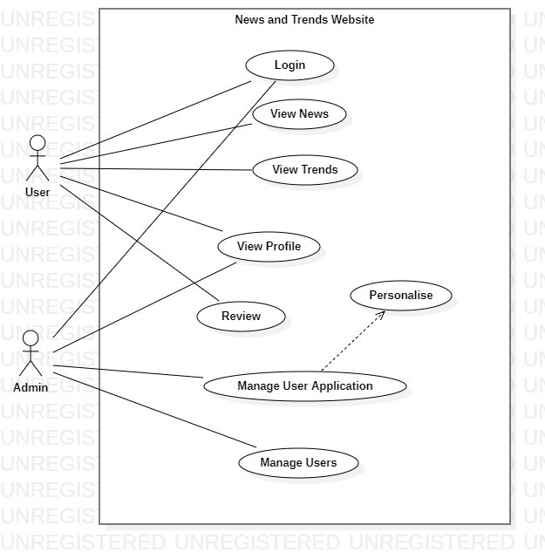

Class Diagram :
