Today’s Agenda

* Stream Ciphers
* How to design a flawed Security Protocol:

– WEP Case Study

* Fixing a flawed Protocol: WPA, WPA2

# Two types of symmetric ciphers

* Block ciphers (last week – recap)
  + Break plaintext message in equal-size blocks
  + Encrypt each block as a unit
  + Used in may Internet protocols (PGP-secure email,

SSL (secure TCP), IPsec (secure net-transport layer)

* Stream ciphers (today)
  + encrypt one bit at time – Used in secure WLAN

# Stream Ciphers

key keystream

keystream

generator

* Process message bit by bit (as a stream)
  + Ideal for real-time communication
  + A keystream must not be reused; otherwise the encrypted messages can be recovered
* *combine each byte of keystream with byte of plaintext to get ciphertext:*
  + m(i) = ith unit of message
  + ks(i) = ith unit of keystream
  + c(i) = ith unit of ciphertext
  + c(i) = ks(i) Å m(i) (Å = exclusive or)
  + m(i) = ks(i) Å c(i)

# Rivest Cipher 4 (RC4)

* Rivest Cipher 4: Designed by Ron Rivest
  + A proprietary cipher owned by RSA.com
  + No longer a trade secret
  + Ideal for software implementation, as it requires only byte manipulations
* Variable key size (40 to 256 bits), byte-oriented stream cipher
* Widely used
  + SSL, Wireless WEP and WPA, Cellular Digital Packet Data, OpenBSD pseudo-random number generator

# Wired Equivalent Privacy (WEP)

* Provide security equivalent to Wired Network – *Problem starts with this thinking!*
* Symmetric key crypto – confidentiality
  + end host authorization
  + data integrity
* Efficient
  + implementable in hardware or software

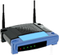

# Stream cipher and packet independence

* Design goal: each packet separately encrypted
* If for frame *n+1*, use keystream from where we left off for frame *n*, then each frame is not separately encrypted

– need to know where we left off for packet *n* (e.g Cipher Block chain approach)

* WEP approach: initialize keystream with key + new IV for each packet:

Key+IVpacket keystreampacket

keystream

generator

# WEP Pre-shared Key

* Enter a key (password) on access point and then enter the key on all devices
  + This is the pre-shared key, AKA WEP Key *(Shared Secret)*.
* Not possible to authenticate individuals
  + hard to distinguish who is using service - needs extra work.
* A key compromise for one user means that every device needs to change new key
  + Must be distributed to all users securely

# WEP encryption (1)

* sender calculates Integrity Check Value (ICV) over data
  + four-bytes for data integrity: uses CRC-32
* each side has 104-bit shared key(earlier only 40-bit)
* sender creates 24-bit initialization vector (IV), appends to key: gives 128-bit key
* sender also appends keyID (in 8-bit field)
* 128-bit key input into pseudo random number generator (PRNG) e.g. RC4 to get keystream
* data in frame + ICV is encrypted with RC4:
  + Bytes of keystream are XORed with bytes of data & ICV – IV & keyID are appended to encrypted data to create payload

encrypted

|  |  |  |  |
| --- | --- | --- | --- |
| IV | Key ID | data | ICV |

MAC payload

WEP encryption (2)

IV

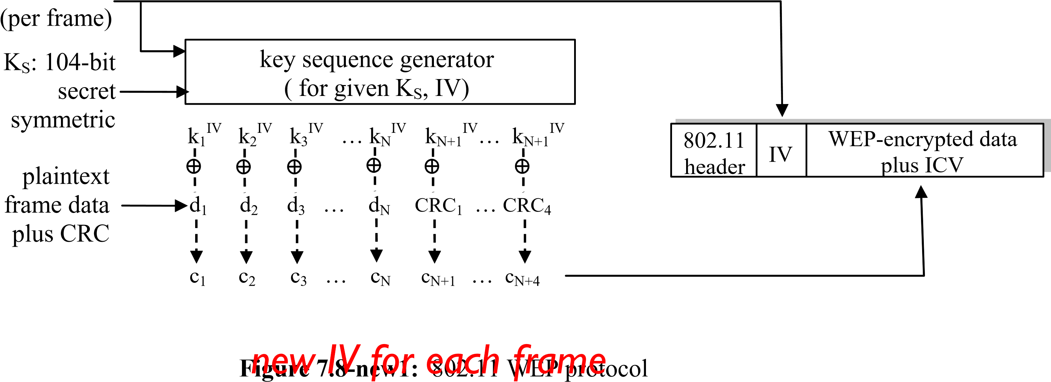

# WEP decryption

encrypted

|  |  |  |  |
| --- | --- | --- | --- |
| IV | Key ID | data | ICV |

MAC payload

* receiver extracts IV (*received in plaintext*)
* inputs IV, shared secret key into pseudo random generator, gets keystream
* XORs keystream with encrypted data to decrypt data + ICV
* verifies integrity of data with ICV

– note: message integrity approach used here is CRC-32 different from MAC (message authentication code) and signatures (using PKI).

# End-point authentication w/ nonce

*Nonce*: number (R) used only *once –in-a-lifetime*

*How to prove Alice* “*live*”*:* Bob sends Alice *nonce*, R. Alice must return R, encrypted with shared secret key



“

I am Alice

”

R

K (R) Alice is live, and only Alice knows key to encrypt nonce, so it

A

-

B

***Nonce:*** *protocol designHandy tool for secure* must be Alice!

# WEP authentication

authentication request



nonce (128 bytes) nonce encrypted shared key success if decrypted value equals nonce

*Notes:*

* not all APs do it, even if WEP is being used
* AP indicates if authentication is necessary in beacon frame v done before association

# Breaking 802.11 WEP encryption

*Security hole:*

• 24-bit IV, one IV per frame, -> IV’s eventually reused

~16Million IVs at high speed exhausted in 2 hours • IV transmitted in ***plaintext*** -> IV reuse detected *Attack:*

* Trudy causes Alice to encrypt known plaintext d1 d2 d3 d4 …
* Trudy sees: ci *=* di XOR kiIV
* Trudy knows ci di, so can compute kiIV *=* di XOR ci – Trudy knows encrypting key sequence k1IV k2IV k3IV … – Next time IV is used, Trudy can decrypt!

# Problem with Linear Checksum

* Encrypted CRC-32 used as integrity check Vector (ICV)
  + Fine for random errors, but not malicious ones
  + Bits can be changed in packet without decrypting
* An attacker can change encrypted content (substitute by gibberish), compute a CRC over the substituted text and produce an 802.11 frame that will be accepted by the receiver.

# Wi-Fi Protected Access (WPA)

* Two versions WPA and WPA2
  + WPA temporary solution to fix WEP while WPA2 developed
* WPA compatible with existing hardware that supported

WEP

* WPA uses Temporal Key Integrity Protocol (TKIP) – Used RC4 for compatibility
  + Every packet encrypted with unique encryption key

# 802.11i: WPA – New Features

* To provide stronger authentication than in WEP:
  + Special purpose Message Integrity Code (MIC) as opposed to

WEP CRC

* To prevent Fluhrer, Mantin and Shamir (FMS) aka FMS-style attacks
  + a new *per-frame key is* constructed using a cryptographic hash
* Temporal Key Integrity Protocol (TKIP) uses a cryptographic mixing function to combine a temporal key, the TA (transmitter MAC address), and the sequence counter into the WEP seed (128 bits)
  + Pre Shared Key (PSK) AKA WPA-Personal similar to WEP-Key o However, it is not used for encryption
  + Instead, PSK serves as the seed for hashing the per-frame key

# FMS Attack

• Fluhrer, Mantin and Shamir (FMS) attack

* + For 50% success rate, capture around 5 Million packets on average
  + Due to inherent weakness in RC4, output of encrypting with first few bytes of key not random
  + Certain key values generate predictable pattern of encrypted data

o Associated packets have IVs that are “weak”

* + Initial determine first bytes of key through IVs and then get the rest through statistical analysis
  + Encrypted ARP packets can be captured and replayed to get encrypted ARP response

o more in lab

802.11i: WPA Contd.

PSK Hash Temporal key Hash/ Encryption key



WEP



MIC

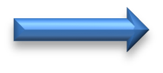

Nonceper frame

Sequence counter (IV) Mixing Integrity key

TA (transmitter per frame

MAC address)

Src: Irwin Wu

– TKIP changes the per packet key completely after every single packet

* + - * + One key for encryption (128 bits)
        + One key for integrity (64 bits)

– The WEP IV is extended to 48 bits, and used as a packet **sequence counter** o A per packet sequence counter is used to prevent **replay attacks** o If a packet is received out of order, it is dropped by the receiving station



Ciphertext



IV



Header



MIC



IC

V



FC

S

802.11 frame with WPA

# Recap: WEP vs WPA security

* WPA temporary solution Key to fix WEP while WPA2 developed
* WEP IV extended to 48-bit IV o Reuse > 100 years for

replay of the same IV

* RC4 key = Function(WPA

Key||IV) WPA:

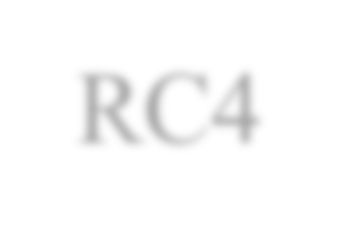

RC4



WEP:



IV: 24 bits

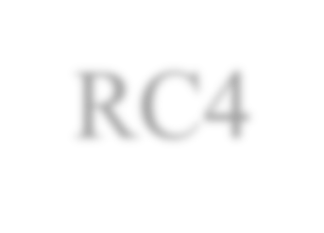

RC4

Temporal

Key



Keystream

i



d

i



c

i



IV: 48 bits

Key:

40

/104/232

bits



Keystream

i



Plaintext

stream

d

i



c

i

Ciphertext

stream



Hash/mixing



o Every packet encrypted Key with unique encryption key

* IV used as a packet sequence space to prevent replay attack

Src: Irwin Wu

# 802.11i: WPA2

* WPA2 2004
  + New AP hardware, 30 Million Instructions/sec, RC4 off-load hardware doesn’t do AES or CCMP
  + AES-CCMP 128-bit AES

o CCMP (Counter Mode with Cipher Block Chaining Message Authentication Code Protocol)

* + Improved 4-way handshake and temporary key generation
* We may cover some details of WPA2 but for now, if you have WPA2, this would be the safest option to use.
* WPA- Enterprise network security (802.1X) in later weeks

# WPA PSK Weakness

* WPA, using the Temporal Key Integrity Protocol, was cracked by Erik Tews and

Martin Beck

* + More in lab
* Thomas Roth demonstrated at the 2011 Black Hat conference that WPA PSKs can be cracked quickly and easily using Amazon's Elastic Compute Cloud (EC2) service
  + He cracked his neighbor's WPA password in 20 minutes using a dictionary attack and a list of 70 million words
  + The attack only required one instance of Roth's self-made Cloud Cracking Suite (CCS) tool running in the cloud
  + It reached about 50,000 PSKs/s
* The EC2 uses 400 cloud CPUs to launch a dictionary attack on a WPA key for $17
  + [http://www.wpacracke](http://www.wpacracker.com/)r.com/
  + The attack is based on a list containing 135 million entries which can be extended to include such optional extras as a German dictionary or an extended English language word list (284 million entries)

# Hotspot Security

* For most hotspots: Unfortunately almost none!
* If you do not have to configure any security parameters besides typing in a username and password in a web page, expect the following:
  + The hotspot operator checks your authenticity at logon time (often protected with SSL to protect against eavesdropping on your password)
  + Only authenticated clients will receive service as packet filtering is deployed to only allow accessing the logon page until successful authentication – Once logon authentication has been checked: no further security measures – No protection for your user data:
* Everything can be intercepted and manipulated
  + However, you can deploy your own measures, e.g. VPN or SSL, but configuration is often tedious or not even supported by communication partner and performance

is affected because of additional (per-packet-) overhead o Plus: your session can be stolen by using your MAC & IP addresses!

# Acknowledgements

* *Acknowledgement: foils are adapted mainly from* **Introduction to Computer Networks and Cybersecurity by Wu and Irwin, CRC Press (Chapter 21)**
* *Some foils are also from Günter Schäfer,* **Security in Fixed and Wireless Networks***, Wiley (new edition available in German only, English in 2015)*
* *A few foils are from Adrian Perrig (ETH)*
* *Refer to Cybok Network Security KA Section:7 for brief summary*

# Message Forgery (Self-Read)

* CRC-32 is *linear*, which means that it is possible to compute the bit difference of two CRCs based on the bit difference of the messages over which they are taken.
* Flipping bit n in the message results in a deterministic set of bits in the CRC that must be flipped to produce a correct checksum on the modified message.
* Because flipping bits carries through after an RC4 decryption, this allows the attacker to flip arbitrary bits in an encrypted message and correctly adjust the checksum so that the resulting message appears valid.
* Implications:
* “Integrity check” does not prevent packet modification
* Can maliciously flip bits in packets o Modify active streams! o Bypass access control
* Partial knowledge of packet is sufficient