Advanced Shell Simulator
Screenshot Description Report
Student: Kolla Mohan Chaitanya
UC ID: 005061481
This document explains the application output shown in the supplied screenshots. Each figure identifies the visible user action, the result produced by the simulator, and the operating-system concept demonstrated.

Project context
The application is a Flutter-based Advanced Shell Simulator. It models shell commands, process management, scheduling, paging, synchronization, piping, authentication, and file permissions in memory. The simulator does not execute commands on the host computer or modify the host filesystem.

How to read the screenshots
Visual area | Meaning
Terminal | Command input, shell output, authentication messages, and simulated process results.
Scheduling tab | Round-Robin and priority controls plus execution metrics.
Memory tab | Resident pages, page faults, frame count, and FIFO/LRU demonstrations.
Synchronization tab | Producer-consumer buffer state and mutex event log.
Security tab | Users, roles, file owners, modes, and access restrictions.

Figure-by-figure explanation
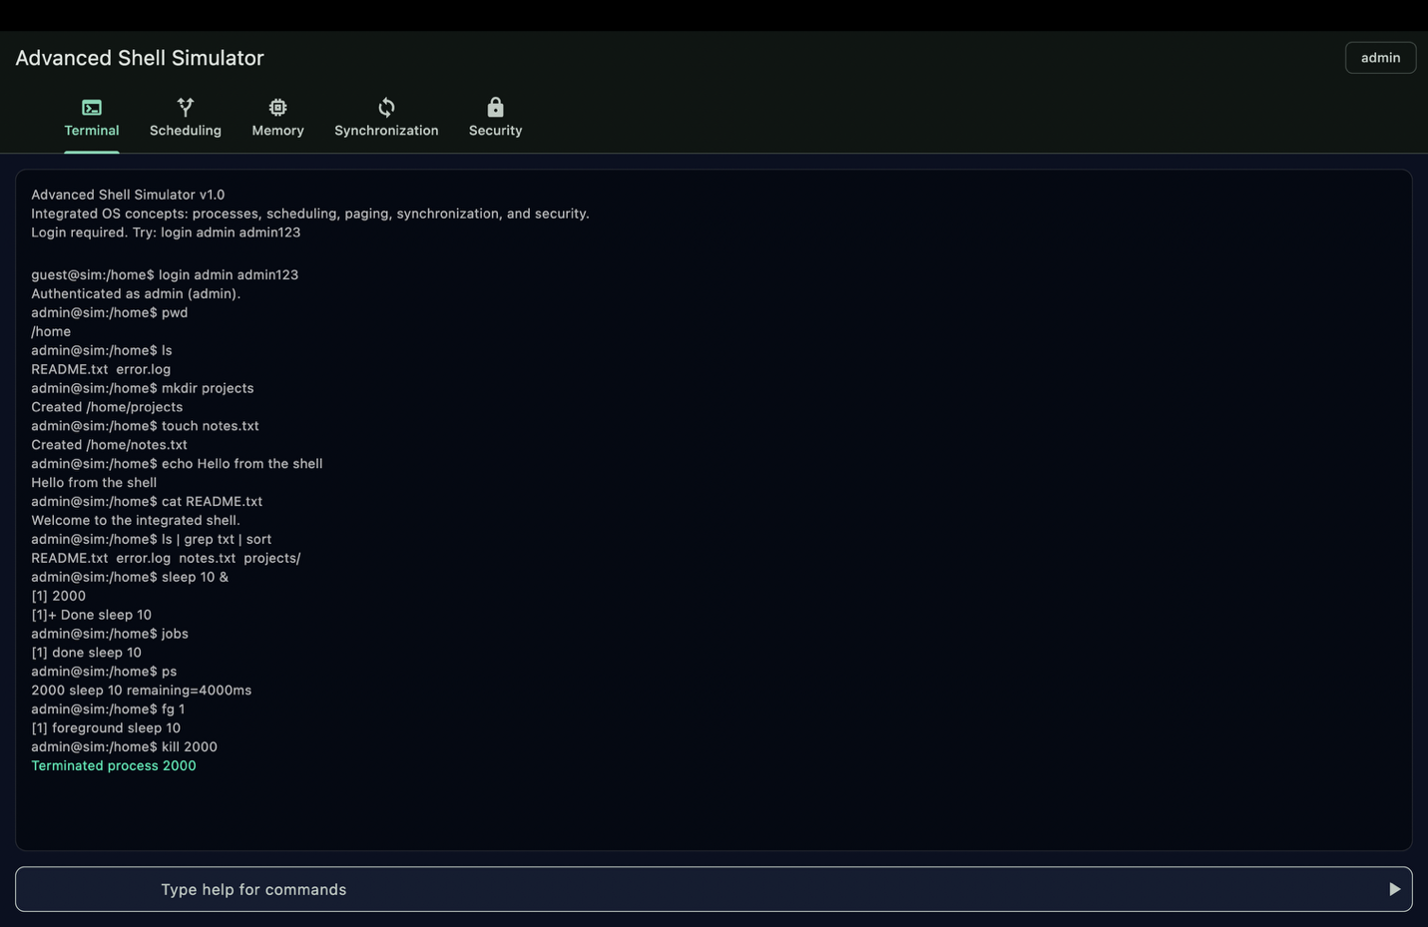
Figure 1. Terminal startup and authentication
What is visible: The first screenshot shows the application opening on the Terminal tab. The shell identifies itself as Advanced Shell Simulator and prints the supported OS concepts. The authentication prompt and login instructions are visible, followed by a successful administrator login. This establishes that the terminal is protected and that commands are entered through the simulated shell rather than executed directly by the host operating system.
Why it matters: This demonstrates the initial shell environment, authentication gate, and the terminal prompt used for later commands.
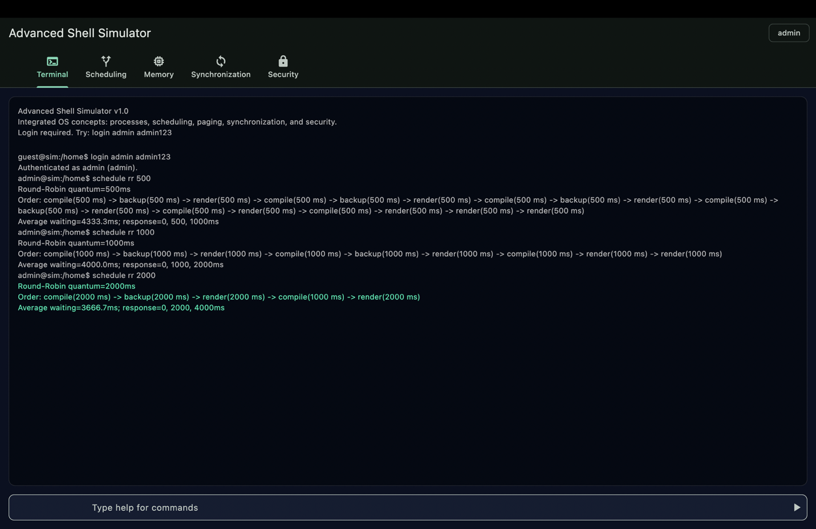
Figure 2. Terminal command execution and process scheduling
What is visible: The second screenshot shows a sequence of terminal commands and their output. The shell accepts built-in commands, starts simulated processes, and displays scheduling results. The output includes Round-Robin execution with a configurable quantum and priority scheduling with process ordering and timing metrics. The result confirms that scheduling is implemented as an internal simulation with synthetic process data.
Why it matters: The screenshot demonstrates command parsing, process creation, scheduling order, and performance information such as waiting, response, and turnaround-related values.

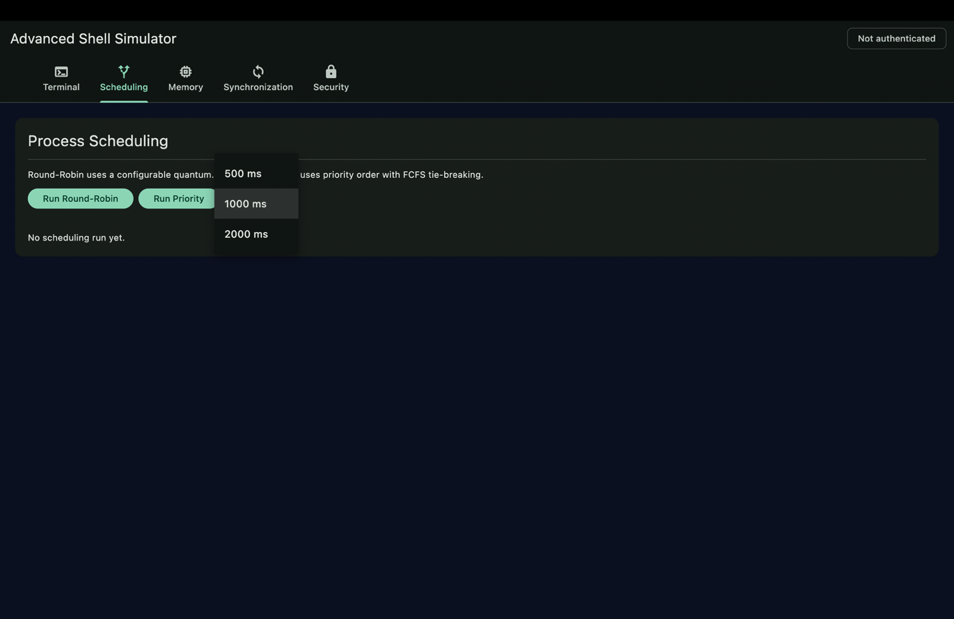
Figure 3. Scheduling control panel
What is visible: The third screenshot shows the dedicated Process Scheduling panel. It provides controls for running Round-Robin and Priority scheduling and a quantum selector with values such as 500 ms, 1000 ms, and 2000 ms. The panel explains that Round-Robin uses a configurable time slice and that priority scheduling uses priority order with FCFS handling for ties.
Why it matters: This is the visual demonstration surface for Deliverable 2. It allows the user to change the time slice and compare scheduling strategies without typing commands.
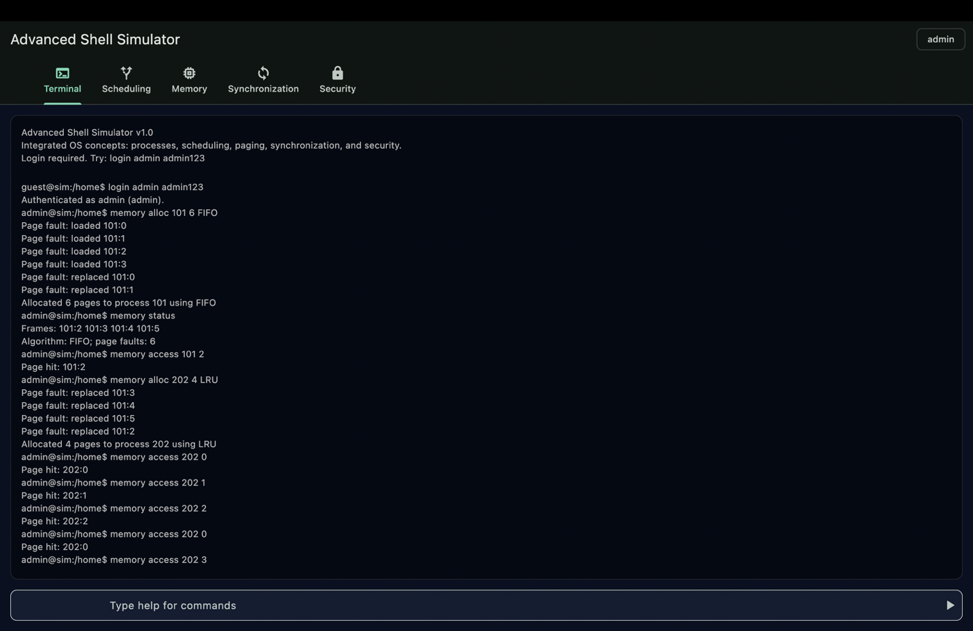
Figure 4. FIFO paging and page faults
What is visible: The fourth screenshot returns to the terminal and shows memory commands using the FIFO replacement algorithm. Pages are allocated to a simulated process, page requests are processed, and page-fault messages appear when requested pages are not resident. Once the fixed number of frames is full, the oldest loaded page is selected for replacement.
Why it matters: The output demonstrates fixed-size page frames, page-fault detection, FIFO victim selection, and memory allocation tracking.

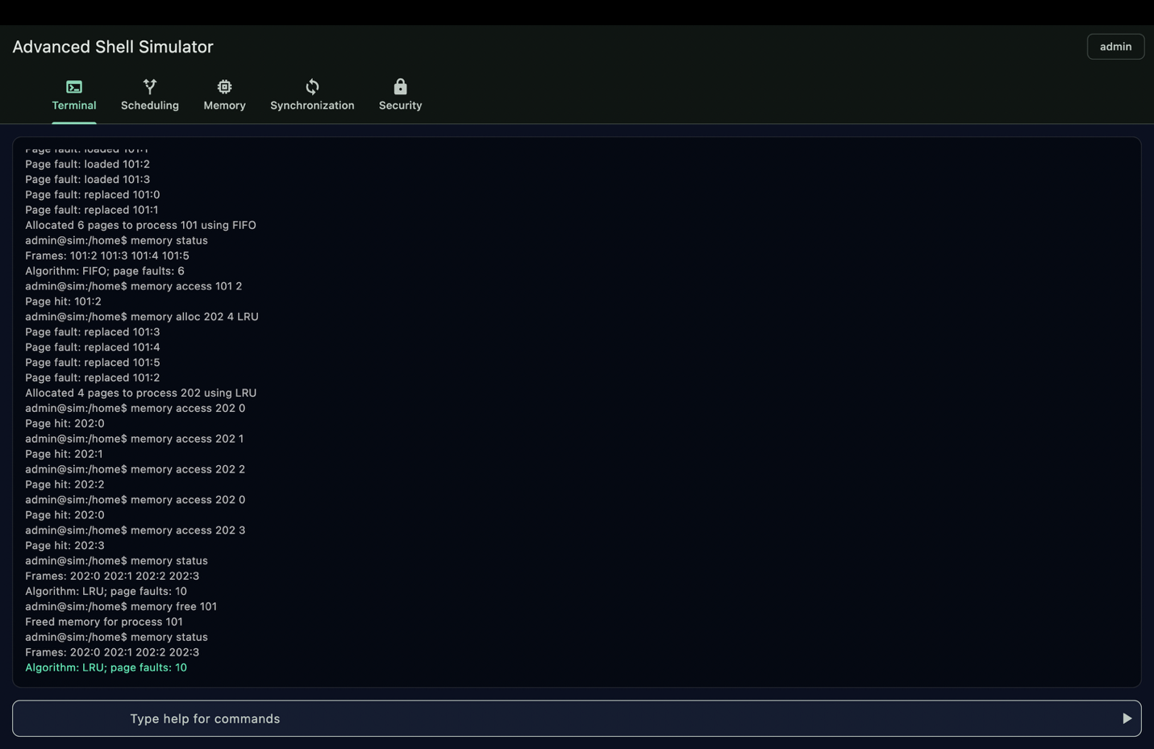
Figure 5. LRU paging and memory status
What is visible: The fifth screenshot continues the memory demonstration using LRU behavior. The terminal shows page accesses and replacements based on recent-use history. The memory status output reports the resident pages, the selected replacement algorithm, and the accumulated page-fault count.
Why it matters: This demonstrates how LRU differs from FIFO: the page that has gone unused for the longest time is replaced rather than simply the page loaded first.
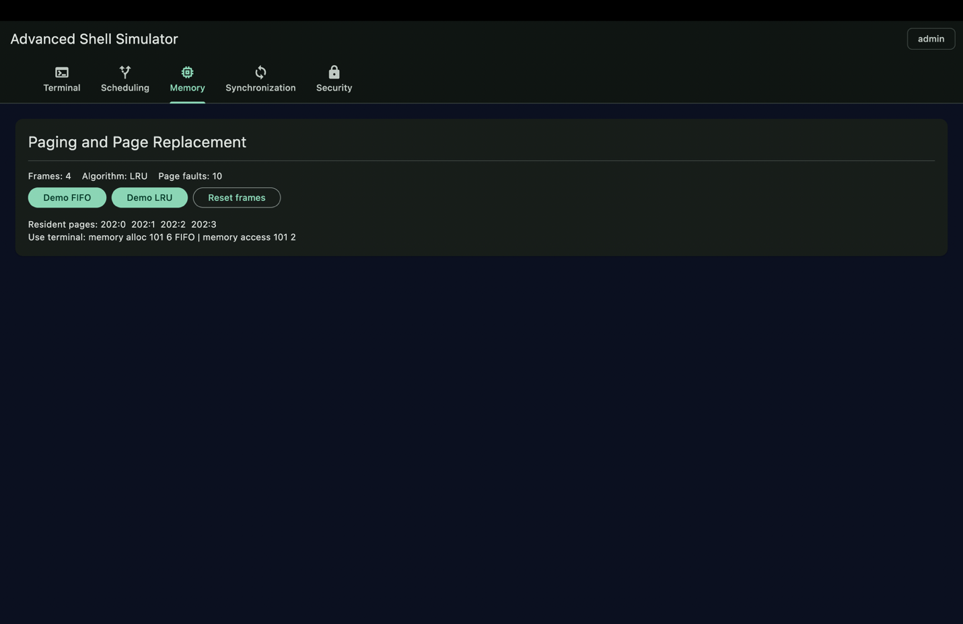
Figure 6. Memory management panel
What is visible: The sixth screenshot shows the Paging and Page Replacement panel. It displays the number of frames, the active algorithm, and the page-fault total. Buttons are provided for FIFO and LRU demonstrations and for resetting the frames. The resident-page list makes the simulated memory contents visible.
Why it matters: This panel provides a concise visual summary of memory usage and allows both replacement algorithms to be demonstrated repeatedly.

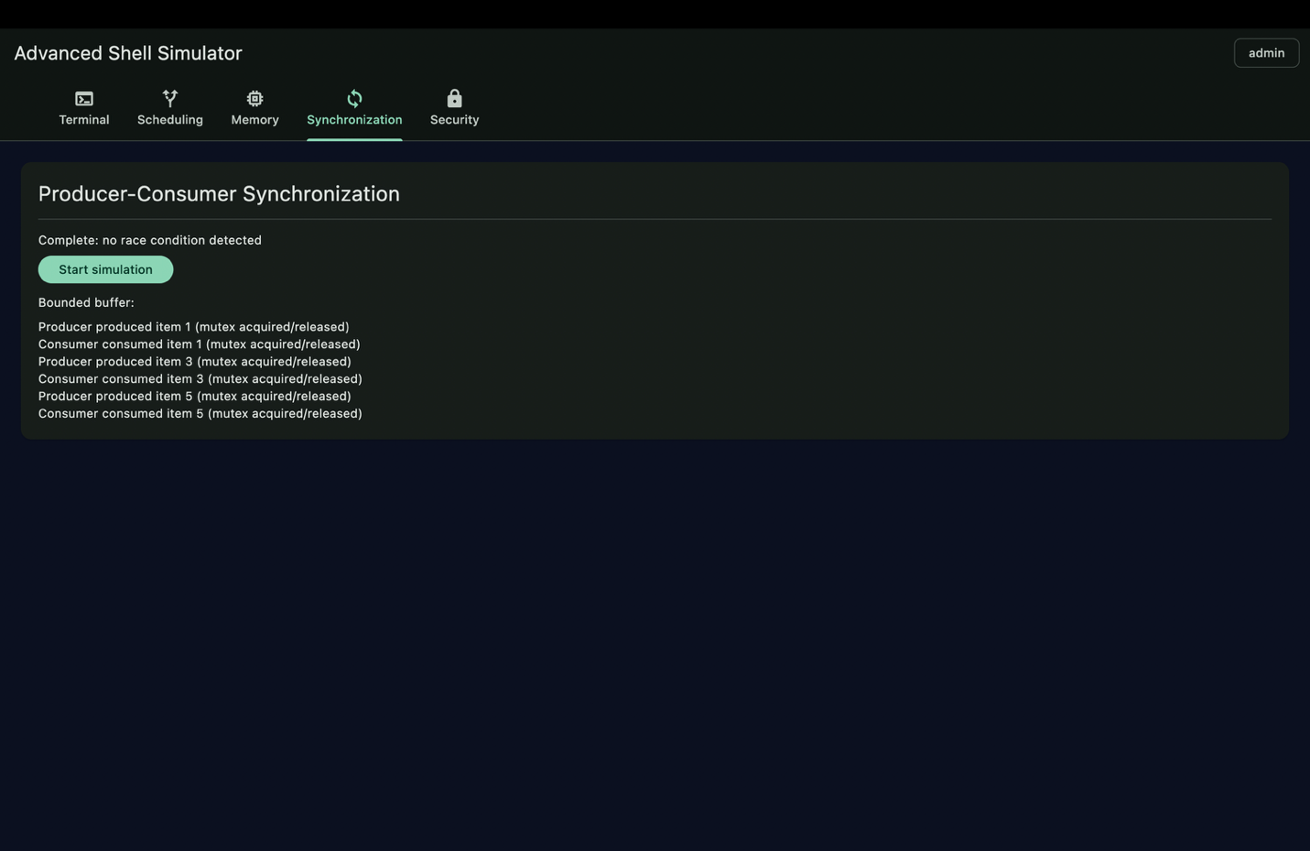
Figure 7. Producer-consumer synchronization
What is visible: The seventh screenshot shows the completed Producer-Consumer Synchronization panel. The status indicates that the simulation finished without a race condition. The bounded buffer and event log show producers creating items and consumers removing them while mutex acquisition and release are recorded.
Why it matters: This demonstrates controlled access to a shared resource, bounded-buffer capacity, and synchronization behavior that prevents unsafe simultaneous updates.
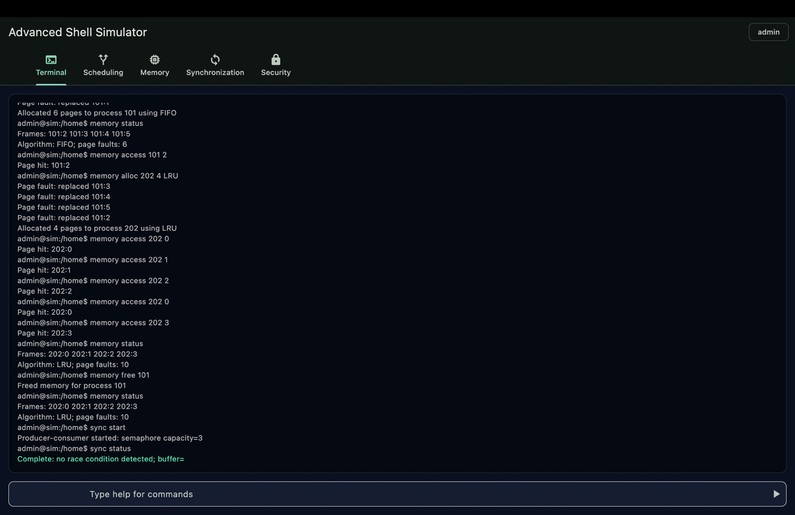
Figure 8. Integrated synchronization and memory output
What is visible: The eighth screenshot shows the terminal after running synchronization and memory-related commands together. It provides a command-line view of page operations, memory status, and synchronization events. The output demonstrates that the deliverables are integrated into one shell session rather than implemented as unrelated screens.
Why it matters: The screenshot is evidence that the terminal can drive the underlying OS simulations while the corresponding panels provide visual summaries.

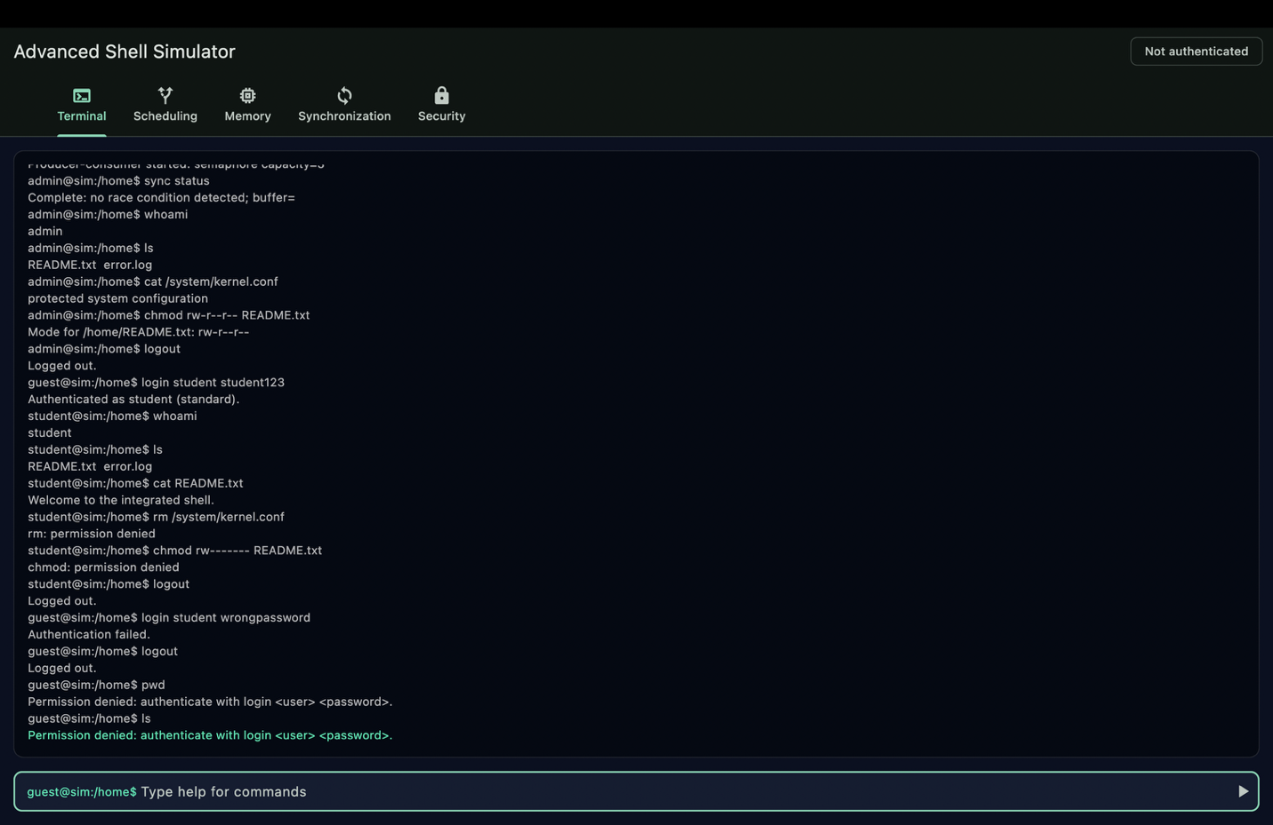
Figure 9. Security commands and permission checks
What is visible: The ninth screenshot shows authentication and file-permission commands in the terminal. It includes user identity changes and attempts to access or modify files with different ownership and modes. Permission-denied messages demonstrate that the shell applies role and ownership checks instead of allowing every user to modify every resource.
Why it matters: This demonstrates administrator versus standard-user behavior, authentication failures or logout/login transitions, and enforcement of protected-file rules.
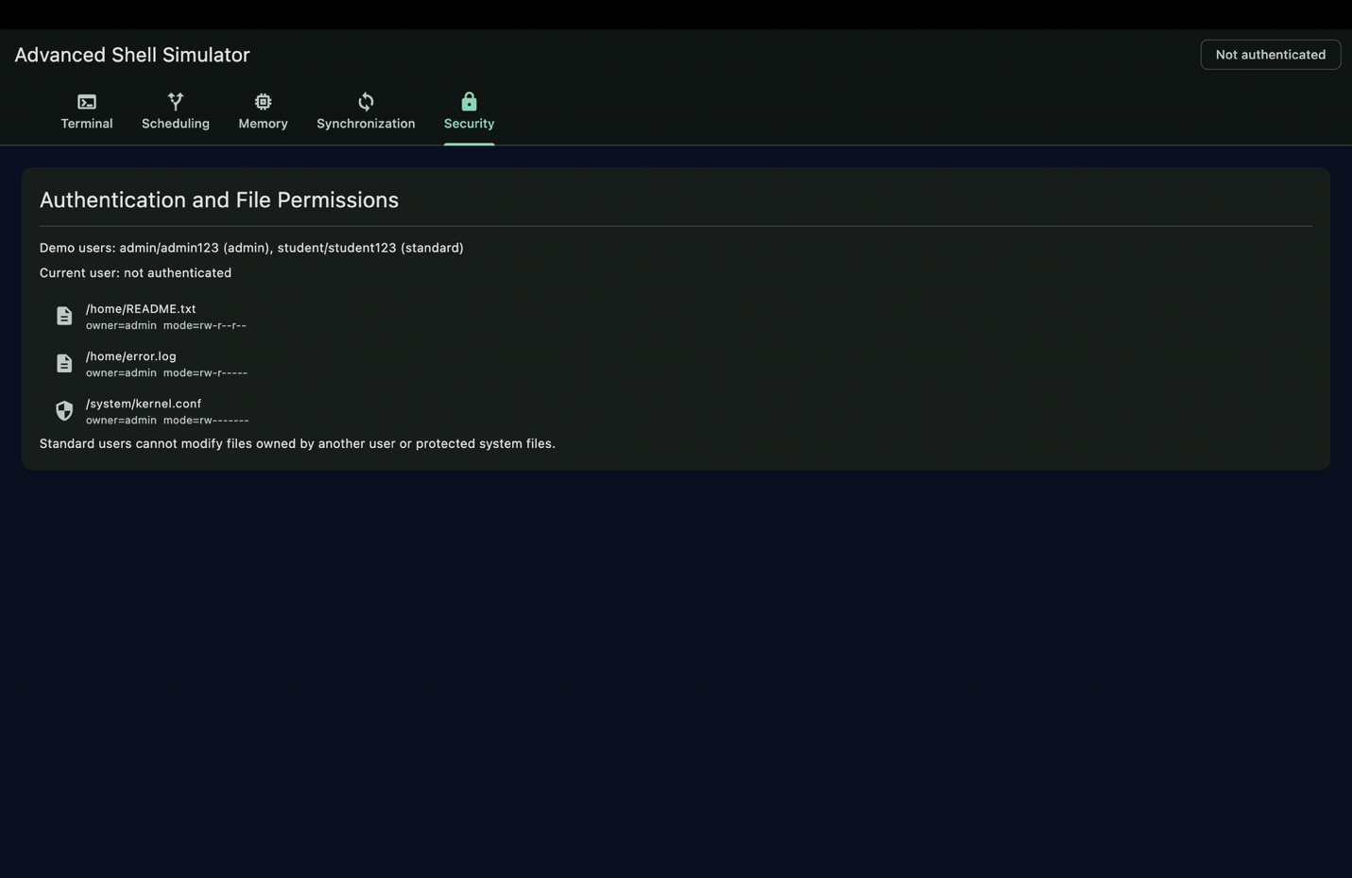
Figure 10. Security and file-permission panel
What is visible: The tenth screenshot shows the Authentication and File Permissions panel. It lists the demo credentials, current user state, file owners, and permission modes. System files are visibly separated from ordinary home files, making the protection model easy to inspect.
Why it matters: This panel documents the security design: authenticated users have roles, files have owners and modes, and standard users cannot modify protected system resources.

Overall interpretation
Taken together, the screenshots show a complete integrated simulation. The terminal is the command-driven interface, while the four additional panels expose the internal state of scheduling, memory, synchronization, and security. The outputs show both successful operations and controlled state changes, including page faults, job transitions, synchronization events, and permission checks.

Suggested screenshot captions for submission
- Figure 1: Terminal startup and authentication in the Advanced Shell Simulator.
- Figure 2: Terminal command execution and process scheduling in the Advanced Shell Simulator.
- Figure 3: Scheduling control panel in the Advanced Shell Simulator.
- Figure 4: FIFO paging and page faults in the Advanced Shell Simulator.
- Figure 5: LRU paging and memory status in the Advanced Shell Simulator.
- Figure 6: Memory management panel in the Advanced Shell Simulator.
- Figure 7: Producer-consumer synchronization in the Advanced Shell Simulator.
- Figure 8: Integrated synchronization and memory output in the Advanced Shell Simulator.
- Figure 9: Security commands and permission checks in the Advanced Shell Simulator.
- Figure 10: Security and file-permission panel in the Advanced Shell Simulator.

Conclusion
The supplied output demonstrates the main requirements of the project. The screenshots can be used as evidence in the final submission because each one is connected to a specific deliverable and explained in terms of the behavior visible in the application.

