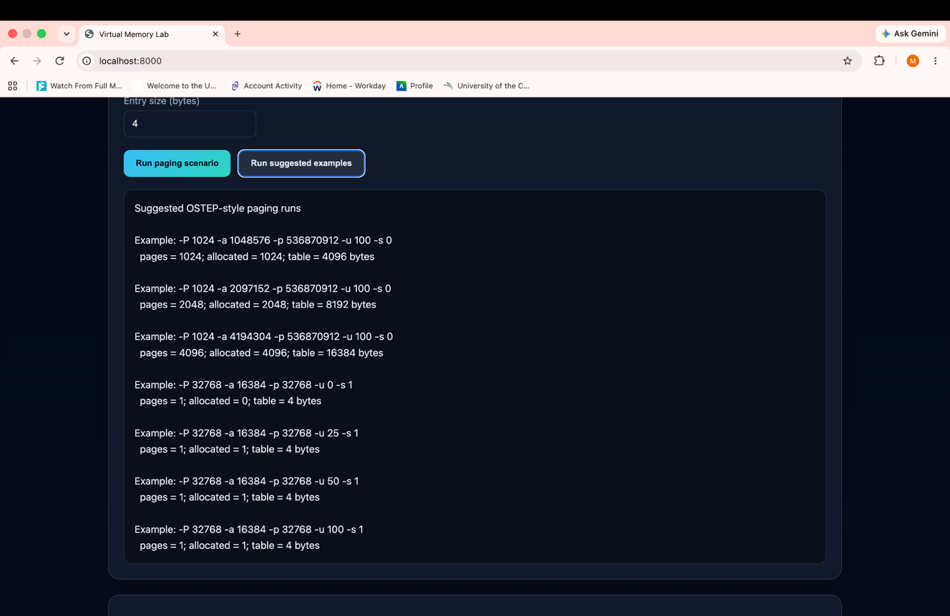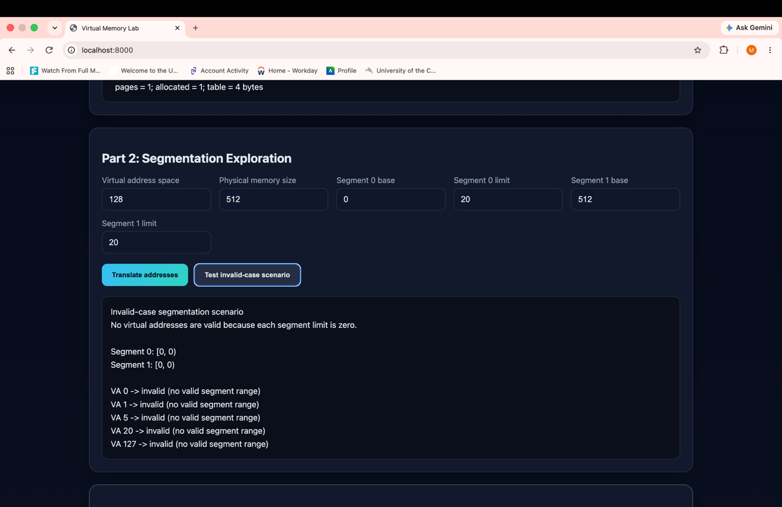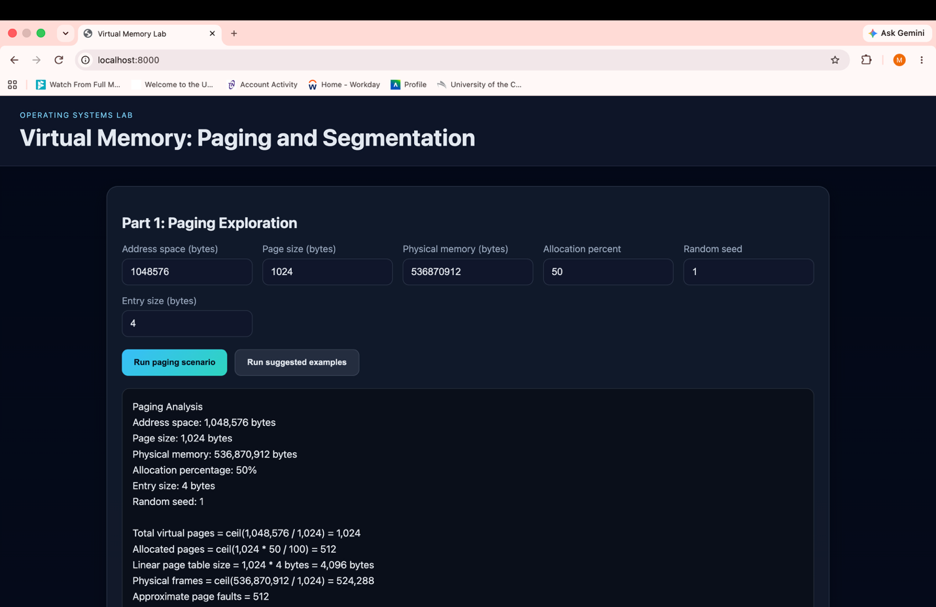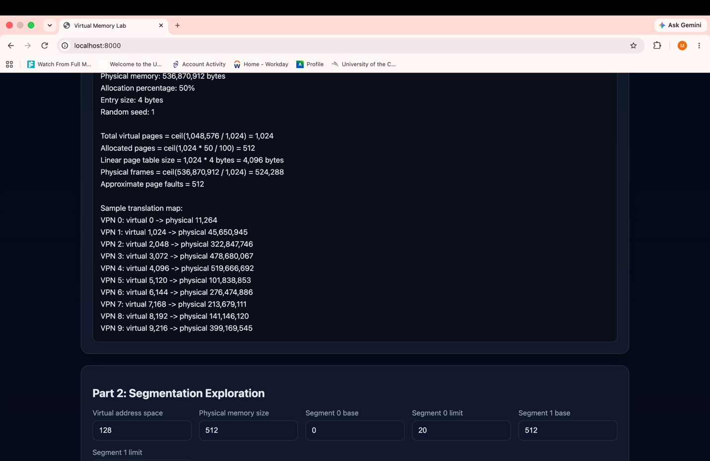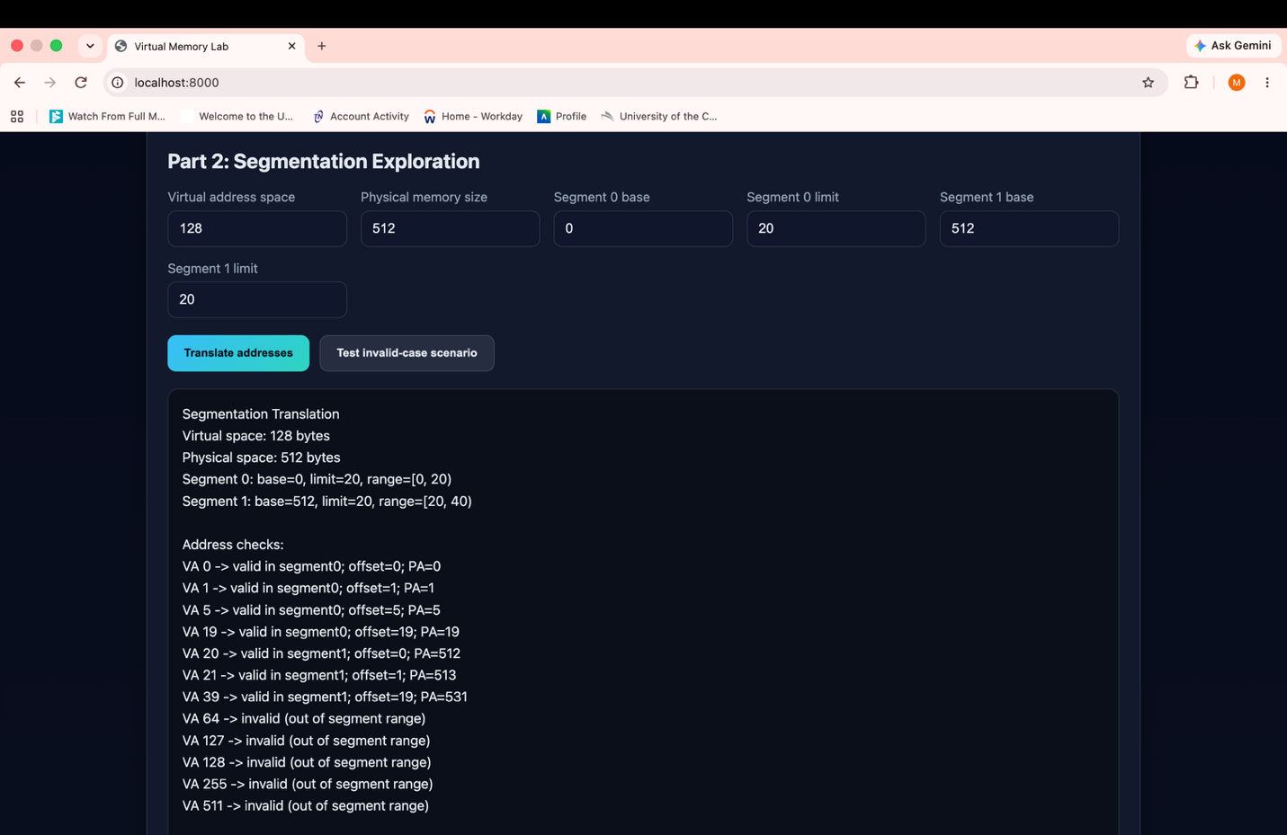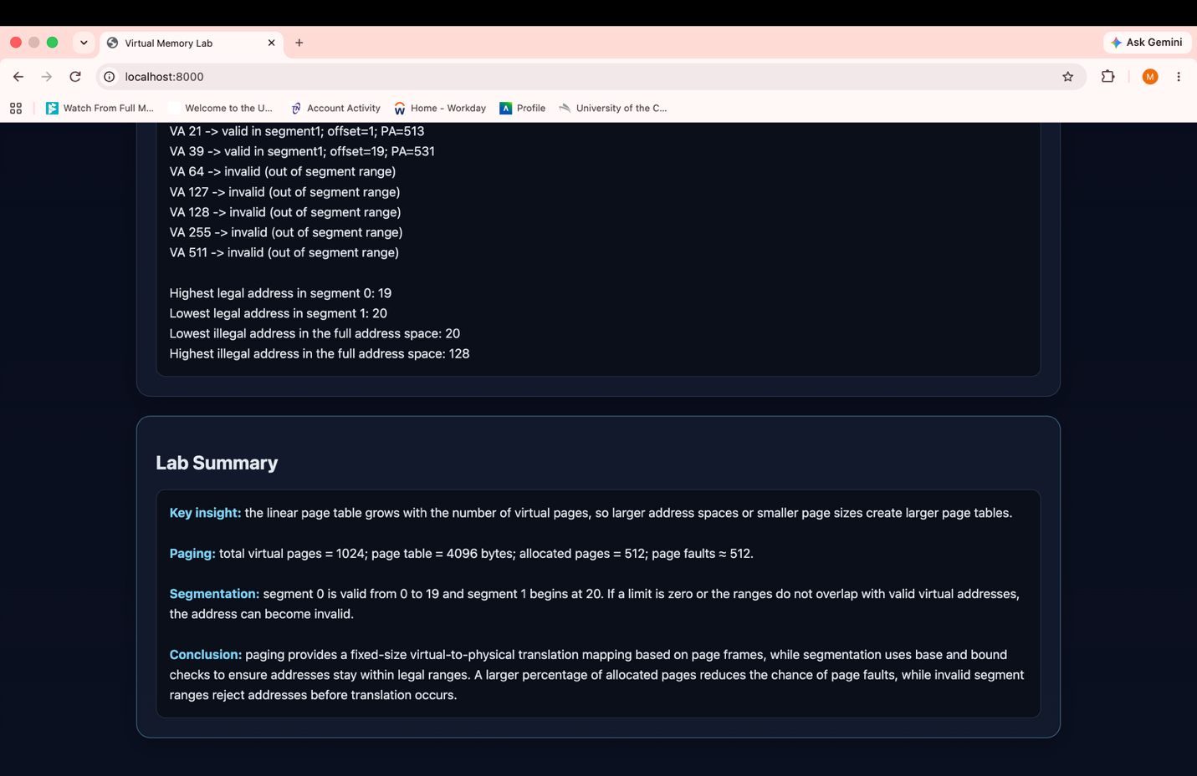

Screenshot Descriptions
The following captions explain what each screenshot demonstrates and how it supports the paging and segmentation lab requirements.

Screenshot 1: Suggested paging experiments
This screenshot shows the suggested OSTEP-style paging runs. Increasing the address space from 1 MB to 2 MB and 4 MB increases the number of virtual pages from 1,024 to 2,048 and 4,096, so the linear page table grows from 4,096 to 8,192 and 16,384 bytes. The lower examples use a 32 KB page size, producing one page for the 16 KB address space and a very small four-byte page table.

Screenshot 2: Segmentation invalid-address test
This screenshot demonstrates the zero-limit boundary case. Both segments have the range [0, 0), so no virtual address is contained in a valid segment. Every tested address is rejected as invalid, confirming how segment limits enforce protection.

Screenshot 3: Paging simulator inputs and analysis
This screenshot shows the paging controls and the calculated results for a 1 MB address space, 1 KB pages, 512 MB physical memory, 50 percent allocation, and four-byte page-table entries. The simulator reports 1,024 virtual pages, 512 allocated pages, a 4,096-byte linear page table, and approximately 512 page faults.

Screenshot 4: Paging translation map
This screenshot shows sample virtual-page translations. Each virtual page is either mapped to a physical address through a frame or would produce a page fault when it is not allocated. The random seed changes the selected frame mappings while leaving the page-table-size calculation unchanged.

Screenshot 5: Segmentation address translation
This screenshot shows the base-and-limit translation rules. Segment 0 covers virtual addresses 0 through 19 and maps them from base 0. Segment 1 covers virtual addresses 20 through 39 and maps them from base 512, so virtual address 20 translates to physical address 512 and address 39 translates to 531. Addresses outside these ranges are invalid.

Screenshot 6: Segmentation range analysis and lab summary
This screenshot summarizes the legal and illegal ranges and connects the simulator output to the lab concepts. The highest legal address in segment 0 is 19, the lowest legal address in segment 1 is 20, and addresses outside the defined ranges are rejected. The summary contrasts fixed-size paging with base-and-bound segmentation.

