Assignment
1) From the Groq and Openairouter
https://console.groq.com/home
https://developers.openai.com/api/docs/models/all
--List down the Multimodels
Source | Multimodel | Input | Output
Groq :https://console.groq.com/home | .Llama 4 Scout 17B 16E | Text, images | Text
Opean AI :https://developers.openai.com/api/docs/models/all | GPT-5.4 , GPT 5.4 mini, GPT-5 Mini, GPT-5,  GPT -5.4 pro, GPT-5.4 nano,GPT-5 nano,GPT-5 nano,GPT4.1 | Text, image | Text
 | GPT Image 1.5 | Text, image | Text,Image
 | GPT Image 1 & mini | Text,Image | Image
 | chatgpt-image-latest | Text,image | Image,Text
 | Sora 2, sora 2 pro | Text,image | video,audio
 | gpt-realtime-mini | Text, image, audio | Text, audio
 | GPT-4o Audio,realtime,GPT audio 1.5 | Text, audio | Text, audio
 | GPT-4o Transcribe & diazire | Audio,text | text

2) Take 3 models from each service provider https://openrouter.ai/models
Provider | Model | Context | Input Cost ($/M tokens) | Output Cost ($/M tokens)
Google | Gemma 4 26B A4B | 262K | $0.0700/M | $0.4000/M
 | Nano Banana 2 (Gemini 3.1 Flash Image Preview) | 66K | $0.5000/M | $3.0000/M
 | Gemini 3.1 Flash Lite Preview | 1.05M | $0.2500/M | $1.5000/M
OpenAI | GPT-5.4 Nano | 400K | $0.2000/M | $1.2500/M
 | GPT-5.4 Mini | 400K | $0.7500/M | $4.5000/M
 | GPT-5.4 Pro | 1.05M | $30.0000/M | $180.0000/M
Qwen | qwen3.5-35b-a3b | 262K | $0.1625/M | $1.3000/M
 | Qwen3.5-27B | 262K | $0.1950/M | $1.5600/M
 | Qwen3.5-122B-A10B | 262K | $0.2600/M | $2.0800/M

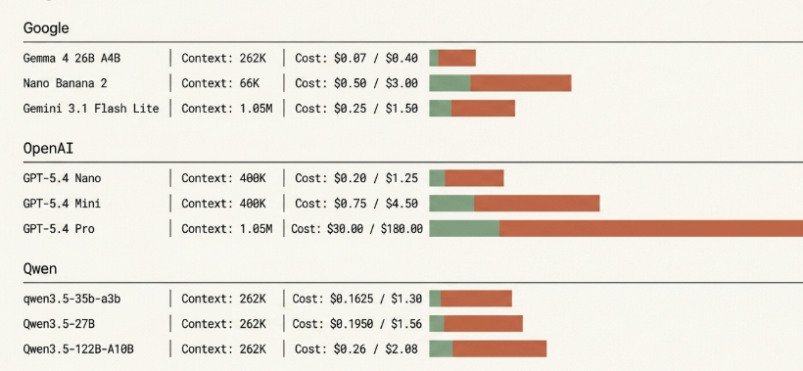

3) use the Tokenizer with different prompt and see how the tokens are generated
https://platform.openai.com/tokenizer
