Customer Churn Prediction and Segmentation using Machine Learning
Report submitted as part of the internship program requirement for the degree of
BACHELOR OF TECHNOLOGY
IN
COMPUTER SCIENCE ENGINEERING (AI & ML)
Submitted by
SUNKARA MOHANA SRUTHI (Registration No. ____________)
Internship carried out through the PEARL Program organised by
Q2D (Quantum Quotient Decode) in collaboration with
IBM Innovation Centre for Education (IBM ICE)
20th May 2026 – 20th July 2026
DEPARTMENT OF CSE (AI & ML)
ANIL NEERUKONDA INSTITUTE OF TECHNOLOGY AND SCIENCES
(UGC AUTONOMOUS)
(Permanently Affiliated to AU, Approved by AICTE, and Accredited by NBA & NAAC with an 'A+' Grade)
SANGIVALASA, Bheemili Mandal, VISAKHAPATNAM – 531162
2023-2027

ANIL NEERUKONDA INSTITUTE OF TECHNOLOGY AND SCIENCES
(Affiliated to Andhra University)
SANGIVALASA, VISAKHAPATNAM – 531162
2023-2027
BONAFIDE CERTIFICATE
This is to certify that this Internship Report “Customer Churn Prediction and Segmentation using Machine Learning” carried out under the Internship in “Artificial Intelligence & Machine Learning”, offered through the PEARL Program organised by Q2D (Quantum Quotient Decode) in collaboration with IBM Innovation Centre for Education (IBM ICE), is the bonafide work of SUNKARA MOHANA SRUTHI (Registration No. ____________) of III/IV CSM, carried out under my supervision.
REVIEWER | CLASS TEACHER
Mr./Ms. ____________________ | Mr./Ms. ____________________
Assistant Professor | Assistant Professor
Department of CSE (AI & ML) | Department of CSE (AI & ML)
ANITS | ANITS

Head of the Department
DR. K. SELVANI DEEPTHI
Department of CSE (AI & ML)
ANITS

ACKNOWLEDGEMENT
An endeavor that spans a significant period becomes a success only with the advice, encouragement, and support of many well-wishers. I take this opportunity to express my sincere gratitude and appreciation to all those who have made this internship experience both enriching and rewarding.
First and foremost, I extend my heartfelt thanks to Dr. K. S. Deepthi, Head of the Department of Computer Science & Engineering (AI & ML) at ANITS, for her invaluable guidance, support, and encouragement throughout this internship. Her mentorship and insights have been crucial to my growth during this period.
I would also like to express my deepest appreciation to Q2D (Quantum Quotient Decode) and the IBM Innovation Centre for Education for offering me the opportunity to undertake this internship under the PEARL Program. I am grateful to my mentors and programme coordinators, whose continuous guidance and expertise helped me navigate challenges and strengthen my technical skills.
My sincere thanks go to all the faculty members of the Computer Science & Engineering (AI & ML) department for their valuable advice and encouragement. I am equally grateful to the support staff, whose assistance in providing resources whenever required was instrumental in the successful completion of my internship.

SUNKARA MOHANA SRUTHI
Registration No. ____________
Application No: IBMQ2DST1189

Table of Contents
1. Introduction
1.1 Background of the Internship
1.2 Objectives of the Internship
1.3 Importance of AI & ML in Customer Analytics
1.4 Scope of the Project

2. Organization Profile
2.1 IBM Innovation Centre for Education (IBM ICE)
2.2 Role of Q2D (Quantum Quotient Decode)
2.3 The PEARL Program
2.4 Programme Summary

3. Project Overview
3.1 Title of the Project
3.2 Problem Statement
3.3 Objectives of the Project
3.4 Relevance to the Telecom Business

4. Literature Review / Theoretical Background
4.1 Customer Churn and Its Business Impact
4.2 Role of Machine Learning in Churn Prediction
4.3 Decision Trees for Classification
4.4 K-Means Clustering for Customer Segmentation
4.5 Evaluation Metrics for Imbalanced Classification
4.6 Related Works

5. Methodology
5.1 Data Collection and Dataset Description
5.2 Data Cleaning and Preprocessing
5.3 Exploratory Data Analysis
5.4 Feature Encoding and Train-Test Split
5.5 Model Selection - Decision Tree with GridSearchCV
5.6 Customer Segmentation using K-Means

6. Implementation
6.1 Phase 1 - Data Loading, Cleaning and Exploration
6.2 Phase 2 - Encoding, Splitting and Model Tuning
6.3 Phase 3 - Model Evaluation and Rule Extraction
6.4 Phase 4 - Clustering and Segment Profiling
6.5 Improvements Made Over the Baseline Approach

7. Results and Discussion
7.1 Classification Performance
7.2 Confusion Matrix and ROC Curve
7.3 Decision Rules Learned by the Model
7.4 Feature Importance
7.5 Customer Segments and Their Churn Behaviour
7.6 Interpretation and Business Recommendations

8. Conclusion & Future Work
8.1 Summary of Learning
8.2 Skills Acquired
8.3 Limitations of the Current Approach
8.4 Future Scope

9. Internship Outcomes
9.1 Technical Skills Acquired
9.2 Soft Skills Developed
9.3 Contribution to Career Growth

Appendix
A. Source Code
B. Dataset Snapshot
C. Certificate of Completion

1. Introduction

1.1 Background of the Internship
This report presents the learning experience and outcomes of a virtual internship in Artificial Intelligence & Machine Learning, undertaken as part of the academic requirements for the Bachelor of Technology in Computer Science and Engineering (AI & ML). The internship was offered through the PEARL Program organised by Q2D (Quantum Quotient Decode) in collaboration with the IBM Innovation Centre for Education (IBM ICE), and was conducted from 20th May 2026 to 20th July 2026.
The programme was built around project-based learning, where the emphasis was not only on understanding machine learning algorithms in theory but on applying them end-to-end to a realistic business dataset. The project selected for this internship was customer churn analysis for a telecommunications provider - a problem that is commercially significant, data-rich, and well suited to both supervised and unsupervised learning techniques.
Customer churn refers to the loss of subscribers who discontinue their service within a given period. In the telecom sector, competition is intense, switching costs for customers are low, and the cost of acquiring a new customer is considerably higher than the cost of retaining an existing one. A provider that can identify which customers are likely to leave - and why - can intervene with targeted offers before the customer actually leaves. This makes churn prediction one of the most widely deployed applications of machine learning in industry.

1.2 Objectives of the Internship
The principal objective of this internship was to gain practical, hands-on exposure to the complete machine learning workflow, from raw data to interpretable business insight. The specific objectives were:
- To understand the role of Artificial Intelligence and Machine Learning in solving real-world business problems.
- To work with a real-world customer dataset and perform data cleaning, type correction, encoding, and exploratory analysis.
- To build and tune a supervised classification model capable of predicting whether a customer will churn.
- To evaluate the model using appropriate metrics for an imbalanced classification problem - accuracy, precision, recall, F1-score and ROC AUC - rather than accuracy alone.
- To apply unsupervised learning (K-Means clustering) to segment customers into behavioural groups and profile each segment.
- To translate the technical output of the models into clear, actionable recommendations for a business audience.
- To strengthen problem-solving, documentation and presentation skills through project-based learning.

1.3 Importance of AI & ML in Customer Analytics
Customer analytics is one of the areas where machine learning delivers measurable commercial value. Traditional reporting can describe what has already happened - how many customers left last quarter - but it cannot say which customers are at risk right now. Machine learning shifts the analysis from descriptive to predictive: given the attributes of a customer who is still active, a trained model estimates the probability that this customer will leave.
Beyond prediction, interpretable models such as decision trees provide the reasons behind the prediction. This matters in practice, because a retention team cannot act on a probability alone; it needs to know whether the risk is driven by contract type, price sensitivity, lack of technical support, or short tenure. Clustering complements this by grouping customers with similar behaviour, allowing the business to design a small number of targeted retention campaigns rather than treating every customer individually.

1.4 Scope of the Project
The scope of this project was to build a complete churn-analysis pipeline on a telecom customer dataset of 2,000 records and 21 attributes. The pipeline covers data cleaning, exploratory data analysis, label encoding, a hyperparameter-tuned Decision Tree classifier for churn prediction, extraction of the human-readable decision rules and feature importances learned by that model, and a K-Means clustering stage that segments the customer base into four behavioural groups whose churn rates are then profiled. The enriched dataset, with cluster labels attached, is exported for downstream reporting.

2. Organization Profile

2.1 IBM Innovation Centre for Education (IBM ICE)
The IBM Innovation Centre for Education is IBM's academic initiative for schools, colleges and universities. It works with educational institutions to bring industry-aligned curriculum, tools and certification into the classroom, with the aim of narrowing the gap between what students learn academically and what the technology industry actually requires. Its programmes span emerging areas such as artificial intelligence, machine learning, data analytics, cloud computing and cyber security.
The involvement of IBM ICE lends the internship industry credibility. The learning path, the project themes and the assessment are framed around the way these problems are approached professionally, so the experience reflects industry practice rather than a purely academic exercise.

2.2 Role of Q2D (Quantum Quotient Decode)
Q2D (Quantum Quotient Decode), operating under QQD Talent Minds Private Limited, served as the operational and talent-development partner for this internship. Q2D manages the full delivery cycle of the programme - registration, orientation, curriculum delivery, mentorship, project review and final certification. Its mentors provide the day-to-day technical guidance, review submitted work, and give feedback on both the code and the interpretation of results.

2.3 The PEARL Program
The internship was delivered under the PEARL Program, an undergraduate-level structured internship track. The programme is organised in progressive levels; this internship was undertaken at UG Level 2 in the Artificial Intelligence & Machine Learning stream. The format combines guided learning sessions with an independent capstone project, so that each concept introduced is immediately applied to a working dataset. Alongside technical instruction, the programme places weight on transferable skills - structured problem-solving, documentation, and the ability to communicate a technical result to a non-technical audience.

2.4 Programme Summary
The following table summarises the key operational details of the internship programme.
Aspect | Details
Partners | Q2D (Quantum Quotient Decode), IBM Innovation Centre for Education (IBM ICE)
Programme | PEARL Program - UG Level 2
Domain | Artificial Intelligence & Machine Learning
Duration | 20th May 2026 to 20th July 2026
Mode | Virtual / remote, with mentor-guided project work
Eligibility | Undergraduate engineering students
Application No. | IBMQ2DST1189
Value Proposition | Hands-on capstone project, industry-aligned mentorship, certificate of completion, and practical exposure to the end-to-end ML workflow

3. Project Overview

3.1 Title of the Project
Customer Churn Prediction and Segmentation using Machine Learning
(Supervised classification with Decision Trees and unsupervised segmentation with K-Means, applied to telecom customer data)

3.2 Problem Statement
A telecom provider loses a measurable share of its subscriber base every month. Identifying these customers after they have left is of no commercial use; by then the revenue is already gone. What the business needs is a way to flag at-risk customers while they are still active, together with an explanation of the factors driving that risk, so that the retention team can act. Manual analysis of thousands of customer records is slow, inconsistent, and cannot scale.
The problem, stated formally, is twofold. First, given a customer's demographic, account and service attributes, predict whether that customer will churn - a binary classification task. Second, group the customer base into a small number of behaviourally coherent segments so that retention strategies can be designed per segment rather than per individual - an unsupervised clustering task.

3.3 Objectives of the Project
- Clean and prepare the raw telecom customer dataset, resolving data-type inconsistencies and missing values.
- Explore the relationship between churn and key attributes such as contract type, tenure, monthly charges and technical support.
- Build a Decision Tree classifier and tune its hyperparameters systematically using cross-validated grid search.
- Evaluate the classifier with metrics appropriate to an imbalanced target, and extract the decision rules and feature importances it has learned.
- Segment the customer base using K-Means clustering and profile each segment by size, tenure, spend and churn rate.
- Translate the combined findings into concrete retention recommendations.

3.4 Relevance to the Telecom Business
Retention is substantially cheaper than acquisition. A model that correctly identifies a large proportion of customers who are about to leave allows the business to direct discounts, contract upgrades or service interventions at exactly the accounts where they will make a difference, instead of spending the same budget uniformly across the entire base. Because the model used here is a decision tree, the reasoning behind every prediction is transparent and can be explained to the retention team in plain language - an important practical advantage over opaque models in a customer-facing context.

4. Literature Review / Theoretical Background

4.1 Customer Churn and Its Business Impact
Churn is the rate at which customers discontinue their relationship with a service provider over a defined period. In subscription industries such as telecommunications, churn directly erodes recurring revenue and increases the pressure on customer acquisition. The attributes that typically drive churn fall into a few broad categories: contractual commitment, tenure with the provider, price and billing experience, and the quality and breadth of services consumed.
The dataset used in this project captures all four categories. The table below describes the attribute groups and their significance for churn analysis.
Attribute Group | Example Fields | Significance for Churn
Demographic | gender, SeniorCitizen, Partner, Dependents | Household context; customers with dependents or partners often show more stable behaviour.
Account | tenure, Contract, Paperless Billing, Payment Method | Tenure measures loyalty already demonstrated; contract type measures commitment locked in.
Financial | Monthly Charges, Total Charges | Price sensitivity. High monthly charges against low accumulated spend signals a new, expensive and unstable account.
Service | Internet Service, Online Security, Tech Support, Streaming TV, Streaming Movies | Breadth of services creates switching friction; support services indicate service-quality experience.

4.2 Role of Machine Learning in Churn Prediction
Machine learning approaches churn as a supervised learning problem: historical records of customers whose outcome is already known are used to learn a mapping from customer attributes to the churn label, and that mapping is then applied to current customers. The advantage over rule-of-thumb heuristics is that the model discovers interactions between variables that a human analyst would not necessarily specify in advance - for instance, that high monthly charges are a strong churn signal only when tenure is low, but much less so once a customer has been with the provider for several years.
Commonly applied algorithms include logistic regression, decision trees, random forests, gradient boosting machines and support vector machines. The choice among them involves a trade-off between predictive accuracy and interpretability. Ensemble methods often achieve marginally higher accuracy, but a single decision tree produces an explicit set of rules that a business stakeholder can read and act on directly.

4.3 Decision Trees for Classification
A decision tree partitions the feature space recursively. At each node the algorithm searches for the feature and threshold that best separate the classes, according to an impurity criterion - Gini impurity or entropy-based information gain. Splitting continues until a stopping condition is met, and each leaf is assigned the majority class of the training samples reaching it.
Left unconstrained, a decision tree will grow until it memorises the training data, producing excellent training accuracy and poor generalisation. Regularisation is therefore essential and is applied here through two hyperparameters: max_depth, which limits how many successive splits may be made, and min_samples_leaf, which forces every leaf to be supported by a minimum number of training samples. Both were tuned by grid search in this project.
A further consideration is class imbalance. When one class is substantially more frequent than the other, a tree optimising overall impurity tends to favour the majority class. Setting class_weight to 'balanced' reweights the two classes inversely to their frequency, so that errors on the minority class - churners, in this case - carry proportionally more penalty during training.

4.4 K-Means Clustering for Customer Segmentation
K-Means is an unsupervised algorithm that partitions observations into k clusters by minimising within-cluster variance. It initialises k centroids, assigns every observation to its nearest centroid, recomputes the centroids as the mean of their assigned members, and iterates until the assignments stabilise. Because the algorithm relies on Euclidean distance, all input features must be standardised beforehand; otherwise a variable measured in hundreds, such as TotalCharges, would dominate variables measured on a 0-1 scale.
The number of clusters k is not learned by the algorithm and must be chosen. Two standard diagnostics were used here. The elbow method plots within-cluster inertia against k and looks for the point where additional clusters stop producing a meaningful reduction. The silhouette score measures, for each observation, how similar it is to its own cluster compared with the nearest neighbouring cluster, and averages this across the dataset; higher values indicate better-separated clusters.

4.5 Evaluation Metrics for Imbalanced Classification
Accuracy alone is misleading when classes are imbalanced. In a dataset where roughly one customer in three churns, a model that predicts 'no churn' for everyone would still achieve about 66% accuracy while being commercially worthless. The following metrics were therefore used together.
Metric | Definition | Business Reading
Accuracy | Proportion of all predictions that are correct. | Overall correctness; least informative here.
Precision | Of the customers flagged as churners, the proportion that actually churn. | Efficiency of the retention budget - how much is spent on customers who would have stayed anyway.
Recall | Of the customers who actually churn, the proportion the model flags. | Coverage - how many of the customers who are about to leave are actually caught.
F1-Score | Harmonic mean of precision and recall. | Single balanced figure used to compare models.
ROC AUC | Probability that a randomly chosen churner is ranked above a randomly chosen non-churner. | Threshold-independent measure of the model's ranking ability.
For churn specifically, recall is usually prioritised over precision. Missing a customer who then leaves costs the full lifetime value of that customer, whereas a false alarm costs only the marginal expense of an unnecessary retention offer.

4.6 Related Works
Churn prediction on telecom data is a well-established benchmark problem, and published studies consistently report the same structural findings: contract type, tenure and monthly charges rank among the most predictive variables, and value-added services such as online security and technical support show a protective effect. Reported classification performance for tree-based and ensemble models on comparable datasets typically falls in the 0.75-0.85 ROC AUC range, with the exact figure depending on the feature set and the class-balance handling.
A parallel body of work applies unsupervised segmentation to the same data, using K-Means or hierarchical clustering to identify customer groups such as long-tenure high-value subscribers, low-usage minimal-service subscribers, and short-tenure high-spend subscribers. The combination of the two approaches - predicting who will churn, and simultaneously describing what kind of customer they are - is the approach adopted in this project.

5. Methodology

5.1 Data Collection and Dataset Description
The project uses a telecom customer dataset supplied as an Excel workbook, Telco_Customer_Churn.xlsx, read from the worksheet named 'Customer Data'. The dataset contains 2,000 customer records described by 21 columns: a customer identifier, 19 predictor attributes, and the binary target variable Churn.
The columns are as follows:
Column | Type | Description
Customer ID | Identifier | Unique customer reference; dropped before modelling.
gender, SeniorCitizen, Partner, Dependents | Categorical | Demographic attributes of the account holder.
tenure | Numeric | Number of months the customer has been with the provider (0 to 72).
Phone Service, Multiple Lines | Categorical | Voice service subscription details.
Internet Service | Categorical | DSL, Fiber optic, or No internet service.
Online Security, Online Backup, Device Protection, Tech Support | Categorical | Value-added service subscriptions.
Streaming TV, Streaming Movies | Categorical | Streaming entertainment subscriptions.
Contract | Categorical | Month-to-month, One year, or Two year.
Paperless Billing, Payment Method | Categorical | Billing preference and payment channel.
Monthly Charges | Numeric | Current monthly billed amount.
Total Charges | Numeric | Cumulative amount billed to date.
Churn | Target | Whether the customer left; mapped to 1 for Yes and 0 for No.
The target is imbalanced but not severely so: the overall churn rate in the dataset is 33.9%, meaning roughly one customer in three has left. This imbalance is modest enough to model directly, but large enough that it must be accounted for in both the training objective and the choice of evaluation metrics.

5.2 Data Cleaning and Preprocessing
Three cleaning operations were required before modelling.
- Type correction of Total Charges. This column is read as a text field because a small number of records contain blank or non-numeric entries. It was converted with pd.to_numeric using errors='coerce', which turns any unparseable value into NaN rather than raising an error.
- Principled imputation. The records with a missing Total Charges are precisely those with tenure = 0 - customers who have just joined and have not yet completed a billing cycle. Rather than substituting a global mean, which would be meaningless for a brand-new customer, the missing value was filled with that customer's own Monthly Charges. This reflects the real situation: a customer in their first month has accumulated approximately one month of charges.
- Target encoding. The Churn column was mapped from the strings 'Yes' and 'No' to the integers 1 and 0, so that it can be used directly as a classification target and so that its mean gives the churn rate.
After these steps, a check confirmed that no column contained any remaining missing values.

5.3 Exploratory Data Analysis
Exploratory analysis was carried out before modelling, to establish whether the variables expected to matter actually show a relationship with churn in this dataset. Four views were produced: churn counts by contract type, the distribution of tenure split by churn outcome, the distribution of monthly charges by churn outcome, and churn counts by technical-support subscription. The findings from this stage are reported in Section 6.1.

5.4 Feature Encoding and Train-Test Split
The customer ID column was dropped, since a unique identifier carries no predictive signal and would only invite overfitting. Every remaining categorical column was converted to numeric form using scikit-learn's Label Encoder, which assigns an integer to each distinct category. Label encoding is appropriate for tree-based models: a decision tree splits on thresholds rather than distances, so it can isolate any individual category through successive splits without being misled by the arbitrary numeric ordering that the encoding introduces.
The resulting feature matrix contains 19 predictors. The data was divided into a training set of 1,500 records and a test set of 500 records - a 75/25 split - using a fixed random state of 42 for reproducibility. The split was stratified on the target, ensuring that the 33.9% churn proportion is preserved in both partitions and that the test set remains a fair reflection of the population.

5.5 Model Selection - Decision Tree with GridSearch CV
A Decision Tree classifier was selected as the primary model for its interpretability: the rules it learns can be read directly and explained to a business audience, which is a requirement of this project rather than an optional extra.
The base estimator was configured with class_weight='balanced' to compensate for the class imbalance described earlier. Hyperparameters were then tuned exhaustively with GridSearch CV over the following grid, using 5-fold cross-validation and the F1-score as the selection criterion:
Hyperparameter | Values Searched | Purpose
max_depth | 3, 4, 5, 6 | Limits tree depth to prevent overfitting.
min_samples_leaf | 20, 30, 50 | Requires every leaf to be supported by enough samples to be statistically meaningful.
criterion | gini, entropy | Impurity measure used to select each split.
F1 was chosen as the scoring metric rather than accuracy because, as explained in Section 4.5, accuracy would reward a model that simply predicts the majority class. The grid search evaluated 24 hyperparameter combinations across 5 folds and selected criterion='entropy', max_depth=4 and min_samples_leaf=50 as the best configuration.

5.6 Customer Segmentation using K-Means
The segmentation stage is independent of the target variable: the Churn column was deliberately excluded from the clustering features, so that the segments emerge from customer behaviour alone and their churn rates can then be examined as a genuine finding rather than a built-in result.
Twelve behavioural features were selected for clustering: tenure, MonthlyCharges, TotalCharges, InternetService, Contract, PaymentMethod, OnlineSecurity, TechSupport, StreamingTV, StreamingMovies, MultipleLines and PaperlessBilling. These were standardised with StandardScaler so that every feature contributes comparably to the Euclidean distance calculation.
The number of clusters was investigated over the range k = 2 to 8 using both the elbow method and the silhouette score, and k = 4 was selected as the configuration that provides distinct, interpretable behavioural profiles without fragmenting the customer base into segments too small to act on. Each cluster was then profiled on size, churn rate, average tenure, average monthly charges, and the proportion of customers on month-to-month contracts, on fiber optic internet, and without technical support.

6. Implementation
The implementation was carried out in Python within a Jupyter Notebook environment, using pandas and NumPy for data handling, Matplotlib and Seaborn for visualisation, and scikit-learn for modelling. The work is presented below in four phases.

6.1 Phase 1 - Data Loading, Cleaning and Exploration
The first phase covers library imports, loading the Excel workbook, correcting data types, handling missing values and producing the exploratory visualisations.
import numpy as np
import pandas as pd
import matplotlib.pyplot as plt
import seaborn as sns

from sklearn.model_selection import train_test_split, GridSearchCV
from sklearn.preprocessing import LabelEncoder, StandardScaler
from sklearn.tree import DecisionTreeClassifier, plot_tree, export_text
from sklearn.metrics import (accuracy_score, precision_score, recall_score,
f1_score, confusion_matrix, classification_report, roc_auc_score,
RocCurveDisplay)
from sklearn.cluster import KMeans
from sklearn.metrics import silhouette_score

RANDOM_STATE = 42
DATA_PATH = "Telco_Customer_Churn.xlsx"
df = pd.read_excel(DATA_PATH, sheet_name="Customer Data")
print(df.shape)
df.head()
Output: (2000, 21)
# Basic cleaning
df["TotalCharges"] = pd.to_numeric(df["TotalCharges"], errors="coerce")
df["TotalCharges"] = df["TotalCharges"].fillna(df["MonthlyCharges"]) # new customers, tenure=0

df["Churn"] = df["Churn"].map({"Yes": 1, "No": 0})

print("Missing values per column:")
print(df.isna().sum()[df.isna().sum() > 0])
print("Churn rate: {:.1%}".format(df["Churn"].mean()))
Output: no remaining missing values; Churn rate: 33.9%
fig, axes = plt.subplots(2, 2, figsize=(14, 10))
sns.countplot(data=df, x="Contract", hue="Churn", ax=axes[0, 0])
axes[0, 0].set_title("Churn by Contract Type")
sns.histplot(data=df, x="tenure", hue="Churn", bins=30, ax=axes[0, 1])
axes[0, 1].set_title("Churn by Tenure (months)")
sns.boxplot(data=df, x="Churn", y="MonthlyCharges", ax=axes[1, 0])
axes[1, 0].set_title("Monthly Charges by Churn")
sns.countplot(data=df, x="TechSupport", hue="Churn", ax=axes[1, 1])
axes[1, 1].set_title("Churn by Tech Support")
plt.tight_layout(); plt.show()
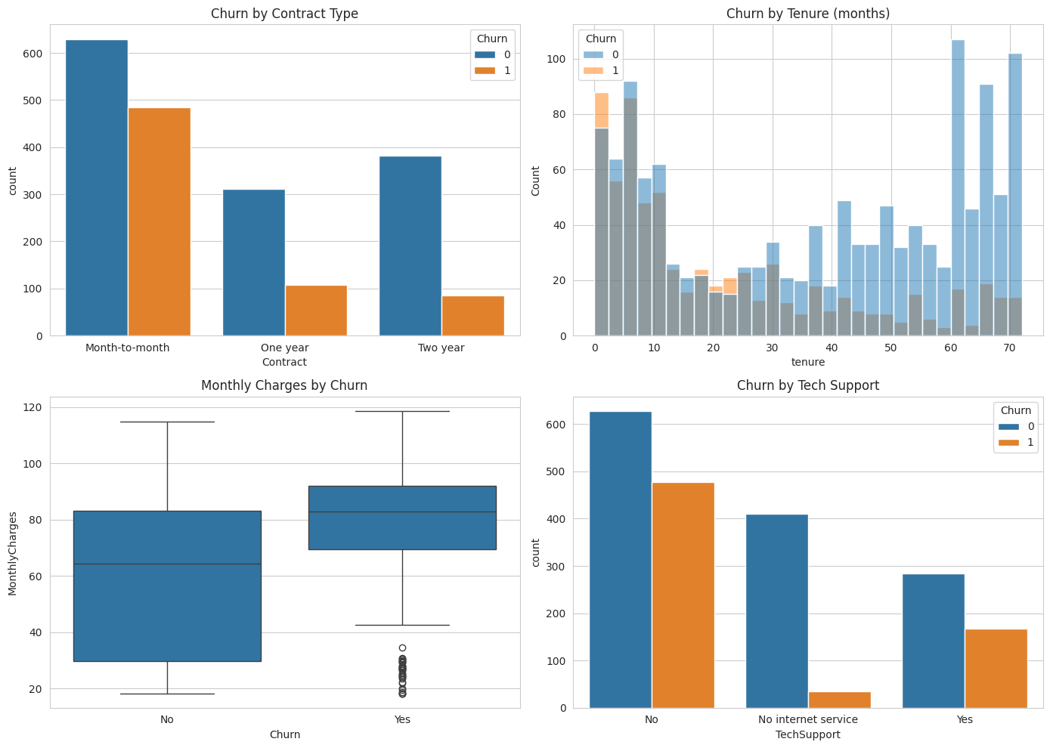
Figure 6.1: Exploratory analysis - churn by contract type, tenure, monthly charges and technical support.
The four panels tell a consistent story. Churn is concentrated among month-to-month customers and falls sharply for customers on fixed-term contracts. Churners cluster at the low end of the tenure distribution, with the highest churn counts in the first few months of the relationship. Customers who churned have visibly higher monthly charges than those who stayed. And customers without technical support churn considerably more than those who subscribe to it.
This was confirmed numerically by computing the churn rate within each contract type:
df.groupby("Contract")["Churn"].mean().sort_values(ascending=False).round(3)
Contract Type | Churn Rate
Month-to-month | 43.5%
One year | 25.8%
Two year | 18.2%
Month-to-month customers churn at more than twice the rate of two-year contract customers. This single relationship is the clearest signal in the dataset and, as Section 7 shows, the model independently rediscovers it.

6.2 Phase 2 - Encoding, Splitting and Model Tuning
feature_df = df.drop(columns=["customerID"]).copy()

categorical_cols = feature_df.select_dtypes(include="object").columns.tolist()
encoders = {}
for col in categorical_cols:
le = LabelEncoder()
feature_df[col] = le.fit_transform(feature_df[col])
encoders[col] = le

X = feature_df.drop(columns=["Churn"])
y = feature_df["Churn"]

X_train, X_test, y_train, y_test = train_test_split(
X, y, test_size=0.25, random_state=RANDOM_STATE, stratify=y)
X_train.shape, X_test.shape
Output: ((1500, 19), (500, 19))
param_grid = {
"max_depth": [3, 4, 5, 6],
"min_samples_leaf": [20, 30, 50],
"criterion": ["gini", "entropy"],
}

base_tree = DecisionTreeClassifier(random_state=RANDOM_STATE, class_weight="balanced")
grid = GridSearchCV(base_tree, param_grid, cv=5, scoring="f1", n_jobs=-1)
grid.fit(X_train, y_train)

print("Best params:", grid.best_params_)
tree_clf = grid.best_estimator_
Output: Best params: {'criterion': 'entropy', 'max_depth': 4, 'min_samples_leaf': 50}

6.3 Phase 3 - Model Evaluation and Rule Extraction
y_pred = tree_clf.predict(X_test)
y_proba = tree_clf.predict_proba(X_test)[:, 1]

print("Accuracy: {:.3f}".format(accuracy_score(y_test, y_pred)))
print("Precision: {:.3f}".format(precision_score(y_test, y_pred)))
print("Recall: {:.3f}".format(recall_score(y_test, y_pred)))
print("F1: {:.3f}".format(f1_score(y_test, y_pred)))
print("ROC AUC: {:.3f}".format(roc_auc_score(y_test, y_proba)))
print(classification_report(y_test, y_pred, target_names=["No Churn", "Churn"]))
cm = confusion_matrix(y_test, y_pred)
sns.heatmap(cm, annot=True, fmt="d", cmap="Blues",
xticklabels=["No Churn", "Churn"], yticklabels=["No Churn", "Churn"])
plt.ylabel("Actual"); plt.xlabel("Predicted")
plt.title("Confusion Matrix - Decision Tree"); plt.show()

RocCurveDisplay.from_predictions(y_test, y_proba)
plt.title("ROC Curve - Decision Tree"); plt.show()
plot_tree(tree_clf, feature_names=X.columns, class_names=["No Churn", "Churn"],
filled=True, rounded=True, fontsize=8, max_depth=3)
plt.title("Decision Tree - Churn Rules (top levels)"); plt.show()

rules_text = export_text(tree_clf, feature_names=list(X.columns))
print(rules_text)

importances = pd.Series(tree_clf.feature_importances_, index=X.columns)
importances = importances[importances > 0].sort_values(ascending=False)
The outputs of this phase - the metric table, the confusion matrix, the ROC curve, the decision-tree diagram, the extracted rules and the feature importances - are presented and discussed in Section 7.

6.4 Phase 4 - Clustering and Segment Profiling
cluster_features = [
"tenure", "Monthly Charges", "Total Charges",
"InternetService", "Contract", "PaymentMethod",
"OnlineSecurity", "TechSupport", "StreamingTV", "StreamingMovies",
"MultipleLines", "PaperlessBilling",
]

X_cluster = feature_df[cluster_features].copy()
scaler = StandardScaler()
X_cluster_scaled = scaler.fit_transform(X_cluster)
inertias, sil_scores = [], []
k_range = range(2, 9)
for k in k_range:
km = KMeans(n_clusters=k, random_state=RANDOM_STATE, n_init=10)
labels = km.fit_predict(X_cluster_scaled)
inertias.append(km.inertia_)
sil_scores.append(silhouette_score(X_cluster_scaled, labels))
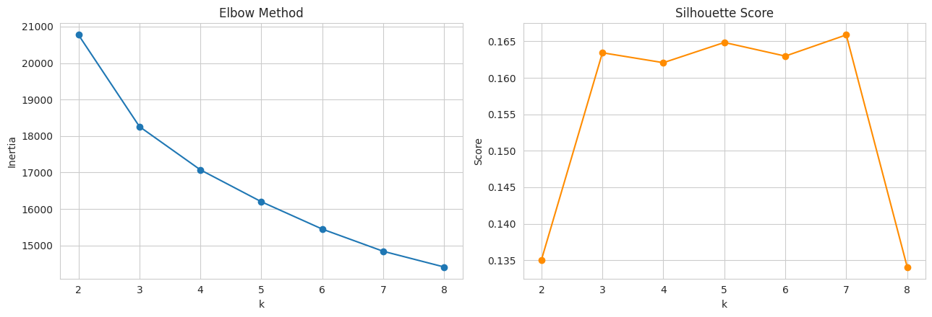
Figure 6.2: Elbow method and silhouette score used to select the number of clusters.
K = 4
kmeans = KMeans(n_clusters=K, random_state=RANDOM_STATE, n_init=10)
df["Cluster"] = kmeans.fit_predict(X_cluster_scaled)

profile = df.groupby("Cluster").agg(
customers=("customerID", "count"),
churn_rate=("Churn", "mean"),
avg_tenure=("tenure", "mean"),
avg_monthly_charges=("MonthlyCharges", "mean"),
pct_month_to_month=("Contract", lambda s: (s == "Month-to-month").mean()),
pct_fiber=("InternetService", lambda s: (s == "Fiber optic").mean()),
pct_no_tech_support=("TechSupport", lambda s: (s == "No").mean()),
).round(2)
profile
df.to_csv("telco_churn_with_clusters.csv", index=False)
print("Saved telco_churn_with_clusters.csv")
The enriched dataset, containing every original column plus the assigned cluster label, was exported to CSV so that the segmentation can be reused in downstream reporting or dashboard tools without re-running the pipeline.

6.5 Improvements Made Over the Baseline Approach
- Domain-aware imputation. Missing Total Charges values were filled with the customer's own Monthly Charges rather than a column mean, because the affected records are all zero-tenure customers.
- Systematic hyperparameter tuning. Rather than accepting default tree parameters, a 24-combination grid was searched with 5-fold cross-validation, which controls overfitting and makes the chosen configuration defensible.
- Imbalance handling. class_weight='balanced' and F1-based model selection were used in place of plain accuracy optimisation, which materially improved recall on the churn class.
- Stratified splitting. The train-test split preserves the churn proportion, so test performance is not distorted by an unrepresentative sample.
- Interpretability as an explicit output. Decision rules and feature importances were extracted and reported, rather than treating the model as a black box that emits predictions.
- Combined supervised and unsupervised analysis. Clustering was performed on behavioural features with the target excluded, so that the resulting churn rates per segment are an independent validation of the classification findings.

7. Results and Discussion

7.1 Classification Performance
The tuned Decision Tree was evaluated on the held-out test set of 500 customers, which the model had not seen at any point during training or cross-validation. The results are as follows.
Metric | Score | Interpretation
Accuracy | 0.744 | 74.4% of all test predictions are correct.
Precision (Churn) | 0.602 | Of customers flagged as churners, 60.2% actually churned.
Recall (Churn) | 0.716 | The model catches 71.6% of all customers who actually churned.
F1-Score (Churn) | 0.654 | Balanced measure of precision and recall on the churn class.
ROC AUC | 0.816 | Strong ability to rank churners above non-churners.
The full per-class classification report is shown below.
Class | Precision | Recall | F1-Score | Support
No Churn | 0.84 | 0.76 | 0.80 | 331
Churn | 0.60 | 0.72 | 0.65 | 169
Macro average | 0.72 | 0.74 | 0.73 | 500
Weighted average | 0.76 | 0.74 | 0.75 | 500
Two observations are worth drawing out. First, the ROC AUC of 0.816 is the most informative single figure: it is well above the 0.5 of a random classifier and indicates that the model ranks customers by churn risk reliably. Because the ranking is good, the business can choose an operating threshold to suit its budget - flagging only the top 10% highest-risk customers for an expensive intervention, or a broader group for a cheaper one.
Second, recall on the churn class (0.72) exceeds precision (0.60). This asymmetry is deliberate and is the direct result of the balanced class weighting and F1-based tuning described in Section 5.5. For a retention use case this is the correct trade-off: the model catches roughly seven out of every ten customers who are about to leave, at the cost of also flagging some customers who would have stayed. Missing a churner forfeits that customer's entire remaining lifetime value, whereas a false positive costs only the marginal expense of a retention offer that was not strictly needed.

7.2 Confusion Matrix and ROC Curve
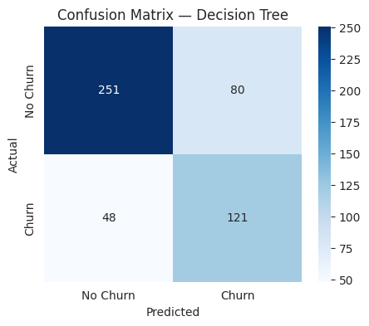
Figure 7.1: Confusion matrix for the tuned Decision Tree on the 500-record test set.
The confusion matrix breaks the 500 test predictions into the four possible outcomes. Of the 331 customers who did not churn, the model correctly identified the large majority, misclassifying a minority as at-risk. Of the 169 customers who did churn, 121 were correctly flagged and 48 were missed. The 48 missed churners represent the practical limit of what this model, at this threshold, can deliver - and they are the group that a higher-capacity model or additional behavioural features would primarily target.
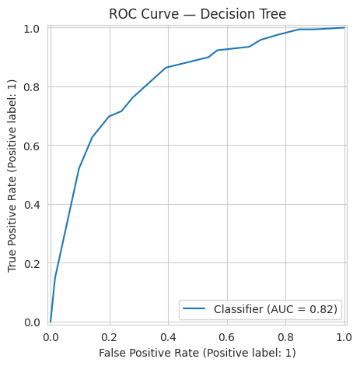
Figure 7.2: ROC curve for the tuned Decision Tree (AUC = 0.816).
The ROC curve plots the true-positive rate against the false-positive rate across all possible decision thresholds. The curve sits well above the diagonal reference line throughout its range, and the area beneath it - 0.816 - quantifies the separation the model achieves between the two classes. The shape of the curve is characteristically stepped, which is expected for a shallow decision tree: with a depth limit of 4, the model produces only a small number of distinct probability values, one for each leaf, so the curve advances in discrete jumps rather than smoothly.

7.3 Decision Rules Learned by the Model
The principal advantage of a decision tree is that the logic behind every prediction can be read directly. The diagram below shows the upper levels of the fitted tree.
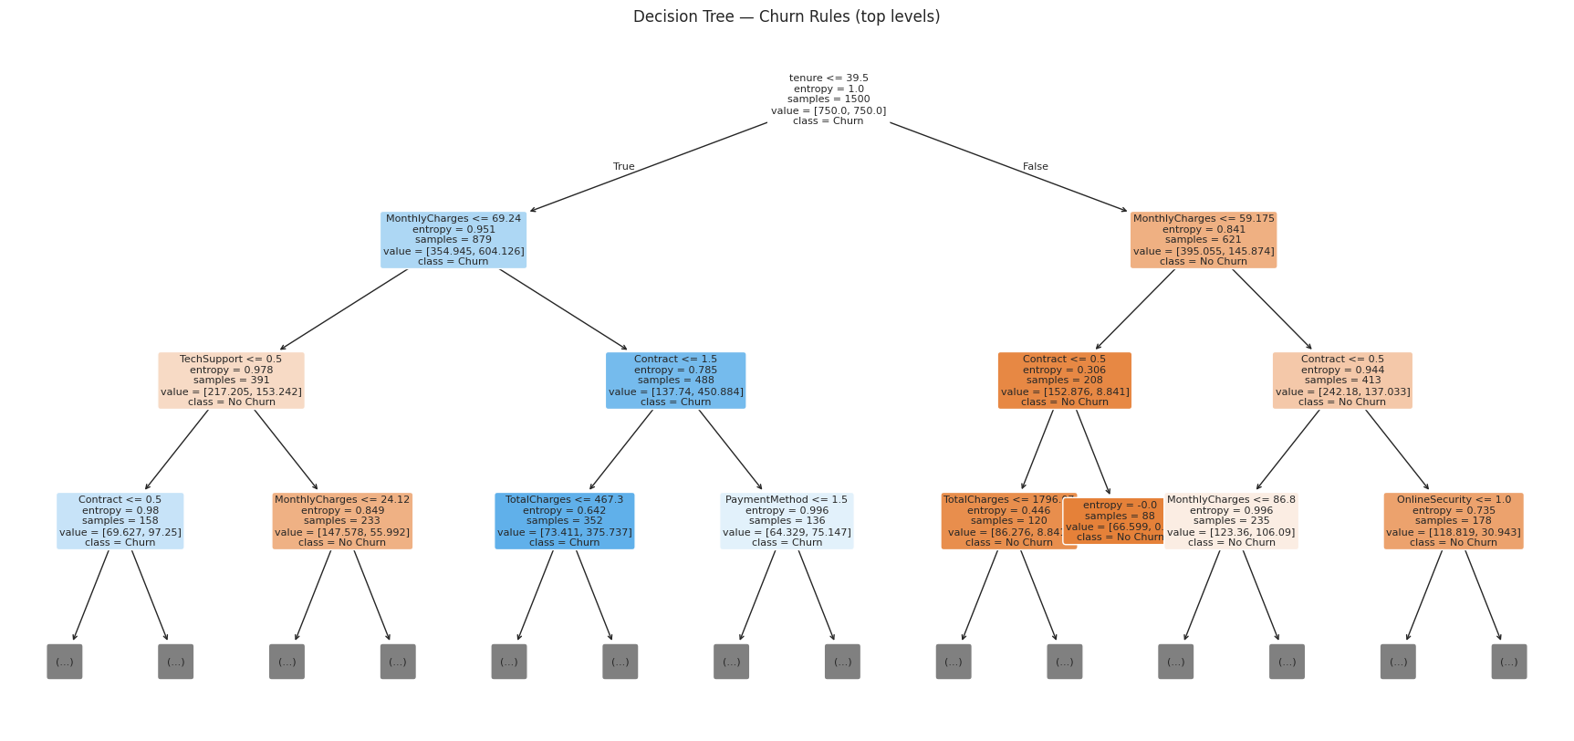
Figure 7.3: Decision tree structure - top levels of the fitted model.
The complete rule set, extracted with export_text, is reproduced below. Note that categorical features appear as encoded integers: for Contract, the label encoder assigns 0 to Month-to-month, 1 to One year and 2 to Two year, so a test of Contract <= 0.50 is a test for a month-to-month contract.
|--- tenure <= 39.50
| |--- MonthlyCharges <= 69.24
| | |--- TechSupport <= 0.50
| | | |--- Contract <= 0.50 --> class: Churn
| | | |--- Contract > 0.50 --> class: No Churn
| | |--- TechSupport > 0.50 --> class: No Churn
| |--- MonthlyCharges > 69.24
| | |--- Contract <= 1.50 --> class: Churn
| | |--- Contract > 1.50
| | | |--- PaymentMethod <= 1.50 --> class: Churn
| | | |--- PaymentMethod > 1.50 --> class: No Churn
|--- tenure > 39.50
| |--- MonthlyCharges <= 59.18 --> class: No Churn
| |--- MonthlyCharges > 59.18
| | |--- Contract <= 0.50
| | | |--- MonthlyCharges <= 86.80 --> class: No Churn
| | | |--- MonthlyCharges > 86.80 --> class: Churn
| | |--- Contract > 0.50 --> class: No Churn
The structure is readable as a short set of business rules:
- Tenure is the root split. The model divides the customer base at 39.5 months. Everything else is conditional on which side of that line a customer falls, which confirms that length of relationship is the single most decisive factor.
- For newer customers (tenure under 40 months), price is the next question. Above roughly 69 per month, the customer is predicted to churn unless they are on a two-year contract and paying by a specific method. Below that threshold, the outcome hinges on technical support: a low-spend month-to-month customer without technical support is predicted to churn, whereas the same customer with technical support is predicted to stay.
- For established customers (tenure over 40 months), the model predicts retention almost everywhere. The single exception is a customer who is simultaneously on a month-to-month contract and paying more than about 86.80 per month - a long-tenured but uncommitted and expensive account, which the model treats as genuinely at risk.
- Technical support acts as a protective factor. Its appearance high in the tree, and the direction of its effect, supports the exploratory finding that customers who subscribe to support services churn less - plausibly because problems get resolved before frustration accumulates, and because the additional service creates switching friction.

7.4 Feature Importance
Feature importance quantifies how much each variable contributed to reducing impurity across the whole tree. Only seven of the nineteen input features received non-zero importance.
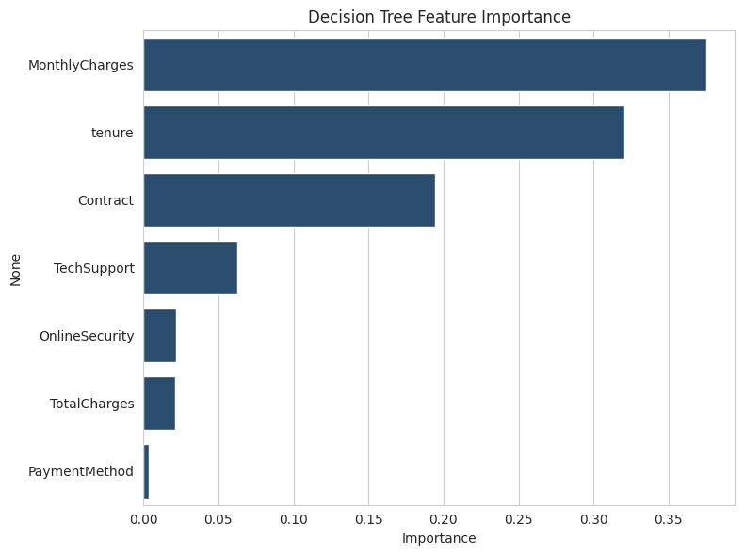
Figure 7.4: Feature importance scores from the tuned Decision Tree.
Rank | Feature | Importance | Reading
1 | Monthly Charges | 0.375 | Price is the largest single driver of churn risk.
2 | tenure | 0.321 | Length of relationship; the root split of the tree.
3 | Contract | 0.195 | Commitment level - month-to-month versus fixed term.
4 | Tech Support | 0.063 | Service quality and switching friction.
5 | Online Security | 0.022 | Secondary value-added service effect.
6 | Total Charges | 0.021 | Largely redundant with tenure and monthly charges.
7 | Payment Method | 0.003 | Marginal contribution at one deep split only.
Three features – Monthly Charges, tenure and Contract - account for approximately 89% of the total importance. This is a useful result in itself: it means a retention team can construct a workable risk view from just three fields that every billing system already holds, without needing a full machine learning deployment to triage accounts.
Equally informative is what the model did not use. None of the demographic attributes - gender, SeniorCitizen, Partner, Dependents - received any importance, and neither did PhoneService, MultipleLines, the streaming services or paperless billing. Within this dataset, churn is driven by the commercial relationship rather than by who the customer is. That finding has a practical consequence: retention campaigns should be segmented by contract, price and tenure, not by demographic profile.

7.5 Customer Segments and Their Churn Behaviour
K-Means partitioned the 2,000 customers into four behavioural segments. The profile of each segment is given below. Recall that churn was excluded from the clustering features, so the churn rates in this table are an independent finding, not a consequence of the clustering.
Cluster | Customers | Churn Rate | Avg Tenure (months) | Avg Monthly Charges | % Fiber | % No Tech Support
0 | 611 | 22% | 58.9 | 78.09 | 57% | 68%
1 | 530 | 52% | 14.2 | 74.46 | 56% | 75%
2 | 445 | 8% | 33.2 | 26.04 | 0% | 0%
3 | 414 | 57% | 16.4 | 84.19 | 60% | 70%
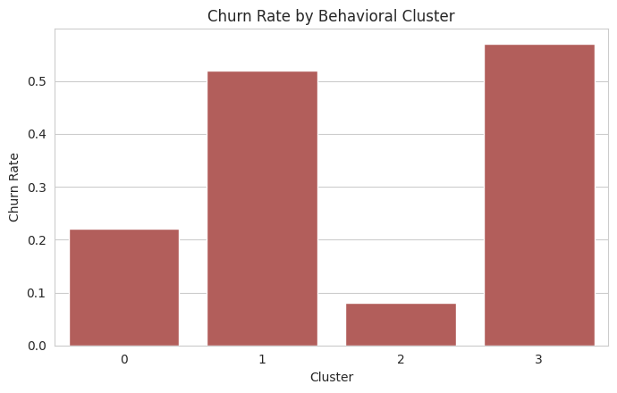
Figure 7.5: Churn rate by behavioural cluster.
The four segments can be characterised as follows.
- Cluster 0 - Established high-value customers (611 customers, 22% churn). The largest segment, and a commercially valuable one: an average tenure of almost five years combined with high monthly spend. Their churn rate sits well below the 33.9% baseline, reflecting the stability that long tenure confers. This is the segment to protect rather than to chase.
- Cluster 1 - New mid-to-high spend customers (530 customers, 52% churn). Average tenure of just over a year with substantial monthly charges, and three-quarters without technical support. More than half of this segment leaves. These customers are past the very first months but have not yet formed a durable relationship with the provider.
- Cluster 2 - Low-spend basic-service customers (445 customers, 8% churn). This segment is defined by the absence of internet service: 0% on fiber and, consequently, 0% recorded as lacking technical support, since the field does not apply to them. Average monthly charges are around 26 - roughly a third of the other segments. Their churn rate of 8% is by far the lowest in the dataset. Low spend paired with very high loyalty makes this a stable, low-maintenance base.
- Cluster 3 - New high-spend customers (414 customers, 57% churn). The highest-risk segment: the shortest tenure combined with the highest monthly charges in the entire dataset, 60% on fiber optic, and 70% without technical support. Nearly three customers in five are lost. This is the segment where intervention has the greatest potential impact and where retention spend should be concentrated first.
The clustering independently confirms what the classifier learned. The two variables that separate the high-churn segments (1 and 3) from the low-churn segments (0 and 2) are exactly tenure and monthly charges - the two features that carry the highest importance in the decision tree and form its first two splits. Two methodologically independent techniques converging on the same drivers is strong evidence that the finding is a genuine property of the data rather than an artefact of either method.

7.6 Interpretation and Business Recommendations
Taken together, the classification and segmentation results support a small number of concrete retention actions.
- Prioritise the first year of the relationship. Both the tree's root split at 39.5 months and the two high-churn clusters point to early tenure as the critical window. Structured onboarding, a proactive check-in in the first quarter, and an early loyalty incentive would target the period in which most customers are lost.
- Move high-spend new customers onto fixed-term contracts. Cluster 3 - short tenure, highest charges, month-to-month - is the single most at-risk group. Given that the churn rate falls from 43.5% on month-to-month to 18.2% on two-year contracts, a discount offered in exchange for a one- or two-year commitment is likely to be recovered many times over in retained revenue.
- Bundle technical support with high-value plans. TechSupport appears explicitly in the decision rules as a protective factor, and 70-75% of customers in the two high-churn segments do not have it. Including support at no additional charge on premium plans addresses a churn driver and increases the perceived value of the plan at the same time.
- Review pricing for newer high-charge accounts. MonthlyCharges carries the highest feature importance, and the tree's threshold of roughly 69 per month for newer customers gives a specific, testable price point at which churn risk rises sharply.
- Do not over-invest in the low-spend basic segment. Cluster 2 churns at only 8%. Retention spend directed here would largely be spent on customers who were never going to leave; the same budget produces far more value applied to Clusters 1 and 3.
- Use the model as a ranking tool, not a binary switch. With a ROC AUC of 0.816 the model ranks risk reliably. Scoring the active base and working down the ranked list allows the retention team to size each campaign to the available budget rather than being forced to accept whatever volume a fixed 0.5 threshold produces.

8. Conclusion & Future Work

8.1 Summary of Learning
This project delivered a complete, working churn-analysis pipeline on a 2,000-record telecom dataset, from raw Excel input through to business recommendations. The tuned Decision Tree achieved a ROC AUC of 0.816 and recall of 0.716 on the churn class, catching roughly seven of every ten customers who actually left. In parallel, K-Means segmentation identified four behavioural groups whose churn rates range from 8% to 57%, giving the business a small, actionable set of targets.
Beyond the numbers, the most valuable outcome was the experience of the full workflow rather than any individual algorithm. Deciding how to impute TotalCharges required understanding what the missing values actually represented; choosing F1 over accuracy as the tuning metric required understanding why accuracy misleads on imbalanced data; and interpreting the tree required mapping encoded integers back to their business meaning. These judgement calls, rather than the model-fitting step itself, constituted the substance of the work.
The convergence of two independent methods on the same conclusion - that tenure, price and contract type drive churn - was a particularly instructive result, and a reminder that cross-validating findings across techniques is more persuasive than optimising a single metric.

8.2 Skills Acquired
Project Task | Skill Category | Specific Skill Acquired
Data loading and cleaning | Technical, Data Engineering | pandas I/O from Excel, type coercion, domain-aware imputation, data quality assessment.
Exploratory data analysis | Technical, Analytical | Seaborn and Matplotlib visualisation, multi-panel figures, group-wise aggregation and rate analysis.
Feature engineering and encoding | Technical | Label encoding of categorical variables, feature selection, stratified train-test splitting.
Model building and tuning | Technical, Research | Decision tree classification, GridSearchCV, cross-validation, class-imbalance handling.
Model evaluation | Analytical | Precision-recall trade-off reasoning, confusion matrix and ROC analysis, metric selection for imbalanced targets.
Model interpretation | Analytical, Communication | Rule extraction, feature importance analysis, translating encoded splits into business language.
Customer segmentation | Technical, Research | Feature scaling, K-Means clustering, elbow and silhouette diagnostics, segment profiling.
Reporting and presentation | Management, Soft Skills | Structuring a technical report, synthesising results for a non-technical audience, actionable recommendations.

8.3 Limitations of the Current Approach
- A single decision tree, though highly interpretable, is less accurate than ensemble methods. Random Forest or gradient boosting would likely improve the ROC AUC, at the cost of losing the readable rule set.
- The dataset is a static snapshot. It contains no time-series information on how usage, complaints or billing evolved before the customer left, and such behavioural trajectories are typically among the strongest churn predictors.
- Label encoding imposes an arbitrary ordinal relationship on nominal categories. This is harmless for trees but would prevent the same feature matrix being reused with distance-based or linear models without re-encoding.
- The decision threshold was left at the default 0.5 and was not optimised against an explicit cost model of false positives versus false negatives.
- The 2,000-record sample limits the depth of tree that can be fitted reliably and constrains how finely the customer base can be segmented.
- No external context is available - competitor pricing, regional network quality, or promotional activity - all of which influence churn in practice.

8.4 Future Scope
- Ensemble models. Train Random Forest and XGBoost classifiers and compare them against the decision-tree baseline, using SHAP values to recover interpretability from the stronger model.
- Cost-sensitive threshold tuning. Replace the default 0.5 threshold with one derived from the actual cost of a retention offer relative to the lifetime value of a lost customer.
- Temporal and behavioural features. Incorporate month-on-month changes in usage and charges, complaint history and service-outage records to capture the trajectory leading up to churn.
- Deployment as a scoring service. Serialise the trained pipeline and expose it through a web application or API so that the retention team can score the active customer base on demand.
- Survival analysis. Extend the binary prediction to a time-to-churn model, which estimates not only whether a customer will leave but when - allowing interventions to be timed rather than merely targeted.
- Campaign measurement. Run the recommendations of Section 7.6 as controlled A/B tests to measure the actual uplift in retention attributable to each intervention.

9. Internship Outcomes

9.1 Technical Skills Acquired
- Gained hands-on experience in loading, cleaning and validating real-world tabular data with pandas, including type coercion and context-appropriate handling of missing values.
- Developed proficiency in exploratory data analysis and in constructing multi-panel visualisations that communicate a finding rather than merely display data.
- Learned to build, tune and validate supervised classification models with scikit-learn, including cross-validated grid search and explicit handling of class imbalance.
- Acquired the ability to select and interpret evaluation metrics appropriate to the problem, and to reason about the precision-recall trade-off in business terms.
- Applied unsupervised learning end to end - feature scaling, K-Means clustering, selecting k via elbow and silhouette diagnostics, and profiling the resulting segments.
- Practised model interpretation through decision-rule extraction and feature-importance analysis, mapping encoded model output back to real business variables.

9.2 Soft Skills Developed
- Improved analytical thinking by framing an open-ended business question as a pair of well-defined machine learning tasks.
- Strengthened technical communication through documenting the pipeline and presenting results in language that a non-technical stakeholder can act upon.
- Developed critical evaluation habits - questioning whether a metric is the right one, and validating findings across independent methods rather than trusting a single result.
- Built time-management and self-direction skills by planning and delivering the project phases independently across the internship period.

9.3 Contribution to Career Growth
- Established a solid practical foundation in applied machine learning for customer analytics, an area with sustained demand across telecom, banking, insurance, retail and SaaS.
- Gained experience of a complete project lifecycle - from raw data to deployable insight - which is what employers assess in data science and machine learning roles.
- Produced a demonstrable portfolio project, supported by code, results and this report, that can be discussed in technical interviews.
- Developed the habit of connecting model output to business decisions, which distinguishes an applied data scientist from a purely technical practitioner.

Appendix

A. Source Code
The complete source code for this project is contained in the Jupyter Notebook telco_customer.ipynb, comprising the data loading and cleaning steps, exploratory analysis, the tuned Decision Tree classifier, rule and feature-importance extraction, and the K-Means segmentation. The key code listings are reproduced in Section 6.
- Notebook: telco_customer.ipynb
- Input dataset: Telco_Customer_Churn.xlsx (worksheet: Customer Data)
- Output dataset: telco_churn_with_clusters.csv (original records enriched with cluster labels)
- GitHub repository: ______________________________________

B. Dataset Snapshot
A sample of the input dataset is shown below, illustrating the structure of the 21 columns described in Section 5.1.
Customer ID | gender | tenure | Internet Service | Contract | Monthly | Total | Churn
1803-URLLW | Female | 13 | Fiber optic | Month-to-month | 92.59 | 1196.14 | Yes
1773-SFCNZ | Male | 3 | Fiber optic | One year | 95.31 | 294.51 | No
7621-TSUND | Male | 10 | Fiber optic | One year | 92.04 | 908.48 | No
8556-LNJEY | Male | 61 | No | Month-to-month | 26.35 | 1597.74 | No
8033-QKVOL | Female | 28 | Fiber optic | Two year | 84.47 | 2386.28 | Yes
Summary statistics: 2,000 records, 21 columns, overall churn rate 33.9%, tenure ranging from 0 to 72 months.

C. Certificate of Completion
The certificate awarded for successful completion of the internship is attached for reference.
Field | Detail
Candidate | Sunkara Mohana Sruthi
Level | CSM - UG Level 2
Internship Domain | Artificial Intelligence & Machine Learning
Programme | PEARL Program
Organised by | Q2D (Quantum Quotient Decode)
In collaboration with | IBM Innovation Centre for Education (IBM ICE)
Duration | 20th May 2026 to 20th July 2026
Application No. | IBMQ2DST1189
Date of Issue | 10th September 2026
Issued by | Gopika S Nair, Chief Operating Officer, QQD Talent Minds Private Limited



