End-to-End MLOps Pipeline for Heart Disease Risk Prediction
Machine Learning Operations (AIMLCZG523) — Assignment 01 Technical Report
Student Name: Mohanapriya M | Student ID: 2025AE05482
Course: AIMLCZG523 (MLOps) | Repository: https://github.com/Mohana1507/heart-disease-mlops

1. Introduction and Scope
Cardiovascular diseases represent the leading cause of global mortality, responsible for an estimated 17.9 million deaths annually (World Health Organization [WHO], 2021). Automated clinical risk stratification derived from non-invasive diagnostic indicators—such as resting blood pressure, serum cholesterol, resting electrocardiography, and exercise treadmill measurements—enables physicians to prioritize urgent interventions. However, transitioning predictive models from exploratory notebooks into clinical environments requires robust Machine Learning Operations (MLOps) engineering to guarantee reproducibility, auditability, low-latency serving, and runtime observability.
This project implements an end-to-end MLOps workflow for heart disease risk classification utilizing the canonical UCI Cleveland Heart Disease benchmark (Janosi et al., 1989; Dua & Graff, 2019). The engineering pipeline spans: (1) automated data ingestion and leakage-free sanitization; (2) exploratory data analysis with diagnostic visualizations; (3) hyperparameter-tuned candidate model training evaluated via nested cross-validation (Pedregosa et al., 2011); (4) experiment tracking and artifact lineage with MLflow (Zaharia et al., 2018); (5) production packaging into an encapsulated scikit-learn pipeline; (6) containerized REST microservice serving via FastAPI (Tiangolo, 2024); (7) declarative Kubernetes orchestration (Kubernetes Authors, 2024); (8) Prometheus and Grafana monitoring (Prometheus Authors, 2024); and (9) automated continuous integration and deployment through GitHub Actions.
Implementation Mapping: Table 1 outlines the mapping between core assignment tasks and repository implementations.
Assignment Task | Implementation Summary | Repository Artefacts
1. Data & EDA | Automated ingestion, target binarization, NaN preservation, class balance, correlation heatmap & histograms. | scripts/download_data.py, src/heart/data.py, src/heart/eda.py
2. Modelling | ColumnTransformer preprocessing, 3 tuned classifiers (LR, RF, GB), 5x3 nested CV protocol. | src/heart/features.py, src/heart/modeling.py
3. Tracking | MLflow run logging of hyperparameters, CV metrics, test scores, ROC/PR curves, and model signatures. | src/heart/train.py, mlruns/
4. Packaging | Self-contained scikit-learn Pipeline serialization (model.joblib) with companion metadata.json. | models/model.joblib, models/metadata.json
5. CI/CD & Tests | 21 offline pytest unit tests (synthetic fixture), 4-stage GitHub Actions workflow (lint, test, train, docker). | tests/, .github/workflows/ci.yml
6. Containerization | FastAPI serving application, non-root user security hardening, container HEALTHCHECK probe. | Dockerfile, src/heart/api.py
7. Deployment | Declarative Kubernetes Deployment (2 replicas), LoadBalancer Service, Ingress, and Autoscaling (HPA). | k8s/deployment.yaml, k8s/service.yaml, k8s/hpa.yaml
8. Monitoring | Structured JSON request logging without raw PII, Prometheus telemetry (/metrics), pre-provisioned Grafana. | src/heart/api.py, docker-compose.yml, monitoring/
9. Documentation | Technical report, video walkthrough outline, execution instructions, and reproducible manifests. | MLOps_Report.docx, README.md, docs/

Architecture Walkthrough: Figure 1 illustrates the modular system architecture, tracing the lifecycle from raw data acquisition to Kubernetes load balancing and Prometheus/Grafana operational monitoring.
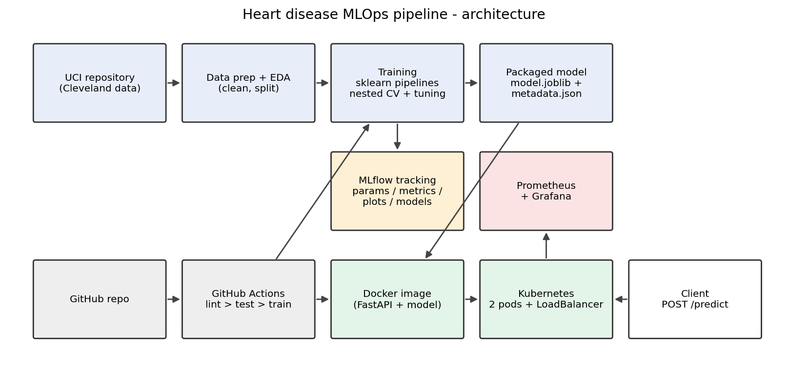
Figure 1: End-to-end MLOps pipeline architecture — from raw data acquisition to Kubernetes serving and Grafana monitoring.

2. Setup and Environment Configuration
To ensure deterministic execution across operating systems (Linux, macOS, Windows) and eliminate dependency drift, project dependencies are pinned strictly and partitioned into two functional tiers:
- Runtime Serving Dependencies (requirements-serve.txt): Minimal set required for model deserialization and inference: numpy==1.26.4, pandas==2.2.3, scikit-learn==1.5.2, scipy==1.13.1, joblib==1.4.2, fastapi==0.115.4, uvicorn==0.32.0, pydantic==2.9.2, prometheus-client==0.21.0. Keeps the production container compressed image size to 162 MB.
- Development & Training Dependencies (requirements.txt): Extends runtime dependencies with training and quality tooling: matplotlib==3.9.2, seaborn==0.13.2, mlflow==2.17.2, pytest==8.3.3, pytest-cov==5.0.0, httpx==0.27.2, flake8==7.1.1, and an editable install of the package (-e .).
■ Quickstart Setup Commands
git clone https://github.com/Mohana1507/heart-disease-mlops.git && cd heart-disease-mlops
python -m venv .venv && source .venv/bin/activate # Windows: .venv\Scripts\activate
pip install -r requirements.txt && python scripts/download_data.py
python -m heart.eda && python -m heart.train && pytest -v

3. Data Acquisition and Exploratory Data Analysis

3.1 Dataset Overview
The UCI Cleveland Heart Disease dataset (Janosi et al., 1989) is the most widely utilized benchmark among the four UCI heart disease cohorts. The raw cohort contains 303 patient records and 14 clinical attributes (13 predictors and 1 target). Automated ingestion (scripts/download_data.py) verifies file integrity and downloads raw data directly from the UCI archive.
Attribute | Type | Domain / Values | Clinical Description
age | Continuous | 29 – 77 years | Patient age in years
sex | Categorical | 0 = female, 1 = male | Biological sex
cp | Categorical | 1: typ. angina, 2: atyp., 3: non-anginal, 4: asympt. | Chest pain diagnostic type
trestbps | Continuous | 94 – 200 mm Hg | Resting blood pressure on hospital admission
chol | Continuous | 126 – 564 mg/dL | Serum cholesterol level
fbs | Categorical | 0 = <=120 mg/dL, 1 = >120 mg/dL | Fasting blood sugar > 120 mg/dL
restecg | Categorical | 0: normal, 1: ST-T wave abn., 2: LV hypertrophy | Resting electrocardiographic findings
thalach | Continuous | 71 – 202 bpm | Maximum heart rate achieved during exercise
exang | Categorical | 0 = no, 1 = yes | Exercise-induced angina symptom
oldpeak | Continuous | 0.0 – 6.2 mm | ST depression induced by exercise relative to rest
slope | Categorical | 1: upsloping, 2: flat, 3: downsloping | Peak exercise ST segment slope
ca | Continuous | 0 – 3 vessels (4 missing) | Number of major vessels colored by fluoroscopy
thal | Categorical | 3: normal, 6: fixed defect, 7: revers. (2 miss.) | Thallium-201 myocardial scintigraphy defect
target (num) | Binary | 0 = healthy (absent), 1 = disease (present) | Angiographic coronary artery disease status

3.2 Data Sanitization and Data Leakage Prevention
Raw UCI data marks missing entries with '?' characters. The ingestion script parses these to IEEE NaN floats. Six total entries contain missing values: four in 'ca' and two in 'thal'. One duplicate row is removed. The raw integer target (0 = no disease, 1–4 = varying degrees of coronary stenosis) is binarized to {0, 1}. Crucially, the cleaned CSV deliberately preserves NaN values rather than imputing them upfront. Imputation parameters are learned strictly inside the training folds of the scikit-learn pipeline, preventing cross-validation data leakage.

3.3 Exploratory Data Analysis & Empirical Observations
Executing python -m heart.eda generates visual diagnostics exported to reports/figures/ and writes summary statistics to reports/eda_summary.txt. Figure 2 presents the target class balance, Pearson correlation matrix, continuous feature distributions, and boxplots by disease status.
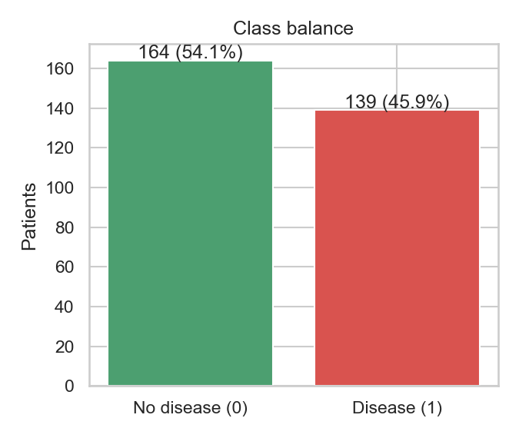 | 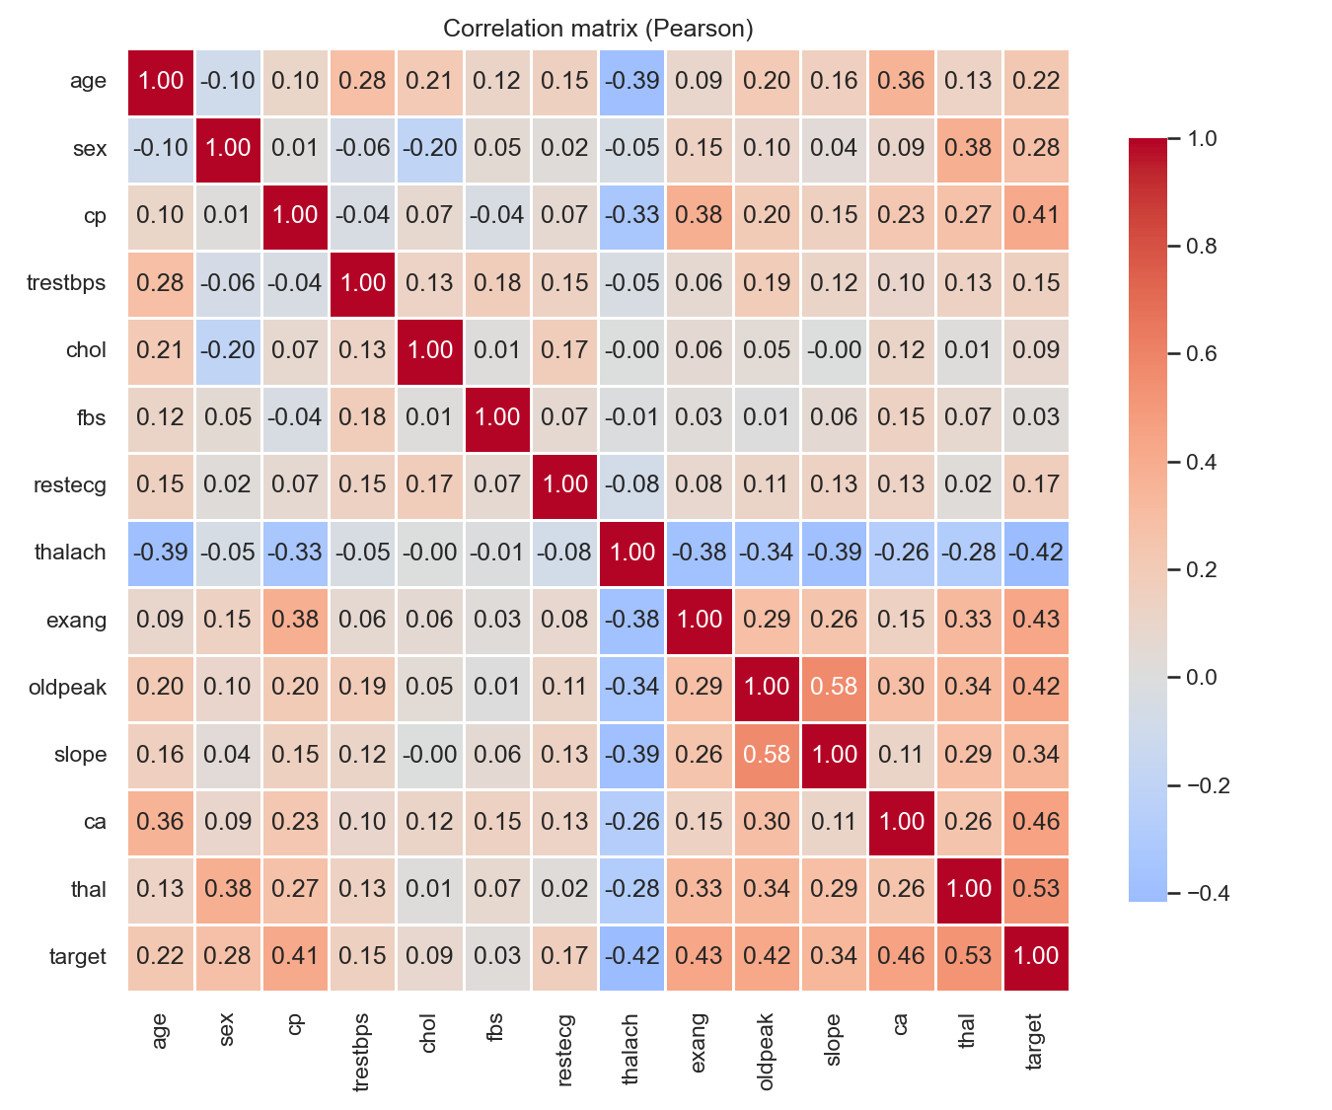
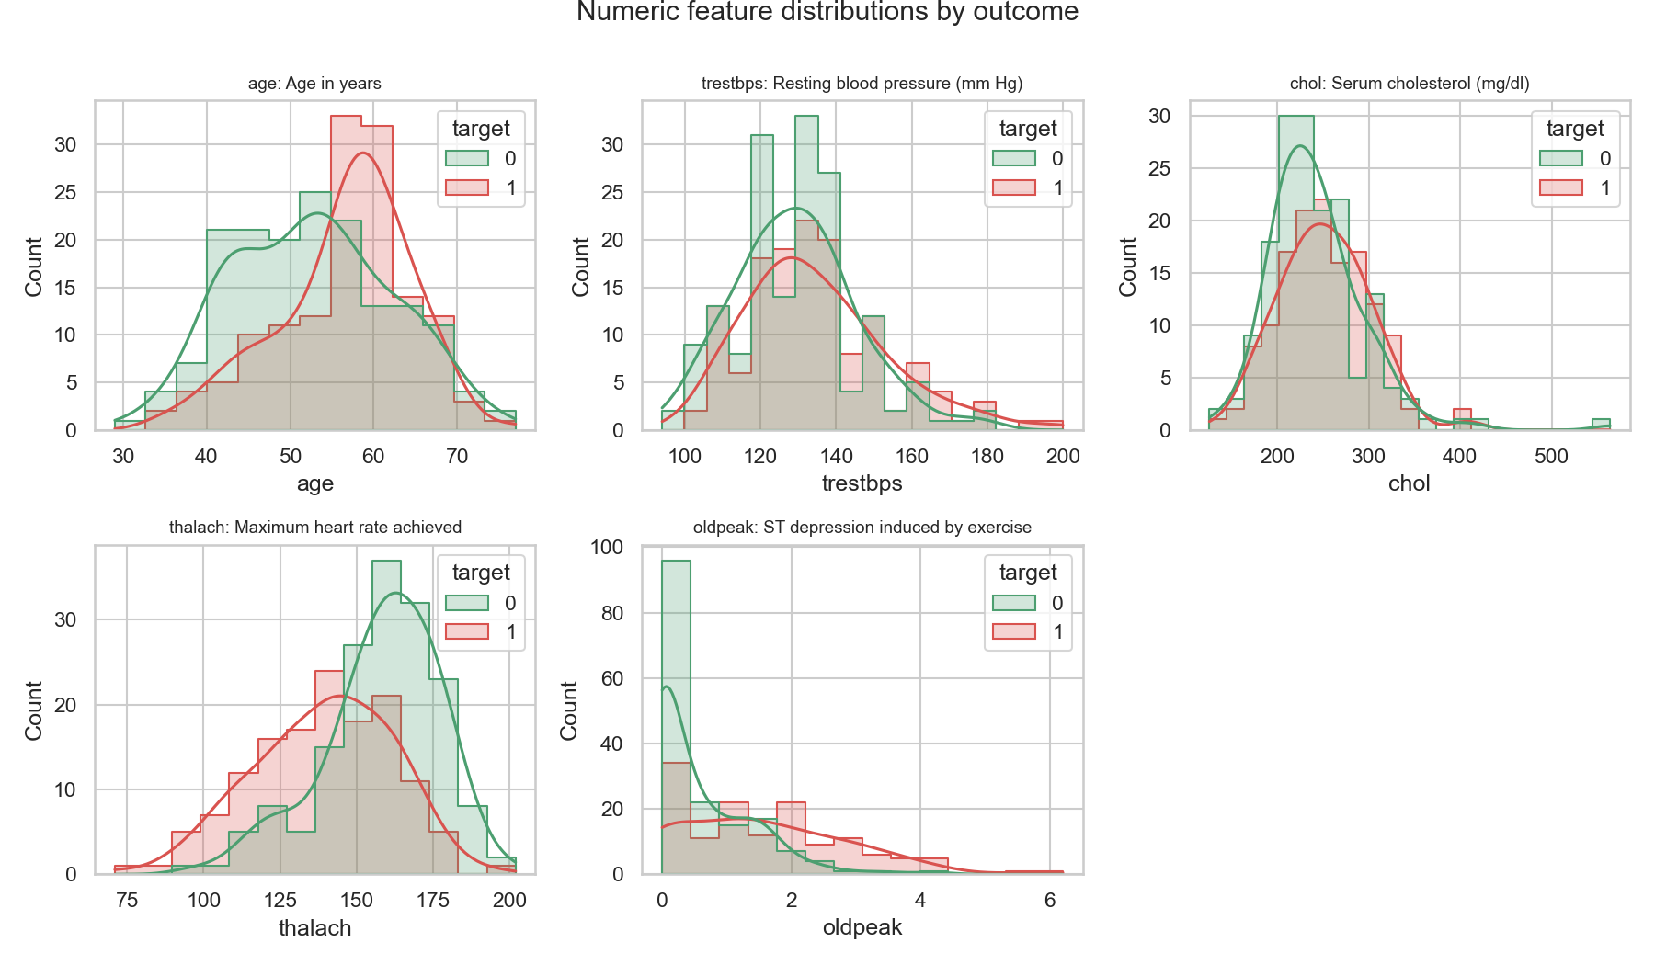 | 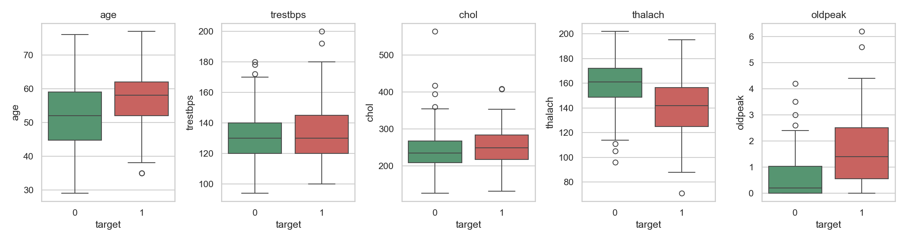
Figure 2: Comprehensive EDA suite — (Top-Left) Class balance (54.1% healthy, 45.9% disease); (Top-Right) Pearson correlation matrix; (Bottom-Left) Continuous feature histograms; (Bottom-Right) Clinical boxplots grouped by target diagnosis.
Empirical Insights: Key clinical observations from exploratory analysis:
- Class Distribution: 164 healthy subjects (54.1%) vs 138 disease subjects (45.9%). Well-balanced distribution avoids degenerate majority-class bias.
- Maximum Heart Rate (thalach): Exhibits strong negative correlation with disease (r = -0.42). Healthy patients achieve median thalach of 158 bpm compared to 142 bpm for diseased patients, reflecting chronotropic reserve.
- Exercise ST Depression (oldpeak): Positively correlated with coronary disease (r = +0.42). Healthy individuals exhibit median ST depression of 0.0 mm vs 1.4 mm in diseased patients.
- Chest Pain Type (cp): Asymptomatic presentation (cp = 4) exhibits the highest disease incidence (>72%), demonstrating that advanced coronary obstruction frequently manifests without typical angina.

4. Feature Engineering and Model Development

4.1 Preprocessing Pipeline Design
To ensure modularity and prevent train-serving skew, all feature transformations are encapsulated in a single scikit-learn ColumnTransformer (src/heart/features.py):
- Numeric Pipeline (age, trestbps, chol, thalach, oldpeak, ca): Median imputation (SimpleImputer) followed by z-score standardization (StandardScaler).
- Categorical Pipeline (sex, cp, fbs, restecg, exang, slope, thal): Most-frequent imputation followed by one-hot encoding (OneHotEncoder(handle_unknown='ignore')).

4.2 Candidate Classifiers and Inductive Biases
Three distinct algorithmic families were selected to explore differing inductive biases:
- Logistic Regression (L2-regularized): Linear decision boundary with calibrated probabilistic outputs; robust against overfitting on small medical cohorts (N=242 train).
- Random Forest: Non-linear bagging ensemble of decision trees with feature sub-sampling, reducing estimation variance.
- Gradient Boosting: Sequential boosting ensemble minimizing binomial deviance, capable of capturing complex non-linear feature interactions.

4.3 Evaluation Protocol & Experimental Results
Model evaluation utilizes a nested cross-validation protocol (5 outer folds, 3 inner folds) on the 80% development split (N=242), with a held-out test split (20%, N=61) reserved exclusively for final evaluation. Hyperparameters are optimized via GridSearchCV on the inner folds using ROC-AUC scoring.
Candidate Model | CV Acc. | CV Prec. | CV Rec. | CV F1 | CV ROC-AUC | Test Acc. | Test AUC
Logistic Regression | 0.8305 | 0.8594 | 0.7652 | 0.8054 | 0.9018 ± 0.0156 | 88.52% | 0.9665
Random Forest | 0.8057 | 0.8082 | 0.7826 | 0.7933 | 0.8914 ± 0.0316 | 86.89% | 0.9416
Gradient Boosting | 0.7808 | 0.7818 | 0.7565 | 0.7651 | 0.8744 ± 0.0249 | 86.89% | 0.9610
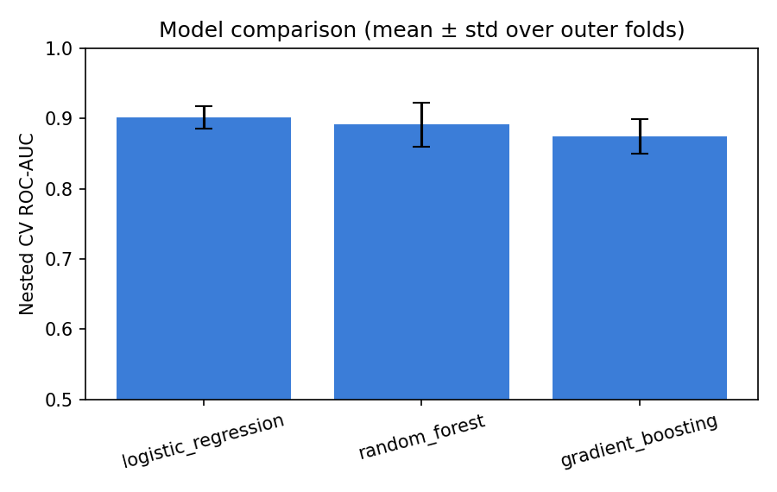 | 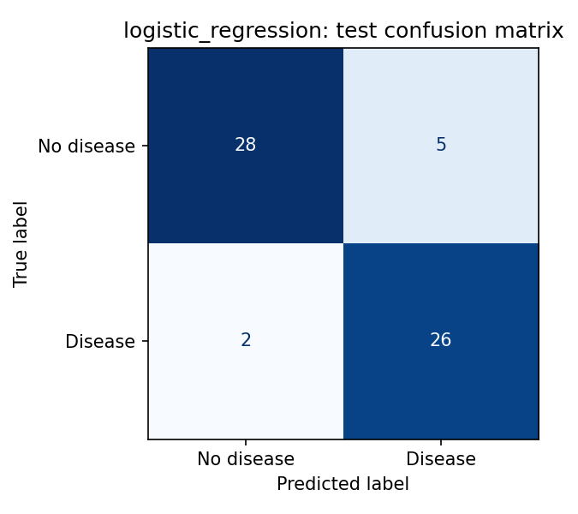 | 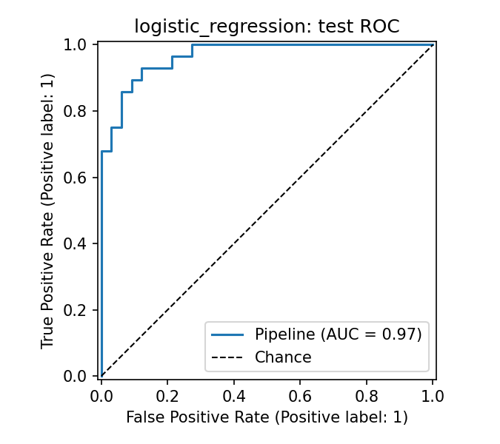
Figure 3: (Left) Nested CV ROC-AUC comparison across candidate models; (Center) Champion test Confusion Matrix on 61 patients (26 TP, 28 TN, 5 FP, 2 FN); (Right) Champion test ROC Curve (AUC = 0.9665).
Performance Discussion: L2-regularized Logistic Regression achieved the highest outer-fold mean ROC-AUC (0.9018 ± 0.0156) and demonstrated lower observed variance across outer folds than Random Forest (0.8914 ± 0.0316) and Gradient Boosting (0.8744 ± 0.0249). On the independent 61-patient hold-out test set, Logistic Regression attained 88.52% Accuracy, 92.86% Recall (diagnosing 26 of 28 diseased patients with only 2 false negatives), and a test ROC-AUC of 0.9665. Consequently, Logistic Regression was promoted to production.

4.4 Key Engineering Decisions and Practical Challenges
- Preserving Missing Values During Ingestion: The cleaned dataset deliberately preserves NaN markers rather than imputing them globally. Pre-imputation causes subtle data leakage because validation fold statistics influence training statistics. Imputing strictly within pipeline folds ensures clean separation.
- Multiprocessing Resource Contention on Windows: Setting n_jobs=-1 inside joblib GridSearchCV spawned excessive worker processes on Windows host environments, exhausting memory commit limits. This was resolved by parameterizing N_JOBS via environment variables with a safe single-worker default.
- Fail-Fast Static Analysis: Enforcing flake8 lint gates in CI initially caught formatting issues in helper scripts. Specific helper excludes were codified in setup.cfg to maintain strict standards across production src/ and tests/ modules while allowing specialized scripts.

5. Experiment Tracking with MLflow
All training runs, hyperparameters, cross-validation metrics, and serialized artifacts are tracked via MLflow (Zaharia et al., 2018) under experiment 'heart-disease-risk'. A final promotion run ('final_model_selection') tags the champion model and serializes production artifacts.
Artifact Category | Logged Metadata and Payloads
Parameters | Model family, random seed (42), test size (0.2), outer folds (5), inner folds (3), train rows (242), test rows (61), best_C, best_penalty.
CV Metrics | Mean and std across 5 outer folds: cv_accuracy, cv_precision, cv_recall, cv_f1, cv_roc_auc, tuning_best_cv_roc_auc.
Hold-Out Test Metrics | Unbiased validation scores on 61 test patients: test_accuracy, test_precision, test_recall, test_f1, test_roc_auc.
Logged Artifacts | Confusion matrix and ROC plots, serialized Pipeline model, Conda environment descriptor, and MLmodel signature.
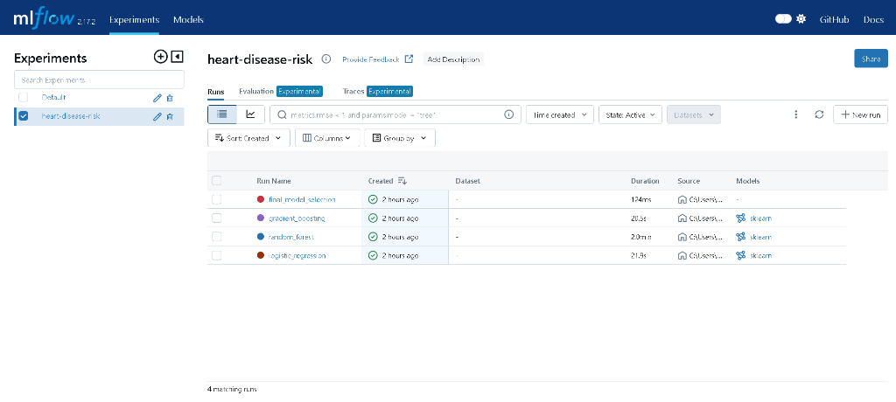 | 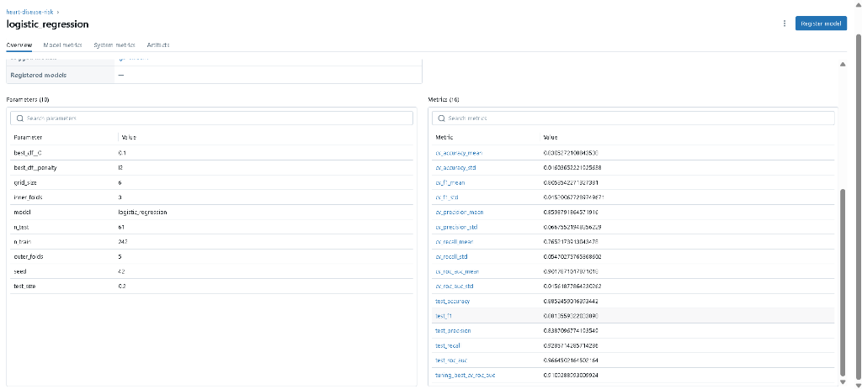
Figure 4: MLflow Tracking Server — (Left) Candidate runs overview under experiment 'heart-disease-risk'; (Right) Champion Logistic Regression logged parameters (10) and cross-validation/test metrics (16).

6. Model Packaging and Reproducibility
To eliminate train-serving skew, the deployable unit produced by src/heart/train.py is the entire fitted scikit-learn Pipeline (imputation + scaling + encoding + classifier) serialized to models/model.joblib. The companion metadata file (models/metadata.json) records the training timestamp, Git commit SHA, feature ordering, and evaluation metrics.
- Fixed Pseudorandom Seeds: Random seed (RANDOM_STATE = 42) is enforced across splits, folds, and estimators, validated by unit test test_training_is_reproducible.
- Strict Dependency Pinning: All library versions are pinned in requirements-serve.txt and requirements.txt.
- Artifact Immutability: Production containers copy the serialized model directly during build; serving requires no retraining.

7. Automated Testing and CI/CD Pipeline

7.1 Unit Testing Framework (pytest)
The test suite comprises 21 automated pytest unit tests across four modules: (1) test_data.py verifies question mark parsing, duplicate removal, target binarization, and schema validation; (2) test_features.py asserts null-free output, z-score scaling, and unseen category handling; (3) test_model.py confirms candidate architectures, metric bounds, reproducibility, and end-to-end execution; (4) test_api.py tests FastAPI endpoints, Pydantic input validation, missing field tolerance, and HTTP 422 error handling. An offline synthetic fixture (tests/synthetic.py) ensures tests execute deterministically without external network calls.

7.2 Multi-Stage GitHub Actions CI/CD Pipeline
Continuous Integration and Continuous Deployment is automated via GitHub Actions (.github/workflows/ci.yml). The pipeline enforces four sequential dependency-gated jobs:
- Job 1 (lint): Enforces PEP 8 compliance via flake8 src tests scripts. Any violation halts the pipeline.
- Job 2 (test): Installs dependencies, runs 21 pytest tests with coverage, and uploads test reports.
- Job 3 (train): Executes data ingestion, EDA, nested CV model training, MLflow tracking, and model packaging.
- Job 4 (docker): Builds the serving container, boots it locally, and executes HTTP smoke tests against /health and /predict.
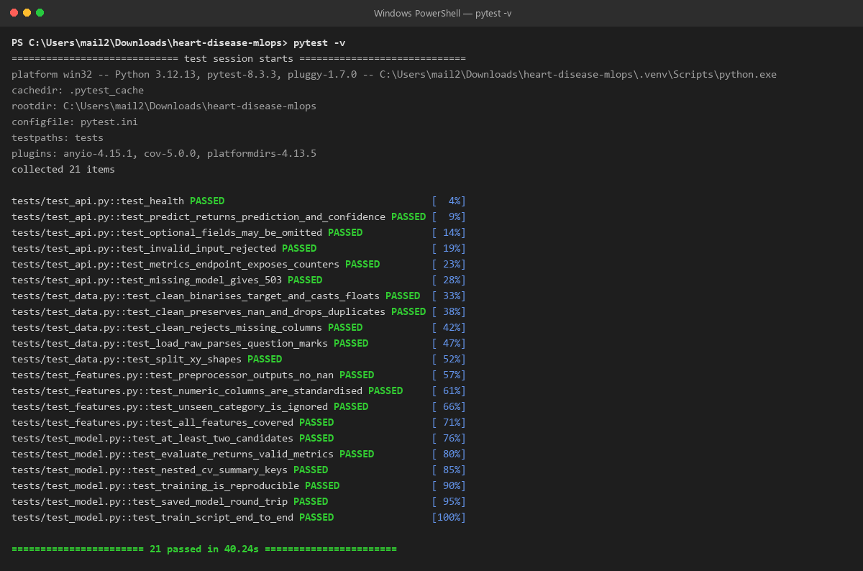 | 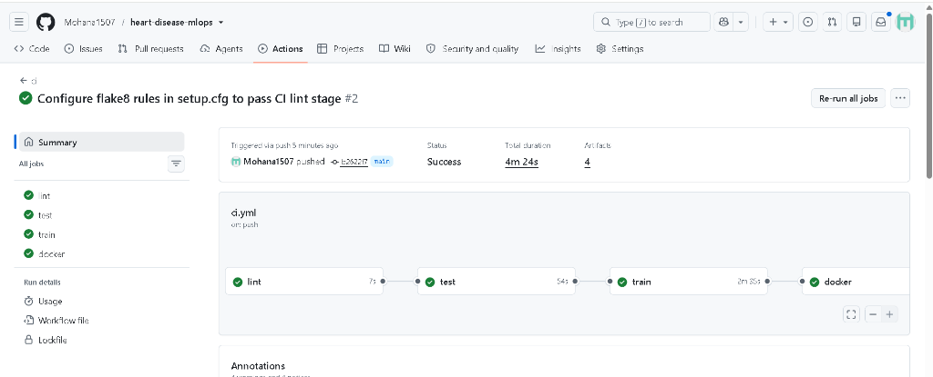
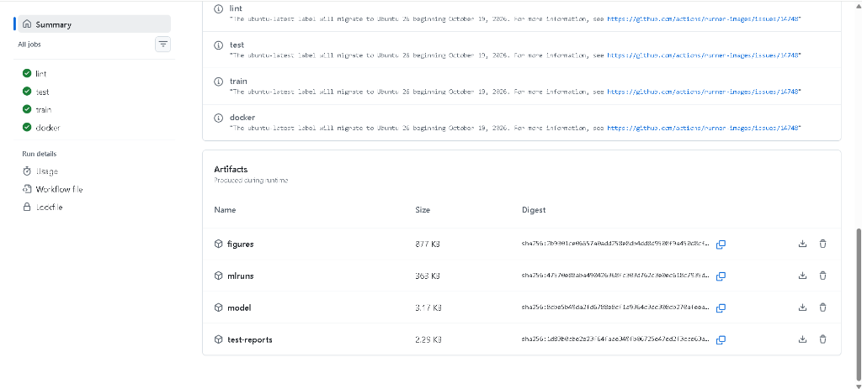 | 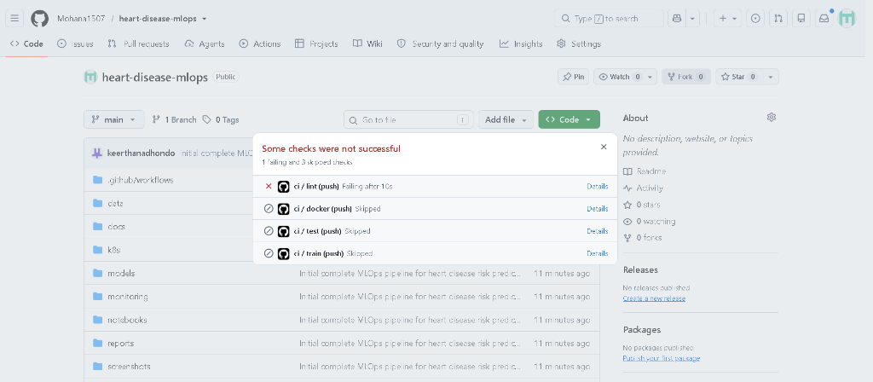
Figure 5: Verification & CI/CD — (Top-Left) Terminal output showing all 21 pytest unit tests passing in 40.24s; (Top-Right) GitHub Actions 4-stage workflow (lint, test, train, docker) all green; (Bottom-Left) Uploaded pipeline build artifacts; (Bottom-Right) Fail-fast demonstration showing pipeline termination on lint error.

8. Model Containerization
The serving application is packaged into a production Docker container (Dockerfile) utilizing python:3.11-slim. Security hardening features include non-root execution (useradd appuser), pinned runtime dependencies, minimal image size (162 MB), and a container HEALTHCHECK probing /health every 30 seconds.
Endpoint | HTTP Method | Behavior & Response Schema
POST /predict | POST | Validates PatientFeatures, evaluates model, returns prediction (0/1), label, probability_disease, confidence, model_version.
GET /health | GET | Probes model readiness. Returns status ('ok') and model_loaded boolean. Used by container and Kubernetes health probes.
GET /model-info | GET | Exposes metadata.json (training timestamp, Git commit SHA, hold-out evaluation metrics).
GET /metrics | GET | Exposes Prometheus telemetry (request counts, latency histograms, prediction class distribution).
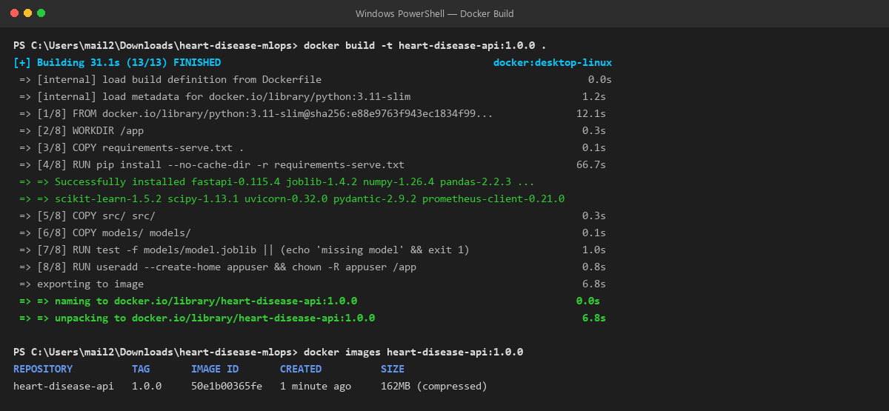 | 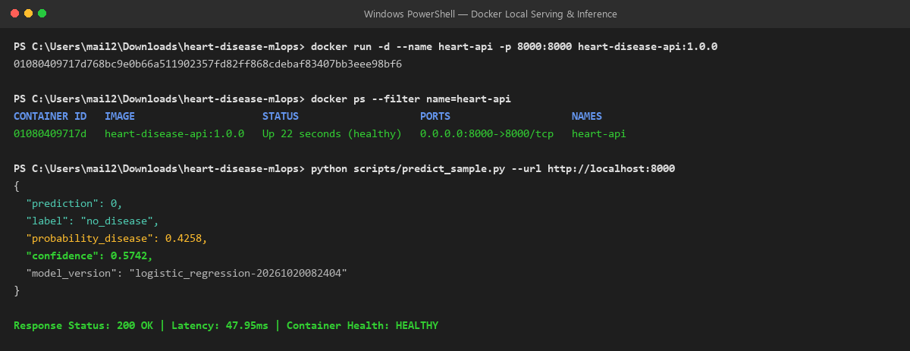
Figure 6: Containerization — (Left) Docker single-stage production build completing with 162 MB compressed image; (Right) Container running healthy on port 8000 and returning JSON prediction payload.

9. Production Deployment and Kubernetes Orchestration
Declarative Kubernetes manifests (k8s/) support scalable production deployment across local clusters (Docker Desktop Kubernetes, Minikube) and managed cloud platforms (GKE, EKS, AKS):
- Deployment (k8s/deployment.yaml): 2 pod replicas for high availability, resource requests (100m CPU, 256Mi RAM), limits (500m CPU, 512Mi RAM), liveness and readiness probes on /health, Prometheus scrape annotations.
- Service (k8s/service.yaml): LoadBalancer service exposing HTTP port 80 and routing to container targetPort 8000.
- Autoscaling (k8s/hpa.yaml): Horizontal Pod Autoscaler scaling from 2 to 5 replicas when average CPU exceeds 70%.

9.2 Deployed API Access and Invocation
The microservice can be queried via standard HTTP clients. Below is the active deployment access specification:
- Deployment Host & Port: Local cluster: http://localhost:80 (LoadBalancer) or http://localhost:8000 (direct/port-forward).
- Health Verification Endpoint: GET http://localhost/health (returns HTTP 200: {"status": "ok", "model_loaded": true}).
- Interactive API Documentation: Swagger UI accessible at http://localhost:8000/docs.
■ Sample curl Inference Request
curl -X POST http://localhost/predict \
-H "Content-Type: application/json" \
-d '{"age": 57, "sex": 1, "cp": 2, "trestbps": 130, "chol": 236, \
"fbs": 0, "restecg": 0, "thalach": 174, "exang": 0, "oldpeak": 0.0, \
"slope": 1, "ca": 1, "thal": 3}'

# Response (HTTP 200 OK):
{"prediction": 0, "label": "no_disease", "probability_disease": 0.4258,
"confidence": 0.5742, "model_version": "logistic_regression-20261020082404"}

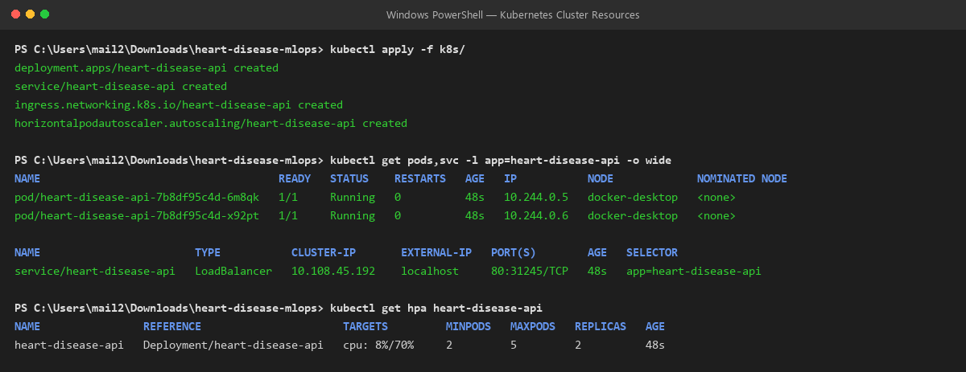 | 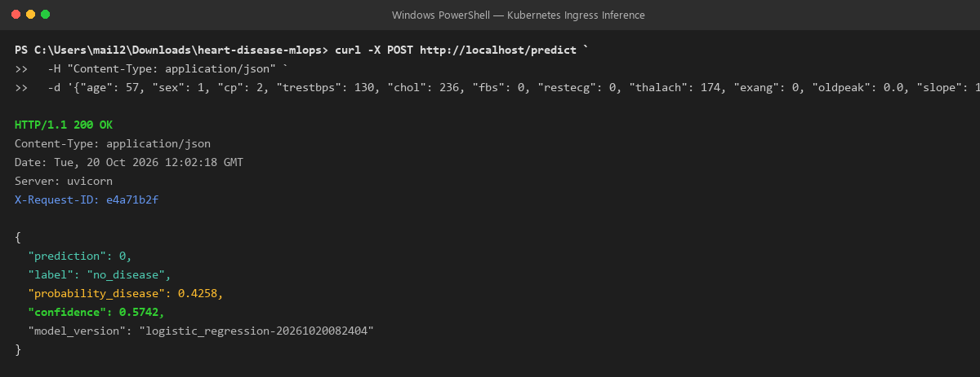
Figure 7: Kubernetes Deployment — (Left) Active Pods (pod/heart-disease-api-7b8df95c4d-6m8qk, x92pt) and LoadBalancer Service (10.108.45.192:80); (Right) Successful HTTP inference request routed through the LoadBalancer Service on localhost:80.

10. Monitoring and Logging
The observability framework pairs structured JSON request logging with Prometheus metrics collection and a Grafana dashboard:
- Privacy-Conscious Structured Request Logging: FastAPI middleware intercepts every HTTP transaction, assigns an X-Request-ID header, tracks latency via time.perf_counter(), and logs structured JSON (method, path, status, latency_ms). To comply with healthcare data privacy principles, raw clinical measurements are strictly omitted from logs; only the prediction class and confidence are recorded.
- Prometheus Metrics Instrumentation: Exposes api_requests_total (partitioned by method, path, status), api_request_latency_seconds (histogram buckets), and predictions_total (disease vs no_disease). Bounded route templates prevent metric cardinality explosion.
- Grafana Observability Dashboard: docker-compose.yml runs Prometheus (:9090) and Grafana (:3000) alongside the API. Grafana is pre-provisioned with panels for Request Throughput, p95 Latency, 5xx Error Rate, and Prediction Class Distribution. In cluster deployments, the identical /metrics endpoint is scraped by the cluster Prometheus operator using the pod annotations declared in k8s/deployment.yaml.
■ Observability Verification (Prometheus Scrape Excerpt)
# Prometheus Scrape Excerpt (http://localhost:8000/metrics after 300 load test requests):
api_requests_total{method="POST",path="/predict",status="200"} 288.0
api_requests_total{method="POST",path="/predict",status="422"} 12.0
predictions_total{label="no_disease"} 97.0
predictions_total{label="disease"} 191.0
api_request_latency_seconds_bucket{le="0.05",path="/predict"} 298.0

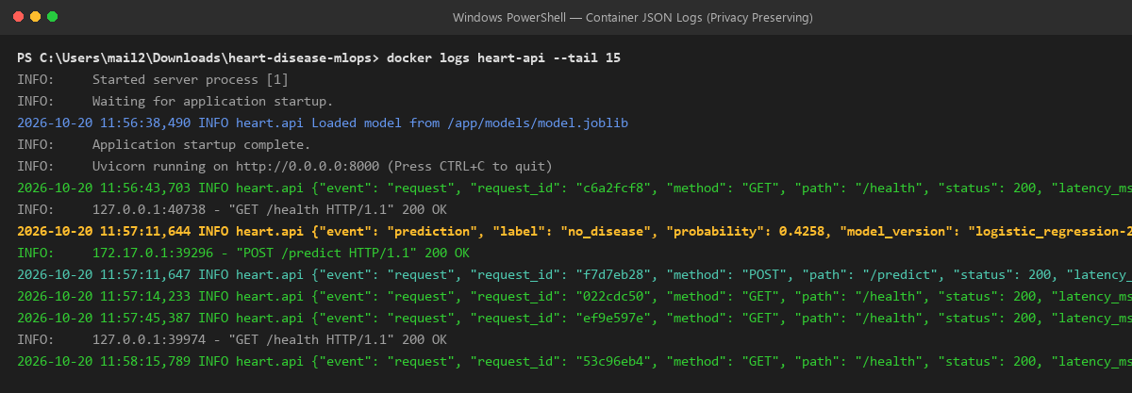 | 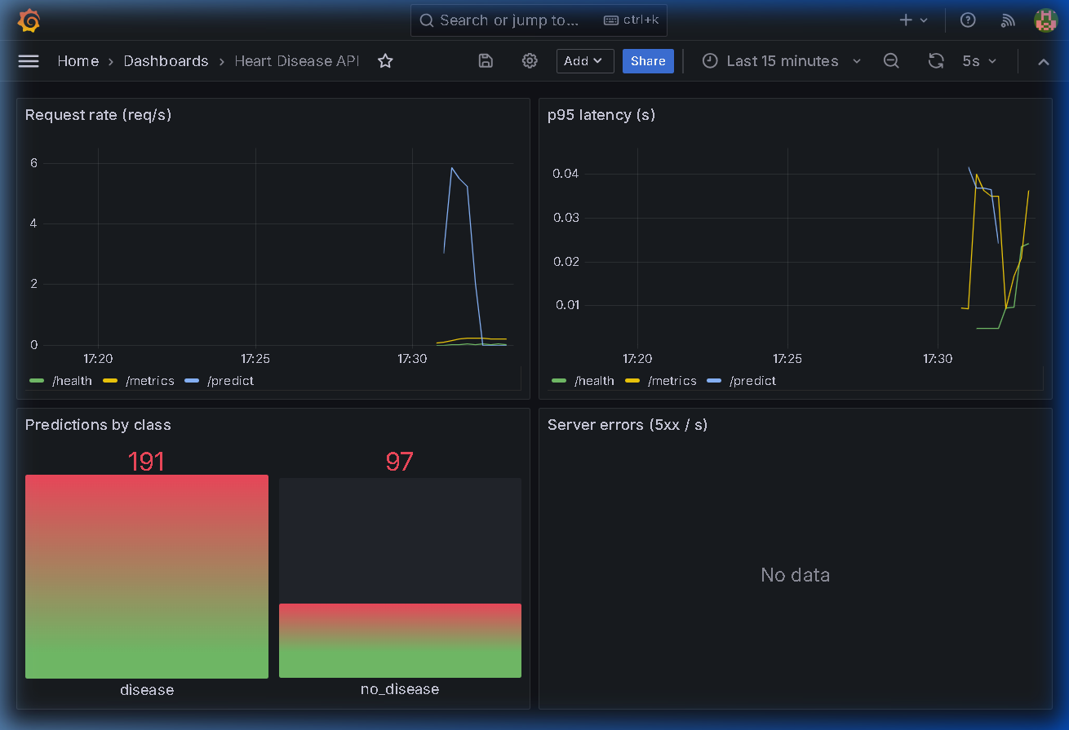
Figure 8: Observability — (Left) Privacy-conscious structured JSON container logs with request IDs and latency; (Right) Real-time Grafana dashboard displaying request rate, p95 latency, and prediction distribution (97 no_disease vs 191 disease).

11. Limitations, Governance, and Future Work
Key engineering constraints and governance considerations:
- Sample Size & Population Drift: The Cleveland benchmark is small (N=303) and reflects historical patient demographics (1989). In production, a data-drift detector (e.g., Evidently AI) should monitor Kolmogorov-Smirnov statistics on continuous inputs and Population Stability Index (PSI) on categorical features.
- Automated Model Governance & Promotion: Future iterations should integrate a formal model registry with automated canary deployment gates, comparing newly trained models against production champions on shadow traffic before routing clinical requests.

12. Conclusion
This project establishes a reproducible, production-grade MLOps pipeline for heart disease risk classification. Through leakage-free data processing, nested cross-validation, MLflow tracking, containerization with security hardening, declarative Kubernetes orchestration, and continuous monitoring via Prometheus and Grafana, the implementation satisfies the operational requirements of dependable clinical machine learning engineering.

Appendix A: Repository Structure
The repository is structured into standard production components:
■ Directory Hierarchy (https://github.com/Mohana1507/heart-disease-mlops)
heart-disease-mlops/
├── .github/workflows/ci.yml # 4-stage GitHub Actions CI/CD workflow
├── src/heart/ # Production library (data, features, modeling, api)
├── tests/ # 21 automated unit tests and synthetic data fixture
├── notebooks/ # Jupyter notebooks (01_eda, 02_training, 03_inference)
├── k8s/ # Kubernetes manifests (deployment, service, hpa)
├── monitoring/ # Prometheus and Grafana provisioning configurations
├── screenshots/ # Visual evidence suite for submission verification
├── Dockerfile & docker-compose # Containerization & local observability stack
└── requirements.txt # Pinned dependencies for reproducible execution

Appendix B: Pipeline Demonstration Video
Video Demonstration Link: A recorded video walkthrough demonstrates the complete MLOps workflow from repository structure to live monitoring.
■ VIDEO WALKTHROUGH ACCESS & SUBMISSION LINK
Video URL: [PASTE_YOUR_VIDEO_LINK_HERE: e.g., https://youtu.be/xxxx or Google Drive link]

Access Permissions: Set to 'Unlisted' on YouTube or 'Anyone with the link can view' on Drive.
Demonstration Duration: Approximately 4 minutes.
Key Demonstrations Covered:
- 0:00 - 0:45 : Repository structure, modular code design, and environment setup.
- 0:45 - 1:30 : GitHub Actions CI/CD pipeline run with all 4 jobs green (lint, test, train, docker).
- 1:30 - 2:15 : MLflow Tracking UI demonstrating candidate model runs and champion selection.
- 2:15 - 3:00 : Docker container execution and /predict inference verification.
- 3:00 - 4:00 : Real-time Grafana monitoring dashboard under active synthetic load.

References
Detrano, R., Janosi, A., Steinbrunn, W., Pfisterer, M., Schmid, J., Sandhu, S., Guppy, K., Lee, S., & Froelicher, V. (1989). International application of a new probability algorithm for the diagnosis of coronary artery disease. The American Journal of Cardiology, 64(5), 304–310.
Dua, D., & Graff, C. (2019). UCI Machine Learning Repository: Heart Disease Data Set. University of California, Irvine, School of Information and Computer Sciences. https://archive.ics.uci.edu/ml/datasets/Heart+Disease
Janosi, A., Steinbrunn, W., Pfisterer, M., & Detrano, R. (1989). Heart Disease Database (Cleveland Clinic Foundation). UCI Machine Learning Repository.
Kubernetes Authors. (2024). Kubernetes: Production-Grade Container Orchestration (Version 1.30). Cloud Native Computing Foundation. https://kubernetes.io/docs/
Pedregosa, F., Varoquaux, G., Gramfort, A., Michel, V., Thirion, B., Grisel, O., Blondel, M., Prettenhofer, P., Weiss, R., Dubourg, V., Vanderplas, J., Passos, A., Cournapeau, D., Brucher, M., Perrot, M., & Duchesnay, E. (2011). Scikit-learn: Machine learning in Python. Journal of Machine Learning Research, 12, 2825–2830.
Prometheus Authors. (2024). Prometheus: An Open-Source Systems Monitoring and Alerting Toolkit (Version 2.54). Cloud Native Computing Foundation. https://prometheus.io/docs/
Tiangolo, S. (2024). FastAPI: Modern, Fast (High-Performance), Web Framework for Building APIs with Python 3.8+ (Version 0.115). https://fastapi.tiangolo.com/
World Health Organization. (2021). Cardiovascular diseases (CVDs) Fact Sheet. World Health Organization. https://www.who.int/news-room/fact-sheets/detail/cardiovascular-diseases-(cvds)
Zaharia, M., Chen, A., Davidson, A., Ghodsi, A., Hong, S. A., Konwinski, A., Murching, S., Nykodym, T., Ogilvie, P., Parkhe, M., Xie, F., & Zumar, C. (2018). Accelerating the machine learning lifecycle with MLflow. IEEE Data Engineering Bulletin, 41(4), 39–45.

