TEST PLAN GENERATOR - TPG

About the application
The Test Plan Generator application is designed to read an EDI map in a Word document format, analyze its contents, and automatically generate corresponding test cases in a formatted test plan. Based on the selected operation type—New or Enhancement—the application adjusts its behavior accordingly. The program supports both inbound and outbound maps.

The intention of the application is
- To reduce the manual effort and time spent by the analyst in creating the test cases from the map and drafting them in the test plan. This will facilitate quick planning and execution of internal testing and move projects further closer to deployment.
- To bring uniformity by maintaining consistency in the test plan structure as well as the test case details entered.
- To reduce oversight of missing out cases present in map when writing test cases in test plan.
- To ensure the bandwidth of analyst is utilized efficiently by providing a jumpstart to the testing process.
- To eliminate repetitive tasks, automating the generation of the desired cases with just a few clicks. This tool provides organized cases and facilitates ease of testing, especially during tight timeline projects.

Creating cases for New/Enhancement
- Download the release zip file and place it in C:\Documents \TestPlanGenerator.
- Unzip the contents and double click the jar to run the file.

- Upon launching, navigation instructions will appear in the Log Area.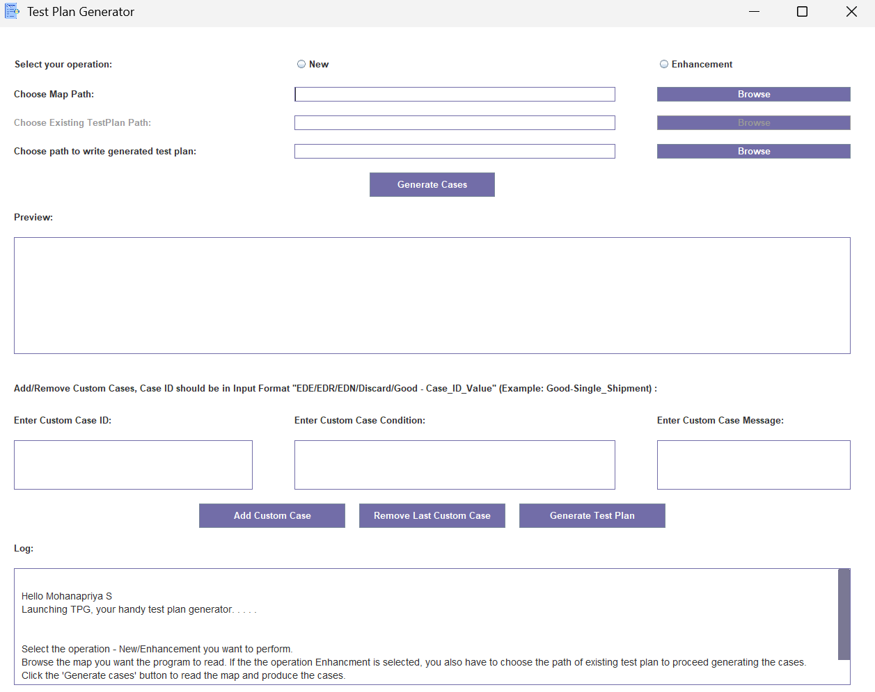

- Select your preferred operation in the given choices – New/ Enhancement
- Use the browse buttons to select the path of Edi Map that you want to read for generating cases. (.docx format only).
- If performing an enhancement, browse to select the path of the existing test plan (.xls or .xlsx formats only).
- If no existing test plan is available, you can proceed without selecting one. Upon clicking Generate Test Plan, a prompt will appear—click Yes to continue. Since certain older projects may not have an existing test plan, the application allows you to forgo choosing the existing plan and instead use a fresh test plan to write down the cases.
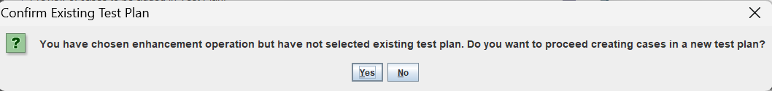
- Click the ‘Generate Cases’ button to read the map and display the generated test cases in the ‘Preview’ area.
- You can include additional cases by entering the values in the corresponding fields for ‘Enter Custom Case ID’, ‘Enter Custom Case Condition’ and ‘Enter Custom Case Message’. Once you have entered the values, click ‘Add Custom Case’ and you’ll have the custom case added in the ‘Preview’ area along with the generated cases.

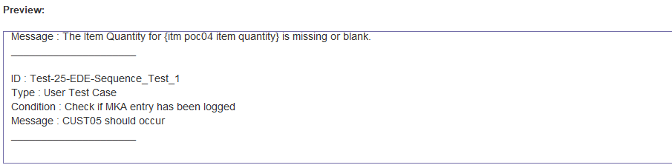
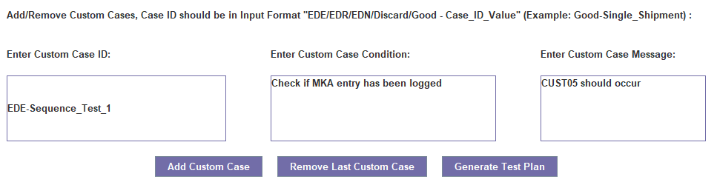
- Custom Cases follow LIFO (Last in First Out) order. The ‘Remove Last Custom Case’ Button can be used to remove the last entered case from the list as well as from the ‘Preview’ area.
- Use the Browse button next to “Choose path to write generated test plan” to select a save location.
- Once done, click the ‘Generate Test Plan’ button to proceed further. A pop will show up to enter the ADO Number. This is a mandatory field and if no input is given, you’ll be prompted to enter it to continue.
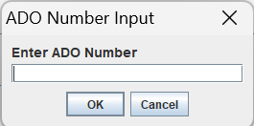

- Upon giving the ado number, a column configuration confirmation will then pop up. This will show the default ordering of the 3 major test plan columns this application interacts with. You can choose between “Use Default Order” and “Enter Custom Case”. For custom column ordering, you must enter your desired order in the format ‘Test Case/Description/Expected Results’. It is mandatory to give input in - number/number/number format.

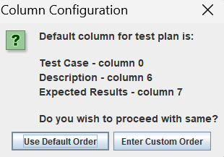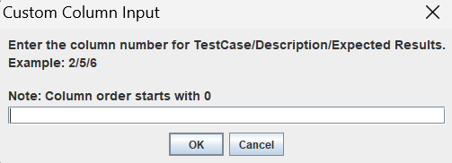

- After configuration, the test plan will be saved to the selected path. If a file with the same name exists, a prompt will ask confirmation for overwriting. Ensure the file is not open in any program or used by any other program to avoid errors.
- If you’re overwriting an existing test plan, ensure that you have the latest copy of it stored elsewhere just in case you want to get back to the old data. This program does not support any rollbacks.
- The Log Area records the execution steps of the program.

Creating cases for Modifications during External Testing
Logical modifications during external testing with clients happen often and to take into account such needs and make test plan creation more efficient, this tool provides a way to add additional cases to existing test plan, with the cases already present for respective ADO.
Consider the scenario where you’re working on a new project with ADO 11223 for client Made_For_Testing. The test plan Made_For_Testing_Inbound_850_Purchase_Order_Export_Test_Plan already has 24 cases under ‘First Install – ADO 11223’. During external testing 1 new case is added, 1 case is removed and 2 validation cases are modified.
Open the test plan generator, select the path of the map with the current changes made during external testing. These changes should be highlighted.
- Select the operation as enhancement. Note: Even if the feature you’re working on is a New, proceed to select operation as enhancement to take into account the current changes made during external testing.
- Point the existing test plan path to the test plan which has the original cases for the current feature prior to external testing changes. Select the destination path you want to write the test plan to.
- Click Generate Cases button and you’ll find the cases with highlights displayed in the preview area. Add any custom cases as needed.
- Click generate test plan.
- In the pop up that asks for ADO number, provide the ADO number of the feature you’re working. In this case, 11223.
- You will get the below pop up to confirm adding cases under the ado section. Click ‘yes’ to proceed.
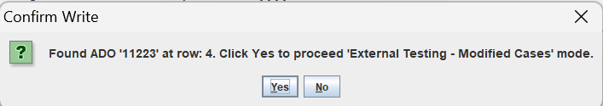

- You’ll get the pop up to confirm overwriting of existing cases if the write path is same and the test plan will be generated with all the cases successfully. If any cases modified or removed was already part of the test plan those will be stricken and will also be displayed in the log of the tool.
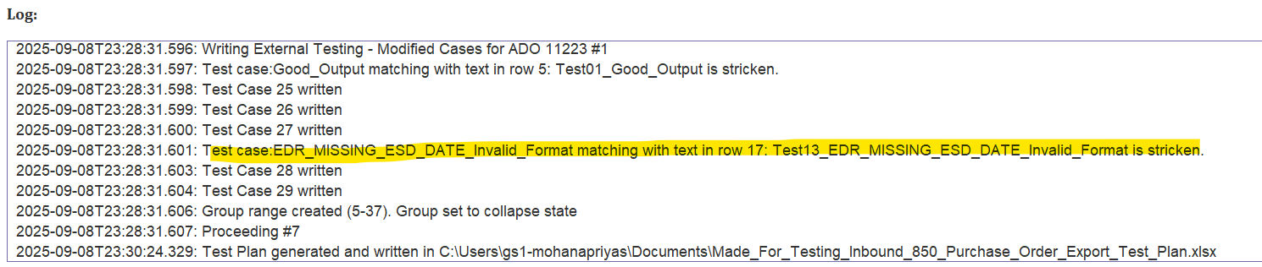
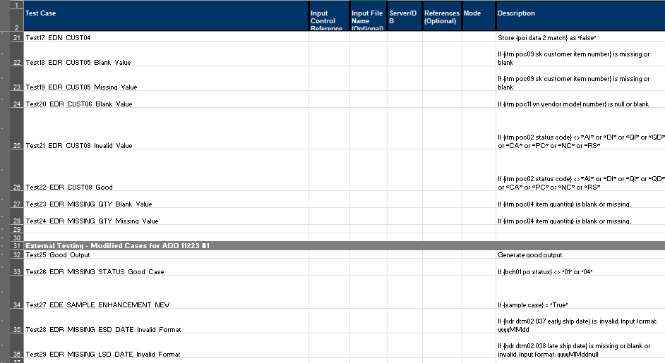

- The ‘External Testing’ tag is not a separate section but rather it is positioned under ‘First Install’/ ‘Enhancement’ sections. The tag is provided to distinguish the cases. The #1 represents it is the first phase of external testing changes captured.

Working Logic of the application
- The application follows the OM mapping standards to define test cases.
- All the text inside the map is read as either paragraphs or tables.
- The program identifies a test case based on any paragraph having “Create ED” or “Create Discard” key words.
- The application takes the paragraph preceding the key words to be the ‘EDI case condition’ . The paragraph succeeding it is split based on first occurring comma as per standards and the first portion is considered as ‘EDI case id’ and the remaining is considered as ‘EDI case message’.

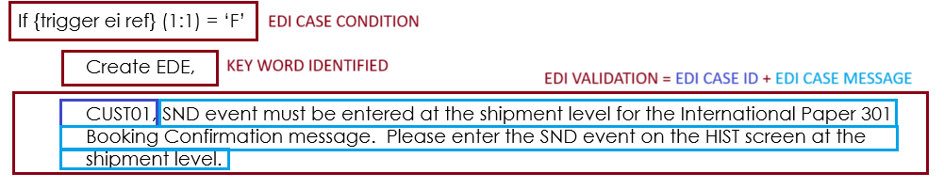

Note: It is mandatory that the Edi case condition, create key word, and Edi validation paragraph should be aligned one after another without any line breaks / new line in between.

- If the Edi Validation paragraph doesn’t have a comma, the program terminates and asks the user to ensure the text in the map matches the format.
- Scenarios for map generated cases are considered based on the values separated by ‘or’.
In the below scenario, MISSING_ESD_DATE has missing, blank and invalid scenario cases generated.
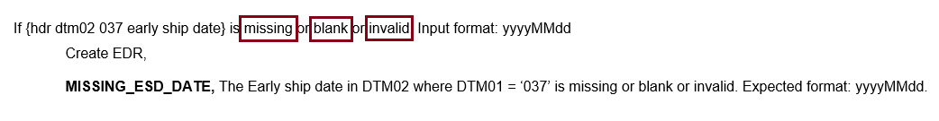

In the scenario below, a good case and an invalid scenario is generated for CUST08.
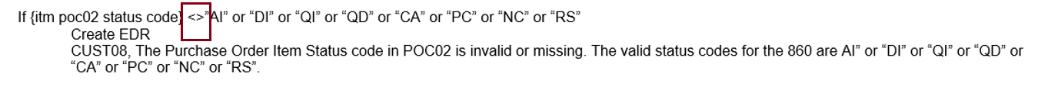
- For standard validation cases, scenarios are generated based on the check boxes marked as checked in the client specific logic column.

In the scenario below, for LOCATION_EI_MISSING, two scenarios Port of Origin and Port of Delivery are generated.
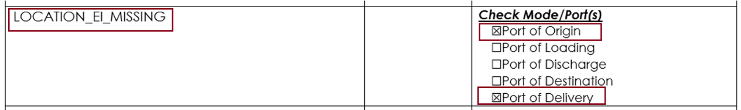
In the below scenario, for EVENT_MISSING_BKD_LOAD_ORIGIN, the scenario case will be Ocean.

- For Enhancement Operation, the above logic is implemented but only in the paragraph where the text is highlighted.
- For Enhancement - In the Map Generated Cases, if the key words are highlighted and stricken, it is considered a “Deletion”, if the key words are highlighted but not stricken it is considered a “New case”. If either the EDI case condition paragraph or the EDI case id or EDI case Message has any highlights that may or may not be stricken, it is considered as a “Modified case”. All the stricken text from the preceding and succeeding paragraph is removed when the text is written to the test plan.

Examples of enhancements for map generated cases:

- Enhancement – Validation Deletion
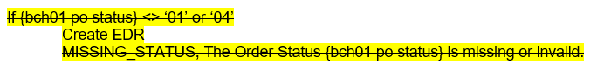
- Enhancement – Validation Newly Added
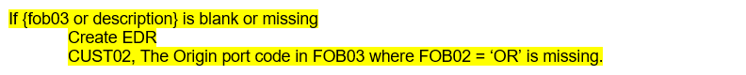

- Enhancement – Validation Modified
- Enhancement – Validation Modified

- For Enhancement – Standard Validation Cases, If the validation key is highlighted, then a case is created for it in the test plan.

Example of enhancement in standard case:
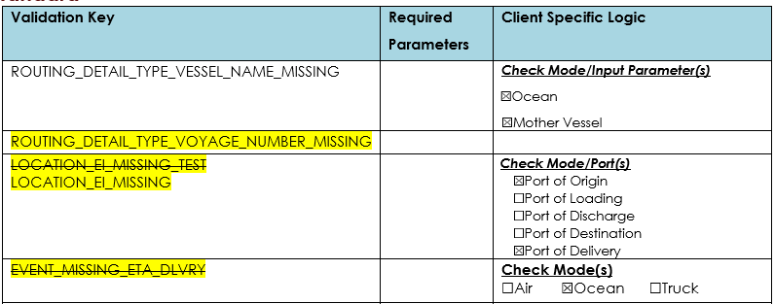

- The test cases are grouped according to the ADO Number written in the test plan. If it is a New operation, the words “First Install’ are added as prefix. Otherwise “Enhancement” is added as prefix in the grouping tab.
- The test cases are added to the second sheet of the test plan as per standards.
- Test Plan Name Format:
  - For New project : Test Plan Name = Map Name + “_Test_Plan.xlxs”
  - For Enhancement without existing test plan : Test Plan Name = Map Name + “_Test_Plan.xlxs”
  - For Enhancement with existing test plan : Test Plan Name = Existing Test Plan Name

Troubleshooting Tips

- File Access Errors
Ensure the EDI map or existing test plan file is not open in another application while generating cases or writing the test plan. Please close the files and re-try generating the cases or generating the test plan.
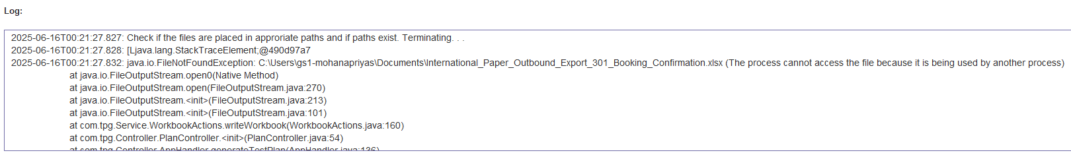

- No Cases Generated
If the application doesn’t generate cases for any of the conditions present in the map, please check if the case is written as per the standards. Additionally, you can also go through the working logic mentioned above to understand the case generation process. Also ensure that the Edi case condition, create key word, and Edi validation paragraph are aligned one after another without any line breaks / new line in between.

- Excess Cases in Enhancement Mode
Check that only required text is highlighted. Unnecessary highlights may result in extra cases.

- Text Parsing Issues
Use paragraph view in Word (¶ symbol) to detect problematic formatting such as tabs, spaces, or indentation or new lines.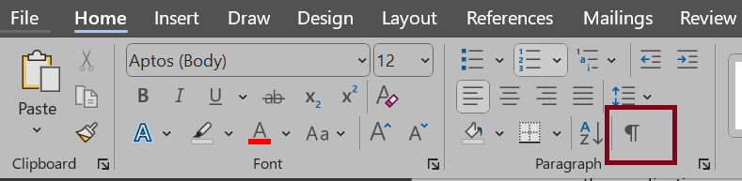

Technical Details
- Language: Java SE 1.8
- Dependencies:
  - Apache POI (poi, poi-ooxml)
  - Java Swing
  - Java AWT
- Build Tool: Maven
- Runtime: JVM

Version Change Details

Version change as on 06/17
Major Changes:
- Addition of UI, replacing command line interaction for better usability
- Addition of logical checks in getting user data through the user interface. Usage of file pickers with filters to read the precise file.
- Facilitating re-arrangement of test plan columns based on user input or proceeding with default arrangement
- Modified the criteria for selecting existing test plan for enhancement cases to be optional and proceeding with creating cases with template when existing plan is not given by user.
- Modified test case verbiage to include counter and type of cases
- Generating additional scenario cases for each map-based cases based on conditions present in the text preceding 'Create EDE/EDR/EDN/Discard'
- Generating additional scenario cases for standard conditions based on values in client specific logics in the validation action table.
- Preserving order of the cases read from map and optimized data storage retrieval

Minor Changes:
- Modularized the code to follow MVC for better implementation.
- Adding log data for better accessibility
- Modified adding and removing custom case logic to follow LIFO order.
- Handling multiple checks present in conditions i.e., blank, missing, invalid, format, <> and not equal to.
- Reading CDF names used in conditions and infusing it in ‘match not found’ scenarios.
- Bug fixes related to reading and writing operations.

Version change as on 09/09
- The message and description fields for adding custom cases are no longer mandatory. Only custom case Id is mandatory.
- The UI widgets have been enlarged with additional scroll bars and text size has been increased for better readability.
- Improved logging with more details for user visibility
- The data present in 'required parameters' column in 'standard validations' table will not be included in creating standard cases.
- Multiple scenario cases for standard validations will now be created in mode-parameter combination rather than having mode specific cases and parameter specific cases separately.
- Addition of 'External Testing - Modifications' mode allowing user to capture more cases in the life cycle of the project.

