TASK1:Singleton Pattern
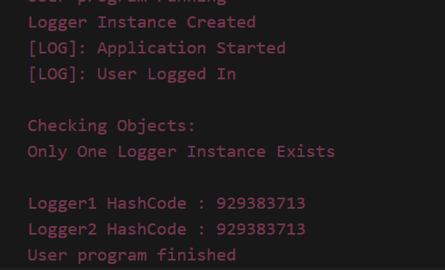
TASK2: Implementing the Factory Method Pattern
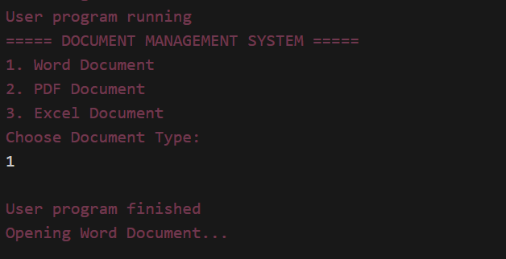
TASK3: Implementing the Builder Pattern
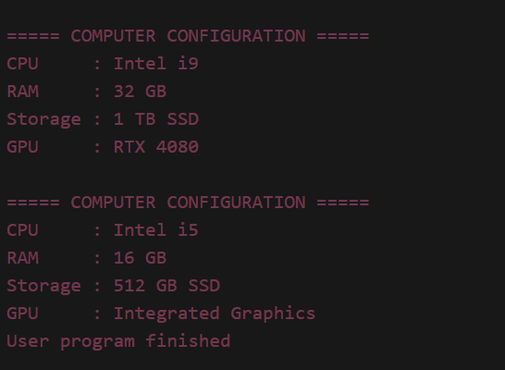
TASK4:Adapter pattern
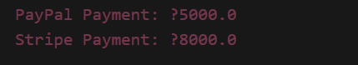

TASK5:Decorator Pattern
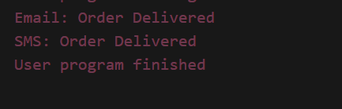
TASK6:Proxy Pattern
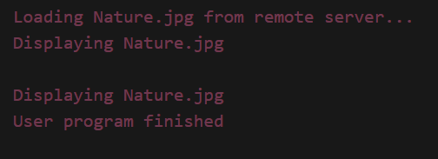
TASK7:Observer Pattern
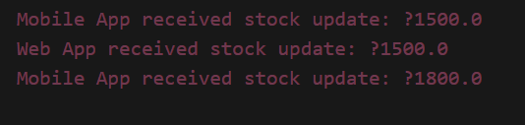
TASK8:Strategy Pattern
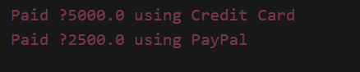
TASK9:Command Pattern
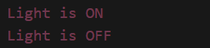
TASK10:MVC Pattern
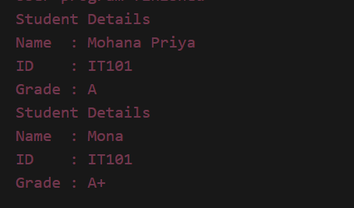
TASK11:Dependency Injection
