This framework is designed in POM and Data driven approach to automate sample test scenario for chatbot. It is designed in robot framework design pattern with selenium tool and python as a programming language.

**Framework Structure:**

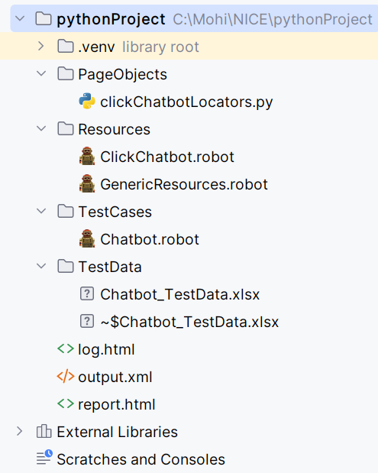

Report file

Test data files

Add up testcases based on scenarios

For actual implementation of logic page wise

add all locator elements page wise

**Test case automated:**

1. The scripts are added to validate a chat bot test case by texting input message and validate expected output message.
2. Test data with input message and response message are maintained in excel file and imported from data driver.

**Approach:**

Data driven approach followed with data driver concept in robotframework.

Came up with a generic keyword to execute all the test data repeatably to input message and validate response in chatbot.

**Code Snippet:**

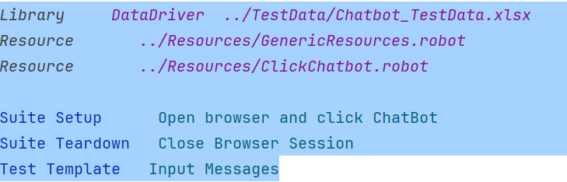

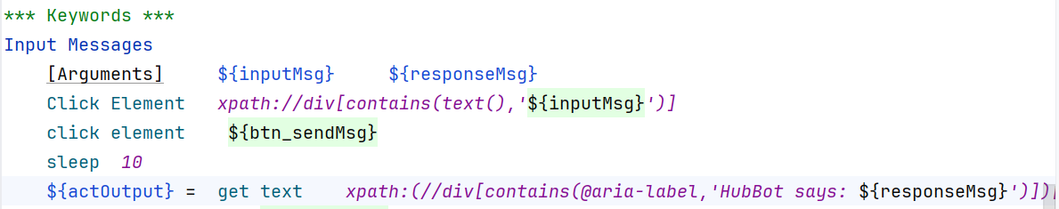

**Report:**

Report.html has detailed report on the test case execution.

**Software setup and environment setup to execute test cases:**

1. Install PyCharm IDE, download [PyCharm Community Edition](https://www.jetbrains.com/pycharm/download/#section=windows).
2. Install python, Download <https://www.python.org/downloads/>
3. Install selenium in cmd prompt -> pip install Selenium
4. Install Robot Framework in cmd prompt -> pip install robotframework
5. Install Selenium3Library -> pip install robotframework
6. Install the Intellibot Plugin in PyCharm for Robot framework.  
    In PyCharm IDE, you need to install the Intellibot plugin for Robot framework. Go to File -> Settings -> Plugins -> Search for Intellibot in the plugins marketplace -> Install the plugin -> Restart the IDE.

**To Run testcase:** Run robot TestCases/Chatbot.robot from cmd.