Output 1: Combination of numbers and characters

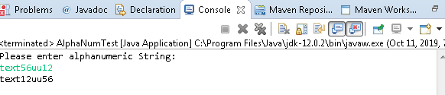

Output 2:Combination with more repeated numbers

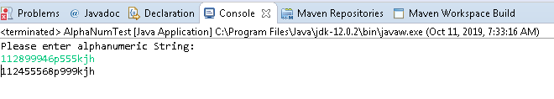

Output 3:Only characters

