**Soda Machine Application**

**By Mohana Boddu**

Soda Machine application is developed to serve the user with a desired drink. When sufficient quarter is inserted, soda is dispensed and remaining change is returned to the user. It is developed using Spring MVC.

1. **Architectural Design:**

Spring MVC helps in building flexible and loosely coupled web applications. The Model-view-controller design pattern helps in separating the business logic, presentation logic, and navigation logic.

* **Models** are responsible for encapsulating the application data.
* The **Views** render a response to the user with the help of the model object.
* **Controllers** are responsible for receiving the request from the user and calling the back-end services.

1. **Application Structure:**

Main functionality of the application is to dispense soda when enough or more amount is inserted than the mentioned price of it. After entering the amount application works on validating the amount, updating the quantity of the soda along with the change to be returned. Below are the details of the application structure :

### WEB-INF/jsp/index.jsp

* It is used to take input from user using Spring MVC and displays the required output.

**WEB-INF/web.xml**

* Called as the deployment descriptor file.In order to load DispatcherServlet as the application is deployed. Whenever a request is made with .jsp as the suffix, DispatcherServlet is processing the request.

**WEB-INF/spring-dispatcher-servlet.xml**

* It is an xml file is used by dispatcher servlet.

**model/Soda.java**

* It is mainly POJO class that encapsulates the application data.

**controller/SodaController.java**

* It is used to process the request. It accesses the DAO to access data and returns the data to .jsp (view) so that data is displayed.

**dao/SodaDao.java**

* It’s a design pattern in which a data access object (DAO) is an object that provides an abstract interface to work on data. All the data required is present in this class.

**service/SodaService.java**

* It is a java class that provides functionalities to the application like validating the amount, updating the quantity after dispensing the soda and returning the balance if any. So it is called as the service provider.

1. **Screenshot :**

Below is the screenshot of the application which is displaying list of items in soda machine with available quantity, price and Item name. And buttons for corresponding functionalities.

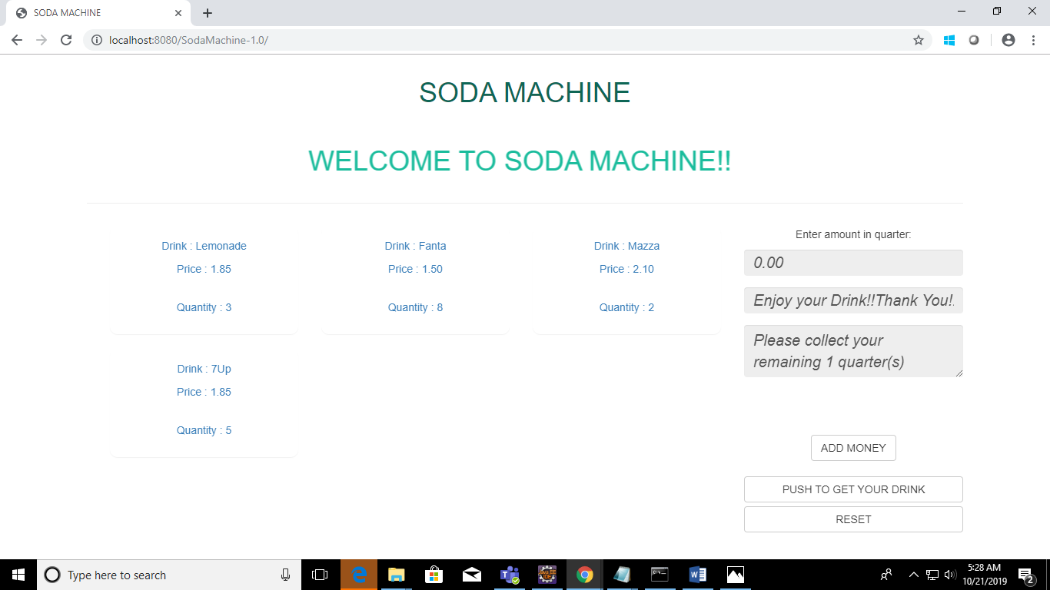

1. **Class Diagram:**

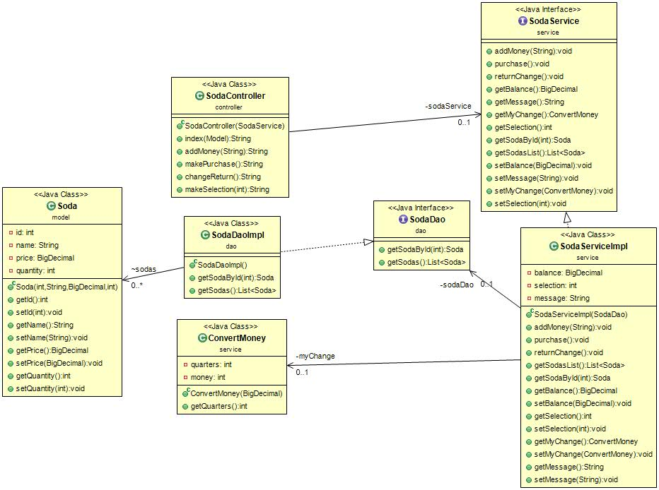

1. **User Guide :**

* First select the drink required.
* Click on “Add money” until required amount or more than required(more or equal to the price of drink) is reached. It is marked in quarter.
* Then click on “Push to get your drink” which dispenses soda along with remaining change (in quarter) if any.
* Reset button is used to reset options.

1. **References :**

Code available in github URL: [**https://github.com/MohanaB/SodaMachine.git**](https://github.com/MohanaB/SodaMachine.git)