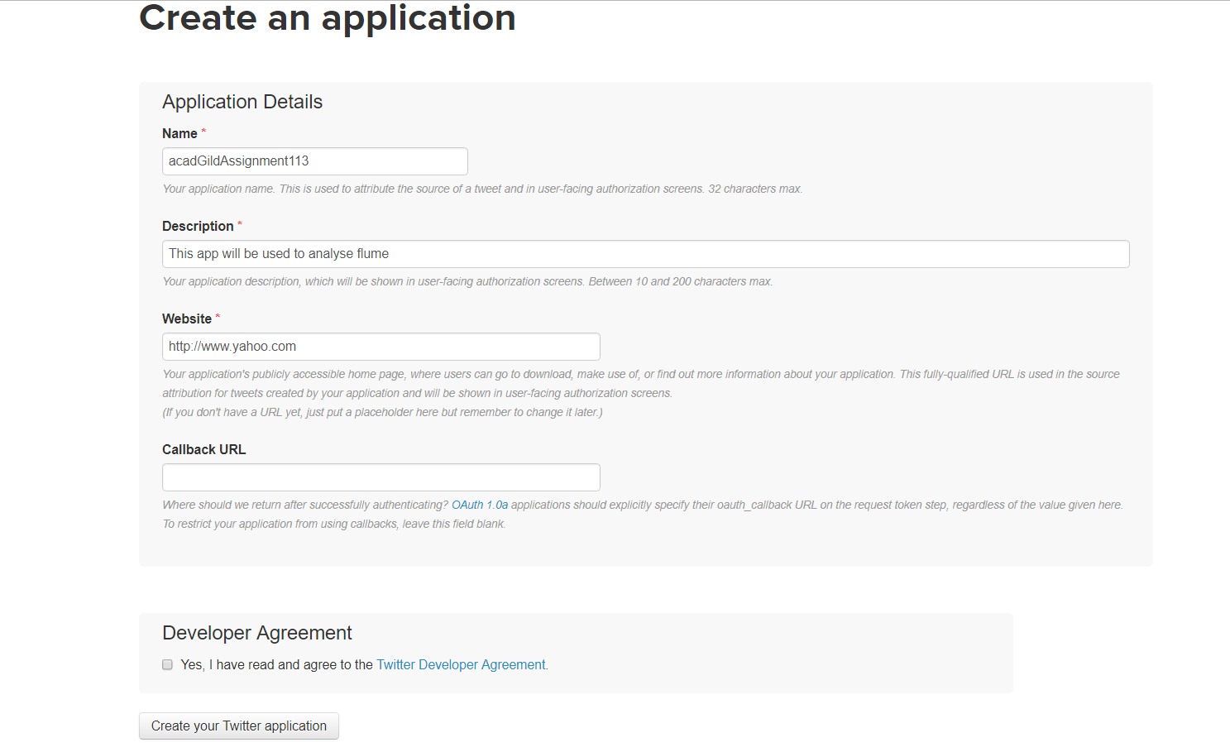

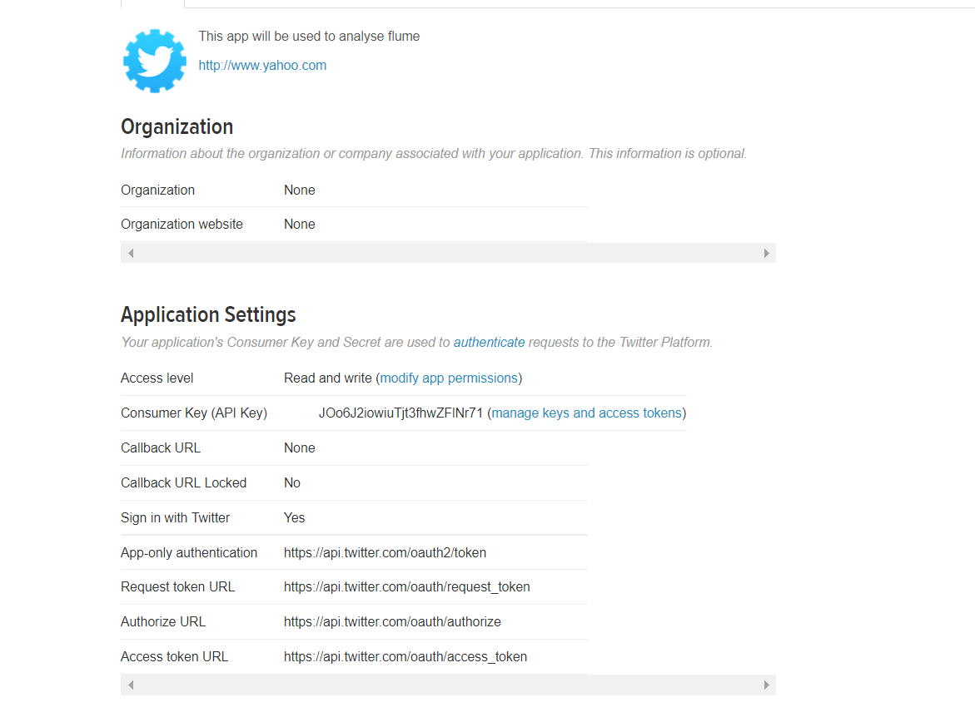

Consumer Key (API Key)JOo6J2iowiuTjt3fhwZFlNr71

Consumer Secret (API Secret)wXeOaIZMuPZgztFbpwpHgLZFGaWTN21dVINXpYrX6TYaXltz5A

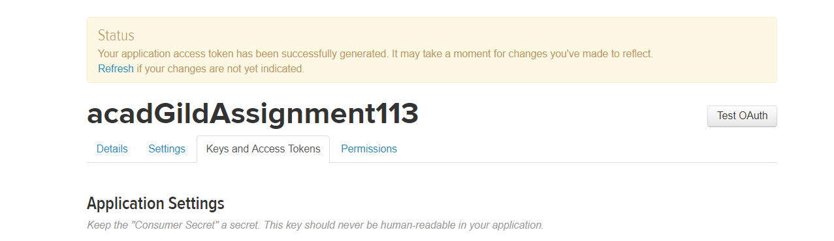

Consumer Key (API Key)JOo6J2iowiuTjt3fhwZFlNr71

Consumer Secret (API Secret)wXeOaIZMuPZgztFbpwpHgLZFGaWTN21dVINXpYrX6TYaXltz5A

Create flume.conf file in flume directory

