### Pwd :

Prints the current working directory.

Output:

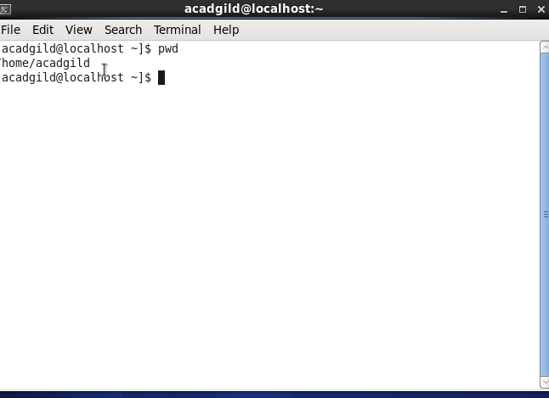

1. Vi:Text editor The command is for editing

Vi filename.txt : creates a file if doesn’t exist



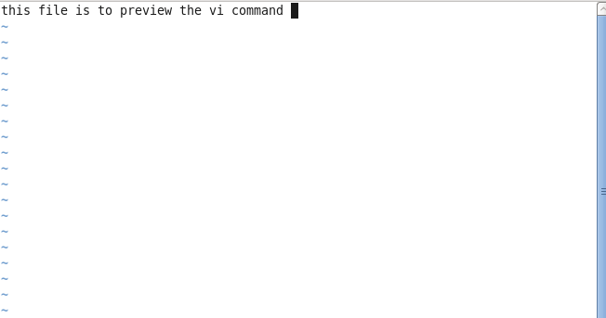

Vi filename.txt opens the file if already exists

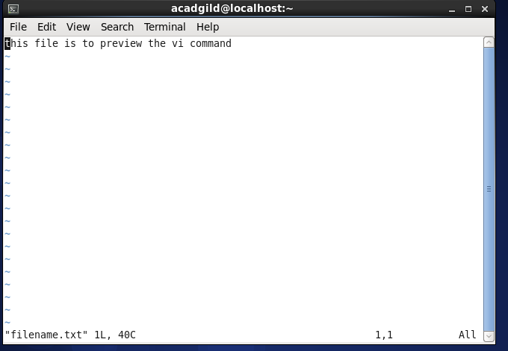

Opens the file in read-only mode

Vi –R filename.txt

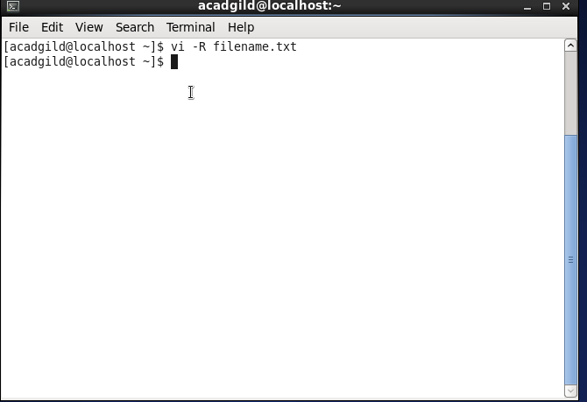

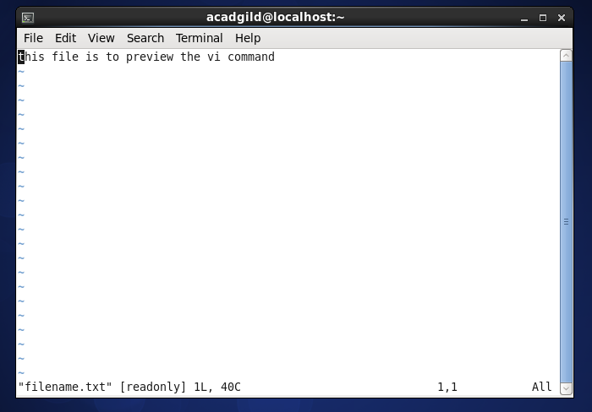

1. Touch :

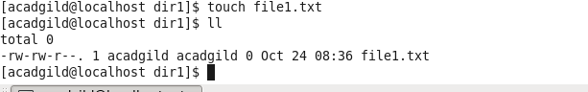

1. Mkdir: Creates a directory

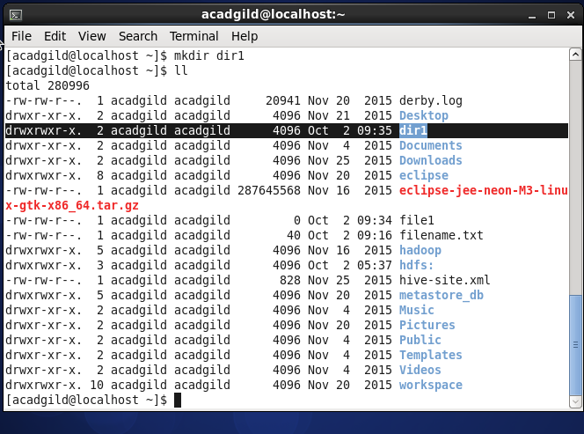

1. Rm: Removes the file

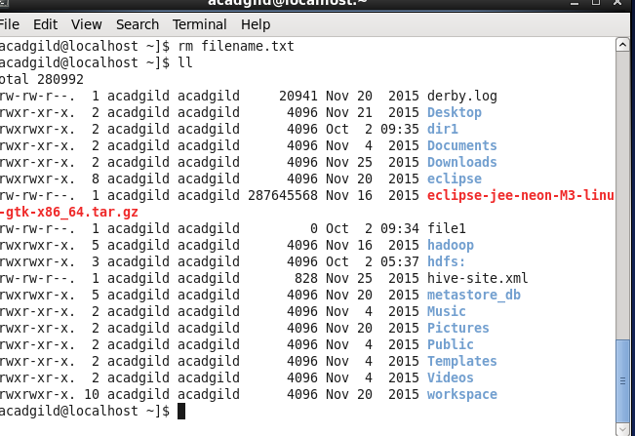

1. **LS**:

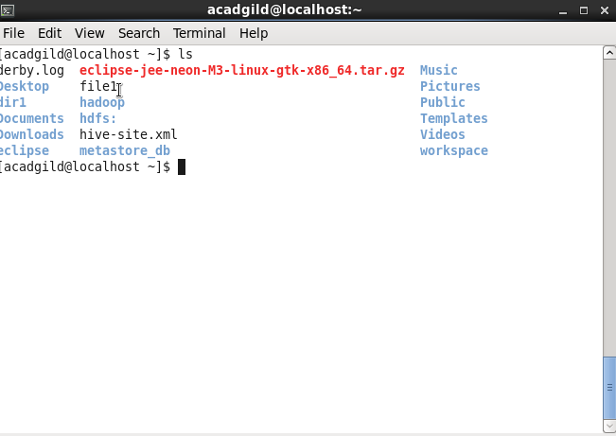

Ls –l:

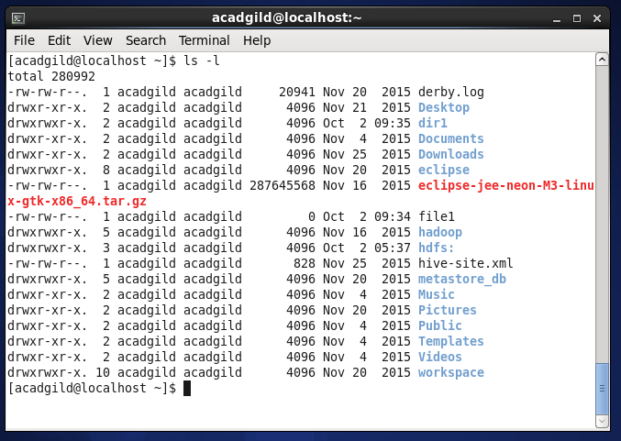

Ls - a

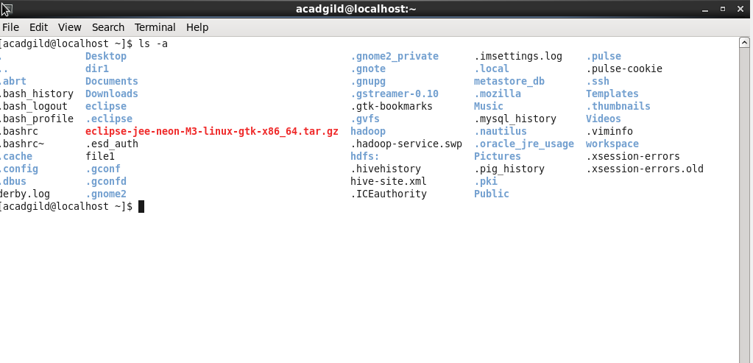

Ls -A

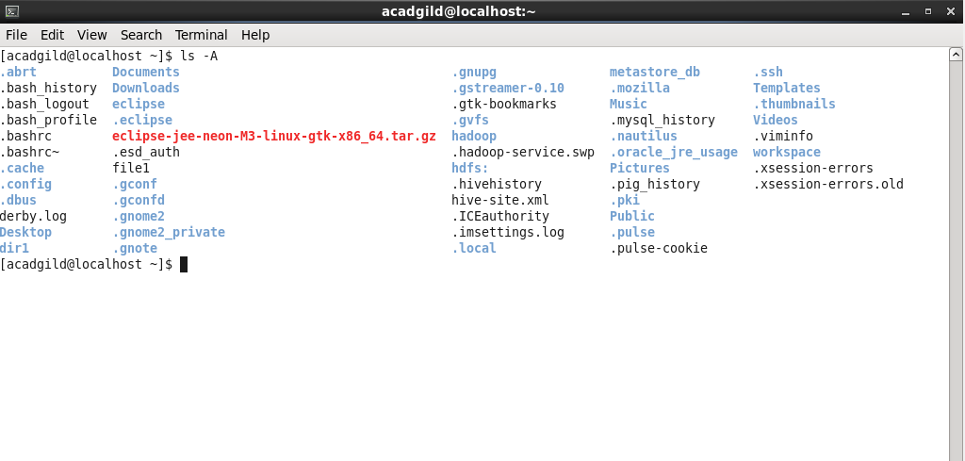

**ls –r :** display files/directories in reverse order

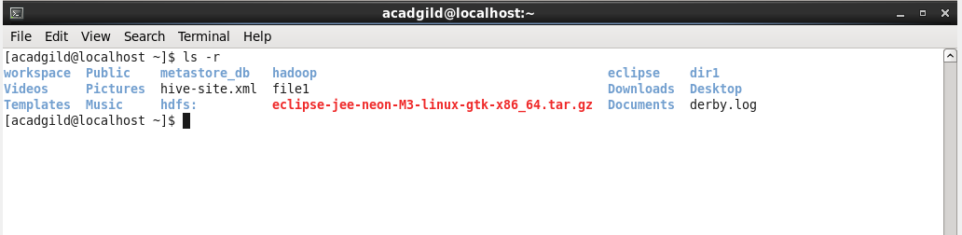

*ls –X :* sort ls command output based on file extensions

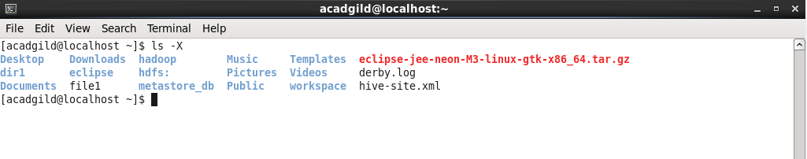

*ls –t :*sort files based on modification time

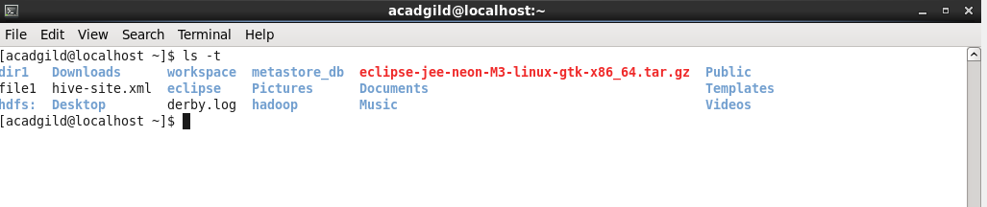

## *ls –R:*to list subdirectories recursively

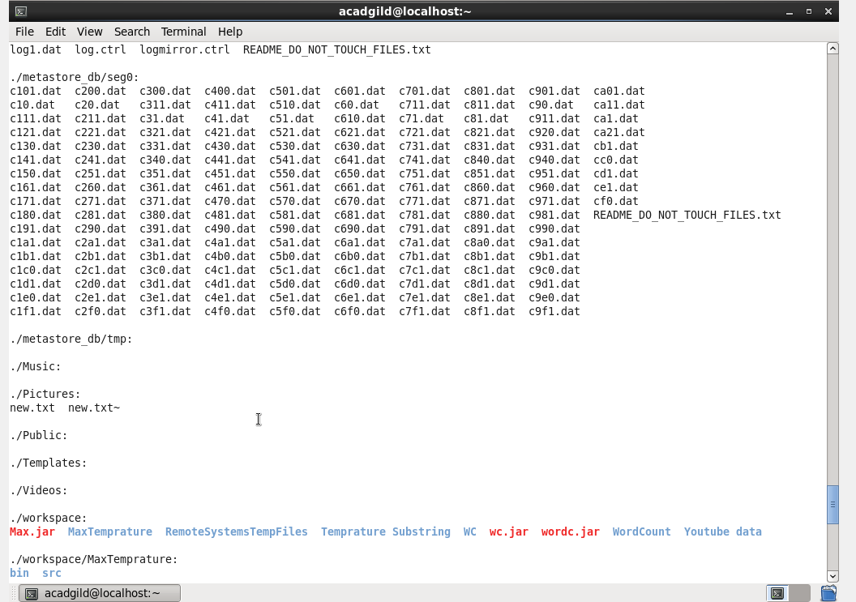Ls –hide=*.log

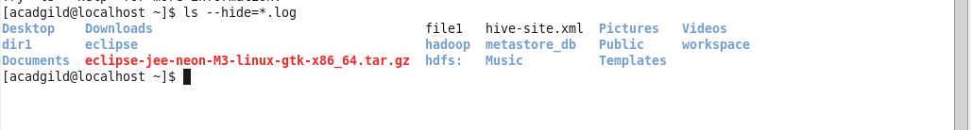

1. Echo:

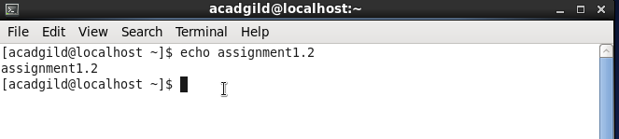

1. cat



1. Who

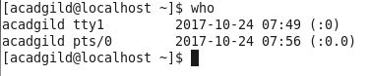

1. cd



1. Date



1. Cal

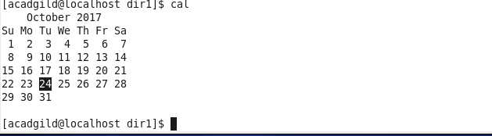

1. Mv

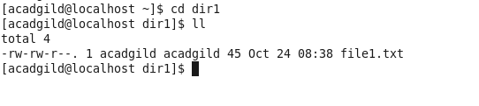

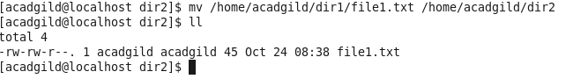

1. Cp

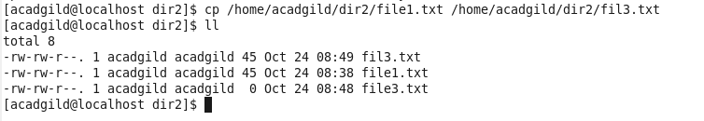

1. Which

