start Hadoop

Start-all.sh

Run history server

Question (a):

Top 5 employees (employee id and employee name) with highest rating. (In case two employees have same rating, employee with name coming first in dictionary should get preference)

Input files folder

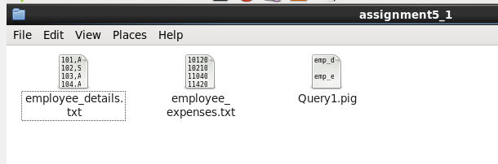

Query :

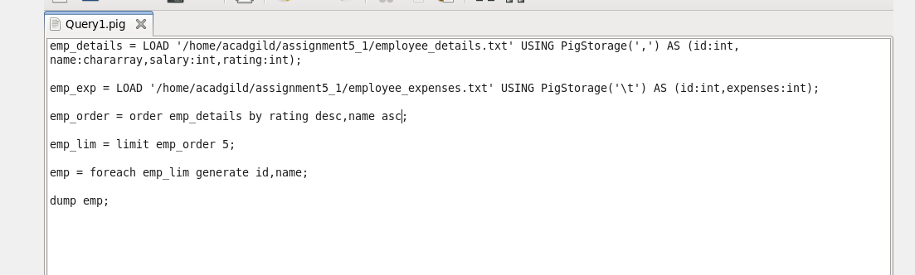

Output :

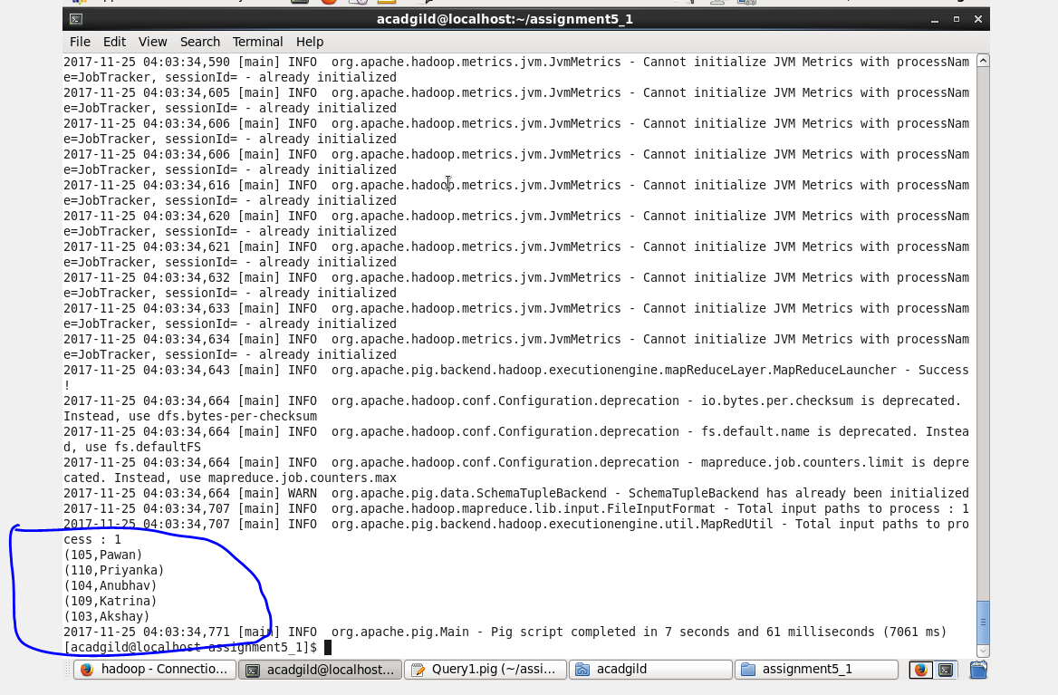

Question (b):

Top 3 employees (employee id and employee name) with highest salary, whose employee id is an odd number. (In case two employees have same salary, employee with name coming first in dictionary should get preference)

Input :

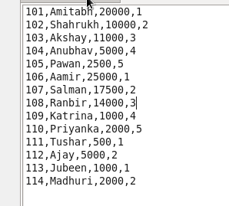

Query :

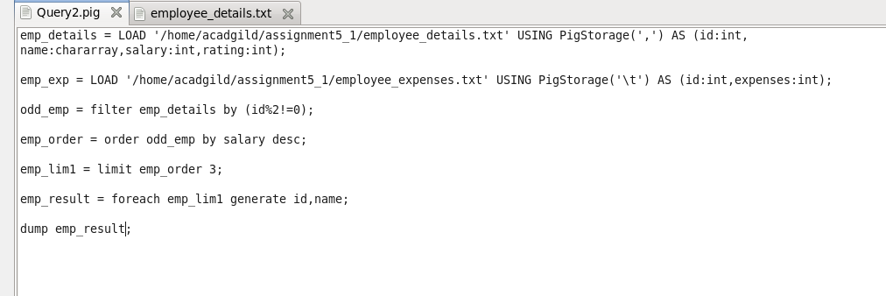

Output:

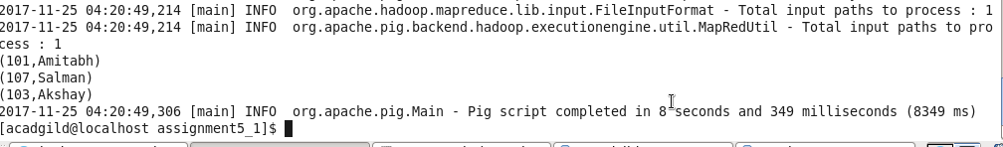

Question (c):

Employee (employee id and employee name) with maximum expense (In case two employees have same expense, employee with name coming first in dictionary should get preference)

Inputs:

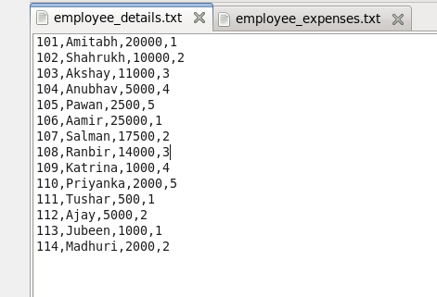

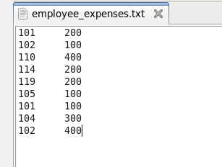

Query:

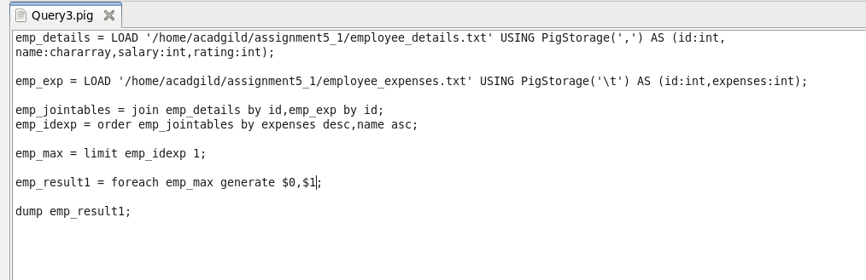

Output:



Question (d):

List of employees (employee id and employee name) having entries in employee_expenses file.

Inputs :





Query:

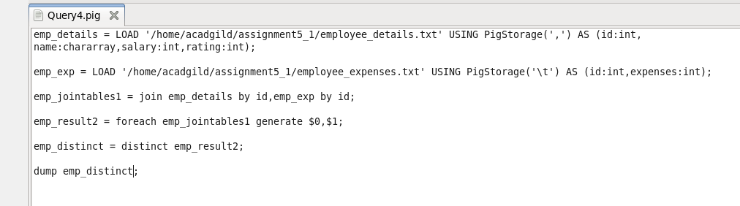

Output :

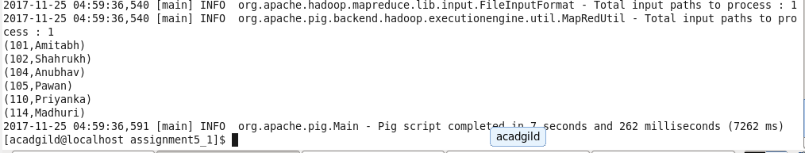

Question (e):

List of employees (employee id and employee name) having no entry in employee_expenses file.

Inputs :





Query:

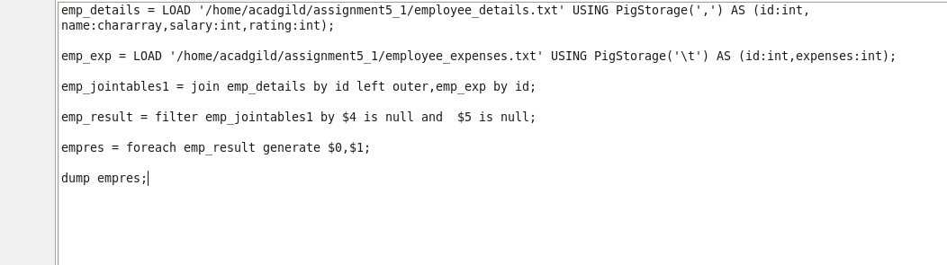

Output:

