Create table employee :



Load data in to table



View the data :

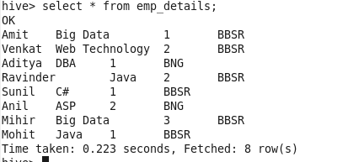

Calculate the number of employees corresponding to each skill from the table 'employee' which is loaded in the Demo.

Query :select skill,count(name) from emp_details group by skill;

