Assignment 9.2

Check whether table exists or not

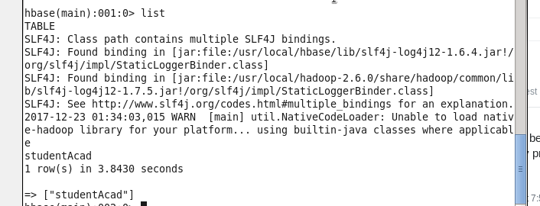

Create a table clicks

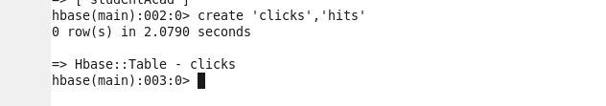

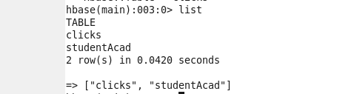

Insert data:



