Create Database custom;

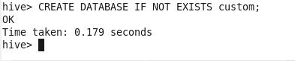

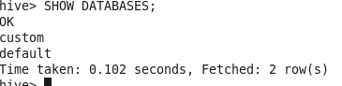

Create a table named temperature_data inside custom having below fields:

1. date (mm-dd-yyyy) format

2. zip code

3. temperature



Load data:

