Create table with fields



Load data in to the table



Verify that data is loaded to the table

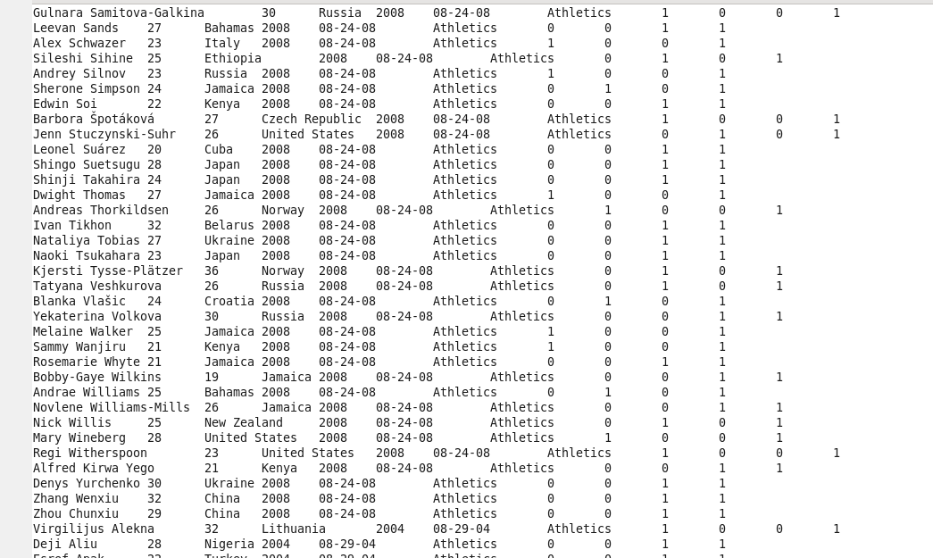

1. Using the dataset list the total number of medals won by each country in swimming.

**select country,SUM(total) from olympic where sport = “Swimming” GROUP BY country**

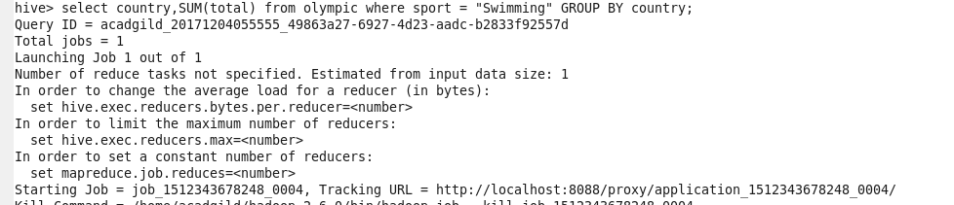

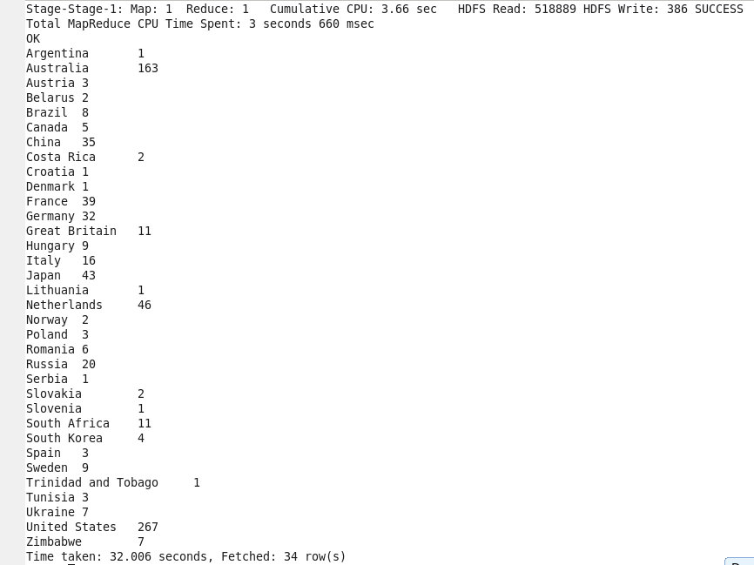

2)Display real life number of medals India won year wise.

**select year,SUM(total) from olympic where country = “India” GROUP BY year;**

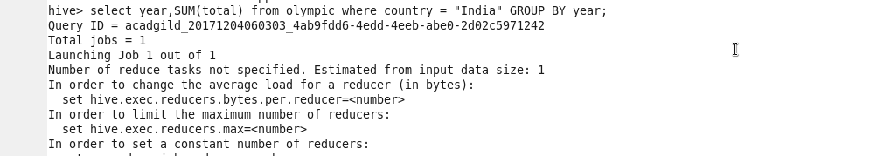

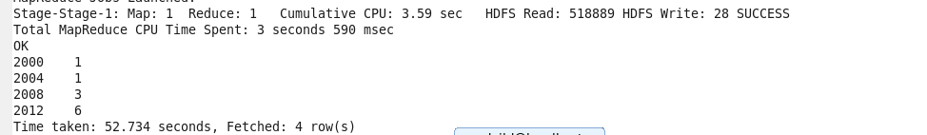

Write a Hive Program to find the total number of medals each country won.

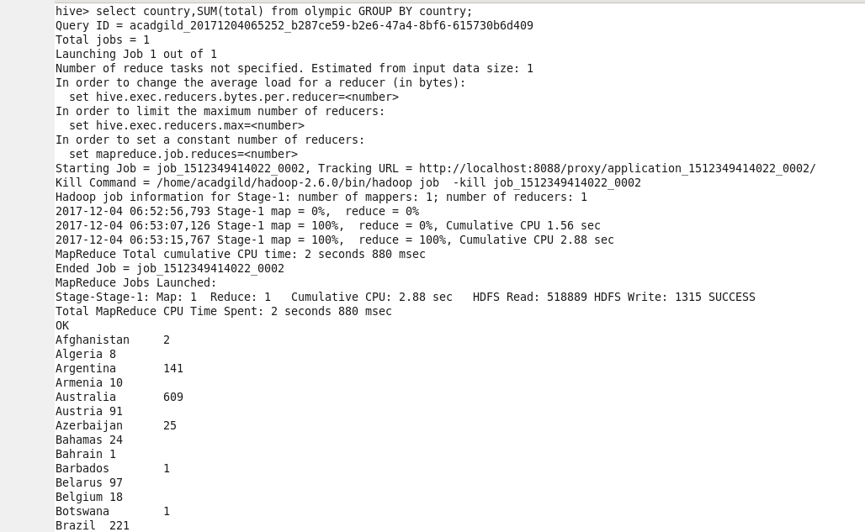

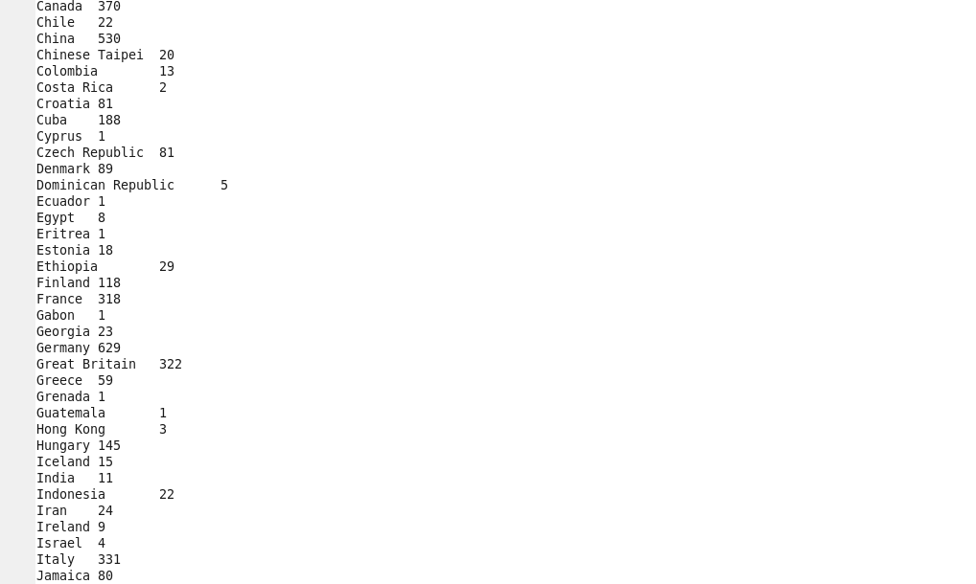

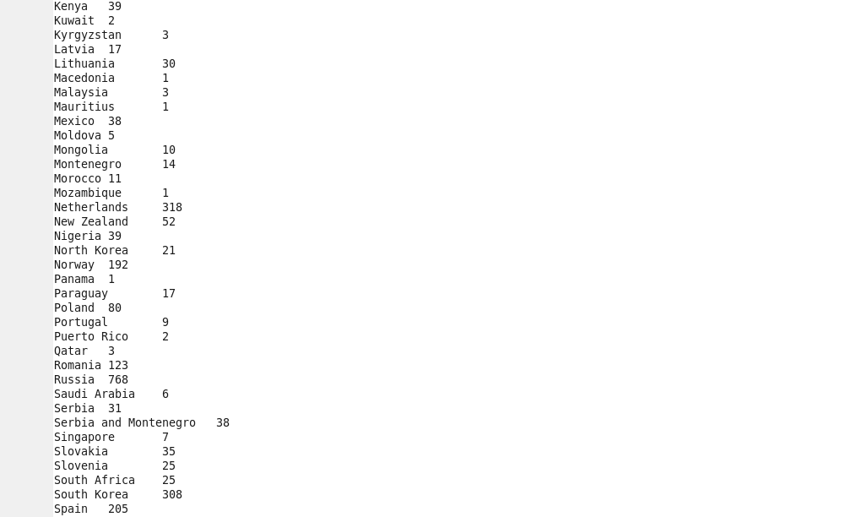

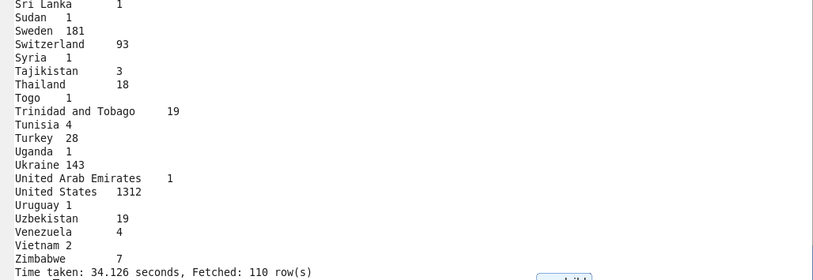

Write a Hive program to find the number of gold medals each country won.

