

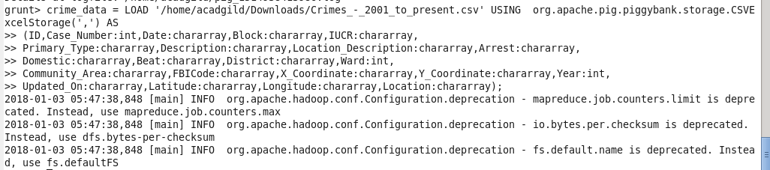





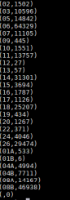

Write a MapReduce/Pig program to calculate the number of cases investigated under FBI code 32.

filter_crime_data = FILTER crime_data BY FBICode == '32';

group_filter_crime_data = GROUP filter_crime_data BY FBICode;

cases_investigated_FBI_32 = FOREACH group_filter_crime_data GENERATE group,COUNT(filter_crime_data);

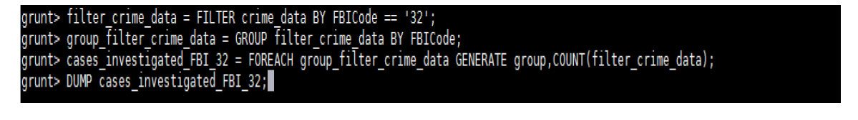





hadoop fs -ls file:/tmp/temp1141537601/tmp2119968396



hadoop fs -cat file:/tmp/temp1141537601/tmp2119968396/part-r-00000



Write a MapReduce/Pig program to calculate the number of arrests in theft district wise.

filter_crime_data_theft_dist = FILTER crime_data BY Primary_Type == 'THEFT' and Arrest == 'true';

distict_theft_data = GROUP filter_crime_data_theft_dist BY District;

distinct_district_theft_data = DISTINCT distict_theft_data;

arrest_district_wise = FOREACH distinct_district_theft_data GENERATE group, COUNT(filter_crime_data_theft_dist);



Output:

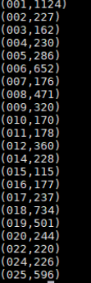

Write a MapReduce/Pig program to calculate the number of arrests done between October 2014 and October 2015.

crime_details_between_dates = FILTER crime_data BY ToDate(Date, 'MM/dd/yyyy hh:mm:ss a') >= ToDate('10/01/2014 12:00:00 AM', 'MM/dd/yyyy hh:mm:ss a') AND ToDate(Date, 'MM/dd/yyyy hh:mm:ss a') <= ToDate('10/31/2015 11:59:59 PM', 'MM/dd/yyyy hh:mm:ss a');

filter_crime_data_arrest = FILTER crime_details_between_dates BY Arrest == 'true';

group_filter_crime_data_arrest = GROUP filter_crime_data_arrest ALL;

final_result = FOREACH group_filter_crime_data_arrest GENERATE group, COUNT(filter_crime_data_arrest.Arrest);

