Place the flume config file ‘filecopy.conf’ at location /home/acadgild/apache-flume-1.8.0- bin/conf filecopy.conf

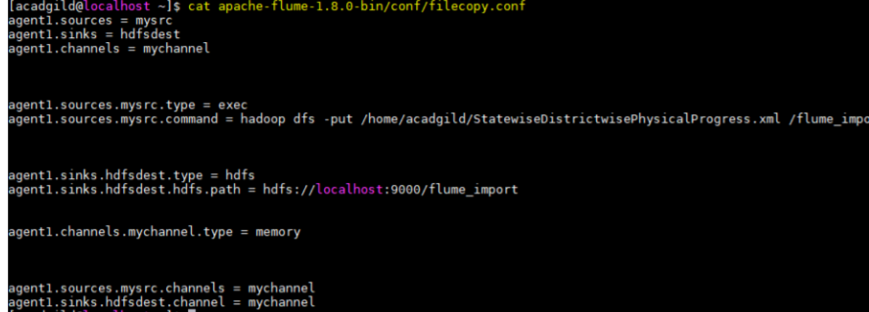

Flume agent

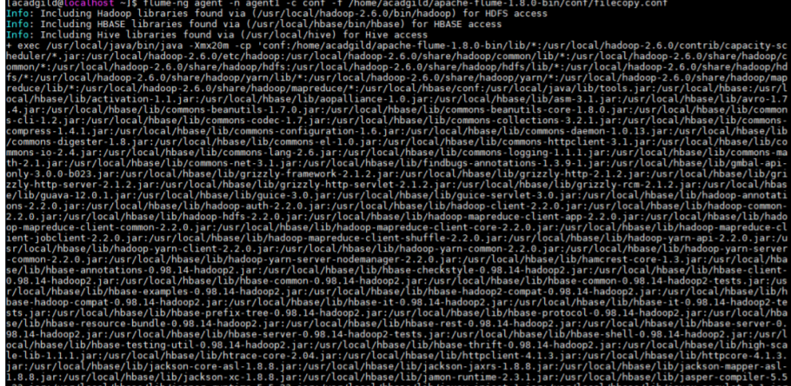

hadoop fs –ls /flume_import

hadoop fs -mkdir districts_having_100percent_objectives

hadoop fs -mkdir districts_having_80percent_objectives



Mysql :create database and tables

create database bpl_results;

use bpl_results;

create table districts_having_100percent_objectives ( name varchar(40) );

create table districts_having_80percent_objectives ( name varchar(40) );

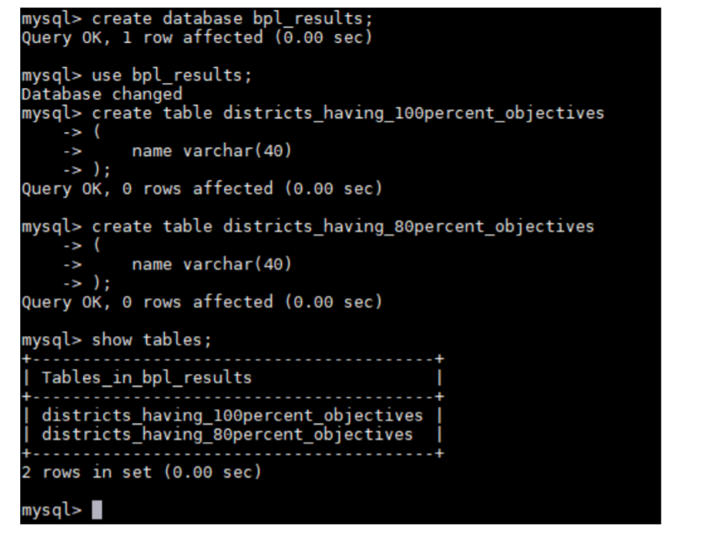

Pig query :

DEFINE XPath org.apache.pig.piggybank.evaluation.xml.XPath;

row_physical_progress = LOAD 'hdfs://localhost:9000/flume_import' USING org.apache.pig.piggybank.storage.XMLLoader('row') as (row:chararray);

physical_progress = FOREACH row_physical_progress GENERATE XPath(row, 'row/State_Name') AS State_Name, XPath(row, 'row/District_Name') AS District_Name, XPath(row, 'row/Project_Objectives_IHHL_BPL') AS Project_Objectives_IHHL_BPL, XPath(row, 'row/Project_Objectives_IHHL_APL') AS Project_Objectives_IHHL_APL, XPath(row, 'row/Project_Objectives_IHHL_TOTAL') AS Project_Objectives_IHHL_TOTAL, XPath(row, 'row/Project_Objectives_SCW') AS Project_Objectives_SCW, XPath(row, 'row/Project_Objectives_Anganwadi_Toilets') AS Project_Objectives_Anganwadi_Toilets, XPath(row, 'row/Project_Objectives_RSM') AS Project_Objectives_RSM, XPath(row, 'row/Project_Objectives_PC') AS Project_Objectives_PC, XPath(row, 'row/Project_Performance-IHHL_BPL') AS Project_Performance_IHHL_BPL, XPath(row, 'row/Project_Performance-IHHL_APL') AS Project_Performance_IHHL_APL, XPath(row, 'row/Project_Performance-IHHL_TOTAL') AS Project_Performance_IHHL_TOTAL, XPath(row, 'row/Project_Performance-SCW') AS Project_Performance_SCW, XPath(row, 'row/Project_Performance-School_Toilets') AS Project_Performance_School_Toilets, XPath(row, 'row/Project_Performance-Anganwadi_Toilets') AS Project_Performance_Anganwadi_Toilets, XPath(row, 'row/Project_Performance-RSM') AS Project_Performance_RSM, XPath(row, 'row/Project_Performance-PC') AS Project_Performance_PC;



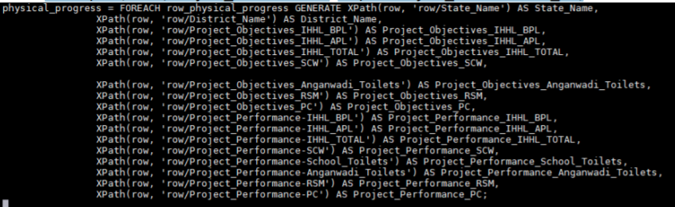

physical_progress_100_percent_bpl = FILTER physical_progress BY Project_Objectives_IHHL_BPL == Project_Performance_IHHL_BPL;

district_100_percent_bpl = FOREACH physical_progress_100_percent_bpl GENERATE District_Name; STORE district_100_percent_bpl INTO 'hdfs://localhost:9000/districts_having_100percent_objectives';





Verify results:

hadoop fs -ls /districts_having_100percent_objectives

hadoop fs -ls /districts_having_100percent_objectives/part-m-00000

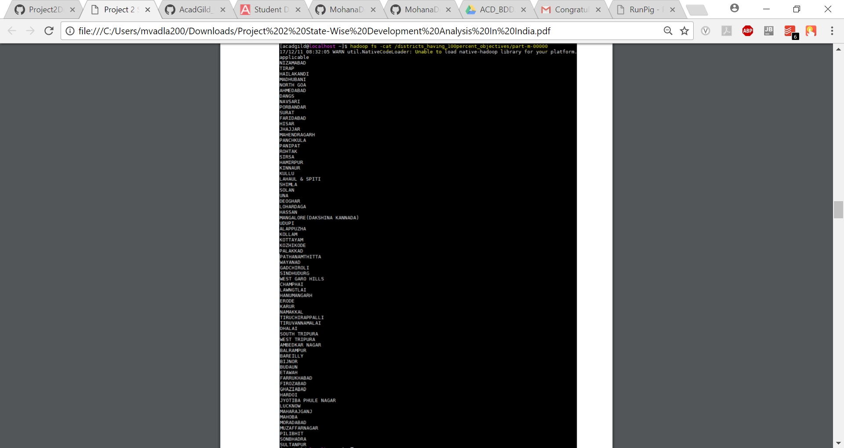

The following sqoop command is used to export data from HDFS folder



Verify results in mysql

select * from districts_having_100percent_objectives;

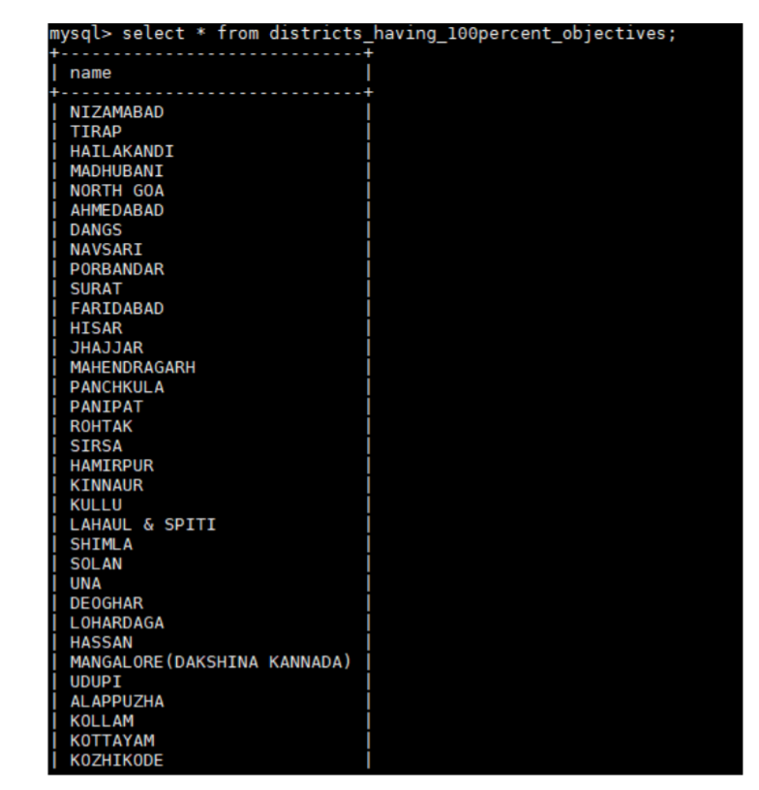

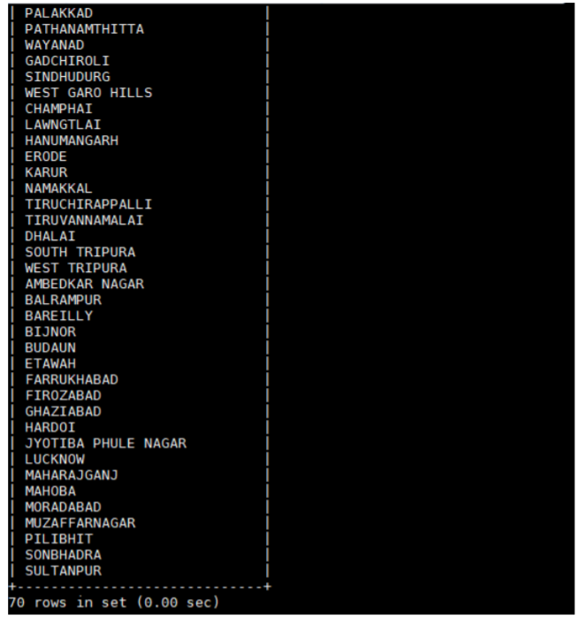

Create a Java project Project2 and Write a Java class FilterDistrictsHavingEightyPercentBPL in eclipse which will filter those tuples for which 80 percent objective in BPL cards are achieved. The logic put in exec method is value of Project_Performance_IHHL_BPL is equal to more than 80% of Project_Objectives_IHHL_BPL.

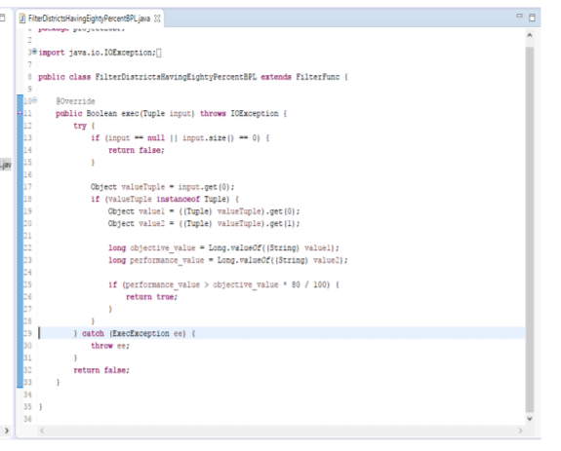

REGISTER /home/acadgild/pig/Project2.jar;

physical_progress_80_percent_bpl = FILTER physical_progress BY project2UDF.FilterDistrictsHavingEightyPercentBPL(TOTUPLE(Project_Objectives_IHHL_BPL, Project_Performance_IHHL_BPL));

district_80_percent_bpl = FOREACH physical_progress_80_percent_bpl GENERATE District_Name;

STORE district_80_percent_bpl INTO 'hdfs://localhost:9000/districts_having_80percent_objectives';



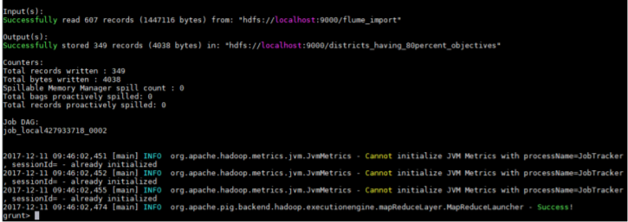

Verify results:

hadoop fs -ls /districts_having_80percent_objectives

hadoop fs –ls /districts_having_80percent_objectives/part-m-00000

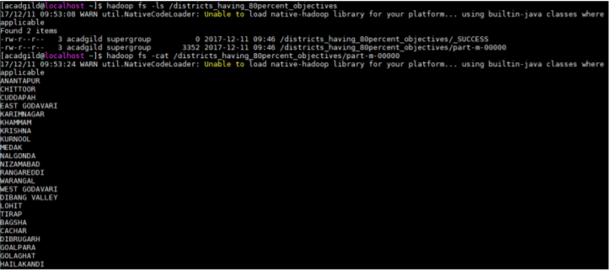

Use sqoop command to export data from HDFS into mysql table districts_having_80percent_objectives in database bpl_result

sqoop export --connect jdbc:mysql://localhost/bpl_results --username 'root' --table 'districts_having_80percent_objectives' --export-dir '/districts_having_80percent_objectives' -- input-fields-terminated-by ',' -m 1 --columns name



Mysql results:

select * from districts_having_80percent_objectives

