**What is Frames?**

**Frames(HTMLFrames)** are used to divide your browser window into multiple sections where each section can load a separate **HTML** document.

For example, with in the same window, one frame might display a static banner,a second a navigation menu, and a third the main document that can be scrolled through or replaced by navigating in the second frame.

**Why Frames?**

•Better organized

–Static and Dynamic content

–Ads/Banners/MainContent

•Better presentation

•Multiple pages in the same browser

•Reduces server load

**How is it implemented by developer?**

1. <iframe
2. <frame

**What is iframe?**

•An **iframe** (Inline Frame) is a HTML document embedded inside another HTML document on a website.

**<iframe Attributes?**

•id

•name

•style

•class

•src

•title

•height

•width, etc…

**Is WebElementinside Frame?**

•Inspect the element

•View the HTML Source Code

•Navigate Up! To see if there is any Frame / iFrametag

•Enter into the Frame

•Perform Action(s)

•Come out of the Frame

**Options To Enter Into The Frame:**

driver.switch**T**o().**f**rame(**id or name**)

driver.switch**T**o().**f**rame(**index**)

driver.switch**T**o().**f**rame(**WebElement**)

driver.switchTo().frame(driver.findElementBy(xpath = '//iframe[@id = 'iframeResult']')

**How to Perform Action(s)?**

driver.findElement(By.id(“usrname”)).sendKeys(“ssp”);

driver.findElement(By.id(“password”)).sendKeys(“ssp”);

driver.findElement(By.classname(“btn”)).click();

**Come out of the Frames**

driver.switchTo().defaultContent();

**FrameException**

**NoSuchFrameException**

**When frame is not presented un AUT**

**And code is referring to frame**

*Org.openqa.selenium.NoSuchFrameException*

**How to identify the iframe:**

We cannot detect the frames by just seeing the page or by inspecting Firebug.

Observe the below image, Advertisement being displayed is an Iframe, we cannot locate or recognize that by just inspecting using Firebug. So the question is how can you identify the iframe?

[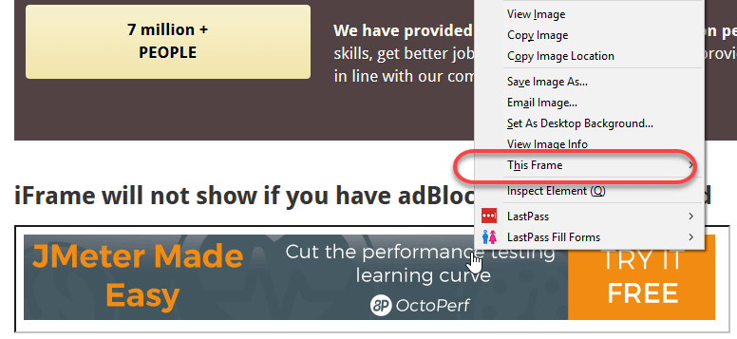](https://cdn.guru99.com/images/Sap-QM/122315_0943_HandlingIfr1.png)

We can identify the iframes using methods given below:

* Right click on the element, If you find the option like 'This Frame' then it is an iframe.(Please refer the above diagram)
* Right click on the page and click 'View Page Source' and Search with the 'iframe', if you can find any tag name with the 'iframe' then it is meaning to say the page consisting an iframe.

In above diagram, you can see that '**This Frame**' option is available upon right clicking, so we are now sure that it is an iframe.

We can even identify total number of iframes by using below snippet.

Int size = driver.findElements(By.tagName("iframe")).size();

## How to switch over the elements in iframes using Web Driver commands:

Basically, we can switch over the elements in frames using 3 ways.

* **By Index**
* **By Name or Id**
* **By Web Element**

**Switch to the frame by index:**

Index is one of the attributes for the Iframe through which we can switch to it.

Index of the iframe starts with '0'.

Suppose if there are 100 frames in page, we can switch to the iframe by using index.

* driver.switchTo().frame(0);
* driver.switchTo().frame(1);

**Switch to the frame by Name or ID:**

Name and ID are attributes of iframe through which we can switch to the it.

* driver.switchTo().frame("iframe1");
* driver.switchTo().frame("id of the element");

**Switch to the frame by Web Element:**

We can even switch to the iframe using web element .

* driver.switchTo().frame(WebElement);

**How to switch back to the Main Frame**

We have to come out of the iframe.

To move back to the parent frame, you can either use switchTo().parentFrame() or if you want to get back to the main (or most parent) frame, you can use switchTo().defaultContent();

driver.switchTo().parentFrame();

driver.switchTo().defaultContent();

**How to switch over the frame, if we CANNOT switch using ID or Web Element:**

Suppose if there are 100 frames in the page, and there is no ID available, in this case, we just don't know from which iframe required element is being loaded (It is the case when we do not know the index of the frame also).

The solution for the above concern is, we must find the index of the iframe through which the element is being loaded and then we need to switch to the iframe through the index.

Below are the steps for finding the index of the Frame by which the element is being loaded by using below snippet

**Step 1)**

WebDriver driver = new FirefoxDriver();

driver.get("http://demo.guru99.com/test/guru99home/");

driver.manage().window().maximize();

* Initialise the Firefox driver.
* Navigate to the "guru99" site which consisting the iframe.
* Maximized the window.

**Step 2)**

int size = driver.findElements(By.tagName("iframe")).size();

* The above code finds the total number of iframes present inside the page using the tagname 'iframe'.

**Step 3)**

**Objective for** this step would be finding out the index of iframe.

for(int i=0; i<=size; i++){

driver.switchTo().frame(i);

int total=driver.findElements(By.xpath("html/body/a/img")).size();

System.out.println(total);

driver.switchTo().defaultContent();}

Above "forloop" iterates all the iframes in the page and it prints '1' if our required iframe was found else returns '0'.

## Concept of Nested Frames(Frames inside Frames):

Let's assume that there are two frames one inside other like shown in below image and our requirement is printing the text in the outer frame and inner frame.

In the case of nested frames,

* At first we must switch to the outer frame by either Index or ID of the iframe
* Once we switch to the outer frame we can find the total number of iframes inside the outer frame, and
* We can switch to the inner frame by any of the known methods.

While exiting out of the frame, we must exit out in the same order as we entered into it from the inner frame first and then outer frame.

[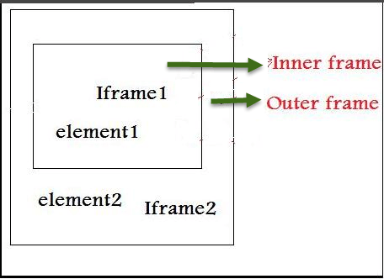](https://cdn.guru99.com/images/Sap-QM/122315_0943_HandlingIfr3.png)

The Html code for the above nested frame is as shown below.

[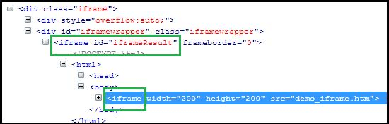](https://cdn.guru99.com/images/Sap-QM/122315_0943_HandlingIfr4.png)

The above HTML code clearly explains the iframe tag (highlighted in green) within another iframe tag, indicating presence of nested iframes.

Below are the steps for switching to outer frame and printing the text on outer frames:

**Step 1)**

WebDriver driver=new FirefoxDriver();

driver.get("Url");

driver.manage().window().maximize();

driver.manage().timeouts().implicitlyWait(2, TimeUnit.SECONDS);

int size = driver.findElements(By.tagName("iframe")).size();

System.out.println("Total Frames --" + size);

// prints the total number of frames

driver.switchTo().frame(0); // Switching the Outer Frame

System.out.println (driver.findElement(By.xpath("xpath of the outer element ")).getText());

* Switch to the outer Frame.
* Prints the text on outer frame.

Once we switch to the outer frame, we should know whether any inner frame present inside the outer frame

**Step 2)**

size = driver.findElements(By.tagName("iframe")).size();

// prints the total number of frames inside outer frame

System.out.println("Total Frames --" + size);

* Finds the total number of iframes inside outer frame.
* If size was found '0' then there is no inner frame inside the frame.

**Step 3)**

driver.switchTo().frame(0); // Switching to innerframe

System.out.println(driver.findElement(By.xpath("xpath of the inner element ")).getText());

* Switch to the inner frame
* Prints the text on the inner frame.

**Here is the complete code:**

public class FramesInsideFrames {

public static void main(String[] args) {

WebDriver driver=new FirefoxDriver();

driver.get("Url");

driver.manage().window().maximize();

driver.manage().timeouts().implicitlyWait(2, TimeUnit.SECONDS);

int size = driver.findElements(By.tagName("iframe")).size();

System.out.println("Total Frames --" + size);

// prints the total number of frames

driver.switchTo().frame(0); // Switching the Outer Frame

System.out.println (driver.findElement(By.xpath("xpath of the outer element ")).getText());

//Printing the text in outer frame

size = driver.findElements(By.tagName("iframe")).size();

// prints the total number of frames inside outer frame

System.out.println("Total Frames --" + size);

driver.switchTo().frame(0); // Switching to innerframe

System.out.println(driver.findElement(By.xpath("xpath of the inner element ")).getText());

//Printing the text in inner frame

driver.switchTo().defaultContent();

}

}