Introduction to Rest Assured
Definition
Rest Assured is an open-source Java library used for automating REST API testing.
It allows us to send HTTP requests (GET, POST, PUT, DELETE, etc.), validate responses, verify status codes, headers, response bodies, and perform end-to-end API testing.
Rest Assured can validate:
- Status Codes
- Response Body
- Headers
- Cookies
- Response Time
- Authentication
- JSON Schema
- API Contracts
- CRUD Operations
What Cannot Be Tested Using Rest Assured?
Rest Assured focuses on APIs and cannot directly test:
- UI elements
- Buttons
- Web pages
- CSS
- Browser interactions
For UI testing, use tools like Playwright or Selenium.
Why is it Called "Rest Assured"?
- REST → Represents RESTful APIs.
- Assured → Means you can be confident that your APIs are working correctly after automated validation
Rest Assured Architecture
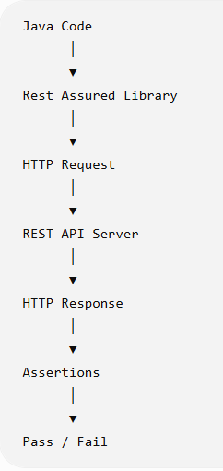
Why Java?
Rest Assured is a Java library, so it works with:
- Java
- Maven or Gradle
- TestNG
- JUnit
It integrates naturally into Java-based automation frameworks.
Features of Rest Assured
1. Supports All HTTP Methods
- GET
- POST
- PUT
- PATCH
- DELETE
- OPTIONS
- HEAD

2. Easy Request Creation
You can easily specify:
- URL
- Headers
- Query Parameters
- Path Parameters
- Cookies
- Request Body

3. Response Validation
Validate:
- Status code
- Headers
- JSON body
- Cookies
- Response time

4. JSON Support
Rest Assured automatically parses JSON responses.
Example:
String firstName = response.jsonPath().getString("data.first_name");

5. Authentication Support
Supports:
- Basic Authentication
- Digest Authentication
- Bearer Token
- OAuth 2.0
- API Key

6. Serialization & Deserialization
Convert:
Java Object
│
▼
JSON
and
JSON
│
▼
Java Object

7. Logging
Useful methods include:
.log().all()
.log().headers()
.log().body()
This helps troubleshoot API failures.

8. Integration
Works well with:
- TestNG
- JUnit
- Maven
- Jenkins
- GitHub Actions
- Allure Reports
- Extent Reports

Advantages of Rest Assured
- Open source
- Free to use
- Easy to learn
- Simple syntax
- Strong community support
- Excellent for API automation
- Supports reusable frameworks
- Easy integration with CI/CD
- Good reporting support
- Fast execution

Limitations
- Java knowledge is required.
- Primarily designed for REST APIs (SOAP support is limited).
- Not intended for UI automation.
- Requires coding, unlike Postman for basic manual testing.

Project Setup
Creating Your First Rest Assured Project in Eclipse
Step 1: Open Eclipse
Open Eclipse IDE.
You will see the Package Explorer on the left.

Step 2: Create a Maven Project
Click
File
↓
New
↓
Maven Project
Click Next.
Check
☐ Create a simple project (skip archetype selection)
Leave it unchecked.
Click Next.

Step 3: Select Archetype
Search for
maven-archetype-quickstart
Select it.
Click Next.

Step 4: Enter Project Details
Example
Group Id----com.restassured
Artifact Id---RestAssuredDemo
Version----1.0-SNAPSHOT

Click
Finish

Step 5: Project Structure
Initially, you'll see something like:
RestAssuredDemo
│── src/main/java
│── src/test/java
│── JRE System Library
│── Maven Dependencies
└── pom.xml

src/main/java
Contains application code.
Since we are only writing API test scripts, we usually don't place test classes here.

src/test/java
Contains automation test scripts.
All Rest Assured test classes should be created here.
pom.xmlStores project dependencies.

Step 6: Add Dependencies
Open
pom.xml
Add
<dependencies>

<!-- Rest Assured -->
<dependency>
<groupId>io.rest-assured</groupId>
<artifactId>rest-assured</artifactId>
<version>5.5.6</version>
<scope>test</scope>
</dependency>

<!-- TestNG -->
<dependency>
<groupId>org.testng</groupId>
<artifactId>testng</artifactId>
<version>7.11.0</version>
<scope>test</scope>
</dependency>

</dependencies>
Save the file.
Maven will automatically download the required libraries.

Step 7: Update Maven Project
Sometimes Eclipse doesn't download dependencies immediately.
Right-click the project
MavenUpdate Project(or press Alt + F5)Click OK

Step 8: Create Package
Expand
src/test/java
Right-click
New
↓
Package
Package Name
com.restassured.tests
Click Finish
Now you'll have:

src/test/java
│
└── com.restassured.tests
Why Create a Package?
Without packages:
UserTest.java
LoginTest.java
EmployeeTest.java
ProductTest.java
All files would be mixed together.
With packages:
com.restassured.tests

── UserTest
── LoginTest
── ProductTest
__ EmployeeTest
Everything stays organized.

Step 9: Create Java Class
Right-click
com.restassured.testsNewClassEnter Class Name(eg:FirstAPITest)--ClickFinish
Project Structure
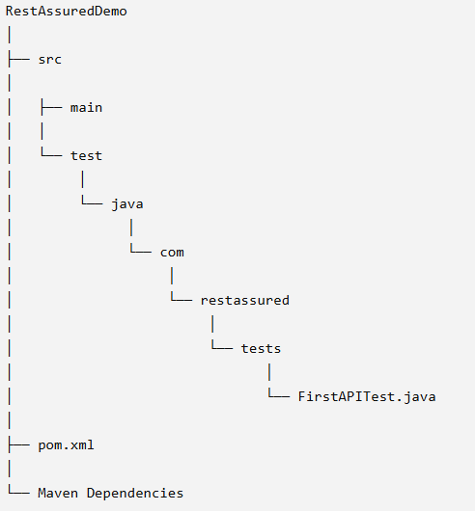
First Rest Assured Program
This is one of the most important modules because students will write their first API automation script. The goal is to understand the basic Rest Assured syntax and the BDD (Behavior-Driven Development) style using given(), when(), and then().
Understanding given(), when(), and then()
1. given()
Purpose: Prepare the request.
This is where you specify everything the API needs before sending the request.
Examples:
- Base URI
- Headers
- Authentication
- Query Parameters
- Path Parameters
- Request Body
- Cookies
Example:
given()
.header("Content-Type", "application/json")
.queryParam("page", 2);

Think of given() as filling out a form before submitting it.

2. when()
Purpose: Send the request.
This is where you specify the HTTP method.
Examples:
- GET
- POST
- PUT
- PATCH
- DELETE
Example:
.when()
.get("/users/2");
3. then()
Purpose: Validate the response.
Here you verify:
- Status Code
- Response Body
- Headers
- Response Time
- Cookies
Example:
.then()
.statusCode(200);

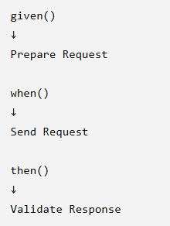

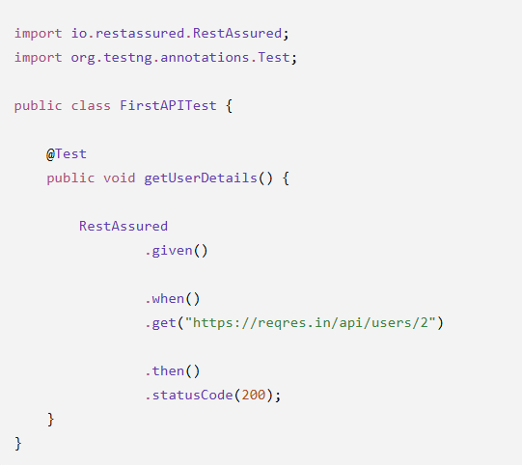
Step 11: Run the Test
Right-clic FirstAPITest.javaRun AsTestNG Test

Expected Console Output
If successful:
===============================================
Default test
Tests run: 1
Failures: 0
Skips: 0
===============================================

Explanation Line by Line
Import Statements
import io.restassured.RestAssured;
Imports the Rest Assured library.

import org.testng.annotations.Test;
Marks the method as a TestNG test.

Test Class
public class FirstAPITest {
Every Java program starts with a class.

Test Method
@Test
public void getUserDetails()
@Test tells TestNG to execute this method.

given()
given()
Currently empty because:
- No headers
- No authentication
- No request body
- No query parameters
It's still included because every Rest Assured test follows the same structure.

when()
.when()
.get("https://reqres.in/api/users/2")
Sends a GET request to the server.

then()
.then()
.statusCode(200);
Checks that the API returns HTTP 200 OK.
What is Status Code 200?
200 OK means:
- Request reached the server.
- Server processed the request successfully.
- Data was returned.
Example response:
{
"data": {
"id": 2,
"email": "janet.weaver@reqres.in",
"first_name": "Janet",
"last_name": "Weaver"
}
}
Validating More Than Status Code
You can also verify the response body.
import static io.restassured.RestAssured.*;
import static org.hamcrest.Matchers.*;

import org.testng.annotations.Test;

public class FirstAPITest {

@Test
public void getUserDetails() {

given()

.when()
.get("https://reqres.in/api/users/2")

.then()
.statusCode(200)
.body("data.first_name", equalTo("Janet"))
.body("data.last_name", equalTo("Weaver"));
}
}
Using baseURI
Instead of repeating the full URL:
.get("https://reqres.in/api/users/2");
Set a base URI:
RestAssured.baseURI = "https://reqres.in";
Then:
given()

.when()
.get("/api/users/2")

.then()
.statusCode(200);
This makes the code cleaner and easier to maintain.

Storing the Response
Sometimes you need to inspect or reuse the response.
import io.restassured.response.Response;

Response response =

given()

.when()
.get("https://reqres.in/api/users/2");
Now you can access details:
System.out.println(response.getStatusCode());
System.out.println(response.getTime());
System.out.println(response.getBody().asString());

Pretty Printing the Response
response.prettyPrint();
Output:
{
"data": {
"id": 2,
"email": "janet.weaver@reqres.in",
"first_name": "Janet",
"last_name": "Weaver"
}
}

Common Beginner Mistakes
Forgetting @Test
Without @Test, TestNG won't execute the method.

Missing .then()
given()

.when()
.get("/users/2");
The request is sent, but nothing is validated.

Wrong Status Code
If you expect:
.statusCode(201);
but the API returns 200, the test fails.

Incorrect Endpoint
.get("/users/99999");
The API may return 404 Not Found, causing the assertion to fail if you expected 200.
HTTP Methods in Rest Assured
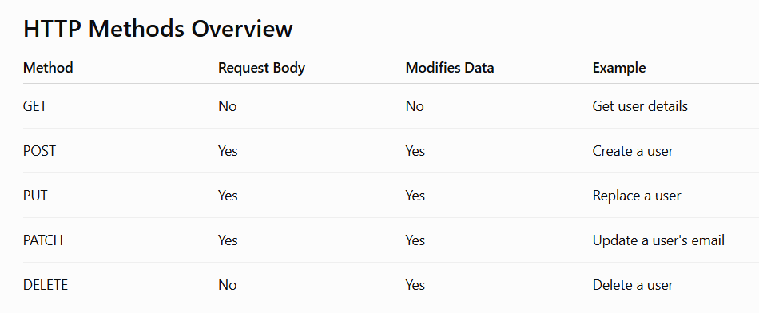
1. GET Method
Purpose
Used to retrieve data from the server.
Real-Life Example
- View a product.
- View a customer.
- View employee details.
API Example
GET https://reqres.in/api/users/2
Rest Assured Code
import static io.restassured.RestAssured.*;

import org.testng.annotations.Test;

public class GetUserTest {

@Test
public void getUser() {

baseURI = "https://reqres.in";

given()

.when()
.get("/api/users/2")

.then()
.statusCode(200);
}
}

GET Response
{
"data": {
"id": 2,
"email": "janet.weaver@reqres.in",
"first_name": "Janet",
"last_name": "Weaver"
}
}

2. POST Method
Purpose
Used to create a new resource.
Example
Register a new employee.
API
POST https://reqres.in/api/users
Request Body
{
"name": "Mohana",
"job": "QA Engineer"
}
Rest Assured Code
import static io.restassured.RestAssured.*;

import org.testng.annotations.Test;

public class CreateUserTest {

@Test
public void createUser() {

baseURI = "https://reqres.in";

String requestBody = """
{
"name": "Mohana",
"job": "QA Engineer"
}
""";

given()
.header("Content-Type", "application/json")
.body(requestBody)

.when()
.post("/api/users")

.then()
.statusCode(201);
}
}

POST Response
{
"name": "Mohana",
"job": "QA Engineer",
"id": "123",
"createdAt": "2026-07-28T10:00:00Z"
}

3. PUT Method
Purpose
Replaces the entire resource.
Example
Suppose an employee record is:
{
"name": "Mohana",
"job": "Tester"
}
After a PUT request:
{
"name": "Mohana",
"job": "Senior QA"
}
The entire record is updated with the new representation.
Rest Assured Code
String body = """
{
"name":"Mohana",
"job":"Senior QA"
}
""";

given()
.header("Content-Type","application/json")
.body(body)

.when()
.put("/api/users/2")

.then()
.statusCode(200);

4. PATCH Method
Purpose
Updates only specific fields instead of replacing the entire resource.
Example
Current record:
{
"name":"Mohana",
"job":"Tester"
}
PATCH Request
{
"job":"Lead QA"
}
Only the job field changes.
Rest Assured Code
String body = """
{
"job":"Lead QA"
}
""";

given()
.header("Content-Type","application/json")
.body(body)

.when()
.patch("/api/users/2")

.then()
.statusCode(200);

PUT vs PATCH
PUT | PATCH
Replaces the entire resource | Updates only specified fields
Full object is sent | Partial object is sent
Common for complete updates | Common for small updates
Interview Answer:
PUT replaces the complete resource with a new representation, while PATCH updates only the fields provided in the request without replacing the entire resource.

5. DELETE Method
Purpose
Deletes a resource.
API
DELETE https://reqres.in/api/users/2
Rest Assured Code
given()

.when()
.delete("/api/users/2")

.then()
.statusCode(204);

Common Status Codes
Method | Success Status
GET | 200 OK
POST | 201 Created
PUT | 200 OK
PATCH | 200 OK
DELETE | 204 No Content

