# Team Manager

1. **Project Definition**

The 20th century has seen considerable advances in many technical fields and artificial intelligence, which have contributed to a rise in all fields. Our project is related to the health field. It will advance the life standard for both patients and ophthalmologists. Our project is a Health Care Maintenance system offers automated case management, patient planning, diagnostic notes, email integration to remind the patient of an appointment, electronic review reports with a paperless environment, POS (Point of Sale), inventory for spectacles, lenses, sundries, and unlimited custom.

# Project Purpose

Our purpose of this project is to design a practice management program for opticians, optometrists, and ophthalmologists that helps eye care organizations run smoothly. After investigation, we have noticed problems that ophthalmologists deal with daily; we aim to limit those hassles, so the ophthalmologists can make decisions more accurately and more effectively, in a shorter time, and without making fallacies.

# Project Scope

The users of this system are opticians, optometrists, ophthalmologists, patients, hospital staff, IT staff, and financial staff.

The users will provide diagnosis notes that should be stored accordingly in the database. They will provide patients information to process it. In addition, they will provide a detailed list of the spectacles, lenses, and sundries that we have stored. Moreover, the payment details will also be entered.

After processing, the data that the user had offered it should make automated cases and scheduling appointments that will match the patient

and the doctors' needs. Producing reported about the patient information, financial reports and bills. We need a connected device and credit card reader, cash drawer, receipt printer and bar code scanner.

Our system may communicate with other hospital brunches and Medical clinics system, therefore all the history of the patent can be reachable to all doctors to review the history of the patient and give the best diagnosis. It also will be commenting on the financial department of the hospital.

Moreover, it will communicate with the warehouses when the spectacles, lenses, and sundries that we have stored.

Our goal from this system is Facilitating the work of doctors, organizing patient files in an environmentally friendly way. Also, reducing incorrect information or incomplete information. Served more patients, reduce the waiting time for patients and keep a history for patients.

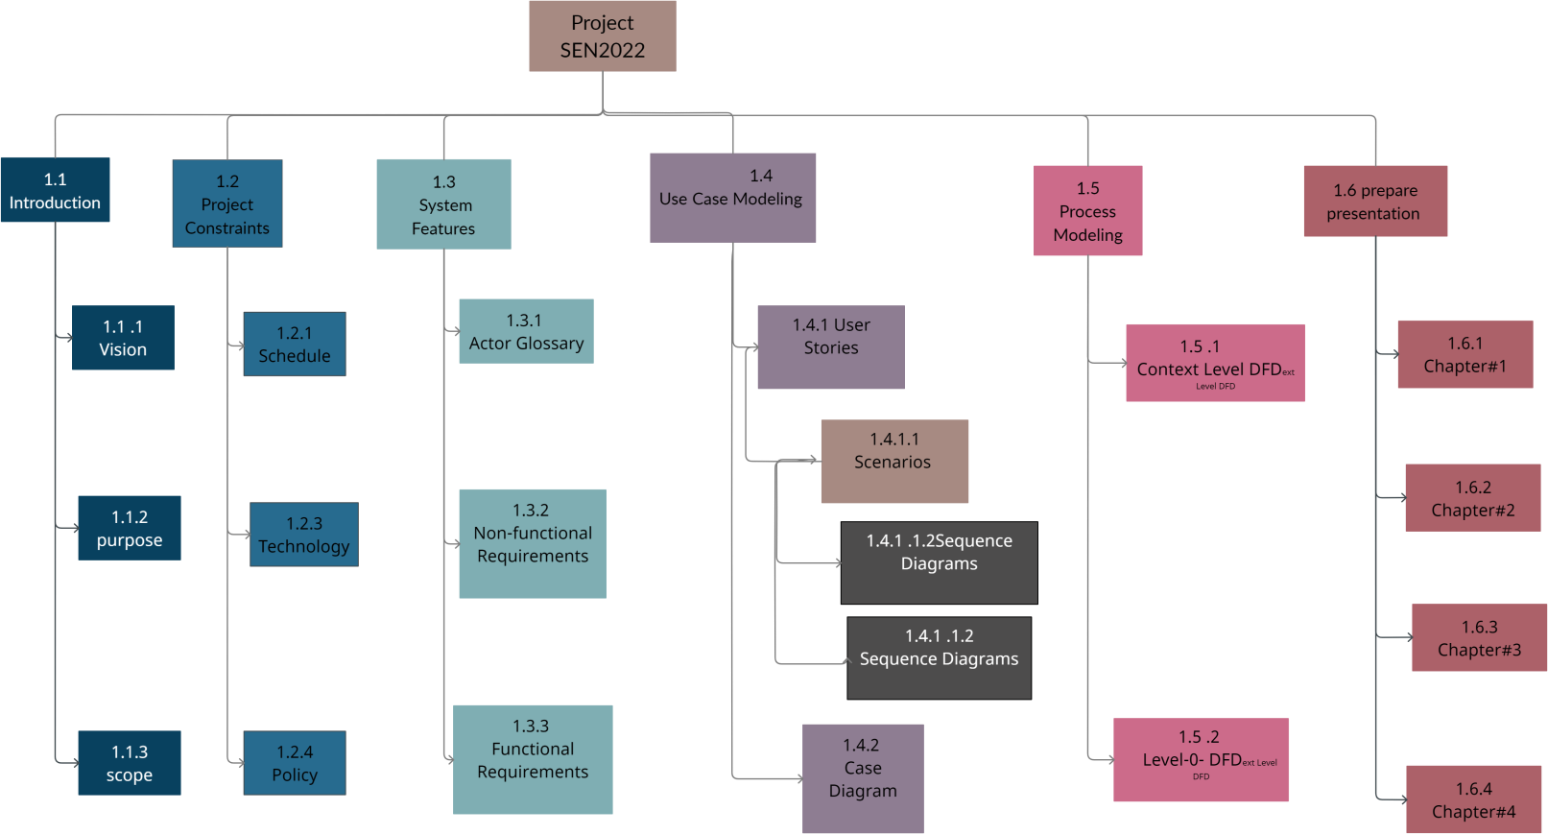

# Project Constraints

* + Schedule:

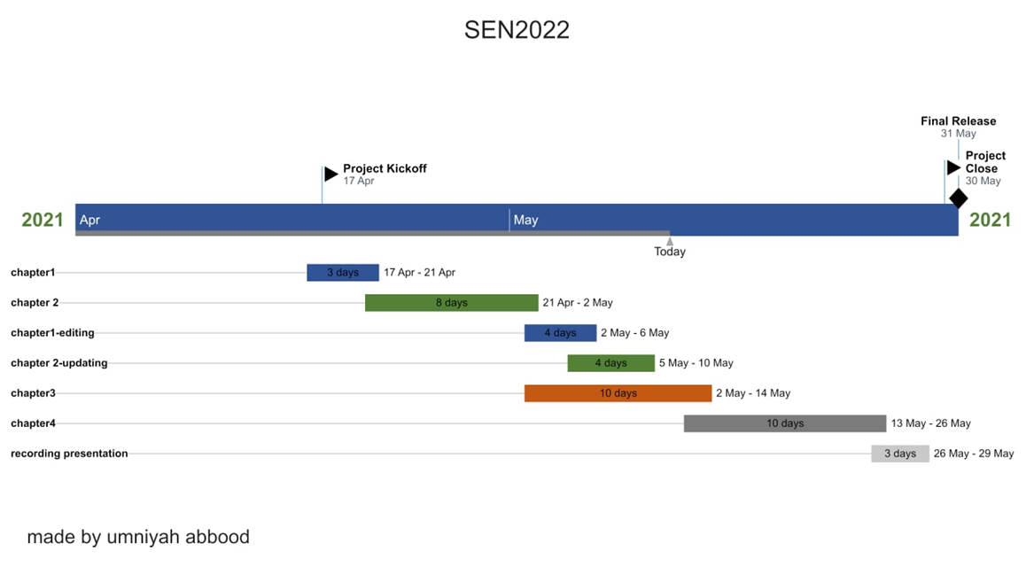

* + Technology: In the management system, the data is collected by Siftery. Database The system shall use the MySQL Database, which is open source and free. Google Wallet for finance, Google Drive, Microsoft (Office 365, Outlook) for business. In addition, we should build a website in JavaScript, CSS and HTML.
  + Policy:

1. The data will be archived every 30 day
2. Email notification for the patient to confirm their appointment and to remind them of the appointment one day before the appointment, send all the bills to their emails.
3. A patient should not be able to cancel his appointment more than 3 times in a row.
4. The system is allowed automatically to put the just canceled appointment into the schedule of that specific doctor
5. the system shall have the patient's information as the following: patient's ID, patient's name, phone number, birth, and the doctor's name which was
6. Only Supervisor can access the whole system and the website.
7. Management System is only accessible within the hospital premises only.
8. Website is accessible within the hospital premises and the patients.

# E) Actor Glossary

|  |  |
| --- | --- |
| **Actor** | **Description** |
| User | The user includes the patient, doctor, Supervisor, secretary, Cashier, IT professional |
| patient | the patient and any other people who visit the doctor |
| Supervisor | The supervisor consists of the main superintendent person in the institution. |
| Doctor | The doctor will consult the patients. |
| Hospital staff | The employees consist of the staff that works under doctors for example nurses, secretaries, opticians, and  optometrists |
| IT staff | The technician will have to maintain, develop and detect the fault in the management program and  diagnose it then solve it. |
| Financial staff | The employees consist of the staff that works in the finical department in the hospital such as cashier,  Credit bureau. |
| Bank system | An independent system that responsible for Payment |

|  |  |
| --- | --- |
|  | processing system |
| Email management  system | An independent system that responsible for confirming  information and the patient |
| Authentication system | this is responsible for authenticates the information that the user is going to enter such as name and  password and it is included in our health care system |

1. **Non-functional Requirements**
   1. Security:
      * Secretary Rights: The secretary can view any data in the Management system, add new patient’s record to it and manage the Scheduling of the doctor and the patient’s, but they do not have any rights alter any data in it.
   2. Performance:
      * Reaction Time: The framework of management system gives affirmation in only three seconds once the 'patient's data is checked.
      * Capacity: The website has to back at slightest 1000 individuals at once.
   3. Maintainability
      * The system offers a backup since large data is being stores.
   4. Accessibility:
      * Supervisor and many other users such as Hospital staff or IT staff can access the system but the access level is controlled for each user according to their work scope
   5. Modification:
      * Any modification (created, delete, edited) for the Database shall be synchronized and only by Supervisor and IT staff can access it.
   6. Error detection
      * The patient cannot cancel their appointment on the same day of the appointment from the website, and cannot alter his appointment 3 times in a row in 1 day

# Functional Requirements

* 1. The secretary shall make appointment for the patient with the doctor using the system
  2. The secretary shall add new patients to the system including all the patient’s information.
  3. The patient shall display the list of doctor’s names and their available time; therefore, the patient will be able to choose the time that fits his/her from the list when they use the website.
  4. The patient shall be able to make an appointment using the website
  5. The patient shall be able to edit her/his appointment using the website
  6. The patient shall be able to cancel an appointment using the website
  7. The patient shall display the payment options such as paying using MasterCard or paying cash when he/she goes to the hospital when they use website.
  8. The Email management system shall send an email to the patient to confirm their appointment and to remind them of the appointment one day before the appointment.
  9. The Email management system shall send an email to the patient to confirm their online payment has been received.
  10. The Email management system shall send an email to the patient when the appointment is created, edited or cancelled by the patient from the website.
  11. The supervise shall display a full on patients regarding various information like patients name, Phone .number, the doctor's name whom its assigns, the method of payment, previous appointment date

12 ) The supervise shall display a full report on the available time of all doctors or each doctor.

1. The supervise shall display all spectacles, lenses, sundries stored in the hospital has.
2. The doctor shall display his/ other doctor’s diagnostic notes for a specific patient.

Chapter#2: Use Case Modeling

1. **User Stories:**

|  |  |  |  |
| --- | --- | --- | --- |
| **INITIATIVE** | **EPIC** | **USER STORY** | **ACCEPTANCE CRITERIA** |
| Develop a health management system. | As a patient, I want to be able to view and choose my doctor and the time of the appointment easily, because I want something that makes the process less stressful. | As a patient I want to be able to choose from different doctors & times for and book the one that fits me well. | Ensure the patient is able to:   * Login to the website. * Visits the “Book an appointment” page. * Select the doctor. * Select the time. |
| As a patient I want to be able to edit a booking that I placed. | Ensure the patient is able to:   * Login to the website. * Visits the “Booked appointments” page. * Select the booking. * Edit the appointment. |
| As a patient I want to be able to cancel a booking that I placed. | Ensure the patient is able to:   * Login to the website. * Visits the “Booked appointments” page. * Select the booking. * Cancel the appointment. |

|  |  |  |  |
| --- | --- | --- | --- |
|  | As a hospital staff, I want to be able to use the system to enter the data regarding which doctors are available at which times and be able to aid patients with their bookings. | As a hospital staff, I want to be able to modify the schedules of the doctors. | Ensure the hospital staff is able to:   * Login to the system * Modify the doctors’ schedule * Updating the new schedule and push it live on the website for the patients to see. |
| As a hospital staff, I want to be able to view & add patients to the system because not all of them can access the website. | Ensure the hospital staff is able to:   * Login to the system. * Add new patients. * View all current patients’   records. |
| As a doctor, I want to be able to access the patients’ previous diagnostic notes and to check spectacles, lenses, sundries availability for the patient from the inventory. | As a doctor, I want to be able to view the previous diagnostic notes of the patient. | Ensure the doctor is able to:   * Login to the system. * View previous diagnostic notes of the patient. |
| As a doctor, I want to be able to view the inventory’s content. | Ensure the doctor is able to:   * Login to the system. * View inventory. |

1. **Scenarios:**

|  |  |
| --- | --- |
| **Use case name:** | Book an appointment |
| **Use case description:** | Once the patient is logged in and their account is filled with the necessary  background information, they will be able to book a appointment with a doctor. |
| **Primary actor(s):** | - Patient |

|  |  |
| --- | --- |
| **Supporting actor(s):** | * Banking System. * Authentication system. * Email management system. |
| **Triggers:** | The patient indicates that she/he wants to proceed with booking an  appointment with a doctor. |
| **Preconditions:** | * The patient must be a registered user. * The patient must have a complete profile. * The hospital has free open appointments to be booked. |
| **Postconditions:** | * The system’s bookings will be updated. * The patient will get frequent emails reminding her/him of the booking. * The patient will know the full amount to be paid, if not paid yet. |
| **Normal Flow:** | 1. The patient visits the “Book an appointment” web page. 2. The authentication system will ask her/him to re-enter their username & password. 3. The patient enters their username & password. 4. The authentication system authenticates the information. 5. The patient chooses their desired doctor 6. The patient chooses their desired time from the booking management system 7. The system displays the bill due amount to be paid. 8. The patient confirms the booking details. 9. The system shows a page with 2 payment options: pay online or in-person at the hospital 10. The patient chooses the pay online option. 11. The patient fills their credit card information. 12. The banking system approves the payment. 13. The system’s bookings get updated. 14. The email management system sends a confirmation email to the patient with the booking details. |
| **Alternate Flows:** | 1. (Alt-Step 2): If the username or password entered is incorrect, the system will ask the patient to enter it again or register as a new user. 2. (Alt-Step 8): The patient will edit the information and change their booking details. 3. (Alt-Step 10): The user chooses the in-person option. |
| **Business Rules** | - The patient must be registered and completed their profile  information. |

|  |  |
| --- | --- |
| **Use case name:** | Edit an appointment |
| **Use case description:** | Once the patient is logged in and they previously booked an appointment,  they will be able to visit the “Booked appointments” page to change either the doctor and/or the time of the booking. |
| **Primary actor(s):** | - Patient. |
| **Supporting**  **actor(s):** | * Email management system. * Authentication system. |

|  |  |
| --- | --- |
| **Triggers:** | The patient indicates that they want to edit the booking by clicking “edit”  on the “Booked appointments” web page. |
| **Preconditions:** | * The patient must be a registered user. * The patient must have a booked appointment. * The booked appointment must be in 24 hours or more. |
| **Postconditions:** | * The system’s bookings will be updated. * The patient will get a confirmation email using the email management system. |
| **Normal Flow:** | 1. The patient visits the “Booked appointments” web page. 2. The authentication will ask her/him to re-enter their username & password. 3. The patient enters their username & password. 4. The authentication system authenticates the information. 5. The patient selects the appointment at interest. 6. The patient clicks “edit”. 7. The patient changes the doctor. 8. The patient selects the time from the available slots. 9. The patient clicks confirm. 10. The system’s bookings get updated. 11. The email management system sends a confirmation email to the patient. |
| **Alternate Flows:** | 1. (Alt-Step 2): If the username or password entered is incorrect, the system will ask the patient to enter it again or register as a new user. 2. (Alt-Step 5): If the user already changed that booking 3 times consecutively, they will be prompted with an error message. 3. (Alt-Step 7): The user changes the time of the appointment only. 4. (Alt-Step 9): The user clicks “reset” to reset the initial appointment   information. |
| **Business Rules** | - The patient can only change their booking 3 times in a row. |

|  |  |
| --- | --- |
| **Use case name:** | Cancel an appointment |
| **Use case description:** | Once the patient has a registered account and an active appointment booked, they can visit the “Booked appointments” web page to cancel  their booking. |
| **Primary actor(s):** | - Patient. |
| **Supporting actor(s):** | * Banking System. * Authentication system. * Email management system. |
| **Triggers:** | The patient indicates that they want to cancel an active appointment. |
| **Preconditions:** | * The patient must be a registered user. * The patient must have a booked appointment. |
| **Postconditions:** | * The patient will get a full refund in case it was already paid. * The canceled appointment will be set as “available” on the system   for others to book.   * A confirmation email will be sent to the patient. |

|  |  |
| --- | --- |
| **Normal Flow:** | 1. The patient visits the “Booked appointment” web page. 2. The authentication will ask her/him to re-enter their username & password. 3. The patient enters their username & password. 4. The authentication system authenticates the information. 5. The patient selects the appointment. 6. The patient clicks “cancel the appointment” button. 7. The system shows a message that asks for confirmation. 8. The patient confirms that they want to cancel the appointment. 9. The system’s bookings get updated. 10. The banking system initiates a full refund to the patient. 11. The billing system sends the refund information to the patient. 12. The email management system sends a confirmation email with   information regarding the refund. |
| **Alternate Flows:** | 1. (Alt-Step 2): If the username or password entered is incorrect, the system will ask the patient to enter it again or register as a new user. 2. (Alt-Step 10): If the patient did not pay yet, no refund process will   be carried out. |
| **Business Rules** | - The patient must have a booking that is scheduled in 24 hours at  minimum. |

|  |  |
| --- | --- |
| **Use case name:** | Change Doctors’ schedule |
| **Use case description:** | Once the hospital staff (a secretary for example) is logged in, they will visit the “Manage Bookings” page to modify or delete doctors’ bookings based on their requests. The doctor in question will then get notified with an  email with the changes made. |
| **Primary actor(s):** | - Hospital staff. |
| **Supporting actor(s):** | * Doctors. * Authentication system. * Email management system. |
| **Triggers:** | The doctor indicates that she/he wants to make modifications to their  current schedule. |
| **Preconditions:** | * The hospital staff is logged in. * The hospital staff is authorized to make changes to the bookings. * The booking schedule has free slots in case of an addition to the schedule. |
| **Postconditions:** | * The booking management database will be updated. * The doctor will get a notification email with the new changes and the overall schedule. |
| **Normal Flow:** | 1. The hospital staff visits the “Manage Bookings” page on the system. 2. The authentication system will ask her/him to re-enter their username & password. 3. The hospital staff enters their username & password. 4. The authentication system authenticates the information. |

|  |  |
| --- | --- |
|  | 1. The hospital staff chooses the doctor they want to alter their schedule. 2. The hospital staff chooses between modifying or deleting a booking. 3. The hospital staff chooses modifying. 4. The hospital staff makes changes to the doctor’s schedule. 5. The hospital staff confirms their changes by clicking a “confirm”   button.   1. An email is automatically sent to the doctor using the email management system to notify them about the changes. |
| **Alternate Flows:** | 1. (Alt-Step 2): If the username or password entered is incorrect, the system will ask the patient to enter it again or register as a new user. 2. (Alt-Step 7): The hospital staff chooses “deleting” and deletes a   booking, and automatically notifying the patient of the change.   1. (Alt-Step 8): The hospital staff cancels their changes by clicking a   “cancel” button. |
| **Business Rules** | * The hospital staff must be registered. * The hospital staff must be authorized to make changes in the   booking management system. |

|  |  |
| --- | --- |
| **Use case name:** | Add new patient |
| **Use case**  **description:** | A hospital staff is able to add a new patient to the records, and  subsequently create an account for them. |
| **Primary actor(s):** | - Hospital staff. |
| **Supporting actor(s):** | * Authentication system. * Email management system. * Patient. |
| **Triggers:** | A hospital staff indicates that they need to add a new patient to the  system. |
| **Preconditions:** | * The hospital staff must be registered. * The hospital staff has permission to make changes to add new users to the system. |
| **Postconditions:** | - The added patient will get the system’s login information sent to  their email address. |
| **Normal Flow:** | 1. The hospital staff visits the “Add new patient” page on the system. 2. The authentication will ask her/him to re-enter their username & password. 3. The hospital staff enters their username & password. 4. The authentication system authenticates the information. 5. The hospital staff fills the form with the patient’s information. 6. The patient provides the hospital staff with their email address. 7. The hospital staff enters the patient’s email address. 8. The hospital staff confirms the information. 9. The email management system sends an email that contains the login information. |

|  |  |
| --- | --- |
| **Alternate Flows:** | 1. (Alt-Step 2): If the username or password entered is incorrect, the system will ask the patient to enter it again or register as a new user. 2. (Alt-Step 7): If the email is already used, the patient will be asked to either login using their account, or to provide a new email address. |
| **Business Rules** | - The hospital staff must have permission to make changes. |

|  |  |
| --- | --- |
| **Use case name:** | View diagnostic notes. |
| **Use case**  **description:** | The doctor shall be able to view the patient’s diagnostic notes history from  the system. |
| **Primary actor(s):** | - Doctor. |
| **Supporting**  **actor(s):** | * Patient. * Authentication system. |
| **Triggers:** | A doctor has an appointment with a patient and the doctor indicates that  they need to check the patient’s previous diagnostic notes record. |
| **Preconditions:** | * The doctor must be registered. * The patient must have an account. |
| **Postconditions:** | - The doctor gets logged out after checking a diagnostic note for  security reasons. |
| **Normal Flow:** | 1. The doctor visits the patient’s profile page on the system. 2. The authentication system will ask her/him to re-enter the username & password. 3. The doctor enters their username & password. 4. The authentication system authenticates the information. 5. The doctor clicks “diagnostic notes”. 6. The system displays the history of diagnostic notes. |
| **Alternate Flows:** | 1. (Alt-Step 2): If the username or password entered is incorrect, the system will ask the patient to enter it again or register as a new user. 2. (Alt-Step 6): If the patient does not have previous records, an error message will be displayed. |
| **Business Rules** | - The doctor must be logged out after checking 1 diagnostic notes  for privacy and security reasons. |

|  |  |
| --- | --- |
| **Use case name:** | Check inventory. |
| **Use case**  **description:** | The doctor shall be able to see what is available in the inventory from the  system and prescribe it to the patient. This will update the inventory. |
| **Primary actor(s):** | - Doctor. |
| **Supporting**  **actor(s):** | - Authentication system. |
| **Triggers:** | The doctor indicates that they want to check the inventory’s content. |
| **Preconditions:** | - The doctor must be registered. |
| **Postconditions:** | - The doctor gets logged out from the system after staying idle for  security reasons. |

|  |  |
| --- | --- |
| **Normal Flow:** | 1. The doctor visits the inventory page on the system. 2. The authentication system will ask her/him to re-enter the username & password. 3. The doctor enters their username & password. 4. The authentication system authenticates the information. 5. The system displays the inventory content. |
| **Alternate Flows:** | 1. (Alt-Step 2): If the username or password entered is incorrect, the system will ask the patient to enter it again or register as a new user. 2. (Alt-Step 5): If the inventory is empty, an error message will be   displayed. |
| **Business Rules** | - The doctor must be logged out after being idle for 30 minutes for  privacy and security reasons. |

1. **Use Case Diagram**

Chapter#3: Data Modeling

1. Activity Diagrams
2. Book an appointment.

2)Edit an appointment

3)Cancel an appointment

5) Add new patient

6) View diagnostic notes

7) Check inventory

1. Sequence Diagrams
2. Book an appointment.

2)Edit an appointment

3)Cancel an appointment

4) Change Doctors’ schedule

5) Add new patient

6) View diagnostic notes.

7) Check inventory.

Context-level DFD

Level-0 DFD

