Technical Report: Edge-Cloud Distributed Video Analytics Pipeline (Prototype)

Overview

Real-time video analytics are now common in domains such as traffic monitoring, surveillance, and smart cities. Building such a solution requires optimizing resources, balancing and trading off latency, privacy, bandwidth efficiency, and accuracy for the target application. This project presents a prototype edge-cloud video analytics pipeline and Streamlit dashboard for metrics monitoring. I designed this solution to be scene-aware with low bandwidth dependency and low latency to achieve comparable detection quality (count and accuracy). The orchestrator manages pipeline modules by preprocessing and filtering frames and conducts on-edge fast object detection to decide whether to offload the frame to the cloud. The system filters frames using a motion detector and performs selective cloud offloading to demonstrate these trade-offs. The system concurrently records per-frame metrics (latency, bytes offloaded, etc.), and the dashboard displays these in near real-time. I conducted experiments to demonstrate the effectiveness of edge intelligence (heuristic filter and object detection). The heuristic filter empirically reduces overall pipeline workload by ~55% (~40% less edge workload, ~70% bandwidth savings, and ~71% less cloud workload). On-edge object detection reduces end-to-end latency by ~50% compared to cloud-only, while maintaining comparable detection quality with marginally less detection quality. This article covers architecture, design, implementation, experiments, results, limitations, and future work.
Figure 1: Real-time video analytics architecture incorporating and orchestrator that decodes videos into individual frame, performs preprocessing and conducts on-edge object detection and decides whether to offload frames to the cloud server. An auxiliary live dashboard module that displays KPIs in real-time.
Pipeline

Architecture

This solution utilises an edge-cloud setup, designed for motion/change awareness, low bandwidth dependency, low latency, and near real-time detection. It incorporates a scene-aware orchestrator, the edge decodes the video, pre-processes frames (resize and greyscale conversion), and filters them using a heuristic change/motion detector. A lightweight on edge object detector conducts inference and selectively offloads frames to the cloud. The cloud runs inference using a more capable and more accurate model through a Flask API and returns results. Concurrently, a small metrics aggregator collects and writes metrics as JSON snapshots. This JSON file is used by a Streamlit dashboard to display live KPIs. Figure 1 shows system’s components including:
- Video decoder: Breaks down raw video stream into individual frames.
- Preprocessor: Resizes and converts frames to greyscale.
- Heuristic frame filter: Detects change/motion using cheap pixel intensity difference between two greyscale frames and drops redundant frames.
- Edge model: A lightweight object detector (YOLO) that decides whether to offload the frame to the cloud.
- Edge–cloud offloader: Converts/encodes the frame into JPEG bytes and transmits them to the cloud when required.
- Cloud heavyweight model: A larger, more accurate cloud model makes inference on the received request and returns detection results.
- Video encoder: Handles edge-side video output, uses predictions to annotate frames, and writes the annotated output or displays it live.
- Metrics aggregator: Concurrently records per-frame telemetry/metrics (latency, bytes sent), calculates analytical metrics (e.g., cloud avoidance ratio), and writes them as per-frame snapshots.
- Dashboard (auxiliary module): A Streamlit UI that visualises edge, network, cloud, and content metrics in near real-time for monitoring and analysis purposes.
The design
Objectives:
The main design objectives are:
- Low Latency: The fast of detection translated directly to timely decision-making, which very vital in application such as threat detection and alert.
- Bandwidth efficiency: Minimise cloud reliance to Bandwidth, as it can be a scarce in many remote and constrained environments. (e.g., military compounds, video analytics involves continuous processing of high volume of visual data from multiple sources/sensors, heavy reliance on a cloud sever requires offloading monolithic visual data through network, which needs state of the art network infrastructure with high capacity bandwidth, in this solution I aim to reduce reliance on cloud server and preserve bandwidth.
- Privacy preservation: Keep raw pixels at the edge as much as possible and selectively and securely offload them when required.Security related video analytics applications usually demand hight privacy requirements due to the nature of the location under surveillance such as military bases, I strive to reduce the exposure and attack surface raw data by enabling the system to make local on edge decisions and conducts selective offloading to the cloud server when required.
- Prediction quality/accuracy: In application such as threat detection and warnings quality of detection is as important as timeliness, as missing a thread source can result is huge losses. I am to balance quality of detection (accuracy and count), and cost (latency and bandwidth).
- Monitoring and observability: I am to design and implement continuous real-time monitoring interface that displays key system performance metrics and video content information to aid evaluation further processing, system debugging, and threat detection. Furthermore, I aim to enable real-time display of the annotated output video to provide situational awareness as human-in-the-loop feature.
Assumptions: — The design and implementation of this system is based on the following assumptions:
- Input video format: The input video either streamed live or prerecorded is in standard format such as MP4, that can be decoded using OpenCV ‘cv2.VideoCapture’ without additional custom logic or code.
- Mounted static camera or have steady controlled motion: Video source should be stationery with controlled steady movement if any (like CCTV cameras) this ensures that the analytic pipeline can take advantage of the edge intelligence (heuristic filter and edge detection).
- Limited but non-trivial edge compute power: I designed the edge device to conduct preprocessing, heuristic filtering and fast detection utilizing a lightweight YOLO model, these processes require a non-trivial compute power at the edge.
- Native video resolution: The original video frames have enough resolution/spatial detail, so resizing (e.g. to 640px width), does not distort or remove important objects’ information from the fame.
Audio information: My design completely omits and ignores audio data and assumes that it’s not required for the analytics.
Design Decisions and Rationale: Design decisions and choices were made based on the objectives (low-latency, bandwidth efficiency, privacy, detection quality, and observability) and taking into consideration the real-life nature of the application. The following lists the pipeline’s main modules, describes each module's responsibilities, provides rationale for the design, and links each module to the objectives.
- Video Decoder (Edge): The configurable frame skipping reduces the workload, speeds up computation, decreases network load, and ultimately improves latency and bandwidth efficiency.
- Preprocessor (Edge): Smaller frames are faster to compute and cheaper to transmit over the network. The grayscale versions of frames are very cheap to compute when assessing the heuristic change/motion detection. This aids latency and saves bandwidth.
- Heuristic Filter (Edge)L: Filtering redundant frames early in the pipeline minimizes the need for unnecessary inference and potential transmission over the network, which improves overall efficiency and saves bandwidth.
- Lightweight Edge Model: This enables fast local inference and decision-making and avoids offloading sensitive data, preserving privacy, saving bandwidth, and reducing end-to-end latency.
- Offloading Module: JPEG compresses the image to a few bytes to be sent over the network, effectively improving bandwidth utilization, aiding privacy, and facilitating better prediction quality/accuracy from the edge server.
- Heavyweight Cloud Model: High-accuracy object detection model improves the system’s overall prediction quality/accuracy and serves as a fallback for the local lightweight model. Furthermore, it helps scalability by serving multiple sources/sensors.
- Video Encoder (Edge): This module enables and facilitates real-time observability and situation monitoring, giving the human operator/ controller situational awareness, supporting decision-making.
- Metrics Aggregator: This module serves as the brain for monitoring and observability objectives. The per-frame metrics snapshots enable system monitoring, analysis, and debugging. They constantly feed the live dashboard with near real-time metrics to be displayed.
- Dashboard Edge /User: This module enables monitoring and observability of all metrics, i.e, edge, network, and cloud metrics, and shows content information, e.g. threat detection signal.

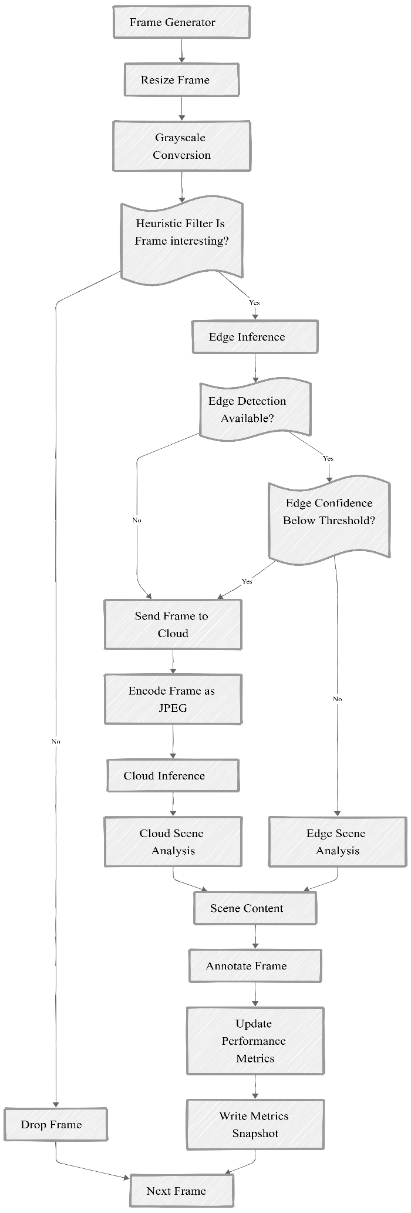
Algorithms and logic: To connect the pieces and realise the sought objectives, I build the orchestrator to run the pipeline using the algorithm shown in Figure 2:
Frame generator: Receives and reads live or prerecorded video stream and decodes it into individual frames using cv2.VideoCapture(). This step has a skip interval as a configurable variable, which controls the number of frames to skip natively without any processing.
Preprocessing: Includes two steps: resizing the frame to a smaller size (has a configurable variable i.e. resize_width, default=640). The resized frames are then converted to greyscale using cv2.cvtColor(), a single colour channel with pixel values ranging from (0/black — 255/white).
Heuristic filter: A vital component of this pipeline. As illustrated in Figure 3, this filter is computationally cheap as it uses the greyscale frame to check whether the frame is interesting by calculating a change score (0–255) based on the mean absolute difference in pixel intensity between the current frame and its predecessor using cv2.absdiff(). This change score serves as a motion indicator. It compares each frame's change score to a configurable heuristic threshold to decide using this logic:
- Change score >= heuristic threshold: frame is interesting (continue processing), return (True, the change score).
- Change score < heuristic threshold: return (False, the change score).
If False, drop the frame (no further processing). If True, the frame is interesting and significant change has been detected. Consequently, continue processing the frame.
Edge model inference: To improve efficiency, the orchestrator lazily loads the model using Ultralytics YOLO class (default yolov8n.pt) and conducts an asynchronous background warmup using threading.Thread() to avoid blocking the pipeline. For each interesting frame, the orchestrator conducts on-edge object detection using the _detect_edge() method and measures inference time in milliseconds. The results are converted from a single Ultralytics object into a structured list of dictionaries using the parse_detections function and are used to annotate the frame. A wrapper method edge_model_decision extracts per-detection confidence scores and implements a gateway logic:
- If no detections (empty conf list) or max(confidences) < edge_conf_threshold: offload to cloud.
- If max(confidences) >= edge_conf_threshold: accept the detections and annotate the frame locally and prepare it as display_frame for output.
Edge confidence threshold range is (0 – 1), and it's configurable through the application CLI. All other exceptions, e.g., edge model unavailability, result in an empty response, so the orchestrator can handle them gracefully by routing the frame to the cloud server.
Figure 2 Algorithm/ logic flowchart of the video analytics pipeline illustrating frame preprocessing, heuristic filtering, edge inference, cloud offloading and metrics aggregation and display on the dashboard.

