**Introduction**

The real estate industry is rapidly developing, and the influencing factors are so varied that it is difficult to evaluate the property quality and so on. Recently, real state agent aim to approach clint via online market (website) which bring several advantage; such as, clearer channels of communication, these are just some of the many benefits that real estate agents can get from having a website of their own. If an agent looking for more clients or a better marketing strategy, putting up their own website is the next step that they should do.

The main objectives of our project are by combining WebGIS technology and algorithm analysis, and to complete the prediction model analysis of the real estate quality and visualize the data through front and back-end interaction and GIS spatial data analysis by combining various influencing factors.

The goals of this system are to process and analyze the Real-estate data, by combining WebGIS technology and algorithm analysis, and to complete the prediction model analysis of the real estate quality and visualize the data through front and back-end interaction and GIS spatial data analysis by combining various influencing factors.

**Acronyms and Definitions**

|  |  |
| --- | --- |
| **Name** | **Definition** |
| Epicollect5 | Epicollect5 is a mobile and web application for free and easy data collection. It provides both the web and mobile application for the generation of forms and freely hosted project websites for data collection. |
| WSGI | Web server gateway interface (WSGI) is a simple calling convention for web servers to forward requests to web applications or frameworks written in the Python programming language. |
| DBMS | Database Management Service (DBMS) is a software that interacts with end users, applications and the database itself to capture and analyze stored data. |
| Web Application | Web application, or web app, is a client–server computer program that the client (including the user interface and client-side logic) runs in a web browser. |
| API | Application programming interface (API) is a computing interface to a software component or a system, that defines how other components or systems can use it. |
| UTM | Universal Transverse Mercator (UTM) is a conformal map projection system for assigning coordinates to locations on the surface of the Earth |
| PostgreSQL | Free and open-source relational database management system with SQL compliance. It will be used in the development of this project. |
| Machine Learning | Machine learning is a method of data analysis that automates analytical model building. It is a branch of artificial intelligence based on the idea that systems can learn from data, identify patterns and make decisions with minimal human intervention. |

**Software Design Document**

The Design Document provides a specification on the architecture of our website system. In fact, this document is corresponding to the Requirements Analysis and Specification

Document which is previously delivered, also it provides further description on its components,

their interactions and the implementation, integration and testing plan.

This document will describe the following characteristics of the project;

• Project Database: data is the most important aspect of our project also data. In fact, data could be so complicated; therefore, preprocessing and cleaning up the data it does result sufficient analysis. Upon these mentioned fact Database characteristics will be explained and described

• Software Structure: as it will be determined in this segment, the software

is divided into a layers architecture which will make the best possible interaction between the client and the server taking in account the static and dynamic elements

• User cases application: As it can be seen in further detail in the RASD,

it can be seen how use cases or requirements map on the components

of the software.

• Test Plan: A test case is a singular set of actions or instructions to perform and validates a specific aspect of a product or application functionality. A detailed document that describes the test hypothesis, input from all users strategy, and steps

**1.Project Database**

The project data, were retrieved from EpiCollect5, pre-processed and copied to a PostgreSQL database. The web app it does interact with DBMS and perform CRUD operations on the PostgreSQL database. **The** advantages for storing the data in a PostgreSQL database as opposed to fetch them directly from Epicollect5 include:

* to enable verification, pre-processing and storing of consistent data;
* to ensure availability of data, decoupling our web application from EpiCollect5;
* to reduce the risk of data loss;
* to improve performance;
* to leverage DBMS capabilities and, in particular, the interface between Python and PostgreSQL.

**1.2 Epicollect5 Dataset**

The dataset of “Analysing the housing quality in Crafers Stirling and Aldgate”. that will be used in this project comes from Epicollect5 and contains data collected in;

Australia.

The dataset consists of 72 georeferenced measurement points of ERP geolocalized

in living out of Crafers, Stirling and Aldgate

Dataset: <https://five.epicollect.net/project/housing-quality-index-crafers-aldgate-stirling>

We retrieved data from an existing project whose main features

are shown below table and we modified the attributes of the dataset according

to the main purpose of our application.

|  |  |
| --- | --- |
| **Attribute** | **Description** |
| **Created At** | expressed in m/dd/yy |
| **Location** | expressed by utilizing UTM Coordinates |
| **Take photo** | Photo of the property |
| **Dwelling type** | The Property house type |
| **Number of trees** | Trees Number within the property |
| **Distance to major junctions** | Distance in Meter from the closest junction |
| **Decibel reading** |  |
| **Age of Property** | The age of the property |
| **Quality of housing** | This represent the quilty of housing considering different aspect such as (Age of house , Type of the house and distance from junction) |

Furthermore, we created a new project called “Reality Housing Solions” Web Application whose main features are summarized in below below;

|  |  |
| --- | --- |
| **Attribute** | **Description** |
| **Created At** | expressed in m/dd/yy |
| **Location** | expressed by utilizing UTM Coordinates |
| **Take photo** | Photo of the property |
| **Dwelling type** | The Property house type |
| **Number of trees** | Trees Number within the property |
| **Distance to major junctions** | Distance in Meter from the closest junction |
| **Decibel reading** |  |
| **Age of Property** | The age of the property |
| **Quality of housing** | This represent the quilty of housing considering different aspect such as (Age of house , Type of the house and distance from junction) |

**1.3 PostgreSQL database**

The web application running on the WSGI server will interact with a Database Management System for data storing and management. In fact, our decision came up to use PostgreSQL since it is a free and open-source relational database management system emphasizing extensibility and SQL compliance, beside that to leverage database adapters for Python programming language,

Furthermore, PostgreSQL provides useful extensions depending on the specific nature of data.

Given that data entries are georeferenced we have decided to exploit PostgreSQL’s extension PostGIS, an open source software program that adds support for geographic objects to the PostgreSQL object-relational database. PostGIS follows the Simple Features for SQL specification from the Open Geospatial Consortium (OGC). Key features of PostGIS include, among others:

● Geometry types for Points, LineStrings, Polygons, MultiPoints, MultiLineStrings, MultiPolygons and GeometryCollections;

● Spatial predicates for determining the interactions of geometries;

● Spatial operators for determining geospatial measurements like area, distance, length and perimeter;

● Spatial operators for determining geospatial set operations, like union, difference, symmetric difference and buffer.

**2 Software Structure**

The software’s architecture will consist on a 3-layer system composed of a Web Server (HTTP Server), Logical Server (Application Server) and Database Server.

* **HTTP Server**

The client is able to communicate with HTTP Server through client requests (URL, clicks, formularies, etc). This server will provide a response to the client server (user browser). The response is composed by HTTP and CSS codes that are run by the client server and the completion status to confirm whether the operation is successful or not.

The HTTP and CSS codes obtained as output from the Web Server are generated by means of requesting to the Application Server all the needed information for producing the required web page. Thus, the Application Server provides the logical outcome as a response to the HTTP Server’s request.

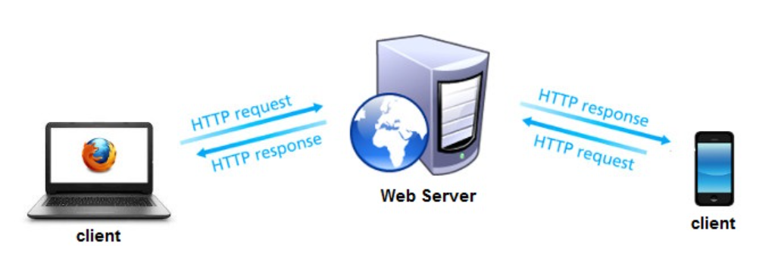

* **Application Server**

This server will provide all the logical operations that will be needed in order to achieve the software requirements. Therefore, Python coding will be used for this project, this is a WSGI Server, thus Python applications can run and serve the Web Server in a consistent way

* **EpiCollect5 Data preprocessing**

When we import the data form EpiCollect5 we had to run data quality check for each attribute of the data and modify some column ;as example of that, we added colum for Latitudes and longitude for object point in order deal with Geopapanda , Also we had ensure about some Colum forma t such as the dates and must be in correct DD/MM/YYYY format.

* **Data import into PostgreSQL**

The required data from EpiCollect5 we have been preprocessed and filtered based on our analysis need. As result of that the data were ready to be imported to PostgreSQL database

* **Mapping Tool**

The WSGI Server will provide a user-interactive map for showing a points of each property , basemaps and geospatial data visualization. The Mapping function will receive a list of elements to be plotted as input as well as specifications of how each element has to be plotted. This function will mainly use the library which is aimed to develop interactive visualization for web applications.

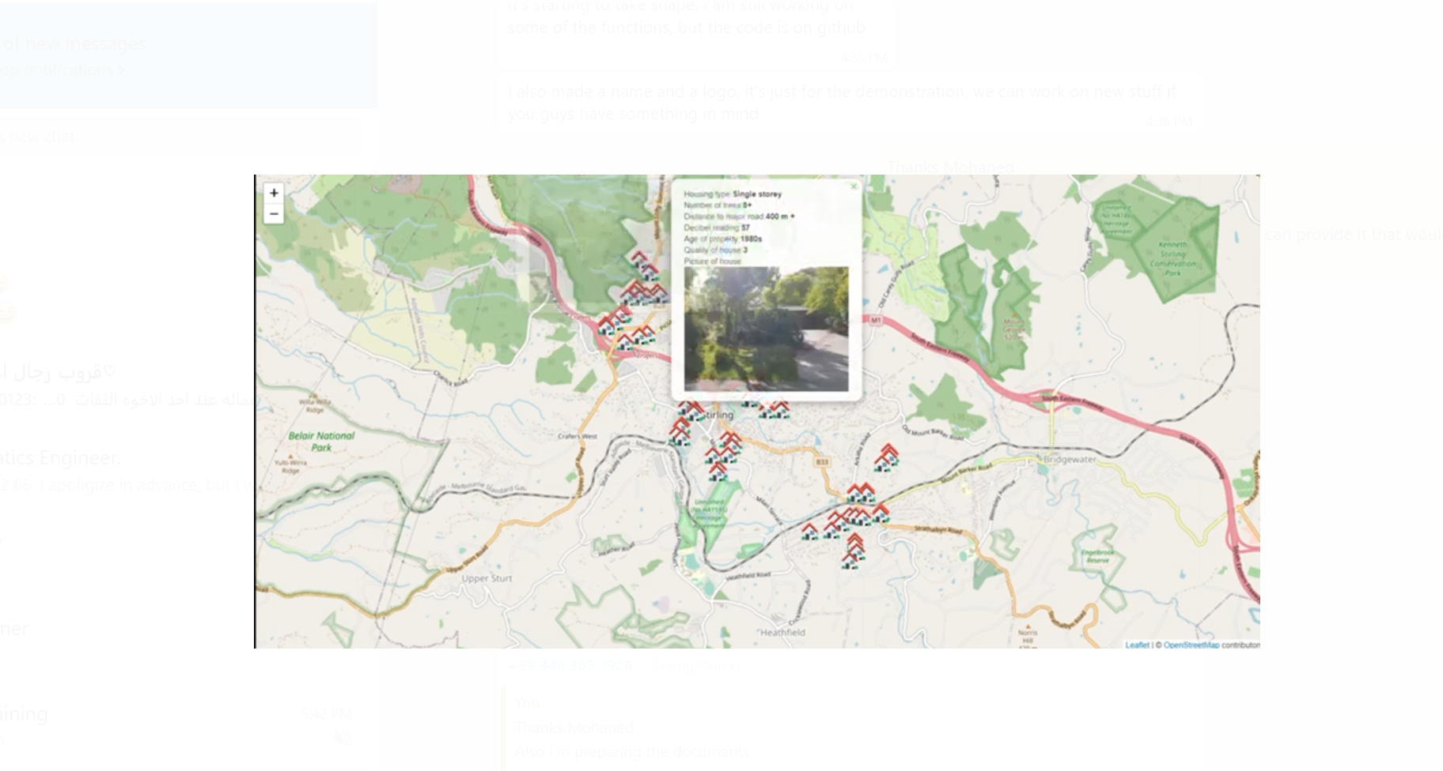

* **Template Engine**

The objective of the template engine is to generate desired content categories for our web-Map Page. for instance, HTML, while using some of the data and programming constructs such as conditionals and for loops to manipulate the output. Template files that are created by developers and then processed by the template engine consist of pre-written markup and template tag blocks where data is inserted.

* **Front-End Development**

The front end development is programming which focuses on the visual elements of a website or app that a user will interact with (the client side). In our project the following (**Front-End** )Engine template used.

* **JINJA**

JINJA template engine which dynamically builds HTML pages using familiar Python concepts such as variables, loops, lists, and etc. based on logic and context. Unlike static HTML, templating systems like JINJA empowers us to do things like share snippets between pages, or render pages conditionally based on context.

* **Leaflet**

Leaflet is the leading open-source JavaScript library for mobile-friendly interactive maps. it has all the mapping features that developers need.

Leaflet is designed with simplicity, performance and usability in mind. It works efficiently across all major desktop and mobile platforms, can be extended with lots of plugins, has a beautiful, easy to use and well-documented API and a simple, readable source code that is a joy to contribute to. We utilize tools to show our map out put and Visualization.

* **CSS codes**

CSS code is the code that styles web content, it does manage the style and the display of the template web pages like border style, color of the components, text align and etc. and it has been utilize to customize our webpage

* **The back-End Development**

The back end development focuses on the side of a website users can't see (the server side). The following development Engine used for utilized for our project;

* **Flask**

Flask is a friendly Python web framework that provides useful tools and features for creating web applications in the Python Language. It gives developers flexibility and is an accessible framework for new developers because you can build a web application quickly using only a single Python file. Flask is also extensible and doesn’t force a particular directory structure or require complicated boilerplate code before getting started.

* **HTML**

The HTML has been used to structure a web page and its content; such as, the content that could be structured within a set of paragraphs, a list of bulleted points, and using images as well as data tables..

* **Linux server**

A Linux server is a server built on the Linux open-source operating system. It offers businesses a low-cost option for delivering content, apps and services to their clients. Because Linux is open-source, on our project we used it set up a PostgreSQL Database on Linux

* **Code function**

Several code functions implemented in this project to run our webpage application , the below table classified the function and its objective

|  |  |
| --- | --- |
| **Function** | **Objective** |
| Setup DB Connection | generic connection path to the server setup |
|  |  |
| Welcome page | Function that navigate the user to he website Home Page |
| Sign in page | Function that allow the website user to sing in by using User Name and Password |
| sign up page | Function that allowed new user to create user name and Password |
| Sing out | Function that allowed existing webpage user to exit the session |
| Map Functions | Function that displays and visualize the map by utilizing java script |
|  |  |

* **Interaction between application server components**

A different components within the application server were utilize and interact with each other . First of all, the Epicollect5 specific data were retrieved and preprocessed. Furthermore, the accurate data were placed into Geodataframe, after that the data were distributed either to the Mapping Tool or to the Data Analysis Tool.

The Template Engine renders the final client-side web page. Each time this function run it, the engine will have as input some built-in base templates designed to provide a user-friendly experience in the web application.

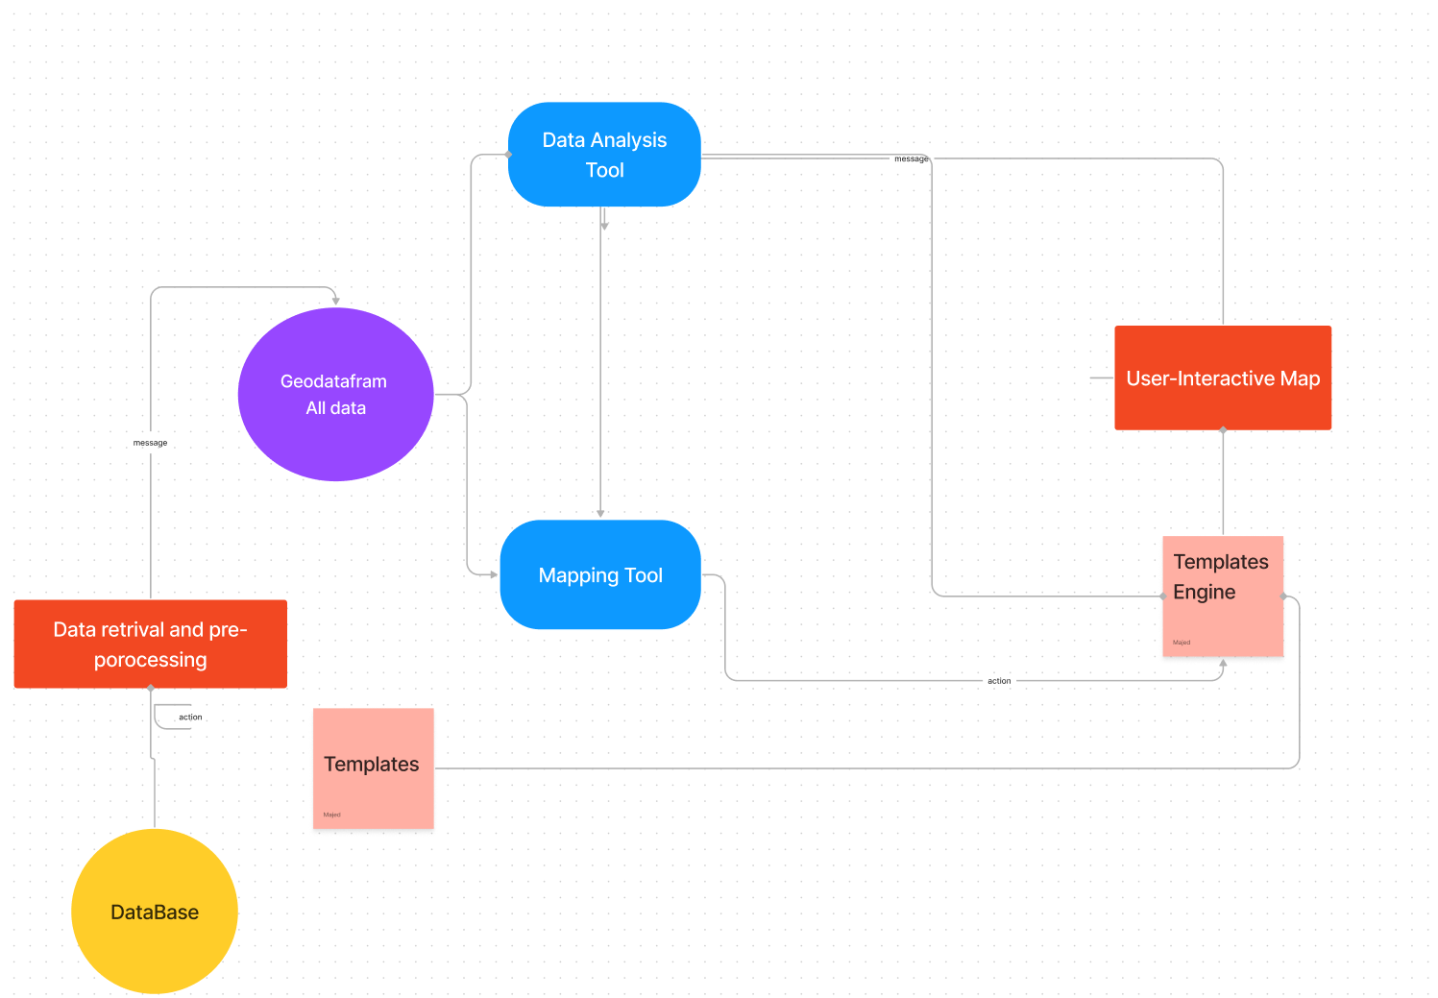

* **User Cases & Scenarios**

In order to explain the software functionalities, this section is going to address an explanation about the actions taken by the software and the user in a list of cases that are useful to explain the internal processes of the application. In this section we describe what is going on from server-side and client-side on when the user cases happen by specifying the different actions that take place in these situations.

Actors:

1. Visitors: To manage this website in an efficient and orderly manner, we don’t allow unregister user to use this website. So, all visitors will be redirected to the register/login page.
2. Registered Users: They get the access to most of the functionalities of this website, including sending request to the server and visualize those responding data by map applications and chart/diagram, add their preferred location and see its score with regard to the prediction model.
3. Administrator (Domain experts): They can modify the relevant APIs, inspect the exception handling feedback and check the usability of each functionality.

Further details for User Cases have been explain in “RASD_V1.1” document

* **Test Cases**

When our Web-Page application completed, test cases will run overall the webpage. Test case can provide several advantages such as; ensure all developed function are working in the efficient way, also Increasing of the found bugs, the following test cases have been conducted;

* + **User case 1: Normal User Registration**

**Test Case 1:** User Registration

|  |  |
| --- | --- |
| **Inputs** | user enters page of registration fills:  username: Mike  password: yy3322yy |
| **Hypothesis** | Mike username’s uniqueness and display the result  yy3322yy is the password with rules of password and display the result |
| **Expected results** | the system sent to the server then stored in the database Alert the registration result, redirect to login page. and The user successfully logs in or registers |

* + **User case 2: Registration**

**TC 1**: Correct username and password

|  |  |
| --- | --- |
| **Inputs** | user accesses to the login page and inserts:  username: Mike  password: yy3322yy |
| **Hypothesis** | Mike username exist in the system  yy3322yy is the password |
| **Expected results** | the system brings the user in the index  page and welcome him/her |

**TC 2**: Incorrect username and password

|  |  |
| --- | --- |
| **Inputs** | user accesses to the login page and inserts:  username: Mike  password: yy3322yy |
| **Hypothesis** | Mike username exist in the system  yy3322y@ is the password |
| **Expected results** | the system informs the user that the username or password is incorrect |

**TC 3**: Username doesn’t exist

|  |  |
| --- | --- |
| **Inputs** | user accesses to the login page and inserts:  username: 113344  password: yy3322yy |
| **Hypothesis** | 13344 username does not exist in the  system |
| **Expected results** | the system informs the user that the username  or password is incorrect |

**User Case 3: Administrator User Login**

**Test Case 1:** Administrator User Login.

|  |  |
| --- | --- |
| **Inputs** | User enters page of login dedicated for admins and inserts:  username: Admin_2  password: MM77UU |
| **Hypothesis** | username and password which are provided exclusively by the development team. |
| **Expected results** | Alert the login result, redirect to main page. |

**User Case 4: Change the personal information**

**Test Case1: Change password**

|  |  |
| --- | --- |
| **Inputs** | user accesses to the login page and inserts:  username: Mike  password: yy3322yy |
| **Hypothesis** | User request change password from yy3322yy to NN5511DD |
| **Expected results** | the system informs the user that the operation is completed successfully |

Other Test ( Need to modify)

* visualize data on interactive map
* visualizes statistical analysis results
* Logging out