**VALLIAMMAL COLLEGE FOR WOMEN[1363]**

**Department of Computer Application**

**Project Tittle : FitFlex: Your Personal Fitness Companion**

**(React Application)**

**Team ID:146008**

**Team Leader: Mohanadevarajan DJ**

**Team Size:4**

**Team Members:1.DJ. Mohanadevarajan**

**2.M.Priya Dharshini**

**3.B.Rajeswari**

**4.S.Akshaya**

**Github Link:**

**Google Drive Link:**

**Fit Flex.. (React Application)**

**Introduction:**

🏋️‍♂️ Welcome to the forefront of fitness exploration with SB Fitzz! Our innovative fitness app is meticulously designed to revolutionize the way you engage with exercise routines, catering to the diverse interests of both fitness enthusiasts and seasoned workout professionals. With a focus on an intuitive user interface and a comprehensive feature set, SB Fitzz is set to redefine the entire fitness discovery and exercise experience.

**Project Goals and Objectives:**

The overarching aim of SB Fitzz is to offer an accessible platform tailored for individuals passionate about fitness, exercise, and holistic well-being. .

**Features of Fiteness app:**

* **Exercises from Fitness API:** Access a diverse array of exercises from reputable fitness APIs, covering a broad spectrum of workout categories and catering to various fitness goals.
* **Visual Exercise Exploration:** Engage with workout routines through curated image galleries, allowing users to explore different exercise categories and discover new fitness challenges visually.
* **Intuitive and User-Friendly Design:** Navigate the app seamlessly with a clean, modern interface designed for optimal user experience and clear exercise selection.

**PRE-REQUISITES**:

Here are the key prerequisites for developing a frontend application using React.js:

* **Node.js and npm**:

Node.js is a powerful JavaScript runtime environment that allows you to run JavaScript code on the local environment. It provides a scalable and efficient platform for building network applications.

Install Node.js and npm on your development machine, as they are required to run JavaScript on the server-side.

* Download: <https://nodejs.org/en/download/>
* Installation instructions: <https://nodejs.org/en/download/package-manager/>

npm start

This command launches the development server, and you can access your React app at [http://localhost:3000](http://localhost:3000%20) in your web browser.

* **HTML, CSS, and JavaScript**: Basic knowledge of HTML for creating the structure of your app, CSS for styling, and JavaScript for client-side interactivity is essential.

* **Version Control**: Use Git for version control, enabling collaboration and tracking changes throughout the development process. Platforms like GitHub or Bitbucket can host your repository.

• Git: Download and installation instructions can be found at: <https://git-scm.com/downloads>

* **Development Environment**: Choose a code editor or Integrated Development Environment (IDE) that suits your preferences, such as Visual Studio Code, Sublime Text, or WebStorm.

• Visual Studio Code: Download from <https://code.visualstudio.com/download>

• Sublime Text: Download from <https://www.sublimetext.com/download>

• WebStorm: Download from [https://www.jetbrains.com/webstorm/download](https://www.jetbrains.com/webstorm/download%20)

To get the Application project from drive:

Follow below steps:

* **Get the code:**

• Download the code from the drive link given below:

<https://drive.google.com/drive/folders/14f9eBQ5W7VrLdPhP2W6PzOU_HCy8UMex?usp=sharing>

**Install Dependencies:**

• Navigate into the cloned repository directory and install libraries:

cd fitness-app-react

npm install

* **Start the Development Server**:

• To start the development server, execute the following command:

npm start

**Access the App:**

• Open your web browser and navigate to [http://localhost:3000](http://localhost:3000/).

• You should see the application's homepage, indicating that the installation and setup were successful.

You have successfully installed and set up the application on your local machine. You can now proceed with further customization, development, and testing as needed.

**Project structure:**

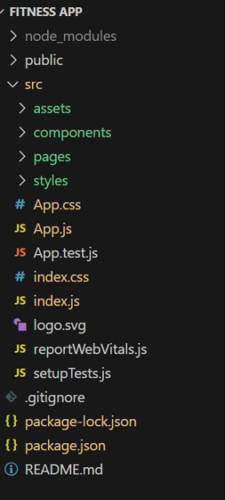 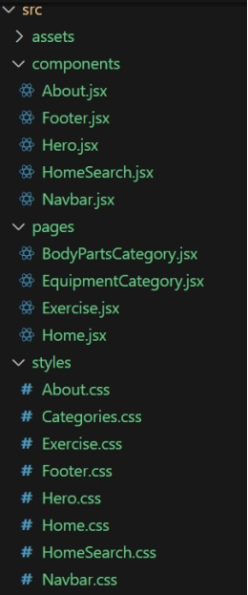

In this project, we’ve split the files into 3 major folders, *Components, Pages and Styles.* In the pages folder, we store the files that acts as pages at different URLs in the application. The components folder stores all the files, that returns the small components in the application. All the styling css files will be stored in the styles folder.

**Project Flow:**

**Project demo:**

Before starting to work on this project, let’s see the demo.

Demo link: <https://drive.google.com/file/d/1dVVEwbZgAltQyv8yXszbQkw98dhnOb9V/view?usp=sharing>

Use the code in:

<https://drive.google.com/drive/folders/14f9eBQ5W7VrLdPhP2W6PzOU_HCy8UMex?usp=sharing>

**Milestone 1: Project setup and configuration.**

* **Installation of required tools**:

1. Open the project folder to install necessary tools

In this project, we use:

* React Js
* React Router Dom
* React Icons
* Bootstrap/tailwind css
* Axios

* For further reference, use the following resources
* <https://react.dev/learn/installation>
* <https://react-bootstrap-v4.netlify.app/getting-started/introduction/>
* <https://axios-http.com/docs/intro>
* <https://reactrouter.com/en/main/start/tutorial>

**Milestone 2: Project Development**

* Setup the Routing paths

Setup the clear routing paths to access various files in the application.Ex:

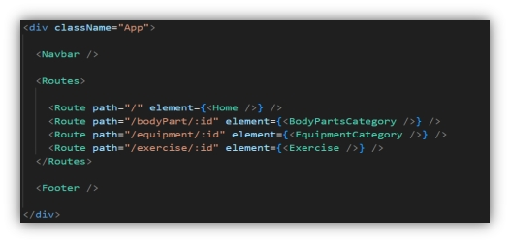

* Develop the Navbar and Hero components
* Code the popular search/categories components and fetch the categories from ***rapid Api***..

**Important Code snips:**

* **Fetching Exercise details**

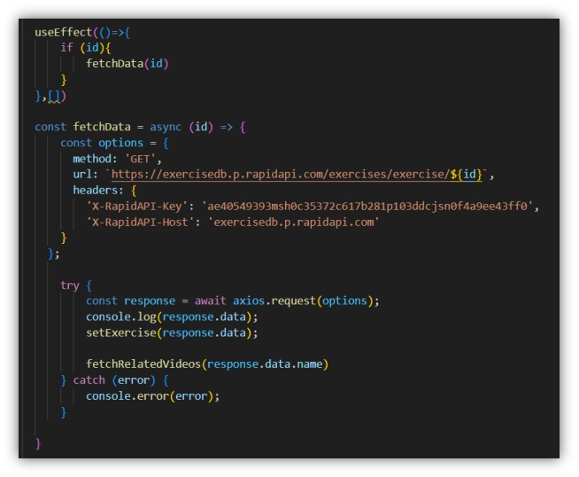

**User Interface snips:**

* Hero component

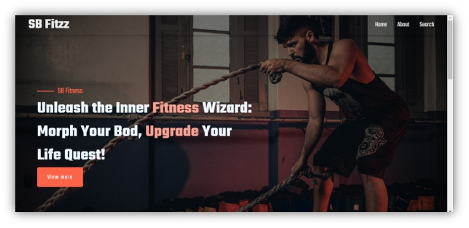

**Search**

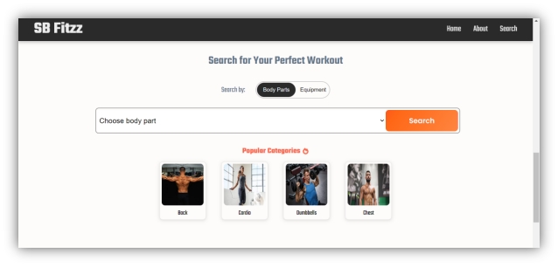

* **Category page**

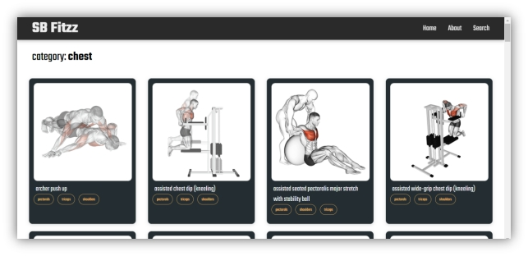

* Exercise page

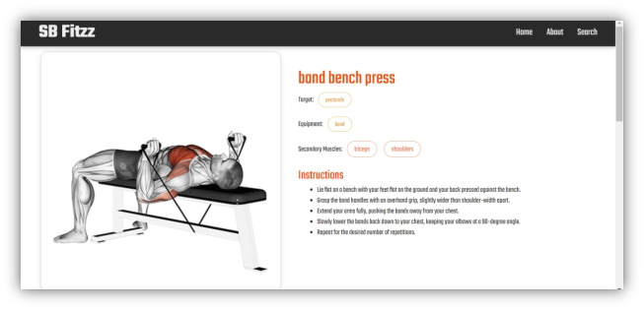

***\*\*\*\*\*Thank You\*\*\*\*\****