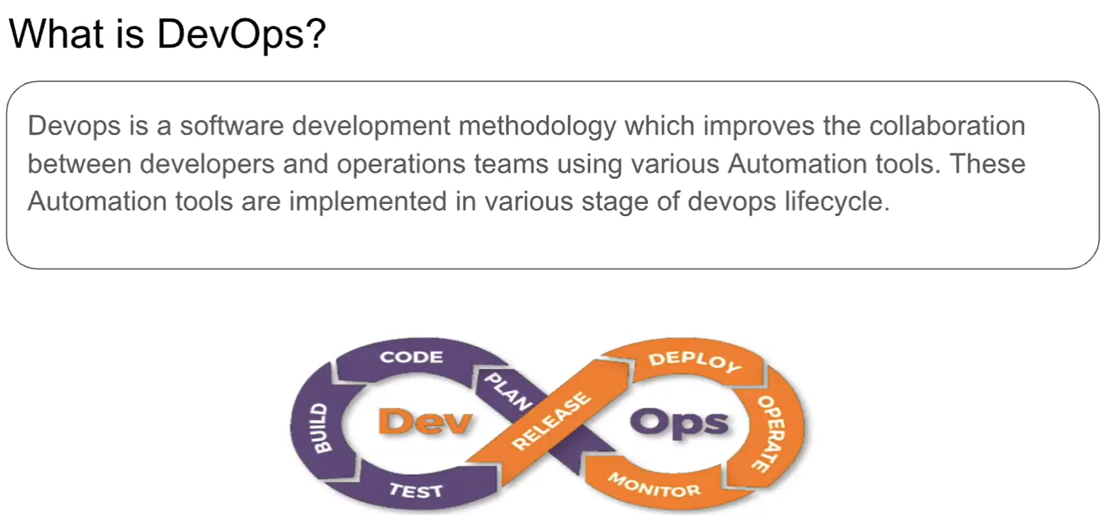

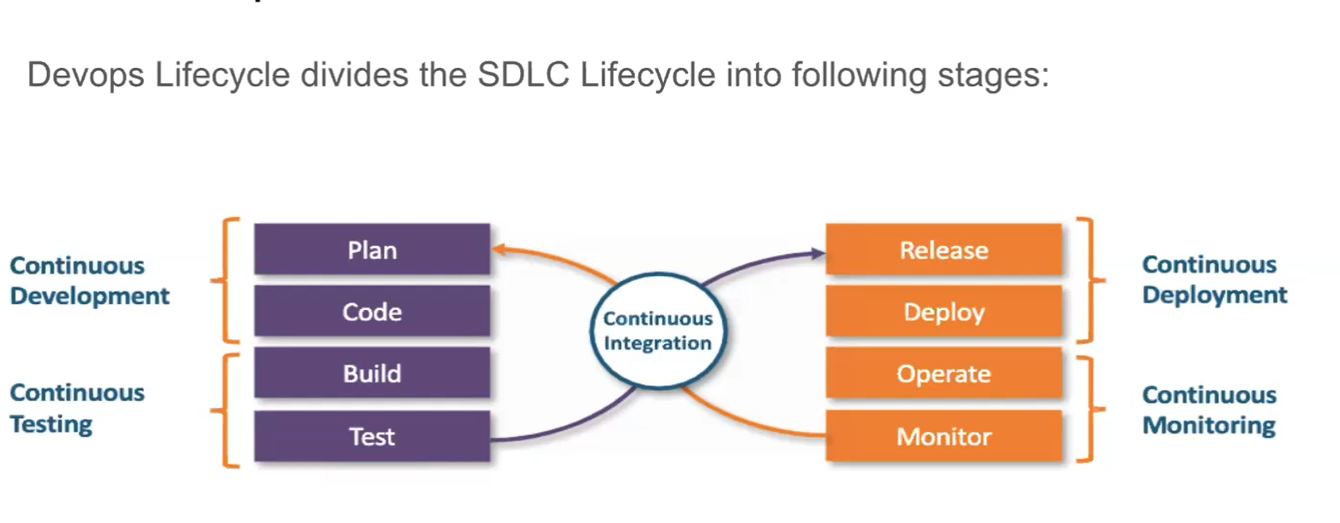

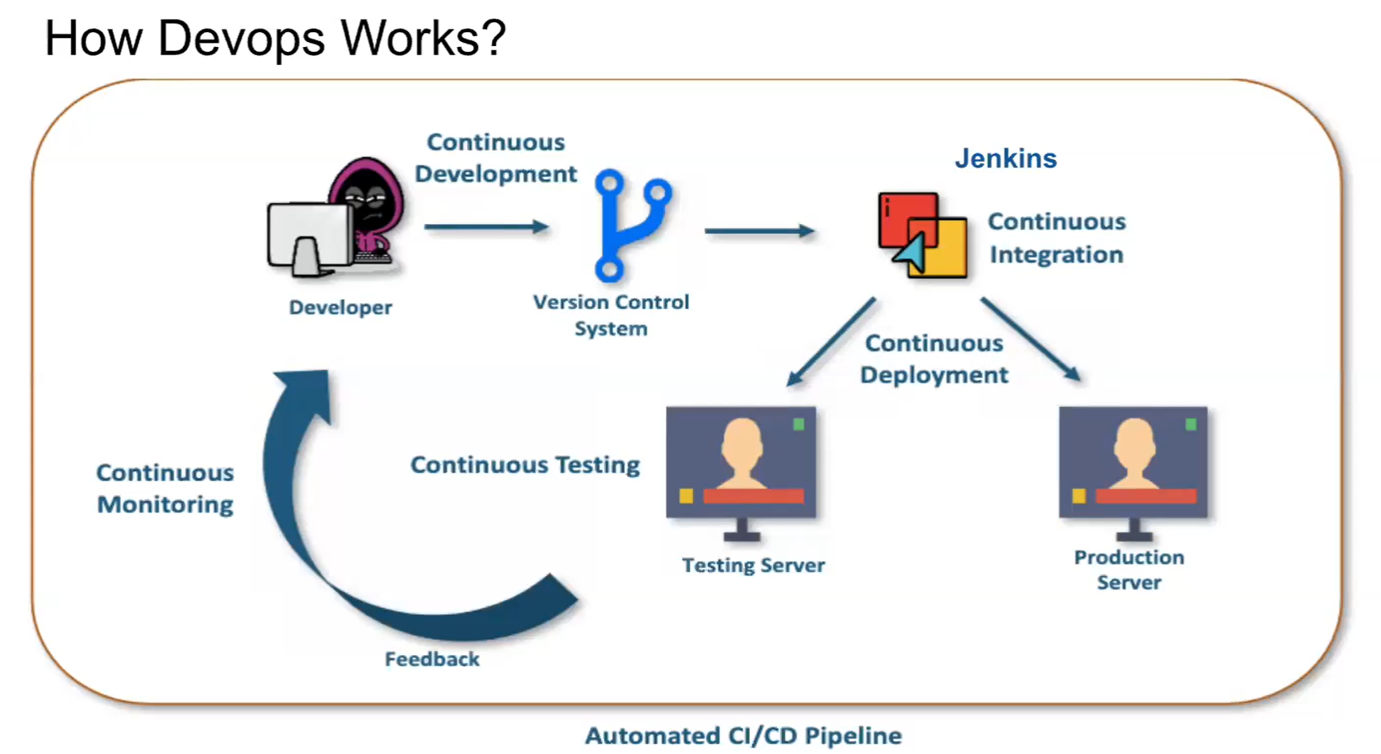

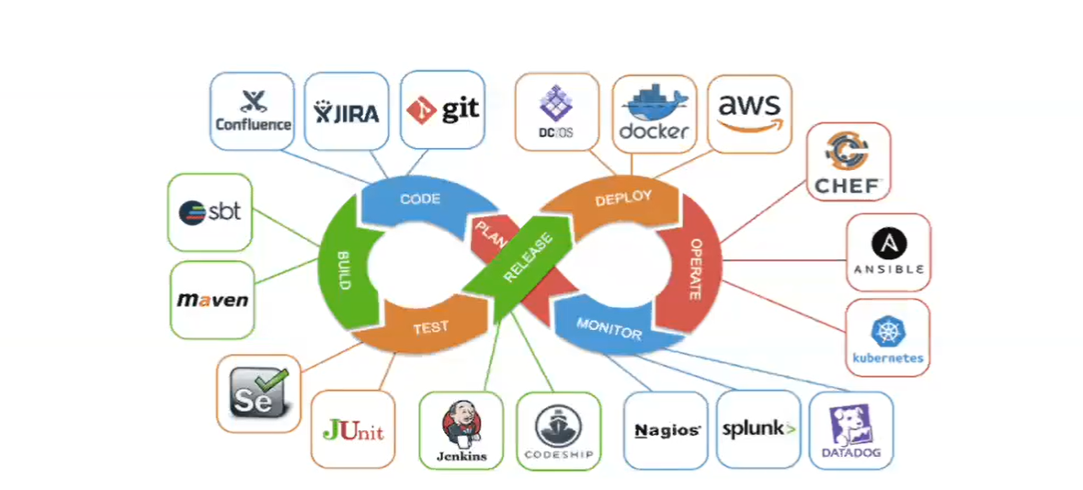

Once the coding done by the developer they will push the code into version control system like git using tools like source tree or direct from the Editors. And next jenkins is the heart of the devops. It will take the code from the version control and run the created jobs using automation tools init. Will call it as contonous deployment

**Continous Development:**

This stage involves commiting the code into version tools like Git, SVN for maintaining different versions of the code, and tools like Maven, Gradle , Ant for packaging the code into executable file which can be ready for the testers for testing.

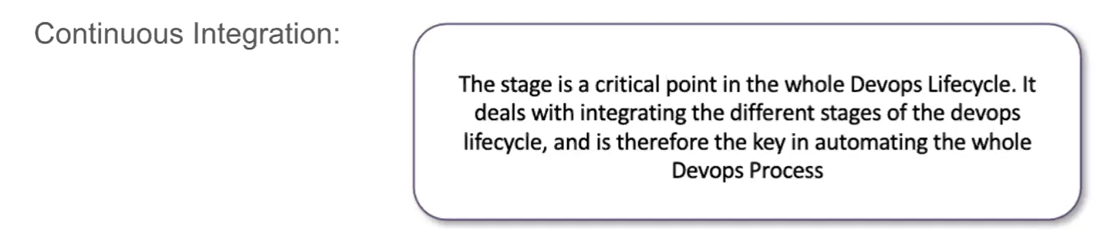

Continous deployment:

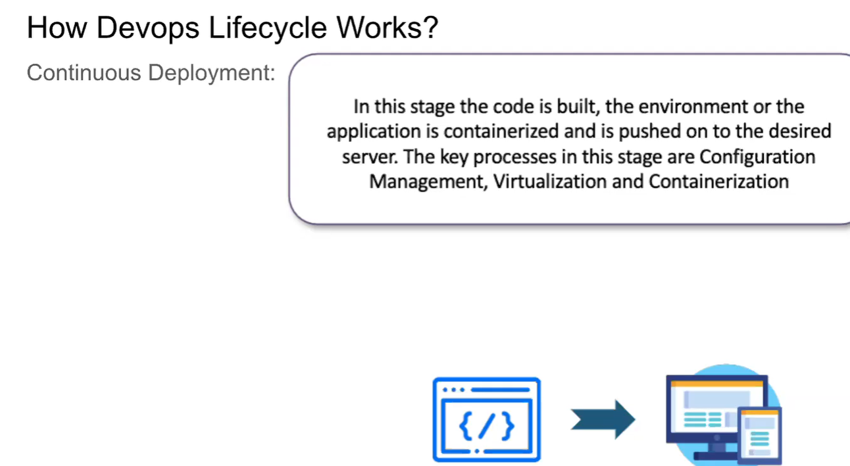

* Here the Docker used for configuration mangament in the enviroment servers. Deployment will happens to the testing servers

Continous testing:

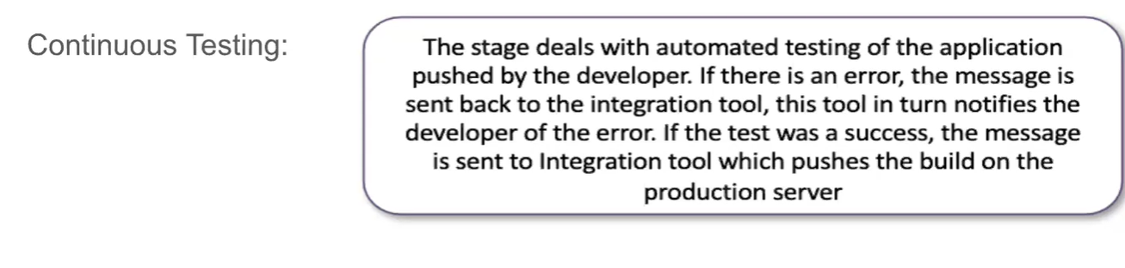

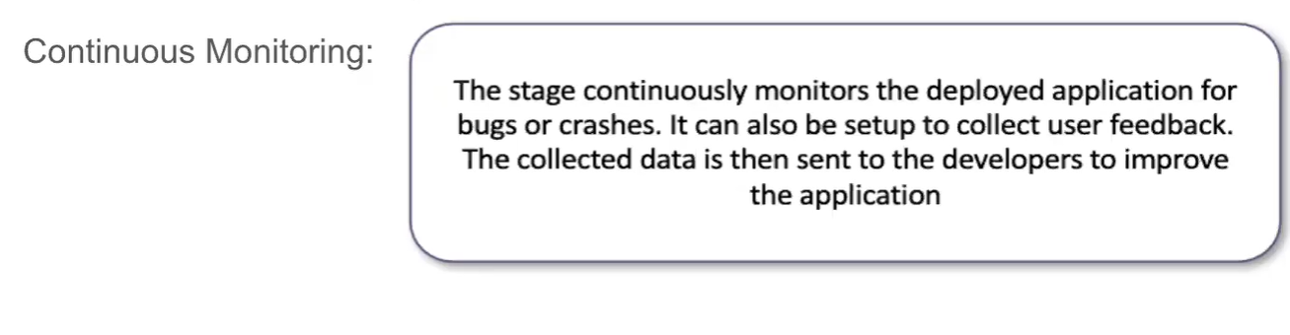

For robot frame work we will not use any build tools like maven, gradle for packaging purpose we will diretly use robot execute command while creation of jenkins job

Ex:

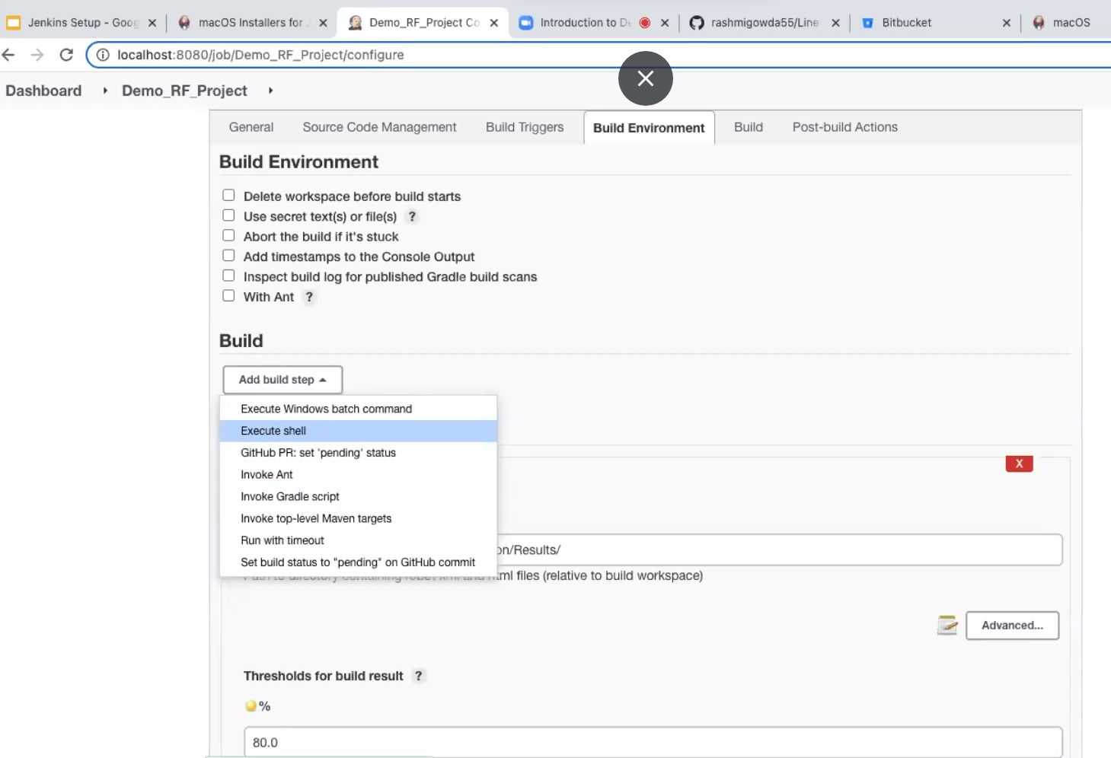

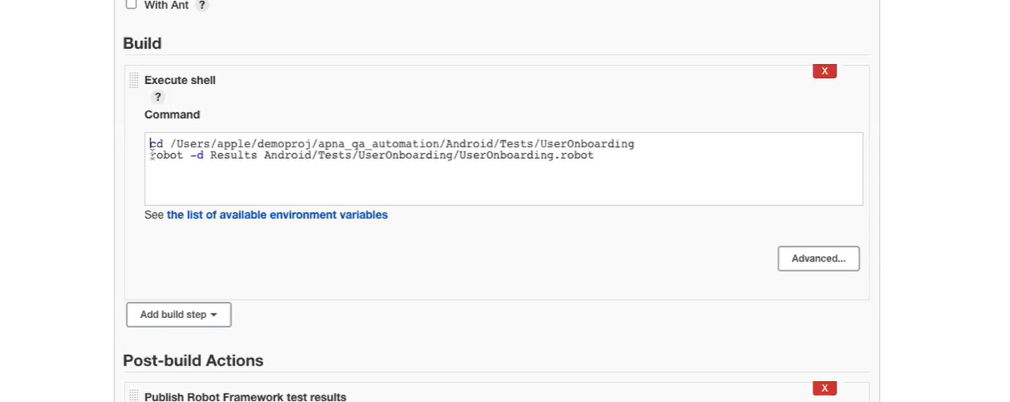

To push the results after the job execution done:

