**Employee Management**

**Database Schema:**

**EMPLOYEE TABLE:**

**CREATE** **TABLE** `employee` (

`EMPLOYEE_ID` **INT**(11) **NOT** **NULL** **AUTO_INCREMENT**,

`EMPLOYEE_NAME` **VARCHAR**(50) **NULL** **DEFAULT** **NULL**,

`SALARY` **INT**(10) **NULL** **DEFAULT** **NULL**,

`DEPARTMENT` **INT**(10) **NULL**,

`DESIGNATION` **VARCHAR**(50) **NULL** **DEFAULT** **NULL**,

`CREATEDBY` **VARCHAR**(50) **NULL** **DEFAULT** **NULL**,

`MODIFIEDBY` **VARCHAR**(50) **NULL** **DEFAULT** **NULL**,

`MODIFIEDDATE` **DATE** **NULL** **DEFAULT** **NULL**,

`CREATEDDATE` **DATE** **NULL** **DEFAULT** **NULL**,

`MANAGER_ID` **INT**(11) **NULL** **DEFAULT** **NULL**,

**PRIMARY** **KEY** (`EMPLOYEE_ID`),

**INDEX** `employee_ibfk_1` (`DEPARTMENT`),

**CONSTRAINT** `employee_ibfk_1` **FOREIGN** **KEY** (`DEPARTMENT`) **REFERENCES** `department` (`DEPTNO`) **ON** **UPDATE** **CASCADE**

)

**AUTO_INCREMENT**=13

;

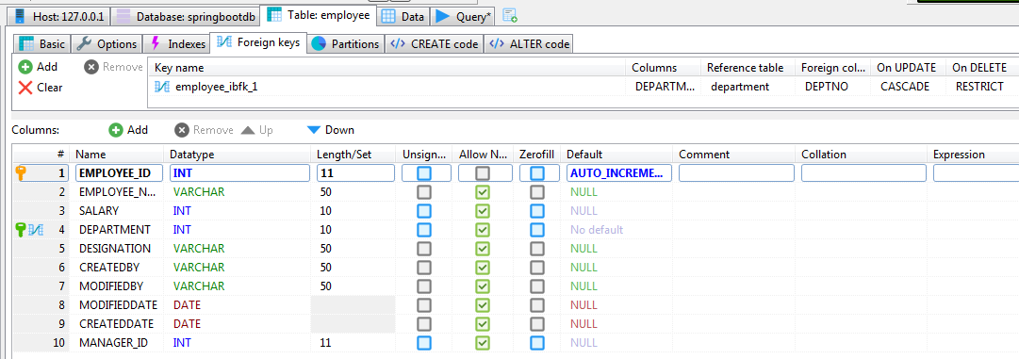

**DEPARTMENT:**

**CREATE** **TABLE** `department` (

`DEPTNO` **INT**(10) **NOT** **NULL**,

`DEPTNAME` **VARCHAR**(50) **NULL** **DEFAULT** **NULL**,

**PRIMARY** **KEY** (`DEPTNO`)

);

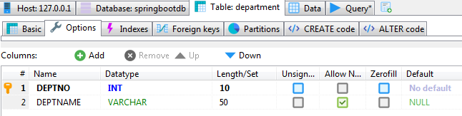

**SEQUENCE GENERATION FOR EMPLOYEE ID:**

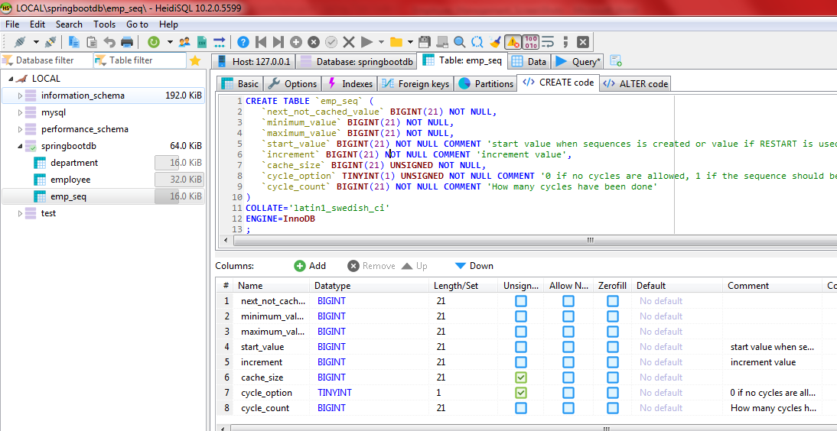

**REST API for following using Repositories:**

1. Creating an Employee

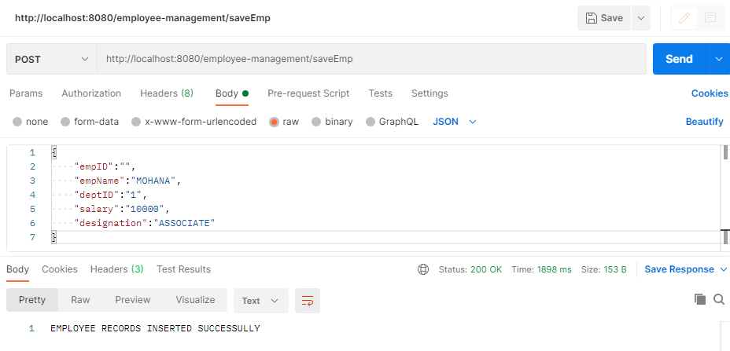

**Log Trace:**

Hibernate: select nextval(emp_seq)

Hibernate: insert into employee (createdby, createddate, modifiedby, modifieddate, department, designation, employee_name, manager_id, salary, employee_id) values (?, ?, ?, ?, ?, ?, ?, ?, ?, ?)

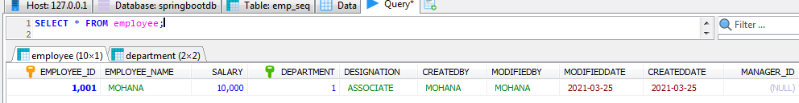

1. Update Employee name, Salary and department (one or more values)

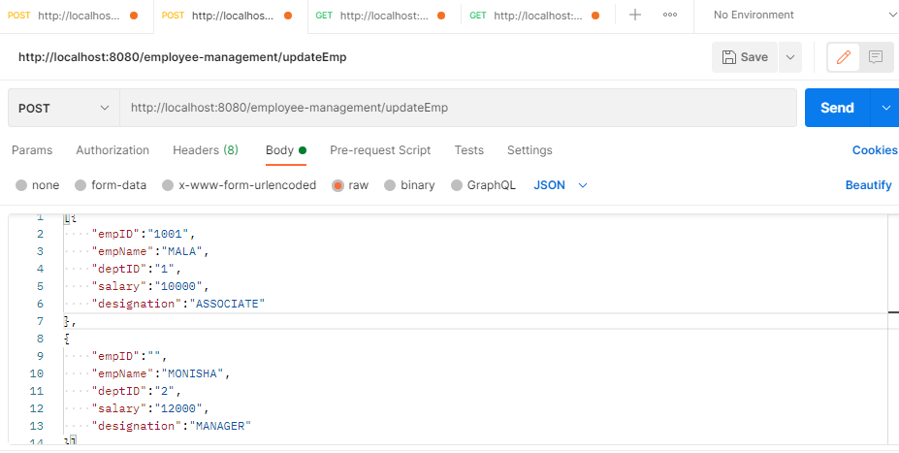

**Log Trace:**

Hibernate: select employee0_.employee_id as employee1_1_0_, employee0_.createdby as createdb2_1_0_, employee0_.createddate as createdd3_1_0_, employee0_.modifiedby as modified4_1_0_, employee0_.modifieddate as modified5_1_0_, employee0_.department as departme6_1_0_, employee0_.designation as designat7_1_0_, employee0_.employee_name as employee8_1_0_, employee0_.manager_id as manager10_1_0_, employee0_.salary as salary9_1_0_ from employee employee0_ where employee0_.employee_id=?

2021-03-25 19:56:51.480 WARN 5016 --- [nio-8080-exec-7] o.h.p.entity.AbstractEntityPersister : HHH000502: The [department] property of the [com.demo.model.Employee] entity was modified, but it won't be updated because the property is immutable.

Hibernate: update employee set createdby=?, createddate=?, modifiedby=?, modifieddate=?, department=?, designation=?, employee_name=?, manager_id=?, salary=? where employee_id=?

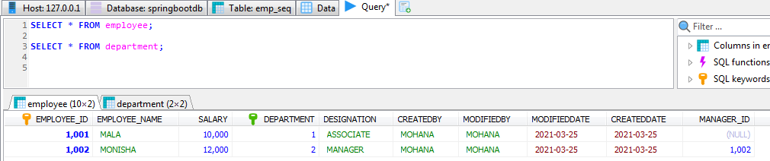

1. Create department

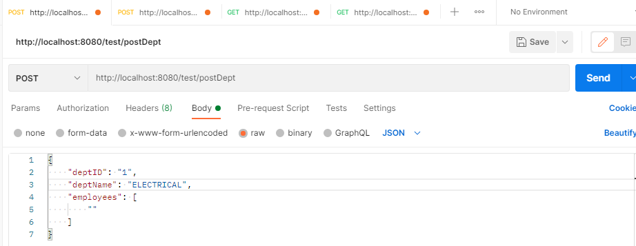

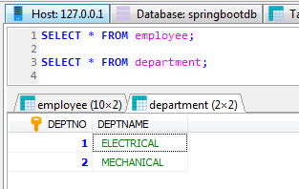

**Log Trace:**

Hibernate: select department0_.deptno as deptno1_0_1_, department0_.deptname as deptname2_0_1_, employees1_.department as departme6_1_3_, employees1_.employee_id as employee1_1_3_, employees1_.employee_id as employee1_1_0_, employees1_.createdby as createdb2_1_0_, employees1_.createddate as createdd3_1_0_, employees1_.modifiedby as modified4_1_0_, employees1_.modifieddate as modified5_1_0_, employees1_.department as departme6_1_0_, employees1_.designation as designat7_1_0_, employees1_.employee_name as employee8_1_0_, employees1_.manager_id as manager10_1_0_, employees1_.salary as salary9_1_0_ from department department0_ left outer join employee employees1_ on department0_.deptno=employees1_.department where department0_.deptno=?

Hibernate: insert into department (deptname, deptno) values (?, ?)

1. Update department name

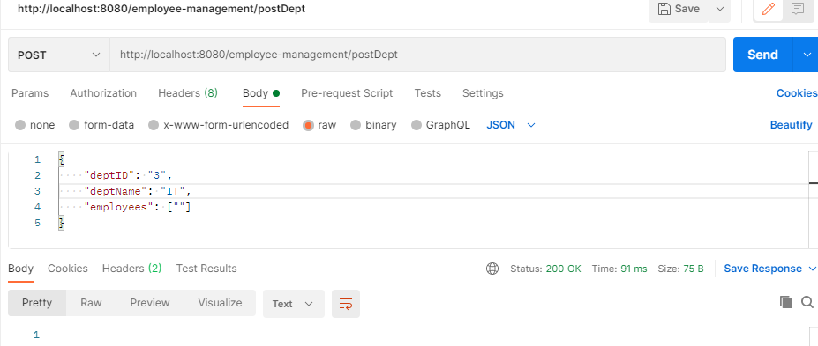

**Log Trace:**

Hibernate: select department0_.deptno as deptno1_0_1_, department0_.deptname as deptname2_0_1_, employees1_.department as departme6_1_3_, employees1_.employee_id as employee1_1_3_, employees1_.employee_id as employee1_1_0_, employees1_.createdby as createdb2_1_0_, employees1_.createddate as createdd3_1_0_, employees1_.modifiedby as modified4_1_0_, employees1_.modifieddate as modified5_1_0_, employees1_.department as departme6_1_0_, employees1_.designation as designat7_1_0_, employees1_.employee_name as employee8_1_0_, employees1_.manager_id as manager10_1_0_, employees1_.salary as salary9_1_0_ from department department0_ left outer join employee employees1_ on department0_.deptno=employees1_.department where department0_.deptno=?

Hibernate: update department set deptname=? where deptno=?

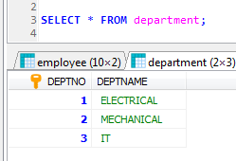

1. Get employee by Id

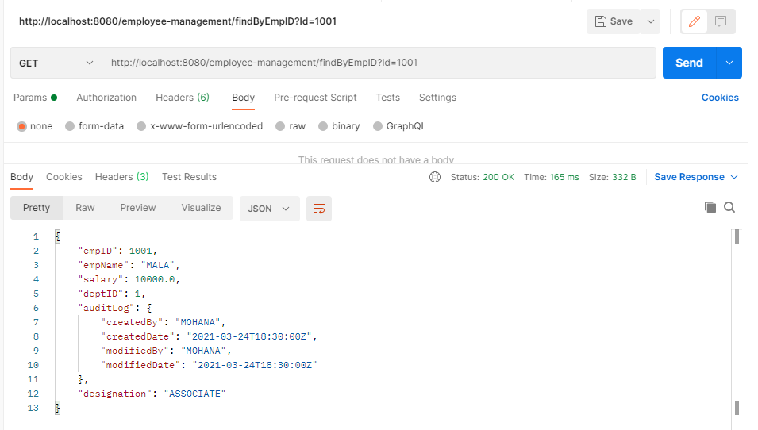

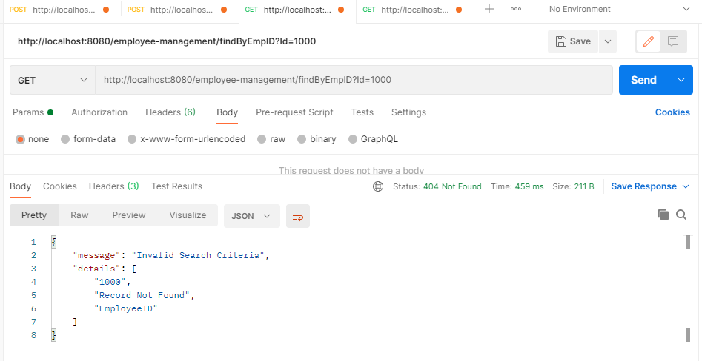

**Log Trace:**

Hibernate: select employee0_.employee_id as employee1_1_, employee0_.createdby as createdb2_1_, employee0_.createddate as createdd3_1_, employee0_.modifiedby as modified4_1_, employee0_.modifieddate as modified5_1_, employee0_.department as departme6_1_, employee0_.designation as designat7_1_, employee0_.employee_name as employee8_1_, employee0_.manager_id as manager10_1_, employee0_.salary as salary9_1_ from employee employee0_ where employee0_.employee_id=1001

1. Get department by Id

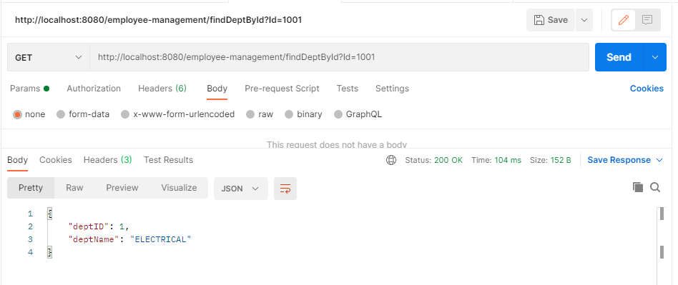

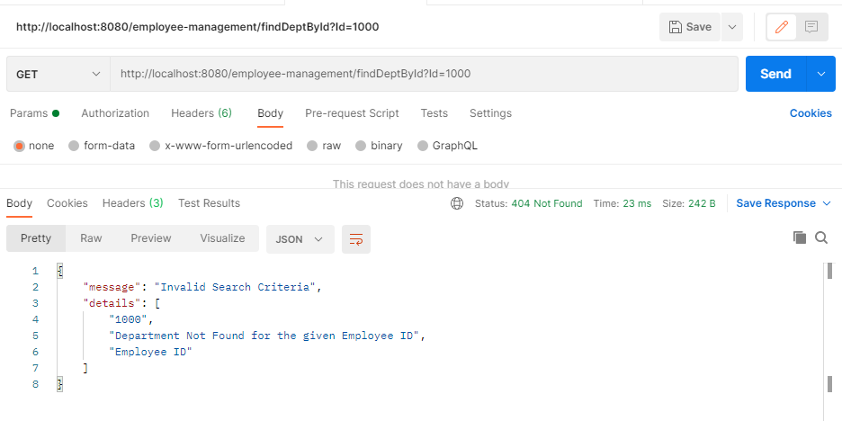

**Log Trace:**

Hibernate: select department0_.deptno as deptno1_0_0_, department0_.deptname as deptname2_0_0_ from department department0_ where department0_.deptno=?

1. Get all employees by department Id

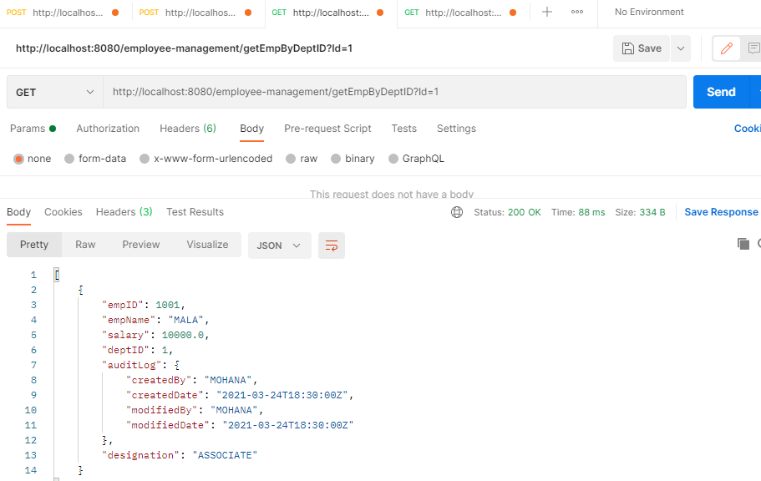

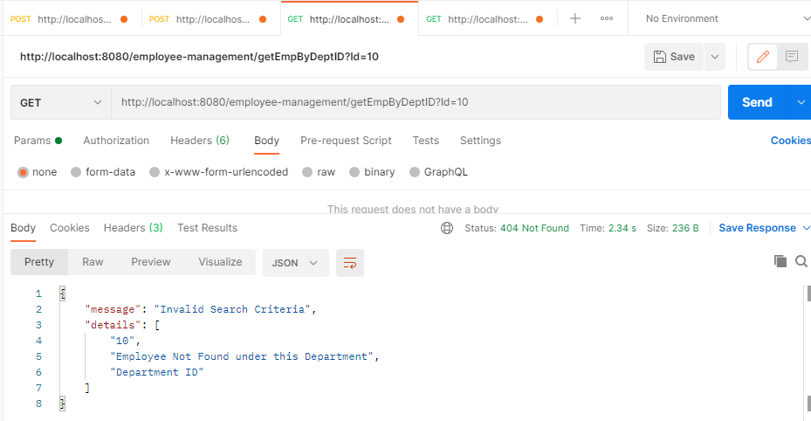

**Log Trace:**

Hibernate: select department0_.deptno as deptno1_0_0_, department0_.deptname as deptname2_0_0_ from department department0_ where department0_.deptno=?

Hibernate: select employees0_.department as departme6_1_0_, employees0_.employee_id as employee1_1_0_, employees0_.employee_id as employee1_1_1_, employees0_.createdby as createdb2_1_1_, employees0_.createddate as createdd3_1_1_, employees0_.modifiedby as modified4_1_1_, employees0_.modifieddate as modified5_1_1_, employees0_.department as departme6_1_1_, employees0_.designation as designat7_1_1_, employees0_.employee_name as employee8_1_1_, employees0_.manager_id as manager10_1_1_, employees0_.salary as salary9_1_1_ from employee employees0_ where employees0_.department=?

**Problem 1:**

1. Get Employee By ID using **Specifications**

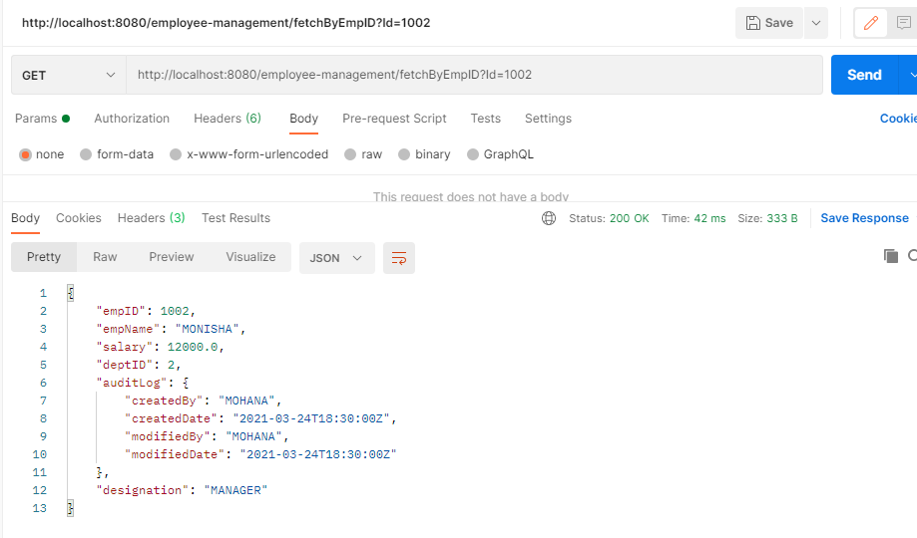

**Log Trace:**

2021-03-25 19:42:51.793 INFO 5016 --- [nio-8080-exec-2] o.s.web.servlet.DispatcherServlet : Completed initialization in 21 ms

Hibernate: select employee0_.employee_id as employee1_1_, employee0_.createdby as createdb2_1_, employee0_.createddate as createdd3_1_, employee0_.modifiedby as modified4_1_, employee0_.modifieddate as modified5_1_, employee0_.department as departme6_1_, employee0_.designation as designat7_1_, employee0_.employee_name as employee8_1_, employee0_.manager_id as manager10_1_, employee0_.salary as salary9_1_ from employee employee0_ where employee0_.employee_id=1

Hibernate: select employee0_.employee_id as employee1_1_, employee0_.createdby as createdb2_1_, employee0_.createddate as createdd3_1_, employee0_.modifiedby as modified4_1_, employee0_.modifieddate as modified5_1_, employee0_.department as departme6_1_, employee0_.designation as designat7_1_, employee0_.employee_name as employee8_1_, employee0_.manager_id as manager10_1_, employee0_.salary as salary9_1_ from employee employee0_ where employee0_.employee_id=1001

Hibernate: select employee0_.employee_id as employee1_1_, employee0_.createdby as createdb2_1_, employee0_.createddate as createdd3_1_, employee0_.modifiedby as modified4_1_, employee0_.modifieddate as modified5_1_, employee0_.department as departme6_1_, employee0_.designation as designat7_1_, employee0_.employee_name as employee8_1_, employee0_.manager_id as manager10_1_, employee0_.salary as salary9_1_ from employee employee0_ where employee0_.employee_id=1002

1. Get all employees whose salary greater than 10K (add new column salary) order by employee name Asc (case insensitive)

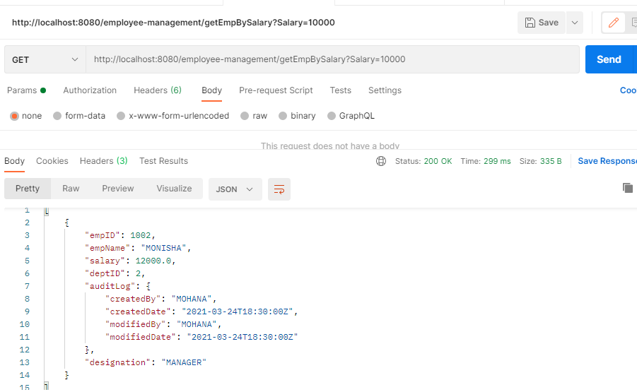

**Log Trace:**

Hibernate: SELECT E.EMPLOYEE_ID FROM EMPLOYEE E

Hibernate: select employee0_.employee_id as employee1_1_, employee0_.createdby as createdb2_1_, employee0_.createddate as createdd3_1_, employee0_.modifiedby as modified4_1_, employee0_.modifieddate as modified5_1_, employee0_.department as departme6_1_, employee0_.designation as designat7_1_, employee0_.employee_name as employee8_1_, employee0_.manager_id as manager10_1_, employee0_.salary as salary9_1_ from employee employee0_ where (employee0_.employee_id in (1001 , 1002)) and employee0_.salary>10000.0 order by employee0_.employee_name asc

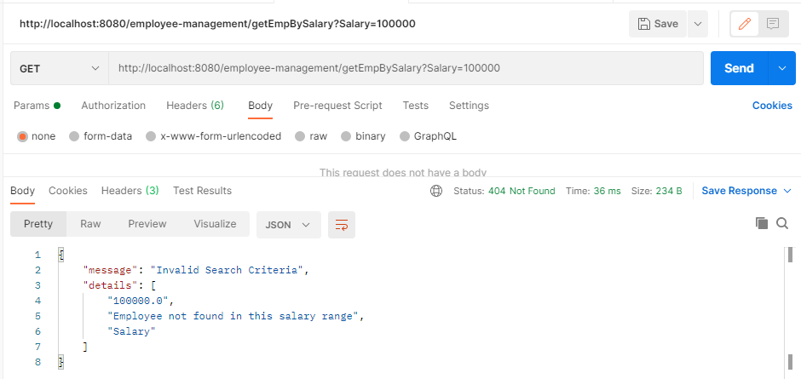

1. Get all employees whose salary greater than 10K and for a given department Id order by Salary Desc

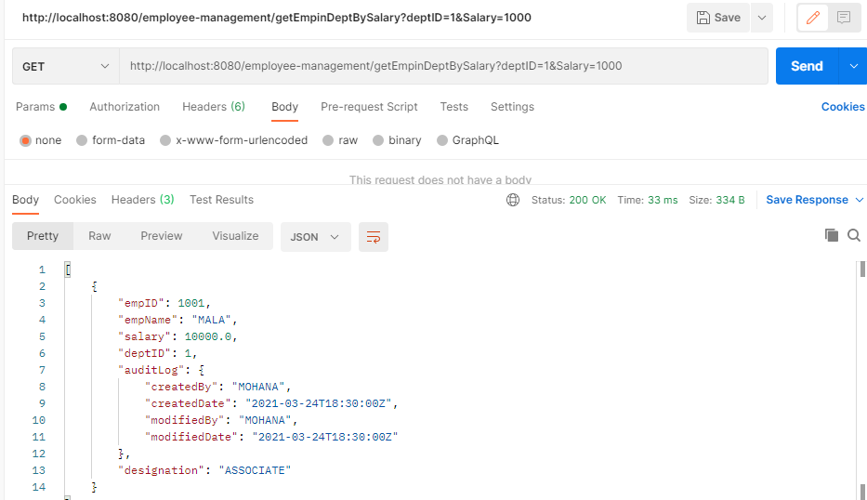

**Log Trace:**

Hibernate: select department0_.deptno as deptno1_0_0_, department0_.deptname as deptname2_0_0_ from department department0_ where department0_.deptno=?

Hibernate: select employees0_.department as departme6_1_0_, employees0_.employee_id as employee1_1_0_, employees0_.employee_id as employee1_1_1_, employees0_.createdby as createdb2_1_1_, employees0_.createddate as createdd3_1_1_, employees0_.modifiedby as modified4_1_1_, employees0_.modifieddate as modified5_1_1_, employees0_.department as departme6_1_1_, employees0_.designation as designat7_1_1_, employees0_.employee_name as employee8_1_1_, employees0_.manager_id as manager10_1_1_, employees0_.salary as salary9_1_1_ from employee employees0_ where employees0_.department=?

Hibernate: select employee0_.employee_id as employee1_1_, employee0_.createdby as createdb2_1_, employee0_.createddate as createdd3_1_, employee0_.modifiedby as modified4_1_, employee0_.modifieddate as modified5_1_, employee0_.department as departme6_1_, employee0_.designation as designat7_1_, employee0_.employee_name as employee8_1_, employee0_.manager_id as manager10_1_, employee0_.salary as salary9_1_ from employee employee0_ where (employee0_.employee_id in (1001)) and employee0_.salary>1000.0 order by employee0_.salary desc

**Problem 2:**

1. Query to fetch employees based on given designation using Specification

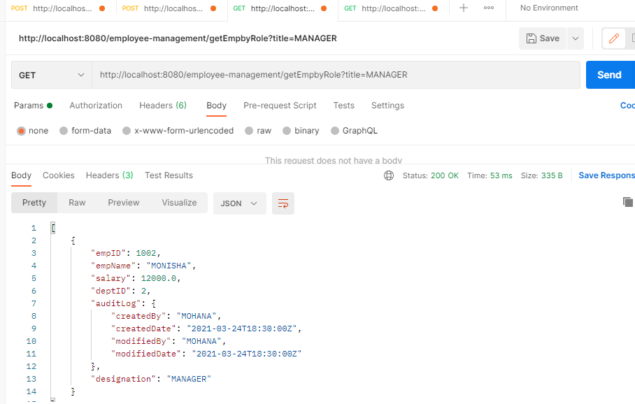

**Log Trace:**

Hibernate: SELECT E.EMPLOYEE_ID FROM EMPLOYEE E

Hibernate: select employee0_.employee_id as employee1_1_, employee0_.createdby as createdb2_1_, employee0_.createddate as createdd3_1_, employee0_.modifiedby as modified4_1_, employee0_.modifieddate as modified5_1_, employee0_.department as departme6_1_, employee0_.designation as designat7_1_, employee0_.employee_name as employee8_1_, employee0_.manager_id as manager10_1_, employee0_.salary as salary9_1_ from employee employee0_ where employee0_.designation=? and (employee0_.employee_id in (1001 , 1002))