
Fall Semester 2026-2027
Digital Assignment

Name: Mohanapriya Kumar
Reg. No: 23BDS0108
Course Code: BCSE331L
Course Name: Exploratory Data Analysis
Course Type: TH
Class Number: VL2026270102447
Slot: A2

Video Link:
https://drive.google.com/drive/folders/1_wFTxNsajp2U4xPCsD9AxHwGMHOxyIGV?usp=sharing
Git Hub:
https://github.com/Mohanapriya-Kumar/EDA_Assignment_Unified.git

CODE:
"""
Fall Semester 2026-2027
Digital Assignment
Name: Mohanapriya Kumar
Reg. No: 23BDS0108
Course Code: BCSE331L
Course Name: Exploratory Data Analysis
Course Type: Th
Class Number: VL2026270102447
Slot: A2
"""

# ================================================================
# IMPORT REQUIRED LIBRARIES
# ================================================================
import warnings
warnings.filterwarnings("ignore")

import math
import urllib.request
from io import StringIO

import numpy as np
import pandas as pd
import matplotlib.pyplot as plt
import seaborn as sns

from scipy.stats import skew, kurtosis, spearmanr, pearsonr
from statsmodels.graphics.tsaplots import plot_acf, plot_pacf
from statsmodels.tsa.seasonal import seasonal_decompose
from statsmodels.tsa.arima.model import ARIMA
from sklearn.preprocessing import StandardScaler, MinMaxScaler
from sklearn.cluster import KMeans, AgglomerativeClustering
from sklearn.decomposition import PCA
from sklearn.metrics import pairwise_distances
from scipy.cluster.hierarchy import linkage, dendrogram, fcluster

sns.set_theme(style="whitegrid")
RANDOM_STATE = 42
HAPPINESS_URL = "https://raw.githubusercontent.com/salemprakash/EDA/main/Data/happiness.csv"

# ================================================================
# SHARED HELPER FUNCTIONS
# ================================================================
def section(title):
"""Print a clear heading before each experiment."""
print("\n" + "=" * 78)
print(title)
print("=" * 78)

def load_happiness_data():
"""Load the happiness.csv dataset used throughout the project."""
# pandas.read_csv() is the Python equivalent of R's read.csv().
data = pd.read_csv(HAPPINESS_URL)
# Convert empty text cells to missing values so missing-value operations work.
data = data.replace(r"^\s*$", np.nan, regex=True)
return data

def mode_value(series):
"""Return the most frequent non-missing value (the mode)."""
modes = series.dropna().mode()
return modes.iloc[0] if not modes.empty else np.nan

def first_numeric_column(frame, preferred=None):
"""Select a numeric column, preferring the requested name if available."""
if preferred and preferred in frame.columns and pd.api.types.is_numeric_dtype(frame[preferred]):
return preferred
numeric_columns = frame.select_dtypes(include=np.number).columns.tolist()
if not numeric_columns:
raise ValueError("No numerical columns are available for this operation.")
return numeric_columns[0]

def finish_plot():
"""Display the current Matplotlib figure."""
plt.tight_layout()
plt.show()

# ================================================================
# ASSESSMENT 1 – DATAFRAME OPERATIONS AND DATA TRANSFORMATIONS
# ================================================================
def assessment_1():
section("ASSESSMENT 1: MERGING, DATA TRANSFORMATION AND NORMALIZATION")

# dataframe1 - Pantry essentials
dataframe1 = pd.DataFrame({
"ProductID": range(101, 111),
"NameofProd": [
"Rice", "Toor Dal", "Gingelly Oil", "Chilly Powder", "Coffee Powder",
"Tea", "Gram Dal", "Asafoetida", "Jaggery", "Urad Dal"
],
"Price": [320, 160, 240, 65, 180, 55, 40, 50, 90, 290]
})
print("\nDataframe 1 - Pantry essentials:\n", dataframe1)

# dataframe2 - ProductId and company location
dataframe2 = pd.DataFrame({
"ProductID": range(101, 111),
"Company_Location": [
"Thanjavur", "Erode", "Tuticorin", "Kashmir", "Kumbakonam",
"Nilgiris", "Madurai", "Kanchipuram", "Salem", "Erode"
]
})
print("\nDataframe 2 - Product location:\n", dataframe2)

# dataframe3 - Additional stock
dataframe3 = pd.DataFrame({
"ProductID": range(111, 121),
"NameofProd": [
"Cardamom", "Ghee", "Nendran Chips", "Dry Chilli", "Appalam",
"Palm Jaggery", "Fenugreek", "Turmeric Powder", "Rava", "Vermicelli"
],
"Price": [250, 340, 90, 30, 45, 190, 60, 55, 60, 40]
})
print("\nDataframe 3 - Additional stock:\n", dataframe3)

# Append dataframe1 and dataframe3 (R rbind -> pandas concat by rows).
new_stock = pd.concat([dataframe1, dataframe3], ignore_index=True)
print("\nNew Stock - appended rows:\n", new_stock)

# Concatenate side by side (R cbind -> pandas concat by columns).
concatenated = pd.concat(
[dataframe1.reset_index(drop=True), dataframe2[["Company_Location"]].reset_index(drop=True)],
axis=1
)
print("\nConcatenated side-by-side dataframes:\n", concatenated)

# Merge the two dataframes using ProductID.
merged = pd.merge(dataframe1, dataframe2, on="ProductID", how="inner")
print("\nMerged products with source:\n", merged)

# Join operations: inner, left, right, and full outer.
for join_type in ["inner", "left", "right", "outer"]:
result = pd.merge(dataframe1, dataframe2, on="ProductID", how=join_type)
print(f"\n{join_type.title()} Join:\n", result)

# II. Data transformations using the ten-value vector.
# Keep 0108 as the integer 108; leading zeroes are not retained by numeric types.
fname = np.array([108, 45, 120, 15, 88, 510, 62, 22, 95, 70], dtype=float)
data_min, data_max = fname.min(), fname.max()
data_mean, data_sd = fname.mean(), fname.std(ddof=1)

# Normalize to [-3, 3] and [-1, 1] using min-max scaling.
range_3 = ((fname - data_min) / (data_max - data_min)) * 6 - 3
range_1 = ((fname - data_min) / (data_max - data_min)) * 2 - 1
min_max_scaled = (fname - data_min) / (data_max - data_min)

# Z-score transformation uses sample standard deviation, matching R's sd().
z_scores = (fname - data_mean) / data_sd

# Decimal scaling: divide by 10 raised to the number of digits in max absolute value.
scale_power = math.ceil(math.log10(np.max(np.abs(fname)) + 1e-12))
decimal_scaled = fname / (10 ** scale_power)

print("\nOriginal vector:", fname)
print("Scaled to [-3, 3]:", range_3)
print("Scaled to [-1, 1]:", range_1)
print("Min-max scaled [0, 1]:", min_max_scaled)
print("Z-scores:", z_scores)
print("Decimal-scaled values:", decimal_scaled)

# ================================================================
# ASSESSMENT 2 – DATA IMPORT, TRANSFORMATION AND BASIC STATISTICS
# ================================================================
def assessment_2(data):
section("ASSESSMENT 2: DATA IMPORT, TRANSFORMATION AND BASIC STATISTICS")

# 1–3. Display first and last ten records.
print("\nFirst 10 records:\n", data.head(10))
print("\nLast 10 records:\n", data.tail(10))

# 4–7. Dimensions, column names, data types, and summary statistics.
print("\nNumber of rows and columns:", data.shape)
print("Number of rows:", len(data))
print("Number of columns:", len(data.columns))
print("Column names:\n", data.columns.tolist())
print("\nData types and non-missing counts:")
data.info()
print("\nSummary statistics:\n", data.describe(include="all").T)

# 8–10. Missing-value counts by column and for the entire dataset.
print("\nMissing values in each column:\n", data.isna().sum())
print("Total missing values:", int(data.isna().sum().sum()))

# 11. Identify rows containing at least one missing value.
rows_with_missing = data[data.isna().any(axis=1)]
print("\nRows with at least one missing value:\n", rows_with_missing.head(10))

# 12. Remove rows with missing values.
clean_data = data.dropna()
print("\nCleaned dataset after dropping missing rows:\n", clean_data.head(10))
print("Cleaned shape:", clean_data.shape)

# 13–15. Demonstrate mean, median, and mode imputation on a separate copy.
imputed_data = data.copy()
if "prestige" in imputed_data:
imputed_data["prestige"] = imputed_data["prestige"].fillna(imputed_data["prestige"].mean())
if "tvhours" in imputed_data:
imputed_data["tvhours"] = imputed_data["tvhours"].fillna(imputed_data["tvhours"].median())
if "income" in imputed_data:
imputed_data["income"] = imputed_data["income"].fillna(mode_value(imputed_data["income"]))

# 16–17. Forward fill and backward fill.
forward_fill = data.ffill()
backward_fill = data.bfill()
print("\nForward-filled sample:\n", forward_fill.head(10))
print("\nBackward-filled sample:\n", backward_fill.head(10))

# 18. Replace remaining missing values with 0 for numeric and "Unknown" for text.
constant_fill = data.copy()
for column in constant_fill.columns:
if pd.api.types.is_numeric_dtype(constant_fill[column]):
constant_fill[column] = constant_fill[column].fillna(0)
else:
constant_fill[column] = constant_fill[column].fillna("Unknown")
print("\nConstant-filled sample:\n", constant_fill.head(10))

# 19. Remove duplicate records.
unique_data = data.drop_duplicates()
print("\nRows after duplicate removal:", len(unique_data))

# 20. Convert appropriate columns to categorical data types (R factors).
for column in ["workstat", "income", "region", "happy"]:
if column in imputed_data.columns:
imputed_data[column] = imputed_data[column].astype("category")
print("\nData types after categorical conversion:\n", imputed_data.dtypes)

# 21. Rename one column.
renamed_data = imputed_data.rename(columns={"workstat": "employment_status"})
print("\nRenamed columns:\n", renamed_data.columns.tolist())

# 22. Create a derived column by adding child age-group counts.
if all(c in renamed_data.columns for c in ["babies", "preteen", "teens"]):
renamed_data["total_children"] = renamed_data[["babies", "preteen", "teens"]].sum(axis=1, min_count=1)
print("\nDerived total_children column:\n", renamed_data[["babies", "preteen", "teens", "total_children"]].head(10))

# 23–28. Summary and descriptive statistics for prestige.
if "prestige" in data:
x = data["prestige"].dropna()
print("\nSummary statistics:\n", x.describe())
print("Minimum:", x.min())
print("Maximum:", x.max())
print("Range:", x.max() - x.min())
print("Variance:", x.var())
print("Standard deviation:", x.std())
print("Interquartile range:", x.quantile(0.75) - x.quantile(0.25))

# ================================================================
# ASSESSMENT 3 – DATA CLEANING AND UNIVARIATE ANALYSIS
# ================================================================
def assessment_3(data):
section("ASSESSMENT 3: DATA CLEANING AND UNIVARIATE ANALYSIS")
data = data.copy()

# 1–4. Import is handled by the shared loader; inspect records and missing values.
print("First six records:\n", data.head(6))
print("Last six records:\n", data.tail(6))
print("Total missing values:", int(data.isna().sum().sum()))
print("Rows containing missing values:\n", data[data.isna().any(axis=1)].head(10))

# 5. Remove columns with more than 70% missing values.
missing_fraction = data.isna().mean()
data = data.loc[:, missing_fraction <= 0.70].copy()

# 6–7. Create mean-imputed and median-imputed versions of numeric columns.
mean_data = data.copy()
median_data = data.copy()
numeric_columns = data.select_dtypes(include=np.number).columns
for column in numeric_columns:
mean_data[column] = mean_data[column].fillna(mean_data[column].mean())
median_data[column] = median_data[column].fillna(median_data[column].median())
print("\nMean-imputed sample:\n", mean_data.head())
print("\nMedian-imputed sample:\n", median_data.head())

# Continue with median-imputed data, as in the R program.
data = median_data

# 8. Replace missing categorical values with each column's mode.
for column in data.select_dtypes(include=["object", "category"]).columns:
data[column] = data[column].fillna(mode_value(data[column]))

# 9–10. Identify and remove duplicate rows.
duplicates = data[data.duplicated(keep=False)]
print("\nDuplicate rows:\n", duplicates.head(10))
data = data.drop_duplicates()

# 11–13. Inspect data types and standardize text to lowercase.
print("\nData types:\n", data.dtypes)
for column in data.select_dtypes(include="object").columns:
data[column] = data[column].astype("category")
for column in data.select_dtypes(include="category").columns:
data[column] = data[column].astype(str).str.lower().astype("category")
print("\nData types after categorical conversion:\n", data.dtypes)

# Select prestige as the example numeric variable, matching the R experiment.
numeric_column = first_numeric_column(data, "prestige")
values = data[numeric_column].dropna()

# 14. Detect outliers using a boxplot.
plt.figure()
sns.boxplot(y=values)
plt.title(f"Boxplot of {numeric_column}")
plt.ylabel(numeric_column)
finish_plot()

# 15–16. Identify outliers with IQR and remove extreme outliers.
q1, q3 = values.quantile(0.25), values.quantile(0.75)
iqr = q3 - q1
lower_bound, upper_bound = q1 - 1.5 * iqr, q3 + 1.5 * iqr
outliers = data[(data[numeric_column] < lower_bound) | (data[numeric_column] > upper_bound)]
print(f"\nIQR outliers for {numeric_column}:\n", outliers[[numeric_column]].head(20))
data_no_outliers = data[data[numeric_column].between(lower_bound, upper_bound) | data[numeric_column].isna()]
print("Shape before/after removing IQR outliers:", data.shape, data_no_outliers.shape)

# 17–18. Histogram and density curve.
plt.figure()
sns.histplot(data[numeric_column], kde=False, bins=30)
plt.title(f"Histogram of {numeric_column}")
plt.xlabel(numeric_column)
plt.ylabel("Frequency")
finish_plot()

plt.figure()
sns.histplot(data[numeric_column], kde=True, stat="density", bins=30)
plt.title(f"Histogram with Density Curve: {numeric_column}")
finish_plot()

# 19. Violin plot of the selected numerical variable.
plt.figure()
sns.violinplot(y=data[numeric_column])
plt.title(f"Violin Plot of {numeric_column}")
finish_plot()

# 20. Dot plot for a small numerical sample.
small_values = data[numeric_column].dropna().head(30).reset_index(drop=True)
plt.figure()
plt.scatter(small_values.index, small_values.values)
plt.title(f"Dot Plot of First 30 {numeric_column} Values")
plt.xlabel("Observation")
plt.ylabel(numeric_column)
finish_plot()

# 21–22. Frequency, proportion, and percentage tables for happiness.
categorical_column = "happy" if "happy" in data.columns else data.select_dtypes(include=["category", "object"]).columns[0]
frequency = data[categorical_column].value_counts(dropna=False)
proportion = data[categorical_column].value_counts(normalize=True, dropna=False)
print("\nFrequency table:\n", frequency)
print("\nProportion table:\n", proportion)
print("\nPercentage table:\n", proportion * 100)

# 23–25. Vertical, horizontal, and percentage bar charts.
plt.figure()
frequency.plot(kind="bar")
plt.title(f"Frequency of {categorical_column}")
plt.xlabel(categorical_column)
plt.ylabel("Frequency")
finish_plot()

plt.figure()
frequency.sort_values().plot(kind="barh")
plt.title(f"Horizontal Frequency Chart of {categorical_column}")
plt.xlabel("Frequency")
finish_plot()

plt.figure()
(proportion * 100).plot(kind="bar")
plt.title(f"Percentage Distribution of {categorical_column}")
plt.ylabel("Percentage")
finish_plot()

# 26. Pie chart for categories.
plt.figure()
frequency.plot(kind="pie", autopct="%1.1f%%")
plt.title(f"Pie Chart of {categorical_column}")
plt.ylabel("")
finish_plot()

# 27–28. Lollipop chart and dot chart of categorical frequencies.
ordered = frequency.sort_values()
plt.figure()
plt.hlines(y=ordered.index.astype(str), xmin=0, xmax=ordered.values)
plt.plot(ordered.values, ordered.index.astype(str), "o")
plt.title(f"Lollipop Chart of {categorical_column}")
plt.xlabel("Frequency")
finish_plot()

plt.figure()
plt.plot(ordered.values, ordered.index.astype(str), "o")
plt.title(f"Dot Chart of {categorical_column}")
plt.xlabel("Frequency")
finish_plot()

# 29. Density plot.
plt.figure()
sns.kdeplot(data=data, x=numeric_column, fill=True)
plt.title(f"Density Plot of {numeric_column}")
finish_plot()

# 30. Faceted distributions across groups, if both columns exist.
if "region" in data.columns:
plot_data = data[[numeric_column, "region"]].dropna()
g = sns.displot(data=plot_data, x=numeric_column, col="region", col_wrap=3, kind="hist")
g.fig.suptitle(f"{numeric_column} Distribution by Region", y=1.02)
plt.show()

# ================================================================
# ASSESSMENT 4 – BIVARIATE ANALYSIS
# ================================================================
def assessment_4(data):
section("ASSESSMENT 4: BIVARIATE ANALYSIS")
data = data.copy()

# 1–2. Compare happiness level and region with contingency and stacked bar charts.
if "happy" in data and "region" in data:
data["Happiness_Level"] = data["happy"].map({
"very happy": "High", "pretty happy": "Medium", "not too happy": "Low"
}).fillna("Low")
contingency = pd.crosstab(data["region"], data["Happiness_Level"])
print("\nRegion by happiness contingency table:\n", contingency)

contingency.plot(kind="bar", stacked=True, figsize=(10, 5))
plt.title("Happiness Level by Region - Stacked Bar Plot")
plt.xlabel("Region")
plt.ylabel("Frequency")
finish_plot()

contingency.plot(kind="bar", stacked=True, figsize=(10, 5), colormap="Set2")
plt.title("Happiness Level by Region - Alternative Stacked Plot")
finish_plot()

# 3. Side-by-side/grouped bar plot.
contingency.plot(kind="bar", stacked=False, figsize=(10, 5))
plt.title("Happiness Levels Across Regions - Grouped Bar Plot")
plt.xlabel("Region")
plt.ylabel("Frequency")
finish_plot()

# 4. Scatter plot: education and occupational prestige.
if {"educ", "prestige"}.issubset(data.columns):
plt.figure()
sns.scatterplot(data=data, x="educ", y="prestige", alpha=0.5)
plt.title("Education and Occupational Prestige")
plt.xlabel("Years of Education")
plt.ylabel("Occupational Prestige")
finish_plot()

# 5. Trend of proportion of "very happy" responses over years.
if {"year", "happy"}.issubset(data.columns):
yearly = data.assign(is_very_happy=data["happy"].eq("very happy")).groupby("year", observed=False)["is_very_happy"].mean()
plt.figure()
plt.plot(yearly.index, yearly.values, marker="o")
plt.title("Trend of Very Happy Responses Over Years")
plt.xlabel("Year")
plt.ylabel("Proportion Very Happy")
finish_plot()

# 6. Correlation heatmap of selected numerical variables.
numeric_names = [c for c in ["year", "educ", "prestige", "babies", "preteen", "teens", "tvhours"] if c in data.columns]
numeric_data = data[numeric_names].apply(pd.to_numeric, errors="coerce")
correlation = numeric_data.corr()
plt.figure(figsize=(9, 7))
sns.heatmap(correlation, annot=True, cmap="coolwarm", center=0)
plt.title("Correlation Heatmap")
finish_plot()

# 7. Compare mean education and prestige.
avg_columns = [c for c in ["educ", "prestige"] if c in data.columns]
if avg_columns:
means = data[avg_columns].mean(numeric_only=True)
plt.figure()
means.plot(kind="bar", color=["orange", "lightgreen"][:len(means)])
plt.title("Average Education and Prestige")
plt.ylabel("Average Value")
finish_plot()

# 8. Compare TV viewing distributions across regions.
if {"tvhours", "region"}.issubset(data.columns):
plt.figure()
sns.kdeplot(data=data, x="tvhours", hue="region", common_norm=False)
plt.title("TV Hours Distribution Across Regions")
finish_plot()

# 9–11. Education distribution by region using box, violin, and combined plots.
if {"educ", "region"}.issubset(data.columns):
plt.figure(figsize=(10, 5))
sns.boxplot(data=data, x="region", y="educ")
plt.title("Education Levels Between Regions")
plt.xticks(rotation=45)
finish_plot()

plt.figure(figsize=(10, 5))
sns.violinplot(data=data, x="region", y="educ", inner="quartile")
plt.title("Education Distribution Across Regions")
plt.xticks(rotation=45)
finish_plot()

plt.figure(figsize=(10, 5))
sns.violinplot(data=data, x="region", y="educ", inner=None, color="lightblue")
sns.boxplot(data=data, x="region", y="educ", width=0.15, color="white")
plt.title("Violin and Box Plot: Education by Region")
plt.xticks(rotation=45)
finish_plot()

# 12. Correlation matrix and pairwise correlation visualization.
if len(numeric_names) >= 2:
plt.figure(figsize=(9, 7))
sns.heatmap(correlation, annot=True, cmap="vlag", center=0)
plt.title("Correlogram of Numerical Variables")
finish_plot()

# ================================================================
# ASSESSMENT 5 – MULTIVARIATE ANALYSIS
# ================================================================
def assessment_5(data):
section("ASSESSMENT 5: MULTIVARIATE ANALYSIS")
data = data.copy()

# 1. Examine data and identify numeric/categorical variables.
print("\nData types:\n", data.dtypes)
print("\nSummary:\n", data.describe(include="all").T)
num_vars = [c for c in ["year", "prestige", "educ", "babies", "preteen", "teens", "tvhours"] if c in data.columns]
cat_vars = [c for c in ["workstat", "region", "happy", "attend", "divorce", "owngun"] if c in data.columns]
print("Numerical variables:", num_vars)
print("Categorical variables:", cat_vars)

# 2. Scatter plot with a third variable represented by color.
plt.figure()
sns.scatterplot(data=data, x="prestige", y="educ", hue="happy", alpha=0.6)
plt.title("Prestige vs Education by Happiness")
finish_plot()

# 3. Scatter plot with color and shape.
plt.figure()
sns.scatterplot(data=data, x="prestige", y="educ", hue="happy", style="divorce", alpha=0.6)
plt.title("Prestige vs Education by Happiness and Divorce")
finish_plot()

# 4. Scatter plot with color and point size.
plt.figure()
sns.scatterplot(data=data, x="prestige", y="educ", hue="happy", size="tvhours", sizes=(15, 150), alpha=0.6)
plt.title("Prestige vs Education by Happiness and TV Hours")
finish_plot()

# 5. Bubble plot: bubble size represents number of babies.
plt.figure()
sns.scatterplot(data=data, x="prestige", y="educ", size="babies", sizes=(15, 250), alpha=0.5, legend=True)
plt.title("Bubble Plot of Prestige, Education and Babies")
finish_plot()

# 6. Facet-wrap equivalent: separate panels by happiness.
g = sns.relplot(data=data, x="prestige", y="educ", col="happy", col_wrap=3, kind="scatter", alpha=0.5)
g.fig.suptitle("Prestige vs Education by Happiness", y=1.03)
plt.show()

# 7. Facet-grid equivalent: rows are regions and columns are happiness categories.
# Limit to categories with enough data so the grid remains readable.
subset = data.dropna(subset=["region", "happy", "prestige", "educ"])
top_regions = subset["region"].value_counts().head(5).index
subset = subset[subset["region"].isin(top_regions)]
g = sns.relplot(data=subset, x="prestige", y="educ", row="region", col="happy", kind="scatter", alpha=0.4)
g.fig.suptitle("Prestige vs Education by Region and Happiness", y=1.02)
plt.show()

# 8. Pairs plot for four numerical variables.
pair_columns = [c for c in ["prestige", "educ", "babies", "preteen"] if c in data.columns]
pair_data = data[pair_columns].dropna()
sns.pairplot(pair_data.sample(min(1000, len(pair_data)), random_state=RANDOM_STATE))
plt.suptitle("Pairs Plot", y=1.02)
plt.show()

# 9. Parallel coordinate plot: normalize selected variables to [0, 1].
parallel_columns = pair_columns
if len(parallel_columns) >= 2 and "region" in data.columns:
parallel = data[parallel_columns + ["region"]].dropna().copy()
parallel = parallel.sample(min(300, len(parallel)), random_state=RANDOM_STATE)
scaled = MinMaxScaler().fit_transform(parallel[parallel_columns])
scaled_df = pd.DataFrame(scaled, columns=parallel_columns)
scaled_df["region"] = parallel["region"].astype(str).to_numpy()
plt.figure(figsize=(10, 5))
for region, group in scaled_df.groupby("region"):
for _, row in group.iterrows():
plt.plot(parallel_columns, row[parallel_columns].values, alpha=0.08)
plt.title("Parallel Coordinate Plot (scaled values)")
plt.xlabel("Variables")
plt.ylabel("Scaled Values")
finish_plot()

# ================================================================
# ASSESSMENT 6 – TIME SERIES ANALYSIS (AIR PASSENGERS)
# ================================================================
def assessment_6():
section("ASSESSMENT 6: TIME SERIES ANALYSIS – AIR PASSENGERS")

# R's built-in AirPassengers dataset is represented here as monthly values.
# It contains 144 monthly observations from January 1949 through December 1960.
passenger_values = [
112,118,132,129,121,135,148,148,136,119,104,118,
115,126,141,135,125,149,170,170,158,133,114,140,
145,150,178,163,172,178,199,199,184,162,146,166,
171,180,193,181,183,218,230,242,209,191,172,194,
196,196,236,235,229,243,264,272,237,211,180,201,
204,188,235,227,234,264,302,293,259,229,203,229,
242,233,267,269,270,315,364,347,312,274,237,278,
284,277,317,313,318,374,413,405,355,306,271,306,
315,301,356,348,355,422,465,467,404,347,305,336,
340,318,362,348,363,435,491,505,404,359,310,337,
360,342,406,396,420,472,548,559,463,407,362,405,
417,391,419,461,472,535,622,606,508,461,390,432
]
dates = pd.date_range("1949-01-01", periods=len(passenger_values), freq="MS")
air_data = pd.Series(passenger_values, index=dates, name="Passengers")

# 1–2. Load and inspect first and last observations.
print("First five observations:\n", air_data.head())
print("\nLast five observations:\n", air_data.tail())

# 3–4. Starting/ending periods, frequency, and time-series characteristics.
print("\nStart:", air_data.index.min())
print("End:", air_data.index.max())
print("Frequency: monthly (12 observations per year)")
print("Python object type:", type(air_data))

# 5. Visualize monthly passenger trend.
air_data.plot(title="Monthly Air Passengers", xlabel="Year", ylabel="Number of Passengers", figsize=(10, 5))
finish_plot()

# 6–7. Decompose the series into trend, seasonal, and residual components.
decomposition = seasonal_decompose(air_data, model="multiplicative", period=12)
decomposition.plot()
plt.suptitle("AirPassengers: Trend, Seasonal and Residual Components")
finish_plot()

# 8. Autocorrelation and partial autocorrelation.
fig, axes = plt.subplots(2, 1, figsize=(10, 7))
plot_acf(air_data, lags=36, ax=axes[0], title="Autocorrelation of AirPassengers")
plot_pacf(air_data, lags=36, ax=axes[1], method="ywm", title="Partial Autocorrelation")
finish_plot()

# 9–10. Fit an ARIMA(1, 1, 1) model.
model = ARIMA(air_data, order=(1, 1, 1))
fitted_model = model.fit()
print("\nARIMA(1,1,1) model summary:\n", fitted_model.summary())

# 11–12. Forecast the next 12 months and plot actual plus forecast.
forecast = fitted_model.get_forecast(steps=12)
forecast_mean = forecast.predicted_mean
confidence = forecast.conf_int()
print("\n12-month forecast:\n", forecast_mean)

plt.figure(figsize=(11, 5))
air_data.plot(label="Actual")
forecast_mean.plot(label="Forecast", color="blue")
plt.fill_between(confidence.index, confidence.iloc[:, 0], confidence.iloc[:, 1], alpha=0.2)
plt.title("AirPassengers Forecast")
plt.xlabel("Year")
plt.ylabel("Number of Passengers")
plt.legend()
finish_plot()

# ================================================================
# ASSESSMENT 7 – 1D, 2D AND ND DESCRIPTIVE ANALYSIS
# ================================================================
def assessment_7(data):
section("ASSESSMENT 7: 1D, 2D AND ND ANALYSIS")
data = data.copy()

# 2–3. Summary statistics for prestige.
x = data["prestige"].dropna()
stats = {
"Mean": x.mean(),
"Median": x.median(),
"Minimum": x.min(),
"Maximum": x.max(),
"Range": x.max() - x.min(),
"Variance": x.var(),
"Standard Deviation": x.std(),
"IQR": x.quantile(0.75) - x.quantile(0.25),
"Skewness": skew(x, bias=False),
"Kurtosis": kurtosis(x, fisher=False, bias=False)
}
summary_stats = pd.DataFrame({"Statistic": list(stats.keys()), "Value": list(stats.values())})
print("\nSummary statistics:\n", summary_stats)

# 4. Frequency and relative frequency with pie and bar plots.
freq = data["happy"].value_counts(dropna=False)
rel_freq = data["happy"].value_counts(normalize=True, dropna=False)
print("\nFrequency:\n", freq)
print("\nRelative frequency:\n", rel_freq)
freq.plot(kind="pie", autopct="%1.1f%%", figsize=(7, 7), title="Happiness Distribution")
plt.ylabel("")
finish_plot()
freq.plot(kind="bar", title="Happiness Distribution", xlabel="Happiness", ylabel="Frequency")
finish_plot()

# 5. Binned frequency distribution, histogram and box plot.
bins = pd.cut(data["prestige"], bins=5)
print("\nPrestige bin frequencies:\n", bins.value_counts().sort_index())
plt.figure()
sns.histplot(data=data, x="prestige", bins=5)
plt.title("Prestige Distribution")
finish_plot()
plt.figure()
sns.boxplot(y=data["prestige"])
plt.title("Prestige Box Plot")
finish_plot()

# 6–7. Contingency table, row/column proportions and stacked bar plot.
tab = pd.crosstab(data["region"], data["happy"])
print("\nContingency table:\n", tab)
print("\nRow percentages:\n", tab.div(tab.sum(axis=1), axis=0))
print("\nColumn percentages:\n", tab.div(tab.sum(axis=0), axis=1))
tab.plot(kind="bar", stacked=True, figsize=(10, 5), title="Region and Happiness")
plt.ylabel("Frequency")
finish_plot()

# 8–9. Grouped statistics, side-by-side box plot and violin plot.
grouped = data.groupby("happy", observed=False)["prestige"].agg(["mean", "median", "std"])
print("\nPrestige summary by happiness:\n", grouped)
plt.figure()
sns.boxplot(data=data, x="happy", y="prestige")
plt.title("Prestige by Happiness")
plt.xticks(rotation=20)
finish_plot()
plt.figure()
sns.violinplot(data=data, x="happy", y="prestige")
plt.title("Prestige Distribution by Happiness")
plt.xticks(rotation=20)
finish_plot()

# 10. Pearson and Spearman correlations plus regression trend line.
pair = data[["prestige", "educ"]].dropna()
print("\nPearson correlation:", pearsonr(pair["prestige"], pair["educ"]))
print("Spearman correlation:", spearmanr(pair["prestige"], pair["educ"]))
plt.figure()
sns.regplot(data=pair, x="prestige", y="educ", scatter_kws={"alpha": 0.4})
plt.title("Prestige vs Education")
finish_plot()

# 11. Summary statistics for combinations of region and happiness.
summary_nd = data.groupby(["region", "happy"], observed=False)["prestige"].agg(["mean", "std"])
print("\nPrestige mean and SD by region and happiness:\n", summary_nd)
plt.figure(figsize=(10, 5))
sns.boxplot(data=data, x="happy", y="prestige")
plt.title("Prestige by Happiness, Faceted by Region")
plt.xticks(rotation=20)
finish_plot()

# 12. Scatter plot by category and category-wise correlation.
plt.figure()
sns.scatterplot(data=data, x="prestige", y="educ", hue="happy", style="happy", alpha=0.5)
plt.title("Prestige vs Education by Happiness")
finish_plot()
for category, group in data.groupby("happy", observed=False):
group_pair = group[["prestige", "educ"]].dropna()
if len(group_pair) >= 2:
print(f"Correlation for {category}: {group_pair.corr().iloc[0, 1]:.4f}")

# 13–14. Correlation matrix heatmap and pairs plot.
num_cols = [c for c in ["prestige", "educ", "babies", "preteen", "teens", "tvhours"] if c in data.columns]
corr_matrix = data[num_cols].corr()
print("\nCorrelation matrix:\n", corr_matrix)
plt.figure(figsize=(8, 6))
sns.heatmap(corr_matrix, annot=True, cmap="coolwarm", center=0)
plt.title("Correlation Matrix Heatmap")
finish_plot()
pair_data = data[num_cols[:4]].dropna()
sns.pairplot(pair_data.sample(min(1000, len(pair_data)), random_state=RANDOM_STATE))
plt.suptitle("Pairs Plot", y=1.02)
plt.show()

# ================================================================
# ASSESSMENT 8 – K-MEANS AND HIERARCHICAL CLUSTERING
# ================================================================
def assessment_8(data):
section("ASSESSMENT 8: K-MEANS AND HIERARCHICAL CLUSTERING")
feature_names = [c for c in ["prestige", "educ", "babies", "preteen", "teens", "tvhours"] if c in data.columns]
numeric_data = data[feature_names].apply(pd.to_numeric, errors="coerce").dropna()

# 1–4. View dataset, missing values and happiness distribution.
print("Dataset sample:\n", data.head())
print("\nMissing values:\n", data.isna().sum())
if "happy" in data:
print("\nHappiness distribution:\n", data["happy"].value_counts(dropna=False))

# 5–6. Select numerical features and standardize them.
scaler = StandardScaler()
scaled = scaler.fit_transform(numeric_data)

# 7–9. K-Means clustering with k = 2.
kmeans2 = KMeans(n_clusters=2, n_init=25, random_state=RANDOM_STATE)
labels2 = kmeans2.fit_predict(scaled)
print("\nK-Means (k=2) inertia/WCSS:", kmeans2.inertia_)
print("Cluster centers in standardized units:\n", kmeans2.cluster_centers_)
print("Cluster sizes:\n", pd.Series(labels2).value_counts().sort_index())

# 10. Calculate WCSS for k = 1 to 10.
wcss = []
for k in range(1, 11):
model = KMeans(n_clusters=k, n_init=25, random_state=RANDOM_STATE)
model.fit(scaled)
wcss.append(model.inertia_)
print("\nWCSS for k=1..10:\n", wcss)

# 11. Elbow plot.
plt.figure()
plt.plot(range(1, 11), wcss, marker="o")
plt.xlabel("Number of Clusters (K)")
plt.ylabel("WCSS")
plt.title("Elbow Plot")
finish_plot()

# 12. Select k=3 after inspecting the elbow plot.
final_kmeans = KMeans(n_clusters=3, n_init=25, random_state=RANDOM_STATE)
final_labels = final_kmeans.fit_predict(scaled)
print("\nFinal K-Means (k=3) cluster centers:\n", final_kmeans.cluster_centers_)
print("Final cluster sizes:\n", pd.Series(final_labels).value_counts().sort_index())

# Hierarchical clustering: use a reproducible sample because distance matrices
# for all 17,000+ rows would consume excessive memory.
sample_size = min(1000, len(numeric_data))
sample = numeric_data.sample(sample_size, random_state=RANDOM_STATE)
sample_scaled = StandardScaler().fit_transform(sample)

# 6–7. Euclidean distance is used by Ward hierarchical clustering.
# scipy linkage computes the hierarchical tree without explicitly storing a square matrix.
linkage_matrix = linkage(sample_scaled, method="ward", metric="euclidean")

# 8. Dendrogram.
plt.figure(figsize=(12, 5))
dendrogram(linkage_matrix, truncate_mode="lastp", p=30, show_leaf_counts=True)
plt.title("Hierarchical Clustering Dendrogram - Ward's Method")
plt.xlabel("Samples or merged groups")
plt.ylabel("Distance")
finish_plot()

# 9–10. Cut the tree into 3 clusters and count observations.
hierarchical_labels = fcluster(linkage_matrix, t=3, criterion="maxclust")
print("\nHierarchical cluster assignments (sample):\n", hierarchical_labels[:30])
print("Number of samples in each hierarchical cluster:\n", pd.Series(hierarchical_labels).value_counts().sort_index())

# ================================================================
# ASSESSMENT 9 – PCA USING THE HAPPINESS DATASET
# ================================================================
def assessment_9(data):
section("ASSESSMENT 9: PCA USING THE HAPPINESS DATASET")

# 1–2. Display the dataset dimensions.
print("Number of rows:", data.shape[0])
print("Number of columns:", data.shape[1])

# 3. Select numeric columns, clean missing/infinite values, and remove constants.
numeric = data.select_dtypes(include=np.number).replace([np.inf, -np.inf], np.nan).dropna()
numeric = numeric.loc[:, numeric.nunique(dropna=True) > 1]
if numeric.shape[1] < 2:
print("At least two varying numerical columns are required for PCA.")
return

# Standardize the variables so each variable has mean 0 and standard deviation 1.
data_scaled = StandardScaler().fit_transform(numeric)

# 4. Perform PCA and summarize variance explained by each component.
pca = PCA()
pca_scores_array = pca.fit_transform(data_scaled)
variance_percent = pca.explained_variance_ratio_ * 100
pca_summary = pd.DataFrame({
"Component": [f"PC{i + 1}" for i in range(len(variance_percent))],
"Standard Deviation": np.sqrt(pca.explained_variance_),
"Proportion of Variance": pca.explained_variance_ratio_,
"Cumulative Proportion": np.cumsum(pca.explained_variance_ratio_)
})
print("\nPCA summary:\n", pca_summary)

# 5. Plot percentage of variance explained by each component.
# The y-axis is limited to 0–60 to match the assessment requirement.
components = np.arange(1, len(variance_percent) + 1)
plt.figure(figsize=(12, 5))
plt.bar(components, variance_percent, color="steelblue")
for component, value in zip(components, variance_percent):
if value >= 1:
plt.text(component, value + 0.5, f"{value:.2f}%", ha="center", fontsize=7)
plt.ylim(0, 60)
plt.xlabel("Principal Components")
plt.ylabel("Percentage of Variance Explained")
plt.title("Scree Plot of Principal Components")
finish_plot()

# 6. Create a biplot-style visualization of observations and variable loadings.
pca_scores = pd.DataFrame(
pca_scores_array,
columns=[f"PC{i + 1}" for i in range(pca_scores_array.shape[1])],
index=numeric.index
)
loadings = pd.DataFrame(
pca.components_.T,
index=numeric.columns,
columns=[f"PC{i + 1}" for i in range(pca.n_components_)]
)

plt.figure(figsize=(10, 7))
plt.scatter(pca_scores["PC1"], pca_scores["PC2"],
color="steelblue", alpha=0.35, s=12)
scale_factor = max(pca_scores[["PC1", "PC2"]].abs().max()) * 0.65
for variable in numeric.columns:
x_loading = loadings.loc[variable, "PC1"]
y_loading = loadings.loc[variable, "PC2"]
plt.arrow(0, 0, x_loading * scale_factor, y_loading * scale_factor,
color="red", alpha=0.65, head_width=0.04, length_includes_head=True)
plt.text(x_loading * scale_factor * 1.08,
y_loading * scale_factor * 1.08,
variable, fontsize=7, color="darkred")
plt.axhline(0, color="gray", linewidth=0.7)
plt.axvline(0, color="gray", linewidth=0.7)
plt.title("PCA Biplot - Happiness Dataset")
plt.xlabel(f"PC1 ({variance_percent[0]:.2f}% variance)")
plt.ylabel(f"PC2 ({variance_percent[1]:.2f}% variance)")
finish_plot()

# 7. Extract PCA scores and display the first six rows.
print("\nFirst six PCA score rows:\n", pca_scores.head(6))

# 8. Plot PC1 versus PC2 using blue circular points and the registration number.
plt.figure()
plt.scatter(pca_scores["PC1"], pca_scores["PC2"],
color="blue", marker="o", s=25)
plt.title("PCA Scatter Plot - Reg. No.: 23BDS0108")
plt.xlabel("First Principal Component (PC1)")
plt.ylabel("Second Principal Component (PC2)")
finish_plot()

# ================================================================
def main():
# Assessment 1 uses manually created dataframes and a numeric vector.
assessment_1()

# The remaining assessments use the supplied happiness dataset.
try:
data = load_happiness_data()
except Exception as exc:
print("\nUnable to load happiness.csv. Check your internet connection.")
print("Download the CSV and replace load_happiness_data() with pd.read_csv('happiness.csv').")
print("Error:", exc)
return

print("\nLoaded happiness dataset shape:", data.shape)

assessment_2(data)
assessment_3(data)
assessment_4(data)
assessment_5(data)
assessment_6()
assessment_7(data)
assessment_8(data)
assessment_9(data)

section("ALL ASSESSMENTS COMPLETED")
print("The unified Python program has completed all nine assessment sections.")

if __name__ == "__main__":
main()
OUTPUT SCREENSHOTS:
Assessment 1
PS C:\Users\MOHANAPRIYA KUMAR> py "D:\VIT Sem 7\Assignments\EDA\EDA_Assignment_Unifiec\Assessment_1.py"
==============================================================================
ASSESSMENT 1: MERGING, DATA TRANSFORMATION AND NORMALIZATION
==============================================================================

Dataframe 1 - Pantry essentials:
ProductID NameofProd Price
0 101 Rice 320
1 102 Toor Dal 160
2 103 Gingelly Oil 240
3 104 Chilly Powder 65
4 105 Coffee Powder 180
5 106 Tea 55
6 107 Gram Dal 40
7 108 Asafoetida 50
8 109 Jaggery 90
9 110 Urad Dal 290

Dataframe 2 - Product location:
ProductID Company_Location
0 101 Thanjavur
1 102 Erode
2 103 Tuticorin
3 104 Kashmir
4 105 Kumbakonam
5 106 Nilgiris
6 107 Madurai
7 108 Kanchipuram
8 109 Salem
9 110 Erode

Dataframe 3 - Additional stock:
ProductID NameofProd Price
0 111 Cardamom 250
1 112 Ghee 340
2 113 Nendran Chips 90
3 114 Dry Chilli 30
4 115 Appalam 45
5 116 Palm Jaggery 190
6 117 Fenugreek 60
7 118 Turmeric Powder 55
8 119 Rava 60
9 120 Vermicelli 40

New Stock - appended rows:
ProductID NameofProd Price
0 101 Rice 320
1 102 Toor Dal 160
2 103 Gingelly Oil 240
3 104 Chilly Powder 65
4 105 Coffee Powder 180
5 106 Tea 55
6 107 Gram Dal 40
7 108 Asafoetida 50
8 109 Jaggery 90
9 110 Urad Dal 290
10 111 Cardamom 250
11 112 Ghee 340
12 113 Nendran Chips 90
13 114 Dry Chilli 30
14 115 Appalam 45
15 116 Palm Jaggery 190
16 117 Fenugreek 60
17 118 Turmeric Powder 55
18 119 Rava 60
19 120 Vermicelli 40

Concatenated side-by-side dataframes:
ProductID NameofProd Price Company_Location
0 101 Rice 320 Thanjavur
1 102 Toor Dal 160 Erode
2 103 Gingelly Oil 240 Tuticorin
3 104 Chilly Powder 65 Kashmir
4 105 Coffee Powder 180 Kumbakonam
5 106 Tea 55 Nilgiris
6 107 Gram Dal 40 Madurai
7 108 Asafoetida 50 Kanchipuram
8 109 Jaggery 90 Salem
9 110 Urad Dal 290 Erode

Merged products with source:
ProductID NameofProd Price Company_Location
0 101 Rice 320 Thanjavur
1 102 Toor Dal 160 Erode
2 103 Gingelly Oil 240 Tuticorin
3 104 Chilly Powder 65 Kashmir
4 105 Coffee Powder 180 Kumbakonam
5 106 Tea 55 Nilgiris
6 107 Gram Dal 40 Madurai
7 108 Asafoetida 50 Kanchipuram
8 109 Jaggery 90 Salem
9 110 Urad Dal 290 Erode

Inner Join:
ProductID NameofProd Price Company_Location
0 101 Rice 320 Thanjavur
1 102 Toor Dal 160 Erode
2 103 Gingelly Oil 240 Tuticorin
3 104 Chilly Powder 65 Kashmir
4 105 Coffee Powder 180 Kumbakonam
5 106 Tea 55 Nilgiris
6 107 Gram Dal 40 Madurai
7 108 Asafoetida 50 Kanchipuram
8 109 Jaggery 90 Salem
9 110 Urad Dal 290 Erode

Left Join:
ProductID NameofProd Price Company_Location
0 101 Rice 320 Thanjavur
1 102 Toor Dal 160 Erode
2 103 Gingelly Oil 240 Tuticorin
3 104 Chilly Powder 65 Kashmir
4 105 Coffee Powder 180 Kumbakonam
5 106 Tea 55 Nilgiris
6 107 Gram Dal 40 Madurai
7 108 Asafoetida 50 Kanchipuram
8 109 Jaggery 90 Salem
9 110 Urad Dal 290 Erode

Right Join:
ProductID NameofProd Price Company_Location
0 101 Rice 320 Thanjavur
1 102 Toor Dal 160 Erode
2 103 Gingelly Oil 240 Tuticorin
3 104 Chilly Powder 65 Kashmir
4 105 Coffee Powder 180 Kumbakonam
5 106 Tea 55 Nilgiris
6 107 Gram Dal 40 Madurai
7 108 Asafoetida 50 Kanchipuram
8 109 Jaggery 90 Salem
9 110 Urad Dal 290 Erode

Outer Join:
ProductID NameofProd Price Company_Location
0 101 Rice 320 Thanjavur
1 102 Toor Dal 160 Erode
2 103 Gingelly Oil 240 Tuticorin
3 104 Chilly Powder 65 Kashmir
4 105 Coffee Powder 180 Kumbakonam
5 106 Tea 55 Nilgiris
6 107 Gram Dal 40 Madurai
7 108 Asafoetida 50 Kanchipuram
8 109 Jaggery 90 Salem
9 110 Urad Dal 290 Erode

Original vector: [108. 45. 120. 15. 88. 510. 62. 22. 95. 70.]
Scaled to [-3, 3]: [-1.87272727 -2.63636364 -1.72727273 -3. -2.11515152 3.
-2.43030303 -2.91515152 -2.03030303 -2.33333333]
Scaled to [-1, 1]: [-0.62424242 -0.87878788 -0.57575758 -1. -0.70505051 1.
-0.81010101 -0.97171717 -0.67676768 -0.77777778]
Min-max scaled [0, 1]: [0.18787879 0.06060606 0.21212121 0. 0.14747475 1.
0.09494949 0.01414141 0.16161616 0.11111111]
Z-scores: [-0.03830085 -0.47701968 0.04526464 -0.68593341 -0.17757667 2.7611431
-0.35863523 -0.63718687 -0.12883013 -0.30292491]
Decimal-scaled values: [0.108 0.045 0.12 0.015 0.088 0.51 0.062 0.022 0.095 0.07 ]
Assessment 2
PS C:\Users\MOHANAPRIYA KUMAR> py "D:\VIT Sem 7\Assignments\EDA\EDA_Assignment_Unifiec\Assessment_2.py"
Loaded happiness dataset shape: (17137, 34)

==============================================================================
ASSESSMENT 2: DATA IMPORT, TRANSFORMATION AND BASIC STATISTICS
==============================================================================

First 10 records:
rownames year workstat prestige divorce widowed educ reg16 babies preteen teens ... gwbush00 occattend regattend y94 y96 y98 y00 y02 y04 y06 unem10
0 1 1994 keeping house 46.0 NaN iap 12.0 middle atlantic 2.0 3.0 0.0 ... NaN 1.0 0.0 1 0 0 0 0 0 0 1.0
1 2 1994 working fulltime 22.0 no iap 12.0 foreign 0.0 0.0 0.0 ... NaN 0.0 0.0 1 0 0 0 0 0 0 0.0
2 3 1994 working fulltime 29.0 no iap 12.0 foreign 0.0 0.0 0.0 ... NaN 0.0 1.0 1 0 0 0 0 0 0 NaN
3 4 1994 working fulltime 42.0 yes iap 8.0 foreign 0.0 0.0 0.0 ... NaN 0.0 0.0 1 0 0 0 0 0 0 1.0
4 5 1994 working parttime 36.0 NaN NaN 13.0 middle atlantic 0.0 1.0 1.0 ... NaN 0.0 0.0 1 0 0 0 0 0 0 0.0
5 6 1994 working parttime 43.0 NaN NaN 15.0 middle atlantic 0.0 0.0 0.0 ... NaN 1.0 0.0 1 0 0 0 0 0 0 NaN
6 7 1994 working fulltime 20.0 no NaN 9.0 middle atlantic 0.0 1.0 1.0 ... NaN 0.0 1.0 1 0 0 0 0 0 0 NaN
7 8 1994 working fulltime 44.0 NaN NaN 12.0 foreign 0.0 0.0 0.0 ... NaN 0.0 1.0 1 0 0 0 0 0 0 0.0
8 9 1994 working fulltime 42.0 no NaN 12.0 foreign 2.0 1.0 0.0 ... NaN 1.0 0.0 1 0 0 0 0 0 0 NaN
9 10 1994 working fulltime 46.0 NaN iap 12.0 middle atlantic 0.0 0.0 1.0 ... NaN 0.0 1.0 1 0 0 0 0 0 0 1.0

[10 rows x 34 columns]

Last 10 records:
rownames year workstat prestige divorce widowed educ reg16 babies preteen ... occattend regattend y94 y96 y98 y00 y02 y04 y06 unem10
17127 17128 2006 retired 45.0 yes iap 11.0 w. sou. central 0.0 0.0 ... 0.0 0.0 0 0 0 0 0 0 1 NaN
17128 17129 2006 retired 68.0 yes iap 12.0 pacific 0.0 0.0 ... 0.0 0.0 0 0 0 0 0 0 1 0.0
17129 17130 2006 keeping house 22.0 no iap 14.0 pacific NaN NaN ... 0.0 0.0 0 0 0 0 0 0 1 NaN
17130 17131 2006 working fulltime 23.0 NaN NaN 14.0 mountain 0.0 0.0 ... 0.0 0.0 0 0 0 0 0 0 1 1.0
17131 17132 2006 working fulltime 29.0 no iap 1.0 foreign 0.0 0.0 ... 1.0 0.0 0 0 0 0 0 0 1 0.0
17132 17133 2006 keeping house 29.0 NaN NaN 9.0 mountain 0.0 0.0 ... 0.0 0.0 0 0 0 0 0 0 1 NaN
17133 17134 2006 temp not working 51.0 NaN iap 16.0 e. nor. central 0.0 1.0 ... 1.0 0.0 0 0 0 0 0 0 1 0.0
17134 17135 2006 retired NaN yes NaN 8.0 mountain 0.0 0.0 ... 0.0 0.0 0 0 0 0 0 0 1 0.0
17135 17136 2006 keeping house 20.0 no iap 6.0 foreign 1.0 2.0 ... 0.0 0.0 0 0 0 0 0 0 1 1.0
17136 17137 2006 unempl, laid off 30.0 NaN iap 12.0 pacific 0.0 0.0 ... 1.0 0.0 0 0 0 0 0 0 1 1.0

[10 rows x 34 columns]

Number of rows and columns: (17137, 34)
Number of rows: 17137
Number of columns: 34
Column names:
['rownames', 'year', 'workstat', 'prestige', 'divorce', 'widowed', 'educ', 'reg16', 'babies', 'preteen', 'teens', 'income', 'region', 'attend', 'happy', 'owngun', 'tvhours', 'vhappy', 'mothfath16', 'black', 'gwbush04', 'female', 'blackfemale', 'gwbush00', 'occattend', 'regattend', 'y94', 'y96', 'y98', 'y00', 'y02', 'y04', 'y06', 'unem10']

Data types and non-missing counts:
<class 'pandas.DataFrame'>
RangeIndex: 17137 entries, 0 to 17136
Data columns (total 34 columns):
# Column Non-Null Count Dtype
--- ------ -------------- -----
0 rownames 17137 non-null int64
1 year 17137 non-null int64
2 workstat 17134 non-null str
3 prestige 16283 non-null float64
4 divorce 9754 non-null str
5 widowed 11096 non-null str
6 educ 17093 non-null float64
7 reg16 17137 non-null str
8 babies 17036 non-null float64
9 preteen 17036 non-null float64
10 teens 17049 non-null float64
11 income 15045 non-null str
12 region 17137 non-null str
13 attend 16864 non-null str
14 happy 17137 non-null str
15 owngun 11297 non-null str
16 tvhours 11794 non-null float64
17 vhappy 17137 non-null int64
18 mothfath16 17132 non-null float64
19 black 17137 non-null int64
20 gwbush04 1930 non-null float64
21 female 17137 non-null int64
22 blackfemale 17137 non-null int64
23 gwbush00 3436 non-null float64
24 occattend 16864 non-null float64
25 regattend 16864 non-null float64
26 y94 17137 non-null int64
27 y96 17137 non-null int64
28 y98 17137 non-null int64
29 y00 17137 non-null int64
30 y02 17137 non-null int64
31 y04 17137 non-null int64
32 y06 17137 non-null int64
33 unem10 11341 non-null float64
dtypes: float64(12), int64(13), str(9)
memory usage: 5.8 MB

Summary statistics:
count unique top freq mean std min 25% 50% 75% max
rownames 17137.0 NaN NaN NaN 8569.0 4947.170117 1.0 4285.0 8569.0 12853.0 17137.0
year 17137.0 NaN NaN NaN 1999.47412 4.143358 1994.0 1996.0 1998.0 2004.0 2006.0
workstat 17134 8 working fulltime 9214 NaN NaN NaN NaN NaN NaN NaN
prestige 16283.0 NaN NaN NaN 43.877541 13.873965 17.0 33.0 43.0 51.0 86.0
divorce 9754 2 no 7421 NaN NaN NaN NaN NaN NaN NaN
widowed 11096 2 iap 10718 NaN NaN NaN NaN NaN NaN NaN
educ 17093.0 NaN NaN NaN 13.319078 2.986785 0.0 12.0 13.0 16.0 20.0
reg16 17137 10 e. nor. central 3148 NaN NaN NaN NaN NaN NaN NaN
babies 17036.0 NaN NaN NaN 0.207091 0.540542 0.0 0.0 0.0 0.0 6.0
preteen 17036.0 NaN NaN NaN 0.255753 0.621533 0.0 0.0 0.0 0.0 6.0
teens 17049.0 NaN NaN NaN 0.18136 0.493698 0.0 0.0 0.0 0.0 7.0
income 15045 12 $25000 or more 9725 NaN NaN NaN NaN NaN NaN NaN
region 17137 9 south atlantic 3340 NaN NaN NaN NaN NaN NaN NaN
attend 16864 9 never 3213 NaN NaN NaN NaN NaN NaN NaN
happy 17137 3 pretty happy 9791 NaN NaN NaN NaN NaN NaN NaN
owngun 11297 2 iap 7180 NaN NaN NaN NaN NaN NaN NaN
tvhours 11794.0 NaN NaN NaN 2.904019 2.327457 0.0 1.0 2.0 4.0 24.0
vhappy 17137.0 NaN NaN NaN 0.306938 0.461237 0.0 0.0 0.0 1.0 1.0
mothfath16 17132.0 NaN NaN NaN 0.692972 0.461274 0.0 0.0 1.0 1.0 1.0
black 17137.0 NaN NaN NaN 0.138414 0.345344 0.0 0.0 0.0 0.0 1.0
gwbush04 1930.0 NaN NaN NaN 0.501554 0.500127 0.0 0.0 1.0 1.0 1.0
female 17137.0 NaN NaN NaN 0.559083 0.496511 0.0 0.0 1.0 1.0 1.0
blackfemale 17137.0 NaN NaN NaN 0.089047 0.28482 0.0 0.0 0.0 0.0 1.0
gwbush00 3436.0 NaN NaN NaN 0.521828 0.499596 0.0 0.0 1.0 1.0 1.0
occattend 16864.0 NaN NaN NaN 0.284986 0.451421 0.0 0.0 0.0 1.0 1.0
regattend 16864.0 NaN NaN NaN 0.131226 0.337658 0.0 0.0 0.0 0.0 1.0
y94 17137.0 NaN NaN NaN 0.173718 0.378878 0.0 0.0 0.0 0.0 1.0
y96 17137.0 NaN NaN NaN 0.168349 0.374187 0.0 0.0 0.0 0.0 1.0
y98 17137.0 NaN NaN NaN 0.163739 0.37005 0.0 0.0 0.0 0.0 1.0
y00 17137.0 NaN NaN NaN 0.162047 0.368505 0.0 0.0 0.0 0.0 1.0
y02 17137.0 NaN NaN NaN 0.079886 0.271124 0.0 0.0 0.0 0.0 1.0
y04 17137.0 NaN NaN NaN 0.078018 0.268208 0.0 0.0 0.0 0.0 1.0
y06 17137.0 NaN NaN NaN 0.174243 0.379329 0.0 0.0 0.0 0.0 1.0
unem10 11341.0 NaN NaN NaN 0.318402 0.465877 0.0 0.0 0.0 1.0 1.0

Missing values in each column:
rownames 0
year 0
workstat 3
prestige 854
divorce 7383
widowed 6041
educ 44
reg16 0
babies 101
preteen 101
teens 88
income 2092
region 0
attend 273
happy 0
owngun 5840
tvhours 5343
vhappy 0
mothfath16 5
black 0
gwbush04 15207
female 0
blackfemale 0
gwbush00 13701
occattend 273
regattend 273
y94 0
y96 0
y98 0
y00 0
y02 0
y04 0
y06 0
unem10 5796
dtype: int64
Total missing values: 63418

Rows with at least one missing value:
rownames year workstat prestige divorce widowed educ reg16 babies preteen teens ... gwbush00 occattend regattend y94 y96 y98 y00 y02 y04 y06 unem10
0 1 1994 keeping house 46.0 NaN iap 12.0 middle atlantic 2.0 3.0 0.0 ... NaN 1.0 0.0 1 0 0 0 0 0 0 1.0
1 2 1994 working fulltime 22.0 no iap 12.0 foreign 0.0 0.0 0.0 ... NaN 0.0 0.0 1 0 0 0 0 0 0 0.0
2 3 1994 working fulltime 29.0 no iap 12.0 foreign 0.0 0.0 0.0 ... NaN 0.0 1.0 1 0 0 0 0 0 0 NaN
3 4 1994 working fulltime 42.0 yes iap 8.0 foreign 0.0 0.0 0.0 ... NaN 0.0 0.0 1 0 0 0 0 0 0 1.0
4 5 1994 working parttime 36.0 NaN NaN 13.0 middle atlantic 0.0 1.0 1.0 ... NaN 0.0 0.0 1 0 0 0 0 0 0 0.0
5 6 1994 working parttime 43.0 NaN NaN 15.0 middle atlantic 0.0 0.0 0.0 ... NaN 1.0 0.0 1 0 0 0 0 0 0 NaN
6 7 1994 working fulltime 20.0 no NaN 9.0 middle atlantic 0.0 1.0 1.0 ... NaN 0.0 1.0 1 0 0 0 0 0 0 NaN
7 8 1994 working fulltime 44.0 NaN NaN 12.0 foreign 0.0 0.0 0.0 ... NaN 0.0 1.0 1 0 0 0 0 0 0 0.0
8 9 1994 working fulltime 42.0 no NaN 12.0 foreign 2.0 1.0 0.0 ... NaN 1.0 0.0 1 0 0 0 0 0 0 NaN
9 10 1994 working fulltime 46.0 NaN iap 12.0 middle atlantic 0.0 0.0 1.0 ... NaN 0.0 1.0 1 0 0 0 0 0 0 1.0

[10 rows x 34 columns]

Cleaned dataset after dropping missing rows:
Empty DataFrame
Columns: [rownames, year, workstat, prestige, divorce, widowed, educ, reg16, babies, preteen, teens, income, region, attend, happy, owngun, tvhours, vhappy, mothfath16, black, gwbush04, female, blackfemale, gwbush00, occattend, regattend, y94, y96, y98, y00, y02, y04, y06, unem10]
Index: []
Cleaned shape: (0, 34)

Forward-filled sample:
rownames year workstat prestige divorce widowed educ reg16 babies preteen teens ... gwbush00 occattend regattend y94 y96 y98 y00 y02 y04 y06 unem10
0 1 1994 keeping house 46.0 NaN iap 12.0 middle atlantic 2.0 3.0 0.0 ... NaN 1.0 0.0 1 0 0 0 0 0 0 1.0
1 2 1994 working fulltime 22.0 no iap 12.0 foreign 0.0 0.0 0.0 ... NaN 0.0 0.0 1 0 0 0 0 0 0 0.0
2 3 1994 working fulltime 29.0 no iap 12.0 foreign 0.0 0.0 0.0 ... NaN 0.0 1.0 1 0 0 0 0 0 0 0.0
3 4 1994 working fulltime 42.0 yes iap 8.0 foreign 0.0 0.0 0.0 ... NaN 0.0 0.0 1 0 0 0 0 0 0 1.0
4 5 1994 working parttime 36.0 yes iap 13.0 middle atlantic 0.0 1.0 1.0 ... NaN 0.0 0.0 1 0 0 0 0 0 0 0.0
5 6 1994 working parttime 43.0 yes iap 15.0 middle atlantic 0.0 0.0 0.0 ... NaN 1.0 0.0 1 0 0 0 0 0 0 0.0
6 7 1994 working fulltime 20.0 no iap 9.0 middle atlantic 0.0 1.0 1.0 ... NaN 0.0 1.0 1 0 0 0 0 0 0 0.0
7 8 1994 working fulltime 44.0 no iap 12.0 foreign 0.0 0.0 0.0 ... NaN 0.0 1.0 1 0 0 0 0 0 0 0.0
8 9 1994 working fulltime 42.0 no iap 12.0 foreign 2.0 1.0 0.0 ... NaN 1.0 0.0 1 0 0 0 0 0 0 0.0
9 10 1994 working fulltime 46.0 no iap 12.0 middle atlantic 0.0 0.0 1.0 ... NaN 0.0 1.0 1 0 0 0 0 0 0 1.0

[10 rows x 34 columns]

Backward-filled sample:
rownames year workstat prestige divorce widowed educ reg16 babies preteen teens ... gwbush00 occattend regattend y94 y96 y98 y00 y02 y04 y06 unem10
0 1 1994 keeping house 46.0 no iap 12.0 middle atlantic 2.0 3.0 0.0 ... 1.0 1.0 0.0 1 0 0 0 0 0 0 1.0
1 2 1994 working fulltime 22.0 no iap 12.0 foreign 0.0 0.0 0.0 ... 1.0 0.0 0.0 1 0 0 0 0 0 0 0.0
2 3 1994 working fulltime 29.0 no iap 12.0 foreign 0.0 0.0 0.0 ... 1.0 0.0 1.0 1 0 0 0 0 0 0 1.0
3 4 1994 working fulltime 42.0 yes iap 8.0 foreign 0.0 0.0 0.0 ... 1.0 0.0 0.0 1 0 0 0 0 0 0 1.0
4 5 1994 working parttime 36.0 no iap 13.0 middle atlantic 0.0 1.0 1.0 ... 1.0 0.0 0.0 1 0 0 0 0 0 0 0.0
5 6 1994 working parttime 43.0 no iap 15.0 middle atlantic 0.0 0.0 0.0 ... 1.0 1.0 0.0 1 0 0 0 0 0 0 0.0
6 7 1994 working fulltime 20.0 no iap 9.0 middle atlantic 0.0 1.0 1.0 ... 1.0 0.0 1.0 1 0 0 0 0 0 0 0.0
7 8 1994 working fulltime 44.0 no iap 12.0 foreign 0.0 0.0 0.0 ... 1.0 0.0 1.0 1 0 0 0 0 0 0 0.0
8 9 1994 working fulltime 42.0 no iap 12.0 foreign 2.0 1.0 0.0 ... 1.0 1.0 0.0 1 0 0 0 0 0 0 1.0
9 10 1994 working fulltime 46.0 no iap 12.0 middle atlantic 0.0 0.0 1.0 ... 1.0 0.0 1.0 1 0 0 0 0 0 0 1.0

[10 rows x 34 columns]

Constant-filled sample:
rownames year workstat prestige divorce widowed educ reg16 babies preteen ... occattend regattend y94 y96 y98 y00 y02 y04 y06 unem10
0 1 1994 keeping house 46.0 Unknown iap 12.0 middle atlantic 2.0 3.0 ... 1.0 0.0 1 0 0 0 0 0 0 1.0
1 2 1994 working fulltime 22.0 no iap 12.0 foreign 0.0 0.0 ... 0.0 0.0 1 0 0 0 0 0 0 0.0
2 3 1994 working fulltime 29.0 no iap 12.0 foreign 0.0 0.0 ... 0.0 1.0 1 0 0 0 0 0 0 0.0
3 4 1994 working fulltime 42.0 yes iap 8.0 foreign 0.0 0.0 ... 0.0 0.0 1 0 0 0 0 0 0 1.0
4 5 1994 working parttime 36.0 Unknown Unknown 13.0 middle atlantic 0.0 1.0 ... 0.0 0.0 1 0 0 0 0 0 0 0.0
5 6 1994 working parttime 43.0 Unknown Unknown 15.0 middle atlantic 0.0 0.0 ... 1.0 0.0 1 0 0 0 0 0 0 0.0
6 7 1994 working fulltime 20.0 no Unknown 9.0 middle atlantic 0.0 1.0 ... 0.0 1.0 1 0 0 0 0 0 0 0.0
7 8 1994 working fulltime 44.0 Unknown Unknown 12.0 foreign 0.0 0.0 ... 0.0 1.0 1 0 0 0 0 0 0 0.0
8 9 1994 working fulltime 42.0 no Unknown 12.0 foreign 2.0 1.0 ... 1.0 0.0 1 0 0 0 0 0 0 0.0
9 10 1994 working fulltime 46.0 Unknown iap 12.0 middle atlantic 0.0 0.0 ... 0.0 1.0 1 0 0 0 0 0 0 1.0

[10 rows x 34 columns]

Rows after duplicate removal: 17137

Data types after categorical conversion:
rownames int64
year int64
workstat category
prestige float64
divorce str
widowed str
educ float64
reg16 str
babies float64
preteen float64
teens float64
income category
region category
attend str
happy category
owngun str
tvhours float64
vhappy int64
mothfath16 float64
black int64
gwbush04 float64
female int64
blackfemale int64
gwbush00 float64
occattend float64
regattend float64
y94 int64
y96 int64
y98 int64
y00 int64
y02 int64
y04 int64
y06 int64
unem10 float64
dtype: object

Renamed columns:
['rownames', 'year', 'employment_status', 'prestige', 'divorce', 'widowed', 'educ', 'reg16', 'babies', 'preteen', 'teens', 'income', 'region', 'attend', 'happy', 'owngun', 'tvhours','vhappy', 'mothfath16', 'black', 'gwbush04', 'female', 'blackfemale', 'gwbush00', 'occattend', 'regattend', 'y94', 'y96', 'y98', 'y00', 'y02', 'y04', 'y06', 'unem10']

Derived total_children column:
babies preteen teens total_children
0 2.0 3.0 0.0 5.0
1 0.0 0.0 0.0 0.0
2 0.0 0.0 0.0 0.0
3 0.0 0.0 0.0 0.0
4 0.0 1.0 1.0 2.0
5 0.0 0.0 0.0 0.0
6 0.0 1.0 1.0 2.0
7 0.0 0.0 0.0 0.0
8 2.0 1.0 0.0 3.0
9 0.0 0.0 1.0 1.0

Summary statistics:
count 16283.000000
mean 43.877541
std 13.873965
min 17.000000
25% 33.000000
50% 43.000000
75% 51.000000
max 86.000000
Name: prestige, dtype: float64
Minimum: 17.0
Maximum: 86.0
Range: 69.0
Variance: 192.4869068137444
Standard deviation: 13.873965071807858
Interquartile range: 18.0
Assessment 3
PS C:\Users\MOHANAPRIYA KUMAR> py "D:\VIT Sem 7\Assignments\EDA\EDA_Assignment_Unifiec\Assessment_3.py"
Loaded happiness dataset shape: (17137, 34)

==============================================================================
ASSESSMENT 3: DATA CLEANING AND UNIVARIATE ANALYSIS
==============================================================================
First six records:
rownames year workstat prestige divorce widowed educ reg16 babies preteen teens ... gwbush00 occattend regattend y94 y96 y98 y00 y02 y04 y06 unem10
0 1 1994 keeping house 46.0 NaN iap 12.0 middle atlantic 2.0 3.0 0.0 ... NaN 1.0 0.0 1 0 0 0 0 0 0 1.0
1 2 1994 working fulltime 22.0 no iap 12.0 foreign 0.0 0.0 0.0 ... NaN 0.0 0.0 1 0 0 0 0 0 0 0.0
2 3 1994 working fulltime 29.0 no iap 12.0 foreign 0.0 0.0 0.0 ... NaN 0.0 1.0 1 0 0 0 0 0 0 NaN
3 4 1994 working fulltime 42.0 yes iap 8.0 foreign 0.0 0.0 0.0 ... NaN 0.0 0.0 1 0 0 0 0 0 0 1.0
4 5 1994 working parttime 36.0 NaN NaN 13.0 middle atlantic 0.0 1.0 1.0 ... NaN 0.0 0.0 1 0 0 0 0 0 0 0.0
5 6 1994 working parttime 43.0 NaN NaN 15.0 middle atlantic 0.0 0.0 0.0 ... NaN 1.0 0.0 1 0 0 0 0 0 0 NaN

[6 rows x 34 columns]
Last six records:
rownames year workstat prestige divorce widowed educ reg16 babies preteen ... occattend regattend y94 y96 y98 y00 y02 y04 y06 unem10
17131 17132 2006 working fulltime 29.0 no iap 1.0 foreign 0.0 0.0 ... 1.0 0.0 0 0 0 0 0 0 1 0.0
17132 17133 2006 keeping house 29.0 NaN NaN 9.0 mountain 0.0 0.0 ... 0.0 0.0 0 0 0 0 0 0 1 NaN
17133 17134 2006 temp not working 51.0 NaN iap 16.0 e. nor. central 0.0 1.0 ... 1.0 0.0 0 0 0 0 0 0 1 0.0
17134 17135 2006 retired NaN yes NaN 8.0 mountain 0.0 0.0 ... 0.0 0.0 0 0 0 0 0 0 1 0.0
17135 17136 2006 keeping house 20.0 no iap 6.0 foreign 1.0 2.0 ... 0.0 0.0 0 0 0 0 0 0 1 1.0
17136 17137 2006 unempl, laid off 30.0 NaN iap 12.0 pacific 0.0 0.0 ... 1.0 0.0 0 0 0 0 0 0 1 1.0

[6 rows x 34 columns]
Total missing values: 63418
Rows containing missing values:
rownames year workstat prestige divorce widowed educ reg16 babies preteen teens ... gwbush00 occattend regattend y94 y96 y98 y00 y02 y04 y06 unem10
0 1 1994 keeping house 46.0 NaN iap 12.0 middle atlantic 2.0 3.0 0.0 ... NaN 1.0 0.0 1 0 0 0 0 0 0 1.0
1 2 1994 working fulltime 22.0 no iap 12.0 foreign 0.0 0.0 0.0 ... NaN 0.0 0.0 1 0 0 0 0 0 0 0.0
2 3 1994 working fulltime 29.0 no iap 12.0 foreign 0.0 0.0 0.0 ... NaN 0.0 1.0 1 0 0 0 0 0 0 NaN
3 4 1994 working fulltime 42.0 yes iap 8.0 foreign 0.0 0.0 0.0 ... NaN 0.0 0.0 1 0 0 0 0 0 0 1.0
4 5 1994 working parttime 36.0 NaN NaN 13.0 middle atlantic 0.0 1.0 1.0 ... NaN 0.0 0.0 1 0 0 0 0 0 0 0.0
5 6 1994 working parttime 43.0 NaN NaN 15.0 middle atlantic 0.0 0.0 0.0 ... NaN 1.0 0.0 1 0 0 0 0 0 0 NaN
6 7 1994 working fulltime 20.0 no NaN 9.0 middle atlantic 0.0 1.0 1.0 ... NaN 0.0 1.0 1 0 0 0 0 0 0 NaN
7 8 1994 working fulltime 44.0 NaN NaN 12.0 foreign 0.0 0.0 0.0 ... NaN 0.0 1.0 1 0 0 0 0 0 0 0.0
8 9 1994 working fulltime 42.0 no NaN 12.0 foreign 2.0 1.0 0.0 ... NaN 1.0 0.0 1 0 0 0 0 0 0 NaN
9 10 1994 working fulltime 46.0 NaN iap 12.0 middle atlantic 0.0 0.0 1.0 ... NaN 0.0 1.0 1 0 0 0 0 0 0 1.0

[10 rows x 34 columns]

Mean-imputed sample:
rownames year workstat prestige divorce widowed educ reg16 babies preteen ... occattend regattend y94 y96 y98 y00 y02 y04 y06 unem10
0 1 1994 keeping house 46.0 NaN iap 12.0 middle atlantic 2.0 3.0 ... 1.0 0.0 1 0 0 0 0 0 0 1.000000
1 2 1994 working fulltime 22.0 no iap 12.0 foreign 0.0 0.0 ... 0.0 0.0 1 0 0 0 0 0 0 0.000000
2 3 1994 working fulltime 29.0 no iap 12.0 foreign 0.0 0.0 ... 0.0 1.0 1 0 0 0 0 0 0 0.318402
3 4 1994 working fulltime 42.0 yes iap 8.0 foreign 0.0 0.0 ... 0.0 0.0 1 0 0 0 0 0 0 1.000000
4 5 1994 working parttime 36.0 NaN NaN 13.0 middle atlantic 0.0 1.0 ... 0.0 0.0 1 0 0 0 0 0 0 0.000000

[5 rows x 32 columns]

Median-imputed sample:
rownames year workstat prestige divorce widowed educ reg16 babies preteen ... occattend regattend y94 y96 y98 y00 y02 y04 y06 unem10
0 1 1994 keeping house 46.0 NaN iap 12.0 middle atlantic 2.0 3.0 ... 1.0 0.0 1 0 0 0 0 0 0 1.0
1 2 1994 working fulltime 22.0 no iap 12.0 foreign 0.0 0.0 ... 0.0 0.0 1 0 0 0 0 0 0 0.0
2 3 1994 working fulltime 29.0 no iap 12.0 foreign 0.0 0.0 ... 0.0 1.0 1 0 0 0 0 0 0 0.0
3 4 1994 working fulltime 42.0 yes iap 8.0 foreign 0.0 0.0 ... 0.0 0.0 1 0 0 0 0 0 0 1.0
4 5 1994 working parttime 36.0 NaN NaN 13.0 middle atlantic 0.0 1.0 ... 0.0 0.0 1 0 0 0 0 0 0 0.0

[5 rows x 32 columns]

Duplicate rows:
Empty DataFrame
Columns: [rownames, year, workstat, prestige, divorce, widowed, educ, reg16, babies, preteen, teens, income, region, attend, happy, owngun, tvhours, vhappy, mothfath16, black, female,blackfemale, occattend, regattend, y94, y96, y98, y00, y02, y04, y06, unem10]
Index: []

Data types:
rownames int64
year int64
workstat str
prestige float64
divorce str
widowed str
educ float64
reg16 str
babies float64
preteen float64
teens float64
income str
region str
attend str
happy str
owngun str
tvhours float64
vhappy int64
mothfath16 float64
black int64
female int64
blackfemale int64
occattend float64
regattend float64
y94 int64
y96 int64
y98 int64
y00 int64
y02 int64
y04 int64
y06 int64
unem10 float64
dtype: object

Data types after categorical conversion:
rownames int64
year int64
workstat category
prestige float64
divorce category
widowed category
educ float64
reg16 category
babies float64
preteen float64
teens float64
income category
region category
attend category
happy category
owngun category
tvhours float64
vhappy int64
mothfath16 float64
black int64
female int64
blackfemale int64
occattend float64
regattend float64
y94 int64
y96 int64
y98 int64
y00 int64
y02 int64
y04 int64
y06 int64
unem10 float64
dtype: object

IQR outliers for prestige:
prestige
80 86.0
114 86.0
163 86.0
306 86.0
365 86.0
716 86.0
1797 86.0
2461 86.0
2831 86.0
3030 86.0
3549 86.0
3725 86.0
3832 86.0
3882 86.0
3885 86.0
4023 86.0
4505 86.0
4579 86.0
4588 86.0
4810 86.0
Shape before/after removing IQR outliers: (17137, 32) (17075, 32)

Frequency table:
happy
pretty happy 9791
very happy 5260
not too happy 2086
Name: count, dtype: int64

Proportion table:
happy
pretty happy 0.571337
very happy 0.306938
not too happy 0.121725
Name: proportion, dtype: float64

Percentage table:
happy
pretty happy 57.133687
very happy 30.693820
not too happy 12.172492
Name: proportion, dtype: float64
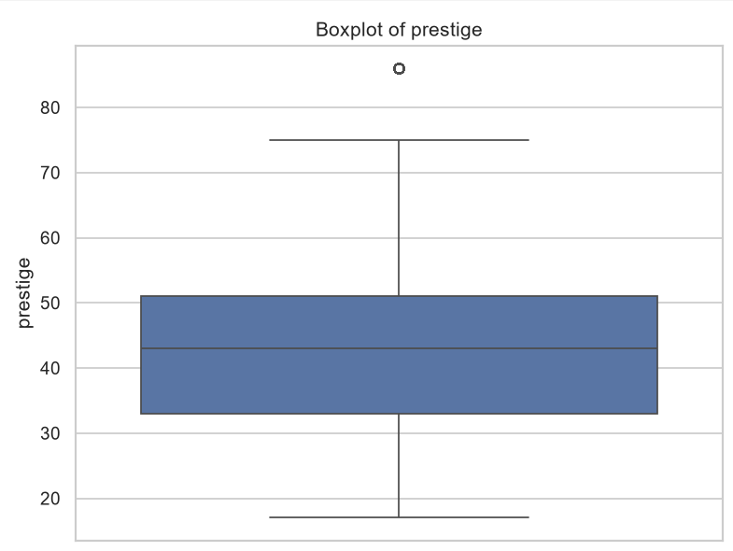
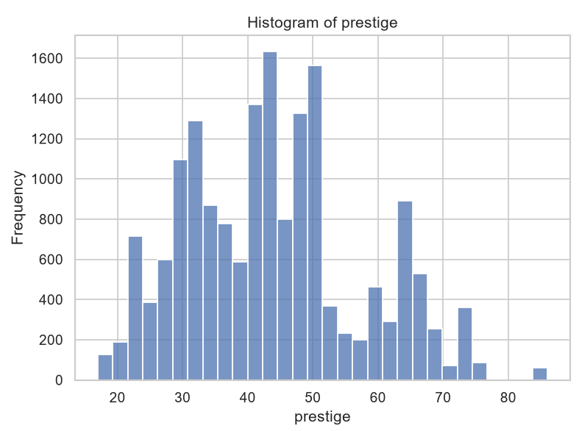
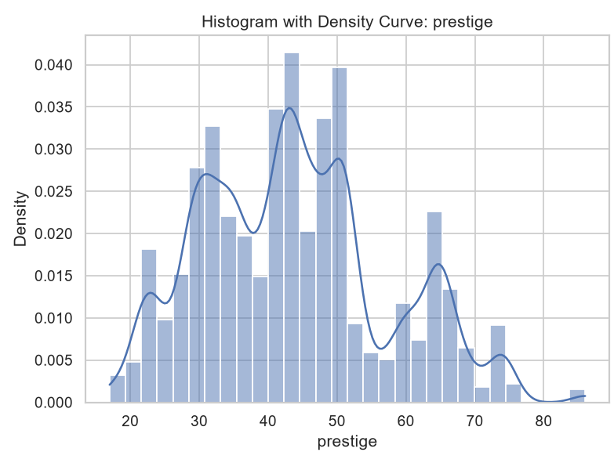
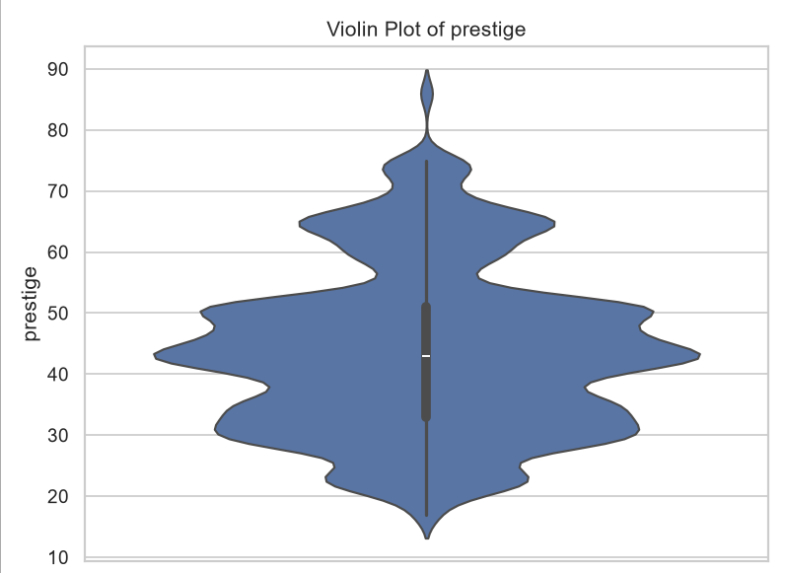
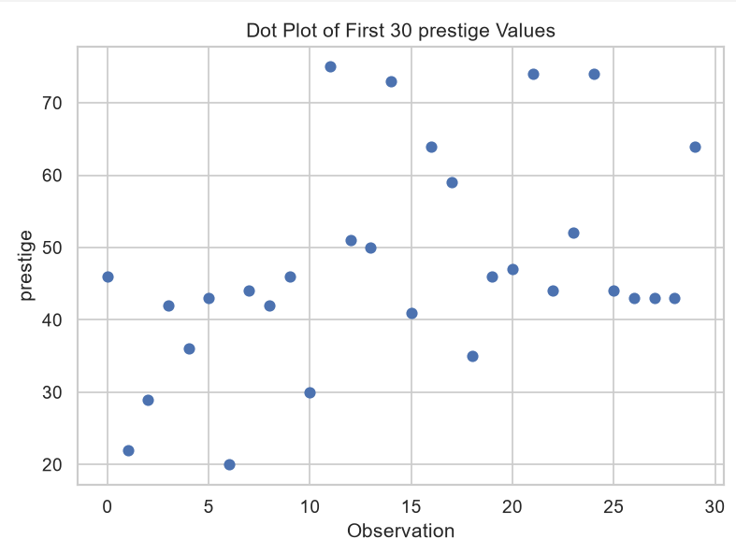
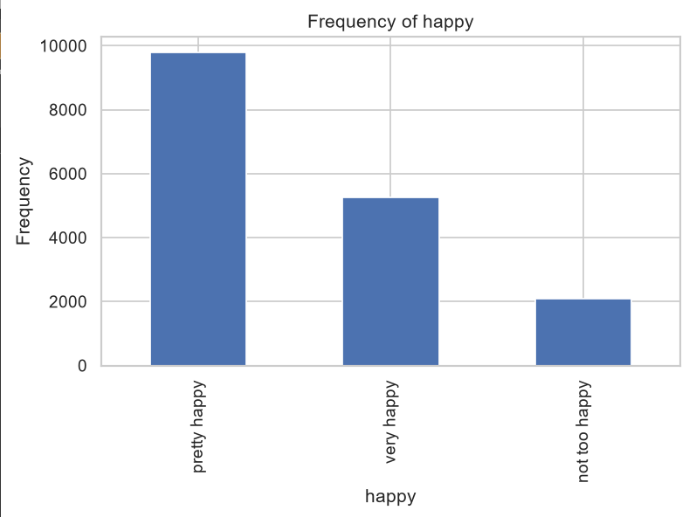
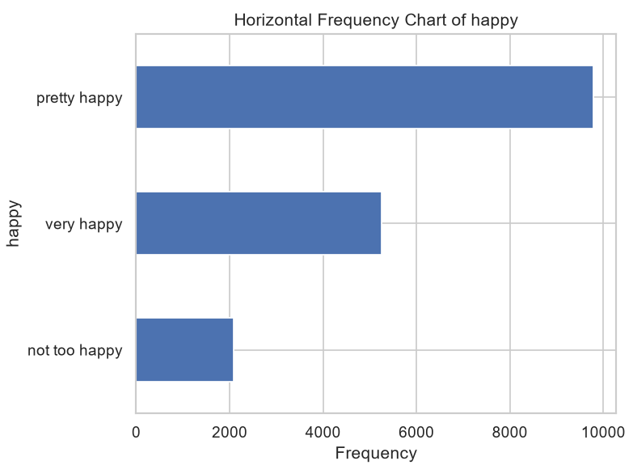
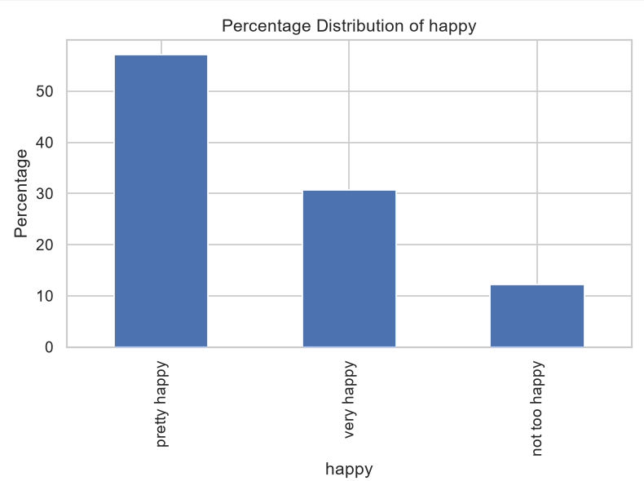
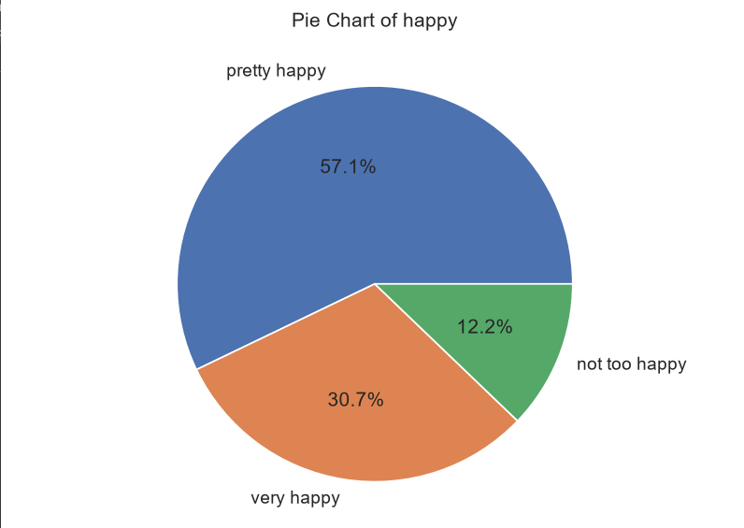
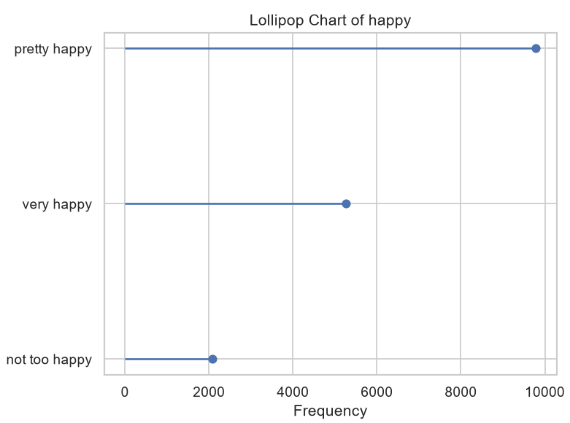
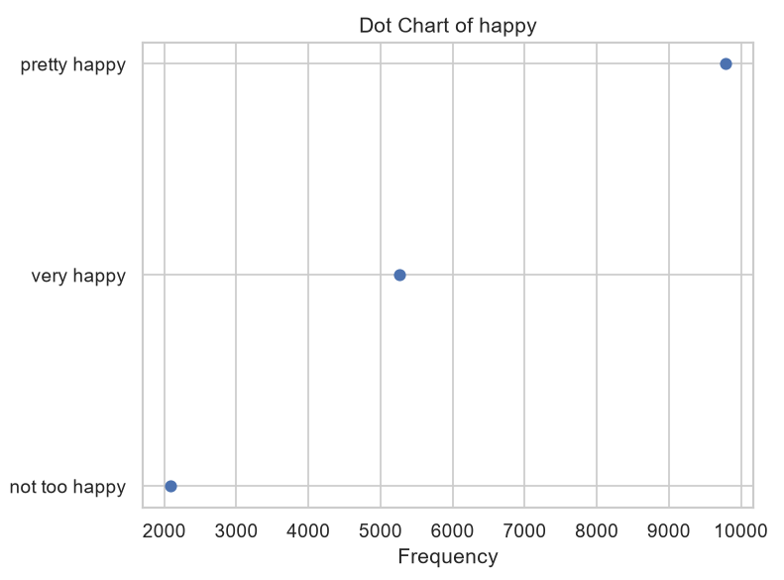
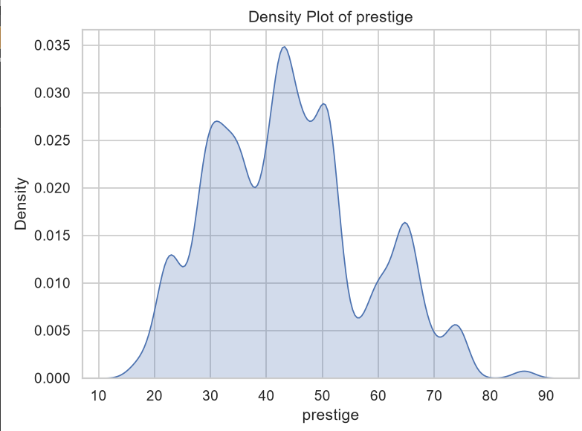
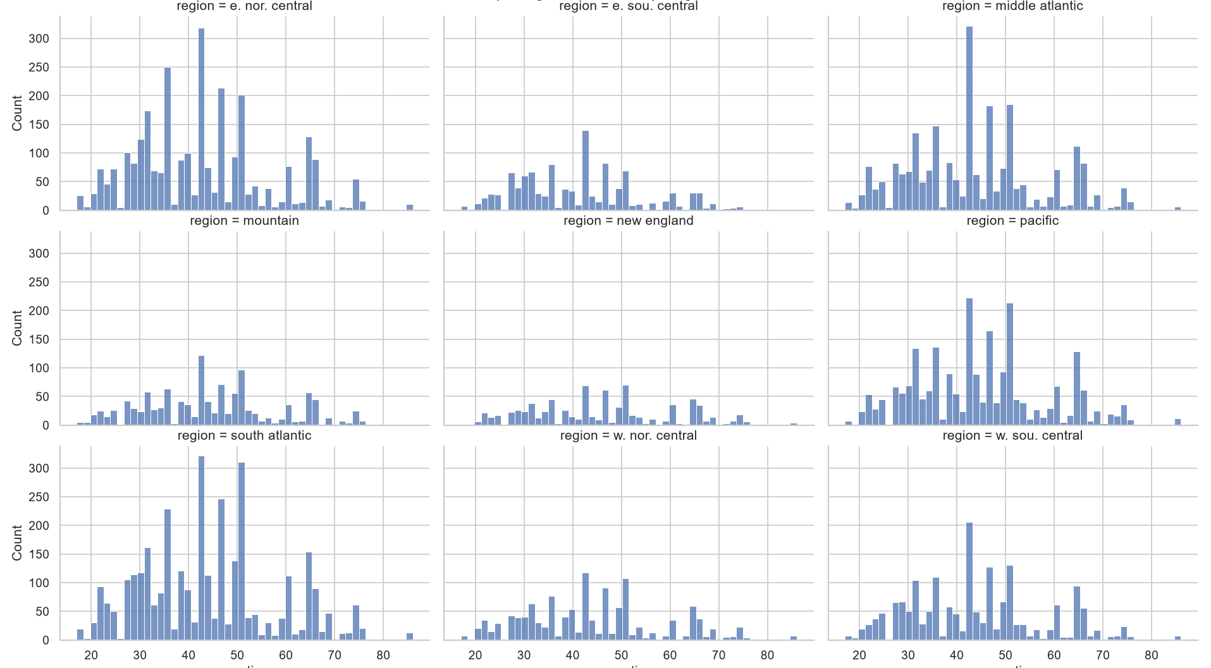
Assessment 4
PS C:\Users\MOHANAPRIYA KUMAR> py "D:\VIT Sem 7\Assignments\EDA\EDA_Assignment_Unifiec\Assessment_4.py"
Loaded happiness dataset shape: (17137, 34)

==============================================================================
ASSESSMENT 4: BIVARIATE ANALYSIS
==============================================================================

Region by happiness contingency table:
Happiness_Level High Low Medium
region
e. nor. central 851 351 1679
e. sou. central 373 130 614
middle atlantic 683 331 1400
mountain 364 135 696
new england 248 89 471
pacific 722 301 1330
south atlantic 1091 411 1838
w. nor. central 372 124 751
w. sou. central 556 214 1012
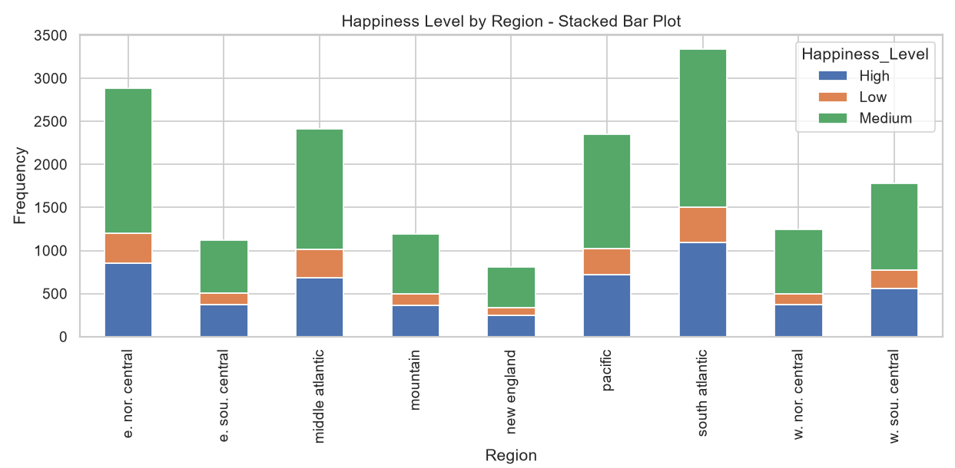
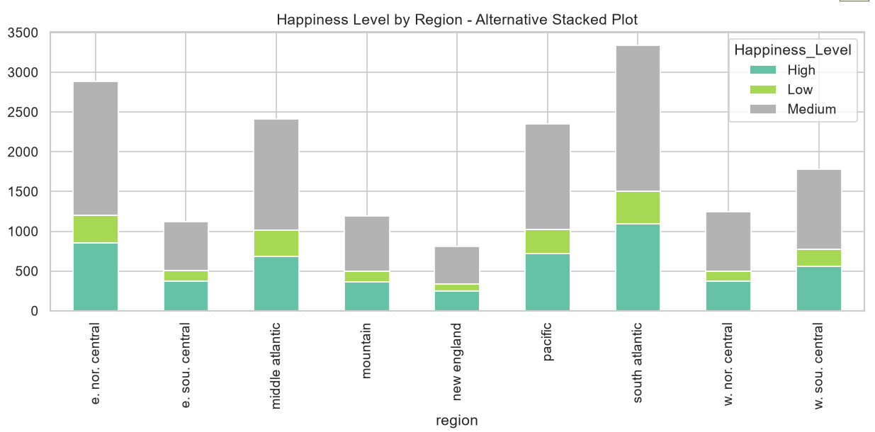
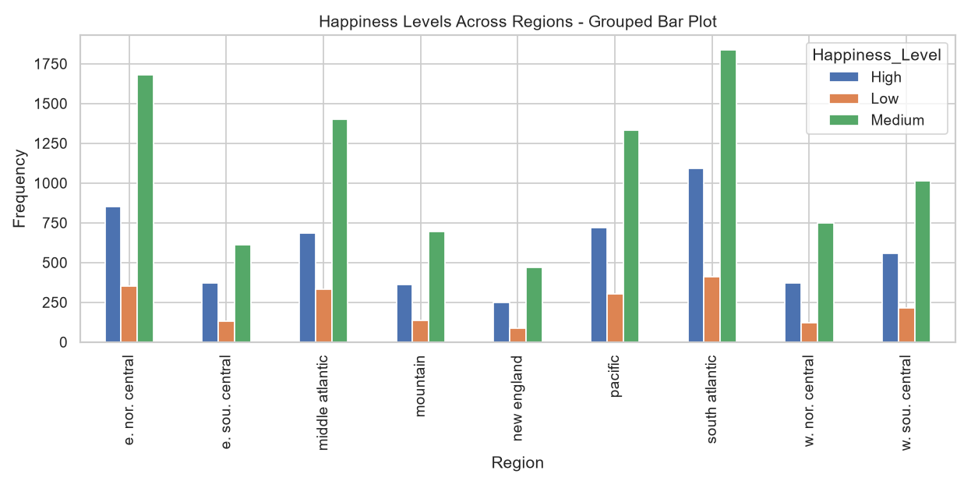
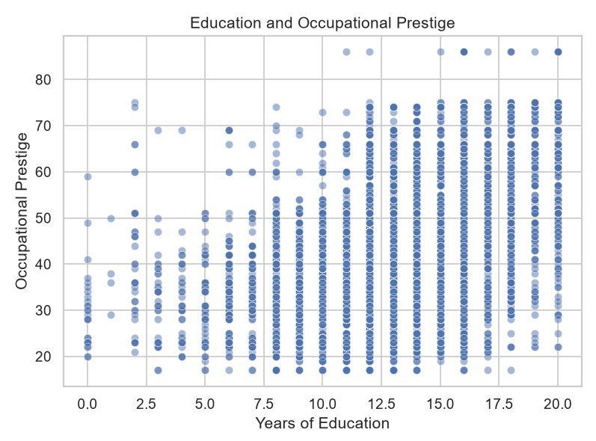
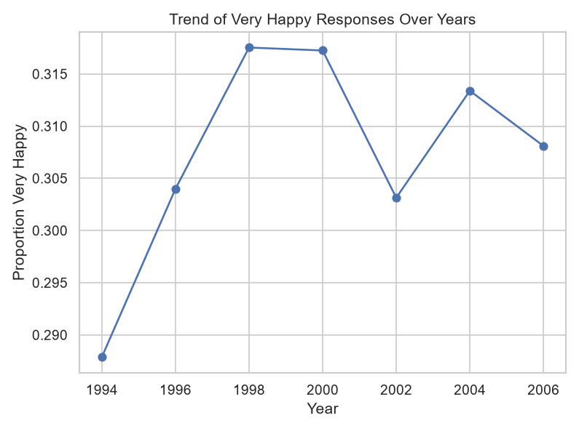
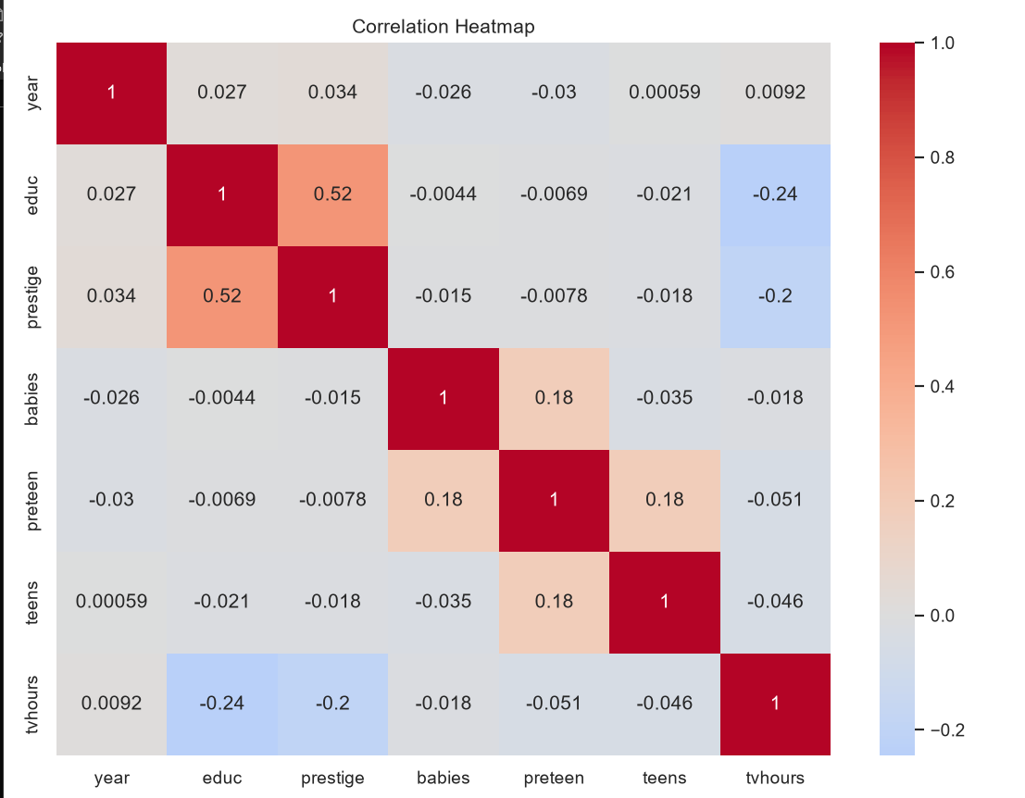
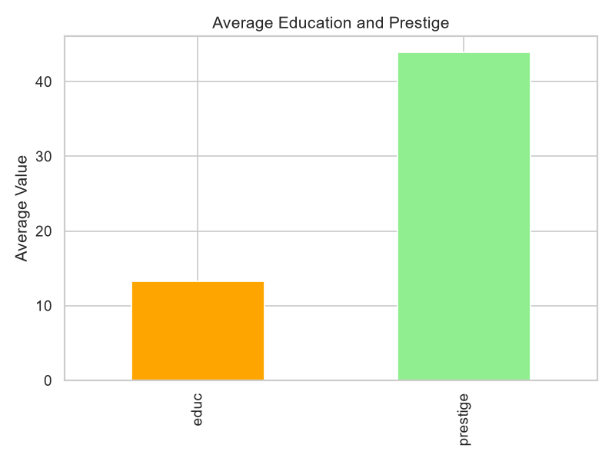
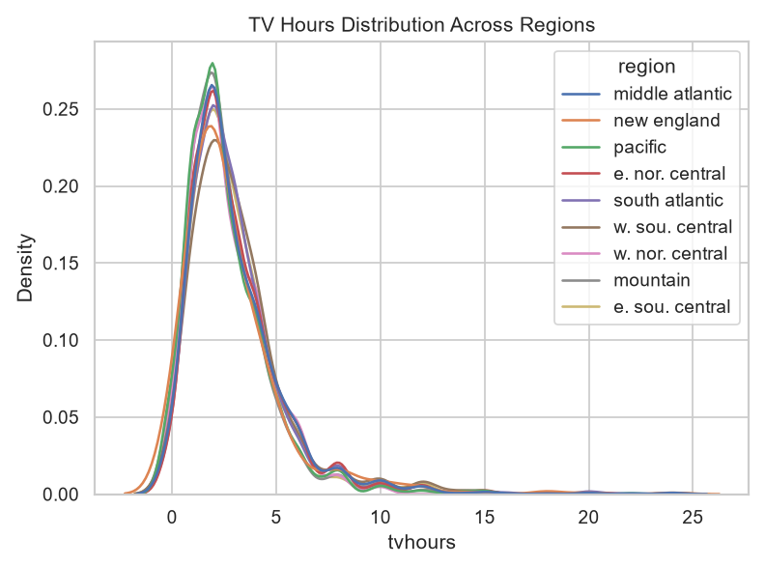
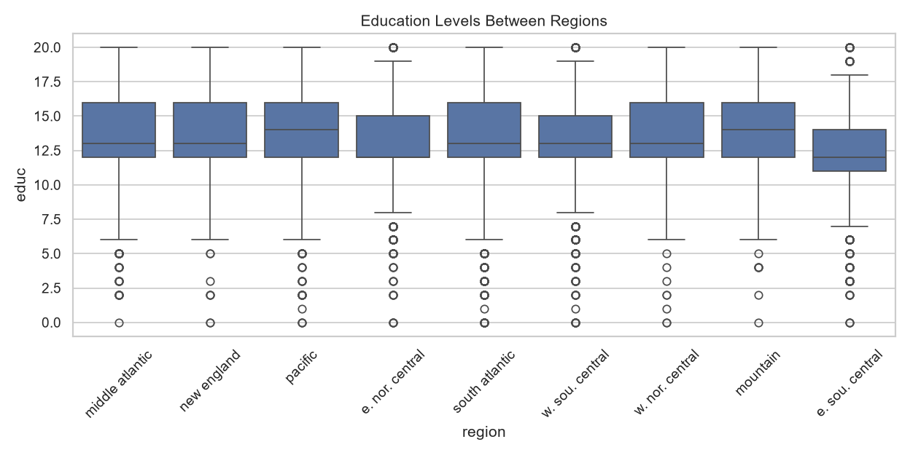
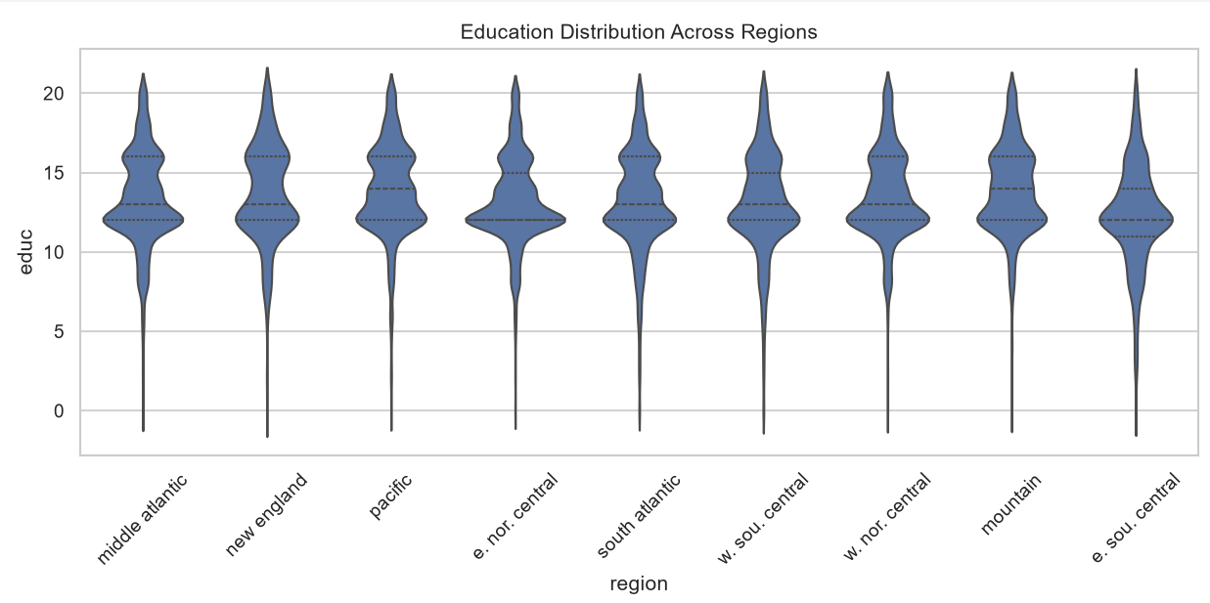
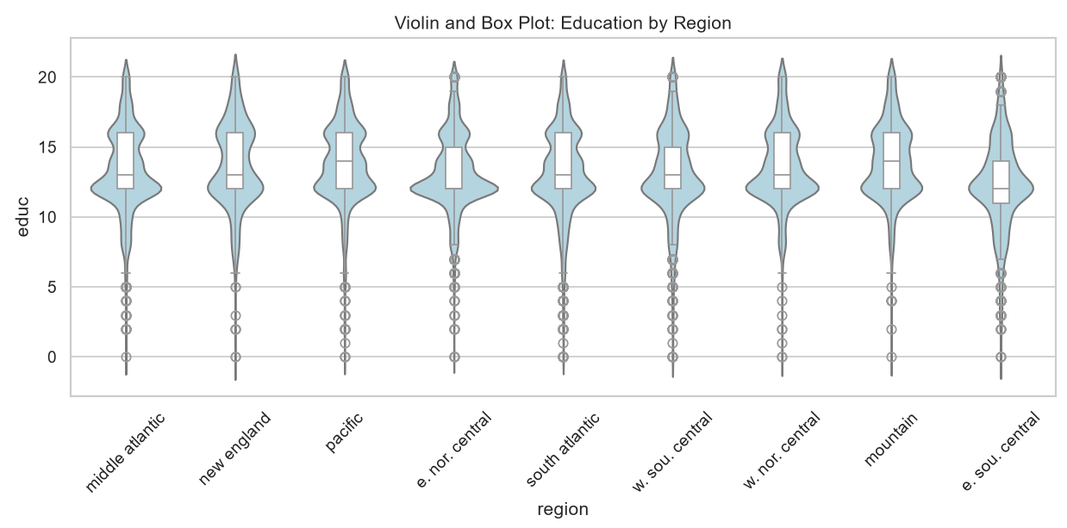
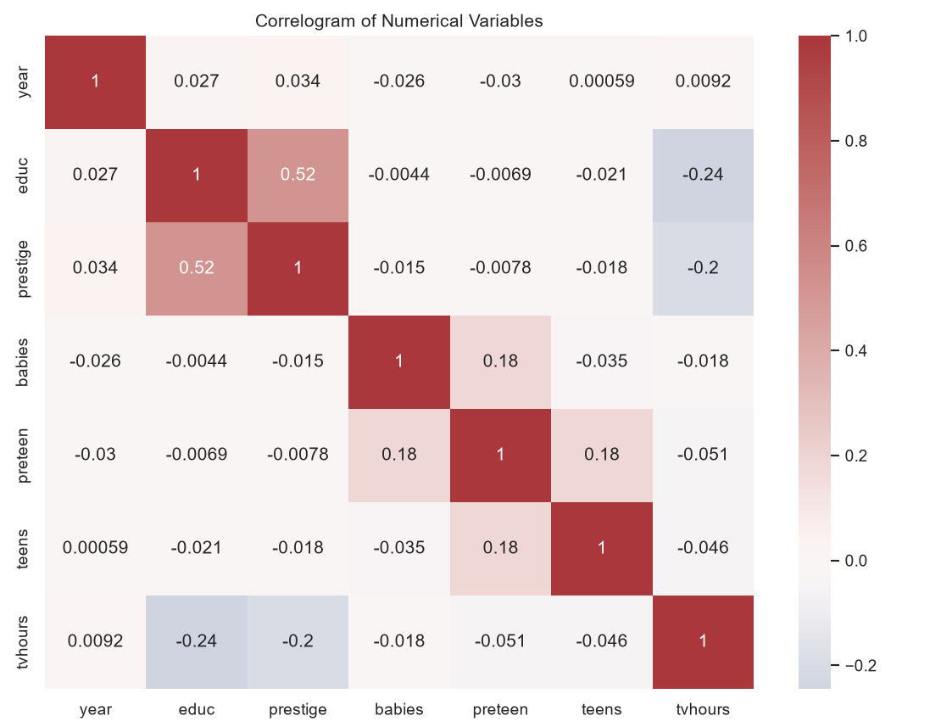
Assessment 5
PS C:\Users\MOHANAPRIYA KUMAR> py "D:\VIT Sem 7\Assignments\EDA\EDA_Assignment_Unifiec\Assessment_5.py"
Loaded happiness dataset shape: (17137, 34)

==============================================================================
ASSESSMENT 5: MULTIVARIATE ANALYSIS
==============================================================================

Data types:
rownames int64
year int64
workstat str
prestige float64
divorce str
widowed str
educ float64
reg16 str
babies float64
preteen float64
teens float64
income str
region str
attend str
happy str
owngun str
tvhours float64
vhappy int64
mothfath16 float64
black int64
gwbush04 float64
female int64
blackfemale int64
gwbush00 float64
occattend float64
regattend float64
y94 int64
y96 int64
y98 int64
y00 int64
y02 int64
y04 int64
y06 int64
unem10 float64
dtype: object

Summary:
count unique top freq mean std min 25% 50% 75% max
rownames 17137.0 NaN NaN NaN 8569.0 4947.170117 1.0 4285.0 8569.0 12853.0 17137.0
year 17137.0 NaN NaN NaN 1999.47412 4.143358 1994.0 1996.0 1998.0 2004.0 2006.0
workstat 17134 8 working fulltime 9214 NaN NaN NaN NaN NaN NaN NaN
prestige 16283.0 NaN NaN NaN 43.877541 13.873965 17.0 33.0 43.0 51.0 86.0
divorce 9754 2 no 7421 NaN NaN NaN NaN NaN NaN NaN
widowed 11096 2 iap 10718 NaN NaN NaN NaN NaN NaN NaN
educ 17093.0 NaN NaN NaN 13.319078 2.986785 0.0 12.0 13.0 16.0 20.0
reg16 17137 10 e. nor. central 3148 NaN NaN NaN NaN NaN NaN NaN
babies 17036.0 NaN NaN NaN 0.207091 0.540542 0.0 0.0 0.0 0.0 6.0
preteen 17036.0 NaN NaN NaN 0.255753 0.621533 0.0 0.0 0.0 0.0 6.0
teens 17049.0 NaN NaN NaN 0.18136 0.493698 0.0 0.0 0.0 0.0 7.0
income 15045 12 $25000 or more 9725 NaN NaN NaN NaN NaN NaN NaN
region 17137 9 south atlantic 3340 NaN NaN NaN NaN NaN NaN NaN
attend 16864 9 never 3213 NaN NaN NaN NaN NaN NaN NaN
happy 17137 3 pretty happy 9791 NaN NaN NaN NaN NaN NaN NaN
owngun 11297 2 iap 7180 NaN NaN NaN NaN NaN NaN NaN
tvhours 11794.0 NaN NaN NaN 2.904019 2.327457 0.0 1.0 2.0 4.0 24.0
vhappy 17137.0 NaN NaN NaN 0.306938 0.461237 0.0 0.0 0.0 1.0 1.0
mothfath16 17132.0 NaN NaN NaN 0.692972 0.461274 0.0 0.0 1.0 1.0 1.0
black 17137.0 NaN NaN NaN 0.138414 0.345344 0.0 0.0 0.0 0.0 1.0
gwbush04 1930.0 NaN NaN NaN 0.501554 0.500127 0.0 0.0 1.0 1.0 1.0
female 17137.0 NaN NaN NaN 0.559083 0.496511 0.0 0.0 1.0 1.0 1.0
blackfemale 17137.0 NaN NaN NaN 0.089047 0.28482 0.0 0.0 0.0 0.0 1.0
gwbush00 3436.0 NaN NaN NaN 0.521828 0.499596 0.0 0.0 1.0 1.0 1.0
occattend 16864.0 NaN NaN NaN 0.284986 0.451421 0.0 0.0 0.0 1.0 1.0
regattend 16864.0 NaN NaN NaN 0.131226 0.337658 0.0 0.0 0.0 0.0 1.0
y94 17137.0 NaN NaN NaN 0.173718 0.378878 0.0 0.0 0.0 0.0 1.0
y96 17137.0 NaN NaN NaN 0.168349 0.374187 0.0 0.0 0.0 0.0 1.0
y98 17137.0 NaN NaN NaN 0.163739 0.37005 0.0 0.0 0.0 0.0 1.0
y00 17137.0 NaN NaN NaN 0.162047 0.368505 0.0 0.0 0.0 0.0 1.0
y02 17137.0 NaN NaN NaN 0.079886 0.271124 0.0 0.0 0.0 0.0 1.0
y04 17137.0 NaN NaN NaN 0.078018 0.268208 0.0 0.0 0.0 0.0 1.0
y06 17137.0 NaN NaN NaN 0.174243 0.379329 0.0 0.0 0.0 0.0 1.0
unem10 11341.0 NaN NaN NaN 0.318402 0.465877 0.0 0.0 0.0 1.0 1.0
Numerical variables: ['year', 'prestige', 'educ', 'babies', 'preteen', 'teens', 'tvhours']
Categorical variables: ['workstat', 'region', 'happy', 'attend', 'divorce', 'owngun']
PS C:\Users\MOHANAPRIYA KUMAR>
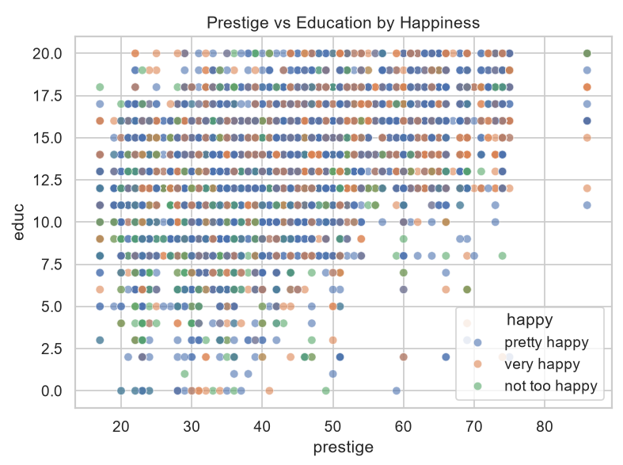
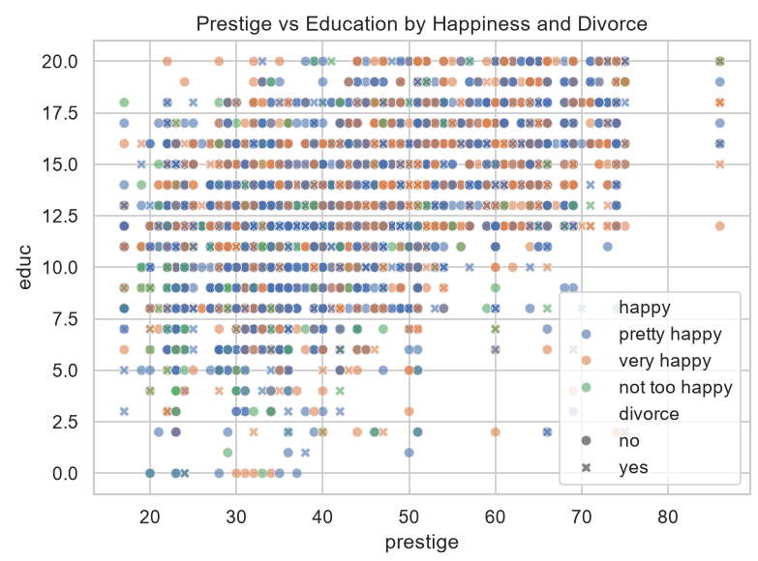
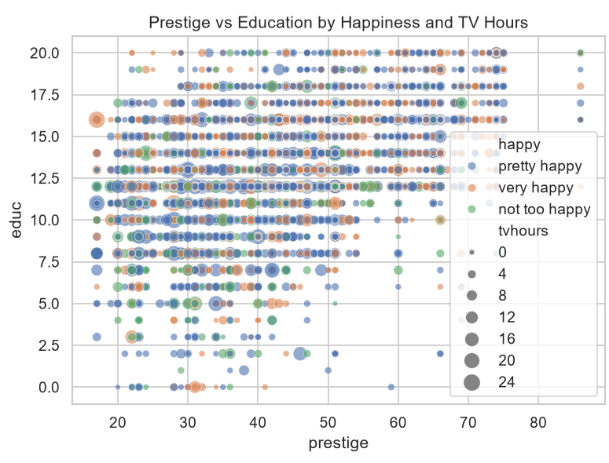
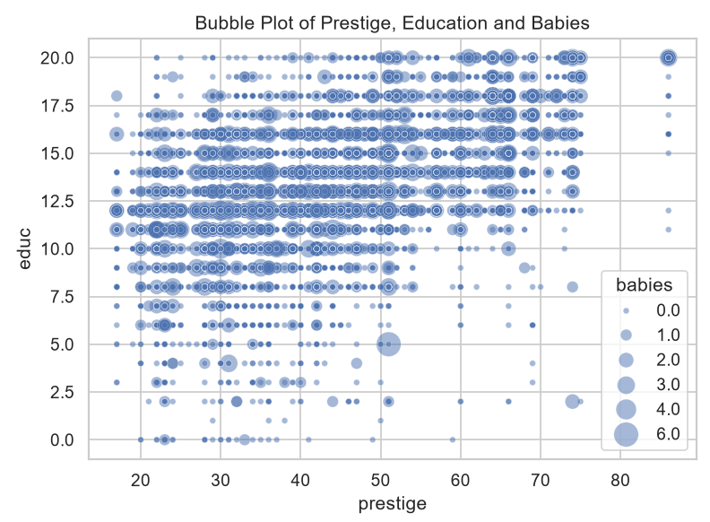
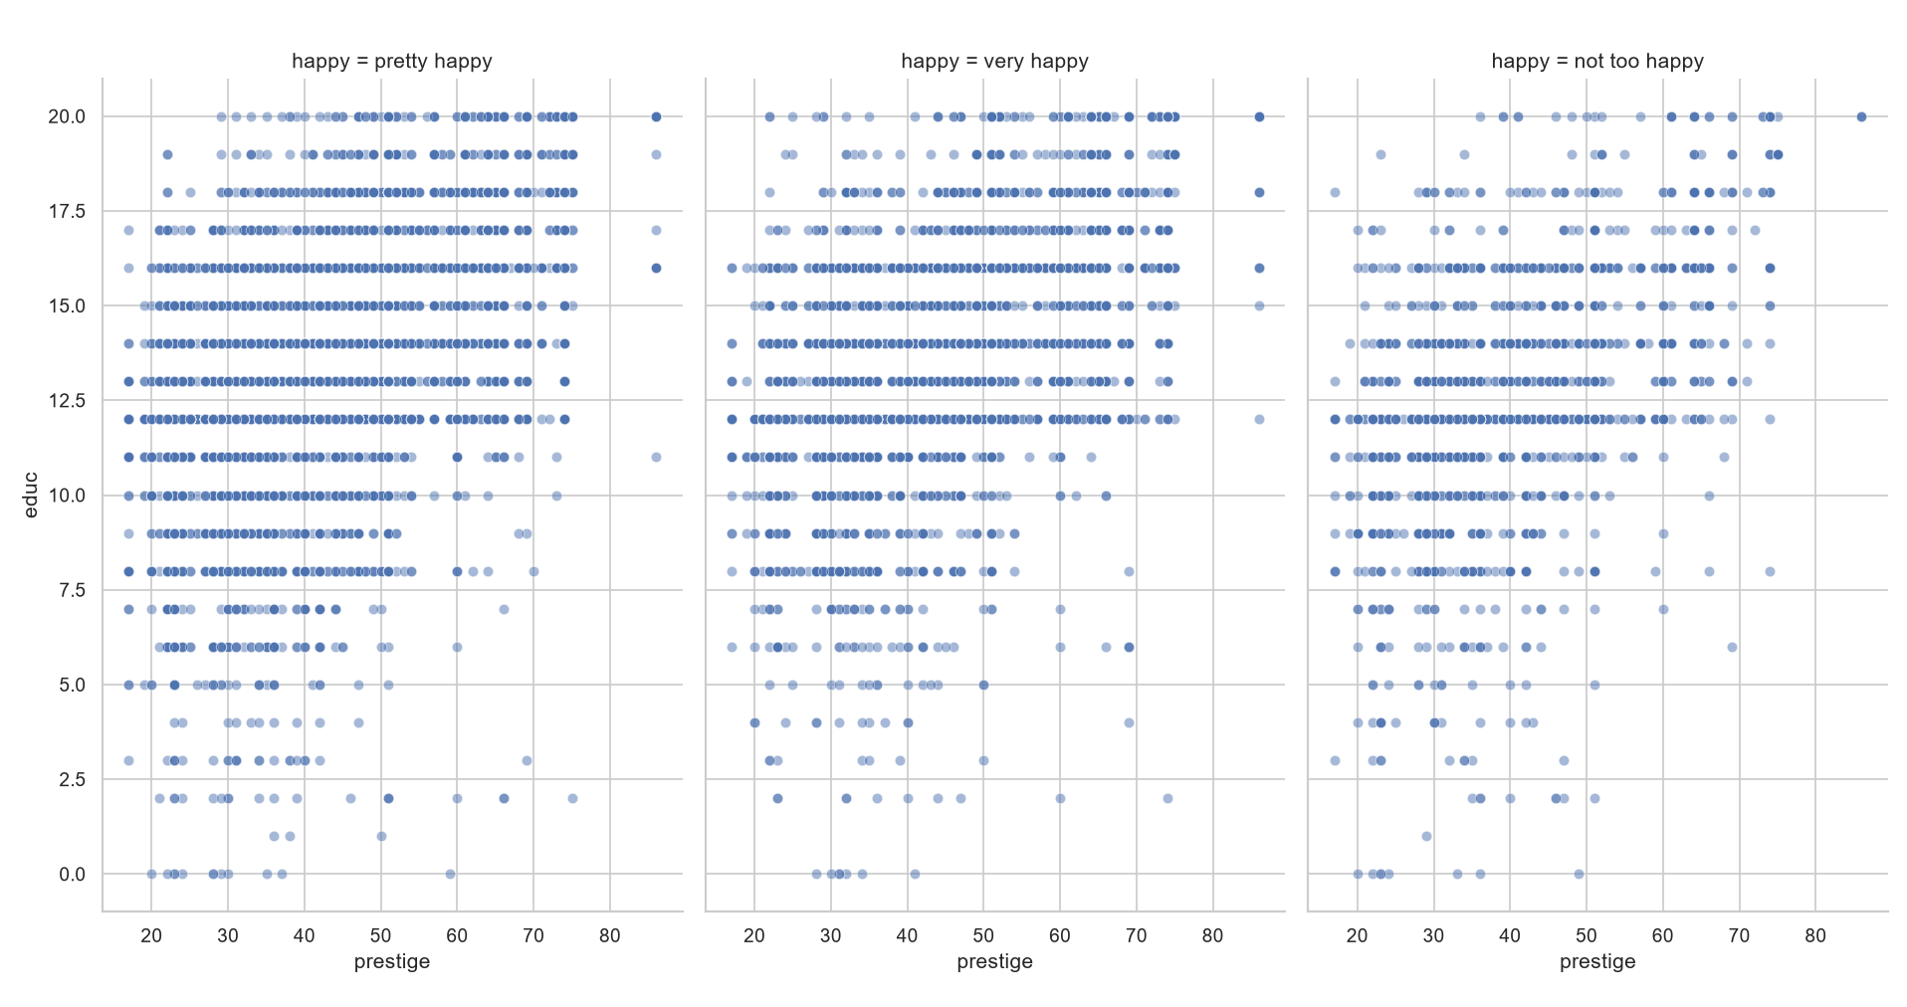
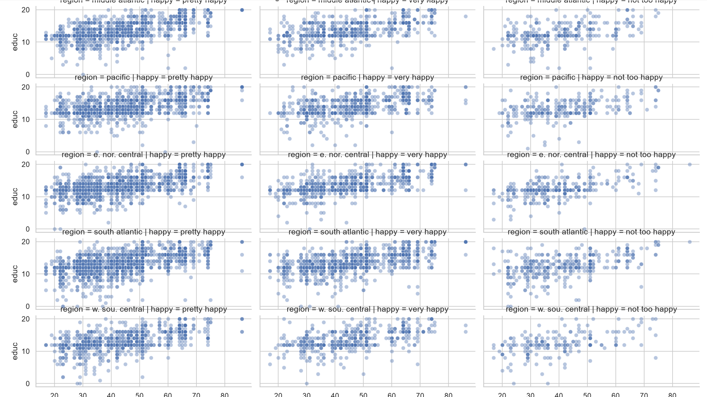
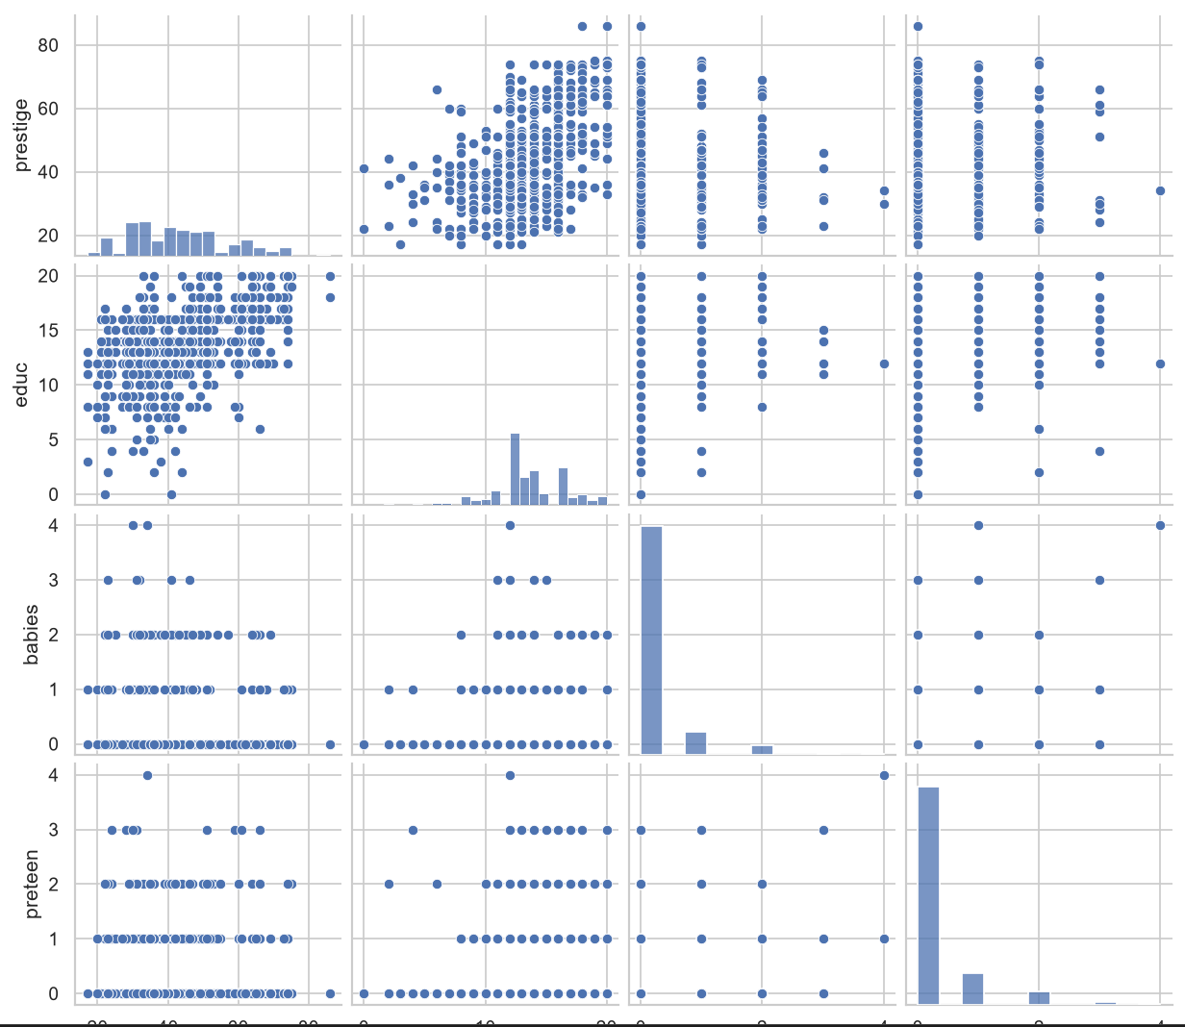
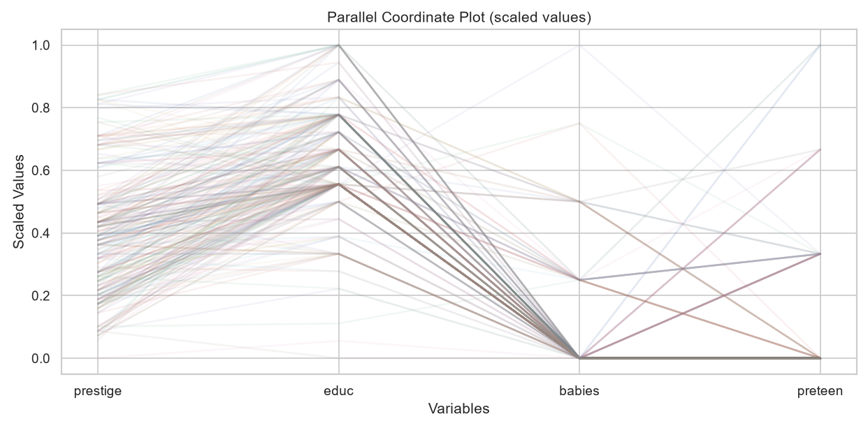

Assessment 6
PS C:\Users\MOHANAPRIYA KUMAR> py "D:\VIT Sem 7\Assignments\EDA\EDA_Assignment_Unifiec\Assessment_6.py"

==============================================================================
ASSESSMENT 6: TIME SERIES ANALYSIS – AIR PASSENGERS
==============================================================================
First five observations:
1949-01-01 112
1949-02-01 118
1949-03-01 132
1949-04-01 129
1949-05-01 121
Freq: MS, Name: Passengers, dtype: int64

Last five observations:
1960-08-01 606
1960-09-01 508
1960-10-01 461
1960-11-01 390
1960-12-01 432
Freq: MS, Name: Passengers, dtype: int64

Start: 1949-01-01 00:00:00
End: 1960-12-01 00:00:00
Frequency: monthly (12 observations per year)
Python object type: <class 'pandas.Series'>

ARIMA(1,1,1) model summary:
SARIMAX Results
==============================================================================
Dep. Variable: Passengers No. Observations: 144
Model: ARIMA(1, 1, 1) Log Likelihood -694.341
Date: Mon, 19 Oct 2026 AIC 1394.683
Time: 21:15:04 BIC 1403.571
Sample: 01-01-1949 HQIC 1398.294
- 12-01-1960
Covariance Type: opg
==============================================================================
coef std err z P>|z| [0.025 0.975]
------------------------------------------------------------------------------
ar.L1 -0.4742 0.123 -3.847 0.000 -0.716 -0.233
ma.L1 0.8635 0.078 11.051 0.000 0.710 1.017
sigma2 961.9270 107.433 8.954 0.000 751.362 1172.492
===================================================================================
Ljung-Box (L1) (Q): 0.21 Jarque-Bera (JB): 2.14
Prob(Q): 0.65 Prob(JB): 0.34
Heteroskedasticity (H): 7.00 Skew: -0.21
Prob(H) (two-sided): 0.00 Kurtosis: 3.43
===================================================================================

Warnings:
[1] Covariance matrix calculated using the outer product of gradients (complex-step).

12-month forecast:
1961-01-01 475.735059
1961-02-01 454.996073
1961-03-01 464.830415
1961-04-01 460.167010
1961-05-01 462.378378
1961-06-01 461.329756
1961-07-01 461.827008
1961-08-01 461.591213
1961-09-01 461.703026
1961-10-01 461.650005
1961-11-01 461.675148
1961-12-01 461.663225
Freq: MS, Name: predicted_mean, dtype: float64
PS C:\Users\MOHANAPRIYA KUMAR>

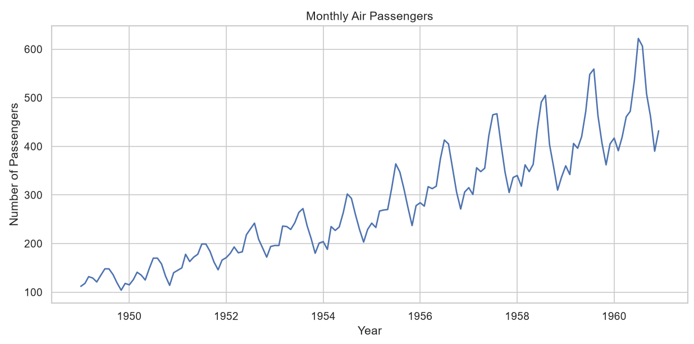
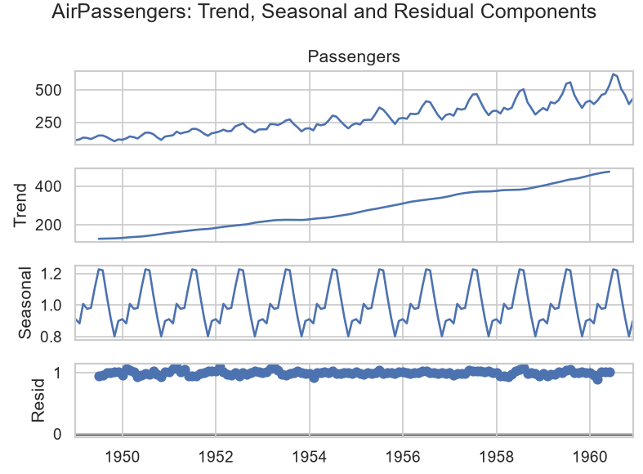
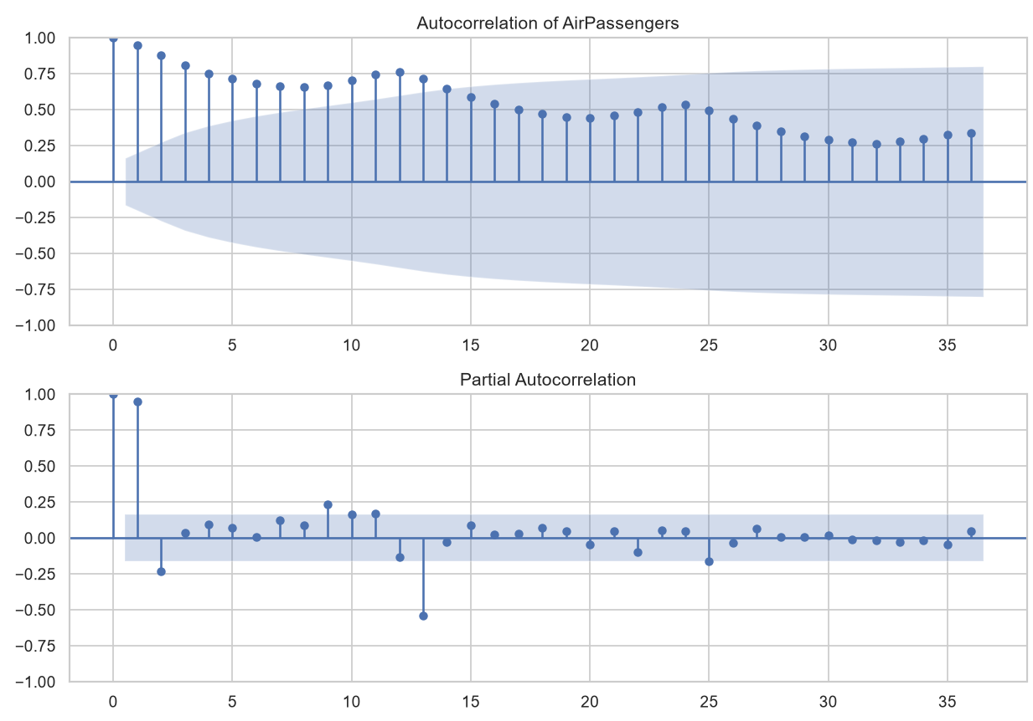
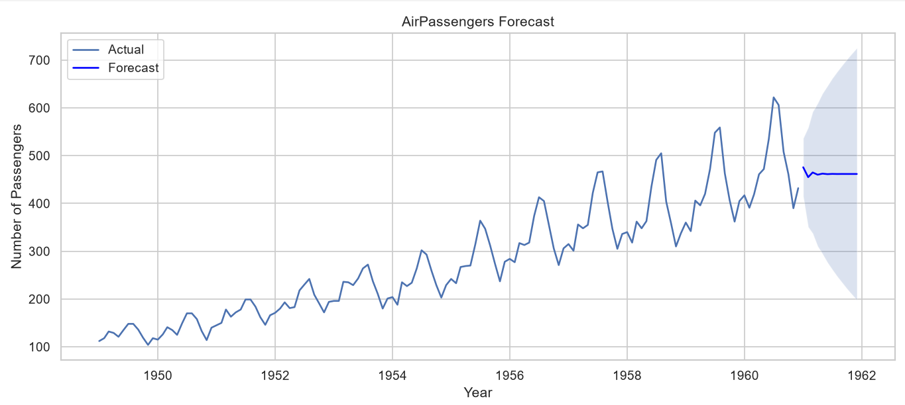
Assessment 7
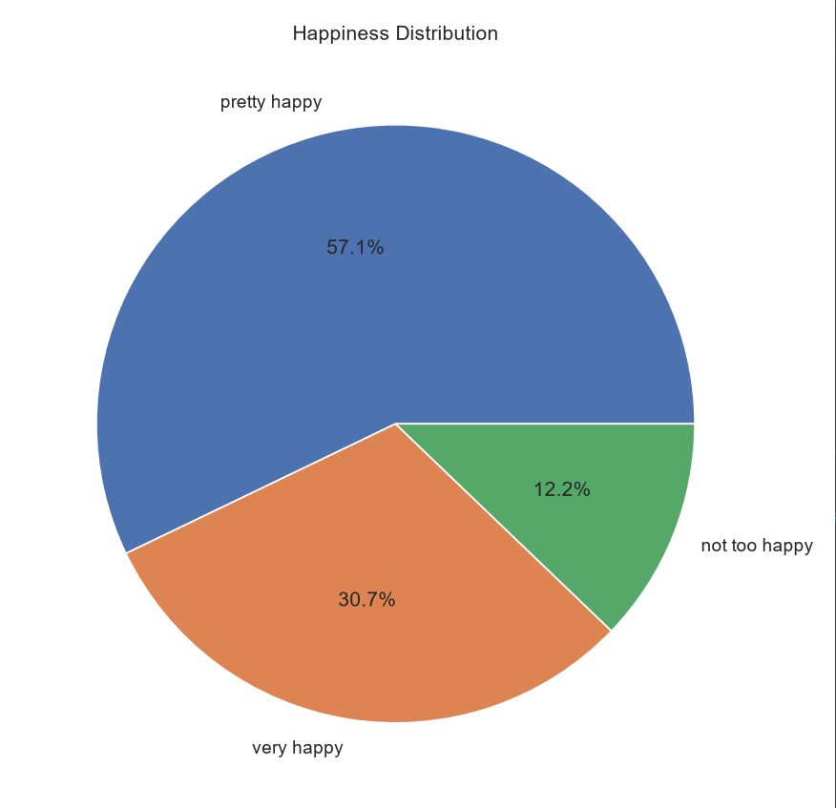
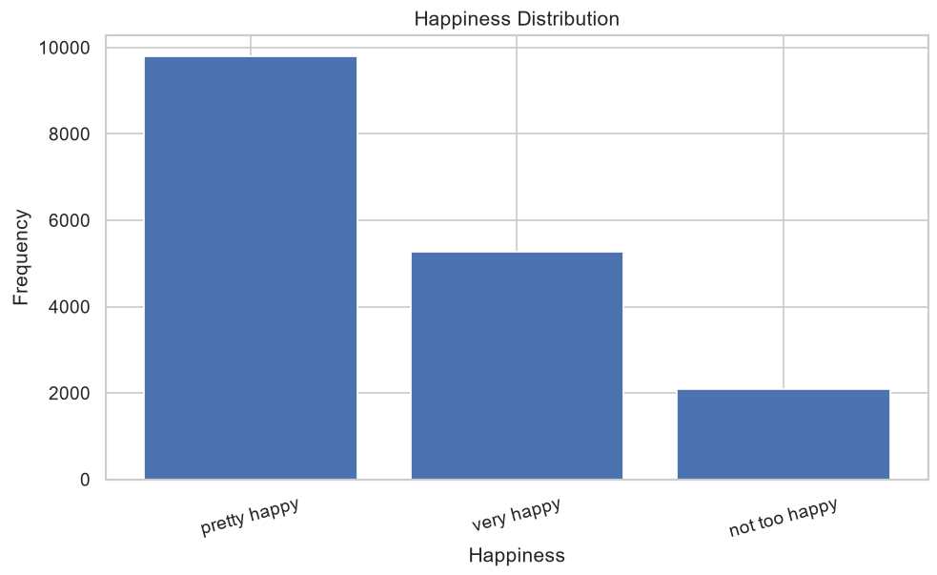
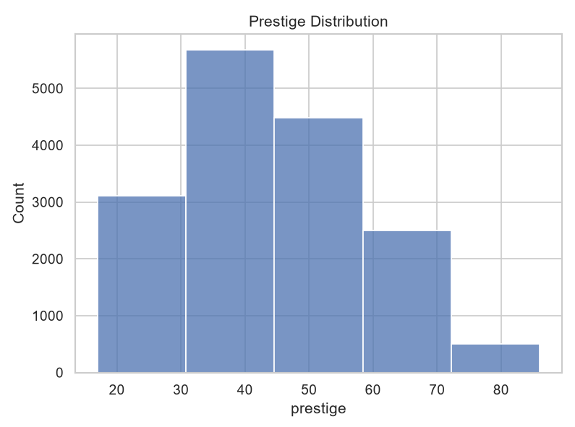
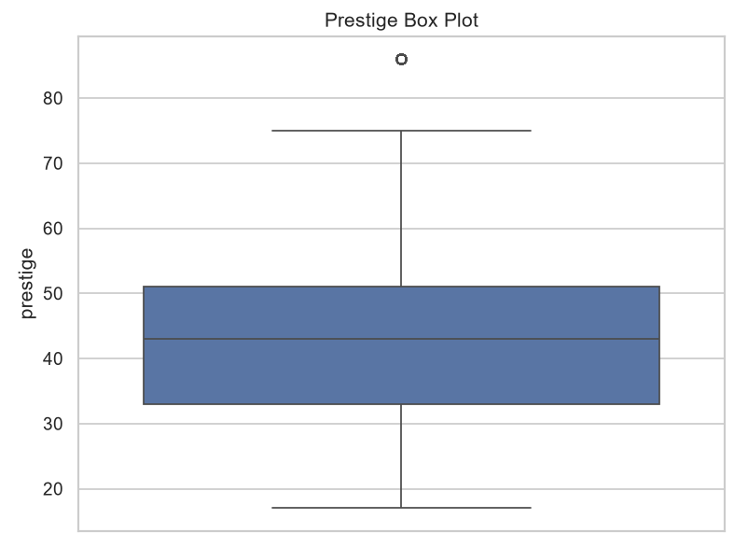
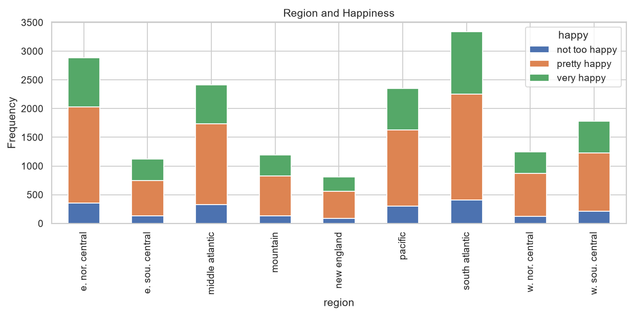
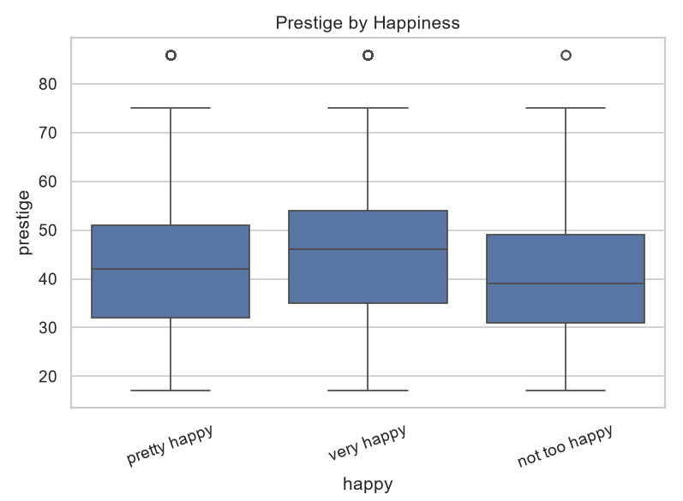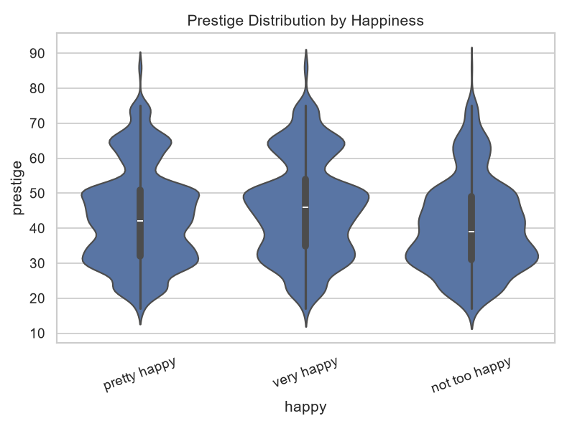
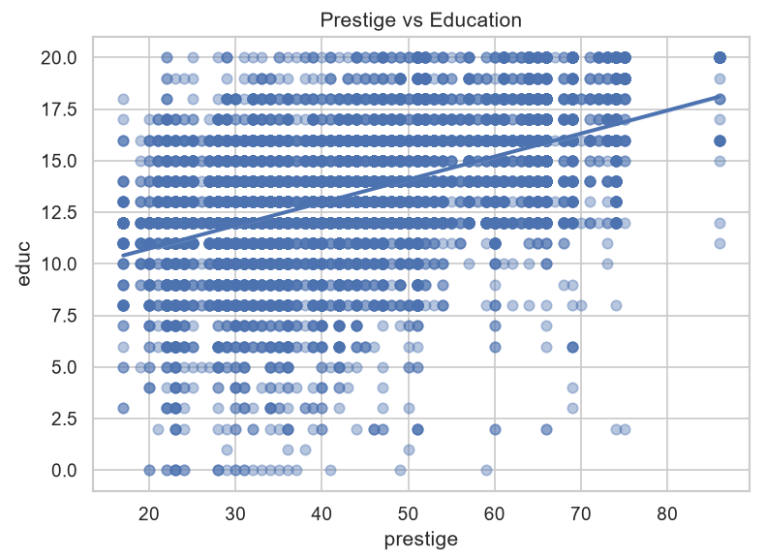
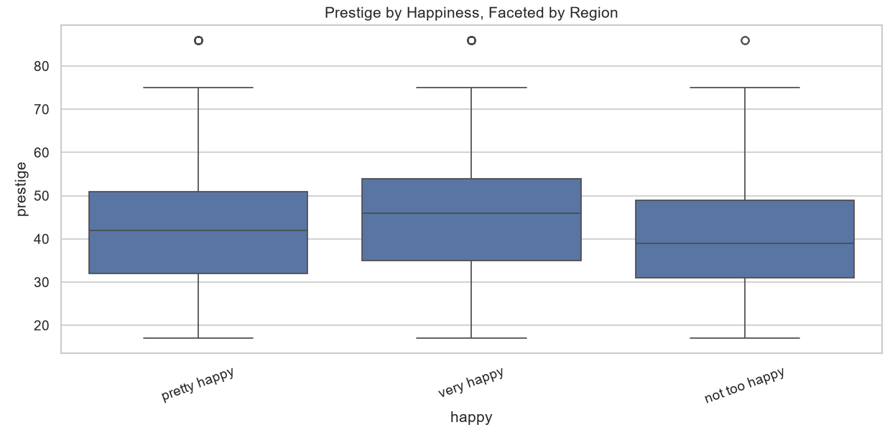
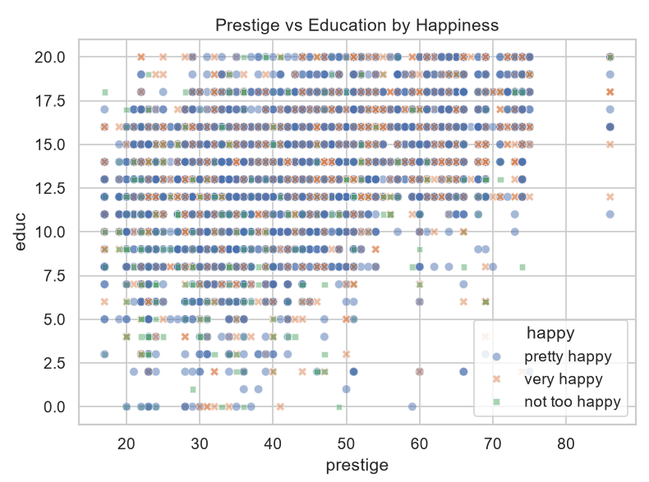
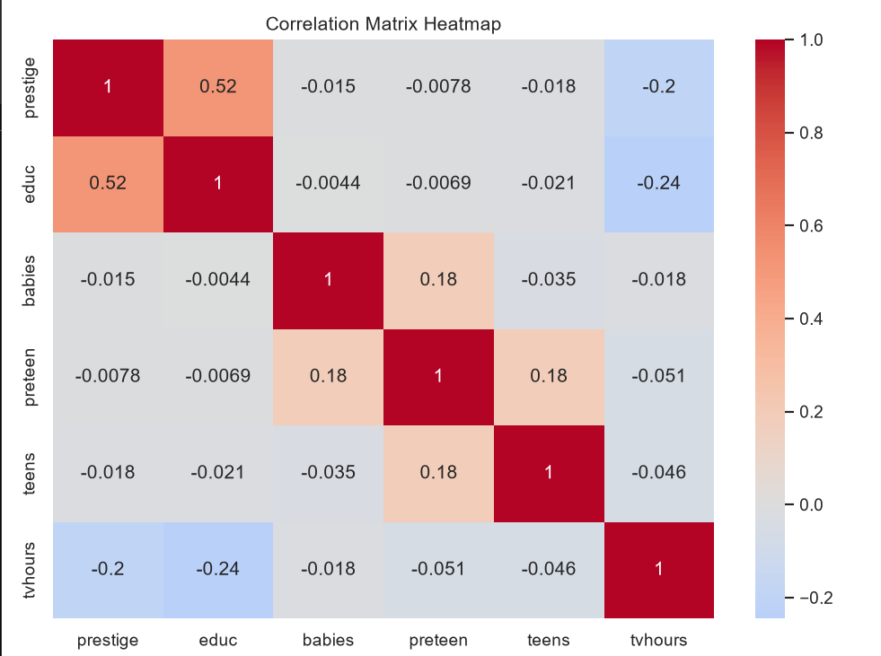
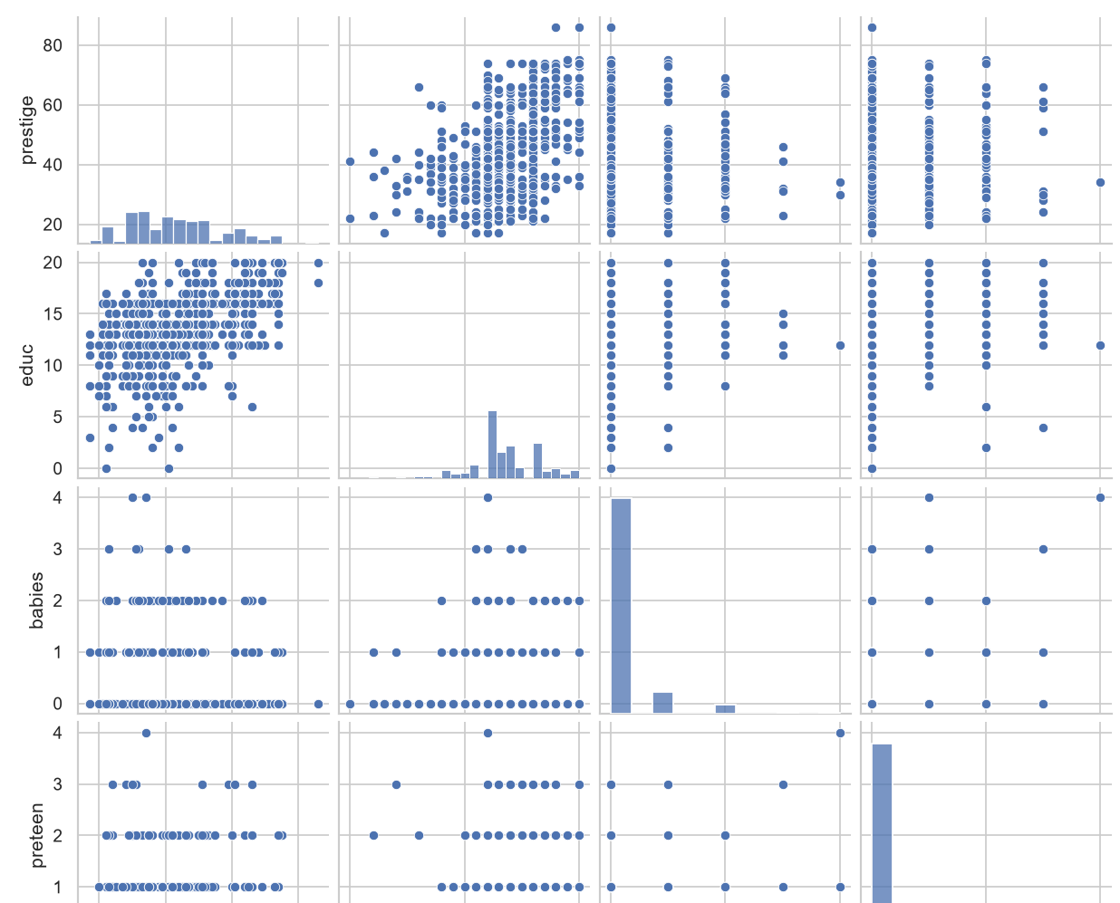
Assessment 7
PS C:\Users\MOHANAPRIYA KUMAR> py "D:\VIT Sem 7\Assignments\EDA\EDA_Assignment_Unifiec\Assessment_7.py"
Loaded happiness dataset shape: (17137, 34)

==============================================================================
ASSESSMENT 7: 1D, 2D AND ND ANALYSIS
==============================================================================

Summary statistics:
Statistic Value
0 Mean 43.877541
1 Median 43.000000
2 Minimum 17.000000
3 Maximum 86.000000
4 Range 69.000000
5 Variance 192.486907
6 Standard Deviation 13.873965
7 IQR 18.000000
8 Skewness 0.381884
9 Kurtosis 2.497405

Frequency:
happy
pretty happy 9791
very happy 5260
not too happy 2086
Name: count, dtype: int64

Relative frequency:
happy
pretty happy 0.571337
very happy 0.306938
not too happy 0.121725
Name: proportion, dtype: float64

Prestige bin frequencies:
prestige
(16.931, 30.8] 3113
(30.8, 44.6] 5673
(44.6, 58.4] 4486
(58.4, 72.2] 2502
(72.2, 86.0] 509
Name: count, dtype: int64

Contingency table:
happy not too happy pretty happy very happy
region
e. nor. central 351 1679 851
e. sou. central 130 614 373
middle atlantic 331 1400 683
mountain 135 696 364
new england 89 471 248
pacific 301 1330 722
south atlantic 411 1838 1091
w. nor. central 124 751 372
w. sou. central 214 1012 556

Row percentages:
happy not too happy pretty happy very happy
region
e. nor. central 0.121833 0.582784 0.295384
e. sou. central 0.116383 0.549687 0.333930
middle atlantic 0.137117 0.579950 0.282933
mountain 0.112971 0.582427 0.304603
new england 0.110149 0.582921 0.306931
pacific 0.127922 0.565236 0.306842
south atlantic 0.123054 0.550299 0.326647
w. nor. central 0.099439 0.602245 0.298316
w. sou. central 0.120090 0.567901 0.312009

Column percentages:
happy not too happy pretty happy very happy
region
e. nor. central 0.168265 0.171484 0.161787
e. sou. central 0.062320 0.062711 0.070913
middle atlantic 0.158677 0.142988 0.129848
mountain 0.064717 0.071086 0.069202
new england 0.042665 0.048105 0.047148
pacific 0.144295 0.135839 0.137262
south atlantic 0.197028 0.187723 0.207414
w. nor. central 0.059444 0.076703 0.070722
w. sou. central 0.102589 0.103360 0.105703

Prestige summary by happiness:
mean median std
happy
not too happy 40.604361 39.0 13.043195
pretty happy 43.489923 42.0 13.771516
very happy 45.850070 46.0 14.074957

Pearson correlation: PearsonRResult(statistic=0.5228105268703355, pvalue=0.0)
Spearman correlation: SignificanceResult(statistic=0.5245633887180347, pvalue=0.0)

Prestige mean and SD by region and happiness:
mean std
region happy
e. nor. central not too happy 39.460123 12.819094
pretty happy 42.418851 13.554202
very happy 44.780220 14.350419
e. sou. central not too happy 36.287037 9.979466
pretty happy 40.882456 13.172449
very happy 43.440341 13.415638
middle atlantic not too happy 40.617940 12.816274
pretty happy 43.522036 13.764736
very happy 45.567939 14.104716
mountain not too happy 41.677419 13.141846
pretty happy 44.329323 13.949396
very happy 46.597734 13.601980
new england not too happy 42.988636 13.985620
pretty happy 44.869180 14.811503
very happy 48.920833 14.148273
pacific not too happy 41.834507 12.945826
pretty happy 44.953870 13.876954
very happy 46.635174 13.468570
south atlantic not too happy 41.735602 13.508848
pretty happy 43.547106 13.562621
very happy 46.118774 14.418391
w. nor. central not too happy 39.763158 12.791938
pretty happy 43.547718 13.854762
very happy 45.922006 14.603877
w. sou. central not too happy 39.633166 13.516212
pretty happy 43.453125 13.721492
very happy 45.969171 13.723659
Correlation for not too happy: 0.4744
Correlation for pretty happy: 0.5172
Correlation for very happy: 0.5330

Correlation matrix:
prestige educ babies preteen teens tvhours
prestige 1.000000 0.522811 -0.014909 -0.007824 -0.017775 -0.199099
educ 0.522811 1.000000 -0.004396 -0.006918 -0.021106 -0.244835
babies -0.014909 -0.004396 1.000000 0.180785 -0.035141 -0.018008
preteen -0.007824 -0.006918 0.180785 1.000000 0.180785 -0.051414
teens -0.017775 -0.021106 -0.035141 0.180785 1.000000 -0.045794
tvhours -0.199099 -0.244835 -0.018008 -0.051414 -0.045794 1.000000
PS C:\Users\MOHANAPRIYA KUMAR>
Assessment 8
PS C:\Users\MOHANAPRIYA KUMAR> py "D:\VIT Sem 7\Assignments\EDA\EDA_Assignment_Unifiec\Assessment_8.py"
Loaded happiness dataset shape: (17137, 34)

==============================================================================
ASSESSMENT 8: K-MEANS AND HIERARCHICAL CLUSTERING
==============================================================================
Dataset sample:
rownames year workstat prestige divorce widowed educ reg16 babies preteen teens ... gwbush00 occattend regattend y94 y96 y98 y00 y02 y04 y06 unem10
0 1 1994 keeping house 46.0 NaN iap 12.0 middle atlantic 2.0 3.0 0.0 ... NaN 1.0 0.0 1 0 0 0 0 0 0 1.0
1 2 1994 working fulltime 22.0 no iap 12.0 foreign 0.0 0.0 0.0 ... NaN 0.0 0.0 1 0 0 0 0 0 0 0.0
2 3 1994 working fulltime 29.0 no iap 12.0 foreign 0.0 0.0 0.0 ... NaN 0.0 1.0 1 0 0 0 0 0 0 NaN
3 4 1994 working fulltime 42.0 yes iap 8.0 foreign 0.0 0.0 0.0 ... NaN 0.0 0.0 1 0 0 0 0 0 0 1.0
4 5 1994 working parttime 36.0 NaN NaN 13.0 middle atlantic 0.0 1.0 1.0 ... NaN 0.0 0.0 1 0 0 0 0 0 0 0.0

[5 rows x 34 columns]

Missing values:
rownames 0
year 0
workstat 3
prestige 854
divorce 7383
widowed 6041
educ 44
reg16 0
babies 101
preteen 101
teens 88
income 2092
region 0
attend 273
happy 0
owngun 5840
tvhours 5343
vhappy 0
mothfath16 5
black 0
gwbush04 15207
female 0
blackfemale 0
gwbush00 13701
occattend 273
regattend 273
y94 0
y96 0
y98 0
y00 0
y02 0
y04 0
y06 0
unem10 5796
dtype: int64

Happiness distribution:
happy
pretty happy 9791
very happy 5260
not too happy 2086
Name: count, dtype: int64

K-Means (k=2) inertia/WCSS: 54880.12625761378
Cluster centers in standardized units:
[[-0.58087161 -0.53615813 0.01753702 0.01841863 0.02015057 0.24700756]
[ 0.89919937 0.82998213 -0.02714762 -0.02851236 -0.03119344 -0.382372 ]]
Cluster sizes:
0 6744
1 4373
Name: count, dtype: int64

WCSS for k=1..10:
[66702.0, 54880.12625761378, 46102.063579409834, 38865.8026005211, 33740.38768745319, 29509.06646353536, 27367.51059479076, 25912.3805044992, 24472.19963393938, 23049.45910094198]

Final K-Means (k=3) cluster centers:
[[ 0.94663071 0.88155235 -0.17949272 -0.27587023 -0.16580392 -0.36928762]
[-0.57459333 -0.54514017 -0.25050965 -0.3324537 -0.22481437 0.30058585]
[-0.17689536 -0.13617481 1.05517321 1.47234364 0.9559707 -0.14822382]]
Final cluster sizes:
0 3687
1 5499
2 1931
Name: count, dtype: int64

Hierarchical cluster assignments (sample):
[2 2 2 1 3 3 3 1 3 2 2 3 1 2 2 3 2 3 2 2 2 2 1 3 1 2 3 3 2 3]
Number of samples in each hierarchical cluster:
1 319
2 272
3 409
Name: count, dtype: int64
PS C:\Users\MOHANAPRIYA KUMAR>

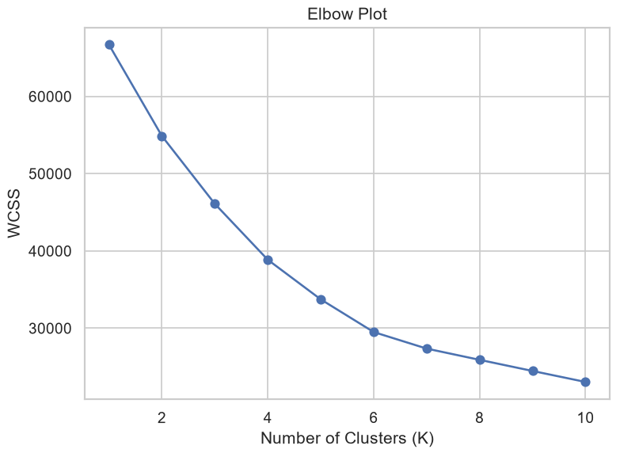
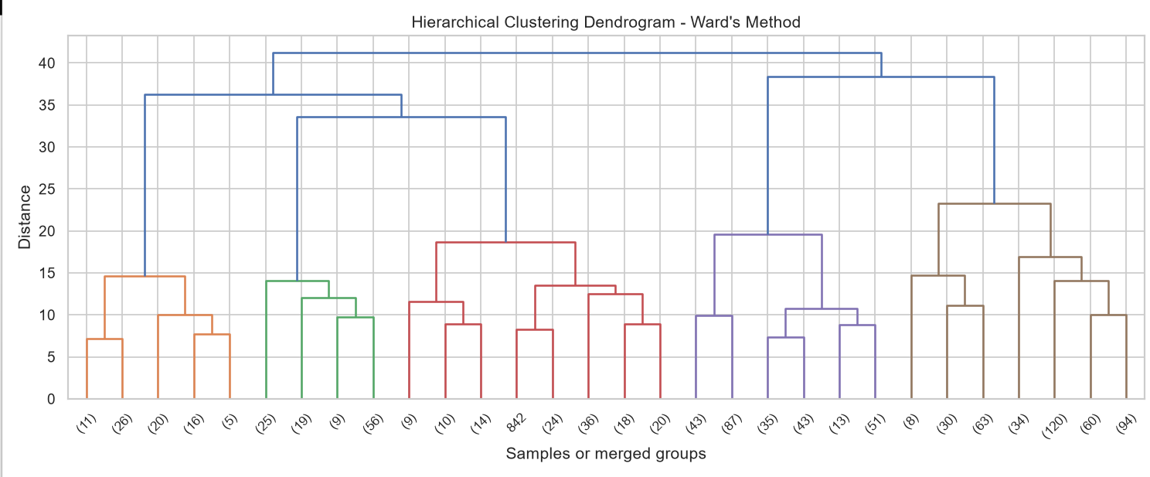
Assessment 9
PS C:\Users\MOHANAPRIYA KUMAR> py "D:\VIT Sem 7\Assignments\EDA\EDA_Assignment_Unifiec\Assessment_9.py"
Loaded happiness dataset shape: (17137, 34)

==============================================================================
ASSESSMENT 9: PCA USING THE HAPPINESS DATASET
==============================================================================
Number of rows: 17137
Number of columns: 34

PCA summary:
Component Standard Deviation Proportion of Variance Cumulative Proportion
0 PC1 1.633128 0.156577 0.156577
1 PC2 1.378605 0.111575 0.268153
2 PC3 1.231809 0.089079 0.357232
3 PC4 1.117486 0.073312 0.430543
4 PC5 1.079518 0.068415 0.498958
5 PC6 1.059055 0.065845 0.564803
6 PC7 1.033322 0.062684 0.627488
7 PC8 0.986338 0.057114 0.684601
8 PC9 0.951107 0.053106 0.737708
9 PC10 0.919601 0.049646 0.787354
10 PC11 0.890115 0.046514 0.833868
11 PC12 0.858116 0.043230 0.877097
12 PC13 0.811677 0.038677 0.915775
13 PC14 0.788092 0.036462 0.952237
14 PC15 0.688665 0.027842 0.980079
15 PC16 0.417453 0.010231 0.990310
16 PC17 0.406277 0.009690 1.000000

First six PCA score rows:
PC1 PC2 PC3 PC4 PC5 PC6 PC7 PC8 PC9 PC10 PC11 PC12 PC13 PC14 PC15 PC16 PC17
14163 2.420400 0.661594 -0.030317 -1.291677 0.710255 0.738543 0.959925 -1.112973 0.932736 1.310949 -0.538573 -0.991812 -0.838564 -0.530301 0.714185 1.177919 -1.413192
14164 -1.236584 -1.181530 2.065079 -1.150870 -0.775051 0.109488 -0.942885 1.681832 1.021903 -0.286527 0.533404 -1.123673 -1.403851 -0.498963 0.226195 0.043861 -0.082582
14176 1.540088 0.343826 -0.398103 -1.421654 2.544335 1.823715 -0.455860 1.043868 0.249877 0.182396 -0.690423 0.504230 1.070973 1.460098 -0.076553 -0.140485 -0.033841
14179 -1.167926 -1.056984 -0.307516 -1.086089 0.945038 0.210723 1.045174 0.272938 -0.230575 1.516617 0.989380 -0.115537 -0.627305 -0.671169 -1.077302 -0.038785 0.146386
14180 -1.201951 -0.705424 -0.129817 -0.891502 0.805682 0.303059 0.913633 0.143524 0.008267 1.378734 0.960472 -0.311876 -0.810633 -0.672211 0.598497 -0.173832 0.141033
14182 4.251842 0.894712 -0.148433 0.393108 0.247624 0.296637 2.290707 1.532822 0.753089 -0.893614 2.103834 0.743708 0.480200 -0.657693 -1.042850 -0.080775 0.392836
PS C:\Users\MOHANAPRIYA KUMAR>


