 | 

DEPARTMENT OF ARTIFICIAL INTELLIGENCE AND DATA SCIENCE

MINI PROJECT REPORT

FLIGHTS DELAY AND
Exploratory Data Analysis, Visualization and Data Preprocessing

Submitted by
MOHANA PRIYA B (814725243110)
LEHAA SHRI S (814725243095)
II AI & DS - B

Under the Guidance of
V. EZHIL SWANLY

Submission Date: 24 October 2026

CERTIFICATE

This is to certify that the mini project report titled “Flights Delay And Airline Performance Analysis” is submitted by MOHANA PRIYA B, with team member LEHAA SHRI M, from the Department of Artificial Intelligence and Data Science, SRM TRP Engineering College. The project analyzes patient health indicators and uses data preprocessing, exploratory data analysis and visualization to examine patterns across the available disease categories.
The report is submitted as part of the academic mini project work under the guidance of V.Ezhil Swanly.

ACKNOWLEDGEMENT

We express our sincere gratitude to SRM TRP Engineering College and the Department of Artificial Intelligence and Data Science for providing us with the opportunity, infrastructure, and facilities to successfully complete this mini project.
We express our heartfelt gratitude to our Dr.Perumalraja, Professor & Head, Department of Artificial Intelligence and Data Science, for providing constant encouragement, valuable support, and a motivating academic environment that greatly contributed to the successful completion of this project.
We sincerely thank our project guide, Mr. V. Ezhil Swanly, Assistant Professor, Department of Artificial Intelligence and Data Science, for his valuable guidance, continuous encouragement, constructive suggestions, and unwavering support throughout the development of this project.
We also extend our sincere thanks to all the faculty members of the Department of Artificial Intelligence and Data Science for their valuable inputs and encouragement. We are grateful to our classmates and family members for their continuous support, cooperation, and motivation during the preparation of the healthcare dataset, data analysis notebook, and project report.
Finally, we acknowledge the healthcare datasets and spreadsheets used for this study, as well as the open-source Python libraries and tools that supported the data preprocessing, analysis, visualization, and report preparation. Their availability greatly contributed to the successful completion of this mini project.

MOHANA PRIYA B
LEHAA SHRI M

TABLE OF CONTENTS

- Abstract
- Chapter 1: Introduction
- Chapter 2: Dataset Description
- Chapter 3: Methodology
- Chapter 4: Data Preprocessing
- Chapter 5: Exploratory Data Analysis
- Chapter 6: Results and Interpretation
- Chapter 7: Key Findings and Recommendations
- Chapter 8: Limitations and Future Enhancements
- Chapter 9: Conclusion
- References
- Appendix: Project Files and Visualizations

ABSTRACT
Flight delays are a major challenge in the aviation industry, affecting passenger satisfaction, airline operations, and airport efficiency. This project, Flight Delay and Airline Performance Analysis, aims to analyze flight data using Python to understand delay patterns and evaluate airline performance.
The project uses the 2015 Flight Delays and Cancellations dataset, which contains information about airlines, airports, departure delays, arrival delays, and cancellations. Data preprocessing techniques are applied to handle missing values, remove duplicate records, and prepare the data for analysis. Exploratory Data Analysis (EDA) is performed using Python libraries such as Pandas, NumPy, Matplotlib, and Seaborn. Visualizations are used to examine delay distributions, compare airline performance, and identify patterns in flight delays.
The analysis helps highlight important factors associated with flight delays and provides insights that may support better operational planning and decision-making. The project demonstrates how data analysis and visualization can be used to understand real-world aviation problems and improve the interpretation of flight performance data.

CHAPTER 1: INTRODUCTION

1.1 Background
Flight delays are a common challenge in the aviation industry, affecting passengers and airline operations. Data analysis helps identify delay patterns and compare airline performance. This project uses Python to analyze flight data through preprocessing, statistics, and visualization.

1.2 Problem Statement
Flight data may contain missing values and duplicate records, making analysis difficult. This project examines flight delays and airline performance using Exploratory Data Analysis

1.3 Objectives
- To load and inspect the flight delay dataset using Python and Pandas.
- To understand the dataset dimensions, column names, data types, and descriptive statistics.
- To identify and handle missing values and duplicate records where appropriate.
- To prepare the data for analysis by applying suitable data preprocessing techniques.
- To analyze departure delays and arrival delays using statistical summaries.
- To compare flight delay patterns across airlines using appropriate visualizations.
- To create graphs that help identify distributions, trends, and relationships in the available flight data.

1.4 Scope
This project focuses on analyzing flight delay data from the year 2015.
It examines departure delays, arrival delays, and airline performance.
Data preprocessing is performed to prepare the dataset for analysis.
Python libraries are used to summarize data and create visualizations.
The analysis helps identify patterns and understand flight delay trends.

1.5 Expected Outcome
The project aims to analyze flight delay patterns using Python.
It produces a cleaned dataset and a Google Colab notebook.
Visualizations help compare delays across different airlines.
The analysis identifies important observations about flight performance.
The final report summarizes the results and recommendations.

CHAPTER 2: DATASET DESCRIPTION

2.1 Dataset Source
The project uses the 2015 Flight Delays and Cancellations dataset obtained from Kaggle. It contains flight information, airline details, airport information, departure delays, arrival delays, and cancellation data. The dataset is analyzed using Python and Pandas in Google Colab.
Dataset link: https://www.kaggle.com/datasets/usdot/flight-delays

2.2 Dataset Overview
- Dataset Name: 2015 Flight Delays and Cancellations
- Dataset Source: Kaggle
- Records Analyzed: 10,000 flight records (sample)
- Files Used: flights.csv, airlines.csv, and airports.csv
- Key Attributes: Airline, origin airport, destination airport, departure delay, arrival delay, and cancellation information.

2.3 Attribute Description
Airline | Description | Role
Origin Airport | Airline operating the flight | Categorical feature
Destination airport | Airport from which the flight departs | Categorical feature
Departure Delay |  | Categorical feature
  Delay in departure time (minutes
Arrival delay | Delay in arrival time (minutes) | Numerical feature
Scheduled departure | Planned departure time | Numeric feature
Scheduled arrival | Planned arrival time | Time related feature
Cancellation | Indicates whether the flight was cancelled | Time related feature
Distance | Distance between origin and destination airports | Numerical feature

CHAPTER 3: METHODOLOGY

3.1 Project Workflow
- Load the flight delay dataset in Google Colab.
- Inspect the dataset structure, data types, and missing values.
- Clean and prepare the data for analysis.
- Calculate descriptive statistics and analyze flight delays.
- Create visualizations to compare delay patterns and airline performance.
- Interpret the results and identify key findings.

3.2 Tools and Technologies
Python in Google Colab, Pandas and NumPy for data processing, and Matplotlib and Seaborn for data visualization were used in this project.

CHAPTER 4: DATA PREPROCESSING

4.1 Data Inspection
The flight dataset is loaded using Pandas in Google Colab. The dataset dimensions, column names, data types, and missing values are examined to understand its structure.

4.2 Cleaning and Preparation
Missing values and duplicate records are identified and handled wherever necessary. The data is prepared to improve its quality and suitability for analysis

4.3 Categorical Encoding
The data types of relevant columns are checked to ensure that numerical and categorical attributes are suitable for analysis and visualization.

4.4 Feature Review
Relevant attributes such as airline, departure delay, arrival delay, and airport details are selected for analyzing flight delay patterns and airline performance

4.5 Clean Dataset Summary
The prepared dataset is used for descriptive statistics and visualization. The analysis focuses on understanding flight delays and comparing airline performance using the selected records.

CHAPTER 5: EXPLORATORY DATA ANALYSIS

5.1 Dataset Summary
Metric | Result
Record analysed | 2015 flight delays and cancellations
Dataset files | 10000
Number of columns | To be confirmed form colab
Data source | Kaggle
Key attributes | Airline, departure delay, arrival delay, airports, cancellation

5.2 Departure Delay Analysis
Departure delays are examined to understand their distribution and identify variations in flight departure times.

5.3 Arrival Delay Analysis
Arrival delays are analyzed using statistical summaries and visualizations to understand differences between scheduled and actual arrival times.

5.4 Airline Performance Analysis
Flight delays are compared across airlines to identify differences in departure and arrival delay patterns

5.5 Visualizations
Graphs such as histograms, bar charts, and comparison plots are used to present flight delay distributions and airline performance patterns clearly.
5.1 Distribution of Flight Departure Delays
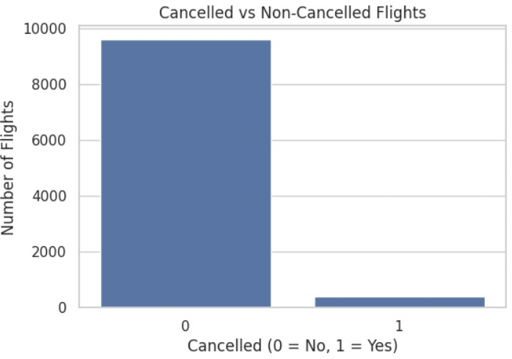

5.3 Average Arrival Delay by Airline

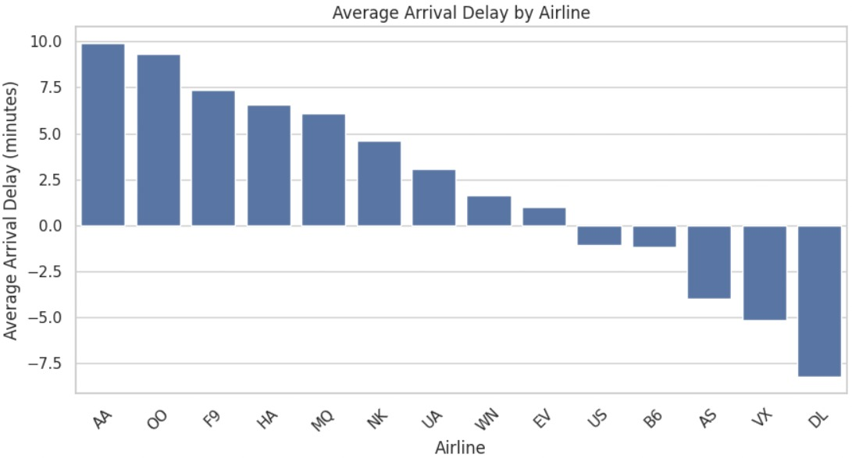

5.4 Cancelled vs Non-Cancelled Flights

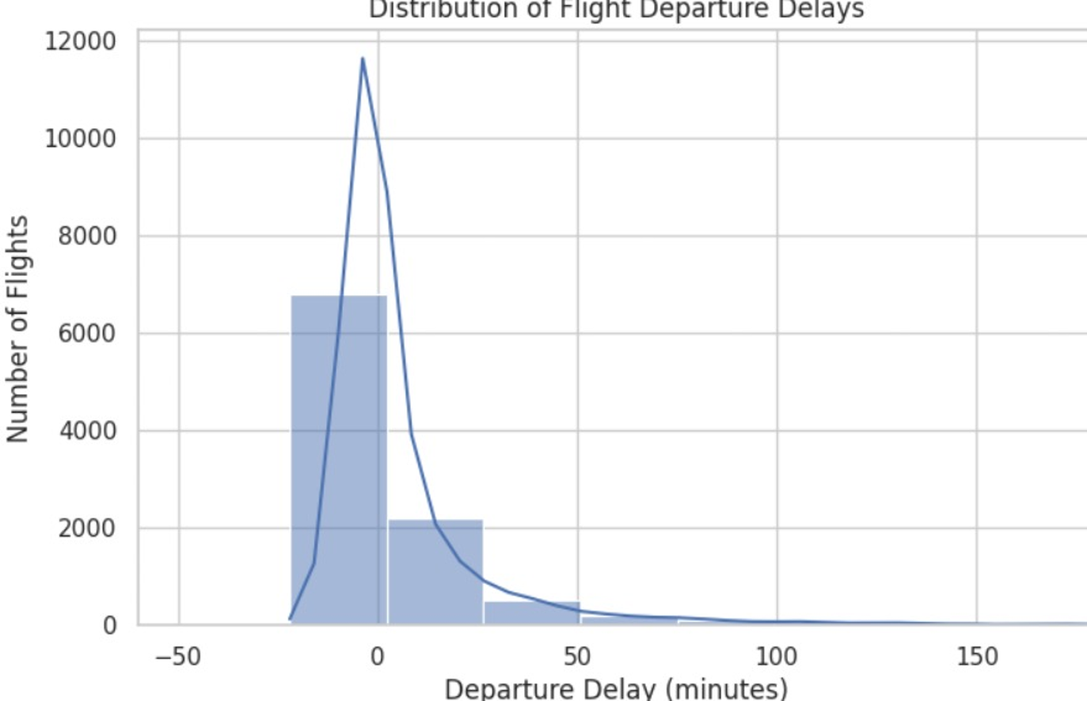

5.5 Flight Dataset Preview
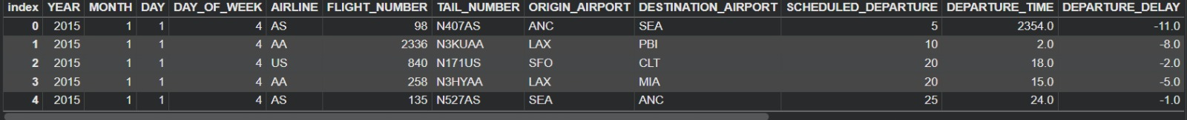

CHAPTER 6: RESULTS AND INTERPRETATION
The analysis of flight data was performed using Python in Google Colab. The visualizations helped identify patterns in departure delays, arrival delays, and flight cancellations.
6.1 Departure Delay Analysis
The histogram shows the distribution of departure delays. Most flights are concentrated around smaller delay values, while a smaller number of flights experience longer delays.
6.2 Arrival Delay Analysis
The bar chart compares average arrival delays across airlines. Some airlines show positive average delays, while others show negative values, indicating that flights arrived earlier than their scheduled arrival times on average.
6.3 Flight Cancellation Analysis
The bar chart shows that non-cancelled flights greatly outnumber cancelled flights in the analyzed sample of
The project output consists of the cleaned healthcare workbook, Google Colab notebook and five charts. These outputs demonstrate an end-to-end introductory workflow for health data inspection, preprocessing and visualization.

CHAPTER 7: KEY FINDINGS AND RECOMMENDATIONS

7.1 Key Findings
- The departure-delay histogram shows that flight delays vary across the analyzed sample.
- The average-arrival-delay chart shows differences in delay patterns among airlines.
- The cancellation chart indicates that non-cancelled flights greatly outnumber cancelled flights in the sample.
- The visualizations provide a simple overview of flight delay patterns and airline performance.

7.2 Recommendations
- Airlines can review recurring delay patterns to support scheduling and operational planning.
- Future analysis should examine possible factors such as departure time, route, and weather when suitable data are available.
- Missing values and duplicate records should be checked carefully before drawing conclusions.
- Analysis should be repeated on a larger portion of the dataset to obtain more representative results.
- Additional visualizations can be used to compare departure and arrival delays across airlines and airports.
- Operational recommendations should be based on verified results and additional supporting data.

CHAPTER 8: LIMITATIONS AND FUTURE ENHANCEMENTS

8.1 Limitations
- The analysis uses a sample of 10,000 flight records, so the findings may not represent the entire 2015 dataset.
- The current analysis focuses on selected attributes and does not examine every possible cause of flight delays.
- The visualizations show patterns in the available data but do not establish that one factor causes a delay.
- The project is based on exploratory data analysis and does not include a predictive machine-learning model.

8.2 Future Enhancements
- Analyze a larger portion or the complete dataset to improve the coverage of flight records.
- Include additional relevant factors, such as weather and route information, if suitable data are available.
- Perform more detailed comparisons of delays by airline, airport, route, and scheduled departure time.
- If prediction is attempted in future, train and evaluate an appropriate model using a separate test dataset and suitable metrics.

CHAPTER 9: CONCLUSION
This mini project demonstrates the use of Python, Pandas, Matplotlib, and Seaborn to explore flight delay data. A sample of 10,000 records from the 2015 Flight Delays and Cancellations dataset was examined in Google Colab. The visualizations were used to study departure-delay distribution, compare average arrival delays across airlines, and review cancelled and non-cancelled flights. The analysis provides an introductory view of flight delay patterns. Further work using more data and additional relevant factors could provide deeper insights into airline performance.

REFERENCES
- User-supplied healthcare spreadsheets: messy_healthcare_data(1).xlsx and cleaned_healthcare_data(1).xlsx.
- Pandas documentation: https://pandas.pydata.org/docs/
- Matplotlib documentation: https://matplotlib.org/stable/
- Seaborn documentation: https://seaborn.pydata.org/

APPENDIX: PROJECT FILES AND VISUALIZATIONS
The project materials used for this report include the Google Colab notebook, raw and cleaned healthcare spreadsheets, and the visualization outputs.
- heathcare data analysis.ipynb
- messy_healthcare_data(1).xlsx
- cleaned_healthcare_data(1).xlsx
- Healthcare_Data_Analysis_Disease_Risk_Prediction_Report(1).pdf
- kernal density estimate(1).png — Age distribution
- grouped bar chart(1).png — Average BMI and glucose by disease category
- scattter plot(1).png — Blood pressure vs cholesterol
- grouped bar chart (1).png — Disease distribution across gender
- correlation heatmap(1).png — Correlation matrix

GITHUB LINK:
https://github.com/ammushalini-hue/Healthcare-Data-Analysis-and-Disease-Risk-Prediction

