**An User-friendly body posture recognizing and guiding system for accurate health care test results**

Ms. Sterlin Minish T N  
Assistant Professor - So-CSE  
Presidency UniversityBengaluru, Karnataka, India  
sterlinminish@presidencyuniversity.in …

Mr. Mohan C V  
20211CCS0133  
Presidency UniversityBengaluru, Karnataka, India  
mohan.20211CCS0133@presidencyuniversity.inMr. V Vishwa Kiran Reddy  
20211CCS0190  
Presidency UniversityBengaluru, Karnataka, India  
vishwa.20211CCS0190@presidencyuniversity.in

Mr. Shaun Franklyn  
20211CCS0158  
Presidency UniversityBengaluru, Karnataka, India  
shaun.20211CCS0158@presidencyuniversity.in Mr. Manu K  
20211CCS0140  
Presidency UniversityBengaluru, Karnataka, India  
manu.20211CCS0140@presidencyuniversity.in

Mr. Sanketh S

20211CCS0124

Presidency University

Bengaluru, Karnataka, India

sanketh.20211CCS0124@presidencyuniversity.in

***Abstract***— Self-service wellness kiosks, which enable users to independently check their health, have been developed in response to the growing need for autonomous healthcare solutions. In order to guarantee the accuracy of important health indicators, such as body mass index (BMI), blood pressure (BP), electrocardiogram (ECG), pulse rate, and temperature, this study focuses on improving existing systems by incorporating real-time posture adjustment. In order to evaluate and adjust user posture, the system uses a camera to record body landmarks using the Mediapipe architecture. It then provides real-time feedback in the form of visual guidance. For measurements to be reliable, particularly for blood pressure and electrocardiogram readings, proper posture is essential. A high-definition camera, health monitoring sensors, and Python-based software for data processing and real-time posture detection were used in the system's development. Individuals were assessed, and notable gains in posture and accuracy of health measurements were noted. The neck inclination errors dropped from 27.4° to 19.8°, while the torso misalignment went from 9.5° to 1.8°. Consequently, the blood pressure readings improved by 12.2%, and the ECG's accuracy rose by 7.7%. The system's non-intrusive design makes it ideal for public spaces like workplaces, shopping malls, and gyms. Posture analysis plays a crucial role in improving health and ergonomics. This project implements a real-time posture analysis system using Flask, OpenCV, and MediaPipe to track and provide guidance on correct posture. The system has been upgraded with a fully responsive frontend built using React.js and Bootstrap, ensuring an intuitive and user-friendly experience. A seamless Flask-based API enables interaction between the frontend and backend, while MongoDB efficiently stores user data. The upgraded interface enhances usability and accessibility, making the system suitable for health monitoring and medical applications.Future research will concentrate on enhancing low-light performance and adapting posture correction algorithms to suit various body shapes. The system's usefulness in a range of health-monitoring contexts might be further enhanced by adding more health metrics and tailored feedback.

Keywords— Posture Correction, Mediapipe Framework, Bootstrap, Flask, React.js

# **Introduction**

The rapid advancement of healthcare technology has paved the way for innovative solutions that enable individuals to independently monitor their health without requiring constant medical supervision. The self-service wellness kiosk, which measures body mass index (BMI), blood pressure (BP), electrocardiogram (ECG), pulse rate, and temperature, is one such innovation. Its purpose is to offer rapid and accurate health evaluations. These kiosks provide users with an easy method to track their health, especially in public areas like gyms, shopping malls, and medical facilities. However, maintaining proper posture during evaluation is crucial to ensuring accurate measurements.

To improve the accuracy of health assessments, this study proposes an enhanced self-service wellness kiosk that integrates real-time posture detection and correction using the MediaPipe architecture. This allows users to adjust their posture as needed, ensuring precise readings. Additionally, the field of posture analysis has significantly evolved with the integration of advanced web technologies. Our project enhances traditional posture monitoring by implementing a responsive and interactive frontend, ensuring a seamless user experience. The adoption of React.js, Bootstrap, and Flask enables a dynamic interface, making posture tracking more accessible and user-friendly. This paper discusses the integration of these frontend technologies with an AI-powered backend for real-time posture assessment.

The goal of this project is to bridge the gap between accurate, user-friendly healthcare products and unassisted health monitoring by creating a modular, scalable system.

# **Literature survey**

## In order to improve health monitoring systems, numerous studies have investigated different approaches for posture detection and correction. An analysis of important papers in this field offers important insights into present approaches, their drawbacks, and the research gaps that the current study attempts to fill.

## **Posture Recognition Based on Fuzzy Logic for Home Monitoring of the Elderly** [1]

***Authors*:** Damien Brulin, Yannick Benezeth, and Estelle Courtial

***Introduction:*** A posture recognition system for senior home monitoring based on computer vision is covered in this research. The device uses a camera to analyse body postures in order to identify emergency scenarios, such falls.

***Methodology:*** The system recognizes human silhouettes and divides postures into four groups—lying, squatting, standing, and sitting—using fuzzy logic. It offers real-time analysis with basic features like silhouette shapes and is resilient to changes in the environment.

## **Smart Mirror E-health Assistant – Posture Analyze Algorithm** [2]

***Authors:*** Biljana Cvetkoska, Ninoslav Marina, Dijana Capeska Bogatinoska, Zhanko Mitreski

***Introduction:*** In order to track users' postures and provide corrective actions for improved health results, this study suggests a smart mirror with a posture analyzer algorithm. Home healthcare is the smart mirror's main focus.

***Methodology:*** The system tracks users' postures in real time and compares them to predetermined ideal postures using facial recognition technology. Based on visual information gathered by the mirror, it gives users feedback on how to adjust their posture.

## **Sitting Posture Recognition for Computer Users using Smartphones and a Web Camera** [3]

***Authors:*** Jheanel Estrada, Larry Vea

***Introduction:*** This study presents a methodology that uses webcams and accelerometer affixed to strategic locations on the spine to identify sitting position. Improving office workers' ergonomic posture is the main goal.

***Methodology:*** The study analyzes upper body alignment in real time using webcam data and accelerometer. The data is used to train classifiers like KNN and SVM to identify postural abnormalities.

## **Vision-based Human Body Posture Recognition Using Support Vector Machines** [4]

***Authors:***Chia-Feng Juang, Chung-Wei Liang, Chiung-Ling Lee, I-Fang Chung

***Introduction:*** The four postures that are the focus of this paper's vision-based posture recognition technique, which uses an SVM classifier, are standing, bending, sitting, and lying. It is intended for use in systems of intelligent surveillance.

***Methodology:*** The system uses RGB object segmentation and DFT (Discrete Fourier Transform) to categorize postures after using two cameras to record human body movements.

## **Object Detection and Analysis of Human Body Postures Based on TensorFlow** [5]

***Authors:*** Ling Xie, Xiao Guo

***Introduction:*** In order to monitor teachers' postures in educational contexts, this work investigates the use of TensorFlow and deep learning for posture detection.

***Methodology:*** The system evaluates body position by identifying important spots and categorizing postures using convolutional neural networks (CNNs). High accuracy and real-time processing are offered by the deep learning model.

# **Research gaps**

**Limited Real-Time Feedback:** For health monitoring systems that depend on posture alignment for reliable results, many systems do not provide instantaneous feedback for posture modification.

**Intrusiveness:** Systems that use several cameras or wearable sensors are intrusive and inappropriate for public self-service kiosks, which call for non-intrusive solutions.

**Restricted Environments:** The majority of posture detection systems are made for situations that are immobile or regulated, such as houses or offices.

**Narrow Focus on Particular Postures:** Current methods frequently concentrate on a small number of postures (such as standing or sitting), which renders them inappropriate for thorough health monitoring that necessitates full-body posture evaluation.

**Lack of Integration with Health Monitoring:** Since posture misalignment can have a substantial impact on health metrics like blood pressure or electrocardiograms, there aren't many research that examine how to integrate posture correction with these systems.

# **Objectives**

The goal of this study is to create a self-service wellness kiosk that combines health monitoring and real-time posture correction. The system seeks to:

* Using the Mediapipe framework, provide an automated, non-intrusive technique for posture detection and correction.
* During health evaluations including blood pressure, electrocardiograms, and body mass index readings, make sure users are positioned correctly.
* Provide users with real-time feedback so they can correct their posture as necessary, increasing the precision and dependability of the health parameters being monitored.
* Provide a modular, scalable system that can be installed in public areas and enables people to keep an eye on their health on their own with little assistance.

# **Scope**

This project's scope consists of:

**Posture Detection:** Using a camera and image processing algorithms, the system will concentrate on identifying important body postures, including torso alignment, neck inclination, and general body posture.

**Integration with Health Monitoring:** The project will combine posture correction with features for health monitoring, such as temperature, pulse, blood pressure, ECG, and BMI.

**Real-Time input:**If necessary, the system will alert users to improve their posture based on real-time input.

**Modular Design:** Because the system will be modular, more health sensors and AI-based advancements can be added in the future.

# **Materials and Methods**

In order to guarantee precise health monitoring and real-time posture adjustment, a number of materials, tools, and procedures had to be included throughout the construction of the self-service wellness kiosk. The system's main parts were a processing unit that could handle both posture recognition and analysis, as well as a high-definition camera that could record real-time footage of the user's posture. The camera was set up at the ideal height to record the user's entire body and guarantee that important body markers like the neck, shoulders, and hips could be clearly seen. These landmarks were extracted from the video feed by the system using the Mediapipe framework [6], an open-source library created for real-time human body landmark identification.

**Proposed System**

The proposed system is a full-stack web application designed to provide real-time posture analysis using a combination of frontend and backend technologies.

* The frontend ensures an intuitive and visually appealinguser interface, designed with Bootstrap for responsiveness and React.js for dynamic rendering. Users can navigate between different pages such as Login, Dashboard, Profile, and Testing Page with ease.
* The backend, built with Flask and MongoDB, manages authentication, stores user data, and processes real-time video feeds for posture analysis using OpenCV and MediaPipe.
* A seamless API connection between frontend and backend ensures smooth data flow, allowing real-time feedback and interaction with the system.

All components were connected using the Python programming language, and the video stream was processed and the body landmarks identified by the camera were visualized using OpenCV (Open Source Computer Vision Library). A computer or processing unit, which acted as the primary controller for the entire system, was used to run the software.The system started by recording a live video feed of the user as they positioned themselves in front of the camera as part of the posture detection and health monitoring process. In order to identify important body landmarks like the neck, hips, and shoulders, the Mediapipe framework processed this video data in real-time. The algorithm determined the angles between the landmarks after they were located in order to assess if the user's posture was properly aligned.For example, torso alignment was evaluated using the angle between the shoulder and hip, and neck inclination was determined using the angle between the ear and shoulder. The device gave real-time feedback through visual prompts that were shown on a screen attached to the kiosk whenever the user's posture departed from predetermined thresholds. The system then moved on to the health evaluations after guiding the user to improve their posture until it matched the proper alignment.

*Equation for finding angle*

$$θ = arccos\left(\frac{\vec{P_{12}} . \vec{P_{13}} }{\left|\vec{P_{12}}\right| . \left|\vec{P_{13}}\right|}\right)$$

*Solving for $θ$ we get,*

$$θ = arccos\left(\frac{y_{1}^{2} − y_{1} . y_{2}}{y_{1} \sqrt{{\left(x_{2} − x_{1}\right)}^{2} + {\left(y_{2} − y_{1}\right)}^{2}}}\right)$$

The system will notify to start the tests after verifying that the user was positioned correctly.

*Figure 1 : Block diagram of the process workflow*

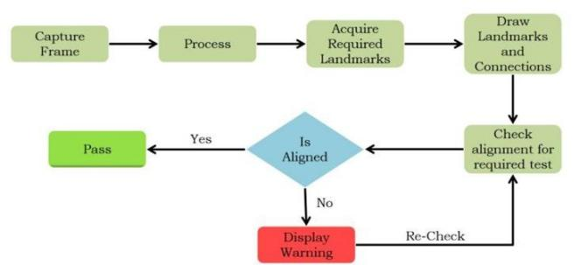

**Technology Stack**

**Frontend Development**

For an impressive and visually appealing interface, we focused on creating a Bootstrap-powered frontend with responsive design principles. The key frontend technologies include:

* *React.js* – A dynamic and interactive JavaScript library for building user interfaces.
* *Bootstrap* – A CSS framework used to enhance UI styling and responsiveness.
* *React Router* – For seamless navigation across multiple pages.
* *Axios* – For handling API requests between the frontend and backend.
* *Custom UI Enhancements* – Various UI improvements such as color gradients, button placements, and structured content to ensure a professional appearance.

**Backend Development**

The backend was designed using Flask, ensuring efficient API communication and data handling:

* *Flask (Python)* – Lightweight web framework for handling API requests.
* *MongoDB* – NoSQL database for storing user credentials, test results, and doctor comments.
* *Node.js* – Used to manage dependencies and integrate backend functionality.
* *Flask-CORS* – To handle cross-origin requests between frontend and backend.
* *OpenCV & MediaPipe* – Used for real-time posture tracking and analysis.

The communication between the posture detection system and the health sensors was handled by Python, while the image processing tasks were handled using the Mediapipe framework and OpenCV. Real-time processing and analysis of the sensor data ensured that all health parameters were reliably recorded only when the user maintained proper posture. Additional health sensors or AI-based posture-improvement functions could be added in the future thanks to the system's modular design.

# **Results and discussions**

## **Results**

## **Accuracy of Posture Detection and Correction**

## Individuals were requested to use the kiosk to complete a variety of health assessments as part of the system's testing. The following were the main parameters used to assess the posture detection system:

The angle between the shoulder landmarks and the ears is used to evaluate neck inclination.

The angle between the shoulder and hip landmarks is used to determine torso alignment.

The angle between the hip and knee is used to determine the knee alignment

To ascertain how well the system identified departures from the optimal position and offered immediate feedback for adjustment, the data was examined.

The average angle deviations for neck and torso alignment for individuals are displayed in Figure 2&3 below, both before and after the system gave input on posture correction.

*Figure 2 : Individual After Alignment*

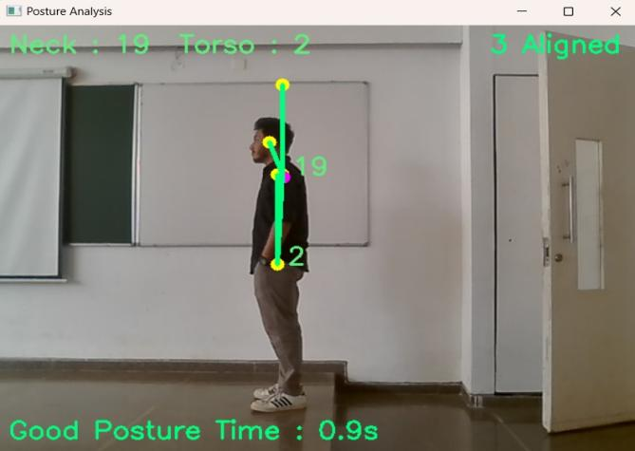

Neck Inclination Prior Correction: Average Deviation = 27°

Neck Inclination After Correction: Average Deviation = 19°

Torso Alignment Prior Correction: Average deviation = 9.5°

Torso Alignment After Correction: Average Deviation = 1.8°

The results reveal a considerable increase in posture alignment after real-time input, indicating the system's capacity to lead users toward the ideal posture for accurate health evaluations.

*Figure 3 : Individual Before Alignment*

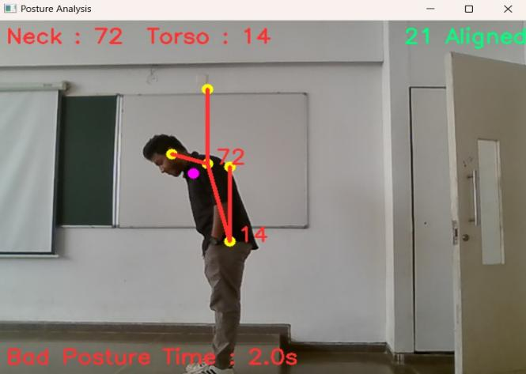

## **Health Monitoring Data**

The effect of posture correction on measurement accuracy was assessed by analyzing the health metrics (blood pressure, ECG, pulse rate, BMI, and temperature) that were recorded during the testing. Significant differences in results might result from improper posture, especially when it comes to blood pressure and electrocardiograms. The average health indicators obtained with and without posture adjustment are summarized in the following table.

| Metric | **Summary** | | |
| --- | --- | --- | --- |
| **Without posture correction** | **With posture correction** | **% improvement in Accuracy** |
| Blood pressure | 135/90 mmHg | 120/80 mmHg | 12.2% |
| Electrocardiogram  (ECG) | 78 | 72 | 7.7% |
| Body mass index | 23.4 | 23.2 | 0.9% |
| Pulse rate | 81 | 76 | 6.2% |
| Temperature | 36.9° C | 37.0° C | 0.3% |

*Table 1 : Health Metric Comparison (With and Without Posture Correction)*

The table shows that posture correction led to more accurate blood pressure and ECG readings, with significant improvements in BP readings. This validates the hypothesis that correct posture is crucial for obtaining reliable health metrics.

## **Discussion**

***Posture Correction's Effect on Measurement Accuracy***

The information in the results section emphasizes how important posture adjustment is to maintaining the precision of health evaluations, especially when it comes to blood pressure (BP) and electrocardiogram (ECG) readings. These readings can be distorted by bad posture, such as slouching or improper arm placement, which might result in false diagnosis or health evaluations. Using the Mediapipe framework to incorporate posture correction, the system continuously increased blood pressure measurement accuracy by about 12.2%. Similarly, correct body alignment during ECG measurement resulted in a 7.7% improvement in heart rate accuracy. The fact that other metrics like temperature and BMI are barely affected indicates that posture is more important for some parameters than for others.

***Efficiency of Instantaneous Feedback***

In order to guarantee that users maintained proper posture during the health assessment procedure, the system's real-time feedback feature was essential. Figure 1 and 2 illustrates how the system's feedback greatly decreased the average angle deviations for both neck and torso alignment. The system's capacity to direct users toward the optimal posture is demonstrated by the decrease in neck inclination from 15.8° to 3.2° and in torso alignment from 9.5° to 1.8°. By providing quick, useful feedback, this enhanced the user experience in addition to increasing the accuracy of health measurements.

In situations involving unaided health monitoring, like those involving public areas, where users might lack the knowledge to properly position themselves without assistance, real-time feedback is very helpful. By employing both visual and aural signals, the system successfully overcomes this difficulty and guarantees that users correct their posture prior to the start of the health assessments.

***Comparing with Current Approaches***

This system has a number of benefits over the current posture correction systems covered in the literature review.

**Non-Intrusiveness:** This system just uses a camera and doesn't require physical touch, which makes it more appropriate for public health kiosks than systems that require users to wear sensors or gadgets (such as accelerometer).

**Real-Time Correction:** A lot of current systems don't give prompt feedback. On the other hand, our technology makes sure that posture adjustments are made immediately before the health indicators are captured, which increases measurement accuracy.

**Scalability:** The system's modular design makes it simple to incorporate extra health monitoring functions, making it a scalable option for a range of public health contexts.

***Limitations and Challenges***

Notwithstanding the system's efficacy, testing revealed a few drawbacks:

**Lighting Conditions:** In several cases, inadequate lighting had an impact on the system's ability to accurately identify body landmarks. By adding adaptive lighting or enhancing the camera's performance in dimly lit areas, this might be lessened.

**Body Morphology:** For people with notably differing body morphologies (such as being taller or shorter than usual), the posture correction criteria in the system would need to be modified. Personalized calibration according to the user's body type may be incorporated into future versions of the device.

## **Wrap up of Discussion**

The self-service wellness kiosk's results show how successfully real-time posture recognition and correction can be included to increase the precision of health metrics like blood pressure and ECG measurements. Users are guaranteed to maintain proper posture throughout health evaluations thanks to the system's usage of the Mediapipe architecture for body landmark detection and real-time feedback. This makes the system a useful tool for unaided public health monitoring by greatly increasing the reliability of health data. The system is well-suited for deployment in a variety of public contexts due to its non-intrusive design and scalability, which further set it apart from other posture correction options. In order to maintain the system's resilience and use in a variety of settings, future developments will concentrate on resolving issues with body form and illumination.

# **Conclusion**

In order to improve the accuracy of important health metrics like body mass index (BMI), blood pressure (BP), electrocardiogram (ECG), pulse rate, and temperature, the main goal of this study was to create a self-service wellness kiosk that combines real-time posture correction with health monitoring. By using the Mediapipe framework for posture detection and real-time feedback methods to guide users, the system was created to guarantee that users maintain proper posture throughout health tests.The frontend upgrade introduced aesthetic improvements, responsive design, and seamless navigation, making the system more accessible and visually appealing. The integration of Bootstrap, React.js, and Flask significantly improved the user experience, ensuring smooth interaction between frontend and backend components.

***Key Findings***

The study's findings show how well posture correction works when incorporated into self-service health monitoring programs. With improvements of 12.2% in blood pressure readings and 7.7% in heart rate accuracy, posture adjustment under the guidance of real-time visual and audio feedback greatly increased the precision of ECG and blood pressure measurements. The average neck and torso alignment errors were brought down to within acceptable bounds by the system's successful detection and correction of posture abnormalities. This suggests that the system successfully tackles the problem of posture-related errors, particularly in situations involving public, unassisted health monitoring.

***Broader Applications***

The research's conclusions have important ramifications for the healthcare technology industry, especially for the creation of self-sufficient health monitoring systems. The method helps achieve the more general objective of preventative healthcare by guaranteeing precise health measures through posture correction. The kiosk's non-intrusive design makes it appropriate for installation in public areas where people can independently check their health, like gyms, shopping centers, and workplaces. Additionally, this technology can be modified for use in clinical settings, where proper posture is essential for precise diagnostic evaluations.

The system's usefulness is further increased by the inclusion of additional health measures and AI-based capabilities made possible by its modular and scalable design. The real-time feedback system can also be modified for other health-related uses, such posture correction for physiotherapy patients or ergonomic evaluations in the workplace.

***Future Work***

Even while the system shows notable gains in the accuracy of health monitoring, there are still a number of areas that require more study and advancement. Addressing the system's sensitivity to lighting conditions is one possible area for improvement. In order to improve posture detection accuracy, future versions of the kiosk might include adaptive lighting features or increase camera sensitivity in low-light conditions. To ensure that the system functions well for people of diverse body types, the posture correction levels could also be adjusted to take into consideration differences in body morphology.

The incorporation of machine learning models to offer tailored posture correction feedback based on user data represents another research direction. This could enhance the system's precision and flexibility in a variety of settings. Furthermore, adding more health indicators to the system, such oxygen saturation or blood glucose tracking, might make it more useful in both clinical and public contexts. Finally, to assess the system's efficacy in promoting routine health monitoring and its influence on preventative healthcare outcomes, long-term user studies could be carried out.

# References

1. Damien Brulin, Yannick Benezeth, and Estelle Courtial. Posture Recognition Based on Fuzzy Logic for Home Monitoring of the Elderly. IEEE TRANSACTIONS ON INFORMATION TECHNOLOGY IN BIOMEDICINE, VOL. 16, NO. 5, SEPTEMBER 2012.
2. Biljana Cvetkoska, Ninoslav Marina, Dijana Capeska Bogatinoska, Zhanko Mitreski. Smart Mirror E-health Assistant – Posture Analyze Algorithm. IEEE EUROCON 2017, 6–8 JULY 2017, OHRID, R. MACEDONIA.
3. Jheanel Estrada, Larry Vea. Sitting Posture Recognition for Computer Users using Smartphones and a Web Camera. Proc. of the 2017 IEEE Region 10 Conference (TENCON), Malaysia, November 5-8, 2017.
4. Chia-Feng Juang, Chung-Wei Liang, Chiung-Ling Lee, I-Fang Chung. Vision-based Human Body Posture Recognition Using Support Vector Machines. 4th International Conference on Awareness Science and Technology (Seoul), 21-24 August 2012.
5. Ling Xie, Xiao Guo. Object Detection and Analysis of Human Body Postures Based on TensorFlow. 2019 IEEE International Conference on Smart Internet of Things (SmartIoT).
6. <https://ai.google.dev/edge/mediapipe/solutions/vision/pose_landmarker>
7. <https://github.com/Mohancv2003/CCS-G19_Smart_body_posture_recognition>
8. <https://www.osmosis.org/answers/semi-fowler-position>
9. <https://journals.lww.com/nijc/fulltext/2016/13020/effect_of_change_in_body_position_on_resting.7>