



KARNATAKA STATE COUNCIL FOR SCIENCE AND TECHNOLOGY
Indian Institute of Science campus, Bengaluru
Telephone: 080 -23600978, 23341652 || Email: spp@kscst.org.in
Website: www.kscst.org.in/spp.html or https://kscst.karnataka.gov.in/en
FORMAT FOR STUDENT PROJECT PROPOSAL FOR THE
48th SERIES OF STUDENT PROJECT PROGRAMME
(Handwritten proposals will not be accepted, please fill all the details in this MS word file, insert images / diagrams wherever necessary. Convert to pdf file, get it approved from the project guide / head of the department and principal of your institution. Keep ready the scanned pdf file of 1) Declaration and Endorsement 2) details of processing fees made and fill-up the Google Form.
https://forms.gle/ks2WxWB4ei1hgv9D9
Name of the College: PRESIDENCY UNIVERSITY

Project Title: Automated Body Posture Recognizing and Guiding System for Accurate Health Care Test Results

Branch: Computer Science and Engineering Specialization in Cyber Security.

Theme (as per KSCST poster): Integrating Internet of Things in Health Care
(The project proposals shall mandatorily be from one of the broad themes / areas. Visit website www.kscst.org.in/spp.html)
Name(s) of project guide(s):

- Name: Mrs. Sterlin Minish T N
Email id: sterlinminish@presidencyuniversity.in
Contact No.: 94896 58291

- Name: Mr. Praveen Giridhar Pawaskar
Email id: praveen.pawaskar@presidencyuniversity.in
Contact No.: 80956 94000

Name of Team Members (Strictly not more than four students in a batch): (Type names in Capital Letters as provided in your college)
(Please paste the latest passport size photograph adjacent to your respective names)
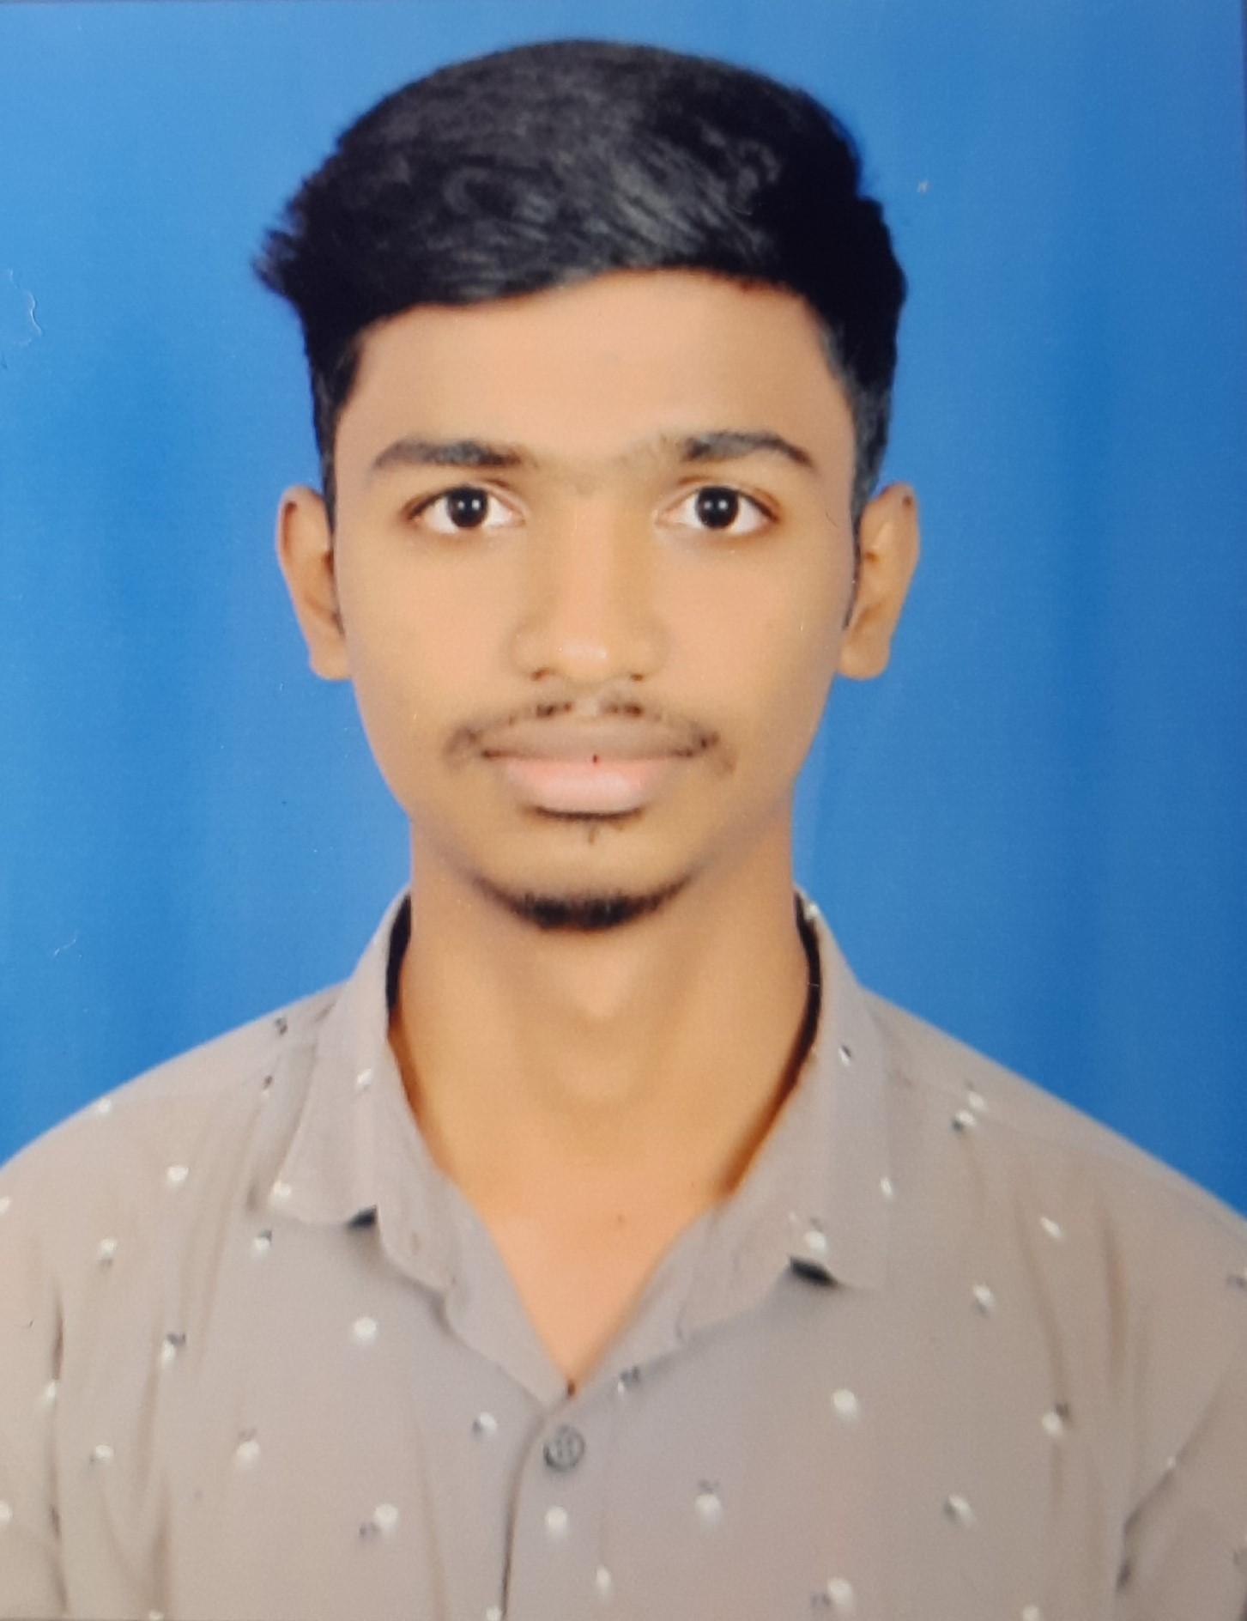
Name: MOHAN C V
USN No.: 20211CCS0133
Email_id:MOHAN.20211CCS0133@presidency university.in
Mobile No: 80730 08155
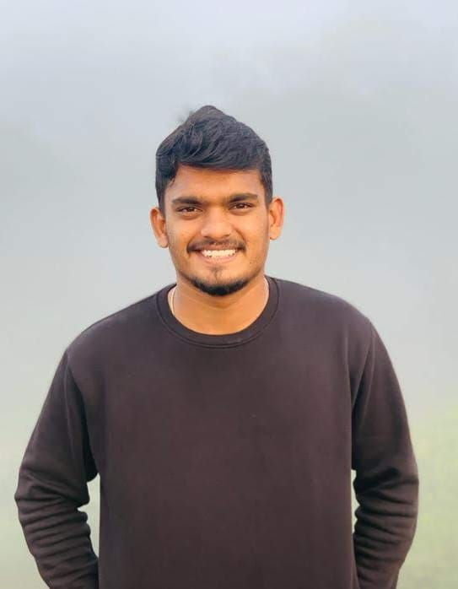
Name: MANU K
USN No.: 20211CCS0140
Email_id:MANU.20211CCS0140@presidency
university.in
Mobile No.: 82177 80965
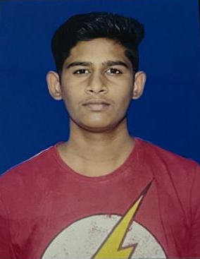
Name: SHAUN FRANKLYN
USN No.: 20211CCS0158
Email_id:SHAUN.20211CCS0158@presidency university.in
Mobile No.: 72043 26558
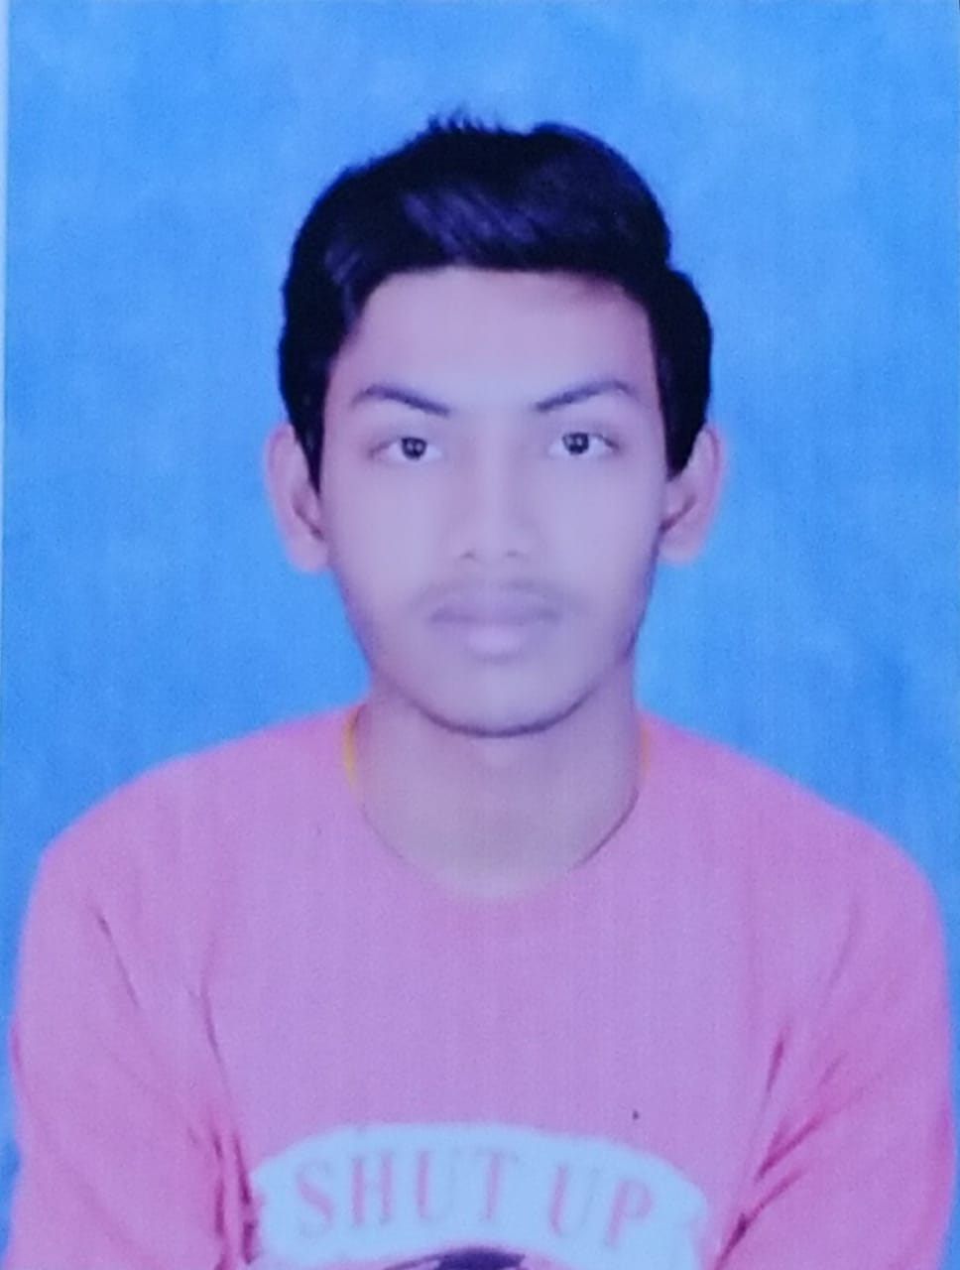
Name: V VISHWA KIRAN REDDY
USN No.: 20211CCS0190
Email_id:VISHWA.20211CCS0190@presidency university.in
Mobile No.: 63631 45755

Team Leader of the Project:
Name: MOHAN C V
USN No.: 20211CCS0133
Email id: MOHAN.20211CCS0133@presidencyuniversity.in
Mobile No: 80730 08155
Processing Fee Details (Through Online Payment only):
(processing fee of Rs. 1180/-)
UPI Transaction ID-432798087780

Please furnish the payment details in the format provided in the last page of the proposal.

Date of commencement of the Project:10-September-2024

Probable date of completion of the project: 30-December-2024

Scope / Objectives of the project:

- Ensure Accurate Health Measurements
- Integrate Real-Time Posture Analysis
- Implement a Flexible Posture Correction System
- Develop an Efficient Image Processing Model
- Modular and Scalable Backend Architecture
- Improve Health Awareness

Methodology:

- Body Landmark Detection: Use Mediapipe framework to detect key body landmarks (e.g., shoulders, hips) from live video feed.
- Posture Analysis:Compare the detected landmarks against predefined reference postures for accuracy in measurements.
- Deviation Calculation: Measure the angle deviation between body parts to identify incorrect posture.
- Real-Time Feedback: Provide real-time corrective feedback to the user if the posture deviates beyond the acceptable threshold.
- Health Parameter Measurement: Once the posture is aligned, measure health vitals like BMI, BMC, BP, ECG, pulse, and temperature.
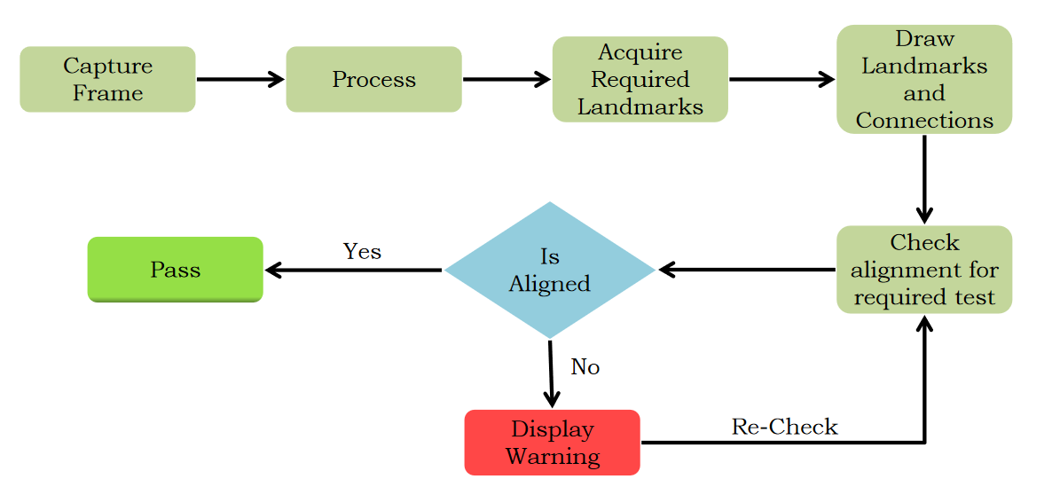

Note: In case of fabrication work in the project, an engineering drawing with dimensions / detailed design should be attached to the proposal.

Expected Outcome of the project:

- Accurate Vital Health Measurements: The system will accurately measure health parameters such as BMI, BMC, BP, ECG, pulse, and temperature, ensuring reliable and precise data collection.

- Posture Correction Guidance: The system will detect improper user posture during the measurement process and provide real-time feedback and corrective guidance. This will help users achieve the correct posture for accurate results.

- Real-Time Feedback and Notifications: Users will receive immediate feedback about their posture and vital measurements, including visual and audio alerts when corrections are needed or when the test is successfully completed.

- Increased Measurement Accuracy: By ensuring that users maintain the correct posture, the system will reduce measurement errors, providing more reliable health data for better analysis and decision-making.

Is the project proposed relevant to the Industry / Society or Institution?

Yes / No: Yes
If yes, please provide details of the industry / institution and contact details: The healthcare industry could benefit from a non-assisted solution that provides real-time analysis of health parameters in public places, workplaces, and healthcare facilities.

(Note: Preference will be given to those projects relevant to the industry / institution. Hence be specific in giving detailed information). Is the industry extending support - technology / funds / use the final product, please specify.

Can the product or process developed in the project be taken up for filing a Patent?
Yes / No: Yes

Prior Art search done?
Yes/No: No

Note: If your answer is “Yes”, you may contact Patent Information Centre of KSCST. For more details, email: pic@kscst.org.in
Budget details (break-up details should be given):
Note: KSCST will provide nominal grant support for carrying out the project by students if selected by the project selection committee.
Budget | Amount
- Materials / Consumables (Please specify)  - High Resolution Cameras  - Computer System | 3,000 - 5,500  (Available)
- Labor (Describe)  - 4-members  - 8-hrs a month  - 4-months  - 75-100 Rs per hour | (4 X 8 X 4 X 75) =9,600  (4 X 8 X 4 X 100) =12,800
- Travel (Describe)  - Healthcare Center Visits (for data collection, validation) | 1,000 - 1,500
e) Miscellaneous (Please specify) | 0.00
Total | 13,600 - 19,800

Any other technical details (Please specify):

- Programming Languages: Python (for backend development)
- Image Processing Library: OpenCV (for live video feed processing)
- Pose Estimation Framework: Mediapipe (for detecting and analyzing body landmarks)
- Hardware: Camera module (for capturing real-time video), sensors (for extended monitoring)

SPP Coordinator (Identified by the college):
Note: To be identified by the principal of the institution. The project proposals must be submitted to KSCST through SPP coordinator designated by the principal.

Name: Prof: Dr. Sampath A K
Email id: sampath.ak@presidencyuniversity.in
Contact No.: 90040 50764

Name of the Project Guide: Mrs.Sterlin Minish T N | Name of the HOD: Dr. S.P. Anandaraj
Email id: sterlinminish@presidencyuniversity.in | Email id: anandaraj@presidencyuniversity.in
Contact No.: 94896 58291 | Contact No.: 97915 84579

DECLARATION
(From Project Students)
(To scan this page and enclose in the project proposal)

We, the project team hereby declare that the details enclosed in the project proposal (Title of the Project: Automated Body Posture Recognizing and Guiding System for Accurate Health Care Test Results, Branch: Computer Science and Engineering Specialization in Cyber Security, College: Presidency University) are true and correct to the best of our knowledge and belief. We undertake to inform the Karnataka State Council for Science and Technology (KSCST) of any changes to the project title or team members' names immediately through our project guide or the SPP Coordinator of our institution.
Additionally, we declare that the project work is original and not a result of copying or purchasing. We are committed to completing the project independently, with support from our faculty and project guide, while utilizing the facilities provided by the college. We will not engage in plagiarism and pledge to be sincere and dedicated in executing and completing the project as proposed.
We understand that if any of the above information is found to be false, untrue, or misleading, we may be held liable. We authorize the sharing of the project information contained in this proposal with KSCST, Bengaluru.
We acknowledge that the project team must exhibit and demonstrate the project, participate in the mid-term evaluation of sanctioned projects, and engage with experts. Additionally, we must exhibit the project at the Annual State-Level Poster Presentation and Exhibition, if selected. Should our team fail to participate in the mid-term evaluation or the Annual Exhibition (if selected), we understand that the supported project funds will be returned to KSCST.
We also enclose the endorsement form for KSCST, Bengaluru.
Name of the students with USN No. Signature with date
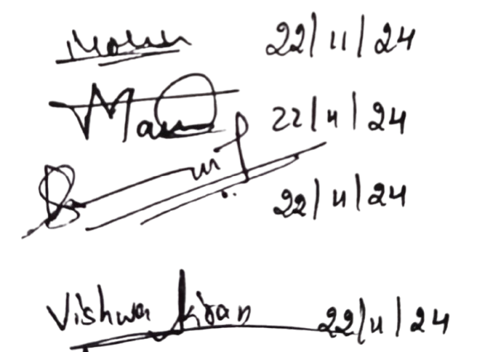
- Mohan C V
- Manu K
- Shaun Franklyn
- V Vishwa Kiran Reddy
(Name & Signature of Project Guide with Seal) | (Name & Signature of HOD with Seal)
Email id: sterlinminish@presidencyuniversity.in | Email id: anandaraj@presidencyuniversity.in
Contact No.: 94896 58291 | Contact No.: 97915 84579

ENDORSEMENT
(From College, endorsement to be taken in the institution / Department Letter head)
(To scan this page and enclose in the project proposal)

This is to certify that 1) Mr. Mohan C V, 2) Mr. Manu K 3) Mr. Shaun Franklyn, 4) Mr. V Vishwa Kiran Reddy, are bonafide student(s) of Department of Computer Science and Engineering in Cyber Security, in the degree program of our institution. If the project proposal submitted by these students under the 48th series of Student Project Programme is selected by KSCST, we will provide the requisite laboratory / Computer / infrastructure support in our college / Institution. Further we also take necessary steps to see that the project team will exhibit / demonstrate their project in the mid-term evaluation of project and in the Annual State-Level Poster Presentation and Exhibition (if selected). If the student team fails to send the completed project report or fails to attend the evaluation in mid-term evaluation of sanctioned projects or fails to attend the Annual State-Level Poster Presentation and Exhibition (if selected), the supported project amount will be returned to KSCST.

(Name & Signature of  Project Guide with Seal) | (Signature of HOD with Seal) | (Signature of the Principal with Seal)
Email_id:sterlinminish@presidencyuniversity.in | Email_id:anandaraj@presidencyuniversity.in | Email id:
Contact No.: 94896 58291 | Contact No.: 97915 84579 | Contact No.:

DETAILS OF PROCESSING FEES MADE THROUGH
NEFT / UPI PAYMENT
(Note: Include this page in the softcopy of the student project proposal. The student team shall furnish the details in the Google Form. It is informed to the students to 1) keep ready the softcopy of the project proposal and other documents and 2) Furnish the payment made details as processing fees and 3) update the details in the Google Form on the same day of payment made to KSCST by NEFT / UPI payment).

- TITLE OF THE PROJECT | : | Automated Body Posture Recognizing and Guiding System for Accurate Health Care Test Results
- NAME OF THE TEAM LEADER | : | Mohan C V
- EMAIL ID | : | MOHAN.20211CCS0133@presidencyuniversity.in
- CONTACT MOBILE NO. | : | 80730 08155
PAYMENT MADE DETAILS
- BANK REF. NO. / UTR NO. / UPI No. (12 digits) | : | 432798087780
- TRANSACTION ID | : | 432798087780
- NAME OF THE SENDER / ACCOUNT HOLDER and CONTACT NUMBER | : | Mohan C V  80730 08155
- NAME OF THE BANK | : | Karnataka Bank
- PROCESSING FEES | : | Rs. 1,180/- (Inclusive of 18% GST)
- DATE OF PAYMENT MADE | : | 22 - November - 2024
- TIME | : | 1:06 PM
- MODE OF PAYMENT MADE  (NEFT / UPI, PLEASE SPECIFY) | : | UPI

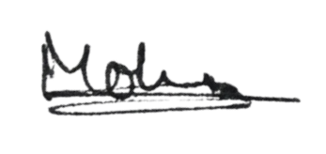  MOHAN C V  (Name & Signature of  the team leader) | (Name & Signature of  Project Guide or HOD with Seal)
KARNATAKA STATE COUNCIL FOR SCIENCE AND TECHNOLOGY
Indian Institute of Science campus, Bengaluru
48th SERIES OF STUDENT PROJECT PROGRAMME (SPP)
(Note: This page is for information about bank details of KSCST to the student team and college / institution and not to include this page in the project proposal softcopy)

BANK ACCOUNT DETAILS OF KSCST
Name and address of the Institution | Karnataka State Council for Science and Technology, IISc Campus, Bangalore -560012
Account holder’s name / Designation | Secretary, Karnataka State Council for Science and Technology
Bank Account No. & Name of the bank | Current A/C No. 0683201000024  Canara Bank, IISc Campus Branch, Bangalore-560012
IFSC Code | CNRB0000683
MICR Code | 560015023
Bank Branch Address | Canara Bank, Indian Institute of Science, Bangalore-560012

