
Initially git status showed that its not a git repository and no branch was tagged to it. After git init, it changed to master branch
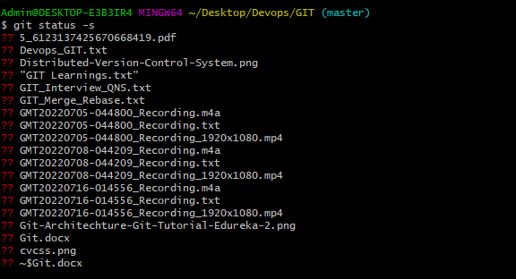
Git status –s – gives short form of status. ?? denotes these files are un tracked files
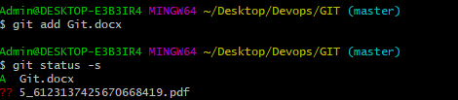
Git add – will push the code to local repository. After that status changed to Added (A)

To check log:
