**Features automated:**

1. Creating of a Mate1.com profile
2. Editing the profile editing the profile details
3. Error messages verification
4. This frame work automatically re-run the failed test cases only for 2 times (Firs run will be done after that only failed test cases will re-run twice automatically)

**Software required:**

Following software are required to run the project

1. Eclipse ( Dowload from this link <http://www.eclipse.org/downloads/packages/eclipse-ide-java-ee-developers/marsr> based on the operating system)
2. JDK 1.7 (Download from this link <http://www.oracle.com/technetwork/java/javase/downloads/jdk7-downloads-1880260.html> from the first table based on operating system and its type)
3. TestNG (Refer this video to add TestNg plugin to Eclipse https://www.youtube.com/watch?v=enrsOjJujwE)
4. Maven (Maven will come by default with the Eclipse we have downloaded)
5. Fire fox browser below 40 version is recommended

**Import the Project into eclipse:**

1. Once the Project has been downloaded from Git it looks like below folder



1. Now go to eclipse🡪File ----🡪import
2. Now a new window will be opened
3. 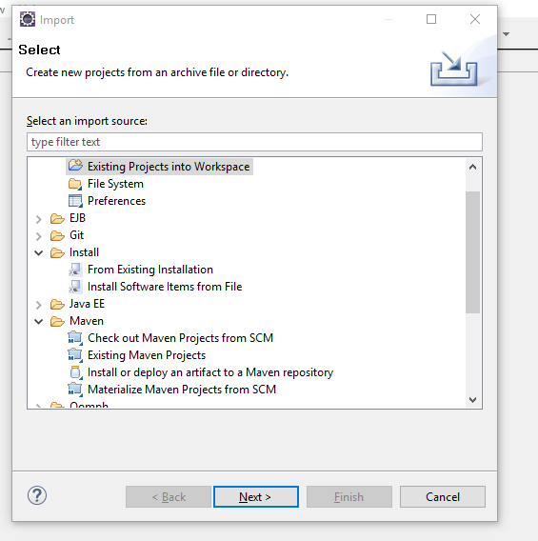
4. Now select the “Existing Maven Projects”
5. Click on “Next” button
6. Then following window will be opened

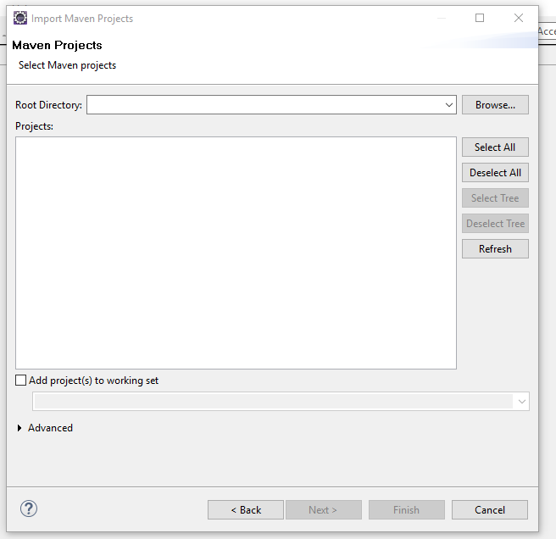

1. Now click on “Browse” and select the Mate1Automation folder which we have downloaded as shown below

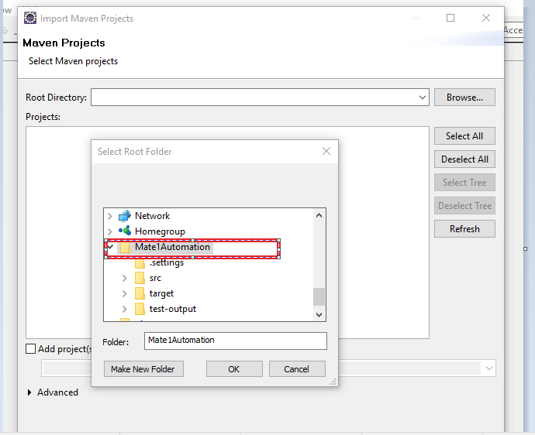

1. Then click on ok
2. Project will be imported into Eclipse and will be shown like this

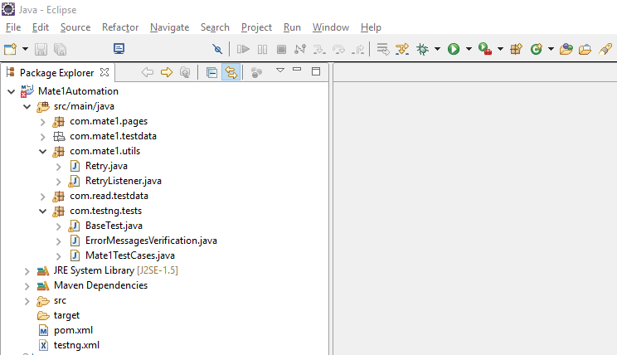

**Running the Mate1Automation Project:**

1. Right click on the pom.xml file
2. Go to Run as -🡪 Maven Clean (After this we will get build success)
3. Again do Run As 🡪 Maven test (Now automation test cases will be invoked)

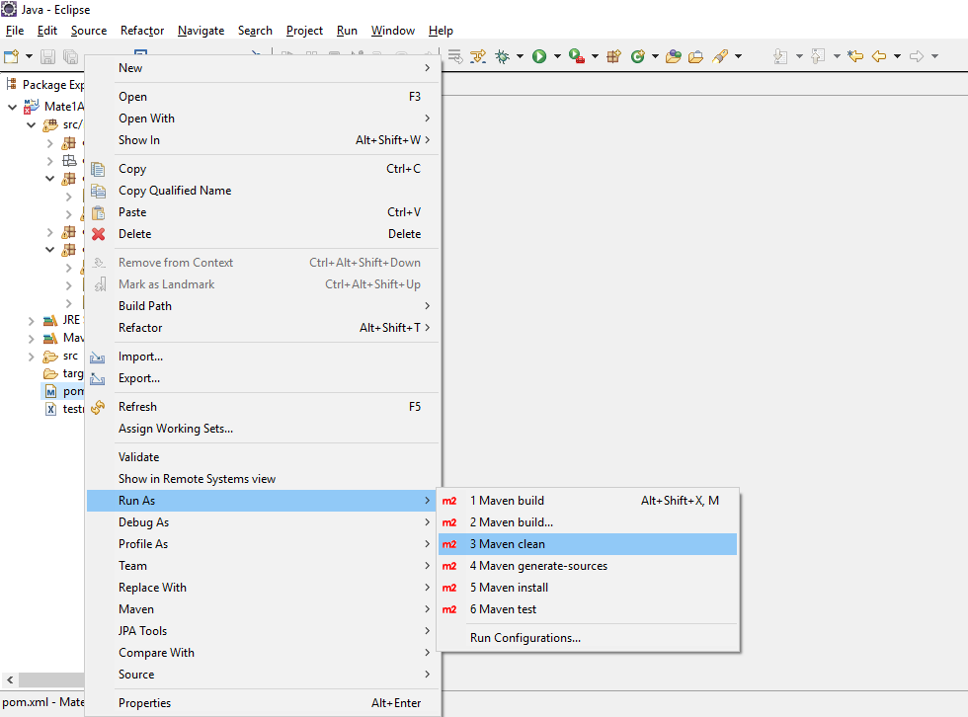

**Verifying the test results:**

1. Once the project has been executed then refresh project in eclipse

Then “target” will be populated in eclipse for the Project

1. Expand the target folder we will found a file with the name “emailable-report.html”
2. Open this file using the browser then we can see the test results

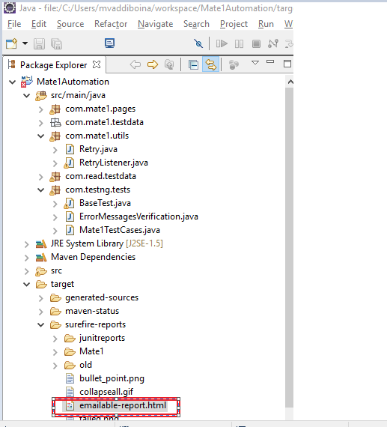

**Sample TestNg Reports**

