UNIT-4﻿
4.1 Cloud computing challenges :﻿
Cloud computing is the provisioning of resources like data and storage on demand, that is, in real-time. It has been proven to be revolutionary in the IT industry, with the market valuation growing at a rapid rate. Cloud development has proved to be beneficial not only for huge public and private enterprises but small-scale businesses as well as it helps to cut costs. It is estimated that more than 94% of businesses will increase their spending on the cloud by more than 45%. This has also resulted in more and higher-paying jobs if you are a cloud developer.

﻿
1. Data Security and Privacy
Data security is a major concern when switching to cloud computing. User or organizational data stored in the cloud is critical and private. Even if the cloud service provider assures data integrity, it is your responsibility to carry out user authentication and authorization, identity management, data encryption, and access control. Security issues on the cloud include identity theft, data breaches, malware infections, and a lot more which eventually decrease the trust amongst the users of your applications﻿
2. Cost Management﻿
Even as almost all cloud service providers have a "Pay As You Go" model, which reduces the overall cost of the resources being used, there are times when there are huge costs incurred to the enterprise using cloud computing. When there is under optimization of the resources, let's say that the servers are not being used to their full potential, add up to the hidden costs. If there is a degraded application performance or sudden spikes or overages in the usage﻿
3.Multi-Cloud Environments﻿
Due to an increase in the options available to the companies, enterprises not only use a single cloud but depend on multiple cloud service providers. Most of these companies use hybrid cloud tactics and close to 84% are dependent on multiple clouds. This often ends up being hindered and difficult to manage for the infrastructure team. The process most of the time ends up being highly complex for the IT team due to the differences between multiple cloud providers﻿
4.4. Performance Challenges﻿
Performance is an important factor while considering cloud-based solutions. If the performance of the cloud is not satisfactory, it can drive away users and decrease profits. Even a little latency while loading an app or a web page can result in a huge drop in the percentage of users. This latency can be a product of inefficient load balancing, which means that the server cannot efficiently split the incoming traffic so as to provide the best user experience. Challenges also arise in the case of fault tolerance, which means the operations continue as required even when one or more of the components fail. ﻿
5. Interoperability and Flexibility﻿
When an organization uses a specific cloud service provider and wants to switch to another cloud-based solution, it often turns up to be a tedious procedure since applications written for one cloud with the application stack are required to be re-written for the other cloud.﻿
6. High Dependence on Network﻿
Since cloud computing deals with provisioning resources in real-time, it deals with enormous amounts of data transfer to and from the servers. This is only made possible due to the availability of the high-speed network. Although these data and resources are exchanged over the network﻿
7.Lack of Knowledge and Expertise﻿
Due to the complex nature and the high demand for research working with the cloud often ends up being a highly tedious task. It requires immense knowledge and wide expertise on the subject. Although there are a lot of professionals in the field they need to constantly update themselves. Cloud computing is a highly paid job due to the extensive gap between demand and supply﻿
4.2 Economics of Cloud Computing :﻿
Economics of Cloud Computing is based on the PAY AS YOU GO method. Users/Customers must have to pay only for their way of the usage of the cloud services. It is definitely beneficial for the users. So the Cloud is economically very convenient for all. Another side is to eliminate some indirect costs which is generated by assets such as license of the software and their support. In the cloud, users can use software applications on a subscription basis without any cost because the property of the software providing service remains to the cloud provider. ﻿
-Economical background of the cloud is more useful for developers in the following ways:﻿
1 Pay as you go model offered by cloud providers.﻿
2 Scalable and Simple.﻿
-Cloud Computing Allows:﻿
1 Reduces the capital costs of infrastructure.﻿
2 Removes the maintenance cost.﻿
3 Removes the administrative cost.﻿
What is Capital Cost? ﻿
It is cost occurred in the purchasing infrastructure or the assets that is important in the production of goods. It takes a long time to generate profit. ﻿
In the case of start-ups, there is no extra budget for the infrastructure and its maintenance. So cloud can minimizes expenses of any small organization in terms of economy. It leads to the developers can only focus on the development logic and not on the maintenance of the infrastructure. ﻿
-There are three different Pricing Strategies that are introduced by Cloud Computing: Tiered Pricing, Per-unit Pricing, and Subscription-based Pricing. These are explained as following below.﻿
1.Tiered Pricing: Cloud Services are offered in the various tiers. Each tier offers to fix service agreements at a specific cost. Amazon EC2 uses this kind of pricing.﻿
2.Per-unit Pricing: The model is based upon the unit-specific service concept. Data transfer and memory allocation include in this model for specific units. GoGrid uses this kind of pricing in terms of RAM/hour.﻿
3 Subscription-based Pricing: In this model, users are paying periodic subscription fees for the usage of the software.﻿
4.3Cloud interoperability and standards :﻿
Interoperability :﻿
It is defined as the capacity of at least two systems or applications to trade with data and utilize it. On the other hand, cloud interoperability is the capacity or extent at which one cloud service is connected with the other by trading data as per strategy to get results.﻿
The two crucial components in Cloud interoperability are usability and connectivity, which are further divided into multiple layers.﻿
1.Behaviour﻿
2.Policy﻿
3.Semantic﻿
4.Syntactic﻿
5.Transport﻿
6.Portability﻿
It is the process of transferring the data or an application from one framework to others, making it stay executable or usable. Portability can be separated into two types: Cloud data portability and Cloud application portability.﻿
Cloud data portability - ﻿
It is the capability of moving information from one cloud service to another and so on without expecting to re-enter the data.﻿
Cloud application portability - ﻿
It is the capability of moving an application from one cloud service to another or between a client's environment and a cloud service.﻿
-What are Cloud Security Standards?﻿
It was essential to establish guidelines for how work is done in the cloud due to the different security dangers facing the cloud. They offer a thorough framework for how cloud security is upheld with regard to both the user and the service provider. ﻿
Cloud security standards provide a roadmap for businesses transitioning from a traditional approach to a cloud-based approach by providing the right tools, configurations, and policies required for security in cloud usage.﻿
1.It helps to devise an effective security strategy for the organization.﻿
2.It also supports organizational goals like privacy, portability, security, and interoperability.﻿
3.Certification with cloud security standards increases trust and gives businesses a competitive edge.

﻿
-Common Cloud Security Standards

1. NIST (National Institute of Standards and Technology)
NIST is a federal organization in the US that creates metrics and standards to boost competition in the scientific and technology industries. The National Institute of Regulations and Technology (NIST) developed the Cybersecurity Framework to comply with US regulations such as the Federal Information Security Management Act and the Health Insurance Portability and Accountability Act (HIPAA) (FISMA). NIST places a strong emphasis on classifying assets according to their commercial value and adequately protecting them.

﻿
2. ISO-27017
A development of ISO-27001 that includes provisions unique to cloud-based information security. Along with ISO-27001 compliance, ISO-27017 compliance should be taken into account. This standard has not yet been introduced to the marketplace. It attempts to offer further direction in the cloud computing information security field. Its purpose is to supplement the advice provided in ISO/IEC 27002 and various other ISO27k standards, such as ISO/IEC 27018 on the privacy implications of cloud computing, and ISO/IEC 27031 on business continuity.

﻿
3. ISO-27018
The protection of personally identifiable information (PII) in public clouds that serve as PII processors is covered by this standard. Despite the fact that this standard is especially aimed at public-cloud service providers like AWS or Azure, PII controllers (such as a SaaS provider processing client PII in AWS) nevertheless bear some accountability. If you are a SaaS provider handling PII, you should think about complying with this standard.

﻿
4. CIS controls
Organizations can secure their systems with the help of Internet Security Center (CIS) Controls, which are open-source policies based on consensus. Each check is rigorously reviewed by a number of professionals before a conclusion is reached. To easily access a list of evaluations for cloud security, consult the CIS Benchmarks customized for particular cloud service providers. For instance, you can use the CIS-AWS controls, a set of controls created especially for workloads using Amazon Web Services (AWS).

﻿
5. FISMA
In accordance with the Federal Information Security Management Act (FISMA), all federal agencies and their contractors are required to safeguard information systems and assets. NIST, using NIST SP 800-53, was given authority under FISMA to define the framework security standards (see definition below).

﻿
6. Cloud Architecture Framework
These frameworks, which frequently cover operational effectiveness, security, and cost-value factors, can be viewed as best parties standards for cloud architects. This framework, developed by Amazon Web Services, aids architects in designing workloads and applications on the Amazon cloud. Customers have access to a reliable resource for architecture evaluation thanks to this framework, which is based on a collection of questions for the analysis of cloud environments.

﻿
7. General Data Protection Regulation (GDPR)
For the European Union, there are laws governing data protection and privacy. Even though this law only applies to the European Union, it is something you should keep in mind if you store or otherwise handle any personal information of residents of the EU.

﻿
8. SOC Reporting
A form of audit of the operational processes used by IT businesses offering any service is known as a "Service and Organization Audits 2" (SOC 2). A worldwide standard for cybersecurity risk management systems is SOC 2 reporting. Your company's policies, practices, and controls are in place to meet the five trust principles, as shown by the SOC 2 Audit Report. The SOC 2 audit report lists security, availability, processing integrity, confidentiality, and confidentiality as security principles. If you offer software as a service, potential clients might request proof that you adhere to SOC 2 standards.

﻿
9. PCI DSS
For all merchants who use credit or debit cards, the PCI DSS (Payment Card Industry Data Security Standard) provides a set of security criteria. For businesses that handle cardholder data, there is PCI DSS. The PCI DSS specifies fundamental technological and operational criteria for safeguarding cardholder data. Cardholders are intended to be protected from identity theft and credit card fraud by the PCI DSS standard.

﻿
10. HIPAA
The Health Insurance Portability and Accountability Act (HIPAA), passed by the US Congress to safeguard individual health information, also has parts specifically dealing with information security. Businesses that handle medical data must abide by HIPAA law. The HIPAA Security Rule (HSR) is the best choice in terms of information security. The HIPAA HSR specifies rules for protecting people's electronic personal health information that a covered entity generates, acquires, makes use of or maintains. ﻿
4.4Fault Tolerance in Cloud Computing﻿
Last Updated : 23 Jul, 2025﻿
Fault tolerance in cloud computing refers to the system's ability to keep running even if a software or hardware malfunction occurs and it enters a down state, critical to increase a system's reliability and maintain it helpful to the user in all circumstances. The entire system will continue to require monitoring of available resources and probable breakdowns, as with any fault tolerance in distributed systems.﻿
What is Fault Tolerance in Cloud Computing?﻿
Fault tolerance In cloud computing is creating a blueprint for continuous work when some components fail or become unavailable. It assists businesses in assessing their infrastructure needs and requirements, as well as providing services if the relevant equipment becomes unavailable for whatever reason. The capacity of an operating system to recover and recognize errors without failing can be managed by hardware, software, or a mixed approach that uses load balancers. As a result, fault tolerance solutions are most commonly used for mission-critical applications or systems.﻿
Main Concepts behind Fault Tolerance in Cloud Computing System﻿
1 Redundancy: When a system system part fails or goes down, it is critical to have backup systems. For example, a website software that uses MS SQL as its database may fail in the middle due to a hardware issue. When the original database goes offline, a new database must be created as part of the redundancy strategy.﻿
2 Replication: The fault-tolerant system operates on the principle of running multiple replicas for every service. As a result, if one component of the system fails, additional instances can be used to maintain it operational.﻿
Techniques for Fault Tolerance in Cloud Computing﻿
1 All services should be prioritized when creating a fault-tolerance system. The database is given special consideration, it powers so many other organizations.﻿
2 After setting priorities, the Enterprise must focus on mock testing. For example, Enterprise offers a forum page where people can check in and leave comments.﻿
3 When authentication services fail due to an issue, users are unable to log in

﻿
-Attributes of Fault Tolerance in Cloud Computing
- Accept the fault isolation concept: The fault is handled separately from other systems. It helps to insulate the Enterprise from an existing system breakdown.
- None Point of Failure: The concepts of redundancy and replication define fault tolerance, which can occur but with small consequences. If there is no single point of failure, the system cannot be fault-tolerant
-Cloud scalability
- refers to a data infrastructure that can easily adjust or adapt its resources according to the changing workloads. It is flexible and reliable because of this adaptability system. It can easily increase(scale up) or decrease(scale down) its capacity and variety of data, application and locations to complete it's demands and objectives of a business.
﻿
- In this article, we will cover an introduction to cloud scalability, the importance of using cloud scalability, the types of scaling in cloud computing (vertical, horizontal, and diagonal), various implementation methods of scaling, real-life examples of cloud scaling, how to determine optimal cloud scalability, and a brief conclusion.
-Types of Scaling in Cloud Computing﻿
The following are the types of scaling in cloud computing:﻿
1.Vertical scaling﻿
2.Horizontal scaling﻿
3.Diagonal scaling﻿
1. Vertical Scaling﻿
It is also known as scaling up. It involves the increasing the capacity of existing resources like upgrading the CPU, memory or storage of a single server. Vertical scaling provide immediate performance improvements, it may have limits and could lead to higher costs. It is the increasing of a single server or virtual machine to handle the additional workload. This type of scaling is best for businesses that have limited budget and cannot afford to invest in additional servers.﻿
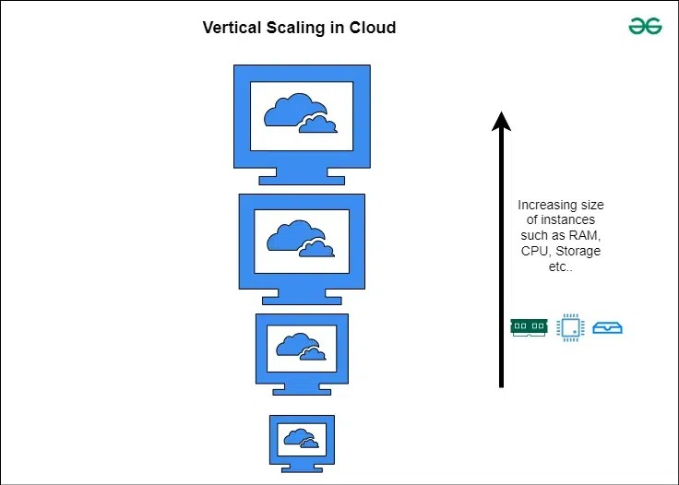
2. Horizontal Scaling﻿
It is also known as scaling out. It involves adding more instances of resources such as servers or virtual machines to increase its processing power. This approach helps in distributing the workload across multiple resources and enables the system to handle increased demand.﻿
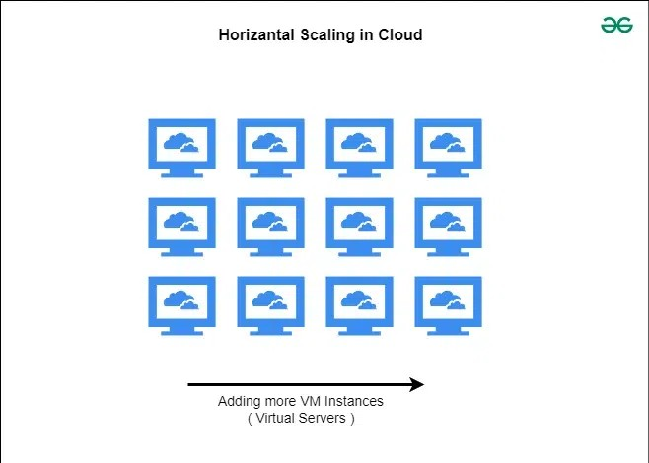
﻿
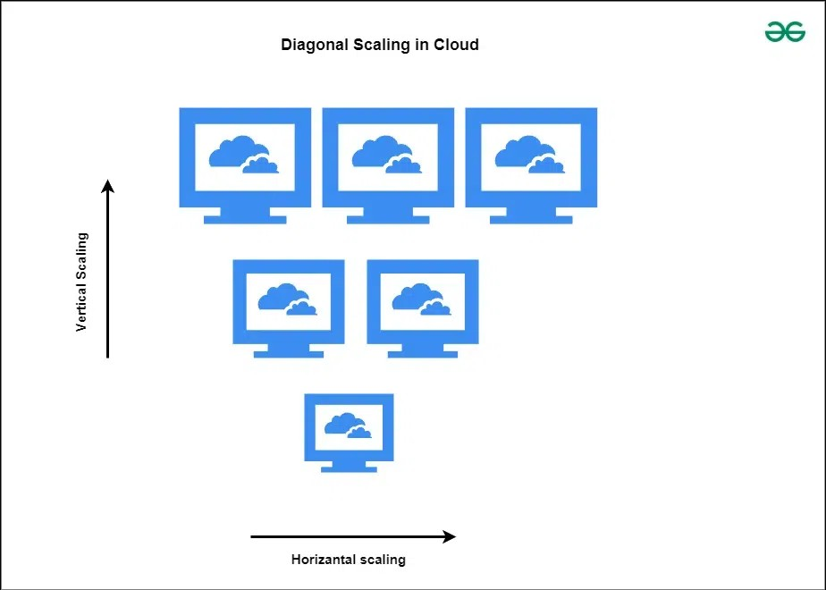
﻿
3. Diagonal Scaling
It is also known as scaling sideways. It is combination of both Vertical and horizontal scaling where resources are added both horizontally or vertically. It is used t create more flexible cloud systems which can handle varying workload demands effectively. Here resources are distributed across various servers and allocated affectively to handle heavy workloads. It involves adding more resources to individual servers or Virtual machines while simultaneously adding more instances to the infrastructure. Because of this reason, it is able to manage the benefits of both horizontal and vertical scaling.﻿
4.5 Efficiency in clouds:﻿
Cloud computing is an internet based computing which provides metering based services to consumers. It means accessing data from a centralized pool of compute resources that can be ordered and consumed on demand. It also provides computing resources through virtualization over internet. Data center is the most prominent in cloud computing which contains collection of servers on which Business information is stored and applications run. Data center which includes servers, cables, air conditioner, network etc.. consumes more power and releases huge amount of Carbon-di-oxide (CO2) to the environment. One of the most important challenge faced in cloud computing is the optimization of Energy Utilization. Hence the concept of green cloud computing came into existence. There are multiple techniques and algorithms used to minimize the energy consumption in cloud. Techniques include:﻿
1 Dynamic Voltage and Frequency Scaling (DVFS)﻿
2 Virtual Machine (VM)﻿
3 Migration and VM Consolidation﻿
-Algorithms are:﻿
1 Maximum Bin Packing﻿
2 Power Expand Min-Max and Minimization 3 Migrations﻿
4 Highest Potential growth﻿
Green cloud computing is using Internet computing services from a service provider that has taken measures to reduce their environmental effect and also green cloud computing is cloud computing with less environmental impact. Some measures taken by the Internet service providers to make their services more green are:﻿
Use renewable energy sources.﻿
1.Make the data center more energy efficient, for example by maximizing power usage efficiency (PUE).﻿
2 Reuse waste heat from computer servers (e.g. to heat nearby buildings).﻿
3 Make sure that all hardware is properly recycled at the end of its life.﻿
4 Use hardware that has a long lifespan and contains little to no toxic materials.﻿
4.6 Federated clouds:﻿
Cloud Federation, also known as Federated Cloud is the deployment and management of several external and internal cloud computing services to match business needs. It is a multi-national cloud system that integrates private, community, and public clouds into scalable computing platforms. Federated cloud is created by connecting the cloud environment of different cloud providers using a common standard﻿
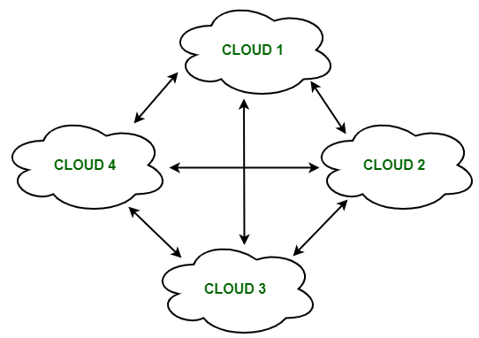
The architecture of Federated Cloud:﻿
The architecture of Federated Cloud consists of three basic components:﻿
1. Cloud Exchange﻿
The Cloud Exchange acts as a mediator between cloud coordinator and cloud broker. The demands of the cloud broker are mapped by the cloud exchange to the available services provided by the cloud coordinator. The cloud exchange has a track record of what is the present cost, demand patterns, and available cloud providers, and this information is periodically reformed by the cloud coordinator.﻿
2. Cloud Coordinator﻿
The cloud coordinator assigns the resources of the cloud to the remote users based on the quality of service they demand and the credits they have in the cloud bank. The cloud enterprises and their membership are managed by the cloud controller.﻿
3. Cloud Broker﻿
The cloud broker interacts with the cloud coordinator, analyzes the Service-level agreement and the resources offered by several cloud providers in cloud exchange. Cloud broker finalizes the most suitable deal for their client.﻿
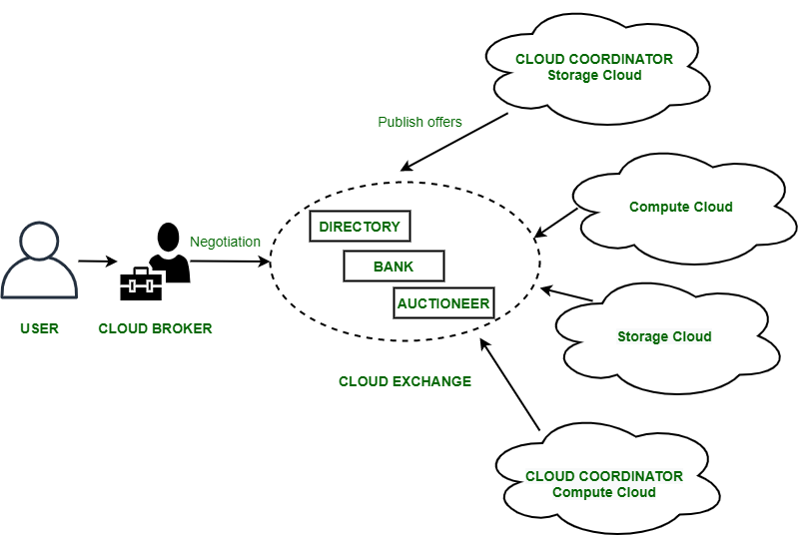

Properties of Federated Cloud:
- In the federated cloud, the users can interact with the architecture either centrally or in a decentralized manner. In centralized interaction, the user interacts with a broker to mediate between them and the organization. Decentralized interaction permits the user to interact directly with the clouds in the federation.
- Federated cloud can be practiced with various niches like commercial and non-commercial.
- The visibility of a federated cloud assists the user to interpret the organization of several clouds in the federated environment.
- Federated cloud can be monitored in two ways. MaaS (Monitoring as a Service) provides information that aids in tracking contracted services to the user. Global monitoring aids in maintaining the federated cloud.
- The providers who participate in the federation publish their offers to a central entity. The user interacts with this central entity to verify the prices and propose an offer.
- The marketing objects like infrastructure, software, and platform have to pass through federation when consumed in the federated cloud.
-Benefits of Federated Cloud:﻿
It minimizes the consumption of energy.﻿
1.It increases reliability.﻿
2 It minimizes the time and cost of providers due to dynamic scalability.﻿
3 It connects various cloud service providers globally. The providers may buy and sell services on demand.﻿
4 It provides easy scaling up of resource﻿
4.7 Cloud Computing security:﻿
What is Cloud Computing ?﻿
Cloud computing refers to the on demand delivery of computing services such as applications, computing resources, storage, database, networking resources etc. through internet and on a pay as per use basis. At the present time the demand for cloud computing services are increasing with respect to that demand for cloud computing skills is also increasing. It provides three main types of service models i.e. SaaS (Software as a Service), PaaS (Platform as a Service) and IaaS (Infrastructure as a Service). With this as starting from small to large organizations have started using cloud services so depending upon their requirement they go for the different types of cloud like Public cloud, Private cloud, Hybrid cloud, Community cloud.﻿
Security In Cloud Computing :﻿
Cloud computing which is one of the most demanding technology of the current time, starting from small to large organizations have started using cloud computing services. Where there are different types of cloud deployment models are available and cloud services are provided as per requirement like that internally and externally security is maintained to keep the cloud system safe. Cloud security is an important concern which refers to the act of protecting cloud environments, data, information and applications against unauthorized access, DDOS attacks, malwares, hackers and other similar attacks. Community Cloud : These allow to a limited set of organizations or employees to access a shared cloud computing service environment.﻿
Planning of security in Cloud Computing :﻿
As security is a major concern in cloud implementation, so an organization have to plan for security based on some factors like below represents the three main factors on which planning of cloud security depends.﻿
Resources that can be moved to the cloud and test its sensitivity risk are picked.﻿
The type of cloud is to be considered.﻿
The risk in the deployment of the cloud depends on the types of cloud and service models﻿
-Types of Cloud Security Controls :﻿
There are 4 types of cloud computing security controls i.e.﻿
1 Deterrent Controls : Deterrent controls are designed to block nefarious attacks on a cloud system. These come in handy when there are insider attackers.﻿
2 Preventive Controls : Preventive controls make the system resilient to attacks by eliminating vulnerabilities in it.﻿
3.Detective Controls : It identifies and reacts to security threats and control. Some examples of detective control software are Intrusion detection software and network security monitoring tools.﻿
4 Corrective Controls : In the event of a security attack these controls are activated. They limit the damage caused by the attack.﻿
Importance of cloud security :﻿
-Cloud security has a lot of benefits -﻿
1 Centralized security : Centralized security results in centralizing protection. As managing all the devices and endpoints is not an easy task cloud security helps in doing so. This results in enhancing traffic analysis and web filtering which means less policy and software updates.﻿
2 Reduced costs : Investing in cloud computing and cloud security results in less expenditure in hardware and also less manpower in administration﻿
3 Reduced Administration : It makes it easier to administer the organization and does not have manual security configuration and constant security updates.﻿
4 Reliability : These are very reliable and the cloud can be accessed from anywhere with any device with proper authorization﻿
4.8 FUNDAMENTAL OF CLOUD SECURITY ﻿
Computer security refers to protecting and securing computers and their related data, networks, software, hardware from unauthorized access, misuse, theft, information loss, and other security issues. The Internet has made our lives easier and has provided us with lots of advantages but it has also put our system's security at risk of being infected by a virus, of being hacked, information theft, damage to the system, and much more.﻿
-Types of computer security﻿
Computer security can be classified into four types:﻿
1. Cyber Security: Cyber security means securing our computers, electronic devices, networks , programs, systems from cyber attacks. Cyber attacks are those attacks that happen when our system is connected to the Internet.﻿
2. Information Security: Information security means protecting our system's information from theft, illegal use and piracy from unauthorized use. Information security has mainly three objectives: confidentiality, integrity, and availability of information.﻿
3. Application Security: Application security means securing our applications and data so that they don't get hacked and also the databases of the applications remain safe and private to the owner itself so that user's data remains confidential.﻿
4. Network Security: Network security means securing a network and protecting the user's information about who is connected through that network. Over the network hackers steal, the packets of data through sniffing and spoofing attacks, man in the middle attack, war driving, etc, aTypes of cyber attack﻿
1. Denial of service attack or DOS: A denial of service attack is a kind of cyber attack in which the attackers disrupt the services of the particular network by sending infinite requests and temporary or permanently making the network or machine resources unavailable to the intended audience.﻿
2. Backdoor: In a backdoor attack, malware, trojan horse or virus gets installed in our system and start affecting it's security along with the main file. Consider an example: suppose you are installing free software from a certain website on the Internet. Now, unknowingly, along with this software, a malicious file also gets installed, and as soon as you execute the installed software that file's malware gets affected and starts affecting your computer security. This is known as a backdoor.﻿
3.Eavesdropping: Eavesdropping refers to secretly listening to someone's talk without their permission or knowledge. Attackers try to steal, manipulate, modify, hack information or systems by passively listening to network communication, knowing passwords etc. A physical example would be, suppose if you are talking to another person of your organization and if a third person listens to your private talks then he/ she is said to eavesdrop on your conversation. Similarly, your conversation on the internet maybe eavesdropped by attackers listening to your private conversation by connecting to your network if it is insecure.﻿
4. Phishing: Phishing is pronounced as "fishing" and working functioning is also similar. While fishing, we catch fish by luring them with bait. Similarly, in phishing, a user is tricked by the attacker who gains the trust of the user or acts as if he is a genuine person and then steals the information by ditching. Not only attackers but some certain websites that seem to be genuine, but actually they are fraud sites. These sites trick the users and they end up giving their personal information such as login details or bank details or card number etc. Phishing is of many types: Voice phishing, text phishing etc.﻿
5. Spoofing: Spoofing is the act of masquerading as a valid entity through falsification of data(such as an IP address or username), in order to gain access to information or resources that one is otherwise unauthorized to obtain. Spoofing is of several types- email spoofing, IP address spoofing, MAC spoofing , biometric spoofing etc.nd misuse the data for their benefits.

﻿
-Types of cyber attack
1. Denial of service attack or DOS: A denial of service attack is a kind of cyber attack in which the attackers disrupt the services of the particular network by sending infinite requests and temporary or permanently making the network or machine resources unavailable to the intended audience.﻿
2. Backdoor: In a backdoor attack, malware, trojan horse or virus gets installed in our system and start affecting it's security along with the main file. Consider an example: suppose you are installing free software from a certain website on the Internet. Now, unknowingly, along with this software, a malicious file also gets installed, and as soon as you execute the installed software that file's malware gets affected and starts affecting your computer security. This is known as a backdoor.﻿
3.Eavesdropping: Eavesdropping refers to secretly listening to someone's talk without their permission or knowledge. Attackers try to steal, manipulate, modify, hack information or systems by passively listening to network communication, knowing passwords etc. A physical example would be, suppose if you are talking to another person of your organization and if a third person listens to your private talks then he/ she is said to eavesdrop on your conversation. Similarly, your conversation on the internet maybe eavesdropped by attackers listening to your private conversation by connecting to your network if it is insecure.﻿
4. Phishing: Phishing is pronounced as "fishing" and working functioning is also similar. While fishing, we catch fish by luring them with bait. Similarly, in phishing, a user is tricked by the attacker who gains the trust of the user or acts as if he is a genuine person and then steals the information by ditching. Not only attackers but some certain websites that seem to be genuine, but actually they are fraud sites. These sites trick the users and they end up giving their personal information such as login details or bank details or card number etc. Phishing is of many types: Voice phishing, text phishing etc.﻿
5. Spoofing: Spoofing is the act of masquerading as a valid entity through falsification of data(such as an IP address or username), in order to gain access to information or resources that one is otherwise unauthorized to obtain. Spoofing is of several types- email spoofing, IP address spoofing, MAC spoofing , biometric spoofing etc.﻿
4 .9 What is Cloud Security Architecture?﻿
Cloud security architecture is the designed blueprint or plan that secures your cloud space—data, apps, and infrastructure. Just as a secure building requires guards, gates, and cameras, your cloud platform requires multiple layers of security to avoid cyber attacks.﻿
-Why Cloud Security Architecture Is Important﻿
-Protects Against Data Breaches and Hacks: Strong design minimizes the likelihood of unauthorized access, data loss, and malware infection. Without effective design, a small misconfiguration will give rise to a giant data breach.﻿
Supports Compliance with ------Regulations: If your company processes personal or financial information, you must comply with regulations such as GDPR, HIPAA, or PCI DSS. A well-designed cloud security architecture makes your cloud environment audit-ready and compliant.﻿
-Builds Customer Trust and Business Reputation: Customers now wish to have confidence that their information is safe. By spending in a reliable cloud security platform, your business can demonstrate that security is core, resulting in increased customer confidence and loyalty.﻿
-cloud security architecture﻿
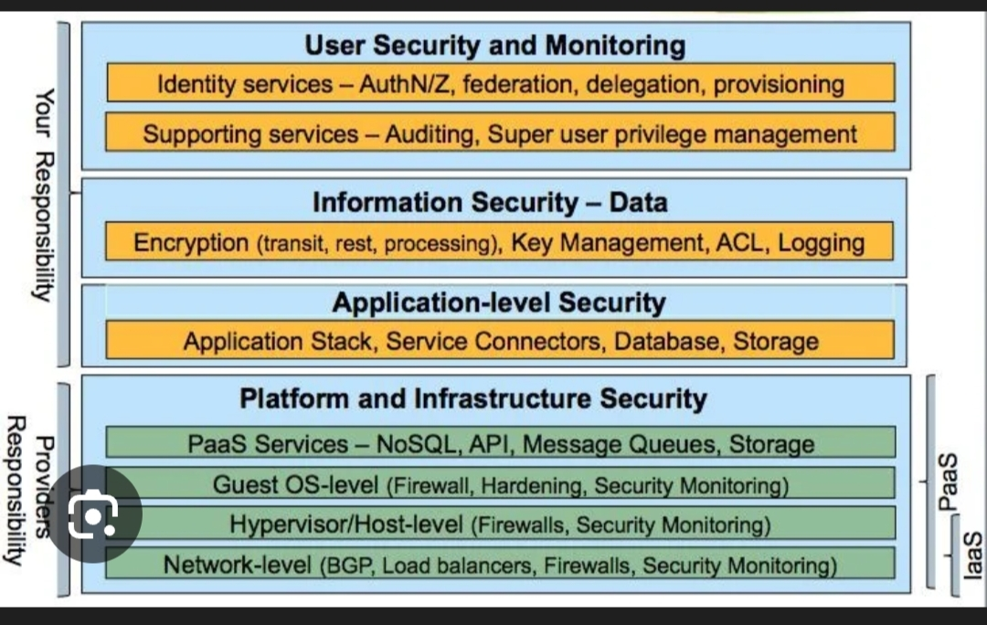
Components of Cloud Security Architecture﻿
When companies shift to the cloud, security becomes a top priority. But cloud security is not a single entity—it's an entire framework constructed using multiple significant components which is working together. This framework is referred to as Cloud Security Architecture.﻿
1. Identity and Access Management (IAM)﻿
It can controls who can access what in your cloud system. When a user logs into a cloud app or dashboard, IAM ensures that person only sees and does what they're allowed to. It reduces the risk of internal misuse or external attacks. It includes﻿
It can govern who gets to see what in your cloud environment. When a user signs on to a cloud application or dashboard, IAM makes sure that individual sign-on sees only and does only what they are permitted to. It reduces the risk of internal misuse or external attacks. It includes﻿
Multi-Factor Authentication (MFA): Introduces an additional layer of security (e.g., a one-time password via phone or mail).﻿
Role-Based Access Control (RBAC): Grants access based on role. For example, an Admin may modify settings, but an Intern may merely view reports.﻿
Least Privilege Access: Provide users with just the minimum they require—no more.﻿
2. Data Protection in the Cloud﻿
It ensures the sensitive data is protected against hackers, leaks, or unintended loss using the encryption methods. It includes﻿
Encryption: Transforms your data into unreadable text. Apply AES-256 encryption to files at rest (stored data) and TLS 1.3 for data in transit (sent via the internet).﻿
Data Loss Prevention (DLP): Automatically scans and blocks sensitive information such as social security numbers, passwords, or credit card information from being exposed.﻿
3. Network Security in Cloud Infrastructure﻿
In this it secures cloud networks against cyberattacks and unauthorized access by employing the tools which includes:﻿
Firewalls: Inspect incoming and outgoing traffic to prevent threats such as malware, ransomware, or brute force attacks.﻿
VPN (Virtual Private Network): Encrypts user and cloud server connections, particularly for remote employees.﻿
Zero Trust Architecture: Don't trust anyone in the first place—always authenticate their identity before providing access
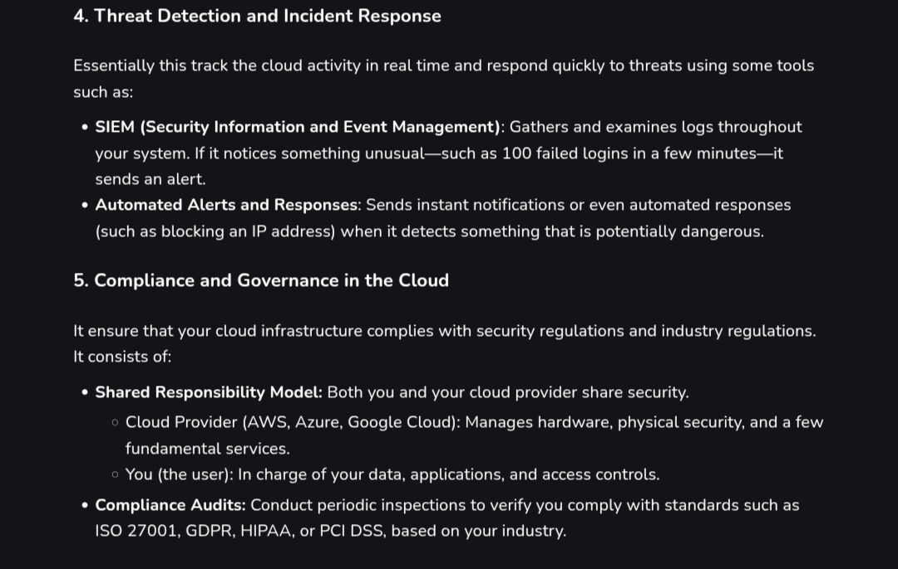
4.10﻿
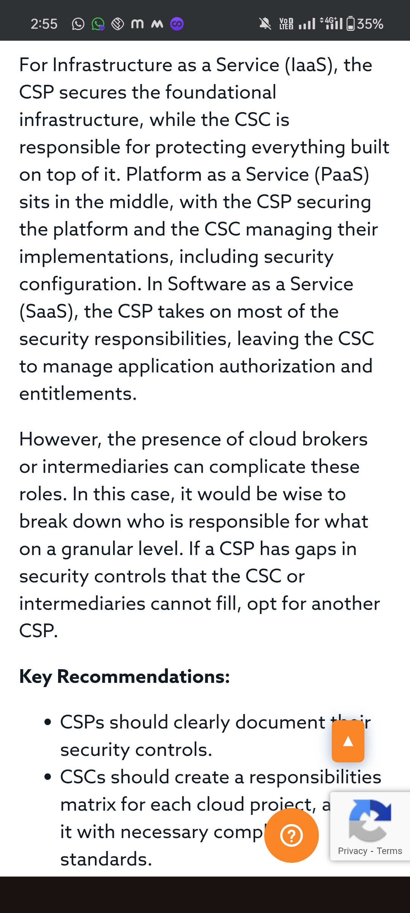
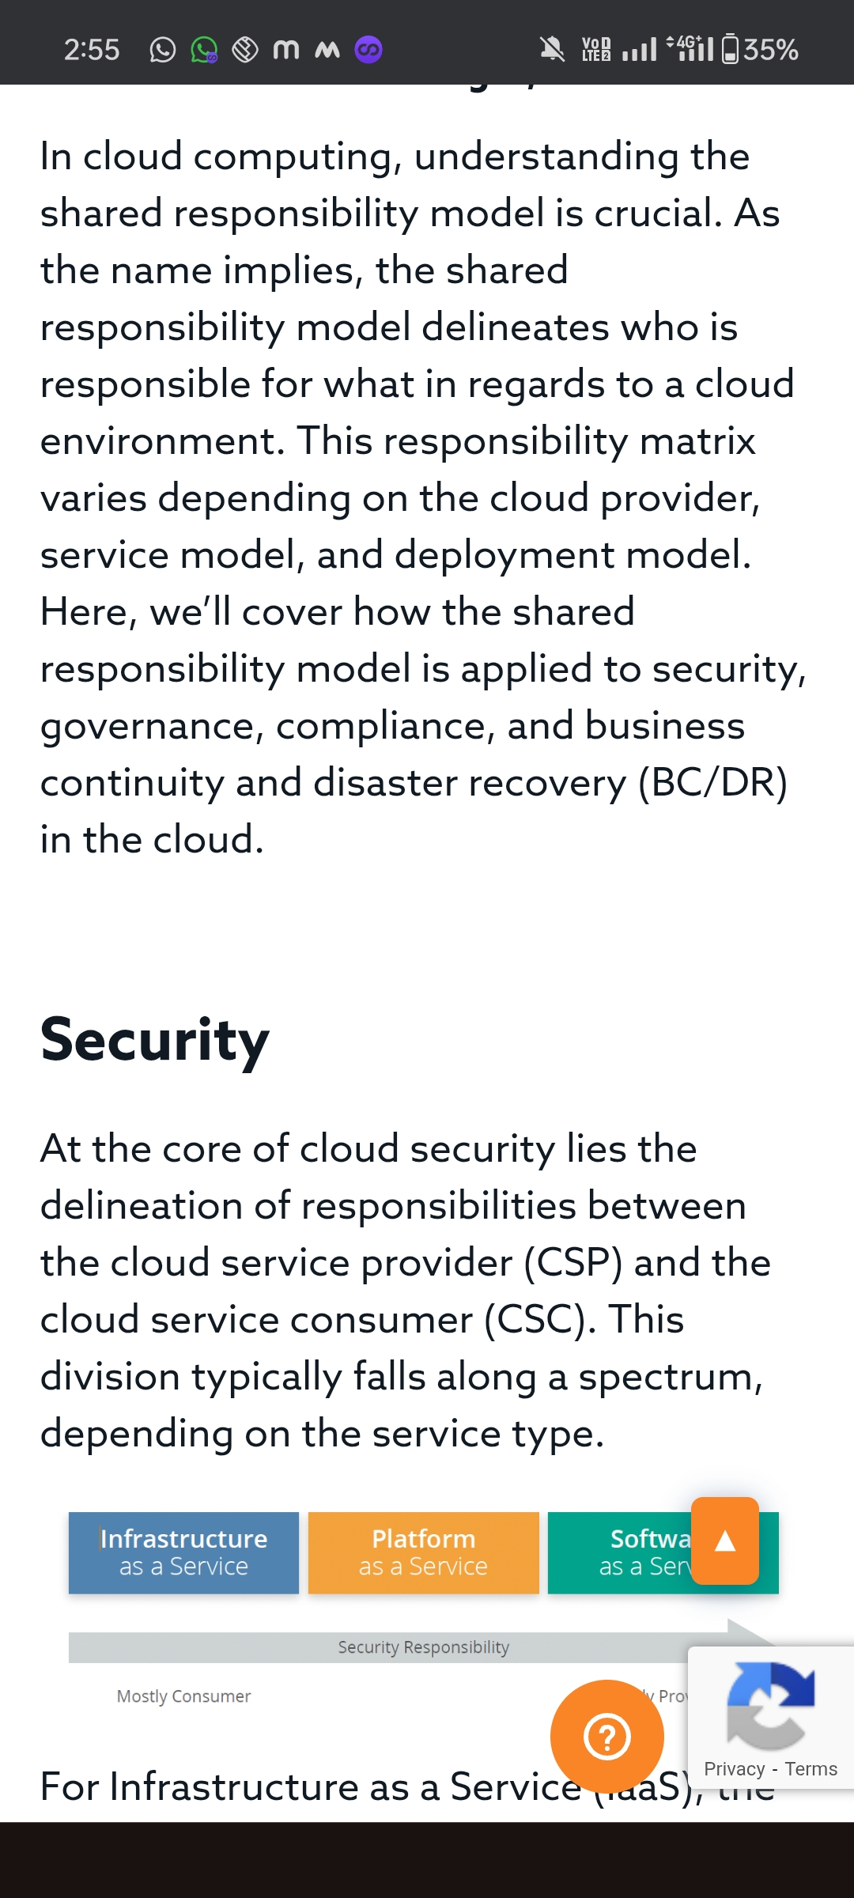
4.11﻿
