UNIT-5﻿
5.1 Advance concepts cloud computing :﻿
Advanced concepts in cloud computing include serverless computing, which eliminates server management; containerization (like Docker and Kubernetes) for application deployment; edge computing, which processes data closer to the source to reduce latency; and multi-cloud and hybrid cloud strategies for flexibility and vendor lock-in avoidance. Other important concepts are advanced networking, advanced security measures, DevOps, and concepts like scalability, elasticity, and infrastructure automation. ﻿
-Architecture and deployment﻿
1 Serverless computing: Allows developers to build and run applications without managing servers, leading to reduced costs and improved scalability because resources are provisioned only when needed.﻿
2 Containerization (e.g., Docker and Kubernetes): Packages applications and their dependencies into containers, making them portable and consistent across different environments.﻿
Edge computing: Moves computation and data storage closer to the source of data generation to improve response times and reduce latency, particularly useful for IoT devices and real-time applications.﻿
3 Hybrid and multi-cloud strategies: Using a combination of public and private clouds (hybrid) or multiple public clouds (multi-cloud) to avoid vendor lock-in, optimize performance, and improve resource utilization﻿
4.2 Serverless computing;﻿
Imagine if you give all of your time in building amazing apps and then deploying them without giving any of your time in managing servers. Serverless computing is something that lets you to do that because the architecture that you need to scale and run your apps is managed for you. The infrastructure has always been an issue for the developers. Serverless computing is a big solution for them as it relieves that burden from them.﻿
Serverless computing is the technology of abstracting the servers, operating systems and the infrastructures. It is a cloud computing execution model in which the cloud provider dynamically manages the allocation of the machine resources. When we are building the serverless application, it helps us in taking our minds off from the infrastructure concerns because we do not need to manage any of the servers. The developers can dedicate their focus on their core products instead of worrying about managing operating systems or configurations for it. In this way lot of time and energy of the developers be saved. They can make use of single services (like S3 for storage or Auth0 for identity management) and elastic computer platforms like AWS Lambda or Microsoft Azure to execute code. Such serverless systems can grow, scale and evolve without requiring the developer’s efforts of remembering to patch the web servers again and again.﻿
The main advantages of the serverless applications are:﻿
1 The regular maintenance of any servers is not required. Also, we there is no software or platform to install for it.﻿
2 The scaling of the application is very flexible in serverless computing. They can be scaled automatically by adjusting the capacity of the configurations required to run the application. Ex:- Memory, processor requirement etc.﻿
3 They have inbuilt availability and fault tolerance. We do not have to decide the architect for these capabilities as they are by default provided by the services that are running the app.﻿
You don't have to pay for idle capacity. 4.There is no need to pre- or over-provision capacity for things like compute and storage. For example, there is no charge when your code is not running.﻿
Serverless computing is more cost-effective than purchasing the servers with required configurations. The features like more efficient bin-packing of the underlying resources of machine can make it more cost-efficient than provisioning an autoscaling group﻿
-Some famous platforms for serverless computing:﻿
1.AWS lambda﻿
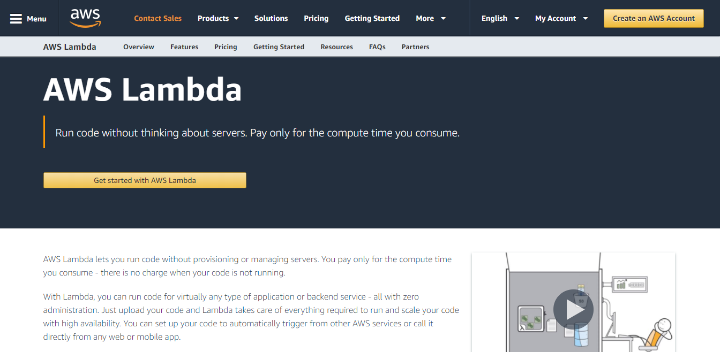
﻿
It stands for Amazon Web Services Lambda. It is the platform of Amazon that executes our code only when we need and also has the features of automatic scaling, from a few requests per day to thousands per second. We have to pay for the time﻿
2 Microsoft Azure﻿

This is the platform provided by Microsoft. It also provides all the features and here also we have to pay for the time we use its services. It is known to improve developer productivity, focus on business goals and building intelligent apps.﻿
3.Google Cloud Platform﻿
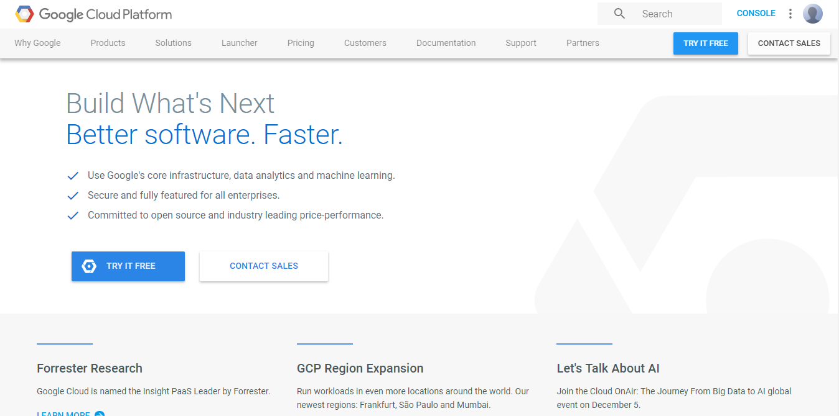
It is Google’s online platform that is based on serverless computing. It is a suite of cloud computing services that runs on the same infrastructure that is used by the Google internally for its end-user products﻿
5.3 Function-as-a-Service:﻿
Function as a Service﻿
FaaS is a cloud service that lets you run small pieces of code - called functions- without managing any servers. You just write your code, upload it, and it runs only when triggered by an event, like a button click or a file upload.﻿
FaaS is event-driven, meaning the code runs only when something specific happens. You don't need to keep a sever running in the background - it starts automatically when needed and stops when the job is done. That's why it is also called serverless (even though servers are still used, they' re managed entirely by the provider).﻿
Example:﻿
Imagine an online photo app that resizes ---images whenever a user uploads a photo. With FaaS, you write a small functions to resize the image. The Function only runs when a photo is uploaded- and you only pay for the execution.﻿
Advantages of FaaS﻿
1.Highly Scalable: Auto scaling is done by the provider depending upon the demand.﻿
2 .Cost-Effective: Pay only for the number of events executed.﻿
3.Code Simplification: FaaS allows the users to upload the entire application all at once. It allows you to write code for independent functions or similar to those functions.﻿
4.Maintenance of code is enough and no need to worry about the servers.﻿
5.Functions can be written in any programming language.﻿
Less control over the system.﻿
6.The various companies providing Function as a Service are Amazon Web Services - Firecracker, Google - Kubernetes, Oracle - Fn, Apache OpenWhisk - IBM, OpenFaaS, ﻿
Disadvantages of FaaS﻿
1 .Cold start latency: Since FaaS functions are event-triggered, the first request to a new function may experience increased latency as the function container is created and initialized.﻿
2 .Limited control over infrastructure: FaaS providers typically manage the underlying infrastructure and take care of maintenance and updates, but this can also mean that users have less control over the environment and may not be able to make certain customizations.﻿
3 Security concerns: Users are responsible for securing their own data and applications, which can be a significant undertaking.﻿
4.Limited scalability: FaaS functions may not be able to handle high traffic or large number of requests.﻿
FaaS vs. PaaS: What's the Difference﻿
1.Scalability:﻿
-FaaS scales automatically as needed.﻿
-PaaS can scale too, but you have to set it up.﻿
2 .Pricing:﻿
-FaaS charges you only when the function runs.﻿
-PaaS charges based on the time and resources, whether used fully or not.﻿
5.4 Severless Computing architecture:﻿
A serverless architecture is a cloud computing execution model that allows the cloud provider to dynamically control server provisioning and allocation. Since cloud providers handle the underlying infrastructure—including scaling, maintenance, and provisioning—developers may concentrate entirely on code with this method.﻿
-The cloud provider automatically executes the code in stateless compute containers that are event-triggered, and fully managed by the provider.﻿
-Developers are unaware of the complexity of operating these servers, which includes capacity planning, scaling, and server maintenance.﻿
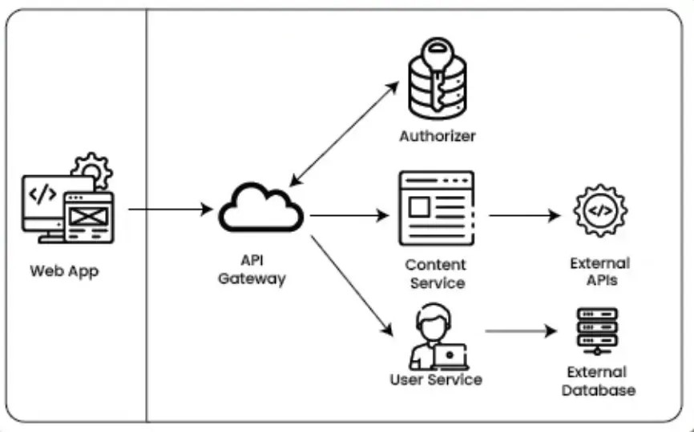

Serverless Computing Providers and Platforms
With distinct platforms and features suited to various development requirements, serverless computing has emerged as a key area of attention for numerous cloud service providers. These are a few of the top platforms and providers of serverless computing:
- AWS Lambda: Without having to provision or manage servers, developers may use AWS Lambda, perhaps the most well-known serverless computing tool, to execute code in response to events from more than 200 AWS services and SaaS apps.
- Azure Functions: With Azure Functions, a serverless compute solution from Microsoft, you can execute event-triggered code without explicitly provisioning or managing infrastructure. Azure Functions easily connects with other Azure services and supports a large number of programming languages.
- Google Cloud Functions: This is the serverless execution environment used by Google to create and link cloud services. All you have to do with Google Cloud Functions is write your code; Google handles the management, scaling, and underlying infrastructure.
- Oracle Cloud Functions: Using functions that are triggered by HTTP requests or events coming from Oracle Cloud services, developers can create apps with Oracle's serverless architecture. It is intended to provide an integrated cloud experience by integrating easily with Oracle's existing cloud products.
5.5 public cloud (e.g. AWS Lambda) and open-source (e.g. OpenFaaS) :﻿
Public cloud offerings like AWS Lambda and open-source solutions like OpenFaaS both provide serverless computing capabilities, but they differ significantly in their operational model, control, and flexibility.﻿
-AWS Lambda (Public Cloud - Functions-as-a-Service):﻿
Managed Service: AWS Lambda is a fully managed service where Amazon handles all the underlying infrastructure, including server provisioning, scaling, and maintenance. Users only focus on writing and deploying their code.﻿
-Event-Driven: It is designed for event-driven architectures, where functions are triggered by various events within the AWS ecosystem (e.g., S3 object creation, API Gateway requests, DynamoDB stream updates).﻿
-Pay-per-use Pricing: Costs are based on the number of requests and the duration of execution, with no charges for idle time.﻿
-Limited Control: Users have limited control over the underlying infrastructure and runtime environment, relying on AWS's provided runtimes and configurations.﻿
-Vendor Lock-in: Being a proprietary service, there is a degree of vendor lock-in to the AWS ecosystem.﻿
OpenFaaS (Open-Source Serverless Platform):﻿
-Self-Hosted or Cloud-Agnostic: OpenFaaS is an open-source framework that can be deployed on various platforms, including Kubernetes clusters on-premises, in any public cloud, or at the edge.﻿
-Container-Based: Functions are packaged as Docker containers, offering greater flexibility in terms of language runtimes and dependencies.﻿
-Full Control: Users have full control over the underlying infrastructure, allowing for customization of scaling behavior, resource allocation, and integration with other tools.﻿
-Portability: Functions built with OpenFaaS are highly portable and can be moved between different environments without code changes.﻿
-Community-Driven: It benefits from a vibrant open-source community, offering flexibility and extensibility.﻿
-Operational Overhead: Managing the underlying infrastructure (e.g., Kubernetes cluster) requires more operational effort compared to a fully managed service like Lambda.﻿
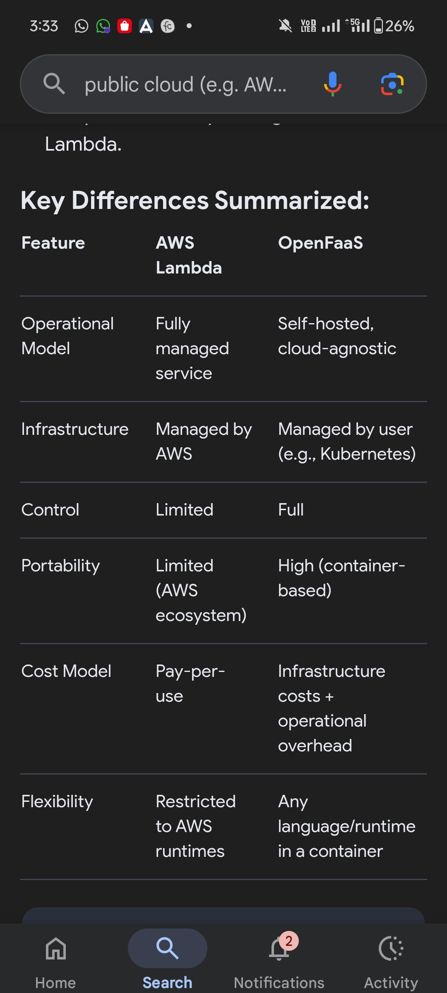
5.6 Internet of Things (IoT)﻿
The Internet of Things (IoT) is a network of physical objects embedded with sensors, software, and other technologies that connect and exchange data over the internet. This network includes everyday items, such as smart home devices, and sophisticated industrial tools, enabling them to collect and transmit data for things like remote control, automation, and enhanced insights through technologies like AI and machine learning.﻿
What IoT is﻿
A network of "things": IoT refers to the network of physical objects, or "things," that are integrated with the internet.﻿
-Embedded with technology: These "things" are equipped with sensors, software, and other technologies that allow them to transmit and receive data.﻿
-Connectivity: Devices connect and exchange data with each other and with systems over the internet.﻿
-Unique identities: Each device can have a unique identity, allowing it to be part of this dynamic network.﻿
^ How it works﻿
-Data collection: Sensors embedded in objects collect data about their environment or usage. For example, a smart thermostat collects temperature data.﻿
-Data transmission: This data is transmitted over the internet to other devices or a central system.﻿
-Data analysis: The data is then analyzed to provide insights, inform users, or trigger automated actions.﻿
-Intelligence: Technologies like artificial intelligence (AI) and machine learning can use this data to make systems more intelligent and allow for real-time decision-making. ﻿
Examples of IoT﻿
-Consumer IoT: Smart home devices like thermostats, appliances, and voice assistants, as well as wearable fitness trackers.﻿
-Industrial IoT (IIoT): Systems of interconnected devices in the industrial sector, such as manufacturing machinery and energy management devices.﻿
-Commercial IoT: Tools used by businesses and healthcare organizations, including systems for inventory management, supply chain tracking, and patient monitoring.﻿
-Transportation: Smart traffic control, fleet management, and connected cars that can communicate with each other and infrastructure. ﻿
5.7﻿
Cloud-centric IoT is an architecture where the cloud is the central hub for data processing, storage, and analytics for connected devices. This model typically consists of a sensing layer (physical devices), a connectivity layer (gateways and network), and a cloud layer (processing, storage, and applications). A common layer-based model includes the perception/sensing layer, a connectivity layer, an edge/processing layer, an application layer, and a business layer. ﻿
-Cloud-centric IoT architecture﻿
This model is popular because it leverages the cloud's scalability and centralized management for large IoT ecosystems. ﻿
Sensing/Perception Layer: This layer consists of physical devices, sensors, and actuators that collect raw data from the environment. This data can be generated by traditional sensors or even smart devices like smartphones.﻿
-Connectivity Layer: This layer handles the transmission of data from the sensing layer to the cloud. It involves gateways and network protocols to collect and provision the sensor data.﻿
-Cloud Layer: This is the central hub where data is processed, stored, and analyzed. It includes several sub-layers:﻿
-Processing Layer: Processes raw data, performs analytics, and can implement technologies like big data and cloud computing. It's where raw data is made useful and can involve resource-intensive operations like creating machine learning algorithms.﻿
-Application Layer: This layer runs the applications that use the processed data to address specific business requirements or provide services to end-users.﻿
-Business Layer: This is the top layer that manages the entire IoT system, including the applications, user privacy, and profit models.﻿
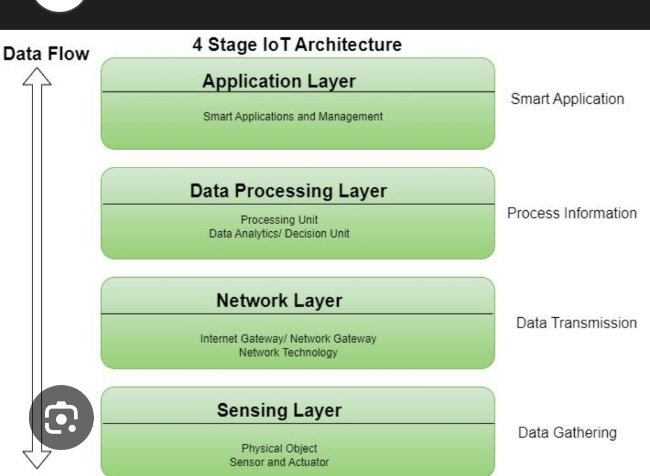
Common IoT architecture layers A more detailed model can break down the architecture into more specific layers, including cloud-based ones. ﻿
- Perception Layer: The physical layer of sensors and devices that collect data. --Connectivity Layer: The network infrastructure that transmits data from devices to a central point. ﻿
-Edge/Fog Layer: Devices or local servers that can perform some processing and filtering on the data at the "edge" of the network, before it reaches the cloud. Processing Layer: In the cloud, this layer is responsible for storing, processing, and analyzing the data.﻿
- Application Layer: The user-facing part of the system that provides specific functionalities based on the processed data. ﻿
-Business Layer: The management layer that oversees the entire system and its business logic. Security Layer: An overarching layer that is critical for protecting the entire system from data breaches and other threats. ﻿
5.8 Edge and fog computing:﻿
Edge Computing﻿
Computation takes place at the edge of a device's network, which is known as edge computing. That means a computer is connected with the network of the device, which processes the data and sends the data to the cloud in real-time. That computer is known as "edge computer" or "edge node". ﻿
With this technology, data is processed and transmitted to the devices instantly. Yet, edge nodes transmit all the data captured or generated by the device regardless of the importance of the data. ﻿
Example of Edge computing:﻿
Autonomous vehicle edge computing devices collect data from cameras and sensors on the vehicle, process it, and make decisions in milliseconds, such as self-parking cars.﻿
In order to accurately assess a patient's condition and foresee treatments, data is processed from a variety of edge devices connected to sensors and monitors.﻿
Here Fog Computing was introduced and becomes an ideal solution. ﻿
Fog Computing﻿
Fog computing is an extension of cloud computing. It is a layer in between the edge and the cloud. When edge computers send huge amounts of data to the cloud, fog nodes receive the data and analyze what's important. Then the fog nodes transfer the important data to the cloud to be stored and delete the unimportant data or keep them with themselves for further analysis. In this way, fog computing saves a lot of space in the cloud and transfers important data quickly. ﻿
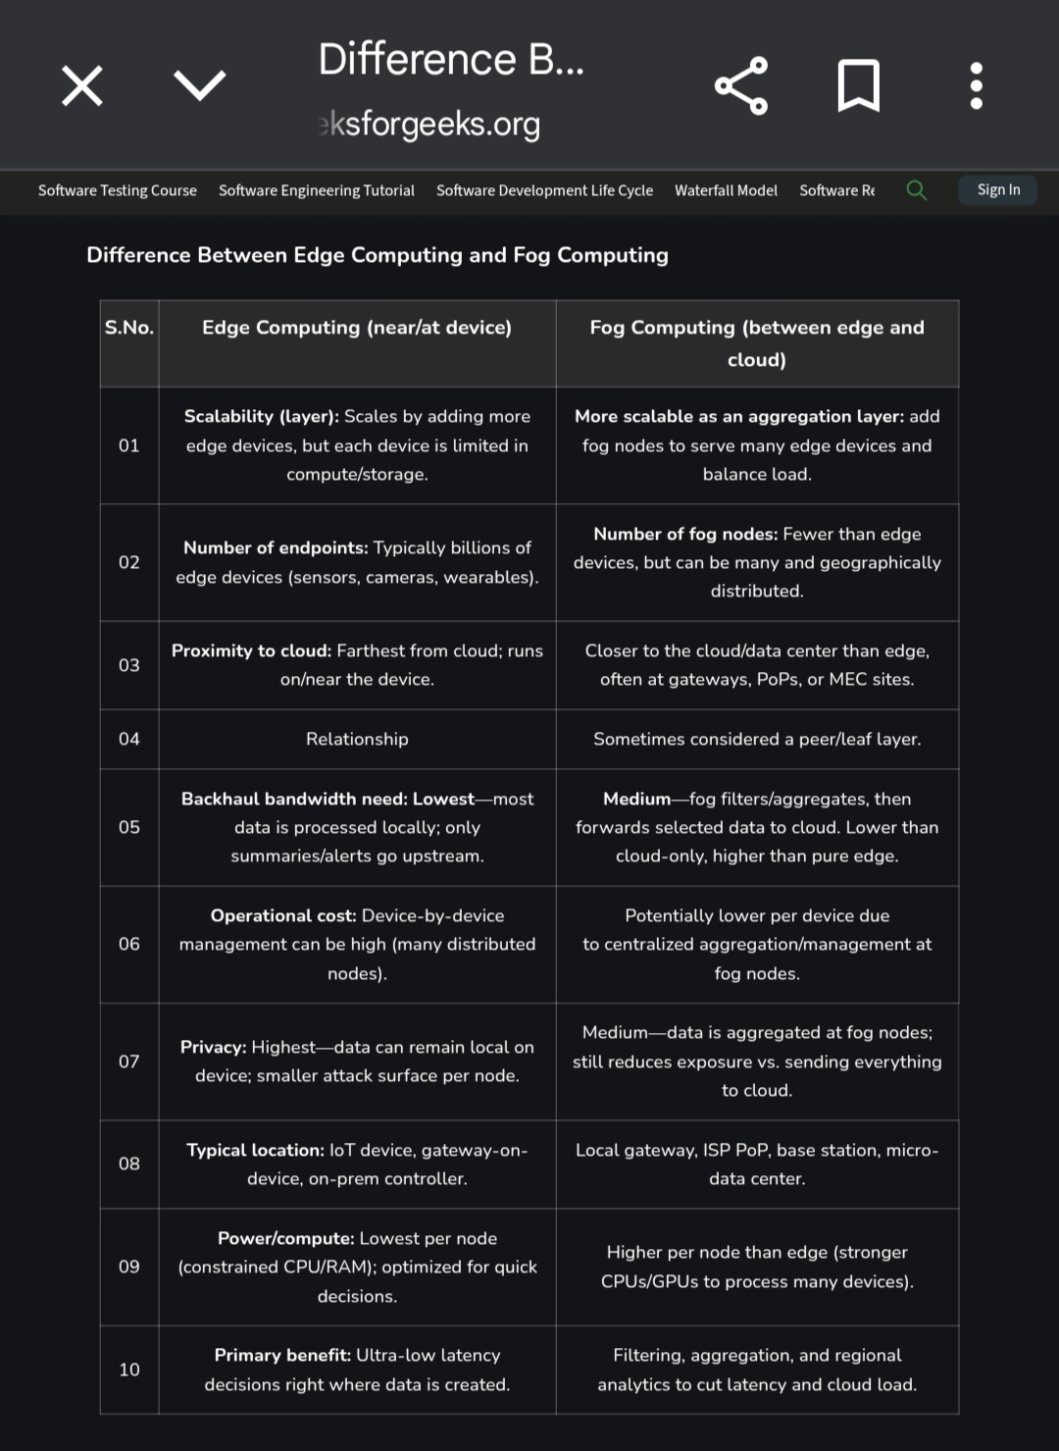
5.9 DevOps ﻿
DevOps is a combination of two words: "Development" and "Operations." It’s a modern approach where software developers and software operations teams work together throughout the entire software life cycle.﻿
The goals of DevOps are:﻿
1 Faster and continuous software releases.﻿
2 Reduces manual errors through automation.﻿
2 Built-in Monitoring, detect failures or issues during delivery or in production.﻿
3 Automate testing throughout the software delivery process.﻿
256040168-.webp﻿
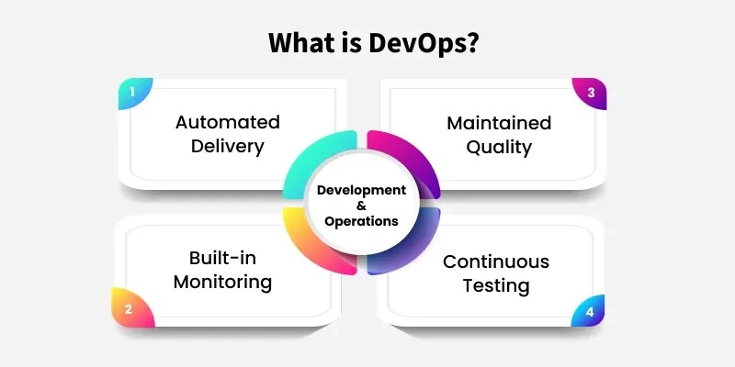
﻿
- Before DevOps, software delivery was slow and manual. Separate teams handled coding, server setup, testing, and deployment, leading to delays and frequent errors due to lack of automation.﻿
With DevOps, the process is fast, automated, and collaborative. Using tools like Git, Jenkins, Docker, and Kubernetes, teams can build, test, and deploy code continuously, enabling deployment in hours instead of days.﻿
1. Understanding DevOps Fundamentals﻿
In this section, we will cover the basic DevOps fundamentals and terminologies that are essential for a DevOps engineer.﻿
2.Linux for DevOps﻿
Linux is one of the most widely used operating systems for servers and cloud environment. This section introduces the core Linux concepts, commands, and networking essentials every DevOps engineer should know.﻿
3. Source Code Management﻿
Source Code Management is one of the key aspects of DevOps. Git is considered to be one of the best tools for version control of source codes. In this section on Source Code Management, we’ll explore the fundamentals of version control using tools like Git, GitHub, GitLab, and Bitbucket.﻿
4. Scripting Language for DevOps﻿
Scripting language is essential in DevOps as it helps automate repetitive tasks, reduces errors, and saves time. Languages like Bash, YAML, and Python are widely used.﻿
5. Starting With A Cloud Platform﻿
Cloud computing is essential as it powers most modern applications through platforms like AWS, Azure, and Google Cloud.﻿
6. Docker﻿
Docker is a popular containerization tool that is used to deliver software quickly by using the concept of containerized code which helps for easy management and maintenance of applications﻿
7. Kubernetes﻿
Kubernetes is used to orchestrate and manage Docker containers at scale﻿
8. Infrastructure as a Code﻿
IaC enables automating and configuring the infrastructure resources using various tools such as Terraform, CloudFormation, ARM Templates, etc.﻿
5.10 Infrastructure-as-code﻿
Infrastructure as Code (IaC) is a practice that uses machine-readable definition files to automate the management and provisioning of IT infrastructure, such as networks, virtual machines, and load balancers, instead of using manual processes. It treats infrastructure like software, applying DevOps practices like version control, testing, and continuous integration/continuous delivery (CI/CD) pipelines to ensure environments are consistent, repeatable, and easy to manage. ﻿
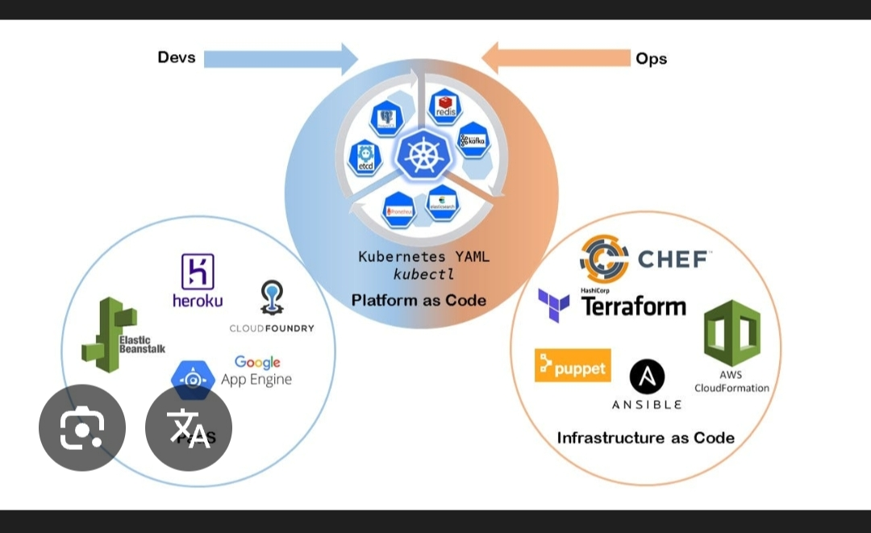
How it works﻿
-Definition files: Infrastructure specifications are written into configuration files using languages like YAML, JSON, or scripting languages like Python.﻿
-Automation: These files are then used by tools to automate the creation, modification, and deletion of infrastructure resources.﻿
-Version control: The configuration files are stored in version control systems like Git, allowing for tracking, collaboration, and rollback of changes.﻿
-Testing: The codified infrastructure can be tested for correctness and compliance before deployment, ensuring consistency and reducing errors. ﻿
Key benefits﻿
-Consistency: IaC ensures that infrastructure is provisioned the same way every time, eliminating configuration drift and the "it works on my machine" problem.﻿
-Speed: Automation allows for the rapid provisioning and scaling of resources in response to fluctuating demand, speeding up development and deployment cycles.﻿
-Cost savings: By enabling quick scaling and reducing manual effort, IaC can help control costs.﻿
-Improved collaboration: Using version control and code review processes allows teams to collaborate more effectively on infrastructure management.﻿
-Reduced risk: Automation reduces the risk of human error that is common in manual processes. ﻿
5.11 Quantum cloud computing:﻿
Cloud quantum computing provides remote access to quantum computing resources over the internet, eliminating the need for users to own expensive and complex hardware. This model allows businesses, researchers, and developers to run quantum algorithms, perform simulations, and experiment with quantum applications by accessing quantum processors hosted in data centers, which are managed by cloud providers. Key providers include Google, IBM, and Microsoft, which offer platforms like Google Quantum AI, IBM Quantum, and Azure Quantum. ﻿
How it works﻿
-Remote access: Users access quantum processors, simulators, and emulators through cloud platforms via the internet. ﻿
-Hybrid model: Classical and quantum computers work together, with quantum computers handling the most complex parts of a problem and classical computers managing routine tasks. ﻿
-Managed infrastructure: Quantum hardware is physically located in controlled data centers, managed by providers who handle the complex requirements like supercooling and isolation. ﻿
-Scalability: The cloud model offers the scalability and accessibility of classical cloud computing to quantum resources. ﻿
Benefits﻿
-Accessibility: Makes quantum computing accessible to a wider audience without the high cost and technical expertise required to own and maintain physical quantum computers. ﻿
-Experimentation: Enables users to experiment with quantum algorithms and develop quantum applications. ﻿
-Efficiency: Allows users to run complex calculations on real quantum hardware without direct interaction with specialized equipment. ﻿
-Cost-effectiveness: Avoids the significant capital expenditure of purchasing a quantum computer.﻿
